Department of Health and Human Services
FIRST-CLASS MAIL
U.S. POSTAGE
PAID
CHICAGO, ILLINOIS
PERMIT NO. XXXX
c/o NORC at the University of Chicago
55 East Monroe Street, 19th Floor | Chicago IL 60603
OFFICIAL BUSINESS
RETURN SERVICE REQUESTED

IMPORTANT INFORMATION ENCLOSED
from the U.S. Centers for Medicare and Medicaid Services

Respondent Name
Address Placeholder
City, State ZIP
[Postcard Front Cover]

[Postcard Inner Top]
OMB No. 0938-0568 | Expires 8/31/2023

Dear [Respondent Name],
Recently you received a letter or phone call from our representatives to request your participation in the Medicare Current Beneficiary Survey (MCBS). Your response is needed now more than ever; the information you provide will be used to make Medicare work better, both now and in the future.
If you have already responded to the survey, thank you for your participation!
If not, please call 1-877-389-3429 to schedule your telephone appointment. For more information about this survey, please visit mcbs.norc.org.
Thank you for your help with this important survey to improve your Medicare services!
Sincerely,
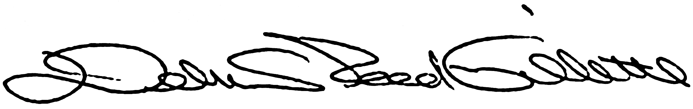
Debra Reed-Gillette, Director
Medicare Current Beneficiary Survey
Centers for Medicare & Medicaid Services
[Postcard Inner Bottom]

[Postcard Back Cover]

