Addendum to Supporting Statement for Form SSA-7-F6
Application for Parent’s Insurance Benefits
20 CFR 404.370, 404.371, 404.373, 404.374 and 404.601-404.603
OMB No. 0960-0012

Revisions to the Form SSA-7-F6

- Change #1: We are updating the title of the application to “Application for Social Security Benefits.”

Justification #1: We are beginning our effort to streamline our Title II benefit applications into one application so that we can avoid unnecessarily re-collecting information from claimants who file for more than one benefit. This change is consistent with our scope of Title II applications, making any application an application for all Title II benefits to which the claimant may be eligible.

- Change #2: We are rewording the scope of the application from “this may also be considered an application” to “this may serve as an application.”

Justification #2: We are removing passive voice and making grammatical corrections, which is consistent with plain language standards.

- Change #3: We are updating the internet links listed in the application from “www.socialsecurity.gov” to “www.ssa.gov.”

Justification #3: We are displaying the internet link using our current naming convention.

- Change #4: We are removing question #1(b): Check (X) one for the Deceased. Male Female

Justification #4: We do not need to collect the gender of the deceased worker to evaluate the eligibility of the applicant. The claims system will utilize the decease information stored in our records. We do not believe that removing this question will cause a decrease in the average burden per response since the questions take less than a minute to complete.

- Change #5: We are adding question #3: Select your relationship to the Deceased.
☐Natural Parent
☐ Adoptive Parent
Date of adoption __________
☐ Step Parent
Date of marriage to Deceased’s parent ______________

Justification #5: We need to collect the relationship of the claimant to the deceased worker. The question is already present on the screens included in previously approved packages. Adding this question will not cause an increase in the average burden per response since the question takes less than a minute to complete.

- Change #6: We are removing question #6 (6a, 6b, and 6c)

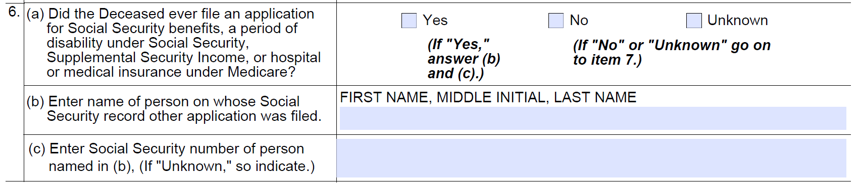

Justification #6: We are removing these questions because we are not required to ask individuals these questions since the information is already in SSA records. The data fields for these questions will remain in the Modernized Claim System (MCS). Technicians will complete the data fields with information they obtained from SSA records. Removing these questions will not cause a decrease in the average burden per response since the questions take less than a minute to complete.

- Change #7: We are removing “Prior to Full Retirement Age or Prior to One Year Past Full Retirement Age, and” from part of the instructions for question #7.

Justification #7: We are simplifying the wording to avoid confusion. SSA can determine if the date of death is relevant to the alleged onset date without making it part of the question to the claimant.

- Change #8: We are removing question #8(a), (b). We moved (c) to new question #15c.

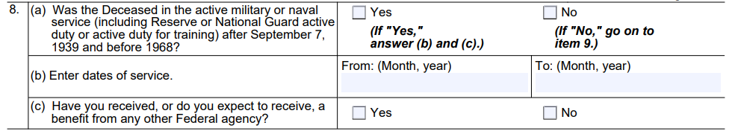

Justification #8: These questions are no longer relevant since they apply to claimants who are currently age 71 and older. Removing these questions will not cause a decrease in the average burden per response since the questions take less than a minute to complete.

- Change #9: We are removing the word “about” from question #9(a) and (b).

Justification #9: We removed the term because it is not meaningful in this context.

- Change #10: We are removing question #10

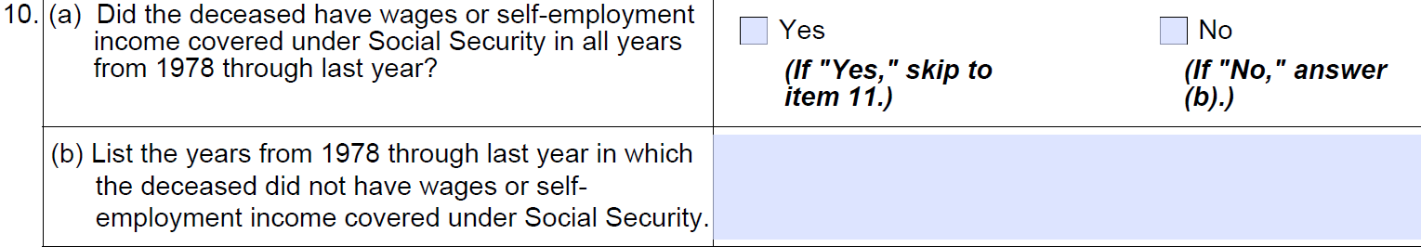

Justification #10: We automated our systems and the technician gets systems’ alerts to indicate gaps in an earning record. Therefore, we no longer need the question. Removing these questions will not cause a decrease in the average burden per response since the questions take less than a minute to complete.

- Change #11: We are removing question #12(c) and (d).

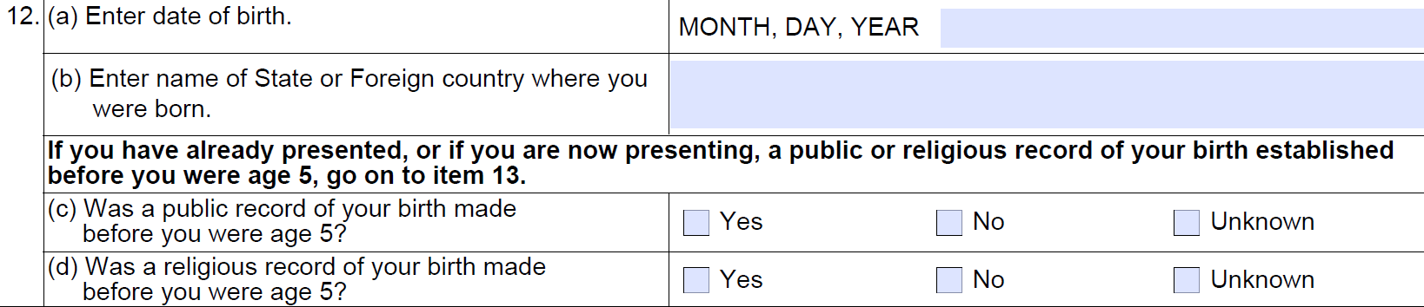

Justification #11: We do not need to see records of birth for documentation in all cases. When we do need to see records, we ask for specific items. We do not need to ask about the existence of records for all claimants. Removing these questions will not cause a decrease in the average burden per response since the questions take less than a minute to complete.

- Change #12: We are adding questions about citizenship and legal presence as the new question #12.
12 | - Are you a U.S. Citizen? | Yes No (if No, proceed to 12b)
 | - Do you have a U.S. lawful presence status? | Yes No

Justification #12: We need to collect the citizenship or legal presence status of the claimant to evaluate payment eligibility. The question is already present on the screens included in previously approved packages. We do not believe that inserting these questions will cause an increase in the average burden per response since the questions take less than a minute to complete.

- Change #13: We are removing question #14
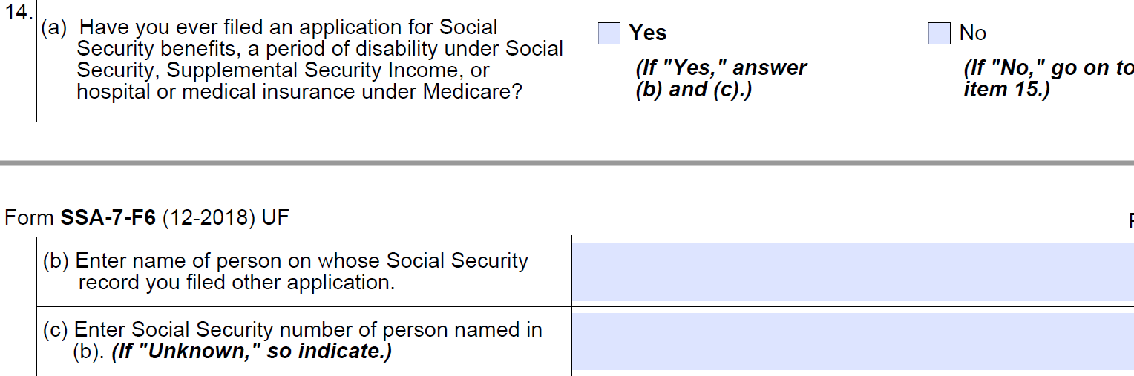

Justification #13: We are removing these questions because we are not required to ask individuals these questions since the information is already in SSA records. The data fields for these questions will remain in the Modernized Claim System (MCS). Technicians will complete the data fields with information they obtained from SSA records. We do not believe that removing these questions will cause a decrease in the average burden per response since the questions take less than a minute to complete.

- Change #14: We are inserting a new question #15 c “Are you filing for foreign Social Security benefits?”

Justification #14: We are inserting this question because the Title II application can establish the filing date for the foreign benefit. The updated format is consistent with other Title II applications. The question is already present on the screens included in previously approved packages.

- Change #15: We are updating the penalty of perjury statement:
From: I declare under penalty of perjury that I have examined all the information on this form, and on any accompanying statements or forms, and it is true and correct to the best of my knowledge. I understand that anyone who knowingly gives a false or misleading statement about a material fact in this information, or causes someone else to do so, commits a crime and may be sent to prison, or may face other penalties, or both.

To: I declare under penalty of perjury that I have examined all the information on this form, and on any accompanying statements or forms, and it is true and correct to the best of my knowledge. I understand that anyone who knowingly gives a false or misleading statement about a material fact in this information, or causes someone else to do so, commits a crime and may be subject to fine or imprisonment, or both.

Justification #15: We are updating the statement to be consistent with our other benefit applications.

- Change #16: We are replacing the “Social Security Claim Number” with the beneficiary notice control number (BNC).

Justification #16: We are removing Social Security numbers from the notices and receipts per the Social Security Number Fraud Prevention Act.

- Change #17: We are simplifying the applications for Title II benefits by combining them into a single collection instrument. We are currently renewing OMB No. 0960-0618. Upon OMB’s approval for both 0960-0618 and 0960-0012, we will submit a Change Request to combine the two Clearance Packages under 0960-0618 to avoid duplication of collection.

Justification #17: This change will reduce the burden to the public for applicants who file for more than one benefit in a lifetime and will support our efforts to identify all potential eligibility for any benefit at the time of filing.

- Change #18: We are revising the PRA statement on this form.

Justification #18: We are revising the PRA statement to reflect our current boilerplate language. The current language, which dates back to the last reprint of the form, is now outdated.

- Change #19: We are revising the Privacy Act Statement on this form.

Justification #19: SSA’s Office of the General Counsel is conducting a systematic review of SSA’s Privacy Act Statements on agency forms. As a result, SSA is updating the Privacy Act Statement on this form.

Preliminary Claims System (PCS)

- Change #20: We are removing the PCS as a collection tool for application questions that we added with the March 2019 Change Request.

Justification #20: Due to reassessing IT Modernization initiatives, we stopped development for the PCS. The focus shifted to creating the Consolidated Claims Experience (CCE), which will replace our current legacy claim system with web-based claims.

We will make these revisions upon OMB’s approval. We do not anticipate a change in the burden as the questions we are removing are offset by the additions we are making to the form. In addition, as these questions take less than a minute to complete, we do not believe the changes will change the current burden estimate for completing the form.

