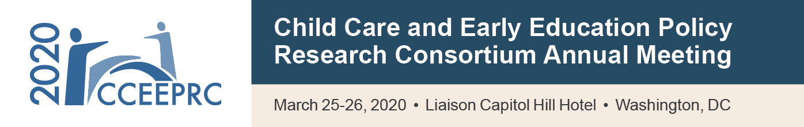

Overall Evaluation Form
This evaluation form can also be completed online at: [INSERT LINK TO SURVEY HERE]

Which professional perspective most closely reflects your current role/position? (Please select one)
Researcher (if selected, please indicate the research setting)  Academic  Research Firm/Institution  Federal, State, or Local Government  Graduate Student |  | State or Local Government  Federal Government  Training/Technical Assistance Organization  Other: (For example, Foundation Staff or National Policy Organization Staff. Please specify)
Please check each day you attended.
Wednesday, March 25, 2020 | Thursday, March 26, 2020

Is this your first time attending CCEEPRC?
Yes | No
If no, how many times have you attended CCEEPRC prior to this year?
[Drop down menu: 1-25]
Are you a current OPRE funded grantee or contractor?
Yes | No
Overall Program
Please rate the statements using the following scale: 1=Poor, 2=Fair, 3=Good and 4=Excellent.
Poor Fair Good Excellent
Overall, the meeting was: …………………. 1 2 3 4
The information discussed and provided was: ………………. 1 2 3 4
The presenters and moderators were: ………………………... 1 2 3 4
The plenary session topics were (i.e. 2019 NSECE;
High Quality Child Care: Who Pays?; Measuring the Impact of CCDBG Reauthorization):..……..……..……..……..………… 1 2 3 4
The breakout session topics were: ………………………….... 1 2 3 4
- Did any of the presentations, discussions, and topics covered in this year’s meeting inspire you to think about your work or interests in a different way? Please explain.

- What topics would you like to see addressed or explored further in future meetings or in a different format? Please specify the topics and preferred format.

- Which plenary and breakout sessions did you find most effective and why?

- What can we improve for next time in terms of meeting content (e.g., topics, sessions, participants)?

- What can we improve for next time in terms of meeting format (e.g., length of meeting, session format, CCEEPRC communications system)?

Making Connections and Networking
For each activity you participated in, please rate your impression of these activities using the following scale: 1=Poor, 2=Fair, 3=Good and 4=Excellent.
Poor Fair Good Excellent N/A
Meeting planning process with Consortium members 1 2 3 4
Meet-and-Greet Reception (Wednesday evening) 1 2 3 4
Affinity Discussions during Extended Lunch (Thursday) 1 2 3 4
Breakout sessions 1 2 3 4

- What can we improve to help you make or strengthen connections with other projects and Consortium members?

Meeting Logistics
Please rate the statements using the following scale: 1=Poor, 2=Fair, 3=Good and 4=Excellent.
Poor Fair Good Excellent N/A
Use of the meeting website 1 2 3 4
Meeting registration process 1 2 3 4
Use of the meeting app 1 2 3 4
Location of hotel 1 2 3 4
Time of year 1 2 3 4
Meeting space (e.g. session rooms, exhibit hall) 1 2 3 4
Hotel accommodations (e.g. guest rooms, hotel amenities) 1 2 3 4
Logistics staff assistance 1 2 3 4
Presentation technology 1 2 3 4
Meeting materials (e.g. agenda, ACF project information) 1 2 3 4

- What can we improve for next time in terms of meeting logistics?

- Did you use the meeting app? What was your experience accessing information about the meeting with or without the app?

- Is there anything else that you would like to share about how we can improve the meeting?

Thank you for completing this Evaluation Form. Please return this completed form to the Registration Desk,
e-mail it to CCEEPRC@icf.com or complete the evaluation online at: [INSERT LINK TO SURVEY HERE].

Paperwork Reduction Act Statement: This collection of information is voluntary and will be used to collect participant feedback to shape future CCEEPRC meetings. Public reporting burden for this collection of information is estimated to average 10 minutes per response, including the time for reviewing instructions, gathering and maintaining the data needed, and reviewing the collection of information. An agency may not conduct or sponsor, and a person is not required to respond to, a collection of information unless it displays a currently valid OMB control number. The OMB number and expiration date for this collection are OMB #0970-0401, expiration date: 05/31/2021. Send comments regarding this burden estimate or any other aspect of this collection of information, including suggestions for reducing this burden to Ann Rivera (Ann.Rivera@acf.hhs.gov).

