EMAIL 3: Grantee survey reminder email
Subject: Family and Youth Services Bureau (FYSB) grantee COVID survey

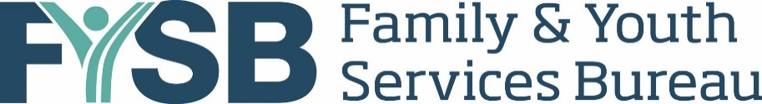

Dear [GranteeContact_FirstName1 and GranteeContact_FirstName 2],
Thank you in advance for your participation in the Family and Youth Services Bureau (FYSB) grantee COVID survey. This is a reminder to please complete the survey by [DATE].
We understand that you have recently or are currently in the process of submitting performance measures data, including items related to COVID-19. These questions are separate from the COVID items asked in the PREP and SRAE performance measures. This survey is designed specifically to provide FYSB with information to better assist grantees in the upcoming months, and survey participation is voluntary.
We appreciate your timely response to the survey so FYSB can quickly incorporate the responses into guidance for grantees. The survey is estimated to take 15 minutes to complete. We recommend that the person who completes this survey is someone familiar with program activities across the sites and how the various sites have been impacted by COVID-19, such as a Project Director or Main Point of Contact for the grant. If that person will not be available to complete the survey by [DATE] we recommend designating someone else who can complete the survey by the due date.
Please click on the grant-specific link below to access the web-based survey. IMPORTANT NOTE: You can share this link with anyone helping complete the survey, but to avoid overwriting responses no more than one respondent should be in the survey at once:

[IF flag for multiple grants =1:]
[The link below is for your [fill grant year and grant type] grant, please answer all questions thinking about that grant.]

URL: [INSERT GRANTEE AND GRANT-SPECIFIC URL]
If you have any questions while completing the survey, please contact us at covidsurvey@mathematica-mpr.com or 844-919-0173. Thank you!

Sincerely,
Melissa Thomas
Survey Director, Mathematica

