Webinar or Workshop Survey
Thank you for attending [Webinar/Workshop Title]. Your thoughts and suggestions are important to improving our [webinars/workshops]. Your individual responses will be kept private. Only aggregate information will be shared. This survey will take about 5 minutes to complete. Thank you for taking the time to help us assess our technical assistance!
Introduction
- Did you attend most or all of [Webinar/workshop title]?
- Yes
- No [If no, skip to end]

Display if registration information does not capture role or state
- Your role (select one)
- State staff
- Partner organization supporting state work
- Federal Program Officer
- PDG B-5 Center TA provider or staff
- Other:
Please specify your role:
______________________________________________________________________

- Select your state:
[Select from list of U.S. states and territories]

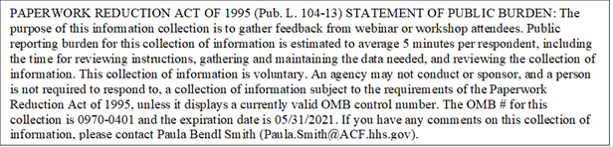

Assessment of the [Workshop/Webinar]
- Rate the quality of the information (and resources, if applicable) provided in the [webinar/workshop].
- Excellent
- Good
- Poor
- Very poor

- Rate the relevance of the information (and resources, if applicable) to your state provided in the [webinar/workshop]
- Very relevant
- Somewhat relevant
- Not relevant
- Not at all relevant

- Rate the usefulness of the information (and resources, if applicable) provided in the [webinar/workshop].
- Very relevant
- Somewhat relevant
- Not relevant
- Not at all relevant

- Was the information presented too simple, too advanced, or just about right?
- Far too advanced
- A bit too advanced
- About right
- A bit too simple
- Far too simple

- Indicate whether you agree or disagree with the following statements.
8a. Presentations and discussions were free from bias and inclusive of diverse and historically underrepresented groups.
- Strongly Agree
- Agree
- Disagree
- Strongly Disagree

As a result of participating in [webinar/workshop name], I …
8b. [Insert Intended Outcome #1, e.g, have a better understanding of logic models]
- Strongly Agree
- Agree
- Disagree
- Strongly Disagree

[Repeat for each outcome.]

We appreciate any additional comments or suggestions for improvement. If you do not want to provide additional feedback, click “Next” and submit your responses.

- Were there any aspects of the [webinar/workshop] that were particularly useful? If so, please describe.
_______________________________________________________________

- Were there any aspects of the [webinar/workshop] that that could have been improved? If so, please describe.
_______________________________________________________________

- Do you have any other comments or suggestions?
____________________________________________________________

