PDG B-5 TA Center Community of Practice and Workgroup Survey
Thank you for being a member of [Community of Practice/workgroup title]. Your thoughts and suggestions are important for improving [Communities of Practice/Workgroup]. Your individual responses will be kept private. Only aggregate information will be shared. This survey should take you about 5 minutes to complete. Thank you for taking the time to complete this feedback form!
- Did you participate* in the [CoP/Workgroup Name] on the MyPeers platform at any time between [date range]?
- Yes
- No [If no, skip to end]

*Participation includes any level of interaction, including reading or uploading files, reading suggested materials, reading or contributing to posts or chats, and/or participating in virtual events.

- Your role (select one)
- State staff
- Partner organization supporting state work
- Federal Program Officer
- PDG B-5 Center TA provider or staff
- Other:
Please specify your role:
______________________________________________________________________

- Select your state:
[Select from list of U.S. states and territories]
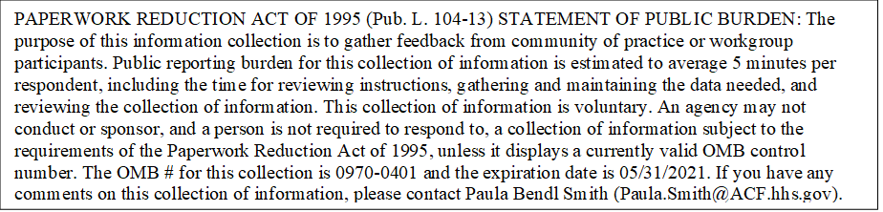
- Indicate how you have participated in the [CoP/Workgroup Name] since [date CoP/workgroup began or last feedback survey for this CoP/workgroup]? Select all that apply.
- Read files or uploaded files
- Read materials suggested or provided
- Read posts or contributed to posts
- Read chats or participated in chats
- Participated in at least one virtual call
- Participated in another way
Specify: _________________________________________________________
- Rate the quality of the information and resources provided in [CoP/Workgroup name].
- Excellent
- Good
- Poor
- Very poor

- Rate the relevance of the information and resources to your state provided in the [CoP/Workgroup name]
- Very relevant
- Somewhat relevant
- Not relevant
- Not relevant at all

- Rate the usefulness of the information and resources provided in the [CoP/Workgroup name].
- Very relevant
- Somewhat relevant
- Not relevant
- Not relevant at all

- Indicate whether you agree or disagree with the following statements.
8a. I had ample opportunities to comment and ask questions.

- Strongly Agree
- Agree
- Disagree
- Strongly Disagree

8b. I built or strengthened relationships with other colleagues from other states as a result of participating in this [CoP/workgroup].
- Strongly Agree
- Agree
- Disagree
- Strongly Disagree

8c. The [CoP/workgroup] provided enough opportunities to connect with my peers,
- Strongly Agree
- Agree
- Disagree
- Strongly Disagree

8d. Discussions were free from bias and inclusive of diverse and historically underrepresented groups
- Strongly Agree
- Agree
- Disagree
- Strongly Disagree

Display on all CoP surveys and only on final workgroup survey
Achievement of Intended Outcomes of [CoP/Workgroup name]
- Indicate whether you agree or disagree with the following statements: As a result of participating in the [CoP/Workgroup name] ...
9a. [Intended Outcome #1…n].
- Strongly Agree
- Agree
- Disagree
- Strongly Disagree

9b. [Intended outcome 2]
- Strongly Agree
- Agree
- Disagree
- Strongly Disagree

We appreciate any additional comments or suggestions for improvement. If you do not want to provide additional feedback, click “Next” and submit your responses.
- Were there any aspects of the [CoP/Workgroup name] that were particularly useful? If so, please describe.
_______________________________________________________________

- Were there any aspects of the [CoP/Workgroup name] that could have been improved? If so, please describe.
_______________________________________________________________

- Do you have any other comments or suggestions?
_____________________________________________________________________

