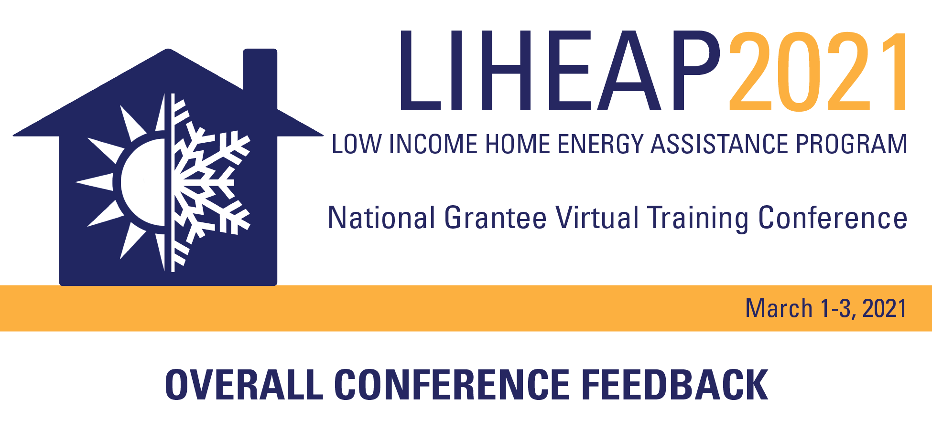

**Grantee Type: State (including Washington D.C.) Territory Native American Tribal Government/Organization**

Please rate the overall meeting from 1 to 4 (4 is the highest) on the following items:

|  |  |  |  |  |  |
| --- | --- | --- | --- | --- | --- |
| **March 1, 2021** | **Excellent** | **Very Good** | **Fair** | **Poor** | **Unsure** |
| **Opening Plenary Session** | 4 ☐ | 3 ☐ | 2 ☐ | 1 ☐ | ☐ |
| **Rising to the Challenge from a Grantee Perspective** | 4 ☐ | 3 ☐ | 2 ☐ | 1 ☐ | ☐ |
| **The Digital Divide: Solutions for Connectivity and Accessing Services** | 4 ☐ | 3 ☐ | 2 ☐ | 1 ☐ | ☐ |
| **OCS Meet and Greet** | 4 ☐ | 3 ☐ | 2 ☐ | 1 ☐ | ☐ |
| **March 2, 2021 (Tribal Sessions)** |  |  |  |  |  |
| **Designing and Evaluating LIHEAP Benefit Matrices** | 4 ☐ | 3 ☐ | 2 ☐ | 1 ☐ | ☐ |
| **What is Fraud: Enhancing Program Integrity** | 4 ☐ | 3 ☐ | 2 ☐ | 1 ☐ | ☐ |
| **Policy Manuals Framework** | 4 ☐ | 3 ☐ | 2 ☐ | 1 ☐ | ☐ |
| **March 3, 2021 (State Sessions)** |  |  |  |  |  |
| **Performance Management Data/Evaluation** | 4 ☐ | 3 ☐ | 2 ☐ | 1 ☐ | ☐ |
| **Effective Oversight of Subrecipients** | 4 ☐ | 3 ☐ | 2 ☐ | 1 ☐ | ☐ |
| **LIHEAP Weatherization and Partner Weatherization Agencies** | 4 ☐ | 3 ☐ | 2 ☐ | 1 ☐ | ☐ |
|  |  |  |  |  |  |
|  |  |  |  |  |  |
| **Overall Conference** | **Excellent** | **Very Good** | **Fair** | **Poor** | **Unsure** |
| **Your ability to clearly see the visual materials** | 4 ☐ | 3 ☐ | 2 ☐ | 1 ☐ | ☐ |
| **Your ability to hear all the presentations and questions** | 4 ☐ | 3 ☐ | 2 ☐ | 1 ☐ | ☐ |
| **The content is relevant to your program** | 4 ☐ | 3 ☐ | 2 ☐ | 1 ☐ | ☐ |
| **Overall Meeting** | 4 ☐ | 3 ☐ | 2 ☐ | 1 ☐ | ☐ |

What new information, or pieces of knowledge, have you gained from the conference?

|  |
| --- |
|  |
|  |
|  |
|  |
|  |

What session(s) was the most beneficial to you and why?

|  |
| --- |
|  |
|  |
|  |
|  |
|  |

Any other comments (name the session and then comment):

|  |
| --- |
|  |
|  |
|  |
|  |
|  |