We have been trying to reach you!

We’re calling about the Health Profession Opportunity Grant, or HPOG study. You agreed to be in this study about 15 months ago. At that time you applied to receive training and services through your local HPOG program.

This is a very important research study. It is funded by the Administration for Children and Families (ACF).

After you complete the survey, you will receive a gift card worth $40 to thank you for your help with this important study.

To schedule your interview or to get more information about the HPOG Study, please:
Call ___________________________
at _____________________________

Please mention this number: ______________________

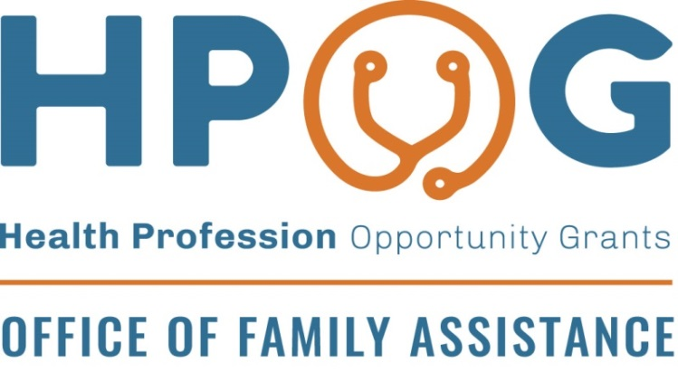
According to the Paperwork Reduction Act (PRA), an agency may not conduct or sponsor, and a person is not required to respond to, a collection of information unless it displays a currently valid OMB control number. The OMB control number for this collection is [0970-0462] and it expires xx/xx/xxxx. If you have comments regarding this burden estimate or any other aspect of this collection of information, including suggestions for reducing this burden, please send them to Gretchen Locke, 55 Wheeler St Cambridge, MA 02138; Attn: OMB-PRA (0970-0462).

