Postcard Reminder
Dear Family Member,
We recently mailed you the Distance Learning Household Survey. If you have already taken the survey, thank you! Your help is greatly appreciated.
If you haven’t taken the survey yet, there is still time for you to make sure your family’s voice is heard. Please complete the Distance Learning Household Survey today to tell us about your family’s experience of online school over the last year. Your answers and opinions are very important.
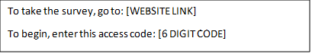
The survey only takes 15 minutes, and your answers will be kept private. If you have any questions, please call 877-777-5332 or email distancelearningsurvey@norc.org.
Thanks in advance,
[NORC SIGNATORY]

OMB Control No. 1076-NEW
Expires XX/XX/XXXX

