Housing Collection Instrument Screen Shots
(Contains Only Updated Screens Planned for Deployment in August 2020)
June 23, 2020

(s-1) Observation: Type of Structure Screen – Modification of Structure Type List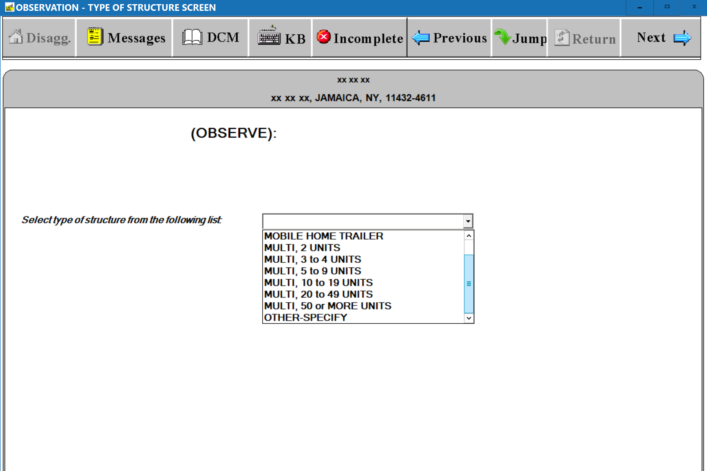
(S-2) Observation: Type of Structure Screen – Addition of Elevator Question
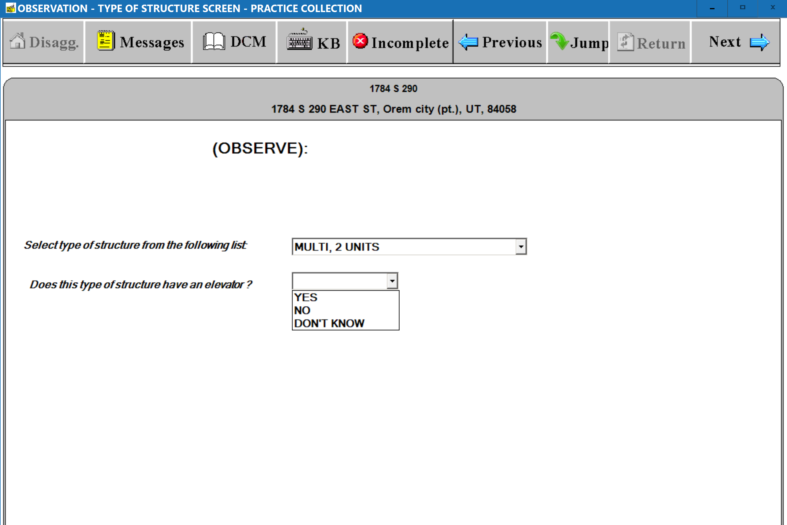
(s-3) Observation: Type of Structure Screen – Display of All Possible Structure Type Fields
*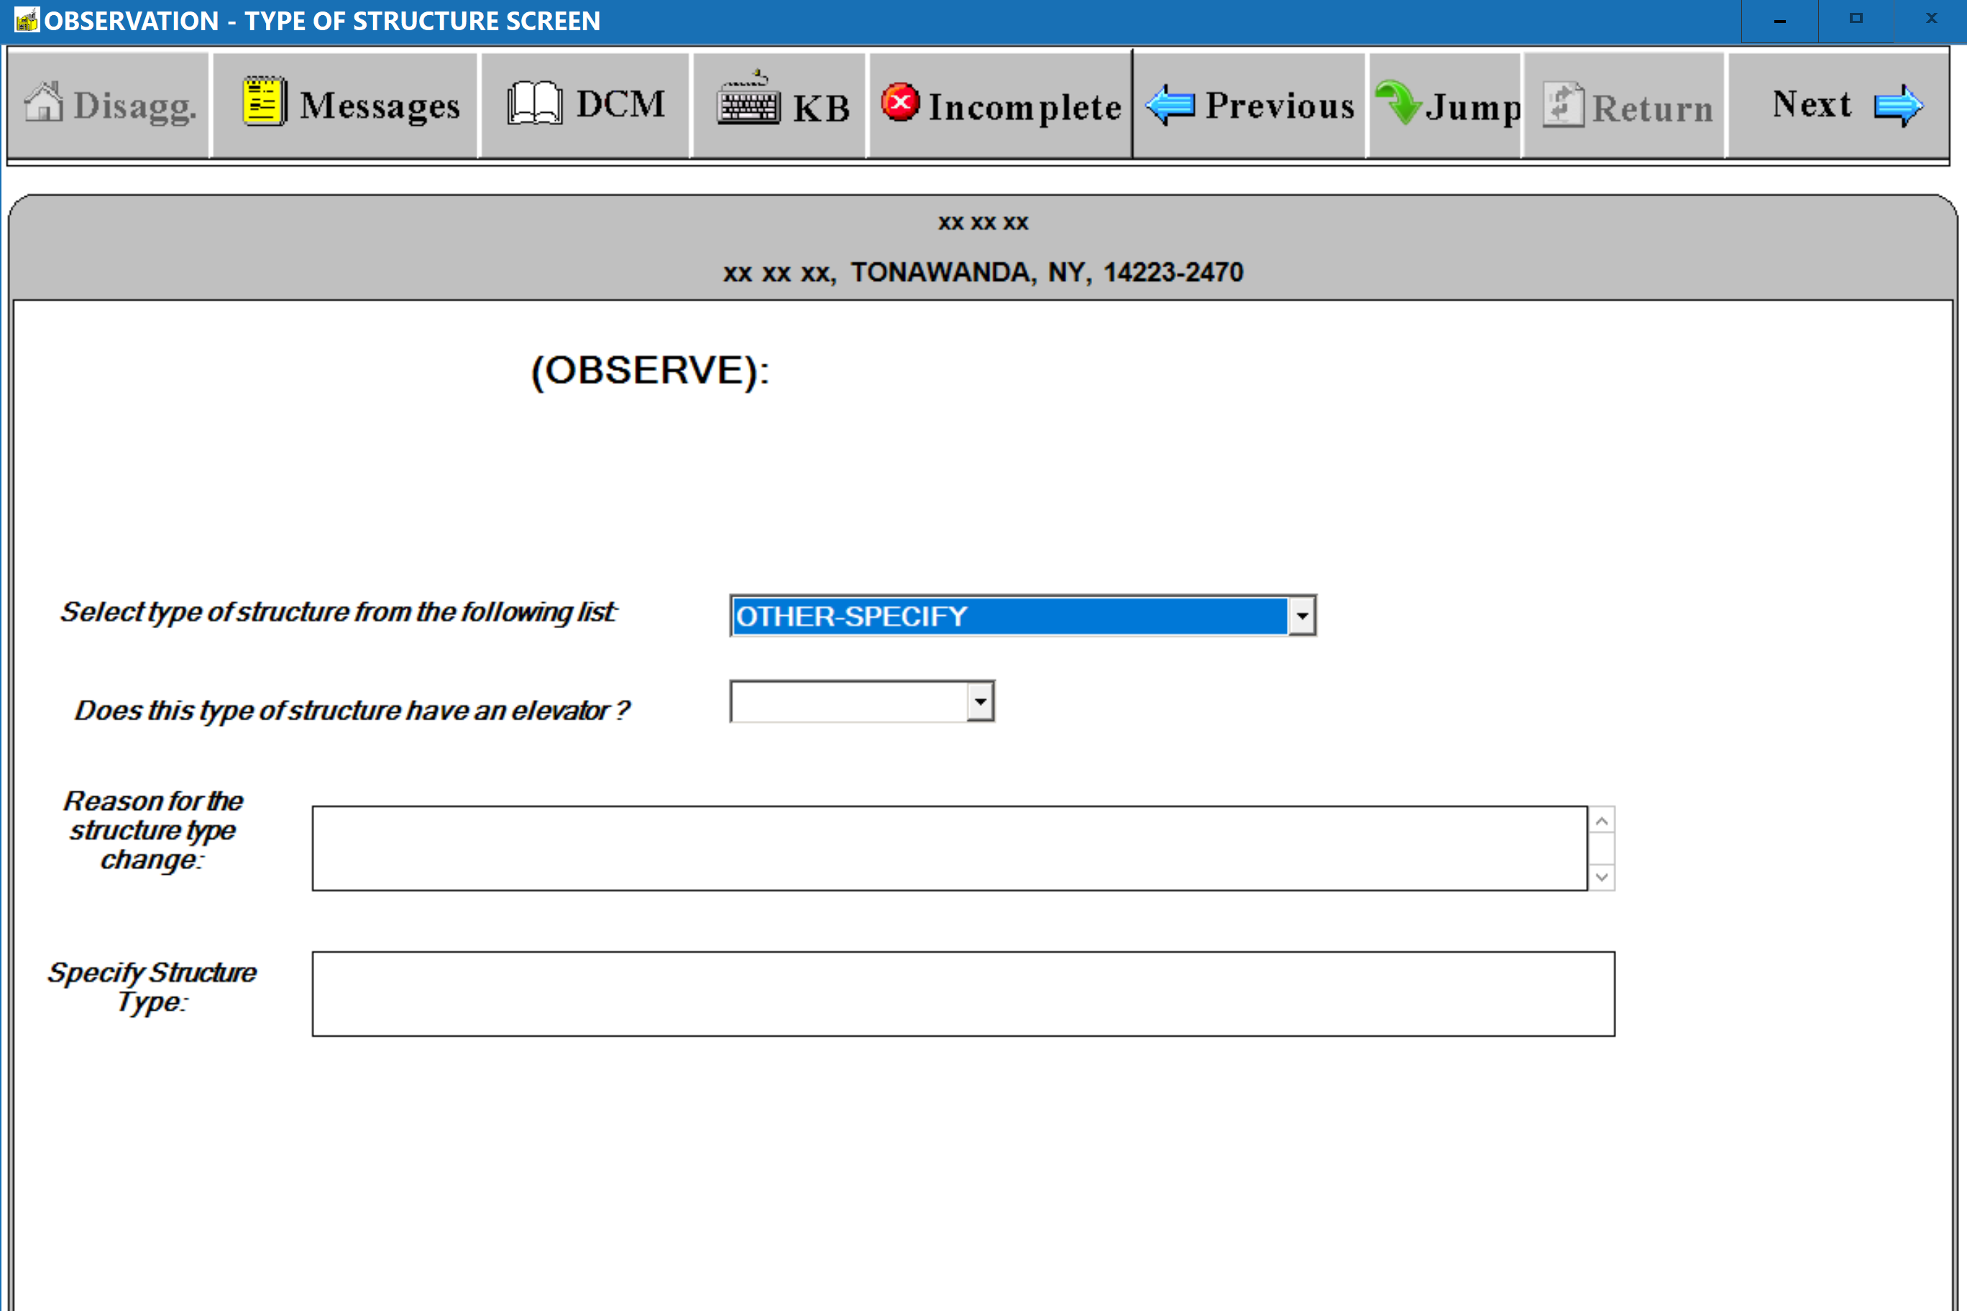
(s-4) Observation: Eligibility Screen – Addition of “Affordable Housing With Unit Based Subsidy” Option
Near the End of the Ineligibility List
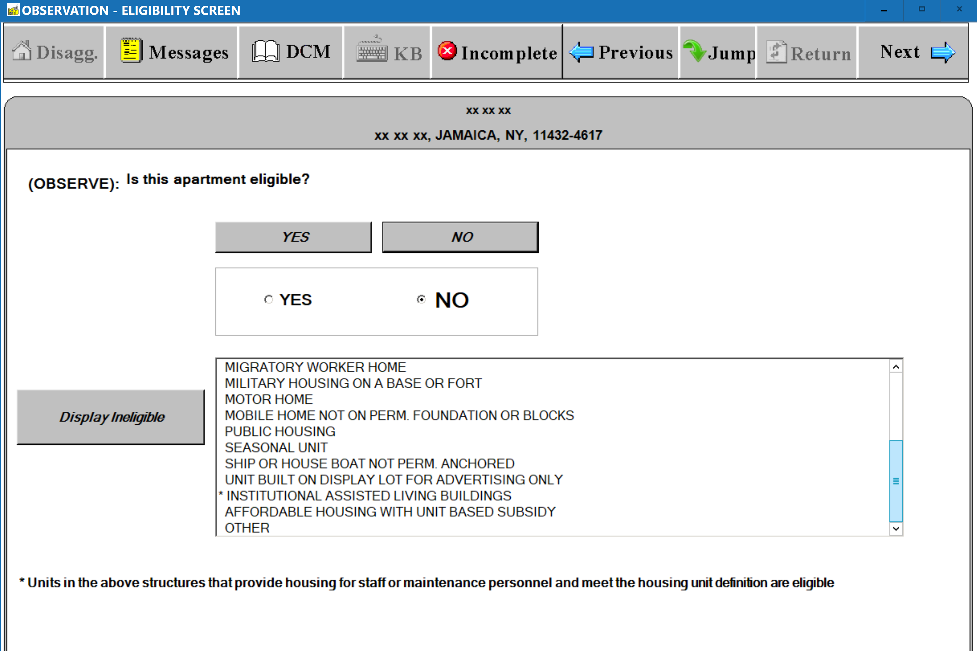
(S-5) Observation: Public Housing Screen – Updated Wording on Definition Window
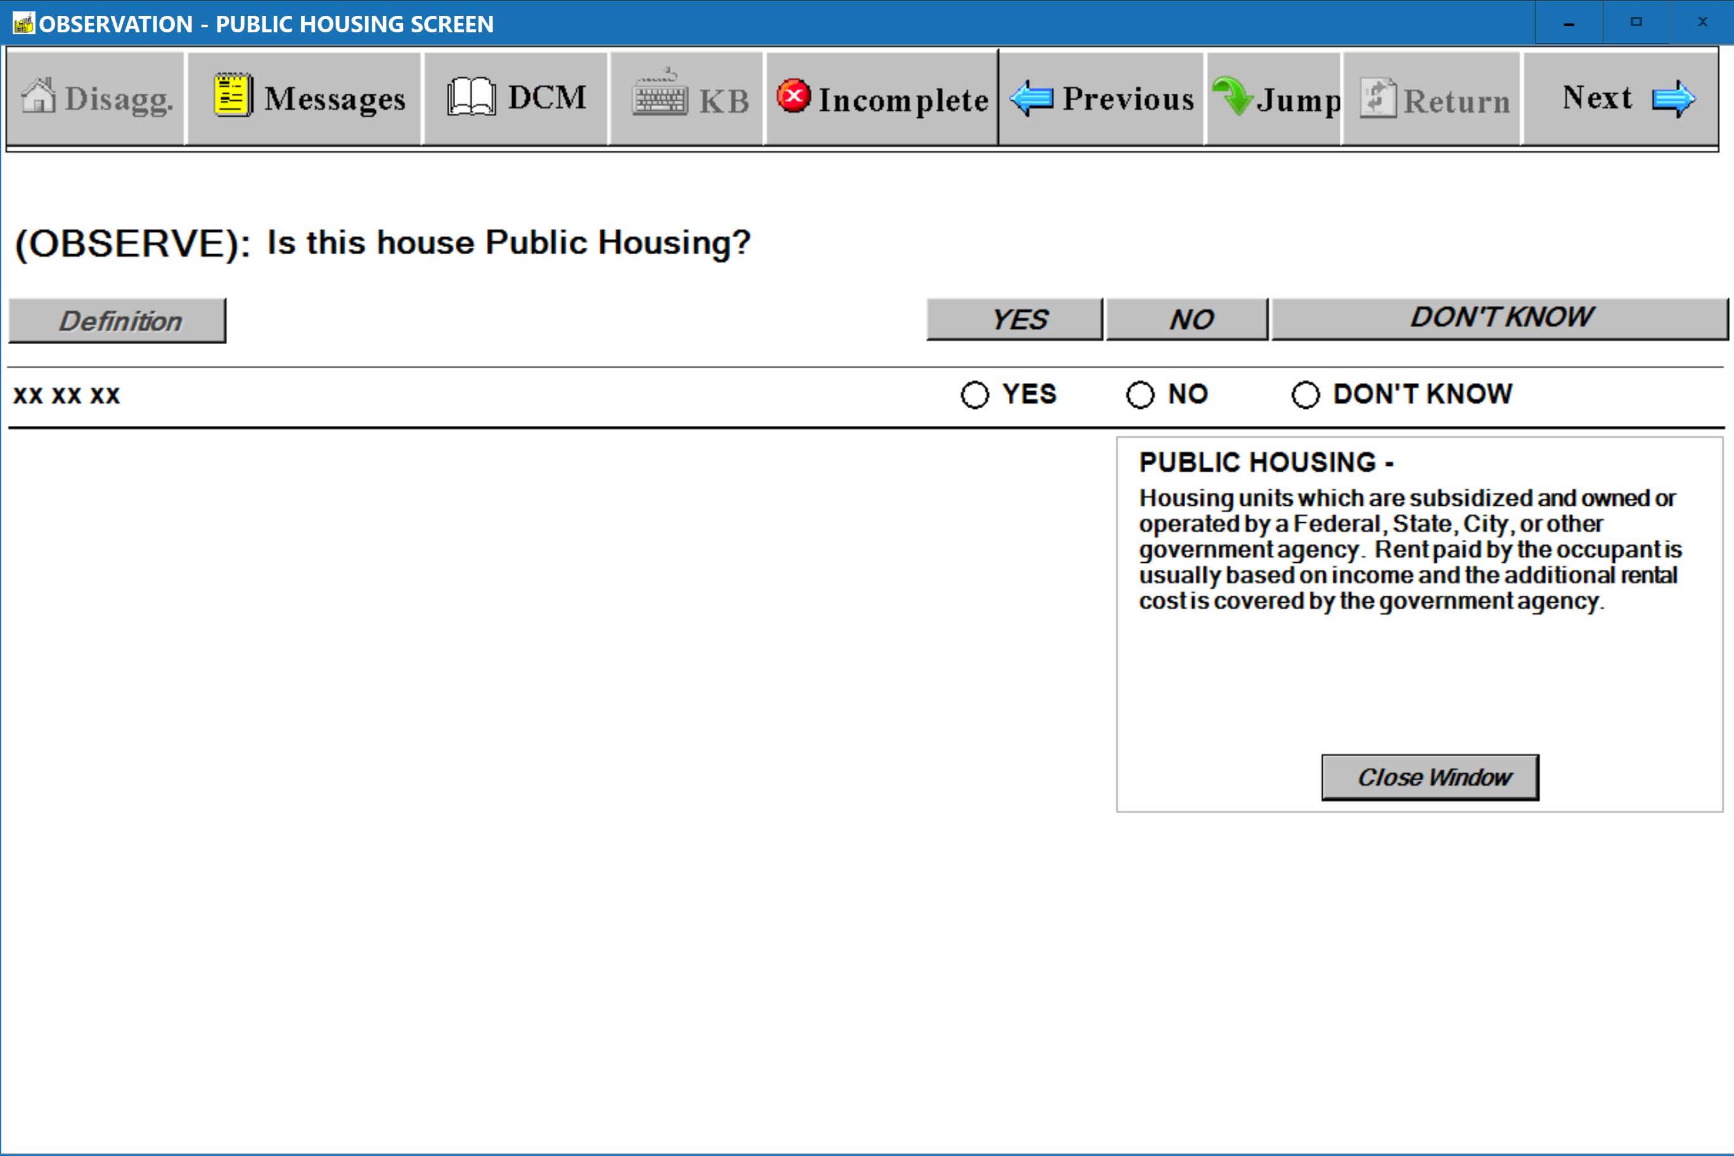
(S-6) Respondent: Public Housing Screen – Updated Wording on Definition Window
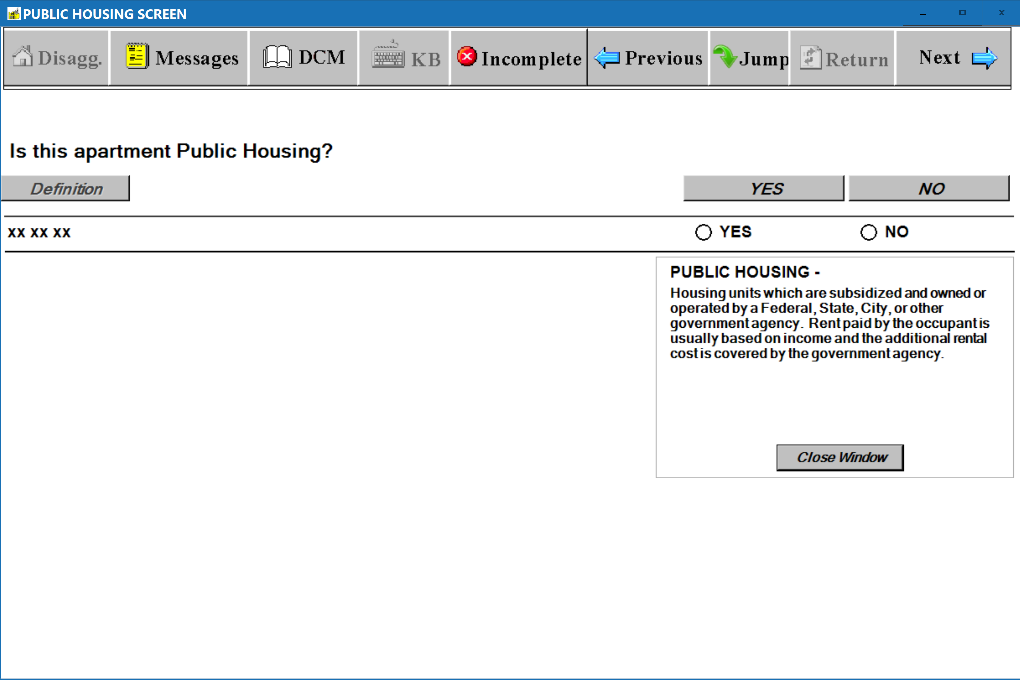

(S-7) when built screen – Addition of ‘2020 – 2029’ to “Select Decade” and “Select Year” Lists
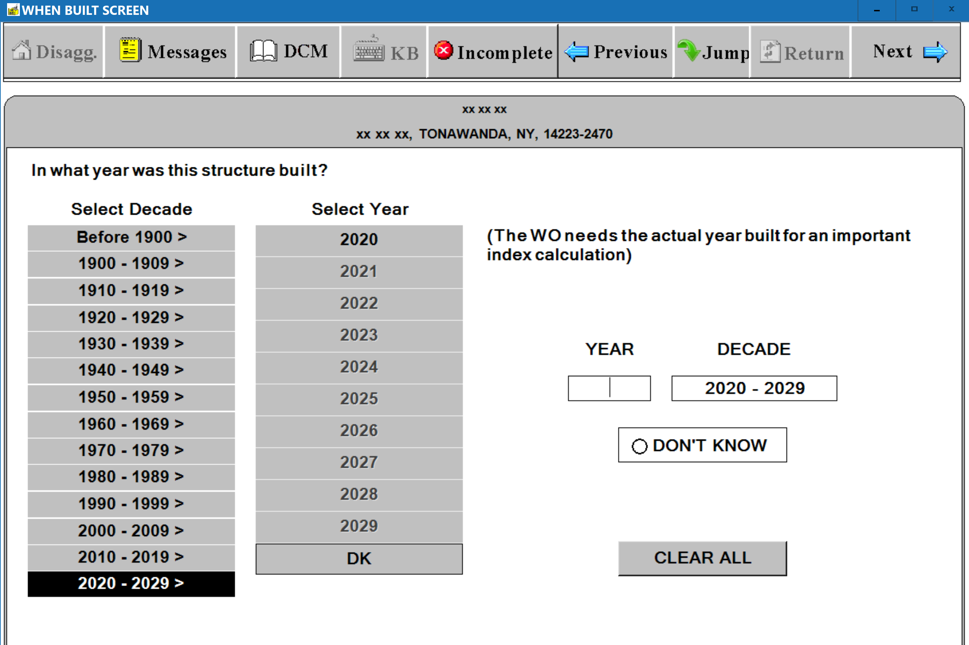
(S-8) LEASE SCREEN – Standard Questions – Lease Agreement & Lease Length Questions
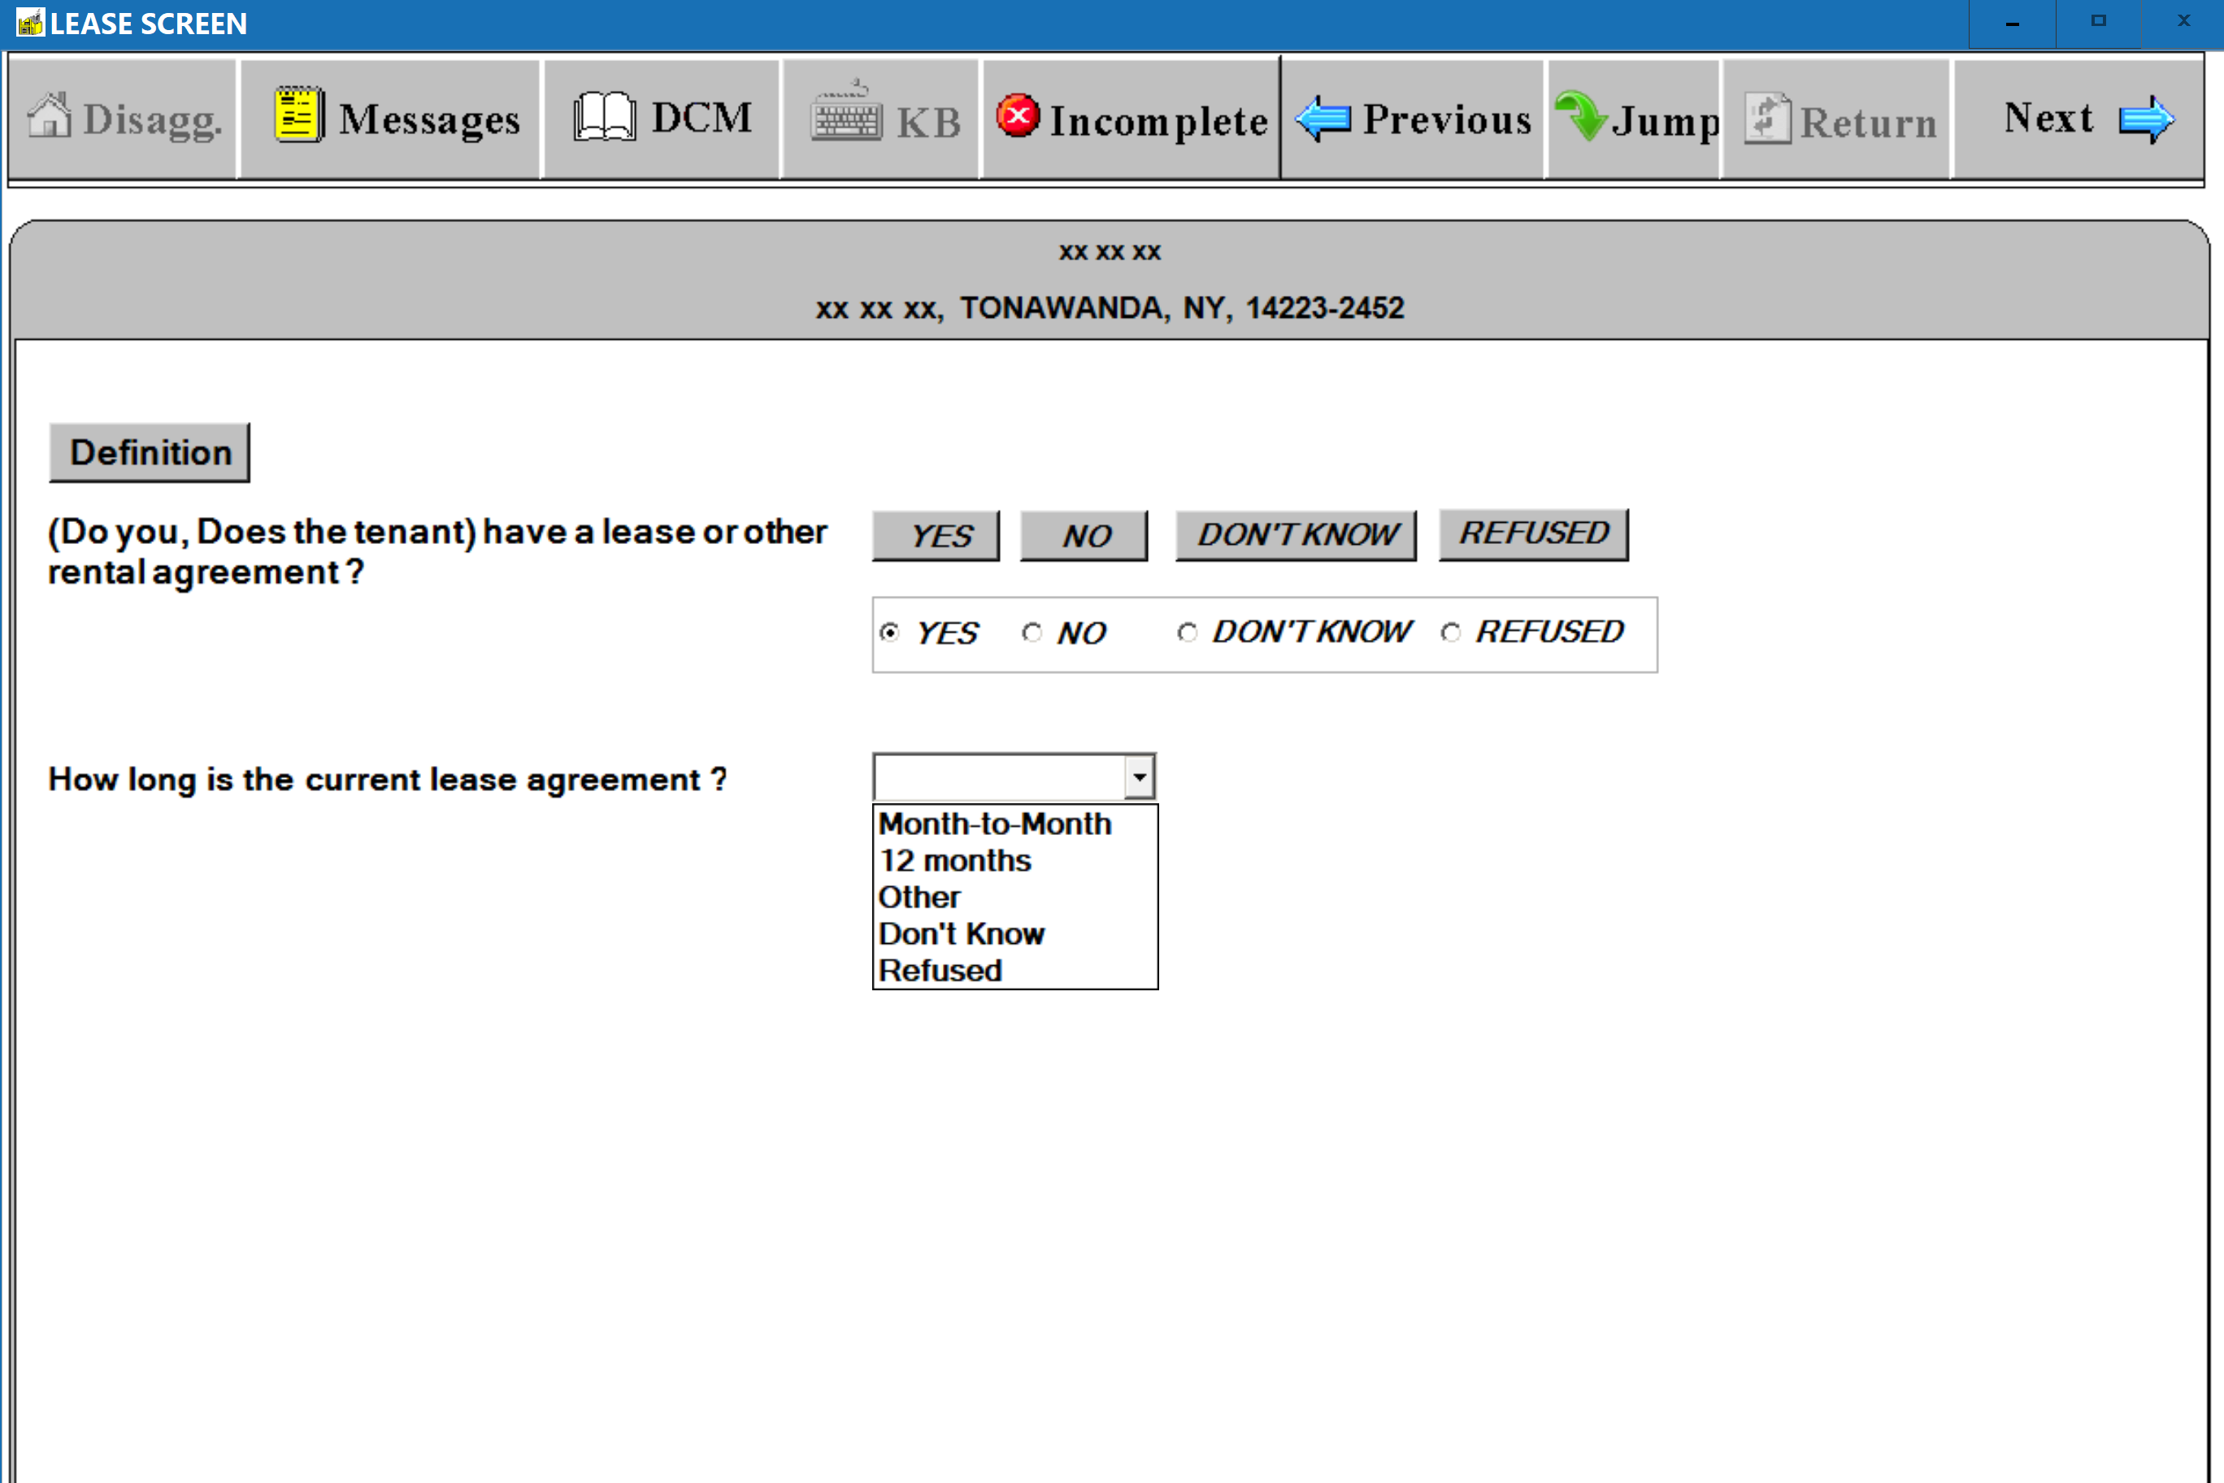
(S-9) LEASE SCREEN – Standard Questions – Lease Agreement, Lease Length, and Lease Start Date Questions
(12 Months Lease)
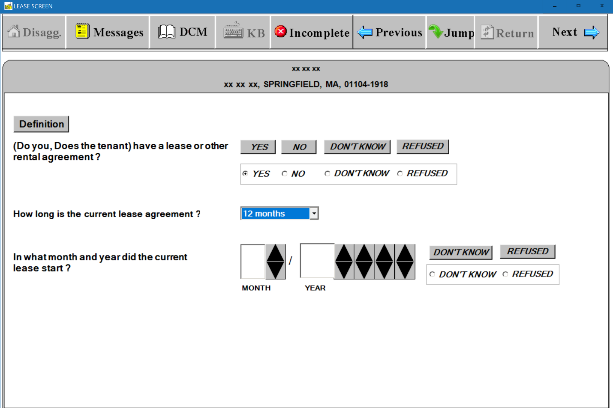

(S-10) LEASE SCREEN – Standard Questions – Lease, Lease Length, and Lease Start Date Questions
(Other Months Lease– Number of Months) 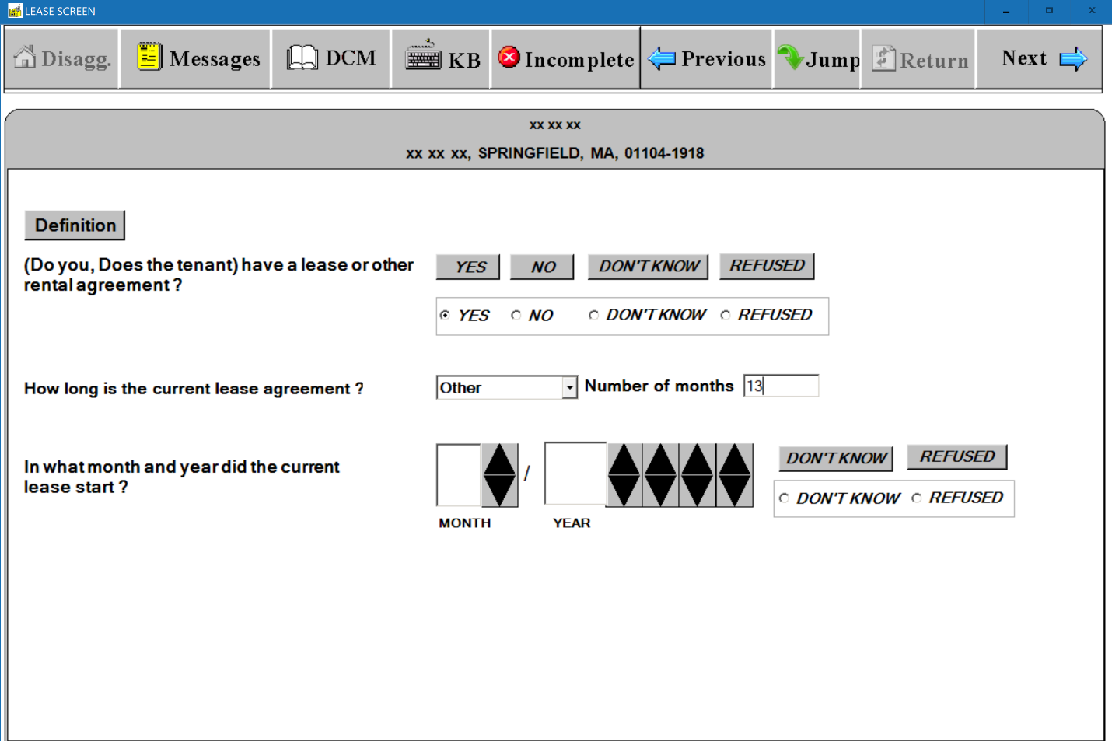
(S-11) LEASE SCREEN – Standard Questions – Lease, Lease Length, and Lease Start Date Questions
(Don’t Know or Refused Lease Start Date) 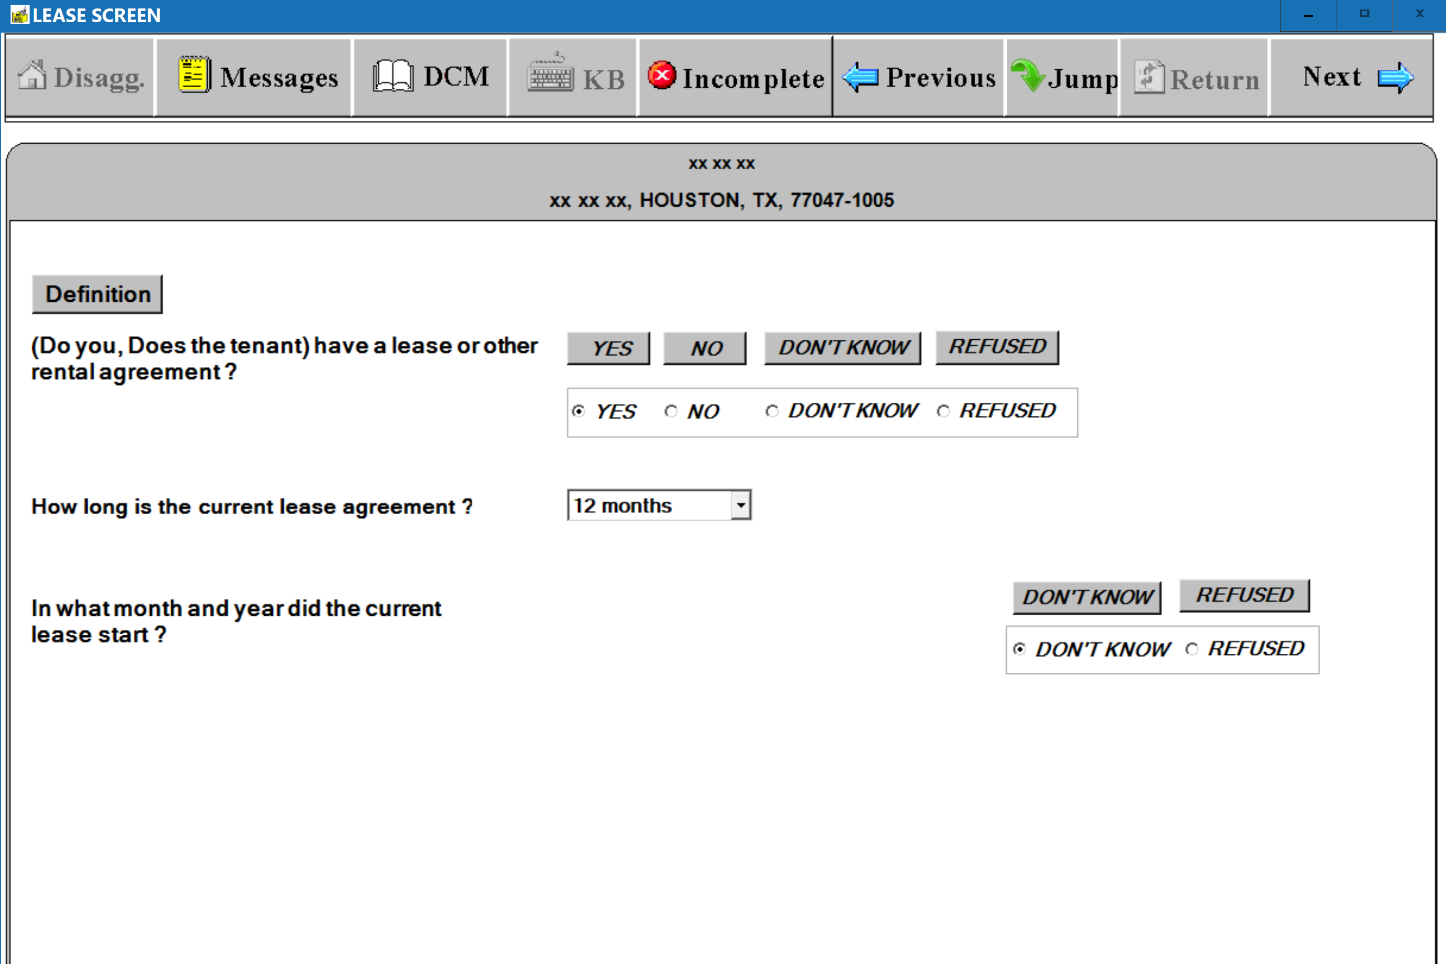
(S-12) LEASE SCREEN – Follow-up Questions – Previous Month-to-Month Lease (Still Month-to-Month Lease)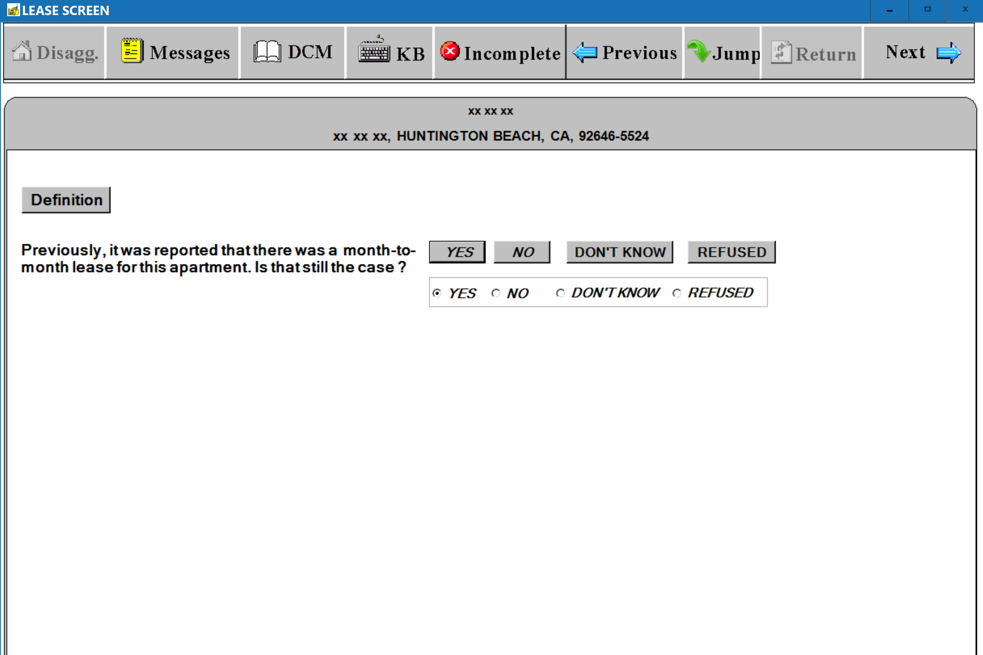

(S-13) LEASE SCREEN – Follow-up Questions – Previous Month-to-Month Lease (Not Still Month-to-Month Lease)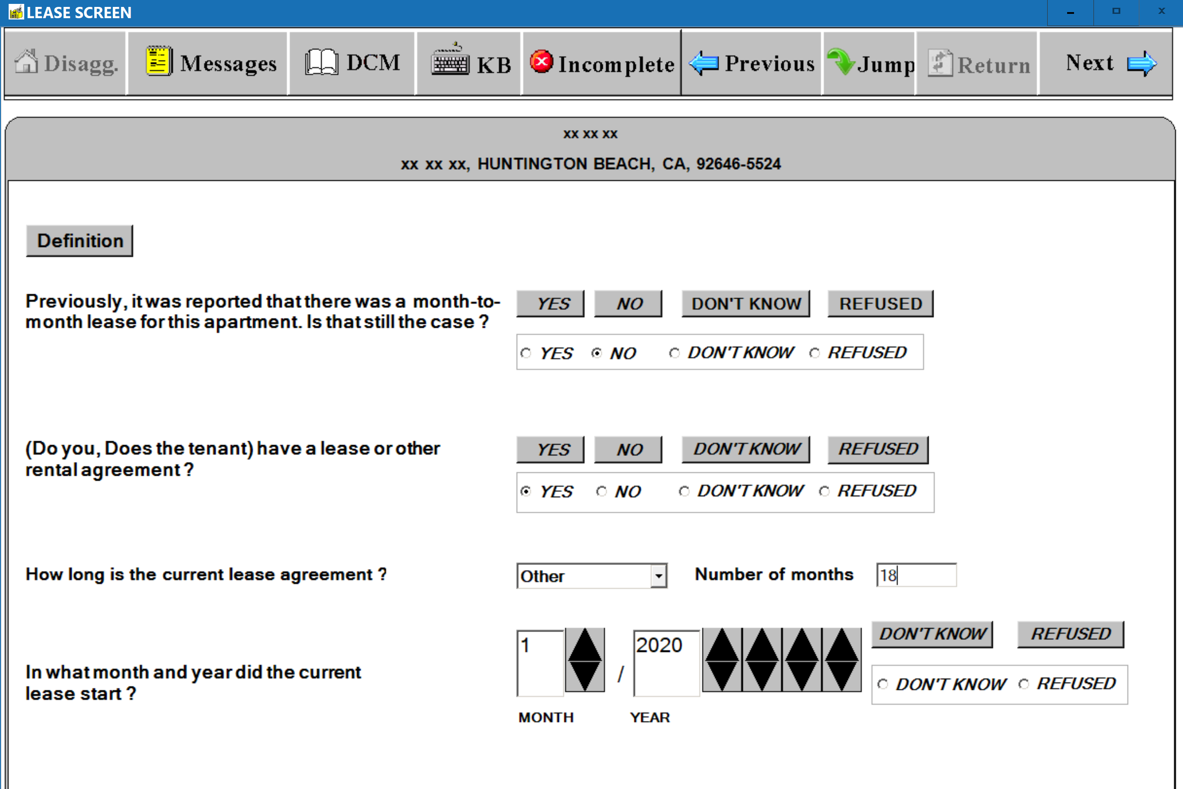

(S-14) LEASE SCREEN – Follow-up Questions – Previous 12 Months Lease or Other Months Lease (New Lease)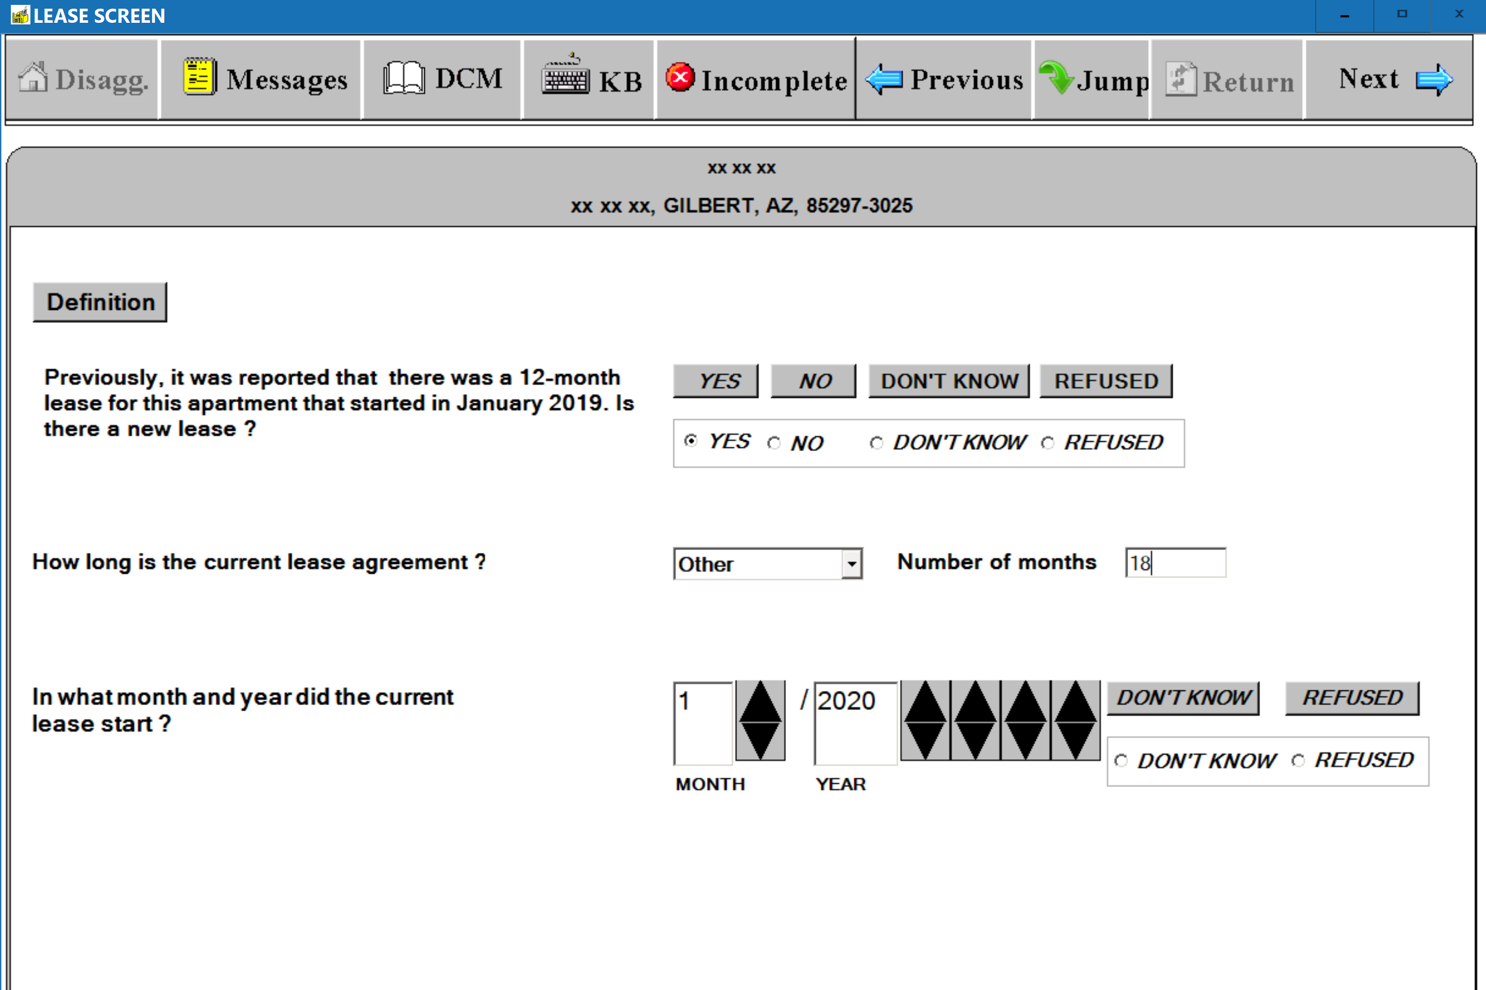
(S-15) LEASE SCREEN – Follow-up Questions – Previous 12 Months Lease or Other Months Lease (No New Lease)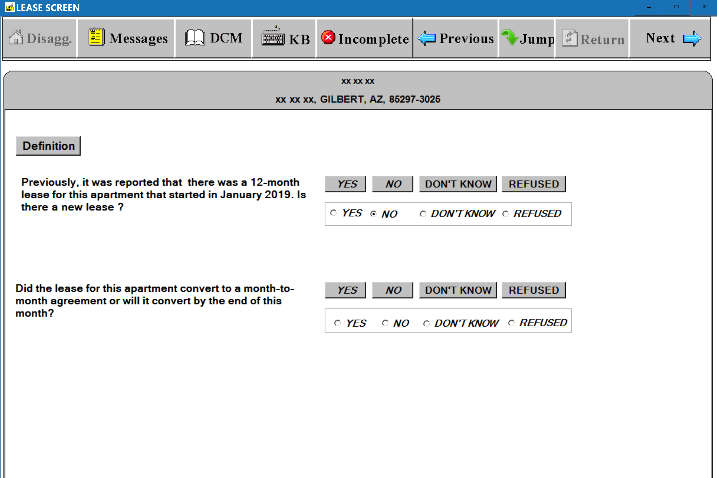
(S-16) LEASE SCREEN – Definition Window
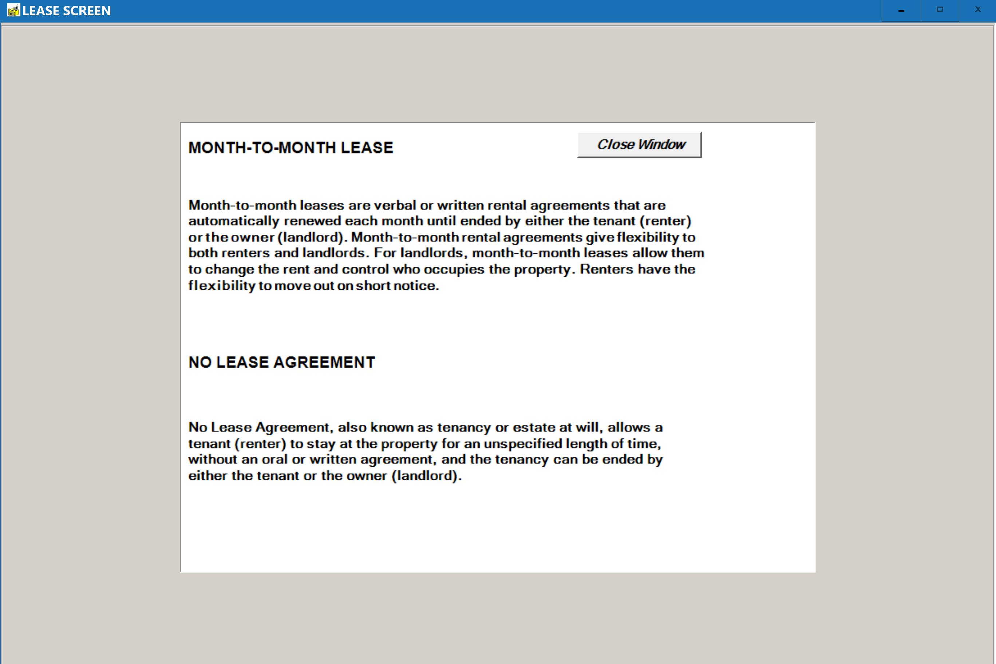
(S-17) LEASE SCREEN - Warning Message Window – Lease End Date Less Than Current Collection Period
[Lease Not Active]
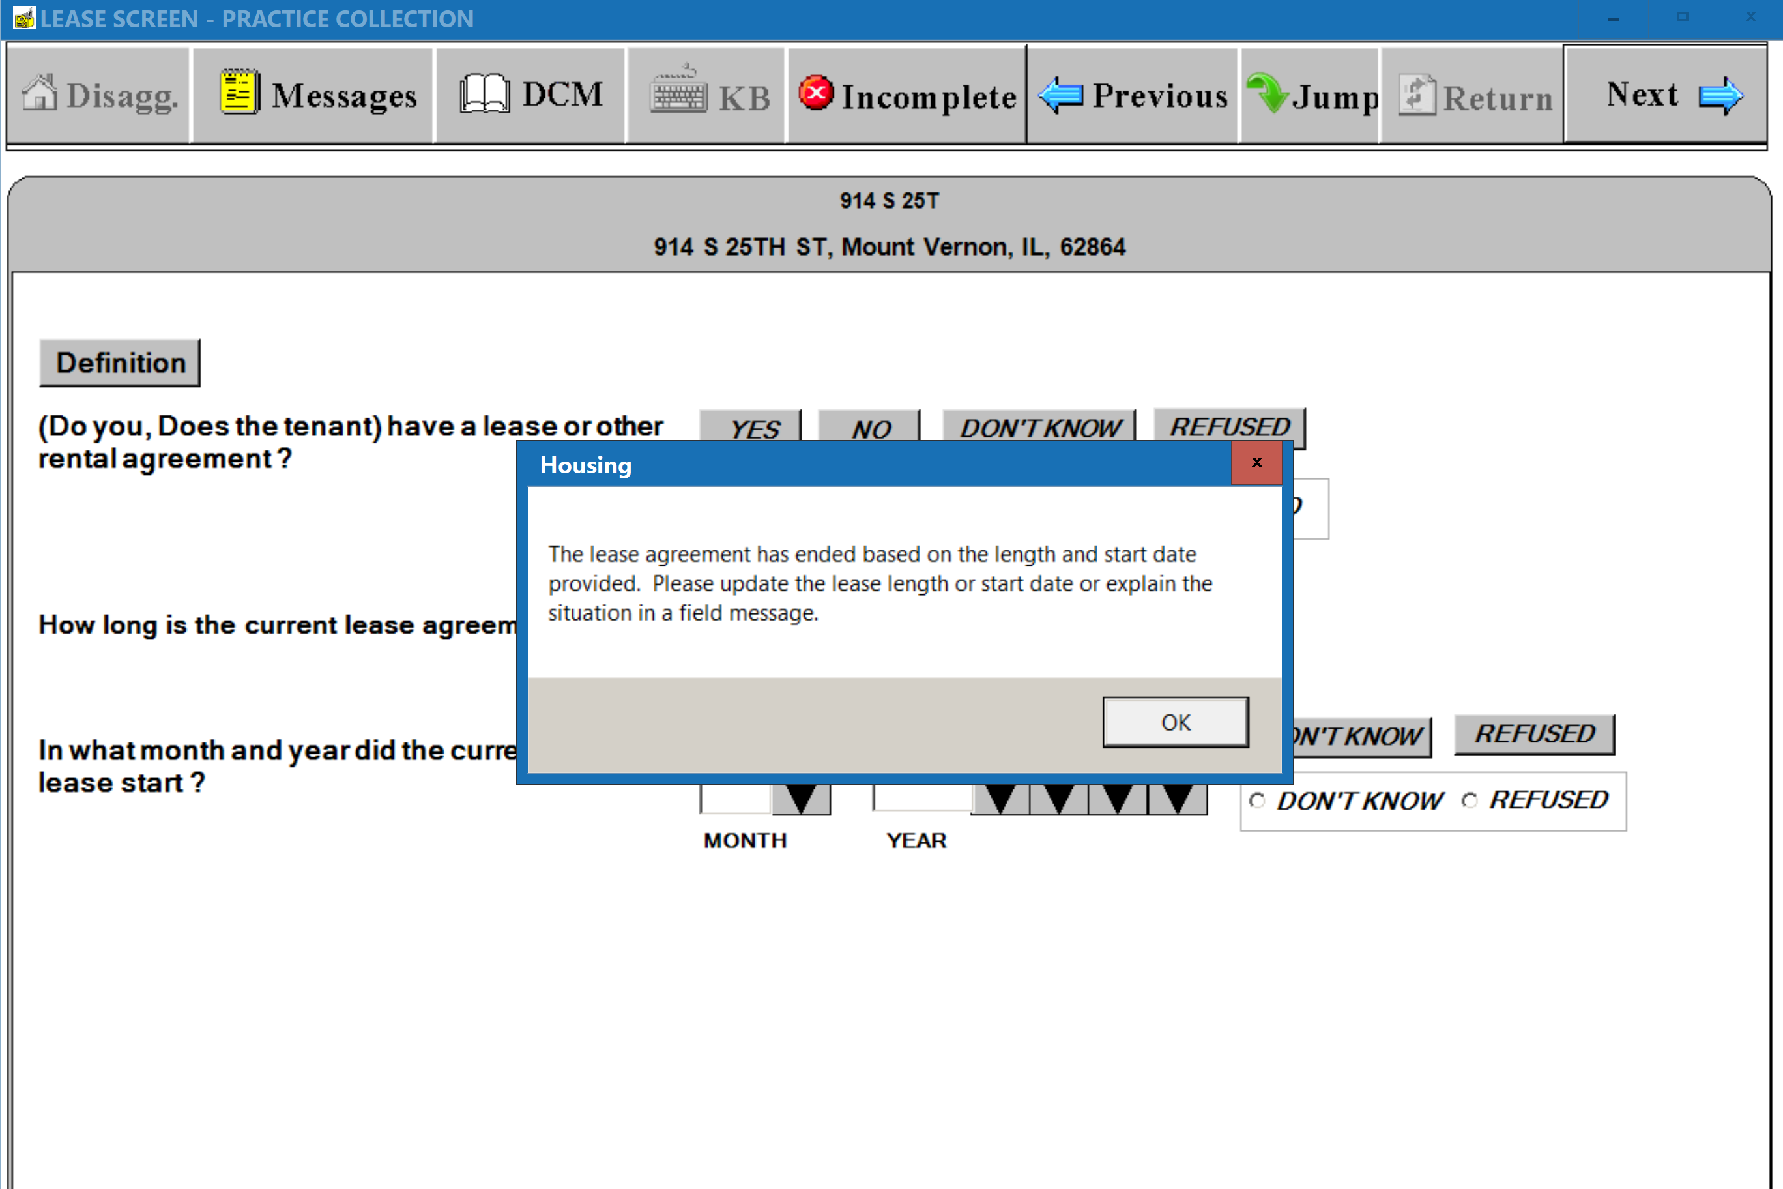
(S-18) LEASE SCREEN - Warning Message Window – Lease Start Date Less Than the Move-in Date
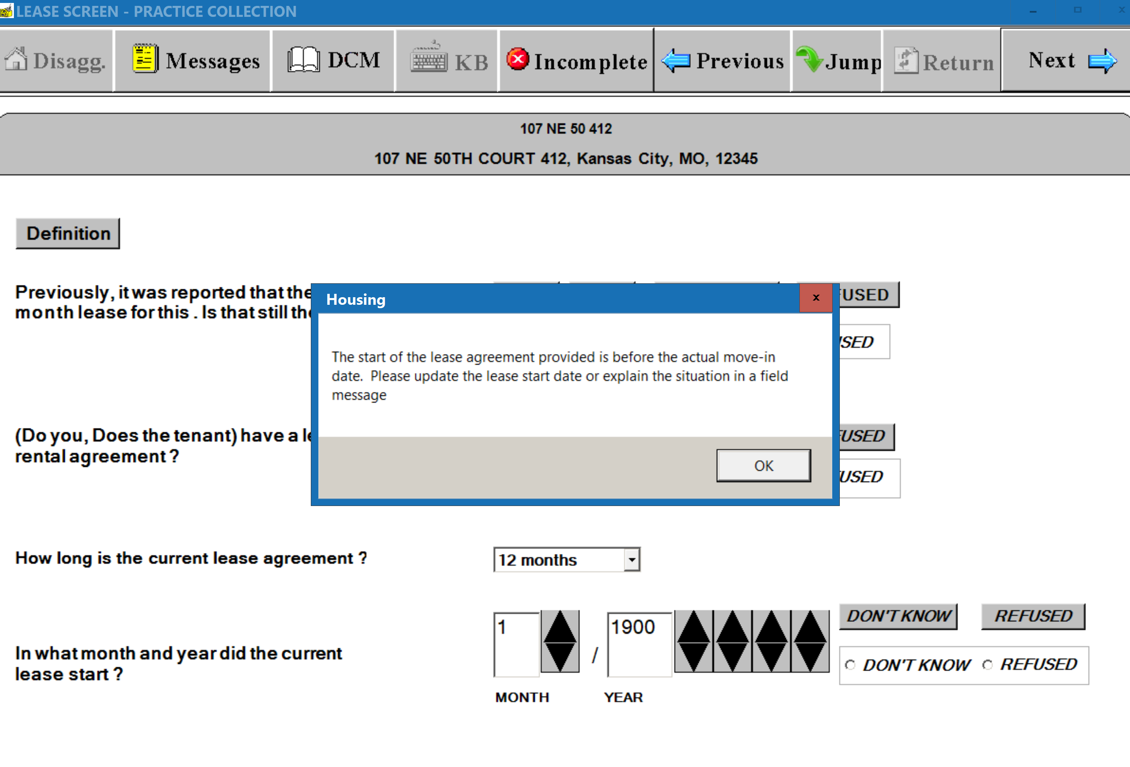
(S-19) LEASE SCREEN LEASE SCREEN - Warning Message Window – Lease Start Date Less Than the Previous
Lease End Date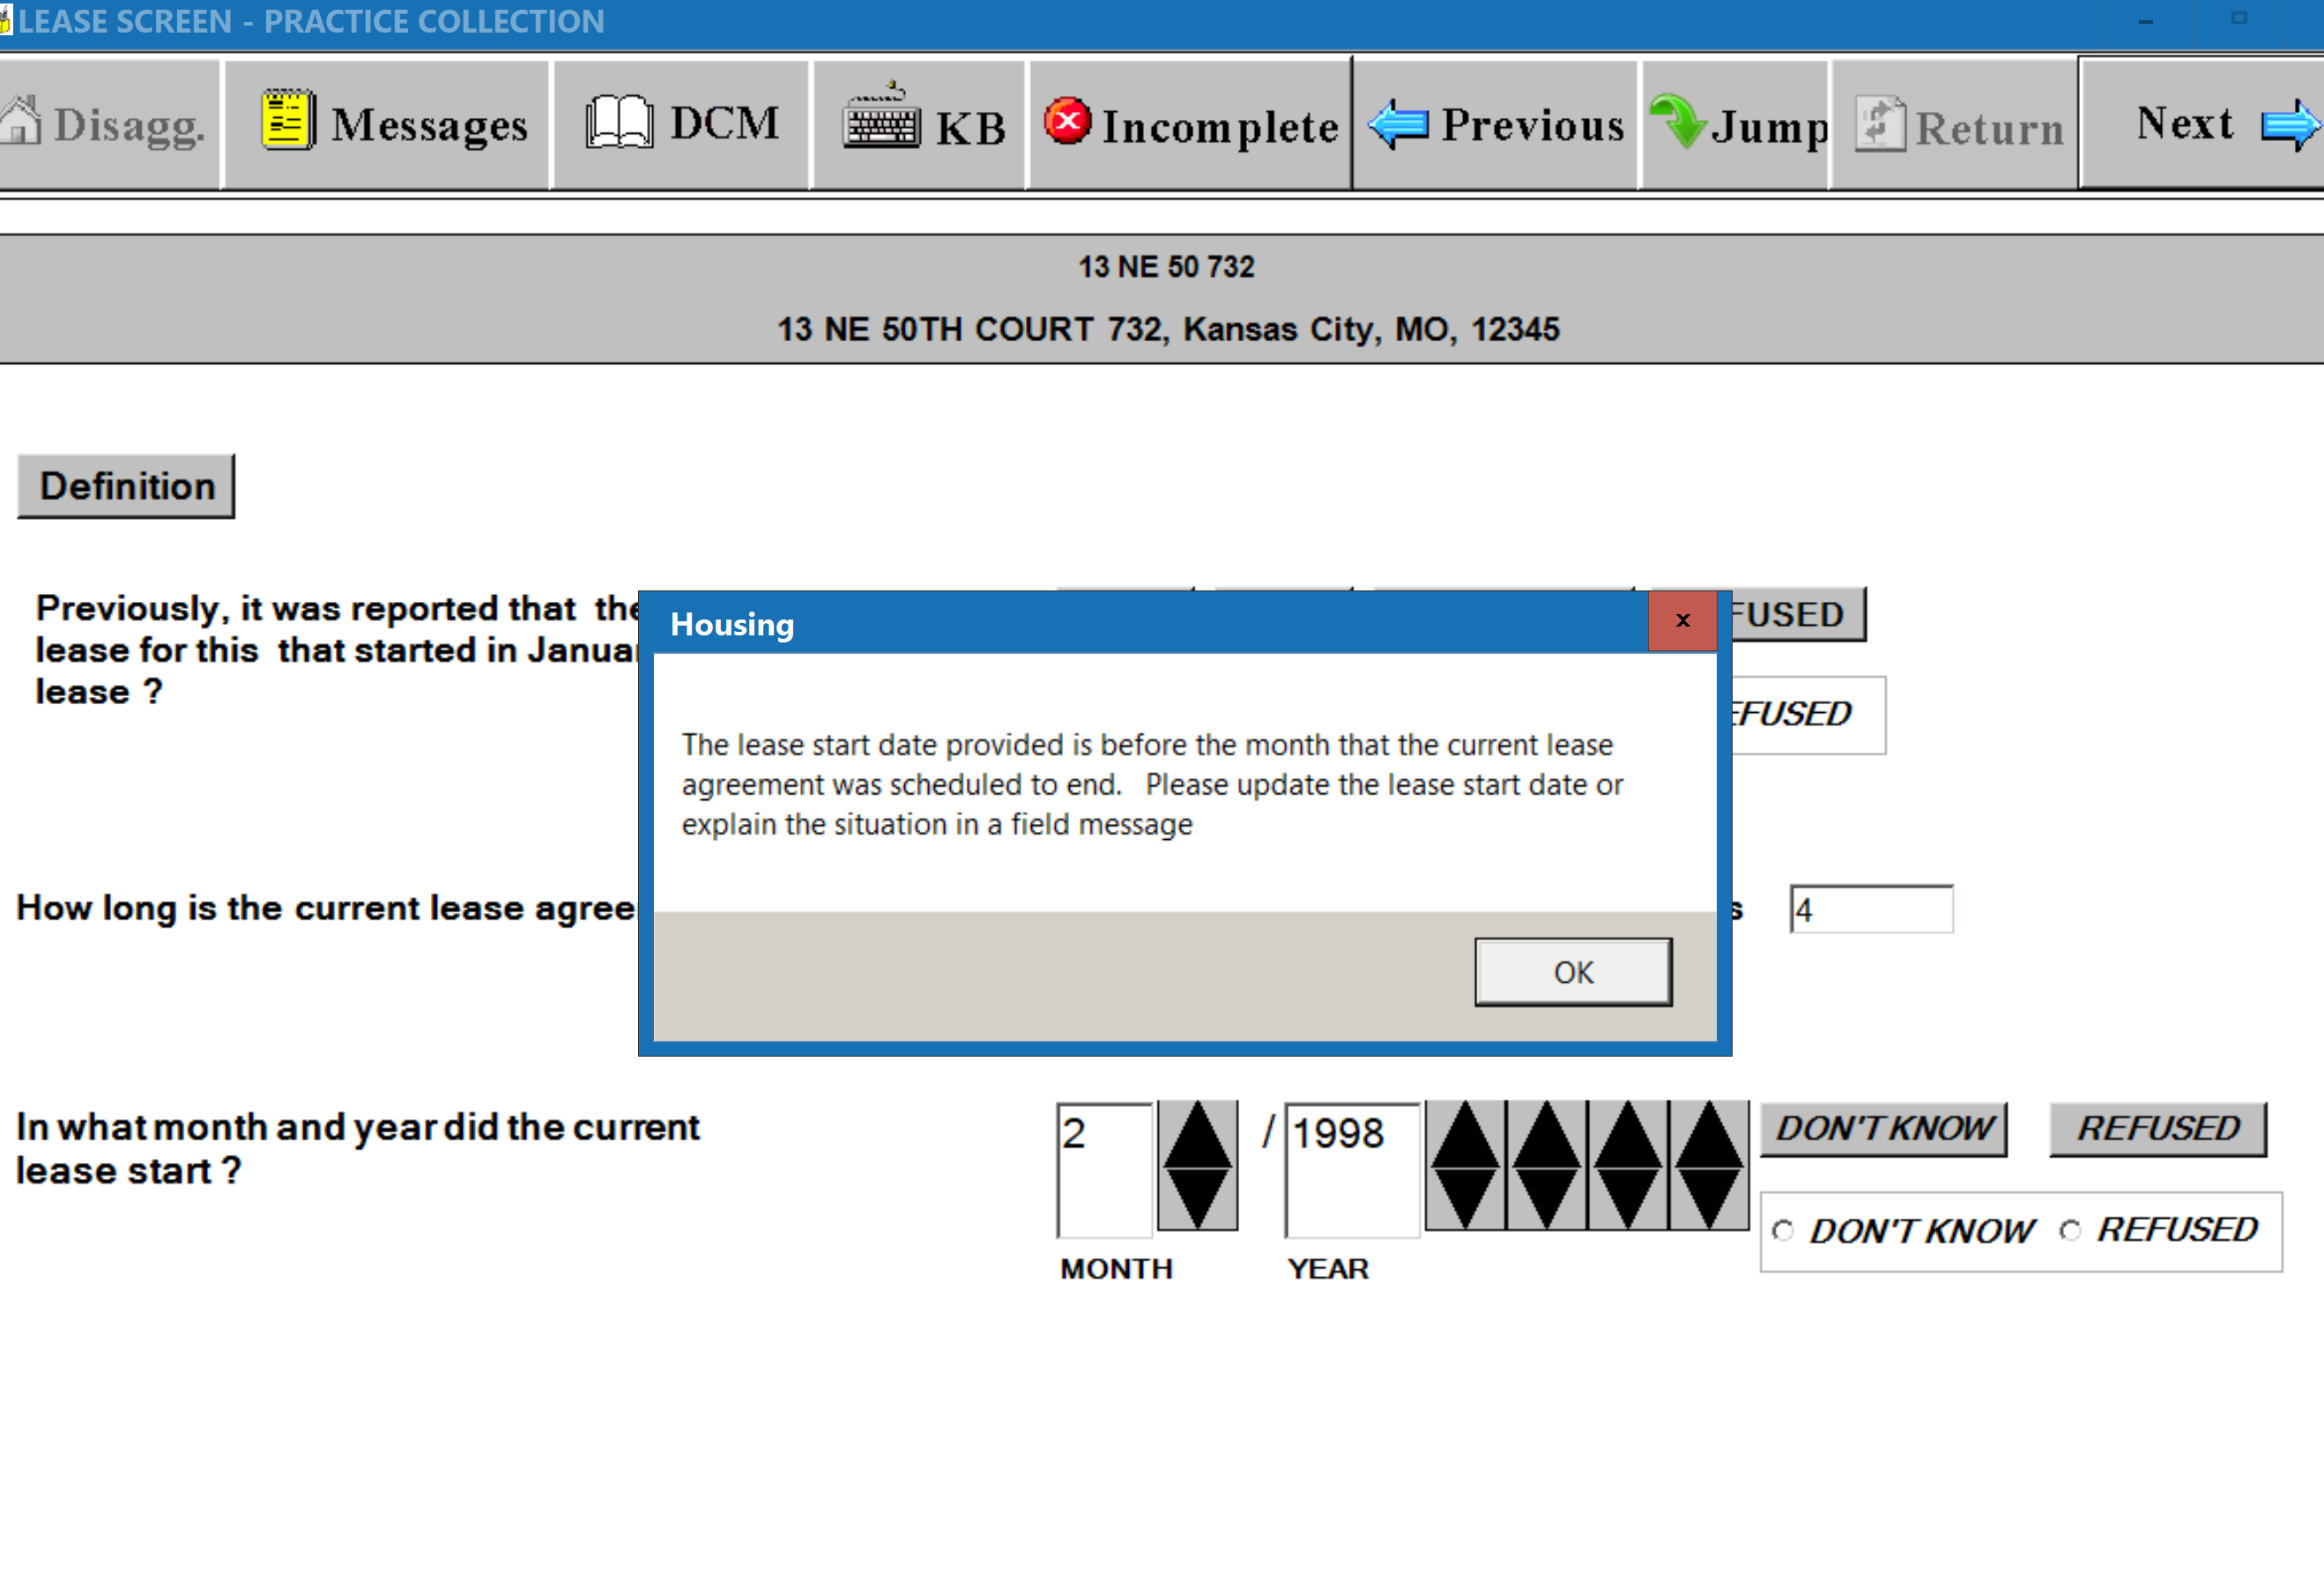
(S-20) RENT POD SCREEN – Rental Period – Change ‘Daily’ to ‘Number of Days’
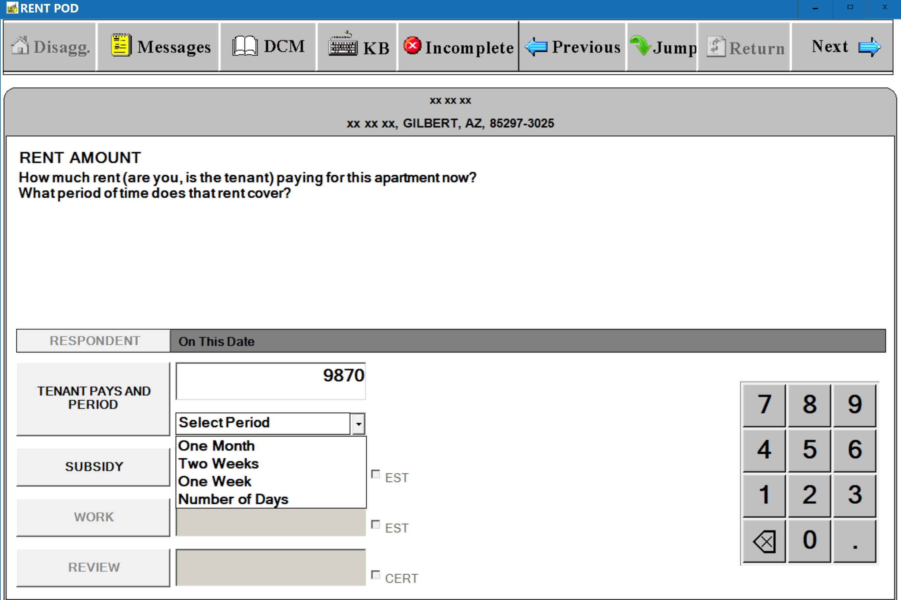
(S-21) RENT POD SCREEN – Subsidy Wording
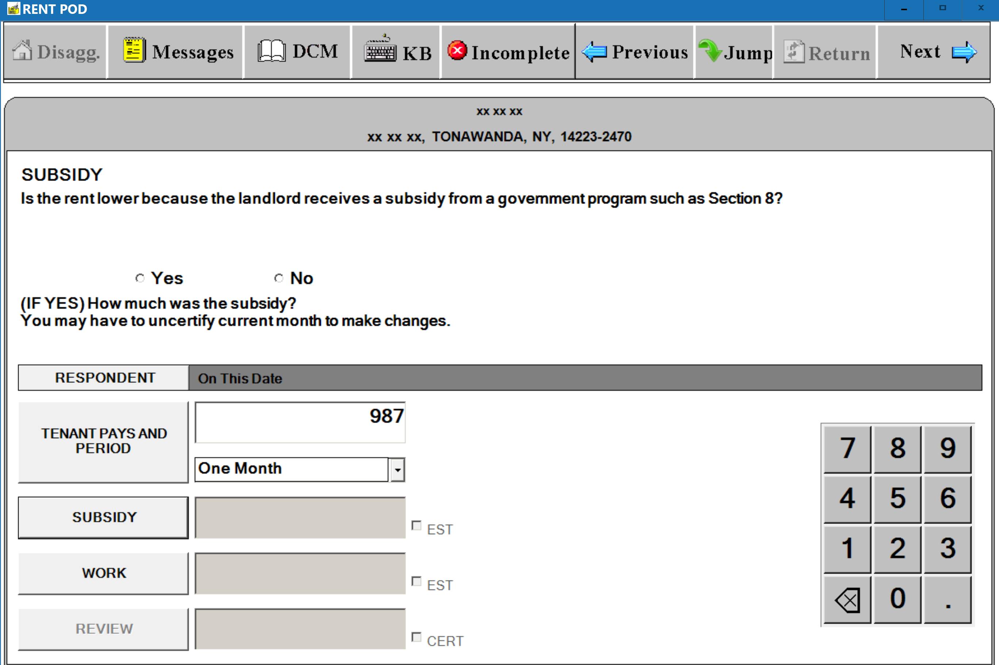

(S-22) RENT POD SCREEN – Work Reduction Wording
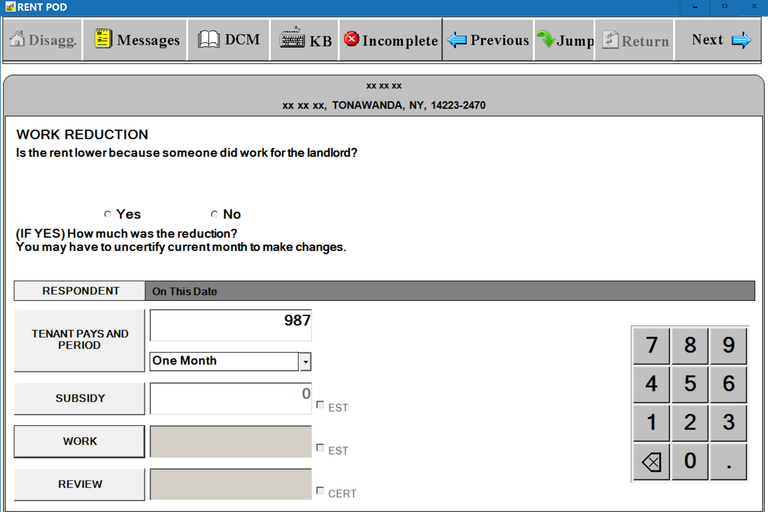
(S-23) RENT POD SCREEN - Display Previous Respondent Information on T-6 Verification Window
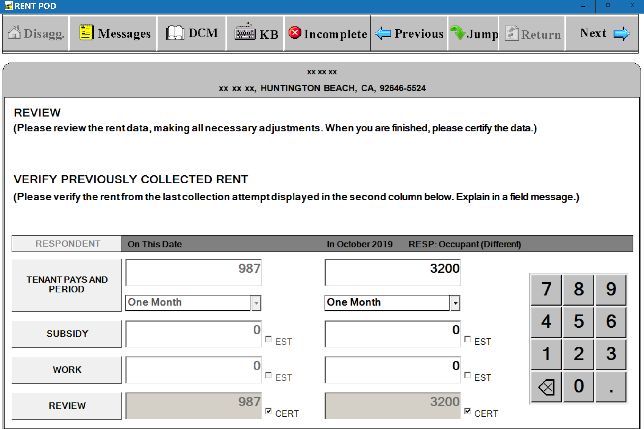

(S-24) UNIT OCCUPANT SCREEN – Move-in Date Wording (Same Occupant)
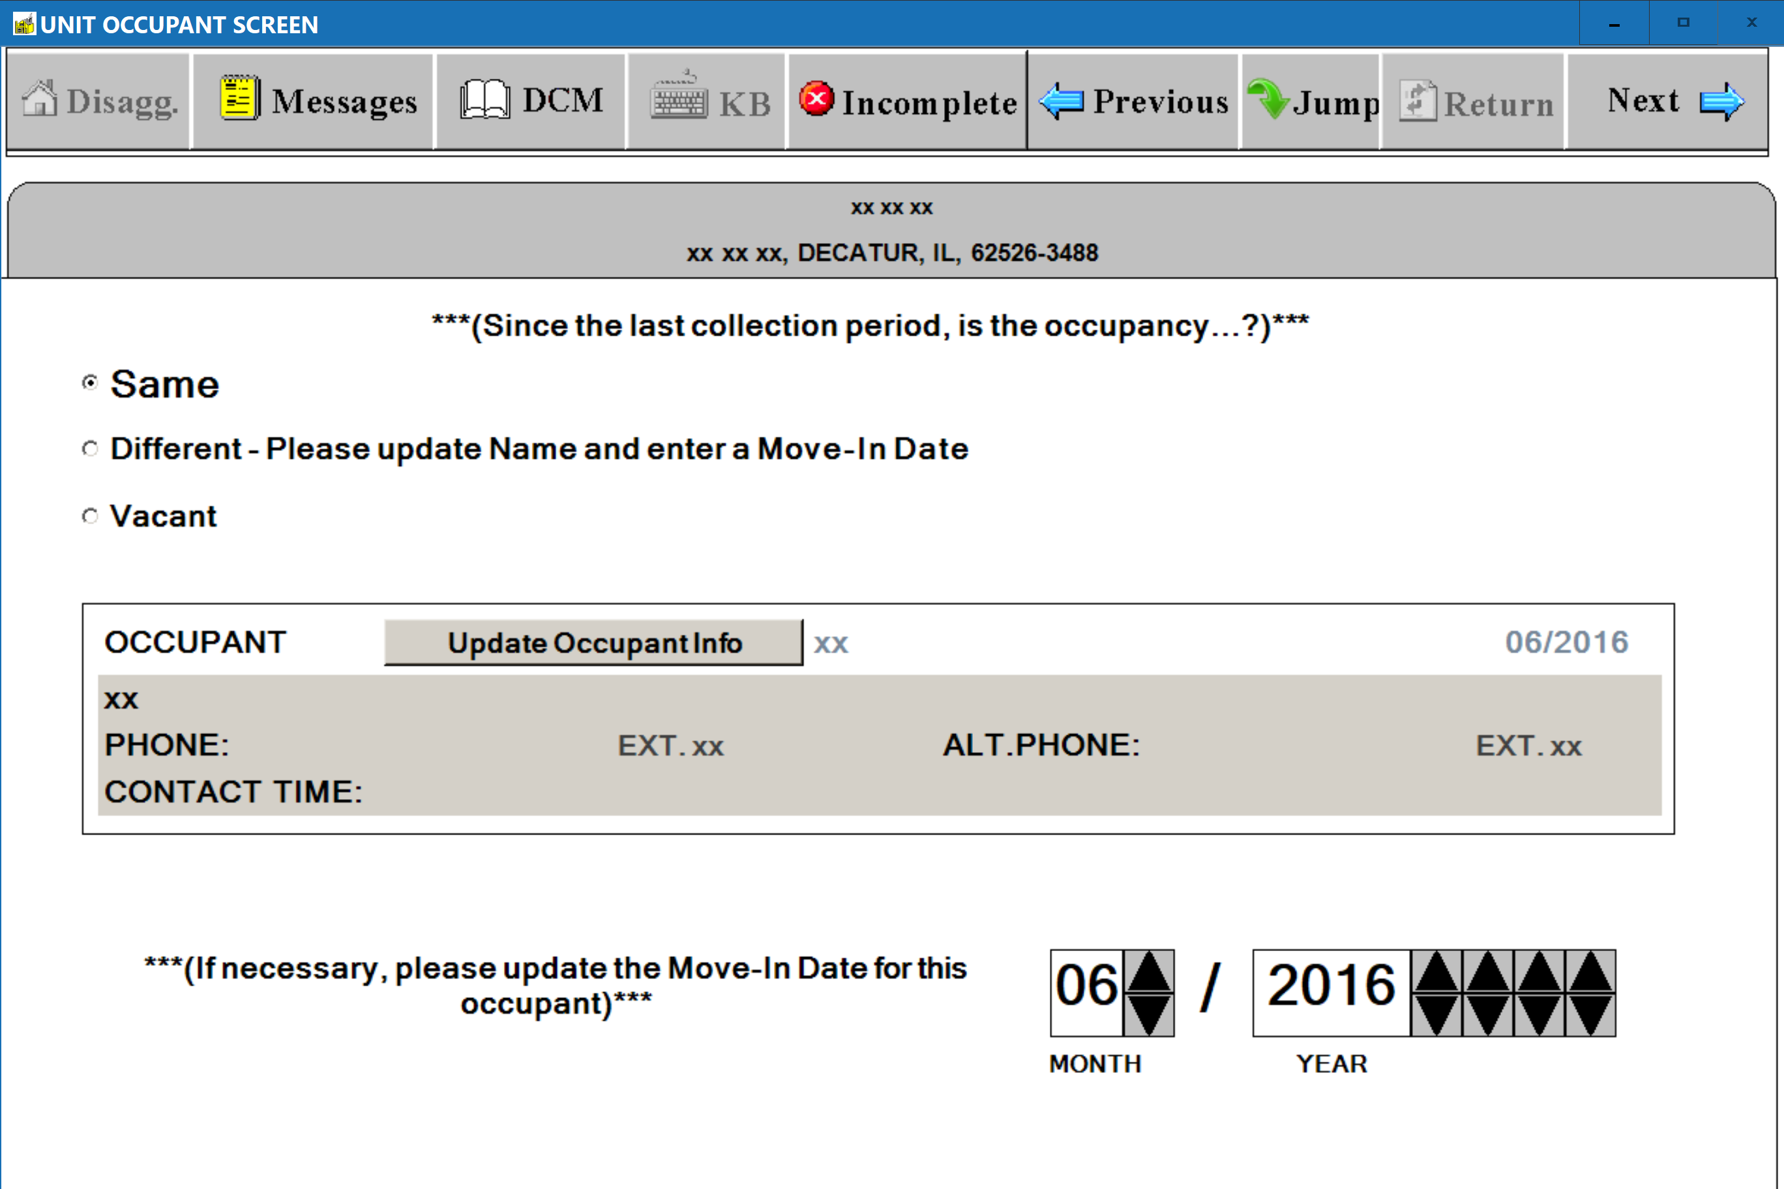
(S-25) UNIT OCCUPANT SCREEN – Move-in Date Wording (Different Occupant)
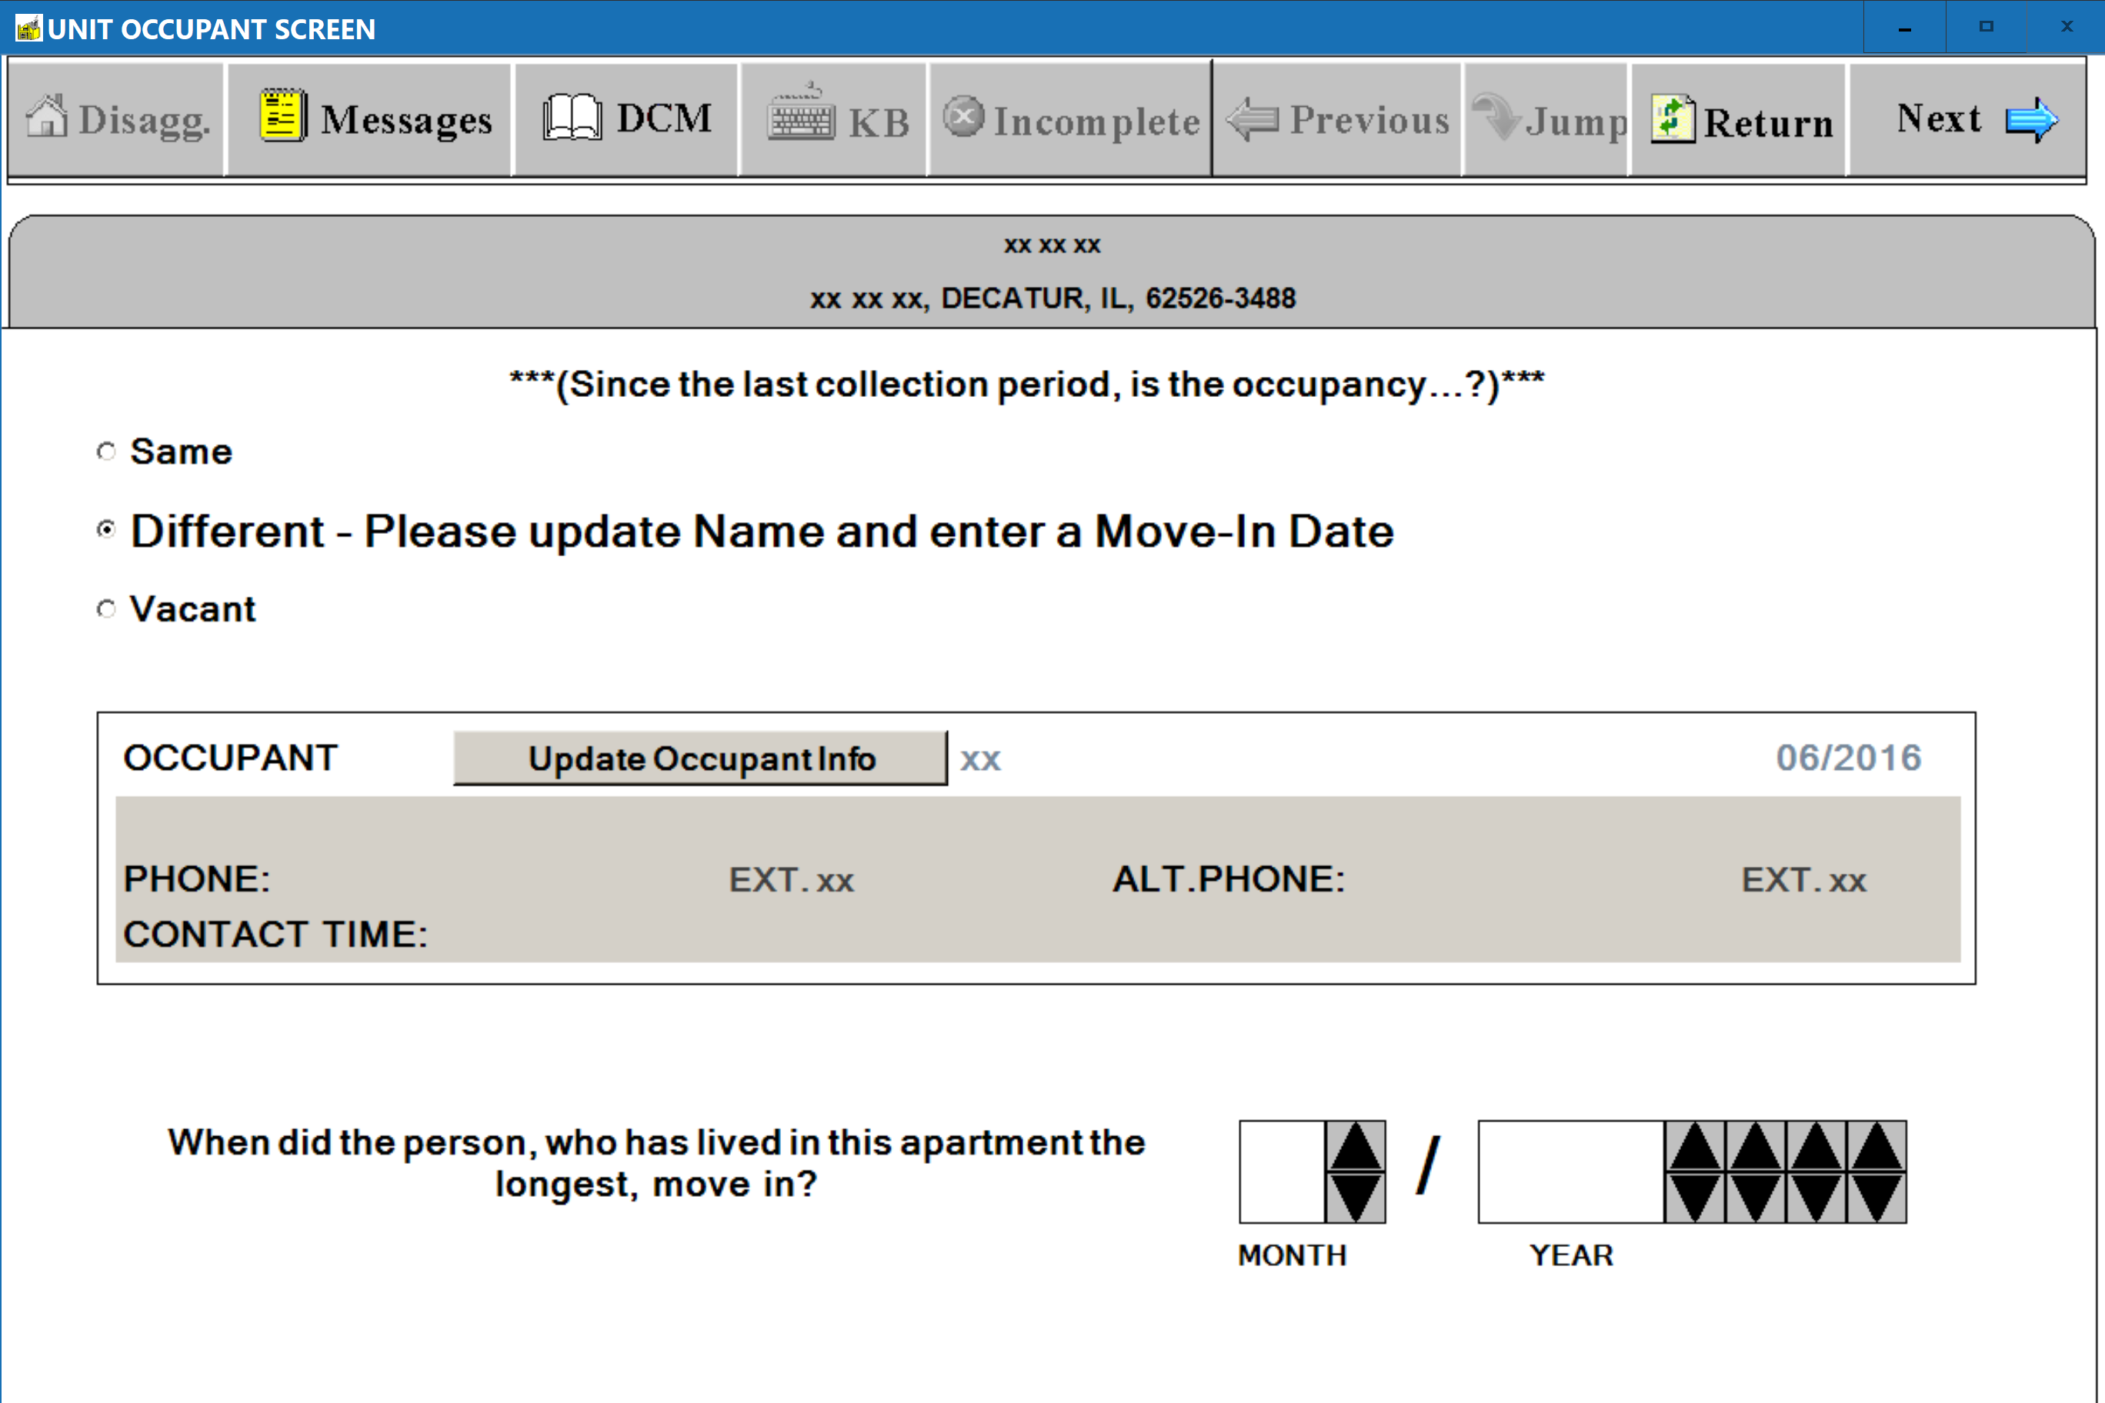

(S-26) UNIT FACESHEET – Structure Type
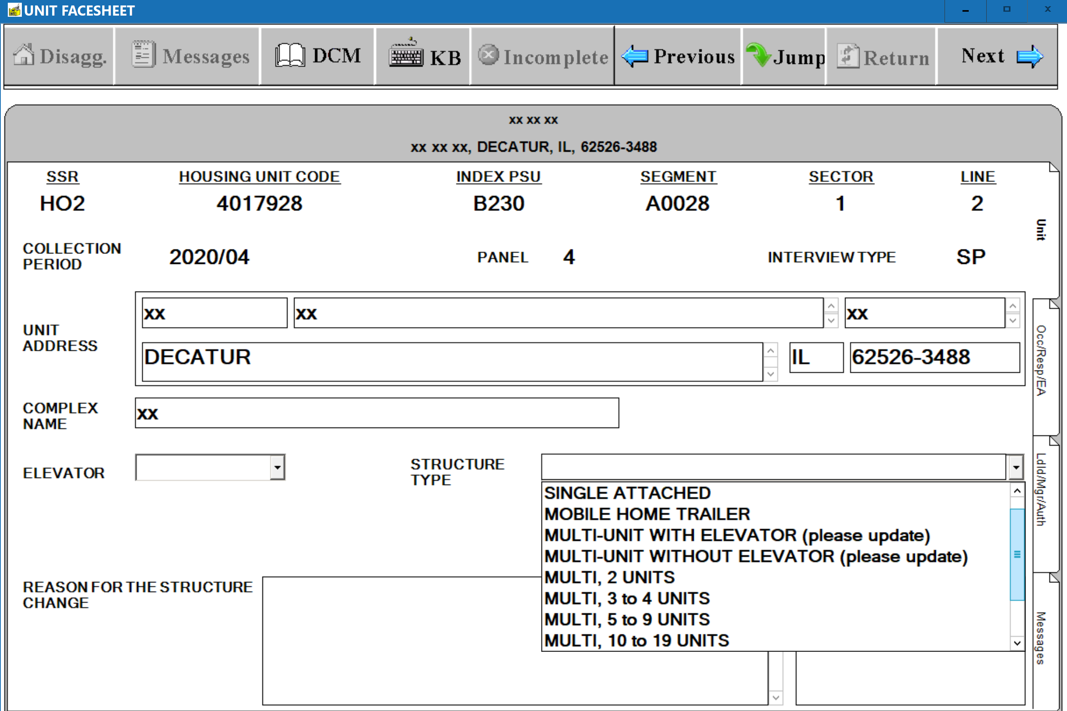
(S-27) UNIT FACESHEET – Elevator
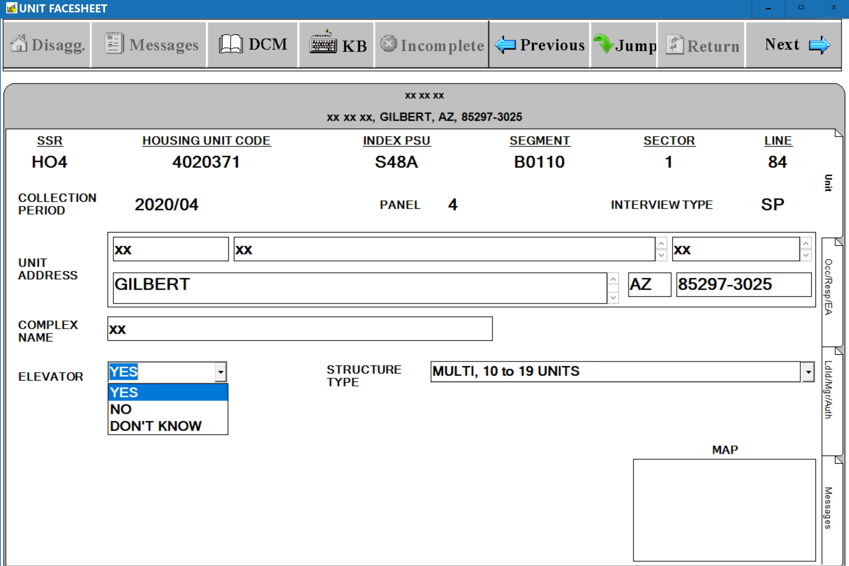
(S-28) UNIT FACESHEET – Structure Type, Elevator, and Other Structure Type-Related Fields

