CFIUS Public Portal Screen shots

This document contains the following sections:
Section 1: Current Declaration Forms – this section contains embedded PDFs of the current fillable PDF forms that are used for Declaration and Real Estate Declarations
Section 2: Entity Form Structures – this section contains an embedded spreadsheet that contains the data fields collected for each of the four CFIUS submission types
Section 3: CFIUS Public Portal Screenshots – this section contains screen shots of the Real Estate Declaration form in the Public Portal for the new CFIUS Case Management System. Compare the collection of information between the Real Estate Declaration in Section 1 and this form.
Section 4: Newly Modified Fields - this section contains an embedded spreadsheet of the newly added optional fields in each of the four CFIUS forms that aren’t explicitly accounted for in the CFIUS Regulations
Section 5: Newly Modified Fields – this section contains screen shots of the newly added optional fields listed in the spreadsheet in Section 4

Section 1: Current Declaration Forms

Current Declaration form
The current declaration form is a fillable PDF available at Treasury.gov (double click to open PDF)

Current Real Estate Declaration form
The current Real Estate declaration form is a fillable PDF available at Treasury.gov (double click to open PDF)

Section 2: Entity Form Structures

This spreadsheet contains the data fields collected for each of the four CFIUS submission types. (double click to open Excel spreadsheet)

Section 3: CFIUS Public Portal Screenshots – Real Estate Declaration
CFIUS Public Portal Real Estate Declaration form – Create

CFIUS Public Portal Real Estate Declaration form – Create

CFIUS Public Portal Real Estate Declaration form - Stages
CFIUS Public Portal Real Estate Declaration form – Participant Admin

CFIUS Public Portal Real Estate Declaration form – Participant Admin Create

CFIUS Public Portal Real Estate Declaration form – Persons Associated with the Transaction

CFIUS Public Portal Real Estate Declaration form – Persons Associated with the Transaction - Create
CFIUS Public Portal Real Estate Declaration form – General Details
CFIUS Public Portal Real Estate Declaration form – General Details (continued)
CFIUS Public Portal Real Estate Declaration form – Real Estate Details

CFIUS Public Portal Real Estate Declaration form – Foreign Person that is a Party to the Transaction
CFIUS Public Portal Real Estate Declaration form – Document Uploads
CFIUS Public Portal Real Estate Declaration form – Submission Review

CFIUS Public Portal Real Estate Declaration form – Submission Review (continued)
CFIUS Public Portal Real Estate Declaration form – Submission Review (continued)
CFIUS Public Portal Real Estate Declaration form – Submission Review (continued)
CFIUS Public Portal Real Estate Declaration form – Submission Review (continued)

Section 4: Newly Modified Fields – Spreadsheet
This section contains an embedded spreadsheet of the newly added optional fields in each of the four CFIUS forms that aren’t explicitly accounted for in the CFIUS Regulations (double click to open Excel spreadsheet)

Section 5: Newly Modified Fields - Screenshots
800 Declarations - Secondary email

800 Declarations – Declaration Mandatory
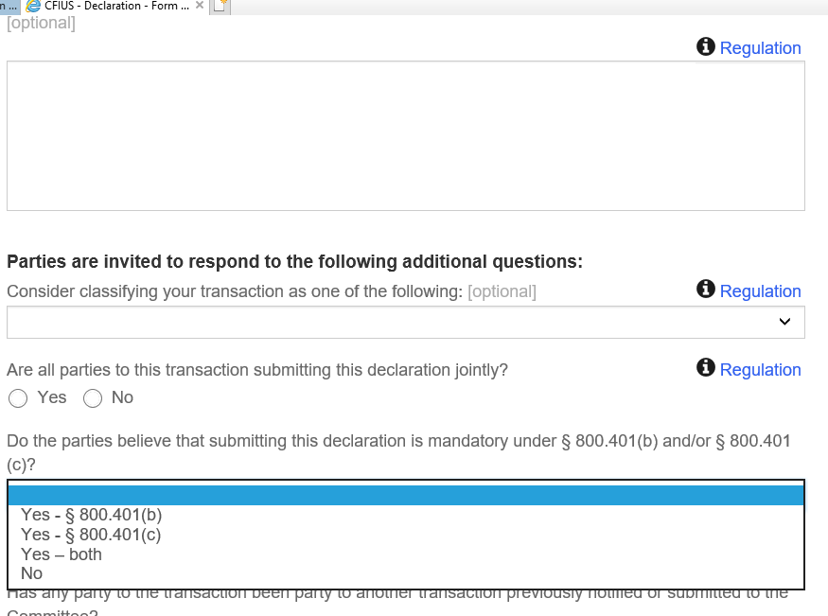

800 Declarations – Contract Subgrid
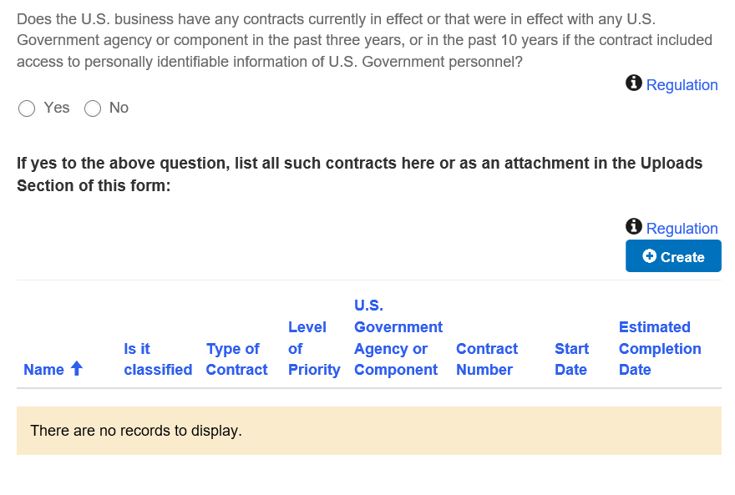

800 Declarations - US Business: Personal Data –One Million PII

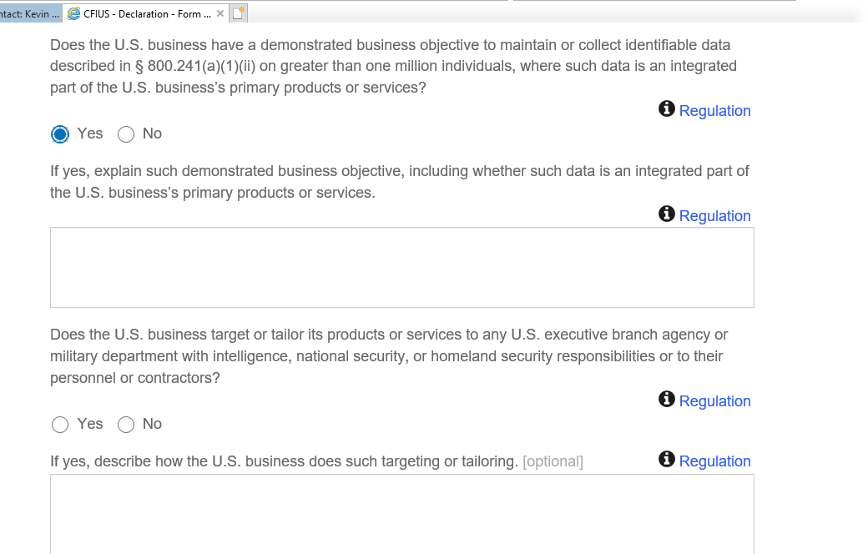

800 Notices: Executive Summary
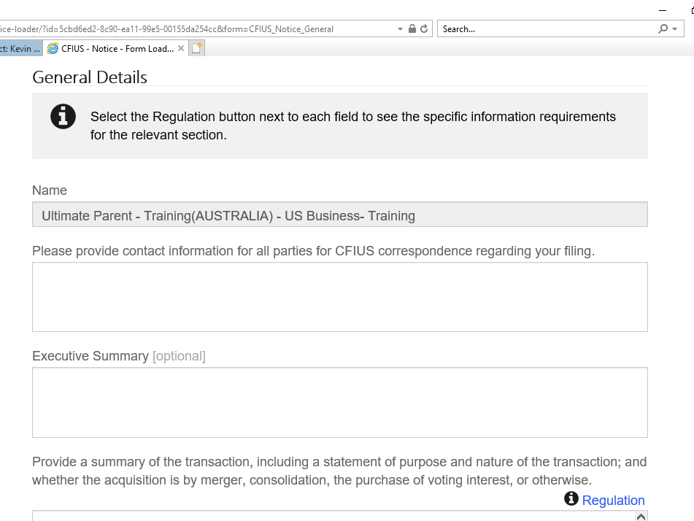

800 Notices: Consider classifying your covered transaction as one of the following
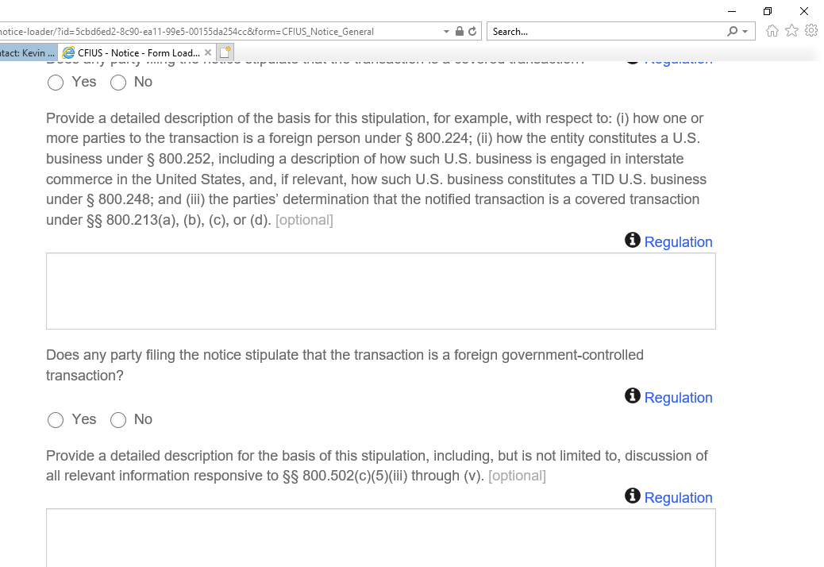

800 Notices: Facilities manufacturing classified or unclassified products or producing services (including research and development) directly or indirectly for the U.S. Government.
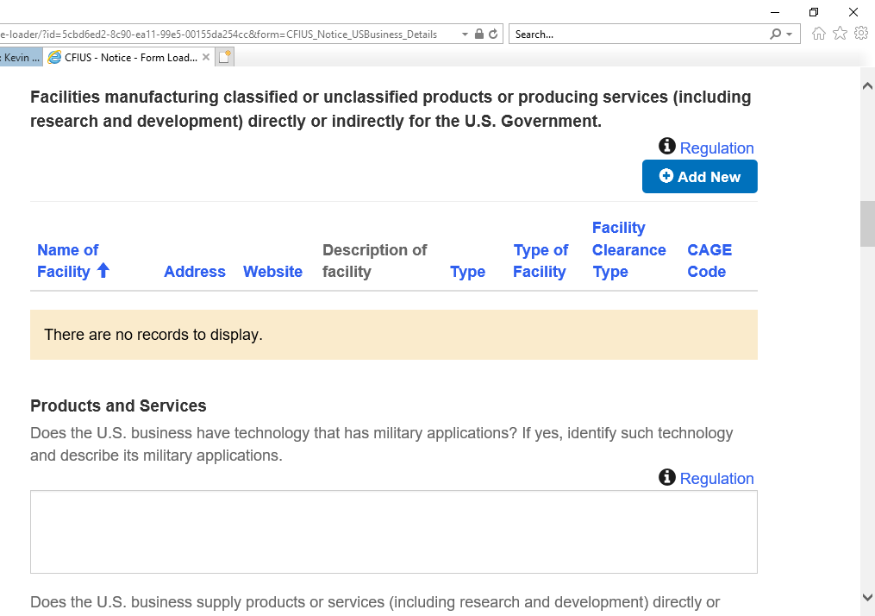

800 Notices: Contract Subgrid

800 Notices: Contract Subgrid - Primary Contractor; Start Date

802: Declaration – Secondary email

802: Declaration - Submitting Jointly/Consider classifying your covered transaction

802: Notice – Executive Summary

802: Notice – Consider classifying your covered transaction
802: Notice – Voluntary Notice: Additional Details

