**Instructions for TTB F 5110.40, Monthly Report of Production Operations**

(<https://www.ttb.gov/images/forms_tutorials/f511040/f511040_tutorial.html>)

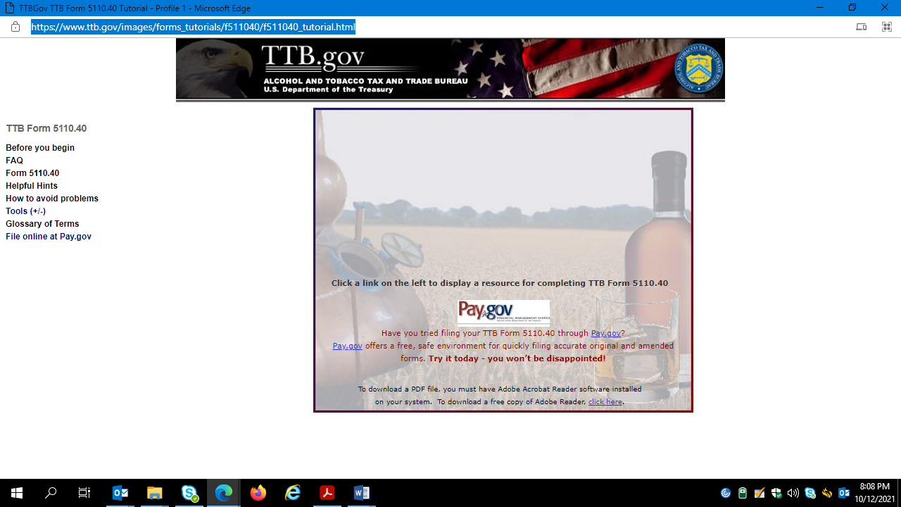

|  |
| --- |
| **Before You Begin Checklist TTB Form 5110.40**  **Purpose**  Form 5110.40 must be filed if distilling/production operations are shown on permit and on registration.  You are required to file this report each month.  If there is no activity during the month, you are required to file the report showing zeros.  **Deadlines for Filing**  This form is to be filed no later than the 15th of the month following the reporting period.  Forward the original to:              Director, National Revenue Center             550 Main Street, Room 8002             Cincinnati, Ohio 45202  **SPECIAL NOTES REGARDING COMPLETION OF FORM 5110.40:**   * Negative numbers may not be entered on this report. Enter all totals on all original and amended reports. * Before using blank Lines 13 or 16, consult with your TTB National Revenue Center specialist at 1-877-882-3277. * See 27 CFR Part 5 and 27 CFR Part 19 requirements and definitions concerning the standards of identity and class or type of spirits products. The columns and lines on the report forms refer to these standards. * Clearly enter the correct month and year the report covers in the upper right corner block of the report; if you are submitting an amended report, please clearly mark “Amended Report” in the top margin of the form. If you need to file an amended report, you must complete all lines on the amended operational report form. You must fill in each applicable line on the new, amended form even if you are not amending that particular line from the original report. * Please refer to guidance in[TTB Industry Circular 2004-4](http://www.ttb.gov/images/industry_circulars/archives/2004/04-04.html)   **Before You Begin**  The following is a list of all the materials and related information you should collect before beginning Form 5110.40.  Top of Form     EIN number     Registry number (Enter in the “Plant Number” block).     Name and address of your bonded premise – exactly as it appears on your registration and permit.     A copy of the completed Form 5110.40 you submitted for the previous month     Documentation of inventories of spirits received for redistillation and for unfinished spirits held at the end of each calendar quarter.     Documentation to provide sufficient support for adjustments     Documentation to provide sufficient support for amounts reported in Part II through Part VI of the form.     Copies of prior month’s Form 5110.11, Form 5110.28, and Form 5110.43, as may be applicable to your operations.     Documentation of the current month’s transactions and summary records that support entries on the Form 5110.40 and other monthly reports.  Bottom of Form |

To download a PDF file, you must have Adobe Acrobat Reader software installed  
on your system.  To download a free copy of Adobe Reader, [click here](http://www.adobe.com/products/acrobat/readstep2.html).

======================================================================================================================

|  |  |
| --- | --- |
| **Frequently Asked Questions** **TTB Form 5110.40**  **Instructions**  The TTB Form 5110.40 in this tutorial has been enhanced to provide links to frequently asked questions (FAQ) about various areas of the form.  To display the FAQ information for a relevant section, simply roll over the desired section/field.  To access the form, click the Form link on the left or [click here](https://www.ttb.gov/images/forms_tutorials/f511040/sample_form.html).  Section A Bulk Wines | |
| **1.** | **What is a proof gallon and how do I convert regular gallons to proof gallons?** |
|  | A proof gallon is one liquid gallon of spirits that is 50% alcohol at 60 degrees F. Distilled Spirits* bottled at 80 proof (40% alcohol) would be 0.8 proof gallons per gallon of liquid. At 125 proof, a gallon of liquid would be 1.25 proof gallons. In the industrial and fuel industries, most alcohol is at 190 or 200 degrees of proof. One gallon of alcohol that is 200 proof is equal to 2.0 proof gallons. Refer to 27 CFR Part 19 and 27 CFR Part 30 concerning procedures for determining proof, gauging spirits to determine quantity by weight or volume, or other procedures and regulations concerning measurement of alcohol.  *(also known in beverage and industrial or fuel industries as alcohol or ethanol) |
| **2.** | **Do I fill out my reports in proof gallons or regular gallons?** |
|  | Three of the required monthly operational reports submitted by a Distilled Spirits Plant (Forms 5110.40 – Production; 5110.11 – Storage; F 5110.28 – Processing) are completed using proof gallons. The fourth report – Form 5110.43 – Processing (Denaturing) – is completed in wine gallons (regular US liquid gallons).  All denatured alcohol and articles manufactured from denatured alcohol are shown in records and reports in wine gallons. Line 11 of Form 5110.28, Used for Denaturation, is expressed in proof gallons. The corresponding line 2 of the Form 5110.43, Produced (denatured spirits) is expressed in wine gallons – it reflects the net quantity of wine gallons of spirits, plus added denaturing materials reflected in the finished denatured alcohol product. |
| **3.** | **I am approved for particular types of operations on my permit, how do I know what reports to file?** |
|  | All plants must be qualified as a warehouseman or distiller, in addition to any processing operations. Your actual operations and the way that you move spirits between and within your production, storage and processing accounts determine how you report your activity.   * Form TTB F 5110.40 (Monthly Report of Production Operations) – You must file this report if *distilling/production* operations appear on your DSP permit and registration. * Form TTB F 5110.11 (Monthly Report of Storage Operations) – You must file this report to report storage account activity at a beverage or industrial DSP.  You must file this report if the operation of *warehouseman* appears on your DSP permit and registration. * Form TTB F 5110.28 (Monthly Report of Processing Operations) – You must file this report if you conduct processing (rectifying), bottling, packaging, or denaturing operations at your DSP. * Form TTB F 5110.43 (Report of Processing (Denaturing) Operations) – You must file this report if you report monthly denaturing activity conducted by industrial DSPs that are authorized to denature spirits and/or manufacture articles. |
| **4.** | **What if I am not doing all the operations that were approved on my permit? Do I still need to file the reports that correspond to that type of operation?** |
|  | Yes. You must file the reports even though you do not currently have any reportable activity. However, if your inactivity will be for an extended period of time, you may request a variance from regulations allowing you to defer filing until such time as you engage in reportable operations for one of the reports. For example, if you are qualified as a warehouseman and processor, and your style of operations does not currently involve storage of spirits in bulk (spirits are entered into processing account upon receipt at your plant) you may obtain approval from TTB to defer filing of storage reports until you begin storing spirits. Such approvals are granted on a case-by-case basis. |
| **5.** | **What is a 5010 credit and how do I compute?** |
|  | Under 26 U.S.C. 5001 and 7652 a tax is imposed on all spirits produced in or imported into the United States at $13.50 per proof gallon. Wines containing more than 24 percent of alcohol by volume are taxed as spirits. A credit against this tax is allowed under 26 U.S.C. 5010 on each proof gallon of alcohol derived from eligible wine or eligible alcohol-containing flavors which do not exceed 2.5 percent of the finished product on a proof gallon basis.  Eligible wines are other than standard (OTS) wines that have not been subject to distillation at a distilled spirits plant and that contain no more than 0.392 g of carbon dioxide per 100 ml. Eligible flavors are those that have been approved by the Nonbeverage Products Laboratory. The producers or importers of distilled spirits are eligible for this credit if the distilled spirits contain an eligible wine and/or eligible flavor used in producing a batch of spirits produced in accordance with an approved formula. |

======================================================================================================================

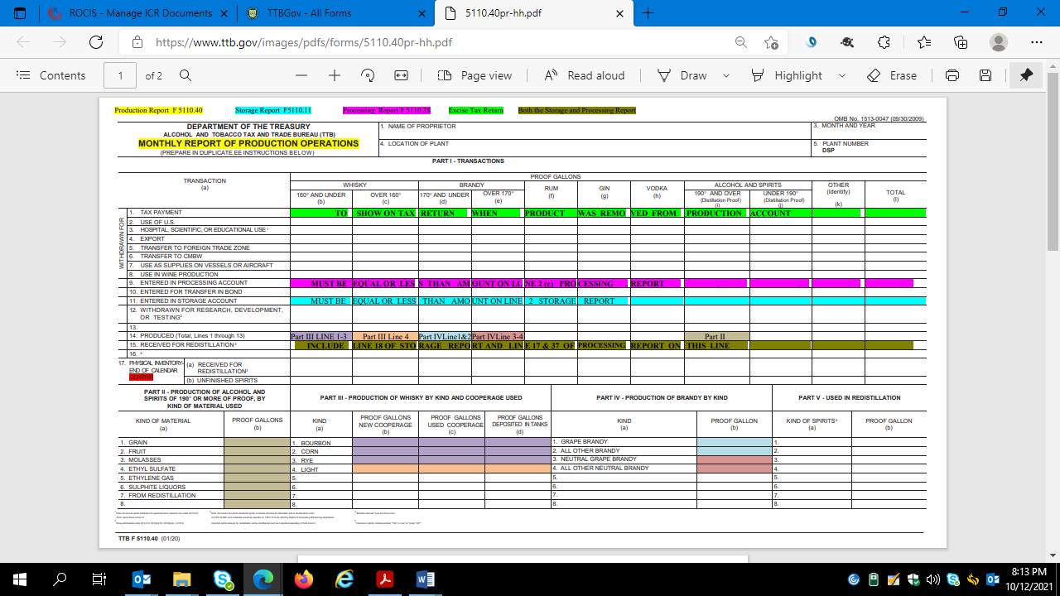

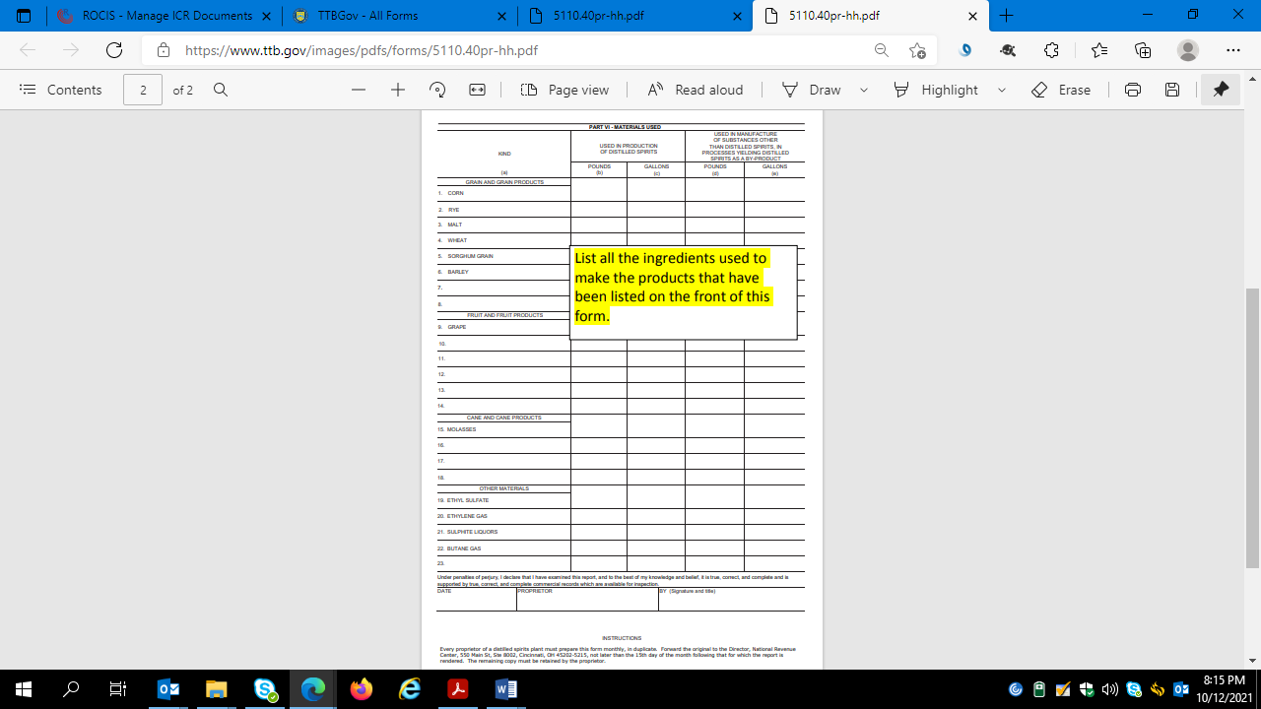

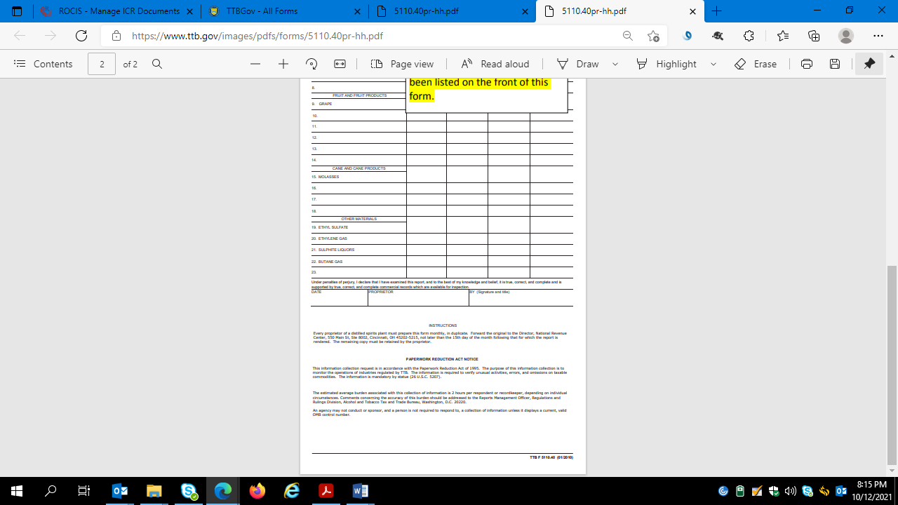

**How to avoid problems with monthly reports**

1. TTB monthly reports must be completed and submitted to [TTB's National Revenue Center (NRC)](https://www.ttb.gov/who-we-are/contact-us/nrc-call-center) by no later than the 15th day of the month following the reporting period, even if there is no activity during the month.
2. Retain copies of these reports for at least 3 years from the date of the report.
3. When completing the forms:
   * Be careful that all the information is entered on the right lines of the form.
   * Review the reports before sending them.  Carefully add the numbers to insure they are correct, check for accurate inventory flow (beginning inventory plus additions minus withdrawals equal ending inventory) and check for clerical errors related to missing and/ or incorrectly recorded information.
4. A good way to avoid problems with the reports is by using [Pay.gov](https://pay.gov/paygov/).  It does many of the calculations and totals on the forms.   For more information see [Pay.gov User Guides](https://www.ttb.gov/distilled-spirits/common-compliance-and-tax-issues-surrounding-distilled-spirits-plant-dsp-audits#_Pay.gov_User_GuidesFiling)
5. For questions or concerns, please call TTB's National Revenue Center at 1-877-TTB-FAQS (1-877-882-3277) toll free; email [ttbinternetquestions@ttb.treas.gov](mailto:ttbinternetquestions@ttb.treas.gov).

======================================================================================================================

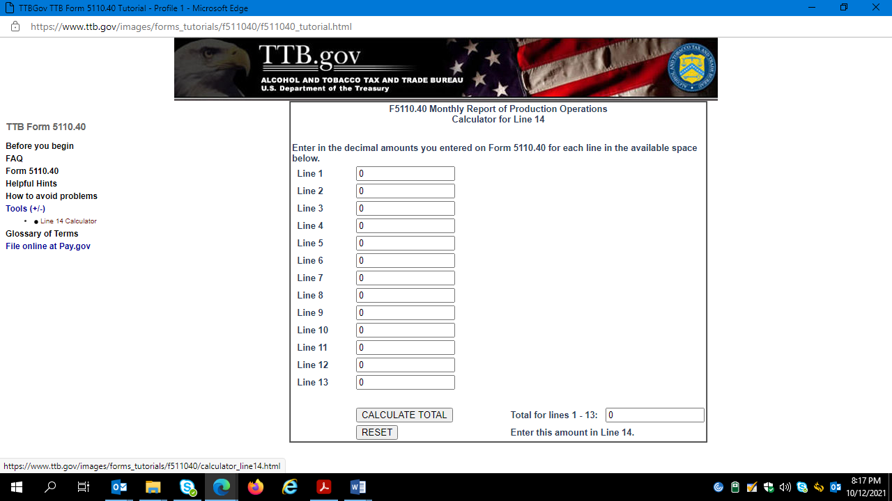

|  |
| --- |
| **Glossary**  Click on the appropriate letter below to access a list of terms beginning with that letter. Then click the term to access the associated definition.  [**A**](https://www.ttb.gov/images/forms_tutorials/glossary/letter_a.html)[**B**](https://www.ttb.gov/images/forms_tutorials/glossary/letter_b.html)[**C**](https://www.ttb.gov/images/forms_tutorials/glossary/letter_c.html)[**D**](https://www.ttb.gov/images/forms_tutorials/glossary/letter_d.html)[**E**](https://www.ttb.gov/images/forms_tutorials/glossary/letter_e.html)[**F**](https://www.ttb.gov/images/forms_tutorials/glossary/letter_f.html)[**G**](https://www.ttb.gov/images/forms_tutorials/glossary/letter_g.html)[**H**](https://www.ttb.gov/images/forms_tutorials/glossary/letter_h.html)[**I**](https://www.ttb.gov/images/forms_tutorials/glossary/letter_i.html)[**J**](https://www.ttb.gov/images/forms_tutorials/glossary/letter_j.html)[**K**](https://www.ttb.gov/images/forms_tutorials/glossary/letter_k.html)[**L**](https://www.ttb.gov/images/forms_tutorials/glossary/letter_l.html)[**M**](https://www.ttb.gov/images/forms_tutorials/glossary/letter_m.html)[**N**](https://www.ttb.gov/images/forms_tutorials/glossary/letter_n.html)[**O**](https://www.ttb.gov/images/forms_tutorials/glossary/letter_o.html)[**P**](https://www.ttb.gov/images/forms_tutorials/glossary/letter_p.html)**Q**[**R**](https://www.ttb.gov/images/forms_tutorials/glossary/letter_r.html)[**S**](https://www.ttb.gov/images/forms_tutorials/glossary/letter_s.html)[**T**](https://www.ttb.gov/images/forms_tutorials/glossary/letter_t.html)[**U**](https://www.ttb.gov/images/forms_tutorials/glossary/letter_u.html)[**V**](https://www.ttb.gov/images/forms_tutorials/glossary/letter_v.html)[**W**](https://www.ttb.gov/images/forms_tutorials/glossary/letter_w.html)**X Y**[**Z**](https://www.ttb.gov/images/forms_tutorials/glossary/letter_z.html) |
|  |

======================================================================================================================

