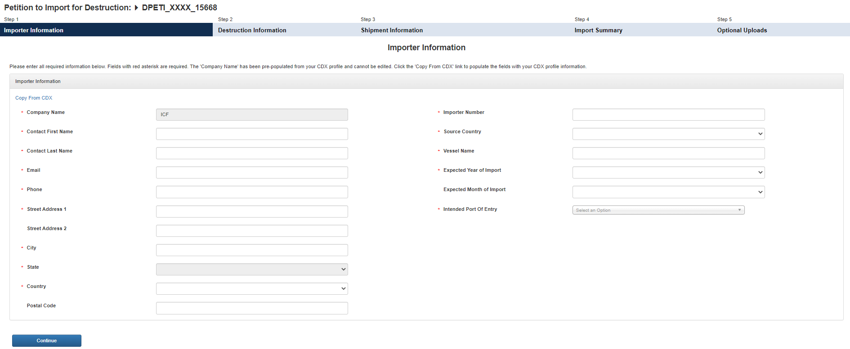

Transformation/Destruction Information

* Intended Use

**Transformation or Destruction**

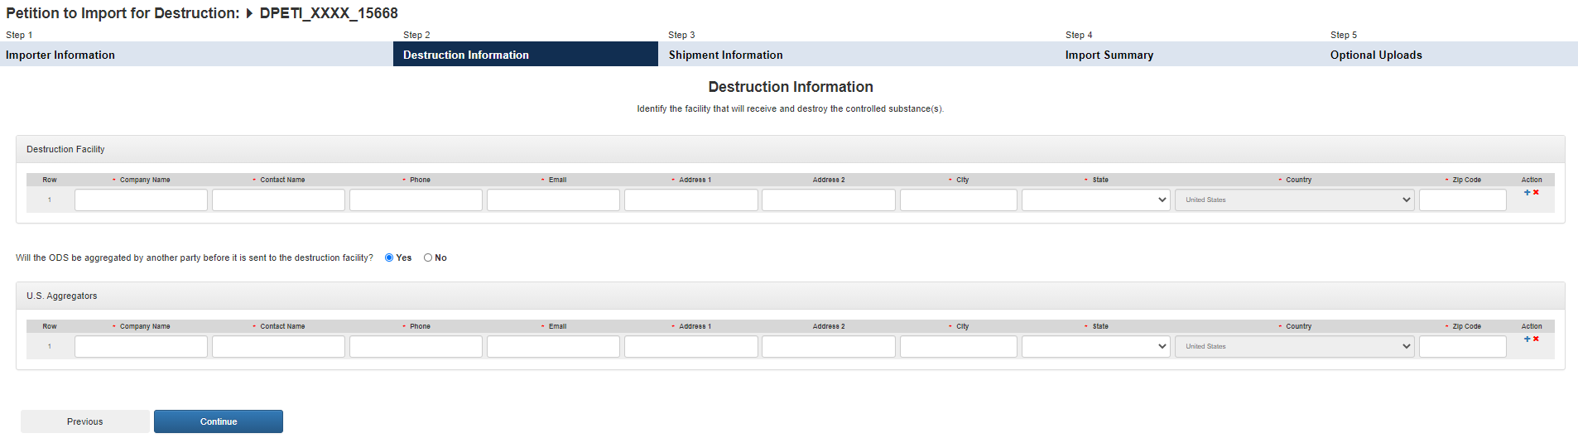

Consignee Information



Transformation/Destruction Information

**Transformation/Destruction**

Transformation/Destruction Facility

**Transformation or Destruction**

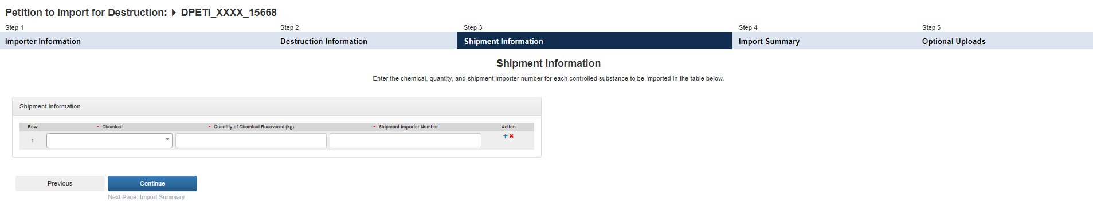

Transformation/Destruction Information

**Transformation or Destruction**

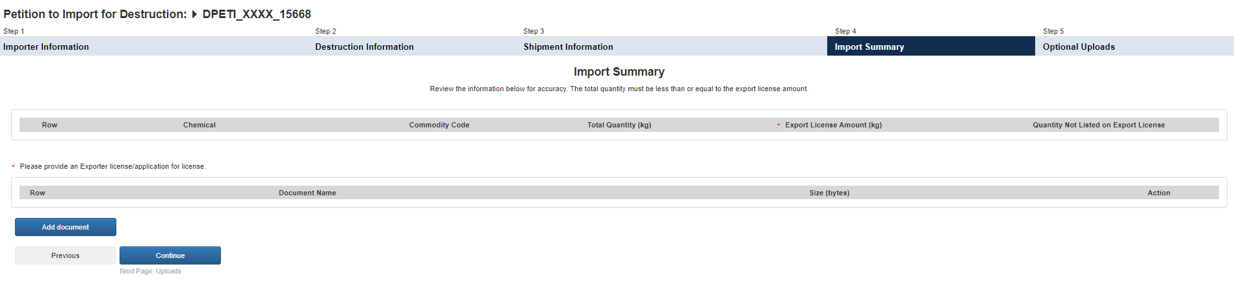

Transformation/Destruction Information

**Transformation or Destruction**

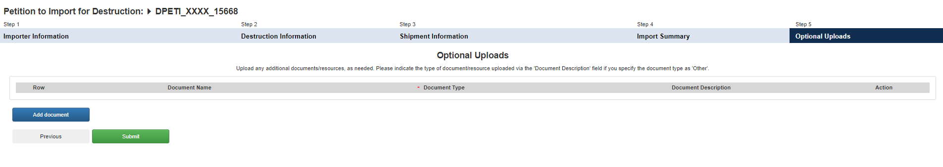

Transformation/Destruction Information

**Transformation or Destruction**