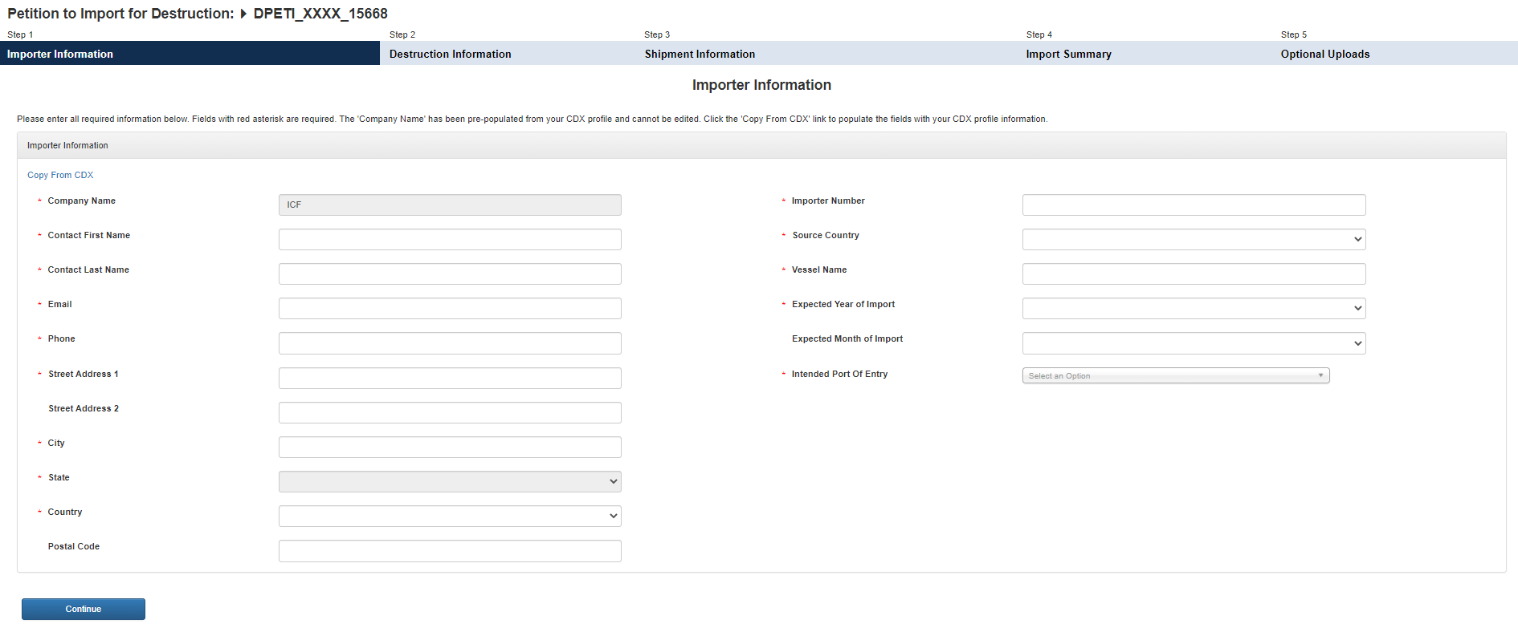
Transformation/Destruction Information
* Intended Use
Transformation or Destruction
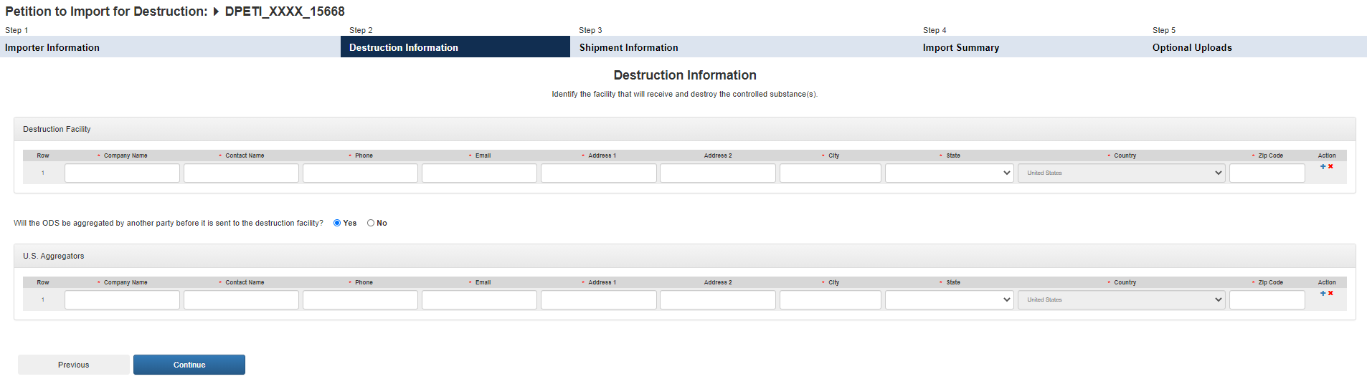
Consignee Information
Transformation/Destruction Information
Transformation/Destruction
Transformation/Destruction Facility
Transformation or Destruction
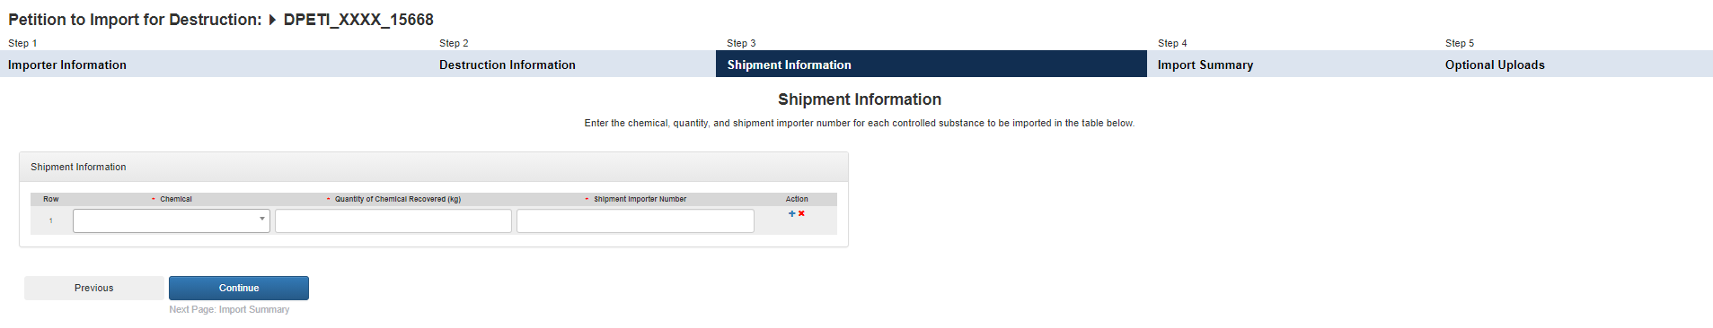
Transformation/Destruction Information
Transformation or Destruction
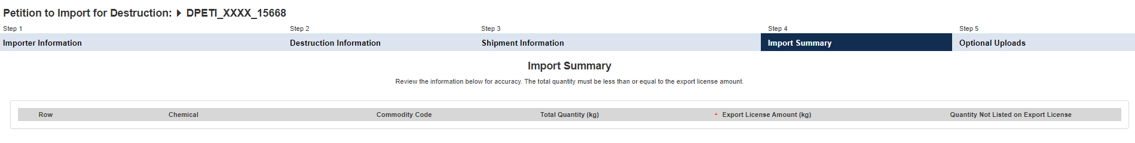
Transformation/Destruction Information
Transformation or Destruction
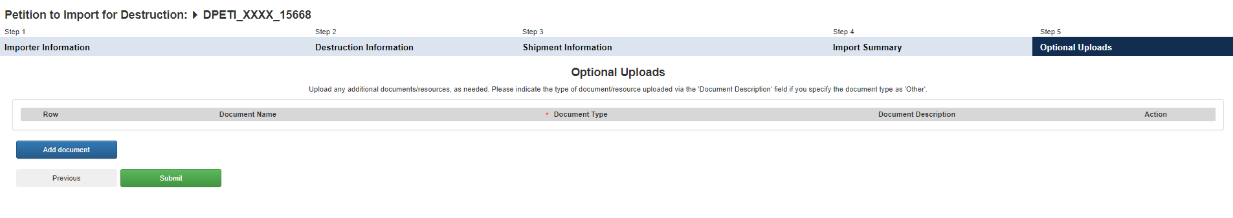
Transformation/Destruction Information
Transformation or Destruction

