Instrument (OMB Control Number: 3090-0297)
Req-4

TITLE OF INFORMATION COLLECTION: USA.gov Website Customer Satisfaction Feedback Surveys

CONTACT: David Kaufmann david.kaufmann@gsa.gov

Pop-up invite Customer Satisfaction Survey English Version

1)
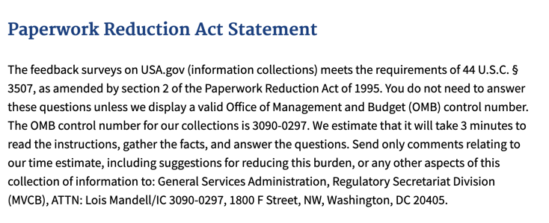

2)
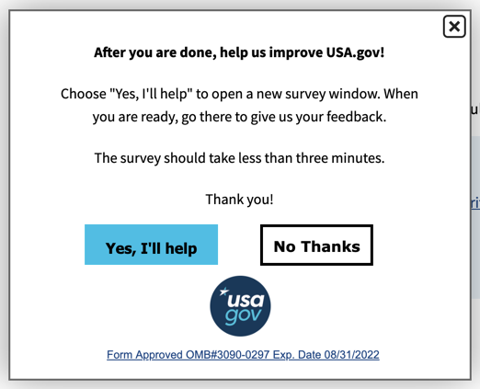
3)
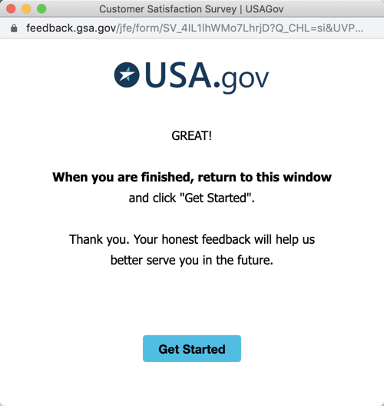

4)
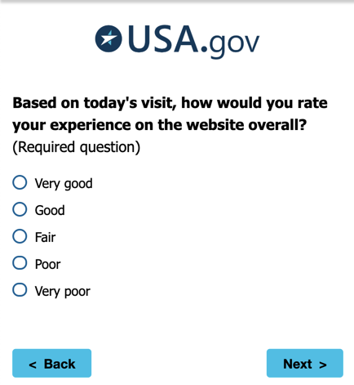
5)
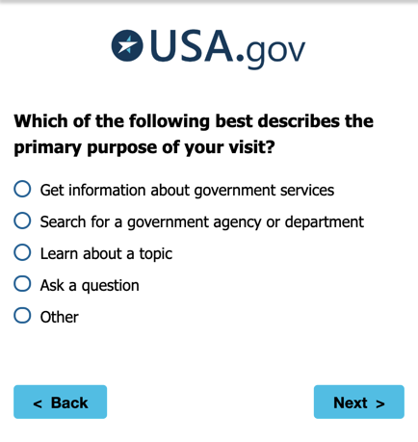
If “Other” then go to (5B). Otherwise, go to (6)

5B)
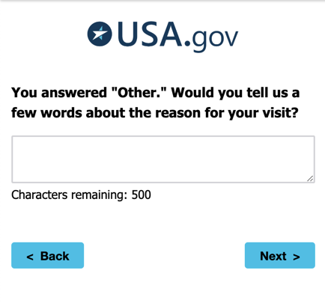

6)
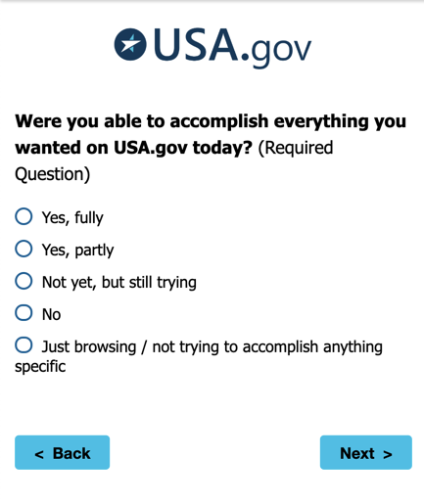

If:
- Yes, fully
- - or -
- Yes, partly
Then Go to (7A)

If:
- Not yet, but still trying
- - or -
- No
Then Go to (7B)

If:
- Just browsing / not trying to accomplish anything specific
Then Go to (7C)

7A)
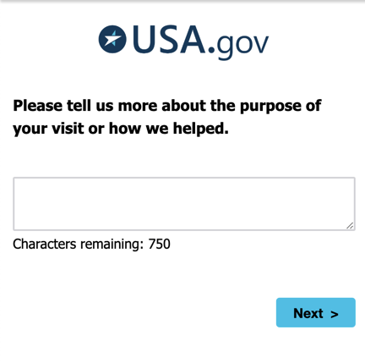
7B)
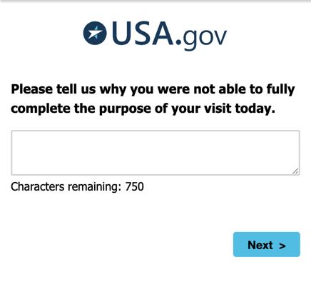

7C)
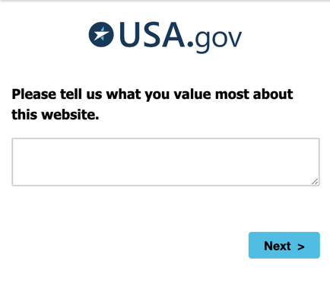

(8)
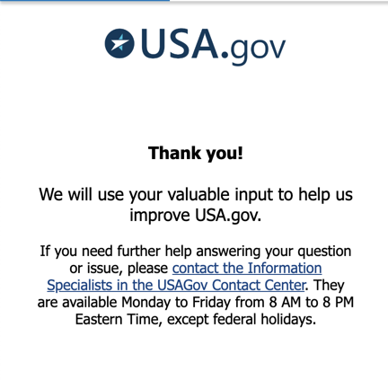

Pop-up invite Customer Satisfaction Survey Spanish Version

1)
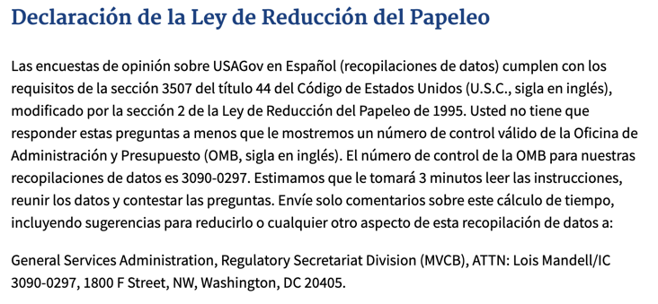
2)
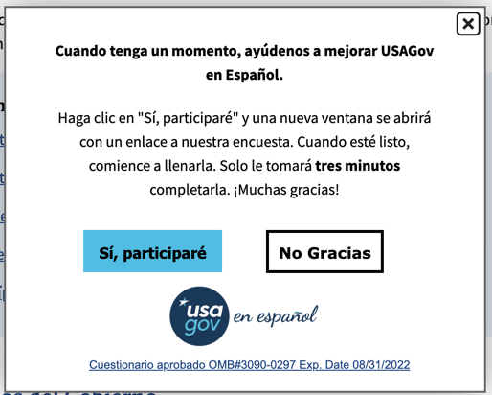

3)
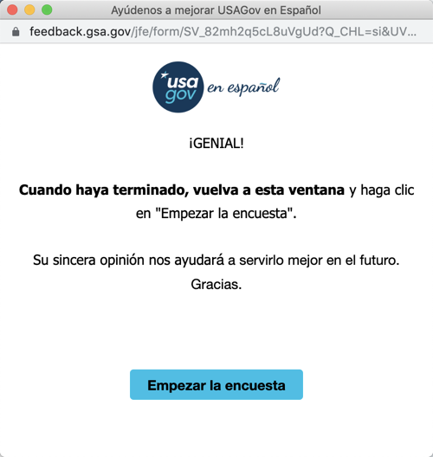

4)
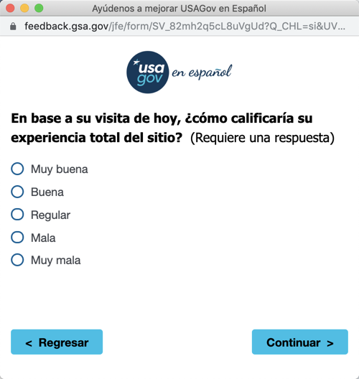

5A)
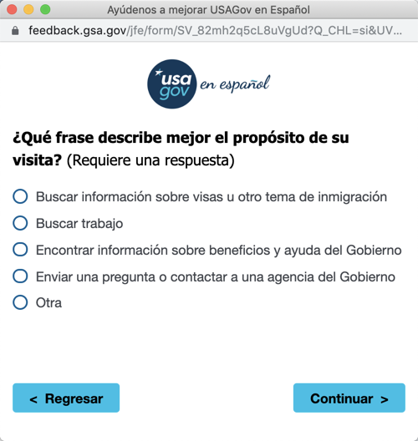
If “Otra” is selected, the go to (5B). Otherwise, go to (6).

5B)
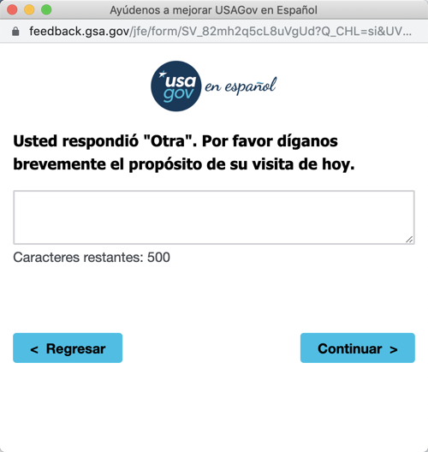
6)
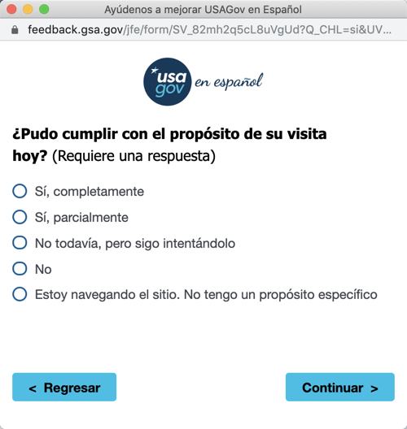

If:
- Sí, completamente
- - or -
- Sí, parcialmente
Then Go to (7A)

If:
- No todavía, pero sigo intentáldolo
- - or -
- No
Then Go to (7B)

If:
- Estoy nevegando el sitio. No tengo un propósitio específico
Then Go to (7C)

7A)
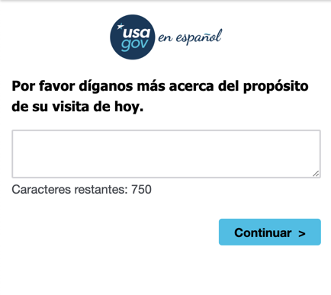
Next, go to (8)

7B)
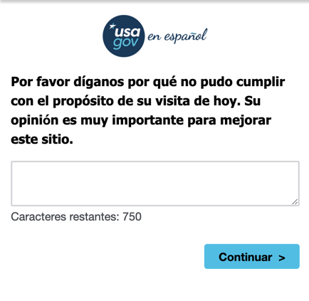
Next, Go to (8)

7C)
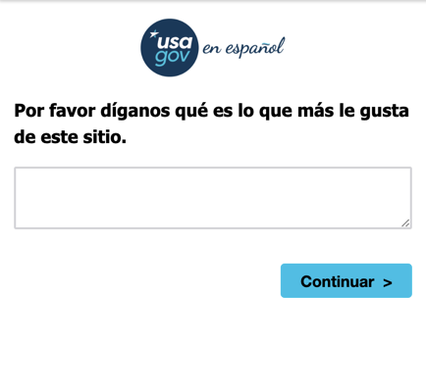
Next, Go to (8)

8)
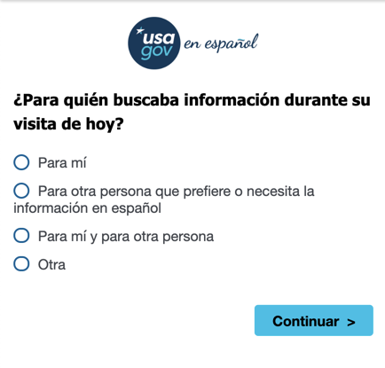

9)
