Request for Approval under the “Generic Clearance for the Collection of Routine Customer Feedback” (OMB Control Number: 3090-0297)
Req-5

TITLE OF INFORMATION COLLECTION: USA.gov Website Page Level Comment Box Feedback Surveys

CONTACT: David Kaufmann david.kaufmann@gsa.gov

Helpful Yes/No Survey English Version

1) 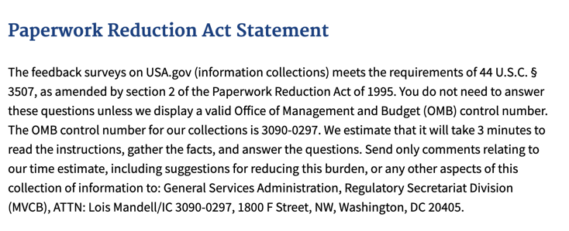

2)

3)
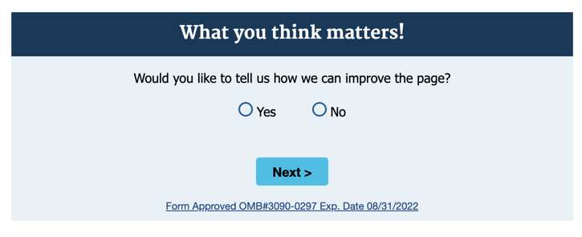

4)
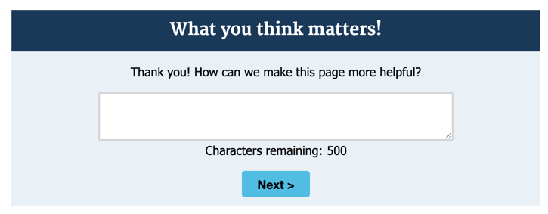

5)
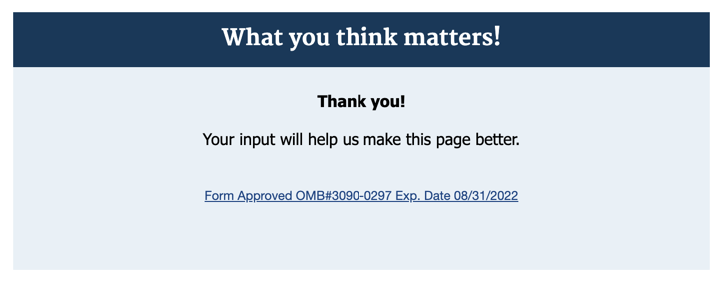

Helpful Yes/No Survey Spanish Version

1)
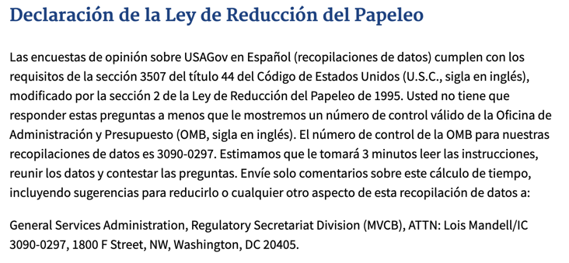

2)

3)
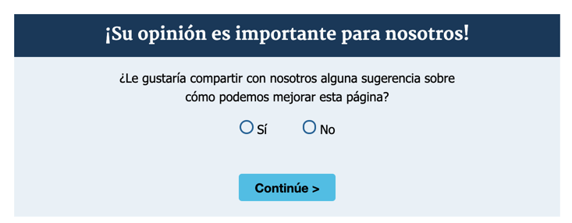

4)
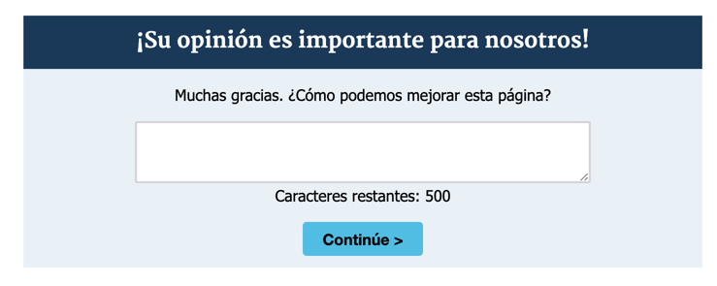

5)

