FAST Track 3090-0297
GSA Auctions Website Survey (Revised Feb 2020)

Screen 1

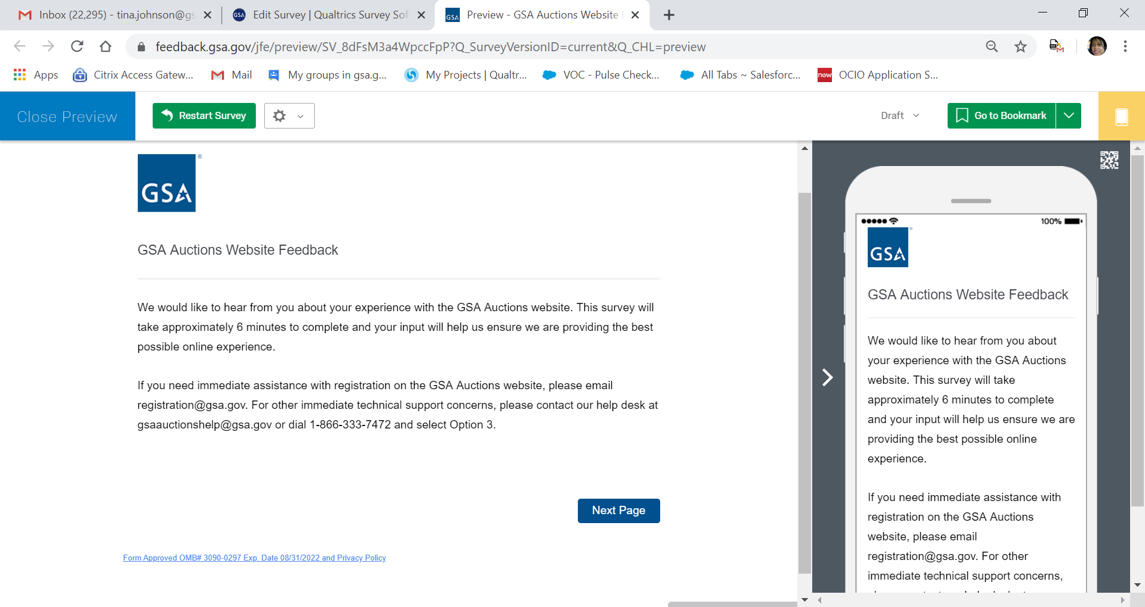

There is a footer link located at the bottom of most screens that will display the Privacy Policy. If the respondent clicks on the link, titled “Form Apporoved OMB# 3090-3097 Exp. Date 08/31/2022 and Privacy Policy, the policy located on the next page will appear.

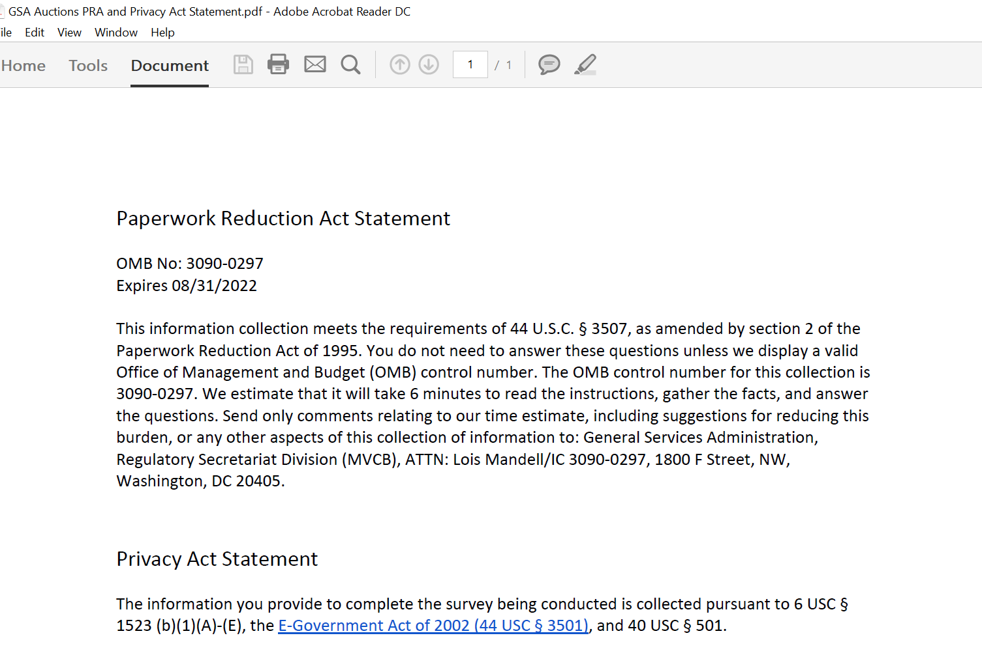

Screen 2

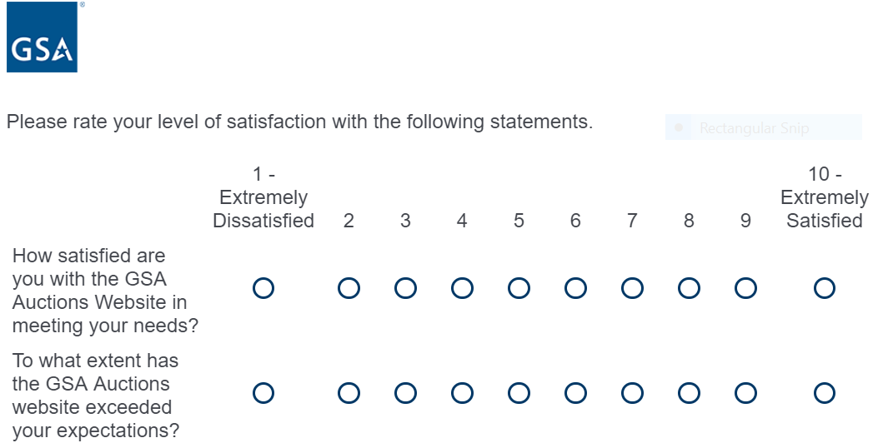

Form Approved OMB# 3090-0297 Exp. Date 08/31/2022 and Privacy Policy

Screen 3

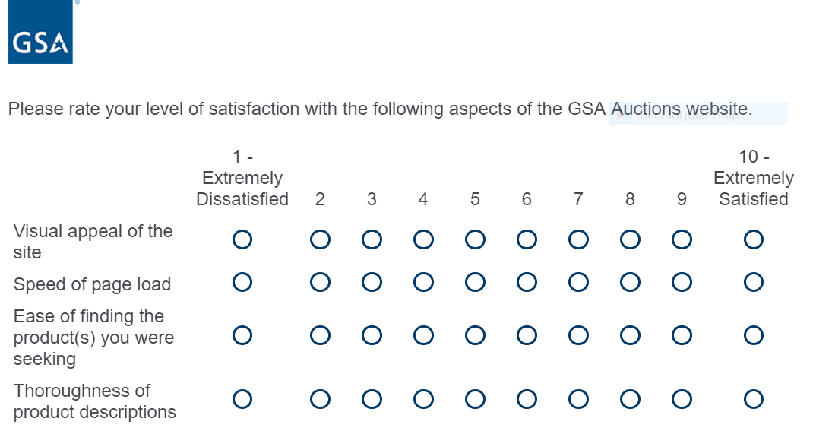

Form Approved OMB# 3090-0297 Exp. Date 08/31/2022 and Privacy Policy

Screen 4

Display this question if respondent did not select a score of 7, 8, 9 or 10 from the scale above for the answer choice titled Thoroughness of product descriptions OR
Display this question if respondent did not select a score of 7, 8, 9, or 10 from the scale above for the answer choice titled Ease of find the product(s) you were seeking

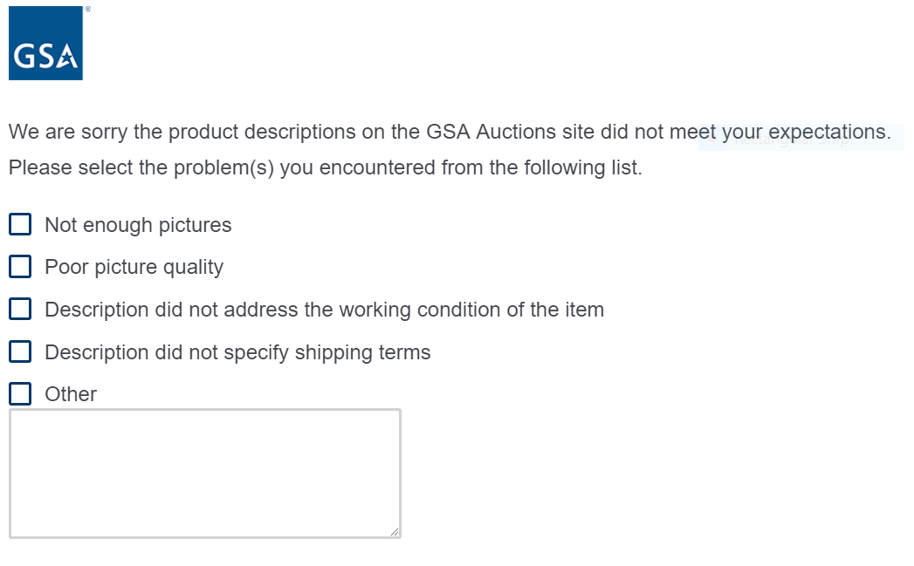

Form Approved OMB# 3090-0297 Exp. Date 08/31/2022 and Privacy Policy

Screen 5

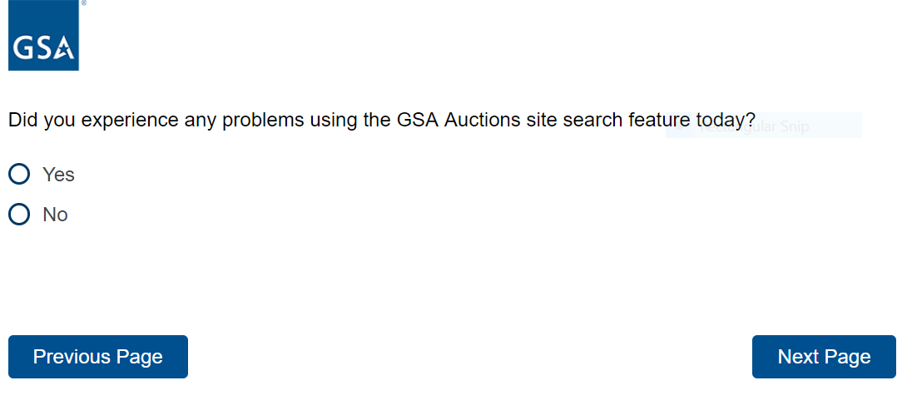
Form Approved OMB# 3090-0297 Exp. Date 08/31/2022 and Privacy Policy

Screen 6

Display this question if respondent selected yes from the above question

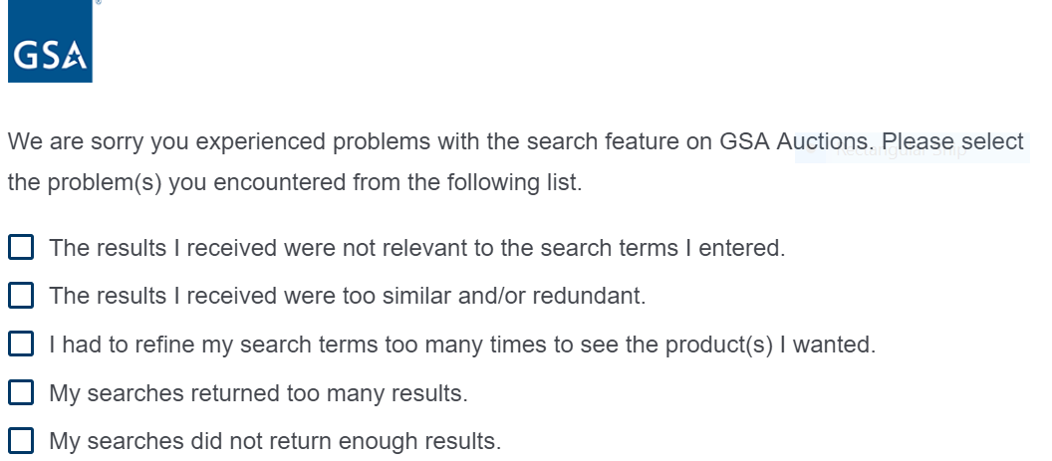
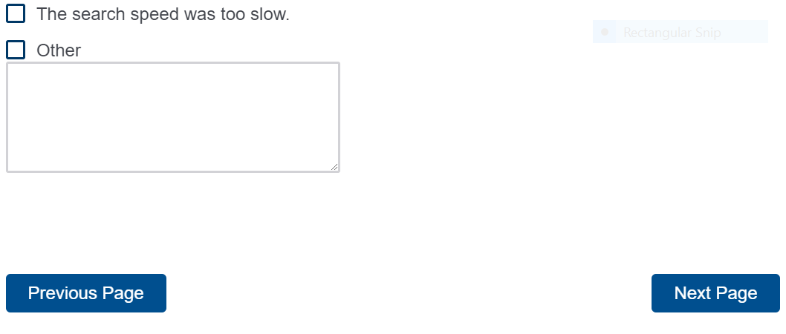

Form Approved OMB# 3090-0297 Exp. Date 08/31/2022 and Privacy Policy

Screen 7

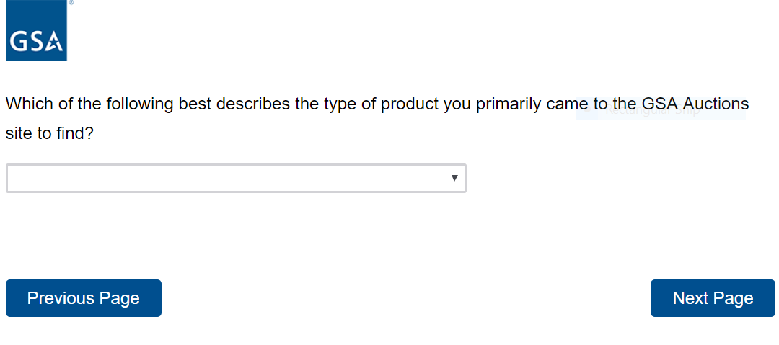
Form Approved OMB# 3090-0297 Exp. Date 08/31/2022 and Privacy Policy

Respondent selects from the drop down list below:

I was Not Looking for Anything Specific
Agricultural Equipment and Supplies
Aircraft and Aircraft Parts
Boats and Marine Equipment
Communication Equipment
Computer Equipment and Accessories
Construction Equipment
Electrical and Electronic Equipment
Fire Trucks and Fire Fighting Equipment
Furniture
Hand Tools and Shop Equipment
Household/Personal
Industrial Machinery
Jewelry and Exotic Collectibles
Lab Equipment
Medical, Dental and Veterinary Equipment and Supplies
Motorcycles and Bicycles
NASA Shuttle/Hubble
Office Equipment and Supplies
Photographic Equipment
Real Estate (houses, buildings, land and farms)
Trailers, Tractors and Manufactured Housing
Vehicles and Vehicle Parts
Other

Screen 8

Display this question if the choice “I was Not Looking for Anything Specific” was not selected

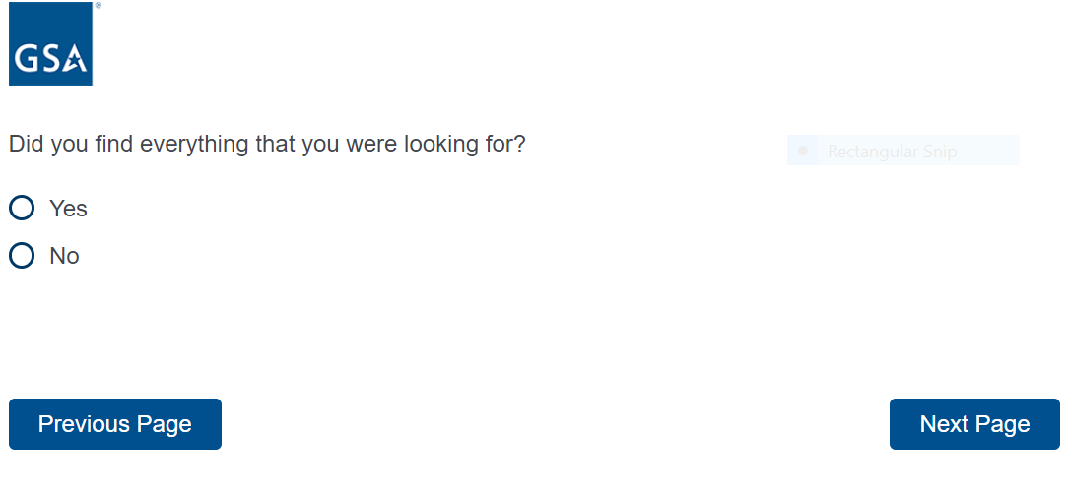
Form Approved OMB# 3090-0297 Exp. Date 08/31/2022 and Privacy Policy

Screen 9

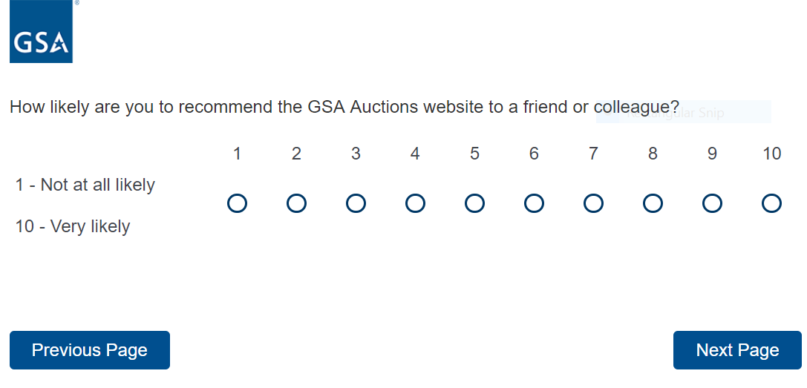

Form Approved OMB# 3090-0297 Exp. Date 08/31/2022 and Privacy Policy

Screen 10

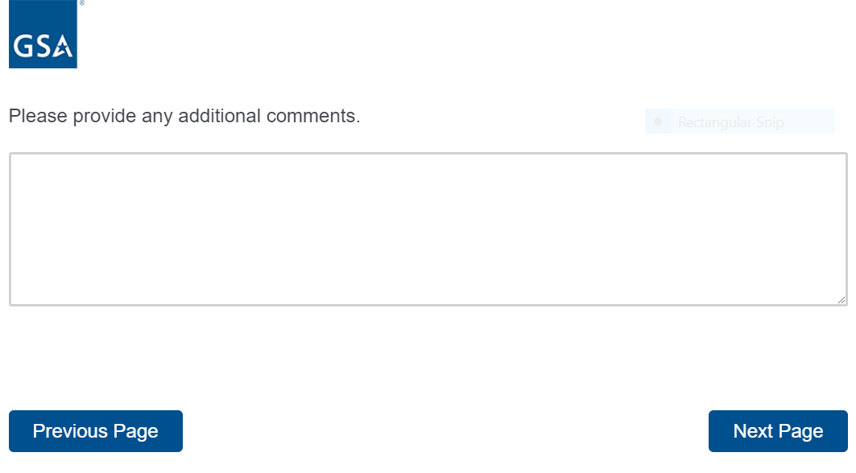

Form Approved OMB# 3090-0297 Exp. Date 08/31/2022 and Privacy Policy

Screen 11

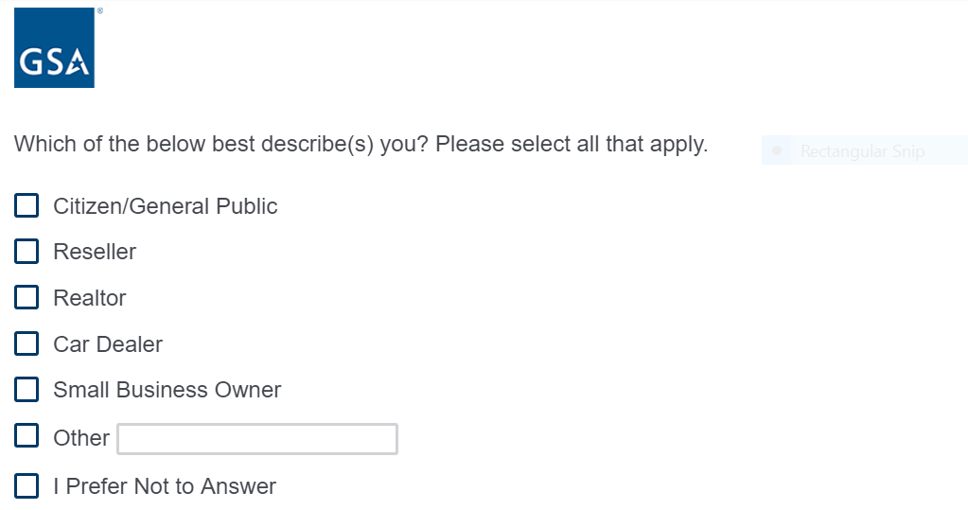

Form Approved OMB# 3090-0297 Exp. Date 08/31/2022 and Privacy Policy

Screen 12

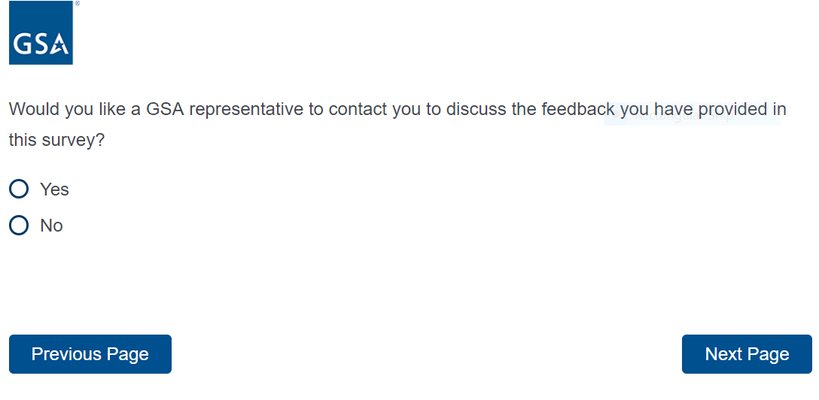

Form Approved OMB# 3090-0297 Exp. Date 08/31/2022 and Privacy Policy

Screen 13

If yes is selected from above, display the following question
If no is selected from above, “Thank You” Screen appears

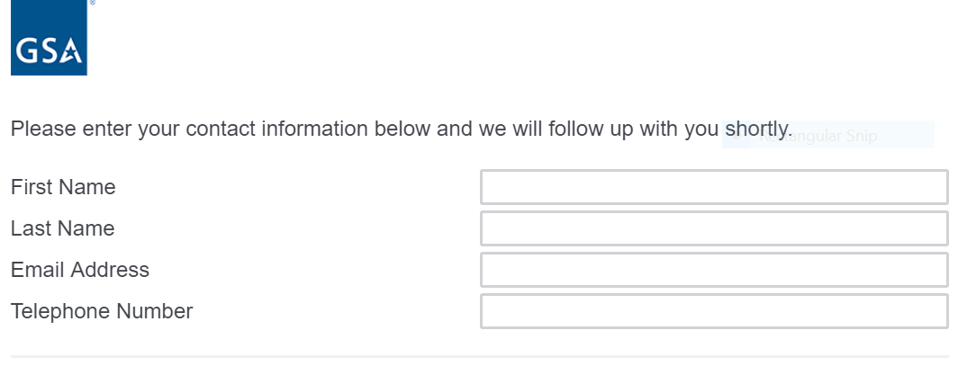

Screen 14

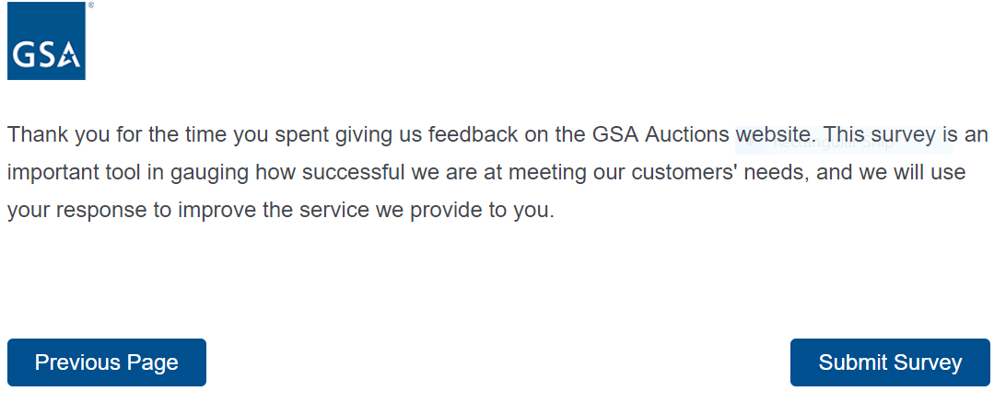

Form Approved OMB# 3090-0297 Exp. Date 08/31/2022 and Privacy Policy

