NCSC Customer Satisfaction Survey
Req-18

Screen 1:

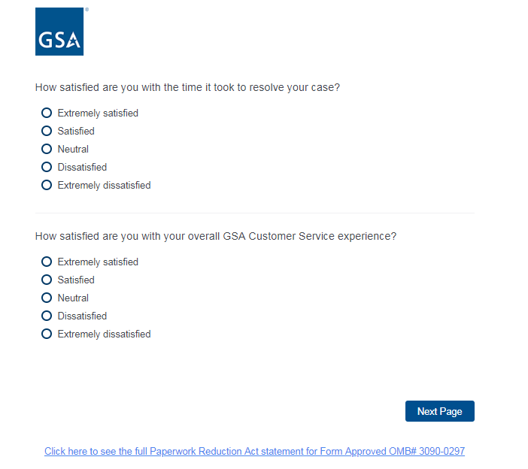

Screen 2:

