The survey will be accessible via a standing feedback tab on all gsa.gov pages.

Questions with Asterisks \* will be required responses from users. The following shown is Q1 & Q2

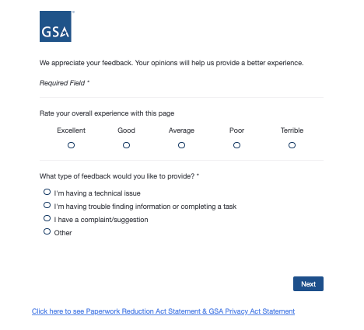

PRA Statement and Privacy Act Statement is hyperlinked to the below page. The approval date will be updated after PRA is officially approved.

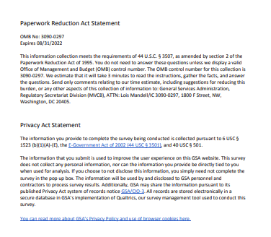

The following will appear if in Q2 “Technical Issue” is selected

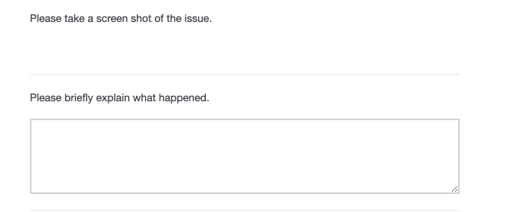

The following will appear If in Q2 “Trouble finding information or completing a task” is selected

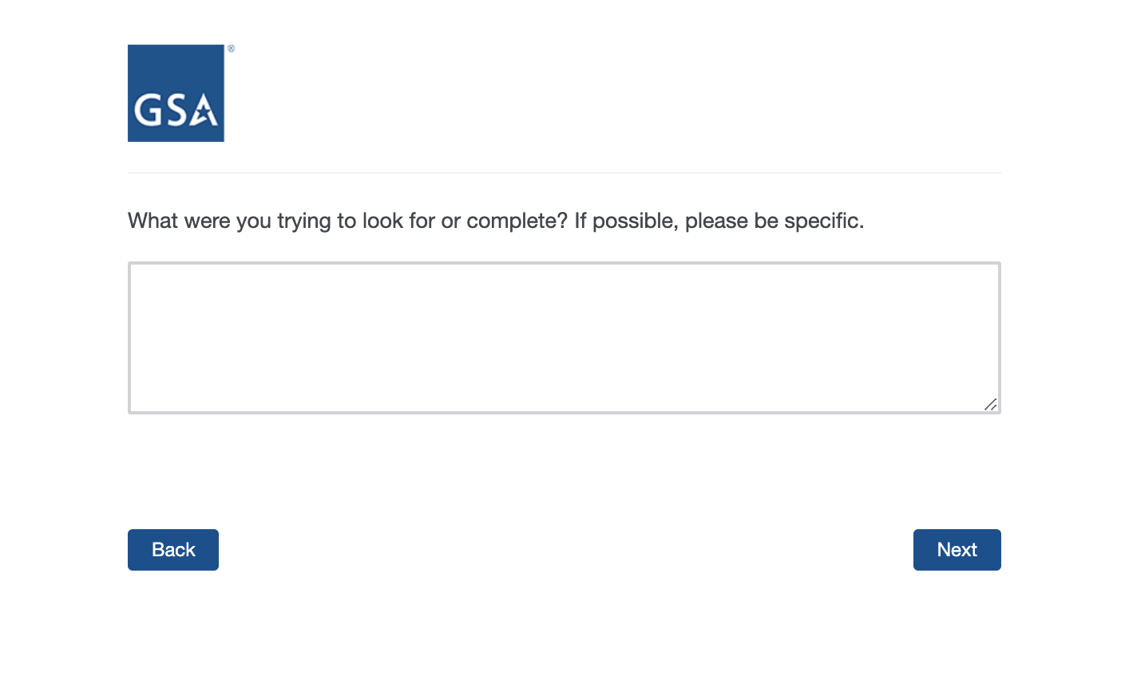

The following will appear If in Q2 “complaint/suggestion” or “other” is selected

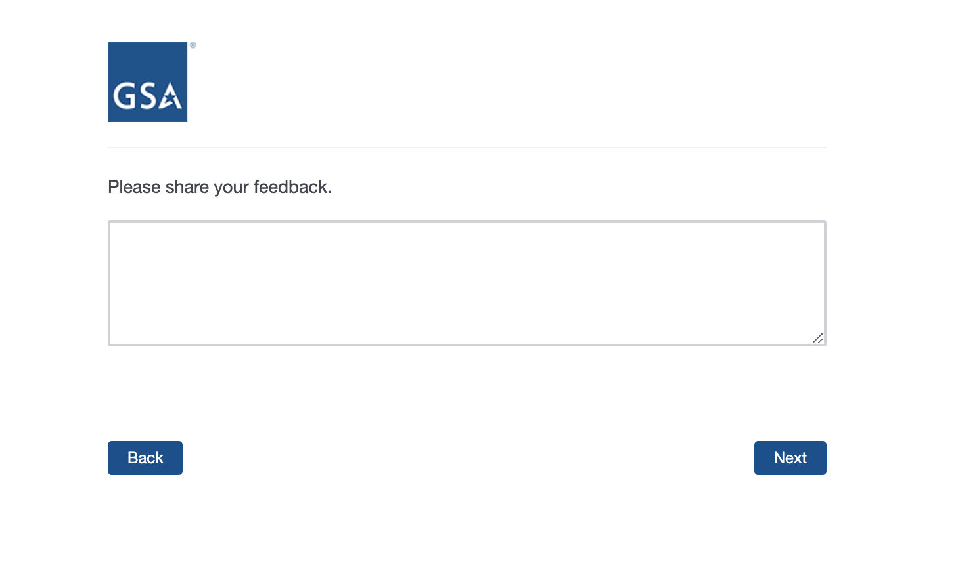

We’ll use A/B testing to show different versions of the following questions. 50% of respondents will see Version A of Q3, 50% will see Version B of Q3

Version A

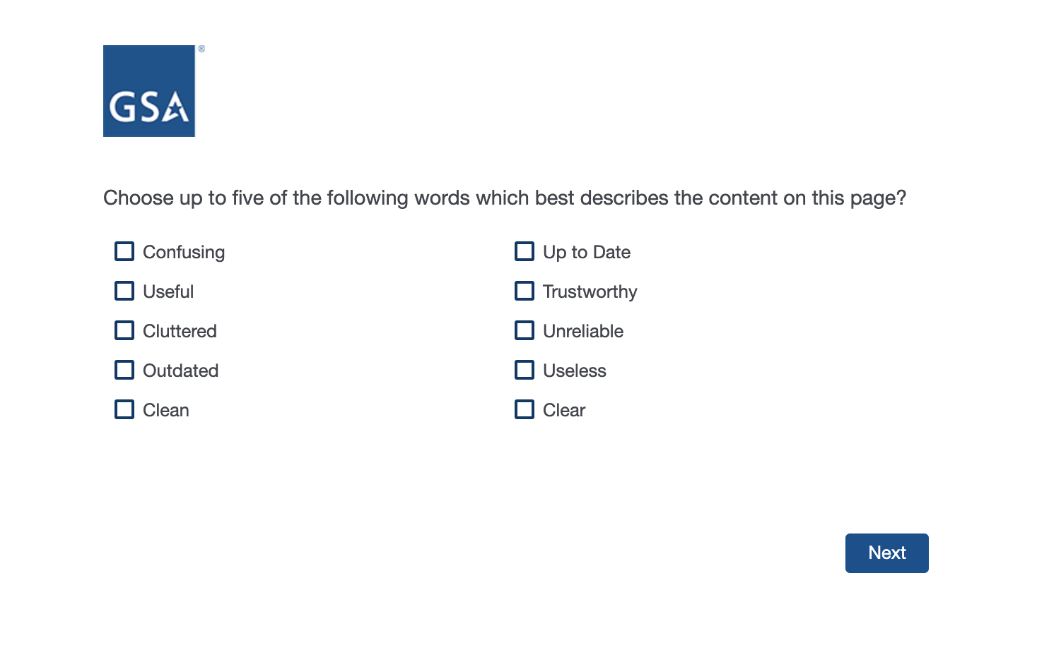

Version B

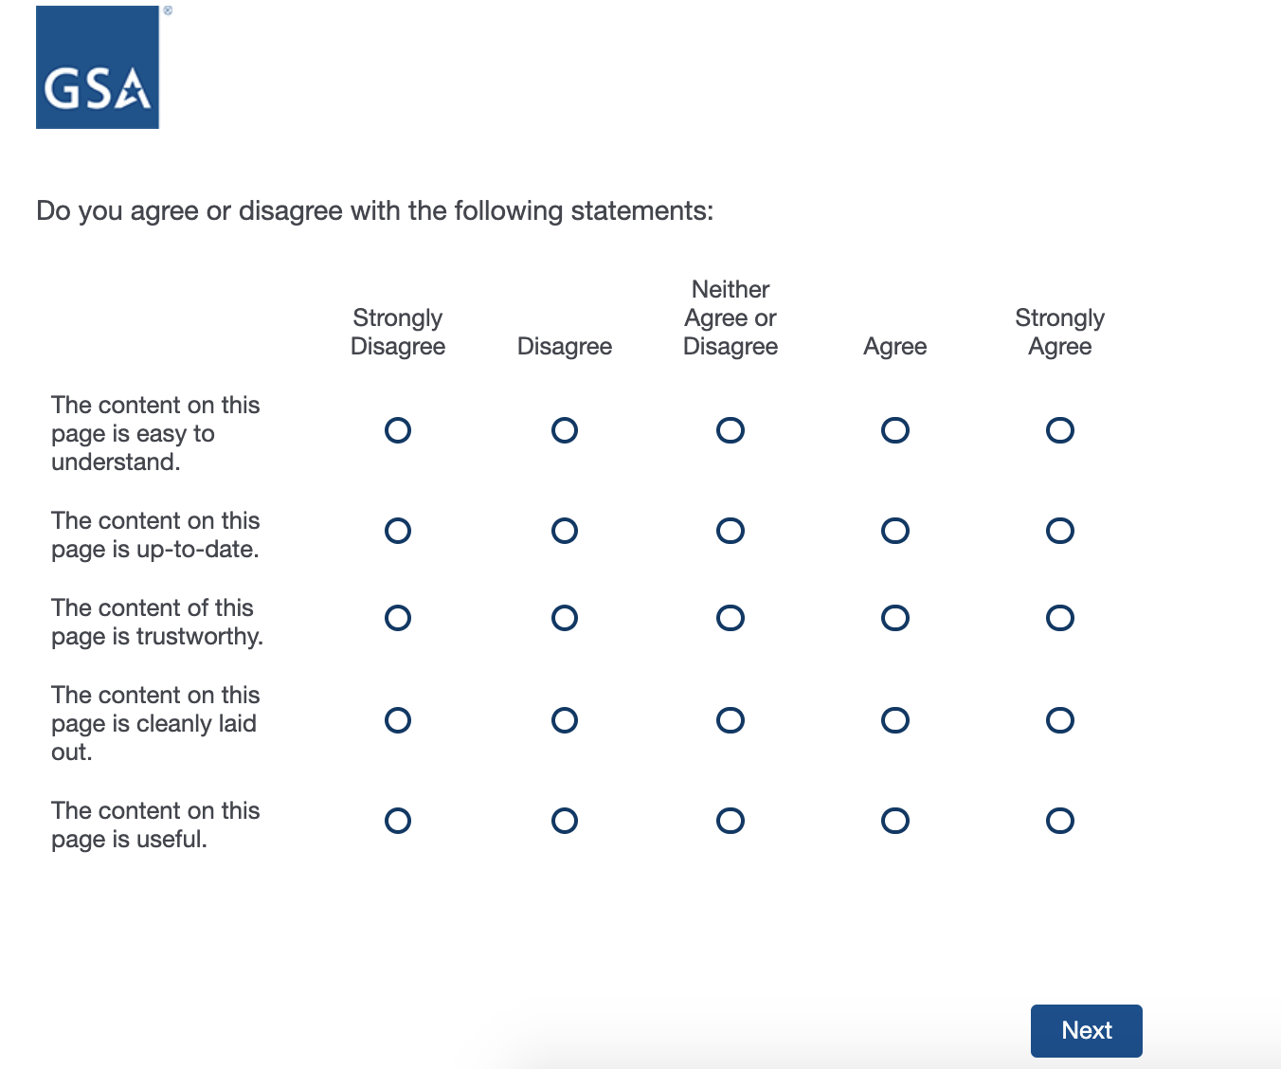

Q4

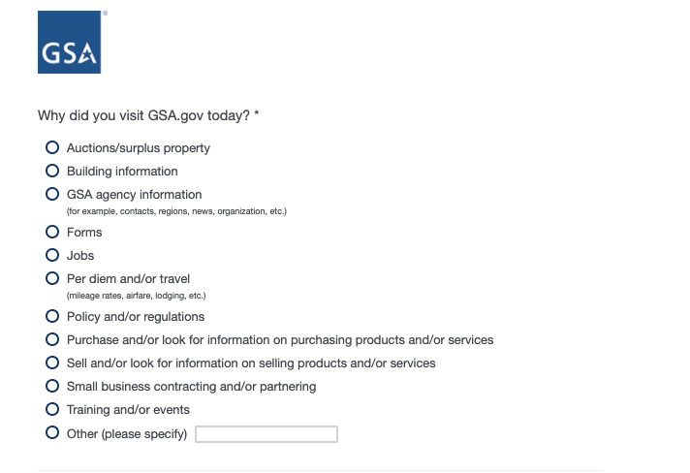

Q5

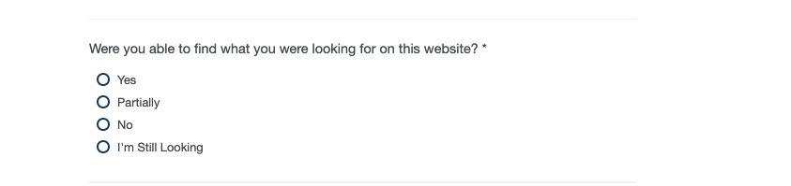

Q6

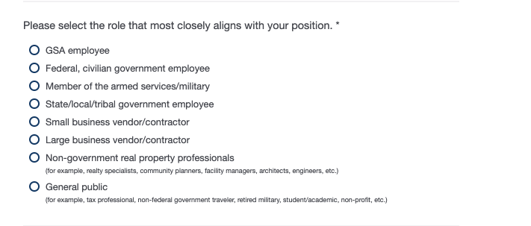

Q6a Will appear if small or large business vendor/contractor is selected in Q6

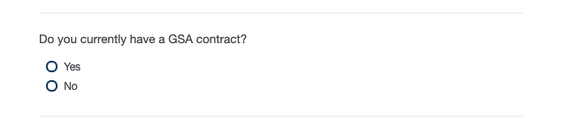

Q7

