OSDBU Matchmaking Session Info Form
Entire questionnaire is on one screen.
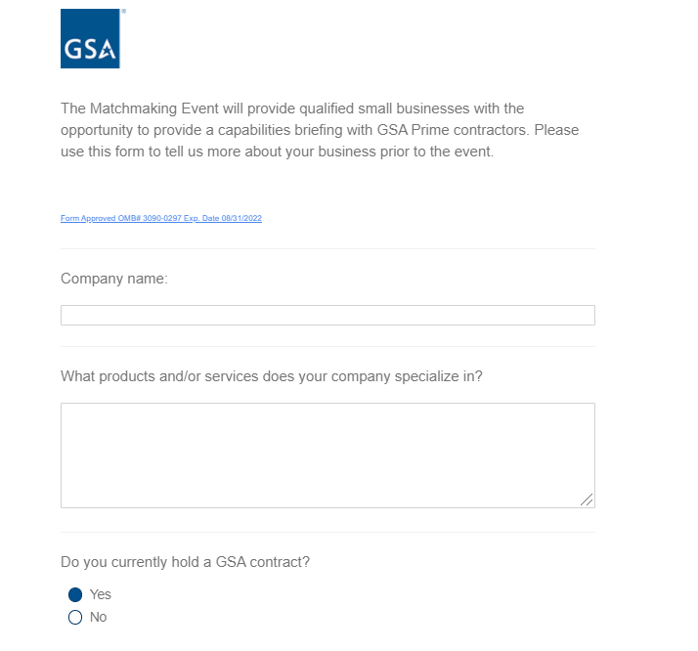
The question “Please select the contract(s) that you currently hold” only appears when ‘yes’ is selected.
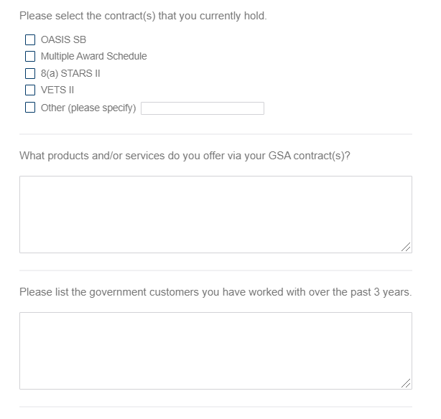
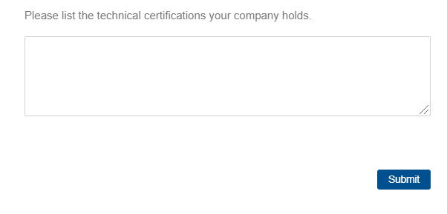
Introductory text link destination:
