**Screen 1**

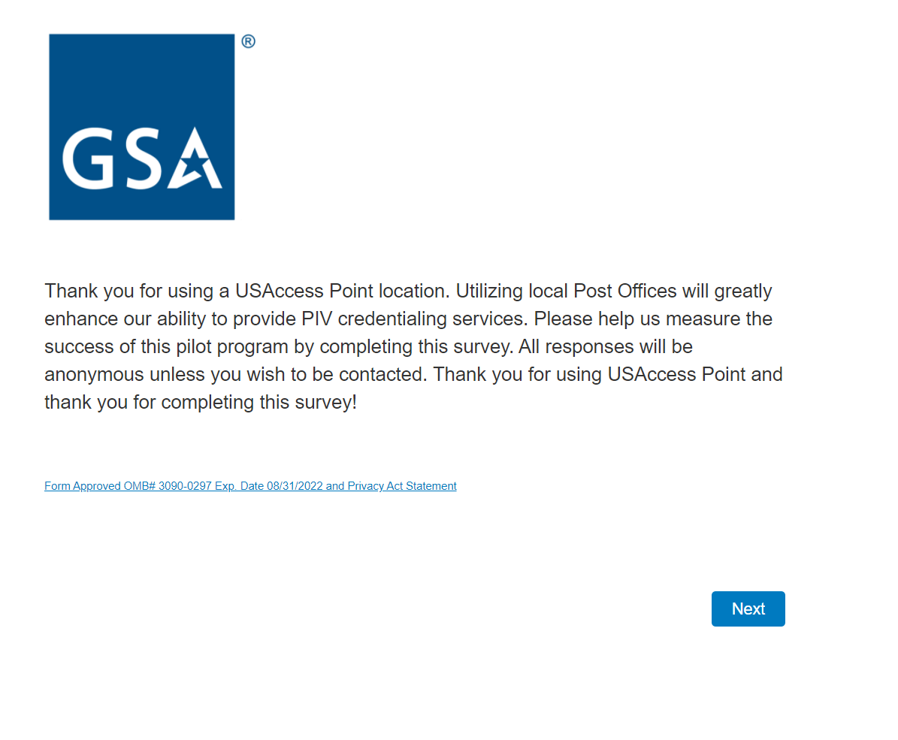

**Screen 2**

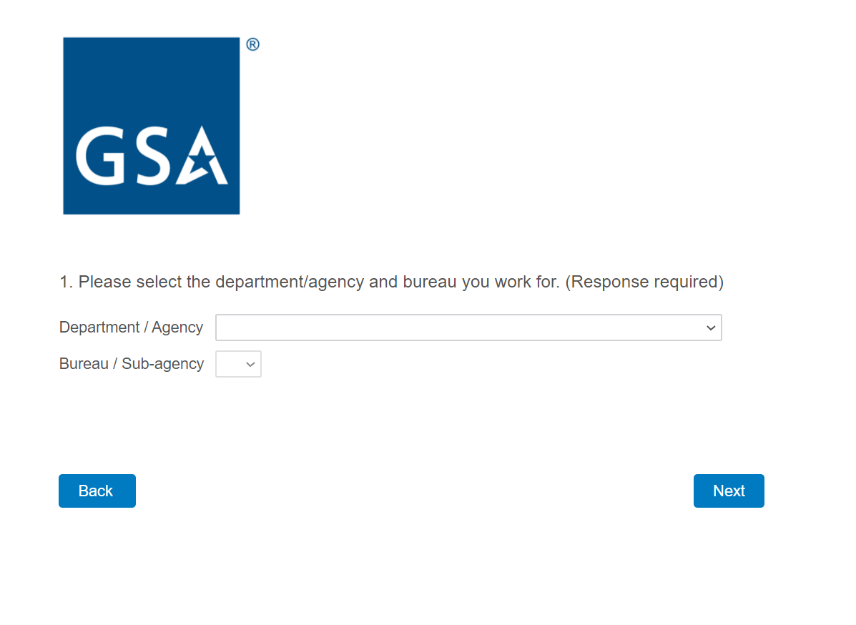

Notes: Complete agency and sub-agency lists are populated in the drop-down menus.

**Screen 3**

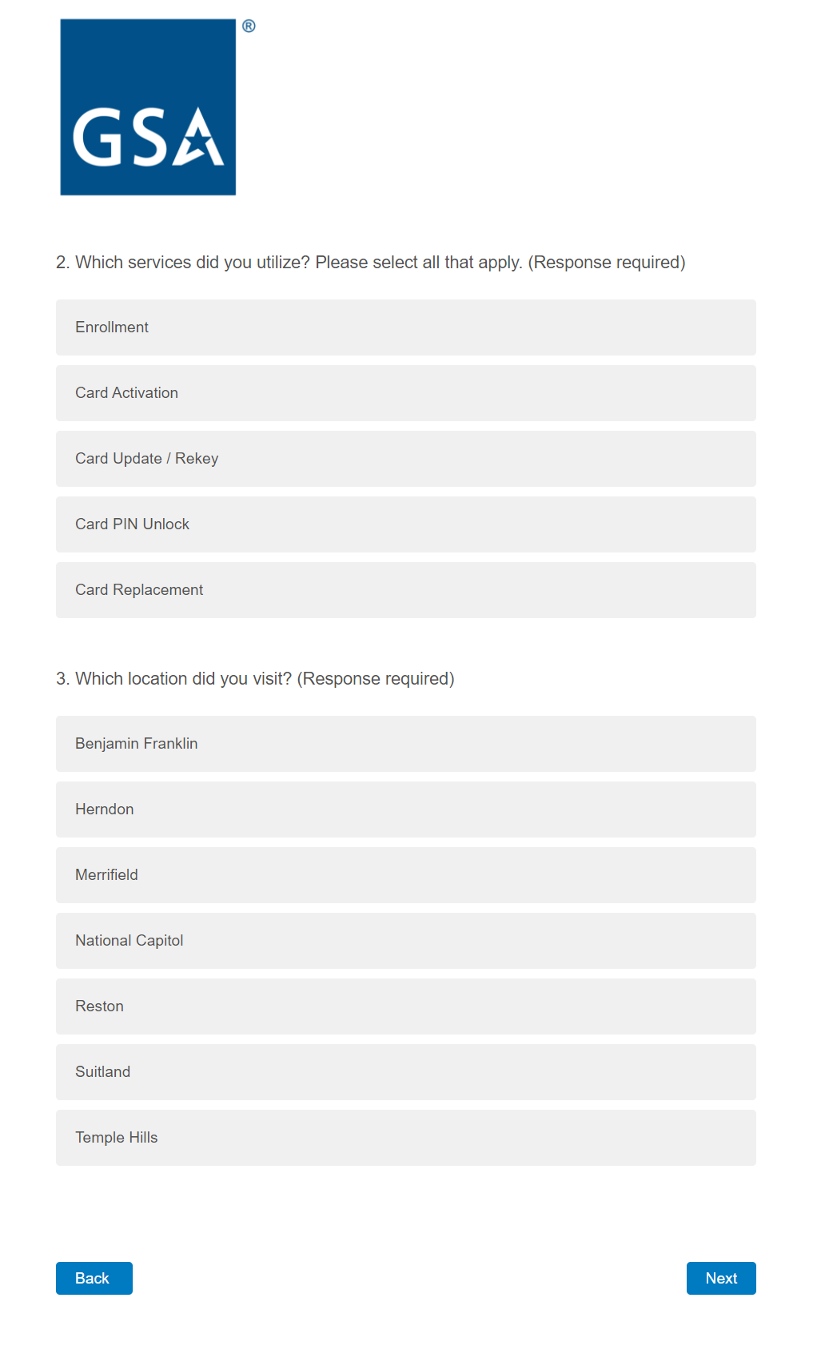

**Screen 4**

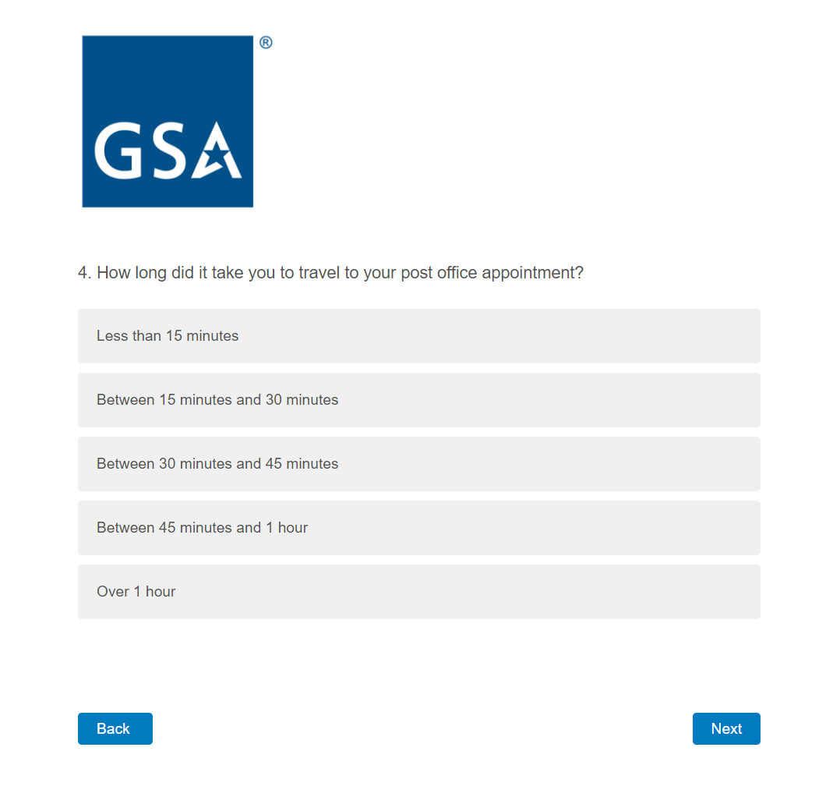

**Screen 5**

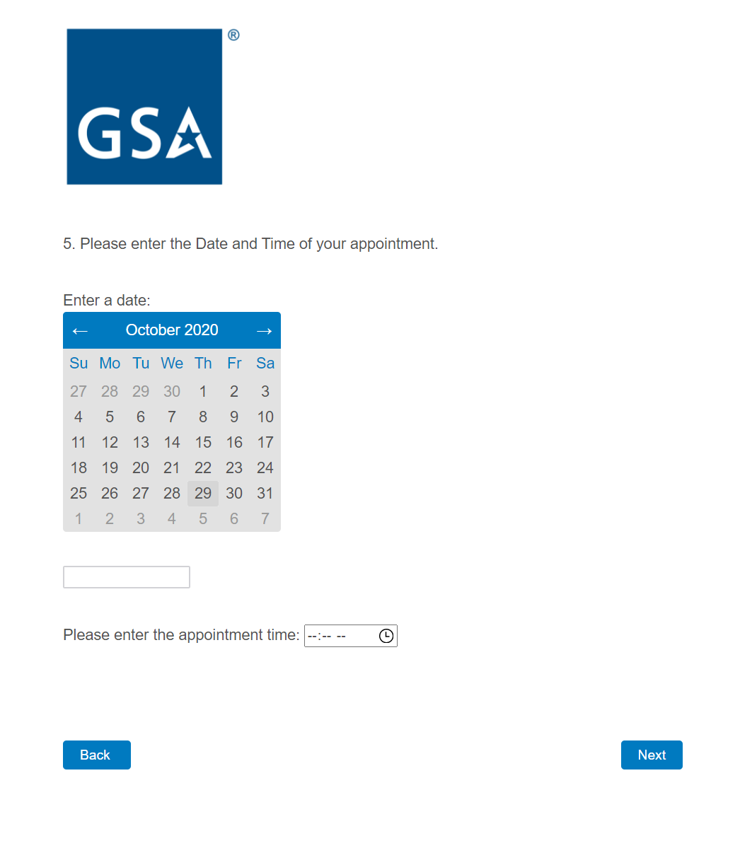

**Screen 6a**

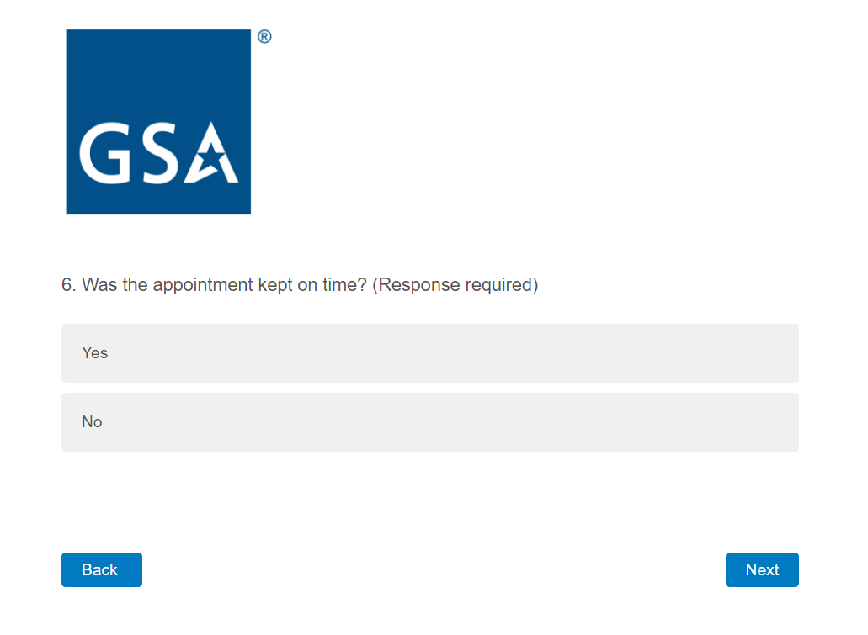

If the respondent answers No, the following screen is displayed, otherwise skip to question 7.

**Screen 6b**

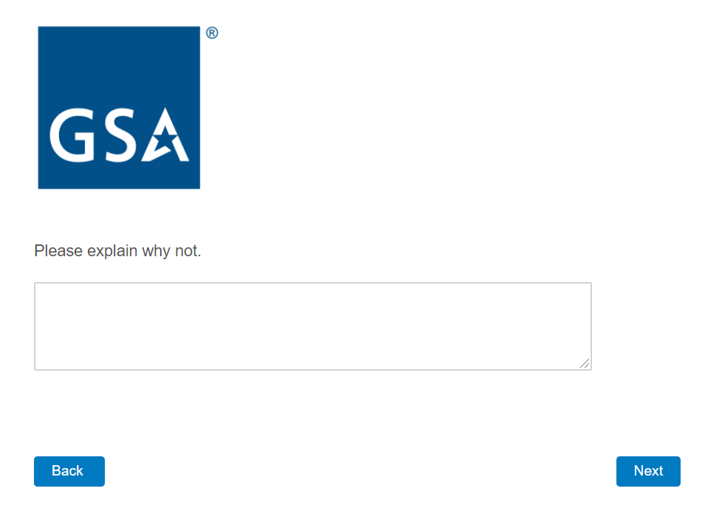

**Screen 7**

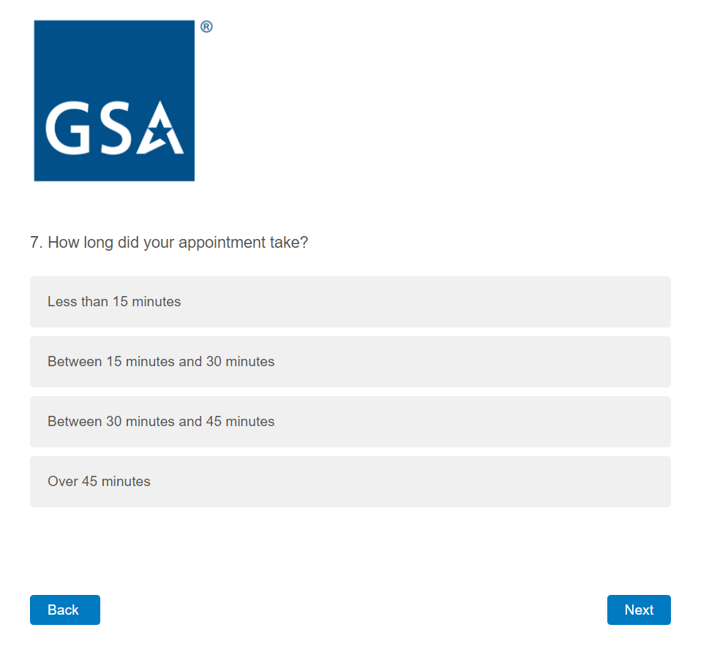

**Screen 8a**

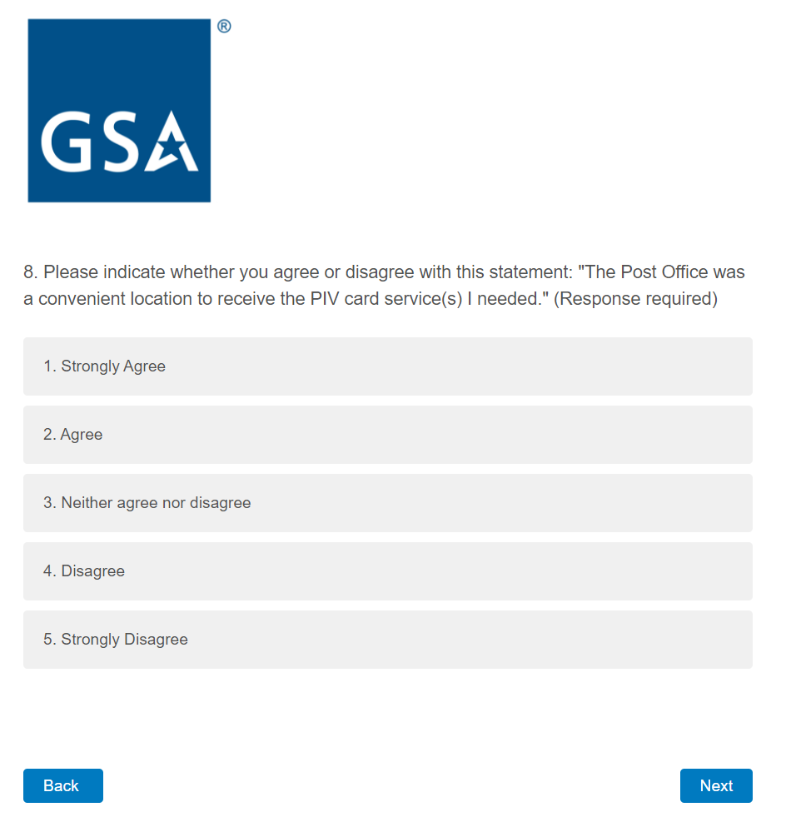

If the respondent answers with 3, 4, or 5, the following screen is displayed, otherwise skip to question 9.

**Screen 8b**

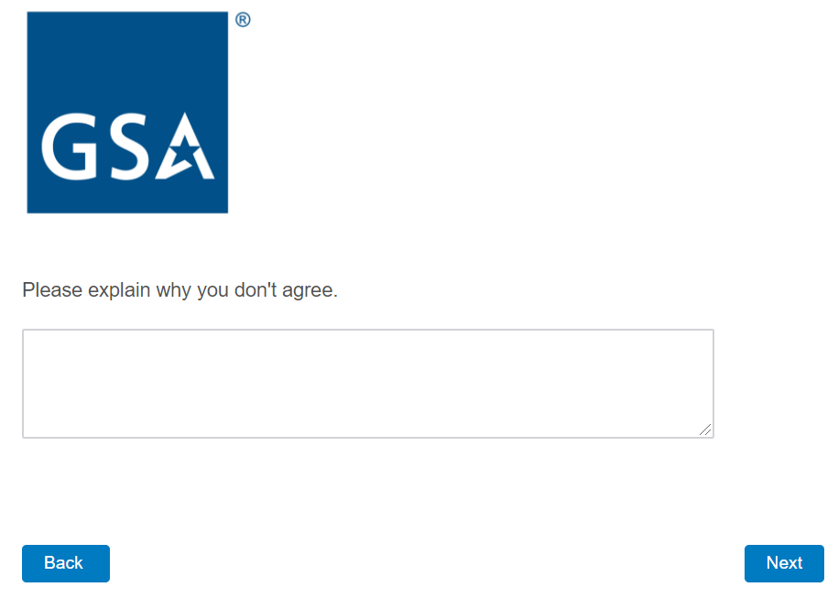

**Screen 9a**

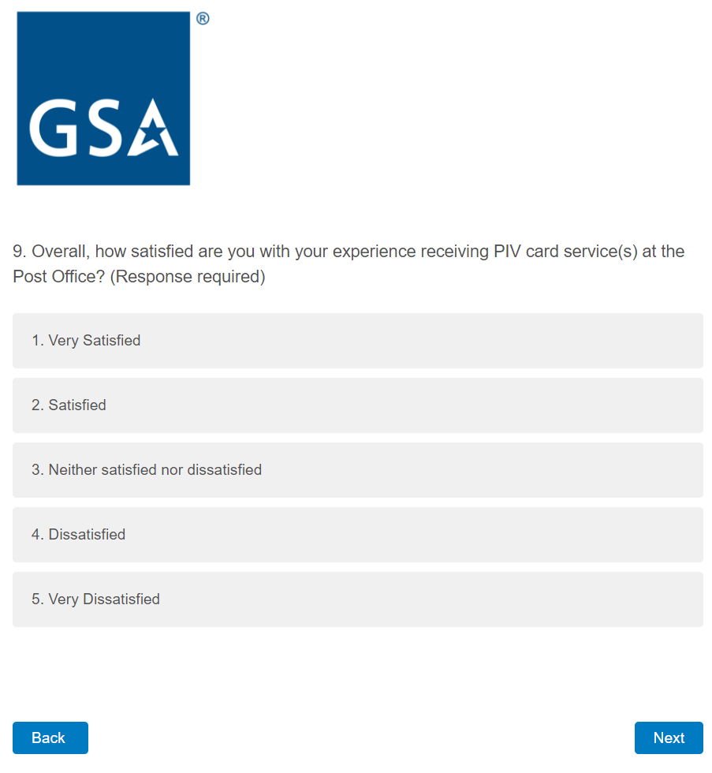

If the respondent answers with 3, 4, or 5, the following screen is displayed, otherwise skip to question 10.

**Screen 9b**

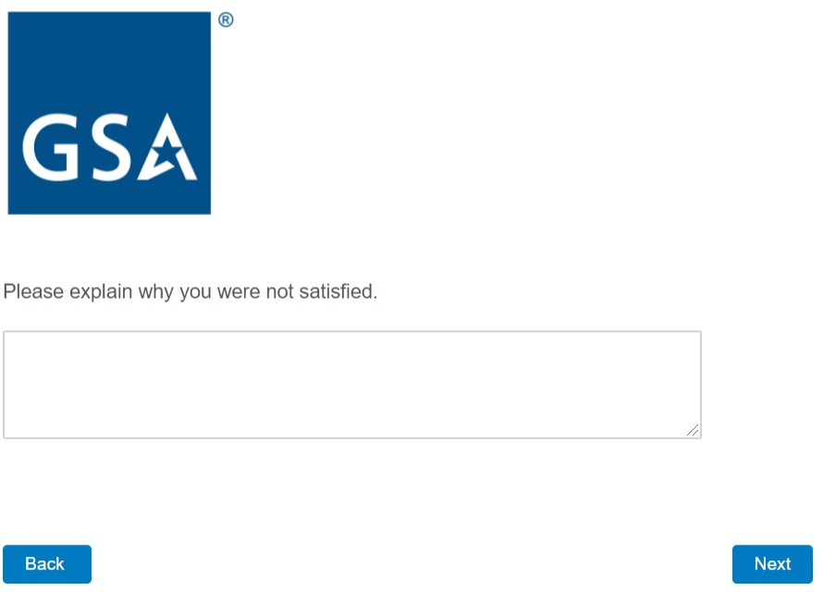

**Screen 10**

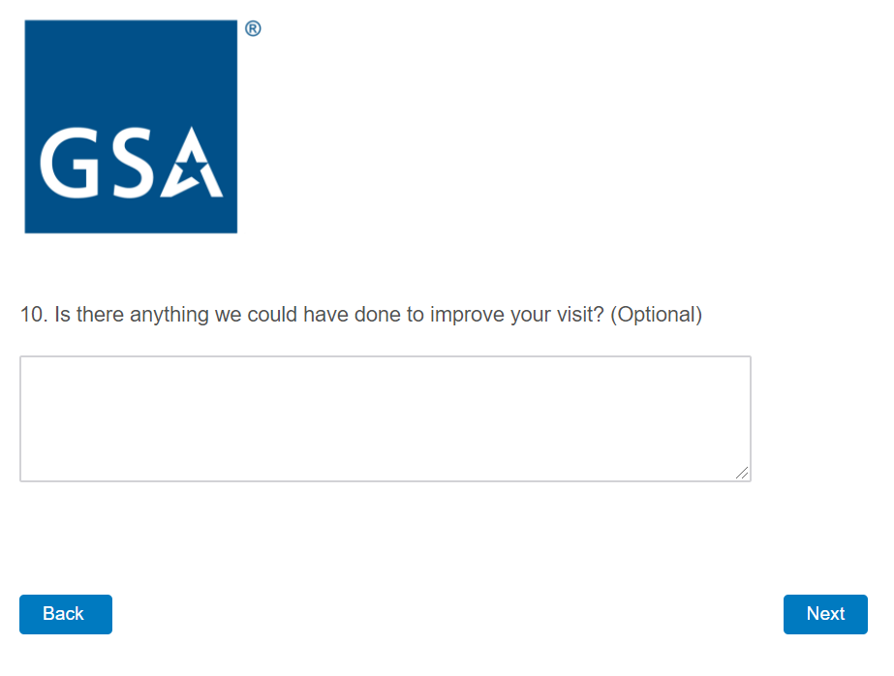

**Screen 11**

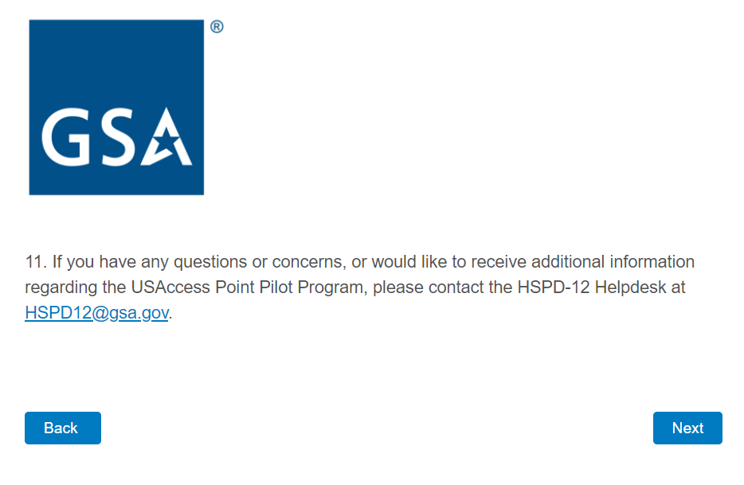

**Screen 12**

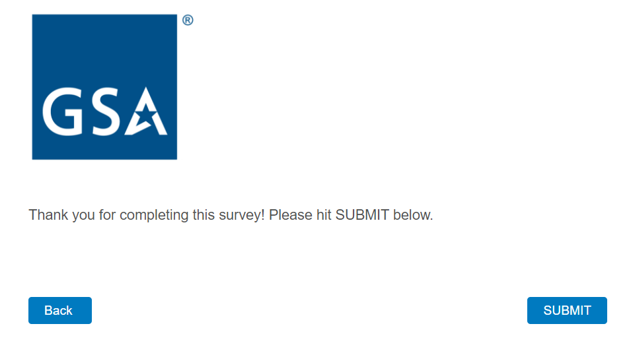

**Screen 13**

