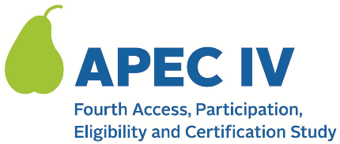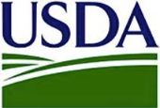

Dear <SFA PRIMARY CONTACT NAME>:

Thank you for confirming and/or updating your school data.

The research team will review the file and contact you with any questions.

Once finalized, we will use your school list to sample schools from your district. We will notify you of the schools sampled from your district in <MONTH, YEAR>. For more information on the study, you may also visit the study’s website at <URL.>

We appreciate your participation in APEC IV.

Sincerely,

The APEC IV Study Team

This information is being collected to provide the Food and Nutrition Service with key information on the annual error rates and improper payments for the school meal programs. This is a voluntary collection and FNS will use the information to examine school meal error rates and inform future APEC studies. This collection requests personally identifiable information under the Privacy Act of 1974. According to the Paperwork Reduction Act of 1995, an agency may not conduct or sponsor, and a person is not required to respond to, a collection of information unless it displays a valid OMB control number. The valid OMB control number for this information collection is 0584-0530. The time required to complete this information collection is estimated to average 0.0167 hours (1 minute) per response, including the time for reviewing instructions, searching existing data sources, gathering and maintaining the data needed, and completing and reviewing the collection of information. Send comments regarding this burden estimate or any other aspect of this collection of information, including suggestions for reducing this burden, to: U.S. Department of Agriculture, Food and Nutrition Service, Office of Policy Support, 1320 Braddock Place, 5th Floor, Alexandria, VA 22306 ATTN: PRA (0584-0530). Do not return the completed form to this address.

