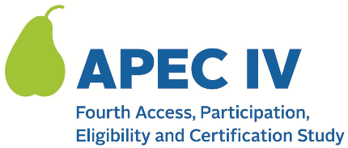

Dear <<SFA CONTACT NAME>>,

We have selected <NUMBER> of your schools to participate in the APEC IV study. Attached you will find:

a) The list of schools selected;
b) The schedule we will follow to contact the schools; and
c) An email template that you can use to notify your selected schools.

We ask that you complete the following two steps to help us recruit the selected schools for the study:
- Please use the email template to inform the schools within the next 5 days that they have been selected for the study, and that you encourage their participation.
- Please email us the contact information for the individual at each school who we should work with to collect data related to the school meal programs, including the person’s name, phone number, and email address.

A member of the APEC IV study team will contact you within a week to follow up on the status of your outreach to schools and to solicit any suggestions you may have for working effectively with your schools on this study.

Please contact us at < TOLL FREE NUMBER> or < EMAIL ADDRESS> if you have any questions. For more information on the study, you may also visit the study’s website at < URL.>

Thank you in advance for your help and cooperation.

Sincerely,

<APEC IV STUDY TEAM>
<NAME AND TITLE OF SENDER>

Attachments:
- List of schools selected and Study Schedule for Contacting Selected Schools
- 012. Email Notification Template from SFA to Schools
This information is being collected to provide the Food and Nutrition Service with key information on the annual error rates and improper payments for the school meal programs. This is a voluntary collection and FNS will use the information to examine school meal error rates and inform future APEC studies. This collection requests personally identifiable information under the Privacy Act of 1974. According to the Paperwork Reduction Act of 1995, an agency may not conduct or sponsor, and a person is not required to respond to, a collection of information unless it displays a valid OMB control number. The valid OMB control number for this information collection is 0584-0530. The time required to complete this information collection is estimated to average 0.334 hours (20 minutes) per response, including the time for reviewing instructions, searching existing data sources, gathering and maintaining the data needed, emailing the schools, and completing and reviewing the collection of information. Send comments regarding this burden estimate or any other aspect of this collection of information, including suggestions for reducing this burden, to: U.S. Department of Agriculture, Food and Nutrition Service, Office of Policy Support, 1320 Braddock Place, 5th Floor, Alexandria, VA 22306 ATTN: PRA (0584-0530). Do not return the completed form to this address.

