OMB Number: 0584-0530
Expiration Date: xx/xx/20xx
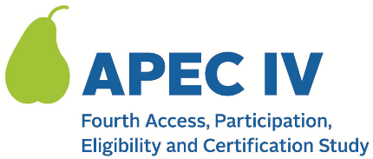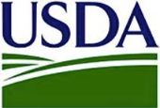

Dear <SCHOOL PRIMARY CONTACT NAME>:

Thank you for agreeing to participate in the APEC IV Study!

Data collection will occur in SY 2023-24, and we will reach out a few months prior to the start of the school year to start preparing with you. No additional steps are needed from you right now. The table below shows the data we will collect from your school and some of your student households once data collection begins:

Data Collection Activities for Schools |  | Timeline
1 | Telephone call with Westat research team to discuss the data collection visit | [Month, Year]
2 | Visit from Westat research team to observe meals and collect meal count and claims records | [Month, Year]*
Data Collection Activities for Households |  | Timeline
1 | Telephone survey with parents/guardians of randomly selected students that applied or were directly certified for free or reduced priced meals in SY 2023-24. A subsample of households will be asked to complete an in-person survey as well. Note: APEC-IV is called the “National School Meals Study” to parents/guardians participating in the telephone survey | [Month, Year]
*Exact timing to be determined in collaboration with the school.

More details about APEC IV are provided in the attached FAQ document and on the study website: <URL>.

We appreciate your time and participation in APEC IV. We look forward to working with you when data collection begins. If you have any additional questions, please contact at <EMAIL ADDRESS> or <TOLL FREE NUMBER>.

We appreciate your time and participation in APEC IV.

Sincerely,

The APEC IV Study Team

Attachment: 024. APEC IV FAQ (for States, SFAs, and Schools)

This information is being collected to provide the Food and Nutrition Service with key information on the annual error rates and improper payments for the school meal programs. This is a voluntary collection and FNS will use the information to examine school meal error rates and inform future APEC studies. This collection requests personally identifiable information under the Privacy Act of 1974. According to the Paperwork Reduction Act of 1995, an agency may not conduct or sponsor, and a person is not required to respond to, a collection of information unless it displays a valid OMB control number. The valid OMB control number for this information collection is 0584-0530. The time required to complete this information collection is estimated to average 0.0835 hours (5 minutes) per response, including the time for reviewing instructions, searching existing data sources, gathering and maintaining the data needed, and completing and reviewing the collection of information. Send comments regarding this burden estimate or any other aspect of this collection of information, including suggestions for reducing this burden, to: U.S. Department of Agriculture, Food and Nutrition Service, Office of Policy Support, 1320 Braddock Place, 5th Floor, Alexandria, VA 22306 ATTN: PRA (0584-0530). Do not return the completed form to this address.

