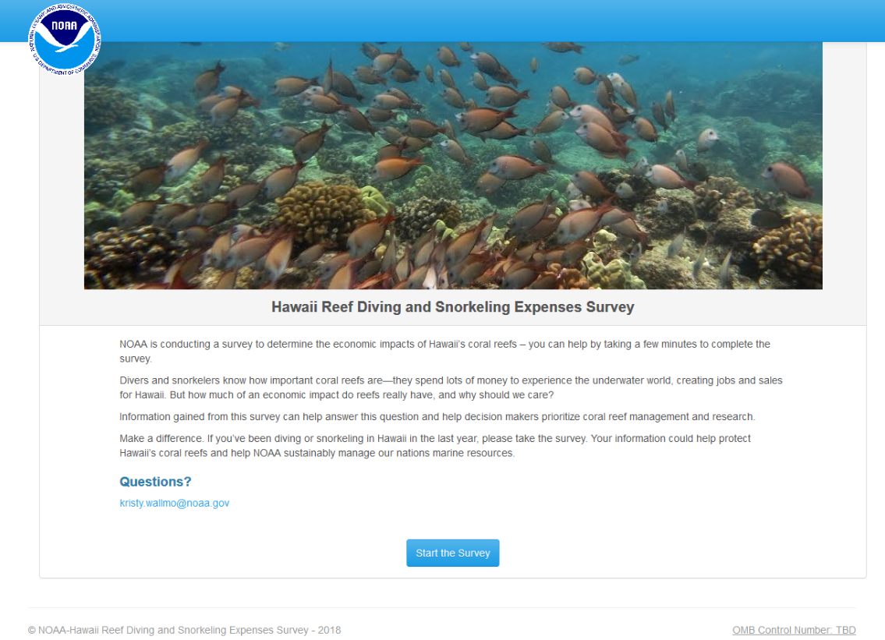
Public reporting burden for this information collection is estimated to average 25 minutes per response. Send comments regarding this burden estimate or other suggestions for reducing this burden to Kristy Wallmo, 301-427-8190 or Kristy.Wallmo@noaa.gov. All data collected in this survey is anonymous and will not be released for public use except in aggregate statistical form. The survey is voluntary and does not ask for any information that will allow for personal identification. Notwithstanding any other provisions of the law, no person is required to respond to, nor shall any person be subjected to a penalty for failure to comply with, a collection of information subject to the requirements of the Paperwork Reduction Act, unless that collection of information displays a currently valid OMB Control Number.

