Socio-Economic Survey of Hired Captains and Crew in New England, Mid-Atlantic, South Atlantic and Gulf of Mexico Commercial Fisheries
FREQUENTLY ASKED QUESTIONS (FAQS)
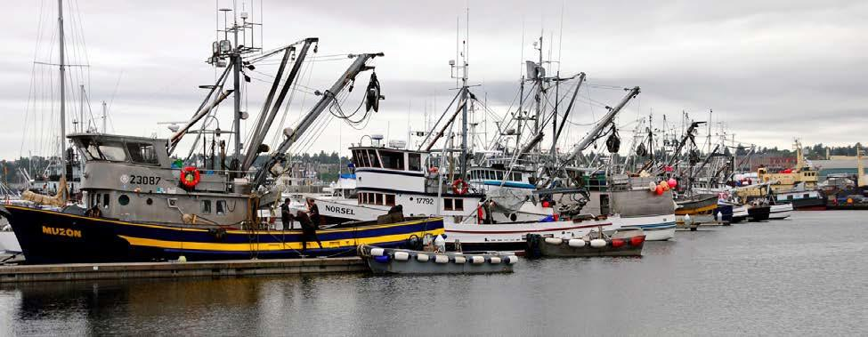
What is the purpose of the survey?
This survey is an effort by the NOAA Fisheries Northeast and Southeast Fisheries Science Centers to assess the current social and economic conditions of commercial fishing crews (including hired captains) in the Northeast and Southeast States for which little is known. The survey is a follow-up to a study conducted in 2018/2019 and will allow for comparisons to determine how and why commercial crew working conditions may have changed over time.

Why does your participation matter?
We simply do not know much about the experiences of commercial fishing crew members and yet they are a critical part of the commercial fishing industry. The majority of economic and social information collected has focused on vessel owners. The results of this survey will not only help fisheries managers understand what is going on in crew members’ lives but also the impacts of management decisions on commercial crew. Your participation is extremely valuable in helping improve and shape fishery management decisions.

What type of information is being collected?
Social and economic information will be collected from commercial crew who voluntarily participate in the survey. Examples of the information to be collected include: demographic information, job opportunities, job satisfaction, wage system calculations, and well-being.

Who are we asking to participate?
Survey participants include commercial crew in the Northeast and Southeast states. Since there is no database of registered crew, participants will be intercepted on the docks at major ports.

Who is conducting this survey?
NOAA Fisheries Northeast and Southeast Fisheries Science Centers are conducting this survey. We conduct applied economic and sociocultural research on the management of commercial and recreational fisheries. It is our commitment to perform independent, relevant and accessible research aimed at providing useful input to the decision-making process in fisheries management.

How long will this survey take?
The survey will take approximately 15-20 minutes to complete. However, times may vary.

How will I be sure my data is anonymous?
Data collected will be kept anonymous, will not be linked to specific individuals and will not be released for public use except in an aggregate statistical form. Participation or lack of participation in the survey will remain anonymous. All economic data will be aggregated into statistical form for all reports.

If you have any questions, contact:

Northeast Fisheries Science Center
Lisa Colburn, Ph.D. lisa.l.colburn@noaa.gov
401-782-3253

Matt Cutler, PhD
matthew.cutler@noaa.gov
508-495-4731

Southeast Fisheries Science Center:
Matt McPherson, PhD
matthew.mcpherson@noaa.gov
305-365-4112
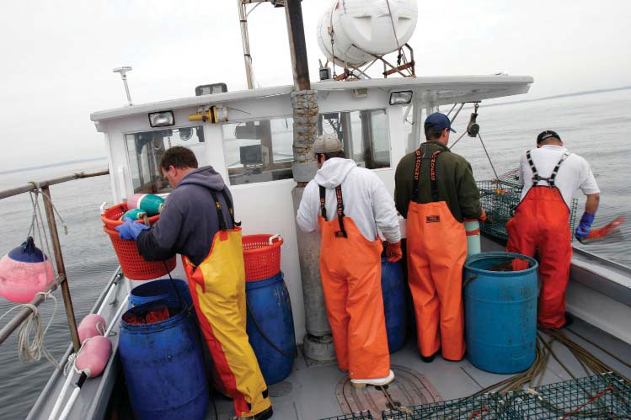

Interviewer’s Name: OMB Control No. 0648-0636
Date: Expiration Date: XX/XX/20XX
Port Name:
Start Time:
End Time:
Socio-Economic Survey of Hired Captains and Crew in New England, Mid-Atlantic, South Atlantic and Gulf of Mexico Commercial Fisheries

Public reporting burden for this collection of information is estimated to average 20 minutes per response, including the time for reviewing instructions, searching existing data sources, gathering and maintaining the data needed, and completing and reviewing the collection of information. Send comments regarding this burden estimate or any other suggestions for reducing this burden to (Northeast) Lisa L. Colburn, 28 Tarzwell Dr., Narragansett, RI 02882, Email: lisa.l.colburn@noaa.gov, or Matthew J Cutler, 166 Water St., Woods Hole, MA 02543, Email:matthew.cutler@noaa.gov, or (Southeast) Matthew McPherson, 75 Virginia Beach Drive, Miami, FL 33149, Email: matthew.mcpherson@noaa.gov.

Notwithstanding any other provisions of the law, no person is required to respond to, nor shall any person be subjected to a penalty for failure to comply with, a collection of information subject to the requirements of the Paperwork Reduction Act, unless that collection of information displays a currently valid OMB Control Number.

1.1. What fisheries do you target? Of these, which do you consider your primary fishery in terms of income?
In this survey, please tell us about your fishing in the last year.
The information you provide will remain private and you will not be identified with your answers.

New England and Mid-  Atlantic Fisheries | Check ALL That  Apply | Primary Fishery  (Check ONE Only)
Lobster
Scallops
Groundfish:
Am. Plaice Flounder
Cod
Haddock
Pollock
Redfish
Winter Flounder
Witch Hake
Other:
Black Sea Bass
Bluefish
Butterfish
Herring
Mackerel
Monkfish
Ocean Quahogs
Red Crab
Scup
Skate
Spiny Dogfish
Squid
Summer Flounder (Fluke)
Surfclams
Other:

1.2. [NEW - SOUTHEAST ONLY] In what commercial fisheries did you work during the past year?
(CHECK ALL THAT APPLY)

Federal fisheries:
- King Mackerel
- Spanish Mackerel
- Atlantic Dolphin/Wahoo
- Reef Fish IFQ
- Reef Fish Non-IFQ
- Snapper-Grouper
- Wreckfish
- Shrimp/Penaeid Shrimp (White, brown, pink)
- South Atlantic Rock Shrimp
- Royal Red Shrimp
- Shark
- Swordfish
- Tuna
- Spiny Lobster
- Golden Crab
- Other (list species)

State fisheries:
- Shrimp
- Stone crab
- Other crabs
- Oysters/Mollusks
- Bait Fisheries
- Menhaden/Industrial Fisheries
- Finfish (Other than bait or menhaden)
- Other (list species)

1.3. [NEW - SOUTHEAST ONLY] Approximately how many days at sea did you spend working in each one of these fisheries in the past year?

Primary fishery name: _______________________________ Days at sea per year: _________________

Next fishery name: _________________________________ Days at sea per year: _________________

Next fishery name: _________________________________ Days at sea per year: _________________

1.4. [NEW - SOUTHEAST ONLY] In the last year, did you also work as a hired crew member in the recreational for-hire fishing industry (charter boat/ head boat/ party boat/ fishing guide)?
a. YES
b. NO

1.5. [NEW – BOTH REGIONS] On your primary vessel, with what type of contract were you employed?
a. Independent contractor (receive 1099 MISC for taxes)
b. Full-time employee (receive W-2 for taxes)
c. Other: _____________________________________________

1.6. [NEW – BOTH REGIONS] Do you have any other formal qualifications, including licenses, certificates or training, related to your commercial fishing activities?

a. Yes (Specify): ___________________________________________________________
b. No

1.7. [NEW – BOTH REGIONS] Where is your primary place of residence?
State: _____________ Zip Code: _______________

- What port did you primarily work out of in the last year?

Port State Country

- Are any members of your family (for example, parents, children, siblings, uncles/aunts, cousins, in- laws) involved in commercial fishing or other fishing-related activities (for example, book-keeping, provisioning vessels, marketing)?
  - YES
  - NO

- How long have you been involved in commercial fishing? If less than a year, how many months?
YEARS

MONTHS

- How many generations of your family have fished commercially including yourself?

Generations

Within your primary fishery, consider the vessel you worked on the most in the last year.
Please answer the following questions based on your fishing activities on that primary vessel.
- What was the main port of landing for that vessel in the last year?

Port State Country

- How many days (24 hour periods) does a typical trip last before returning to port?

_Days

- What was the average size of the crew in the last year (including the captain)?

Members

- How many hours per day (24 hour period) did you usually work while on a fishing trip?

Hours

- Was the vessel you worked on most in the last year owner-operated? (Please circle one response).

  - YES
  - NO
  - DON’T KNOW

In the following questions please tell us how revenues and expenses are distributed amongst crew.

- For your current vessel, how were you paid?

  - A share system: revenues and expenses were shared between the boat and crew (CONTINUE)
  - Other (e.g., per trip, hourly), please specify: (SKIP TO Q14)

- For share systems, what were the typical percentages distributed to the boat (the vessel owner) and crew?

% Boat (owner) share
% Crew share
Don’t Know

- For share systems, which trip expenses were usually deducted? (CHECK ALL THAT APPLY)
  - Fuel/Oil
  - Ice
  - Fishing quota or days-at-sea
  - Food
  - General fishing supplies (hooks, bags, totes, gloves, etc.)
  - Bait
  - Other

In the following questions, please tell us about your fishing activities and employment on your primary vessel.

- What was your position on the vessel in the last year? (CHECK ALL THAT APPLY).

  - Captain
  - Deck hand
  - Engine mechanic
  - Cook
  - Other (please specify):

- Which of the following was the first crew position you ever had when you began fishing? (CHECK ONE ONLY)
  - Captain
  - Deck hand
  - Engine Mechanic
  - Cook
  - Other (please specify):

- How were you hired for the vessel you currently work on? (CHECK ONE ONLY)

  - Word of mouth
  - Referred by a friend
  - Related to owner
  - Related to non-owner crew member (may include hired captain)
  - Previous work with the same vessel
  - Advertisement
  - Other________

- How difficult was it for you to find employment on your vessel? (CHECK ONE RESPONSE)

  - Very easy
  - Easy
  - Neither easy nor difficult
  - Difficult
  - Very difficult

- As of today, how many years have you worked on your primary vessel?

Years
Months

- How many different vessel owners did you work for in the last year?

Vessel owners

- About how many miles do you travel from where you live to where your primary vessel docked for the past year? (Please circle only one response).

Miles

In the following questions, please tell us how you feel about the regulations and management process in your primary fishery.

- Please indicate the extent to which you agree or disagree with the following statements regarding the rules and regulations in your primary fishery. (CHECK ONE RESPONSE PER ITEM)

 | Strongly Disagree | Disagree | Neutral | Agree | Strongly Agree
a. The rules and regulations change so quickly it is hard to keep up. | 1 | 2 | 3 | 4 | 5
b. The fines that are associated with breaking the rules and regulations of my primary fishery are fair. | 1 | 2 | 3 | 4 | 5
c. I feel that the regulations in my primary fishery are too restrictive. | 1 | 2 | 3 | 4 | 5

- Have you ever participated in any aspect of federal fisheries management (such as attending meetings, writing letters, or serving on a committee)?

  - YES (CONTINUE)
  - NO (SKIP TO Q24)

In the following questions, we are interested in commercial fishing as a lifestyle and how satisfied you are.

- Please indicate the extent to which you agree or disagree with the following statements about fishing as a career. (CHECK ONE RESPONSE PER ITEM)

 | Strongly Disagree | Disagree | Neutral | Agree | Strongly Agree
a. Fishing is just a job to me. | 1 | 2 | 3 | 4 | 5
b. Leaving the fishing industry is something that I have considered. | 1 | 2 | 3 | 4 | 5

- Would you advise a young person to enter fishing?

  - YES
  - NO WHY?___________________________________________________________________________________________________________________________
___________________________________________________________________________________________________________________________________

- Would you still be a commercial fisherman if you had your life to live over?

  - YES
  - NO WHY?___________________________________________________________________________________________________________________________
___________________________________________________________________________________________________________________________________
- How satisfied or dissatisfied are you with the following items relating to the job of fishing? (CHECK ONE RESPONSE PER ITEM)

 |  | Extremely dissatisfied | Somewhat dissatisfied | Neither satisfied or dissatisfied | Somewhat satisfied | Extremely satisfied
a. | Your actual earnings | 1 | 2 | 3 | 4 | 5
b. | The predictability of your earnings | 1 | 2 | 3 | 4 | 5
c. | Job safety (e.g. physical risks to you from working as a fisherman) | 1 | 2 | 3 | 4 | 5
d. | The amount of time spent away from home | 1 | 2 | 3 | 4 | 5
e. | Physical fatigue of the job | 1 | 2 | 3 | 4 | 5
f. | Healthfulness of the job (e.g. how your job as a fisherman may impact your physical and mental health) | 1 | 2 | 3 | 4 | 5
g. | Adventure of the job | 1 | 2 | 3 | 4 | 5
h. | Challenge of the job | 1 | 2 | 3 | 4 | 5
i. | Opportunity to be your own boss | 1 | 2 | 3 | 4 | 5

- In general, how satisfied are you with: (CHECK ONE RESPONSE PER ITEM)

 | Extremely dissatisfied | Somewhat dissatisfied | Neither satisfied or dissatisfied | Somewhat satisfied | Extremely satisfied
a. Your life | 1 | 2 | 3 | 4 | 5
b. Your physical health | 1 | 2 | 3 | 4 | 5
c. The overall health of the marine  environment | 1 | 2 | 3 | 4 | 5

In the following questions, please tell us about any health insurance you have.

- Did you have health insurance in the last year?

  - YES (CONTINUE)
  - NO (SKIP TO Q31)
- Where did the insurance come from? (CHECK ALL THAT APPLY).
  - From my employer (the vessel owner)
  - From another employer I have
  - Spouse’s/Partner’s employer
  - Own Private Insurance
  - Federal or State Insurance Program
  - Other
Below, please respond to each question about Hispanic origins, race, and ethnicity.

- Are you of Hispanic, Latino, or Spanish origin? “Hispanic or Latino” refers to a person of Cuban, Mexican, Puerto Rican, South or Central American, or other Spanish culture or origin, regardless of race.

  - Yes
  - No

- Which racial category describes you? (CHECK ALL THAT APPLY)

1. | White
2. | Black or African American
3. | American Indian or Alaska Native
4. | Asian
5. | Native Hawaiian or Other Pacific Islander
6. | Some other race (please specify):

In the following questions, we are interested in gathering demographic and economic data about crew.

- What is your age? __________________

33. [NEW – BOTH REGIONS]. What is your gender?

1. Male
2. Female
3. Other
4. Prefer not to answer

34. What is the primary language you speak at home?

- Where were you born?

  - U.S.: State
  - Outside U.S.: Country

- What is your marital status? (CHECK ONE RESPONSE)

  - Married
  - Widowed
  - Divorced
  - Separated
  - Never Married
  - Living with an unmarried partner

- How many people lived in your primary household in the last year?

Adults and children under 18

- Which category best describes the highest level of education that you have completed? (CHECK ONE RESPONSE)

  - Did not complete high school; indicate highest grade completed:
  - High school diploma/equivalency
  - Associate’s/ two year degree
  - Bachelor’s/ four year degree
  - Graduate degree

- What percentage does fishing contribute to your annual household income?

% (If 100% SKIP to Q41)

- If you have other sources of household income besides fishing, please list the top three most important sources of income other than fishing for your household.

Source
Most important
2nd most important
3rd most important

- What was your annual fishing income in the last year? (CHECK ONE RESPONSE)
1. Less than $10,000
2. $10,000 - $19,999
3. $20,000 - $29,999
4. $30,000 - $39,999
5. $40,000 - $49,999
6. $50,000 - $59,999
7. $60,000 - $69,999
8. $70,000 - $79,999
9. $80,000 - $89,999
10. $90,000 - $99,999
11. $100,000 - $119,999
12. $120,000 or more

Your contribution to this eﬀort is greatly appreciated. Thank you

