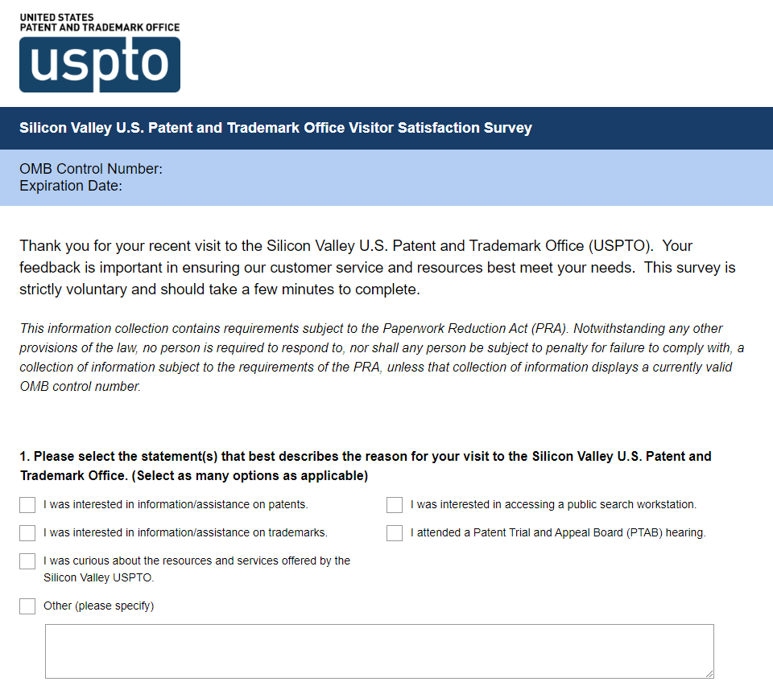

A Federal agency may not conduct or sponsor, and a person is not required to respond to, nor shall a person be subject to a penalty for failure to comply with an information collection subject to the requirements of the Paperwork Reduction Act of 1995 unless the information collection has a currently valid OMB Control Number. The OMB Control Number for this information collection is 0651-0080. Without this approval, we could not collect this information. Public reporting for this information collection is estimated to be approximately 5 minutes per response, including the time for reviewing instructions, gathering and maintaining the data needed, and completing and reviewing the survey. All responses to this information collection are voluntary. Send comments regarding this burden estimate or any other aspect of this information collection, including suggestions for reducing this burden to the Chief Administrative Officer, United States Patent and Trademark Office, P.O. Box 1450, Alexandria, VA 22313-1450 or email InformationCollection@uspto.gov.

