APPENDIX V
FACES 2019 FALL 2021 SPECIAL RESPONDENT MATERIALS
This page has been left blank for double-sided copying.

FACES 2019 FALL 2021 SPECIAL PARENT-TEACHER
FREQUENTLY ASKED QUESTIONS (FAQS)
This page has been left blank for double-sided copying.

Frequently Asked Questions About the head start Family and Child Experiences Survey (FACES)
for Teachers and Parents of children selected for the study
- What is FACES about?
FACES is about the experiences of families in Head Start and the services Head Start provides to children and their families. It asks about the growth of Head Start children, quality of Head Start programs and classrooms, and views of Head Start teachers and other staff. New study activities have been added for fall 2021 and spring 2022 to look at child, family, and teacher well-being 18 months into the COVID-19 pandemic.
- Who is conducting the study?
The U.S. Department of Health and Human Services, Administration for Children and Families, sponsors the study. The study is being conducted by Mathematica, a respected, independent research organization whose studies of education initiatives and other programs have been used to inform national policymakers for more than 50 years.
- When will the study take place?
Parents and teachers will be asked to participate in fall 2021 and spring 2022.

4) Will anyone visit programs to collect data in 2021?

No. All data collection in fall 2021 will be remote. Parent surveys will be available on the web or over the telephone, and teacher surveys via the web or on paper. In spring 2022, Mathematica staff will visit your program to conduct classroom observations.
- How did you pick classrooms and children for the study?
We randomly selected your Head Start center and class from all eligible centers and classes in this Head Start program. We then randomly sampled children from each selected class.
- Will taking part in the study affect the Head Start services the child and family receive?
No. Taking part in the FACES study will not affect any Head Start services the child or family receives.
- Is this a new survey?
No. This is the seventh round of the study. FACES is an ongoing study of Head Start that began in 1997. The current wave is a special study to look at child, family, and teacher well-being 18 months into the COVID-19 pandemic.
- What will you ask teachers to do?
In fall 2021 and spring 2022, we will ask teachers who have FACES children in their classes to complete a brief form. This form will cover the behavior and skills of each child in FACES. Each form will take about 10 minutes to complete. The forms will be available on the web or on paper. In the fall, we will also ask teachers to complete a short survey about their well-being 18 months into the COVID-19 pandemic. The survey will take about 10 minutes. In the spring, we will ask teachers to complete a survey about their training and background, classroom activities, and the Head Start program. The survey will take about 30 minutes. In the spring, we will also observe the classroom for about four hours to get an idea of classroom activities and children’s interactions. Teachers will receive a $10 gift card for every form they complete about each child in FACES and a gift for participating in the classroom observation.
- Do parents need to do anything beyond signing the consent?
On the consent forms, parents should include their email address and phone number so we can contact them about completing the parent survey.
- What will you ask parents to do?
We will ask parents to complete a survey. We will conduct surveys in fall 2021 and spring 2022. Each will last about 35 minutes. In both the fall and spring, parents will be mailed a $30 gift card after they complete the survey.
- Is there a phone number parents and teachers can call if they have questions?
Parents can call Sara Skidmore, the survey director, at 800-xxx-xxxx, toll-free, to ask questions. Teachers can call Sara Skidmore, the survey director, at 800-xxx-xxxx, toll-free, to ask questions.
- How will my privacy be protected?
Mathematica agrees to protect the privacy of all study participants to the extent permitted by law. All staff working on the study are required to sign a privacy agreement. The information we collect will be electronically and securely stored at the Mathematica offices, and will not be shared with anyone outside of the study team. Your survey responses will be stripped of any identifying features of you and your family and will be securely shared only with qualified individuals for additional learning purposes to better understand the strengths and needs of children and families served by Head Start.
We have also obtained a Certificate of Confidentiality from the National Institutes of Health. The Certificate helps us protect your privacy. This means no one can force the study team to give out information that identifies you, even in court. However, we may need to share your information if it shows a serious threat to you or to others, including reporting to authorities when required by law. The U.S. Department of Health and Human Services (DHHS) may ask for data for an audit or evaluation. If they do, we will need to provide it. However, only DHHS staff involved in the review will see it.

The referenced collection of information is voluntary. Information will be kept private. An agency may not conduct or sponsor, and a person is not required to respond to, a collection of information unless it displays a currently valid OMB control number. The OMB control number for this collection is 0970-0151 and it expires XX/XX/XXXX.

FACES 2019 FALL 2021 SPECIAL PARENT BROCHURE

This page has been left blank for double-sided copying.

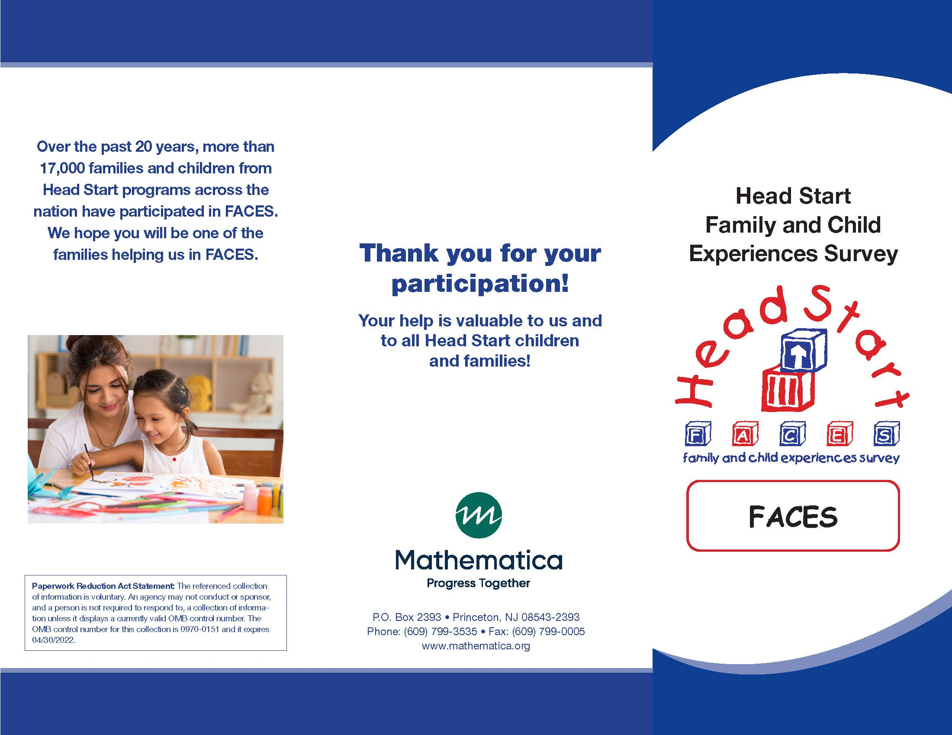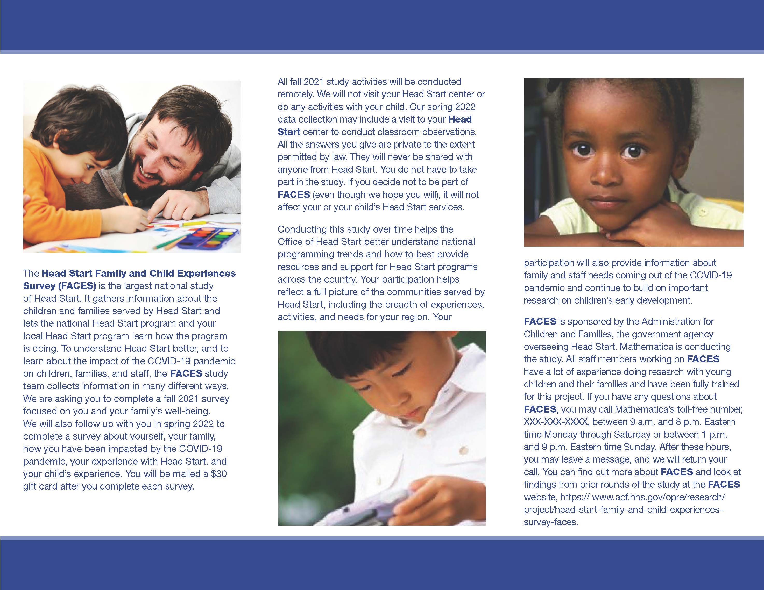

FACES 2019 FALL 2021 SPECIAL PARENT SURVEY INVITATION EMAIL
This page has been left blank for double-sided copying.

FACES: Important Parent Survey
TO: [RESPONDENT EMAIL ADDRESS]
FROM: FACES STUDY TEAM
SUBJECT: FACES STUDY INVITATION

Dear [First name] [Last name],
Thank you for taking part in the Head Start Family and Child Experiences Survey (FACES). This email serves as confirmation that you have provided consent for your child to participate in the study. Below is a link to a blank copy of the consent form that you completed.
A few things you should know about the study:
- The study focuses on children’s development, family involvement, and program quality to identify strategies for improving Head Start. It is very important because it will help the Office of Head Start (OHS) understand the unique needs of Head Start families 18 months into the COVID-19 pandemic.
- It is funded by the Administration for Children and Families, U.S. Department of Health and Human Services.
- Mathematica, an independent research firm, is conducting the study.
As part of this study, we invite you to complete a survey about you and your child. The survey is available in English and Spanish. You can complete it over the phone or on the web. To complete it over the phone, or if you need to complete the survey in a language other than English or Spanish please call 800-xxx-xxxx toll-free. The survey will take about 35 minutes to complete. After you complete the survey, as a thank you, we will send you a $30 gift card.

We encourage you to complete the survey online at:
[UNIQUE SURVEY LINK]

Please complete the survey as soon as you can. Here are some points to keep in mind:
- Your answers will be kept private to the extent permitted by law. We will only report results for groups. We will never report details that identify you, your child, or your child’s Head Start program. No one from your Head Start program will see or hear your individual responses, and your name and your program’s name will not be shared with OHS or in any reports. In the future, survey responses from the study (with nothing identifying individuals, programs, or communities) may be securely shared with qualified individuals for additional learning purposes to better understand the strengths and needs of children and families in Head Start and the programs that serve them.
- Taking part in FACES is up to you. There is no penalty if you withdraw. There are no risks from taking part in the study. However, you may be asked sensitive questions. You may choose not to answer those questions or any questions.
- This study will not affect the Head Start services you and your child receive. No one from Head Start will see your answers.
If you have questions about FACES, please call Sara Skidmore, the survey director, at 800-xxx-xxxx. This call is toll-free. You can also email us at FACES@mathematica-mpr.com. To learn more about FACES, visit the FACES website at https://www.acf.hhs.gov/opre/project/head-start-family-and-child-experiences-survey-faces-1997-2022.
Thanks again for taking part in FACES.
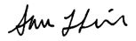
Sincerely,

Sara Skidmore
FACES Survey Director
The referenced collection of information is voluntary. Information will be kept private. An agency may not conduct or sponsor, and a person is not required to respond to, a collection of information unless it displays a currently valid OMB control number. The OMB control number for this collection is 0970-0151 and it expires XX/XX/XXXX.
Paperwork Reduction Act Statement: The referenced collection of information is voluntary. An agency may not conduct or sponsor, and a person is not required to respond to, a collection of information unless it displays a currently valid OMB control number. The OMB control number for this collection is 0970-0151 and it expires XX/XX/XXXX.
Paperwork Reduction Act Statement: The referenced collection of information is voluntary. An agency may not conduct or sponsor, and a person is not required to respond to, a collection of information unless it displays a currently valid OMB control number. The OMB control number for this collection is 0970-0151 and it expires XX/XX/XXXX.
Paperwork Reduction Act Statement: The referenced collection of information is voluntary. An agency may not conduct or sponsor, and a person is not required to respond to, a collection of information unless it displays a currently valid OMB control number. The OMB control number for this collection is 0970-0151 and it expires XX/XX/XXXX.

FACES 2019 FALL 2021 SPECIAL PARENT SURVEY INVITATION LETTER

This page has been left blank for double-sided copying.

Sara Skidmore
FACES Survey Director

1100 First Street, NE, 12th Floor
Washington, DC 20002
Phone: 202-484-5273
Fax: 202-863-1763

[DATE]
[PARENT NAME]
[PARENT ADDRESS]

Dear [PARENT]:
Thank you for taking part in the Head Start Family and Child Experiences Survey (FACES).
A few things you should know about the study:
- The study focuses on children’s development, family involvement, and program quality to identify strategies for improving Head Start. It is very important because it will help the Office of Head Start (OHS) understand the unique needs of Head Start families 18 months into the COVID-19 pandemic.
- It is funded by the Administration for Children and Families, U.S. Department of Health and Human Services.
- Mathematica, an independent research firm, is conducting the study.
As part of this study, we invite you to complete a survey about you and your child. The survey is available in English and in Spanish. You can complete it over the phone or on the web. To complete it by phone, or if you need to complete the survey in a language other than English or Spanish, please call 800-xxx-xxxx toll-free. The survey will take about 35 minutes to complete. After you complete the survey, as a thank you, we will send you a $30 gift card.
We encourage you to complete the survey online at:
[WEBSITE].
Use the log-in ID and password shown.
LOG-IN ID: [LOG-IN ID]
PASSWORD: [PASSWORD]

Please complete the survey as soon as you can. Here are some points to keep in mind:
- Your answers will be kept private to the extent permitted by law. We will only report results for groups. We will never report details that identify you, your child, or your child’s Head Start program. No one from your Head Start program will see or hear your individual responses, and your name and your program’s name will not be shared with OHS or in any reports. In the future, survey responses from the study (with nothing identifying individuals, programs, or communities) may be securely shared with qualified individuals for additional learning purposes to better understand the strengths and needs of children and families in Head Start and the programs that serve them.
- Taking part in FACES is up to you. There is no penalty if you withdraw. There are no risks from taking part in the study. However, you may be asked sensitive questions. You may choose not to answer those questions or any questions.
- This study will not affect the Head Start services you and your child receive. No one from Head Start will see your answers.
If you have questions about FACES, please call Sara Skidmore, the survey director, at 800-xxx-xxxx. This call is toll-free. You can also email us at FACES@mathematica-mpr.com. To learn more about FACES, visit the FACES website at https://www.acf.hhs.gov/opre/project/head-start-family-and-child-experiences-survey-faces-1997-2022.
Thanks again for taking part in FACES.
Sincerely,
Sara Skidmore
FACES Survey Director

The referenced collection of information is voluntary. Information will be kept private. An agency may not conduct or sponsor, and a person is not required to respond to, a collection of information unless it displays a currently valid OMB control number. The OMB control number for this collection is 0970-0151 and it expires XX/XX/XXXX.
Paperwork Reduction Act Statement: The referenced collection of information is voluntary. An agency may not conduct or sponsor, and a person is not required to respond to, a collection of information unless it displays a currently valid OMB control number. The OMB control number for this collection is 0970-0151 and it expires XX/XX/XXXX.
Paperwork Reduction Act Statement: The referenced collection of information is voluntary. An agency may not conduct or sponsor, and a person is not required to respond to, a collection of information unless it displays a currently valid OMB control number. The OMB control number for this collection is 0970-0151 and it expires XX/XX/XXXX.
Paperwork Reduction Act Statement: The referenced collection of information is voluntary. An agency may not conduct or sponsor, and a person is not required to respond to, a collection of information unless it displays a currently valid OMB control number. The OMB control number for this collection is 0970-0151 and it expires XX/XX/XXXX.

FACES 2019 FALL 2021 SPECIAL PARENT SURVEY REMINDER EMAIL
This page has been left blank for double-sided copying.

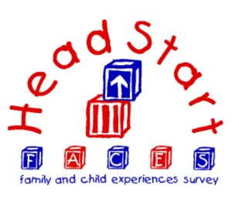
TO: [RESPONDENT EMAIL ADDRESS]
FROM: FACES STUDY TEAM
SUBJECT: FACES STUDY REMINDER
Dear [First name] [Last name],
Recently, we invited you to complete a survey about you and your child for the Head Start Family and Child Experiences Survey (FACES). The survey is available in English and in Spanish. You can complete it over the phone or on the web. To complete it by phone, or if you need to complete the survey in a language other than English or Spanish, please call 800-xxx-xxxx toll-free. The survey will take about 35 minutes to complete. After you complete the survey, as a thank you, we will send you a $30 gift card.
As a reminder:
- The study focuses on children’s development, family involvement, and program quality to identify strategies for improving Head Start. It is very important because it will help the Office of Head Start (OHS) understand the unique needs of Head Start families 18 months into the COVID-19 pandemic.
- It is funded by the Administration for Children and Families, U.S. Department of Health and Human Services.
- Mathematica, an independent research firm, is conducting the study.
We encourage you to complete the survey online at:
[UNIQUE SURVEY LINK]

We hope you will complete the survey as soon as you can. Here are some points to keep in mind:
- Your answers will be kept private to the extent permitted by law. We will only report results for groups. We will never report details that identify you, your child, or your child’s Head Start program. No one from your Head Start program will see or hear your individual responses, and your name and your program’s name will not be shared with OHS or in any reports. In the future, survey responses from the study (with nothing identifying individuals, programs, or communities) may be securely shared with qualified individuals for additional learning purposes to better understand the strengths and needs of children and families in Head Start and the programs that serve them.
- Taking part in FACES is up to you. There is no penalty if you withdraw. There are no risks from taking part in the study. However, you may be asked sensitive questions. You may choose not to answer those questions or any questions.
- This study will not affect the Head Start services you and your child receive. No one from Head Start will see your answers.
If you have questions about FACES, please call Sara Skidmore, the survey director, at 800-xxx-xxxx. This call is toll-free. You can also email us at FACES@mathematica-mpr.com. To learn more about FACES, visit the FACES website at https://www.acf.hhs.gov/opre/project/head-start-family-and-child-experiences-survey-faces-1997-2022.
Thanks again for taking part in FACES.
Sincerely,

Sara Skidmore
FACES Survey Director

The referenced collection of information is voluntary. Information will be kept private. An agency may not conduct or sponsor, and a person is not required to respond to, a collection of information unless it displays a currently valid OMB control number. The OMB control number for this collection is 0970-0151 and it expires XX/XX/XXXX.
Paperwork Reduction Act Statement: The referenced collection of information is voluntary. An agency may not conduct or sponsor, and a person is not required to respond to, a collection of information unless it displays a currently valid OMB control number. The OMB control number for this collection is 0970-0151 and it expires XX/XX/XXXX.
Paperwork Reduction Act Statement: The referenced collection of information is voluntary. An agency may not conduct or sponsor, and a person is not required to respond to, a collection of information unless it displays a currently valid OMB control number. The OMB control number for this collection is 0970-0151 and it expires XX/XX/XXXX.
Paperwork Reduction Act Statement: The referenced collection of information is voluntary. An agency may not conduct or sponsor, and a person is not required to respond to, a collection of information unless it displays a currently valid OMB control number. The OMB control number for this collection is 0970-0151 and it expires XX/XX/XXXX.

FACES 2019 FALL 2021 SPECIAL PARENT SURVEY REMINDER LETTER
This page has been left blank for double-sided copying.

Sara Skidmore
FACES Survey Director

1100 First Street, NE, 12th Floor
Washington, DC 20002
Phone: 202-484-5273
Fax: 202-863-1763

[DATE]
[PARENT NAME]
[PARENT ADDRESS]

Dear [PARENT]:
Recently, we invited you to complete a survey about you and your child for the Head Start Family and Child Experiences Survey (FACES). The survey is available in English and Spanish. You can complete it over the phone or on the web. To complete it by phone, or if you need to complete the survey in a language other than English or Spanish, please call 800-xxx-xxxx toll-free. The survey will take about 35 minutes to complete. After you complete the survey, as a thank you, we will send you a $30 gift card.
As a reminder:
- The study focuses on children’s development, family involvement, and program quality to identify strategies for improving Head Start. It is very important because it will help the Office of Head Start (OHS) understand the unique needs of Head Start families 18 months into the COVID-19 pandemic.
- It is funded by the Administration for Children and Families, U.S. Department of Health and Human Services.
- Mathematica, an independent research firm, is conducting the study.

We encourage you to complete the survey online at:
[WEBSITE].
Use the log-in ID and password shown.
LOG-IN ID: [LOG-IN ID]
PASSWORD: [PASSWORD]
We hope you will complete the survey as soon as you can. Here are some points to keep in mind:
- Your answers will be kept private to the extent permitted by law. We will only report results for groups. We will never report details that identify you, your child, or your child’s Head Start program. No one from your Head Start program will see or hear your individual responses, and your name and your program’s name will not be shared with OHS or in any reports. In the future, survey responses from the study (with nothing identifying individuals, programs, or communities) may be securely shared with qualified individuals for additional learning purposes to better understand the strengths and needs of children and families in Head Start and the programs that serve them.
- Taking part in FACES is up to you. There is no penalty if you withdraw. There are no risks from taking part in the study. However, you may be asked sensitive questions. You may choose not to answer those questions or any questions.
- This study will not affect the Head Start services you and your child receive. No one from Head Start will see your answers.
If you have questions about FACES, please call Sara Skidmore, the survey director, at 800-xxx-xxxx. This call is toll-free. You can also email us at FACES@mathematica-mpr.com. To learn more about FACES, visit the FACES website at https://www.acf.hhs.gov/opre/project/head-start-family-and-child-experiences-survey-faces-1997-2022.
Thanks again for taking part in FACES.
Sincerely,

Sara Skidmore
FACES Survey Director

The referenced collection of information is voluntary. Information will be kept private. An agency may not conduct or sponsor, and a person is not required to respond to, a collection of information unless it displays a currently valid OMB control number. The OMB control number for this collection is 0970-0151 and it expires XX/XX/XXXX.
Paperwork Reduction Act Statement: The referenced collection of information is voluntary. An agency may not conduct or sponsor, and a person is not required to respond to, a collection of information unless it displays a currently valid OMB control number. The OMB control number for this collection is 0970-0151 and it expires XX/XX/XXXX.
Paperwork Reduction Act Statement: The referenced collection of information is voluntary. An agency may not conduct or sponsor, and a person is not required to respond to, a collection of information unless it displays a currently valid OMB control number. The OMB control number for this collection is 0970-0151 and it expires XX/XX/XXXX.
Paperwork Reduction Act Statement: The referenced collection of information is voluntary. An agency may not conduct or sponsor, and a person is not required to respond to, a collection of information unless it displays a currently valid OMB control number. The OMB control number for this collection is 0970-0151 and it expires XX/XX/XXXX.

FACES 2019 FALL 2021 SPECIAL TEACHER SURVEY AND TEACHER CHILD REPORT INVITATION LETTER
This page has been left blank for double-sided copying.

Sara Skidmore 1100 First Street, NE, 12th Floor
FACES Survey Director Washington, DC 20002
Phone: 202-484-5273
Fax: 202-863-1763
www.mathematica-mpr.com
DATE
Dear [TEACHER]:
Welcome to the Head Start Family and Child Experiences Survey (FACES). [HEAD START PROGRAM NAME] has been selected to take part in this important study.
A few things you should know about the study:
- Mathematica, an independent research company, is conducting FACES.
- The Administration for Children and Families, part of the U.S. Department of Health and Human Services, funds the study.
- The study focuses on children’s development, family involvement, and program quality to identify strategies for improving Head Start. It is very important because it will help the Office of Head Start (OHS) understand the unique needs of Head Start families and staff 18 months into the COVID-19 pandemic.
This fall, we will ask about 2,400 3- and 4-year-old children and their families as well as 240 teachers from 60 Head Start programs to take part in FACES. Over the life of the study, the sample will include children, parents, and staff from 180 programs nationwide. We are excited about the study and hope you will be too. As one of only a few hundred teachers taking part, your help is vital to the study’s success.
Your program director has selected [OSC NAME] to work with us. [OSC NAME] will ensure that we can gain consent from parents and schedule the spring data collection. We appreciate any help with obtaining consents from parents that you can offer [OSC NAME] and our team.
In fall 2021 and spring 2022 we will ask parents who have agreed to take part in the study to take a survey. We are asking you to complete a short form, the Teacher Child Report (TCR), for each child participating in FACES in your class. The form asks about the social skills, problem behaviors, and approaches to learning that you have seen these children use. Each form should only take about 10 minutes to complete. We think you will enjoy completing these forms on the web. If you do not have internet access or prefer to complete these forms on paper, you may complete the enclosed paper copies. Please return them in the pre-paid envelope provided. As a thank you, we will send you a $10 gift card for each TCR you complete.
In addition to completing the TCRs, we are asking you to complete a short survey in fall 2021. It should take about 10 minutes to complete. The survey will ask about your well-being 18 months into the COVID-19 pandemic. If you prefer to complete the survey on paper please call Sara Skidmore, the survey director, at 800-xxx-xxxx. This call is toll-free. You can also email us at FACES@mathematica-mpr.com.
In spring 2022, we will also ask you, your program director, and your center director to complete a short survey. Your survey will ask about children’s classroom activities, the materials used in the classroom, the use of different languages in the classroom, and the ways that you involve and interact with children’s parents. It will also ask about your feelings, education and training, and any professional development you may have taken part in over the past year.
We want you to know that:
- Taking part in FACES is voluntary. You do not have to take part in this study. If at any point you decide not to continue in the study, that is okay.
- Study results will only be reported for groups. No one from your Head Start program will see or hear your individual responses, and your name and your program’s name will not be shared with OHS or in any reports.
- We have a Certificate of Confidentiality from the National Institutes of Health. The Certificate helps us protect your privacy. This means no one can force the study team to give out information that identifies you, even in court. However, we may need to share your information if it shows a serious threat to you or to others, including reporting to authorities when required by law.
- The U.S. Department of Health and Human Services (DHHS) may ask for data for an audit or evaluation. If they do, we will need to provide it. However, only DHHS staff involved in the review will see it.
- In the future, survey responses from the study (with nothing identifying individuals, programs, or communities) may be securely shared with qualified individuals for additional learning purposes to better understand the strengths and needs of children and families in Head Start and the programs that serve them.
We have enclosed a list of frequently asked questions and some helpful tips for completing your teacher survey and TCRs online. When you visit the website, you should use the log-in ID and password below. These are secure and will not be shared with anyone. All information you provide will be kept private to the extent permitted by law. Only selected members of the study team will see your responses. Using the log-in ID and password ensures that your information will be protected.
We encourage you to complete the survey and TCRs online at:
[WEBSITE].

Use the log-in ID and password shown.
LOG-IN ID: [LOG-IN ID]
PASSWORD: [PASSWORD]

Mathematica staff will be happy to answer any questions about FACES and to assist you in any way you need. You can contact Sara Skidmore, the survey director, toll-free at 800-xxx-xxxx or email us at FACES@mathematica-mpr.com. To learn more about FACES, visit the FACES website at https://www.acf.hhs.gov/opre/project/head-start-family-and-child-experiences-survey-faces-1997-2022. Thank you in advance for your help with this important research.

Sincerely,

Sara Skidmore
FACES Survey Director

The referenced collection of information is voluntary. Information will be kept private. An agency may not conduct or sponsor, and a person is not required to respond to, a collection of information unless it displays a currently valid OMB control number. The OMB control number for this collection is 0970-0151 and it expires XX/XX/XXXX.
Paperwork Reduction Act Statement: The referenced collection of information is voluntary. An agency may not conduct or sponsor, and a person is not required to respond to, a collection of information unless it displays a currently valid OMB control number. The OMB control number for this collection is 0970-0151 and it expires XX/XX/XXXX.
Paperwork Reduction Act Statement: The referenced collection of information is voluntary. An agency may not conduct or sponsor, and a person is not required to respond to, a collection of information unless it displays a currently valid OMB control number. The OMB control number for this collection is 0970-0151 and it expires XX/XX/XXXX.
Paperwork Reduction Act Statement: The referenced collection of information is voluntary. An agency may not conduct or sponsor, and a person is not required to respond to, a collection of information unless it displays a currently valid OMB control number. The OMB control number for this collection is 0970-0151 and it expires XX/XX/XXXX.

This page has been left blank for double-sided copying.

faces 2019 FALL 2021 SPECIAL Teacher Survey and TEACHER CHILD REPORT REMINDER EMAIL

This page has been left blank for double-sided copying.
REMINDER EMAIL
TO: [RESPONDENT EMAIL ADDRESS]
FROM: FACES STUDY TEAM
SUBJECT: FACES STUDY REMINDER
Dear [TEACHER FNAME TEACHER LNAME]:
A few weeks ago, you were invited to complete a Teacher Child Report (TCR) for each child participating in the Head Start Family and Child Experiences Survey (FACES) in your class. Each TCR should take only about 10 minutes to complete. You were also invited to complete a 10-minute teacher survey. According to our records, you have [IF TEACHER SURVEY NOT COMPLETE: not completed the Teacher Survey and have] [XX] TCRs left to complete.
As a reminder:
- The study focuses on children’s development, family involvement, and program quality to identify strategies for improving Head Start. It is very important because it will help the Office of Head Start (OHS) understand the unique needs of Head Start families and staff 18 months into the COVID-19 pandemic.
- It is funded by the Administration for Children and Families, U.S. Department of Health and Human Services.
- Mathematica, an independent research firm, is conducting the study.
We encourage you to complete the survey and TCRs online at:
[UNIQUE SURVEY LINK]

As a thank you, when you have completed all of your TCRs, we will send you a $10 gift card for each TCR you completed.
If you have questions about FACES or if you prefer to complete the survey or TCRs on paper, please call Sara Skidmore, the survey director, at 800-xxx-xxxx. This call is toll-free. You can also email us at FACES@mathematica-mpr.com. To learn more about FACES, visit the FACES website at https://www.acf.hhs.gov/opre/project/head-start-family-and-child-experiences-survey-faces-1997-2022.
Sincerely,
Sara Skidmore
FACES Survey Director

The referenced collection of information is voluntary. Information will be kept private. An agency may not conduct or sponsor, and a person is not required to respond to, a collection of information unless it displays a currently valid OMB control number. The OMB control number for this collection is 0971-0151 and it expires XX/XX/X

