Dear

I need your help with an important initiative I am undertaking to improve our service to America's taxpayers. I want to get feedback from taxpayers like you who have worked with an assigned revenue officer to resolve a tax issue.

In a few days, you will receive a survey asking your opinions about the contact you had with an assigned IRS revenue officer. Please direct it to the person who had the most contact with the IRS on this matter. The survey should take less than 5 minutes to complete. Your answers will be combined with others to give us an evaluation of customer satisfaction with IRS service.

The primary purpose for requesting this information is to help the IRS improve its service to taxpayers. Our authority for requesting the information is 5 USC and 26 USC 7801.

Providing information is voluntary. However, if you do not answer all or part of the survey questions, the IRS may lack information it could use to improve taxpayer service. The information you provide may be disclosed to an IRS contractor when authorized by law. The contractor is required to follow confidentiality protections required by the Privacy Act and/or Internal Revenue Code section 6103.

I am committed to improving IRS service to every taxpayer. Please help me in this effort by completing and returning the survey as soon as possible. If you do not receive a survey, please contact the Survey Helpline at
1-800-521-7177.

Sincerely,

Robert L. Hunt
Director, Collection Division

L1_13257-D

Dear

A few days ago, you received a letter from Robert L. Hunt, Director, Collection Division, asking for your help with an important research project.

We are administering a nationwide survey among people who have had contact with the Internal Revenue Service (IRS). We want to know your opinions about the process of resolving a tax issue with an assigned revenue officer. Your responses are critical to the accuracy of this research.

We are sending surveys to a random sample of taxpayers who have had such discrepancies. All responses will be anonymous to the IRS and your participation is voluntary. We will group your responses with others, so that no individual reply can be traced back to any one person.

The survey is quite brief and should take less than 5 minutes to complete. Please use the postage-paid reply envelope to return your completed survey. If you have any questions about this survey, please feel free to call us toll-free at 1-800-521-7177, or email us at irssurveyhelp@forsmarshgroup.com.

The IRS is committed to improving its performance and service to the American public. A first step in this process is to gather reliable information from those who have had contact with IRS services and employees. Your honest opinions will help bring about this improvement.

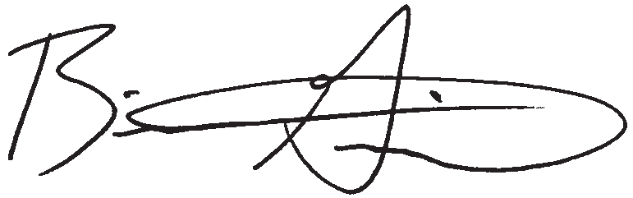
Sincerely,

Brian K. Griepentrog, Ph. D. Director of Research
Fors Marsh Group LLC

L2_13257-D
Research conducted by

P.O. Box 42048 • Arlington, VA 22204-9048

IRS SMALL BUSINESS/ SELF-EMPLOYED CUSTOMER SATISFACTION SURVEY COLLECTION

P.O. BOX 42048
ARLINGTON, VA 22204-9048

Do We Have Your Input Yet?

IRS SMALL BUSINESS/ SELF-EMPLOYED CUSTOMER SATISFACTION SURVEY COLLECTION
Recently, you received a survey asking your opinions about the service you received from the IRS in a recent contact. If you have already completed and returned the survey, please
accept our sincere thanks. If not, please take a few minutes to complete it and return it today. We want to be sure we have your opinions and suggestions.

If you did not receive the survey, or it got misplaced, please call us at 1-800-521-7177.

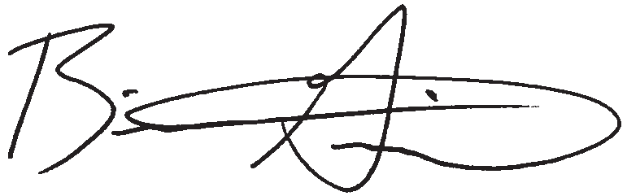
Sincerely,

Research conducted by

Brian K. Griepentrog, Ph.D. Director of Research
Fors Marsh Group LLC

L3_13257-D

Dear

Recently you received a survey requesting your feedback with an important research project. So far, we have
not received your completed survey. If you have not already completed the survey, please take a few minutes to fill in your responses. If another person was primarily responsible for dealing with the IRS on this matter,
please direct the survey to that person and encourage him or her to respond.

We are administering a nationwide survey among people who have had contact with the Internal Revenue Service (IRS). We want to know your opinions about the process of resolving a tax issue with an assigned revenue officer. Your responses are critical to the accuracy of this research.

We are sending surveys to a random sample of taxpayers who have had such discrepancies. All responses will be anonymous to the IRS, and your participation is voluntary. We will group your responses with others, so that no individual reply can be traced back to any one person.

The survey is quite brief and should take less than 5 minutes to complete. Please use the postage-paid reply envelope to return your completed survey. If you have any questions about this survey, please feel free to call us toll-free at 1-800-521-7177, or email us at irssurveyhelp@forsmarshgroup.com.

The IRS is committed to improving its performance and service to the American public. A first step in this process is to gather reliable information from those who have had contact with IRS services and employees. Your honest opinions will help bring about this improvement.

Thank you in advance for your cooperation.

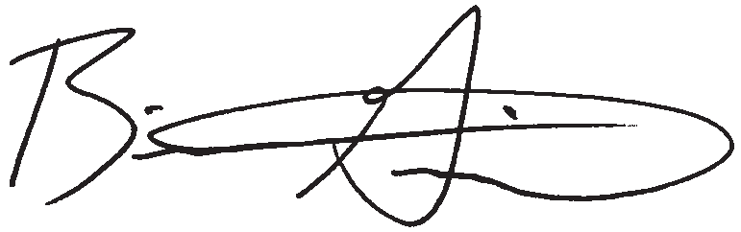
Sincerely,

Brian K. Griepentrog, Ph. D. Director of Research
Fors Marsh Group LLC

L4_13257-D
Research conducted by

P.O. Box 42048 • Arlington, VA 22204-9048

IRS SMALL BUSINESS/SELF-EMPLOYED CUSTOMER SATISFACTION SURVEY
COLLECTION
OMB# 1545-1432

The IRS is trying to improve its service to the public. You can help in this important mission by answering the questions below. This voluntary survey should take less than 5 minutes to complete. Your responses will be kept completely anonymous to the IRS. If you have any questions about this survey, you may call the Survey Helpline at 1-800-521-7177.

We want to ask you very specifically about the contacts you had with a Collection revenue officer—not about all of your contacts with the IRS.

The questions that follow ask your opinion regarding your experience working with the revenue officer assigned to your case from our local IRS office. For each question, regardless of whether you agree or disagree with the final case outcome, please indicate your answer by filling in the circle that best represents your opinion.
Q1

a.

b .

c .

d .

e.

f .

g .

h .

i.

j .

k .

l .

m.

n .

Regardless of whether you agree or disagree with the final

Please continue on back
 | Again, focusing on your experience working with the revenue officer assigned to your case from the local IRS office,  how satisfied are you with:  Ease of understanding correspondence from your assigned revenue officer? | Very  Dissatisfied  1 | Somewhat  Dissatisfied  2 | Neither Satisfied Nor Dissatisfied  3 | Somewhat  Satisfied  4 | Very  Satisfied  5
 | Ease of contacting your assigned revenue officer? | 1 | 2 | 3 | 4 | 5
 | Amount of time your revenue officer took to respond to you? | 1 | 2 | 3 | 4 | 5
 | Courtesy and professionalism of your assigned revenue officer? | 1 | 2 | 3 | 4 | 5
 | Explanation of the collection process by your revenue officer? | 1 | 2 | 3 | 4 | 5
 | Explanation of what would happen if you did not comply? | 1 | 2 | 3 | 4 | 5
 | Acknowledging receipt of the information you submitted? | 1 | 2 | 3 | 4 | 5
 | Consideration given to the information you submitted? | 1 | 2 | 3 | 4 | 5
 | Explanation of payment options that may be available to you? | 1 | 2 | 3 | 4 | 5
 | Flexibility of your revenue officer in resolving the issue? | 1 | 2 | 3 | 4 | 5
 | Keeping you up-to-date on your field collection process? | 1 | 2 | 3 | 4 | 5
 | Notifying you of case closure? | 1 | 2 | 3 | 4 | 5
 | Amount of time you had to spend on this collection issue? | 1 | 2 | 3 | 4 | 5
 | Fairness of treatment by your revenue officer? | 1 | 2 | 3 | 4 | 5
Q2 case outcome, how would you rate your overall satisfaction with your experience working with the revenue officer assigned to your case from the local IRS office? |  | 1 | 2 | 3 | 4 | 5

IRS SMALL BUSINESS/SELF-EMPLOYED CUSTOMER SATISFACTION SURVEY

COLLECTION
OMB# 1545-1432

6 6 or more
How many IRS revenue officers contacted you | 0 None | 2 2 | 4 4
regarding this case? | 1 1 | 3 3 | 5 5

Q3
7 Don’t remember

Q4 Are you…?

If you are the taxpayer, did you use a tax professional to assist you in handling your Collection case with the IRS?
Q5

Whom did you rely on most for information regarding the status of your Collection case?
Q6

1 The taxpayer
2 A tax professional who represented the taxpayer
(SKIP TO BOX AFTER QUESTION Q7)
3 Someone else who represented the taxpayer
(SKIP TO BOX AFTER QUESTION Q7)

1 Yes
2 No
3 Don’t recall

1 Your tax professional
2 Your IRS revenue officer (SKIP TO BOX AFTER QUESTION Q7)

3 Other (SKIP TO BOX AFTER QUESTION Q7)
Q7 keeping you up-to-date on your field collection process? | Very  Dissatisfied  1 | Somewhat  Dissatisfied  2 | Neither Satisfied Nor Dissatisfied  3 | Somewhat  Satisfied  4 | Satisfied  5
Occasionally, we conduct additional in-depth IRS-related research. Research participants may receive a small monetary incentive to participate depending on the research. If you are interested in participating in future research, please provide us with your telephone number and your e-mail address (if available). This information will not be shared with the IRS and will be used only for the purpose of survey research.

TELEPHONE NUMBER: E-MAIL ADDRESS:

How satisfied are you with your tax professional
Very

Q8 Use this space for comments or suggestions for improvement.

If you have been unable to resolve any specific problems with your tax matter through the normal IRS channels, or now face a significant hardship due to the application of the tax law, we encourage you to contact the Taxpayer Advocate Service at 1-877-777-4778.

Thank you for completing the survey.
Please return the questionnaire to P.O. Box 42048, Arlington, VA 22204-9048 USA.

Paperwork Reduction Act Notice. The Paperwork Reduction Act requires that the IRS display an OMB control number on all public information requests. The OMB Control Number for this study is 1545-1432. Also, if you have any comments regarding the time estimates associated with this study or suggestions on making this process simpler, please write to the: Internal Revenue Service, Special Services Section, SE:W:CAR:MP:T:M:S, 1111 Constitution Ave. NW, Room 6129, Washington, DC 20224.

