Attachments

Procedure: The Dillman Method will be used and includes a prenote, a letter with the survey, a reminder postcard, and a reminder letter with the survey, along with postage-paid reply envelopes. These mailings and the survey questions are attached below:

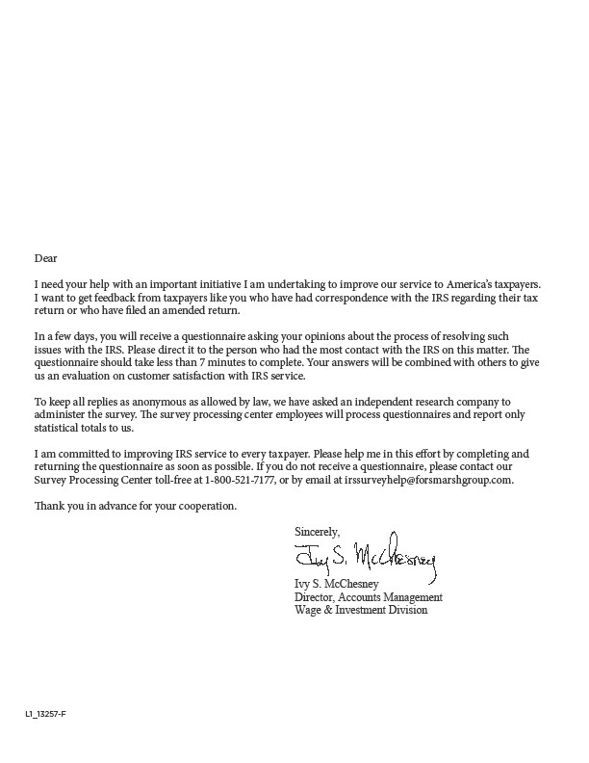

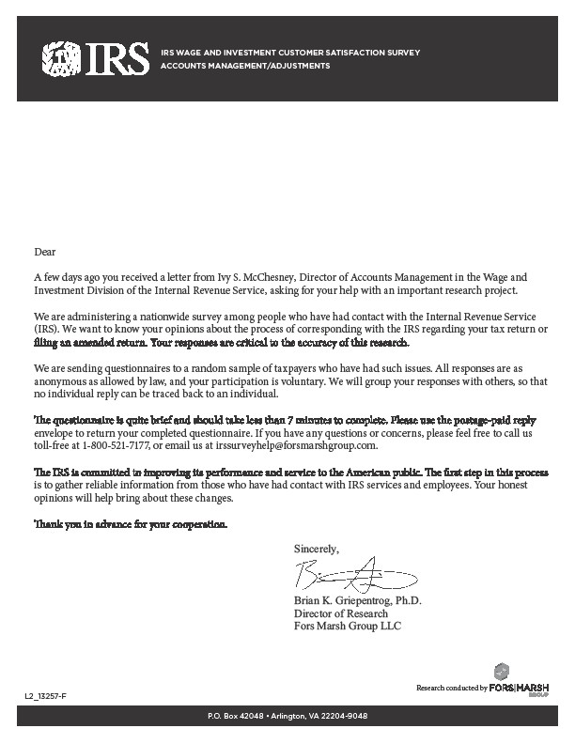

Do We Have Your Input Yet?

Recently, you received a questionnaire asking your opinions about the services you received from the IRS in a recent contact. If you have already completed and returned the questionnaire, please accept our sincere thanks. If not, please take a few minutes to complete it and return it today. We want to be sure we have your opinions and suggestions.

If you did not receive the questionnaire, or it got misplaced, please call us at 1-800-521-7177.

Sincerely,
15
Brian K. Griepentrog, Ph.D. Director of Research
Fors Marsh Group, LLC

fJJIRS

L3_13257-F

PRESORTED FIRST CLASS MAIL

POSTAGE &
FEES PAID

IRS PERMIT NO. G-48

IRS WAGE AND INVESTMENT CUSTOMER SATISFACTION SURVEY ACCOUNTSMANAGEMENV
ADJUSTMENTS

P.O. BOX 42048
ARLINGTON, VA 22204-9048

RESEARCH CONDUCTED BY

FORSI MARSH
GROUP

OMB# 1545-2250

IRS WAGE & INVESTMENT CUSTOMER SATISFACTION
ACCOUNTS MANAGEMENT/ADJUSTMENTS

The IRS is trying to improve the service it provides taxpayers. You can help in this important mission by answering the questions below. This voluntary survey should take less than 7 minutes to complete. Your responses will be kept as anonymous as allowed by law to the IRS. If you have any questions about this survey, you may call the Survey Helpline at 1-800-521-7177.

The following survey is concerned with any adjustments made to your originally filed tax return. These include the submission of a second 1040, the 1040X, the 1040EZ, the 1040A, or any adjustment to your originally filed tax return.

Do you recall having written contact with the IRS
1
regarding your tax return within the last 365 days?

2 Was the first contact made by you or by the IRS?
1 Yes (Reply to question 2)
2 No (Skip to question 3)

1 By me
2 By the IRS

Did you file an amended return to the IRS within

2
3 the last year?
1 Yes (Reply to question 4)
2 No, I did not file an amended return (Skip to question 5)

Did you file the amended return because a notice or
4 letter from the IRS instructed you to do so?
1 Yes, the notice prompted me to file an amended return
2 No, I filed an amended return, but not because I received a notice/letter

5
Regardless of whether you agree or disagree with | Very | Dissatisfied | Neither | Satisfied | Very | Don’t Know /
the final outcome, how would you rate your overall  satisfaction with the way your issue was handled? | Dissatisfied |  | Satisfied nor  Dissatisfied |  | Satisfied | Not  Applicable
 | 1 | 2 | 3 | 4 | 5 | NA

For the following questions, please focus on the outcome of the issue you recently resolved with the IRS.

6
How satisfied were you…  A. With the final outcome of your recent issue with the IRS? | Very  Dissatisfied  1 | Dissatisfied  2 | Neither Satisfied nor Dissatisfied  3 | Satisfied  4 | Very  Satisfied  5 | Don’t Know / Not Applicable  NA
B. That your outcome was appropriate based  on information you provided the IRS? | 1 | 2 | 3 | 4 | 5 | NA

For the next set of questions, regardless of your satisfaction with the outcome of your issue, please focus on the
process and procedures that the IRS used to address and resolve your issue.

7
How satisfied were you with the...  A. Ease of getting more information about your issue from the IRS? | Very  Dissatisfied  1 | Dissatisfied  2 | Neither Satisfied nor Dissatisfied  3 | Satisfied  4 | Very  Satisfied  5 | Don’t Know / Not Applicable  NA
B. Ease of providing information requested by the IRS? | 1 | 2 | 3 | 4 | 5 | NA
C. Length of time it took to resolve the issue? | 1 | 2 | 3 | 4 | 5 | NA
D. Extent to which the IRS used accurate information  about you to process your issue? | 1 | 2 | 3 | 4 | 5 | NA

Form 13257-F (Rev. 7-2013) Cat. No. 36148R www.irs.gov Department of the Treasury - Internal Revenue Service

For the next set of questions, regardless of your satisfaction with the outcome of your issue, please focus on the clarity and timeliness of the information regarding your issue that was provided by the IRS.

8
How satisfied were you with the…  A. Ease of understanding the initial notice and what was requested of you? | Very  Dissatisfied  1 | Dissatisfied  2 | Neither Satisfied nor Dissatisfied  3 | Satisfied  4 | Very  Satisfied  5 | Don’t Know / Not Applicable  NA
B. Completeness of instructions you received for resolving your issue? | 1 | 2 | 3 | 4 | 5 | NA
C. Ease of understanding responses from the IRS? | 1 | 2 | 3 | 4 | 5 | NA
D. IRS keeping you informed about  the status of your case? | 1 | 2 | 3 | 4 | 5 | NA
E. Explanation regarding the resolution of your issue? | 1 | 2 | 3 | 4 | 5 | NA

For the next set of questions, regardless of your satisfaction with the outcome of your issue, please focus on the personal treatment you received throughout the process of resolving your issue.

9
How satisfied were you with the…  A. Tone of the written IRS correspondence concerning your issue? | Very  Dissatisfied  1 | Dissatisfied  2 | Neither Satisfied nor Dissatisfied  3 | Satisfied  4 | Very  Satisfied  5 | Don’t Know / Not Applicable  NA
B. Politeness of any individuals you spoke with at the IRS concerning your issue? | 1 | 2 | 3 | 4 | 5 | NA

If you were ‘very dissatisfied’ or ‘dissatisfied’ with any of the aspects in question 5-8 above, please provide a brief explanation of why you gave this rating in the box provided.

10

Please mark the topic that best describes your main issue.
1 Status of refund
2 Status of payment
3 Penalty/Interest charges
4 Earned income credit
11 5 Exemptions/Dependents
6 Name/Address changes
7 Credits (child care, education, etc.)
8 Identity theft
9 Other changes or attachments to original return not specified in list

For this recent interaction, how many days elapsed between the time you submitted your correspondence or amended return and the time you received a reply?
1 Less than 15 days
2 15-29 days
12 3 30-44 days
4 45-60 days
5 Over 60 days
6 Did not receive a reply

Form 13257-F (Rev. 7-2013) Cat. No. 36148R www.irs.gov Department of the Treasury - Internal Revenue Service

What do you think is a reasonable time frame to wait for the IRS to respond to your issue?
1 Less than 15 days
2 15-29 days
13 3 30-44 days
4 45-60 days
5 Over 60 days

Was your issue with the IRS completely resolved?
14
1 Yes
2 No (Skip to question 16)
3 Not sure (Skip to question 16)

How many days did it take to resolve your issue from the time you contacted, or were contacted by, the IRS about this issue?
1 Less than 15 days
15 2 15-29 days
3 30-44 days
4 45-60 days
5 Over 60 days

Who represented you while resolving your issue?

16
A. A tax professional | Yes  1 | No  2
B. Yourself | 1 | 2
C. An individual with tax knowledge | 1 | 2
D. Other (Please specify) | 1 | 2

Did you use any of the following methods to contact the IRS about this issue?

17
A. Email | Yes  1 | No  2
B. Mail | 1 | 2
C. Toll-free line | 1 | 2
D. In person | 1 | 2
E. Other (Please specify) | 1 | 2

Have you contacted the IRS about the same issue
18 for any prior year's tax return?
1 Yes
2 No (Skip to question 20)

How would you rate the level of service received
19 from this contact versus previous contacts?
1 Better
2 Worse
3 The same

Regardless of the outcome of your case, how much do you agree with the following statements?

20
A. I received an adequate description of the Adjustments process | Strongly  Disagree  1 | Disagree  2 | Neutral  3 | Agree  4 | Strongly  Agree  5 | Don’t Know / Not Applicable  NA
B. My experience reflected the described  Adjustments process | 1 | 2 | 3 | 4 | 5 | NA
C. I had the opportunity to provide information  important to my case | 1 | 2 | 3 | 4 | 5 | NA
D. I was treated with respect during the  Adjustments process | 1 | 2 | 3 | 4 | 5 | NA

Form 13257-F (Rev. 7-2013) Cat. No. 36148R www.irs.gov Department of the Treasury - Internal Revenue Service

Overall, how well did the IRS meet your expectations
21 while handling your Adjustments case?
Much Worse Than Expected
Worse Than
Expected
As
Expected
Better Than
Expected
Much Better Than Expected

1 2 3 4 5

If you answered “Worse than expected” or “Much worse than expected” to the above question, can you describe what caused you to feel that way?

22

Occasionally, we conduct additional in-depth IRS-related research. Research participants may receive a small monetary incentive to participate depending on the research. If you are interested in participating in future research, please provide us with your telephone number and your email address (if available). This information will not be shared with the IRS and will be used only for the purpose of survey research.

PHONE NUMBER
EMAIL ADDRESS

If you have been unable to resolve any specific problems with your tax matter through the normal IRS channels, or now
! face a significant hardship due to the application of the tax law, we encourage you to contact the Taxpayer Advocate
Service at 1-877-777-4778.

Use this space for comments or suggestions for improvements.

23

Paperwork Reduction Act Notice. The Paperwork Reduction Act requires that the IRS display an OMB control number on all public information requests. The OMB Control
Number for this study is 1545-2250. Also, if you have any comments regarding the time estimates associated with this study or suggestions on making this process simpler, please write to the: Internal Revenue Service, Special Services Section, 1111 Constitution Ave. SE:W:CAR:MP:T:M:S – Room 6129, NW, Washington, DC 20224.

Thank you for completing the survey.

Please return the questionnaire to P.O. Box 42048, Arlington, VA 22204-9048 USA.

Form 13257-F (Rev. 7-2013) Cat. No. 36148R www.irs.gov Department of the Treasury - Internal Revenue Service

