*NATIONAL CENTER FOR EDUCATION STATISTICS NATIONAL ASSESSMENT OF EDUCATIONAL PROGRESS*

*National Assessment of Educational Progress (NAEP)2022*

*Materials Update #1*

*Appendix J1*

*2022 Student Questionnaires*

*OMB# 1850-0928 v.23*



June 2021

Appendix J1 provides updated student survey questionnaires to be used in NAEP 2022. The change tables indicate any revisions that have been made to the previous versions of the SQs. Please note, the change tables compare the 2022 items to the 2019 versions of the items. No changes to the items have been made since OMB# 1850-0928 v.22. If further revisions are required, they will be submitted in this Appendix in Amendment #2 by August 2021.

Table of Contents

Student Questionnaires

**Student Login Screen** 3

**Appendix J1-1**: Summary of Changes Operational Grade 4 (CORE) 4

**Appendix J1-2**: Operational Grade 4 (CORE) 9

**Appendix J1-3**: Summary of Changes Operational Grade 8 (CORE) 13

**Appendix J1-4**: Operational Grade 8 (CORE) 19

**Appendix J1-5**: Summary of Changes Operational Grade 4 (Mathematics) 26

**Appendix J1-6**: Operational Grade 4 (Mathematics) 31

**Appendix J1-7**: Summary of Changes Operational Grade 8 (Mathematics) 35

**Appendix J1-8**: Operational Grade 8 (Mathematics) 41

**Appendix J1-9**: Summary of Changes Operational Grade 4 (Reading) 47

**Appendix J1-10**: Operational Grade 4 (Reading) 51

**Appendix J1-11**: Summary of Changes Operational Grade 8 (Reading) 56

**Appendix J1-12**: Operational Grade 8 (Reading) 61

**Appendix J1-13**: Summary of Operational Grade 8 Civics 67

**Appendix J1-14**: Operational Grade 8 Civics 74

**Appendix J1-15**: Summary of Operational Grade 8 U.S. History 80

**Appendix J1-16**: Operational Grade 8 U.S. History 87

**Appendix J1-17**: Summary of Operational Grade 4 Debrief 92

**Appendix J1-18**: Operational Grade 4 Debrief 93

**Appendix J1-19**: Summary of Operational Grade 8 Debrief 94

**Appendix J1-20**: Operational Grade 8 Debrief 95

**Appendix J1-21**: Operational Grade 4 COVID-19 Student Items (ELA) 96

**Appendix J1-22**: Operational Grade 8 COVID-19 Student Items (ELA) 99

**Appendix J1-23**: Operational Grade 4 COVID-19 Student Items (Math) 102

**Appendix J1-24**: Operational Grade 8 COVID-19 Student Items (Math) 105

**Appendix J1-25**: Operational Grade 8 COVID-19 Student Items (Civics) 108

**Appendix J1-26**: Operational Grade 8 COVID-19 Student Items (U.S. History) 111

### **Student Login Screen**

**The student login screens will have the updated OMB expiration dates added in Amendment #2 in August 2021.**

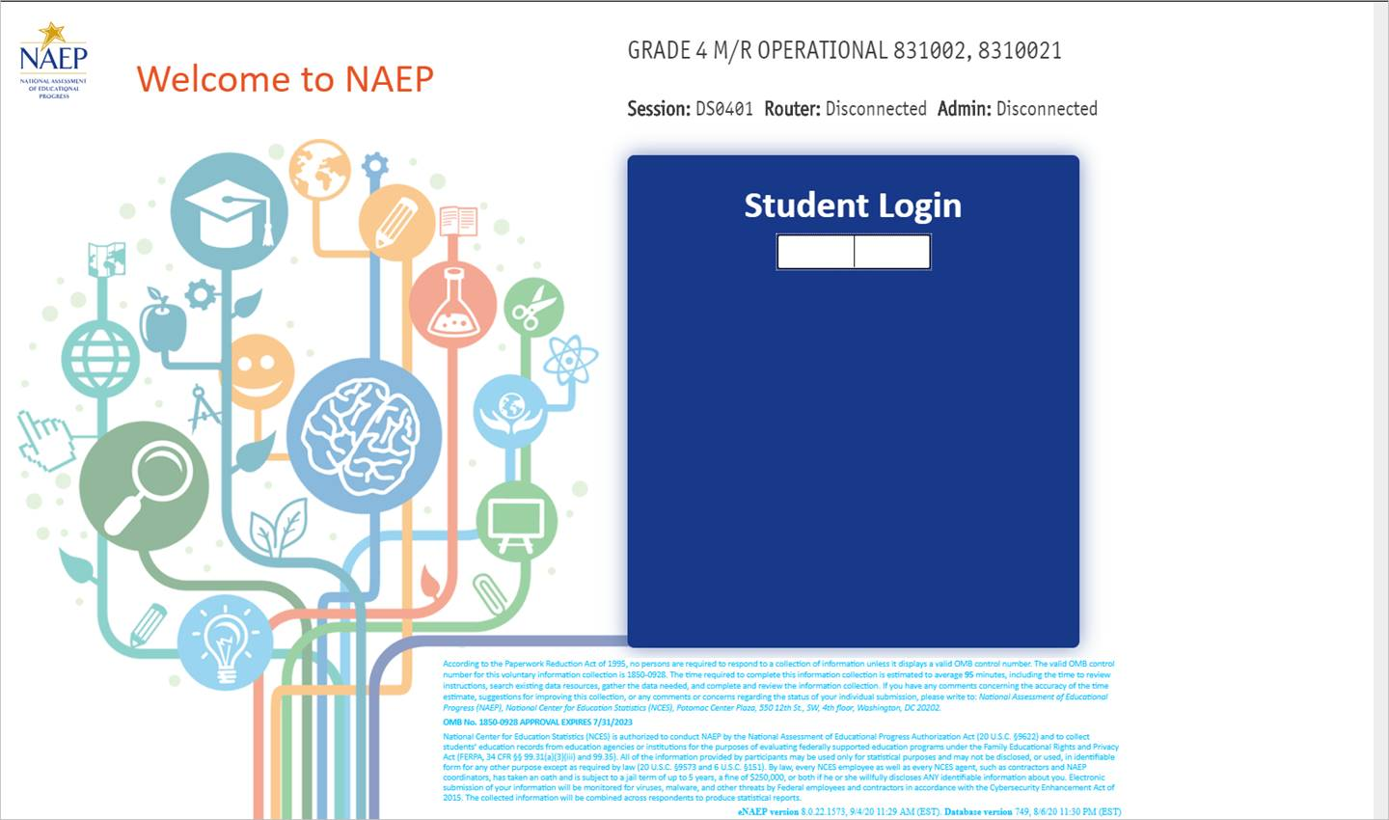

### **Appendix J1-1**: Summary of Changes Operational Grade 4 (CORE)

|  |  |  |  |
| --- | --- | --- | --- |
| **2022 Operational Grade 4 Core Student** | | | |
| **Previous item** | **2022 item** | **D/A/ R/NC+** | **Rationale** |
| (2019 Grade 4) | **Issue:** Race/Ethnicity | NC | N/A |
| (2019 Grade 4) | **Issue:** Race/Ethnicity | NC | N/A |
| (2019 Grade 4) | **Issue:** Socioeconomic Status | NC | N/A |

|  |  |  |  |
| --- | --- | --- | --- |
| **2022 Operational Grade 4 Core Student** | | | |
| **Previous item** | **2022 item** | **D/A/ R/NC+** | **Rationale** |
| (2019 Grade 4) | **Issue:** Socioeconomic Status | R | To keep student burden low, sub-items b and e were dropped. |
| (2019 Grade 4) | N/A | D | To keep student burden low, this item was dropped. |
| (2019 Grade 4) | **Issue:** School Climate | NC | N/A |
| (2019 Grade 4) | N/A | D | To keep student burden low, this item was dropped. |

|  |  |  |  |
| --- | --- | --- | --- |
| **2022 Operational Grade 4 Core Student** | | | |
| **Previous item** | **2022 item** | **D/A/ R/NC+** | **Rationale** |
| (2019 Grade 4) | **Issue:** Socioeconomic Status | NC | N/A |
| (2019 Grade 4) | **Issue:** Technology Use | NC | N/A |
| (2019 Grade 4) | N/A | D | To keep student burden low, this item was dropped. |

|  |  |  |  |
| --- | --- | --- | --- |
| **2022 Operational Grade 4 Core Student** | | | |
| **Previous item** | **2022 item** | **D/A/ R/NC+** | **Rationale** |
| (2019 Grade 4) | N/A | D | To keep student burden low, this item was dropped. |
| (2019 Grade 4) | **Issue:** Desire for Learning | NC | N/A |
| (2019 Grade 4) | **Issue:** Grit | NC | N/A |
| **2022 Operational Grade 4 Core Student** | | | |
| **Previous item** | **2022 item** | **D/A/ R/NC+** | **Rationale** |
| (2019 Grade 4) | N/A | D | To keep student burden low, this item was dropped. |

### **Appendix J1-2**: Operational Grade 4 (CORE)

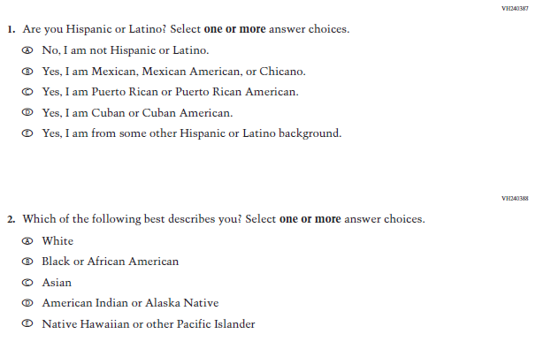

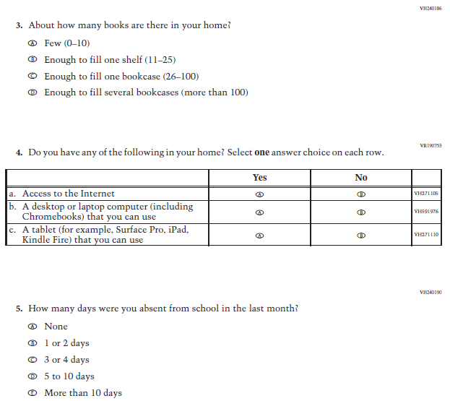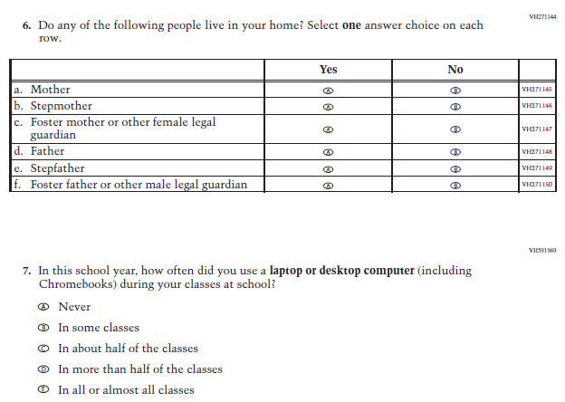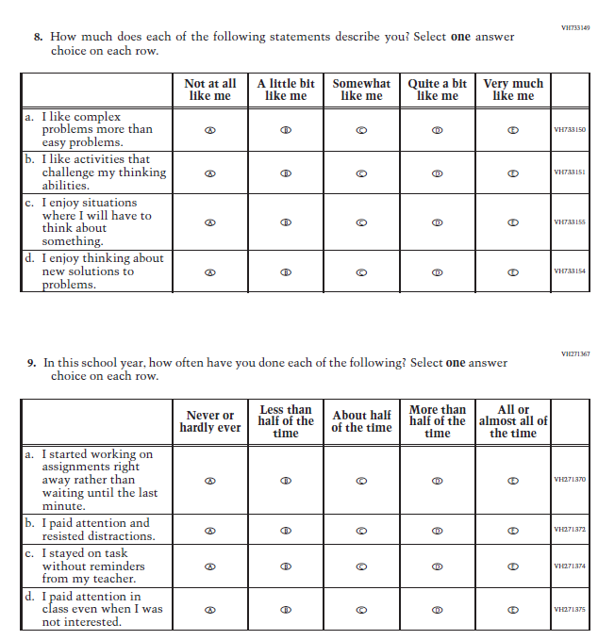

### **Appendix J1-3**: Summary of Changes Operational Grade 8 (CORE)

|  |  |  |  |
| --- | --- | --- | --- |
| **2022 Operational Grade 8 Core Student** | | | |
| **Previous item** | **2022 item** | **D/A/ R/NC+** | **Rationale** |
| (2019 Grade 8) | **Issue:** Race/Ethnicity | NC | N/A |
| (2019 Grade 8) | **Issue:** Race/Ethnicity | NC | N/A |
| (2019 Grade 8) | **Issue:** Socioeconomic Status | NC | N/A |

|  |  |  |  |
| --- | --- | --- | --- |
| **2022 Operational Grade 8 Core Student** | | | |
| **Previous item** | **2022 item** | **D/A/ R/NC+** | **Rationale** |
| (2019 Grade 8) | **Issue:** Socioeconomic Status | NC | N/A |
| (2019 Grade 8) | **Issue:** Technology Use | NC | N/A |
| (2019 Grade 8) | **Issue:** School Climate | NC | N/A |
| (2019 Grade 8) | **Issue:** Socioeconomic Status | NC | N/A |

|  |  |  |  |
| --- | --- | --- | --- |
| **2022 Operational Grade 8 Core Student** | | | |
| **Previous item** | **2022 item** | **D/A/ R/NC+** | **Rationale** |
| (2019 Grade 8) | **Issue:** Socioeconomic Status | NC | N/A |
| (2019 Grade 8) | **Issue:** Socioeconomic Status | NC | N/A |
| (2019 Grade 8) | **Issue:** Socioeconomic Status | NC | N/A |
| (2019 Grade 8) | **Issue:** Socioeconomic Status | NC | N/A |

| **2022 Operational Grade 8 Core Student** | | | |
| --- | --- | --- | --- |
| **Previous item** | **2022 item** | **D/A/ R/NC+** | **Rationale** |
| (2019 Grade 8) | **Issue:** Socioeconomic Status | NC | N/A |
| (2019 Grade 8) | **Issue:** Technology Use | NC | N/A |
| (2019 Grade 8) | **Issue:** Technology Use | NC | N/A |
| (2019 Grade 8) | **Issue:** Grit | NC | N/A |
| (2019 Grade 8) | **Issue:** Desire for Learning | NC | N/A |
| (2019 Grade 8) | **Issue:** Grit | NC | N/A |
| (2019 Grade 8) | N/A | D | To keep student burden low, this item was dropped. |
| (2019 Grade 8) | **Issue:** Educational Experiences | NC | N/A |

### **Appendix J1-4**: Operational Grade 8 (CORE)

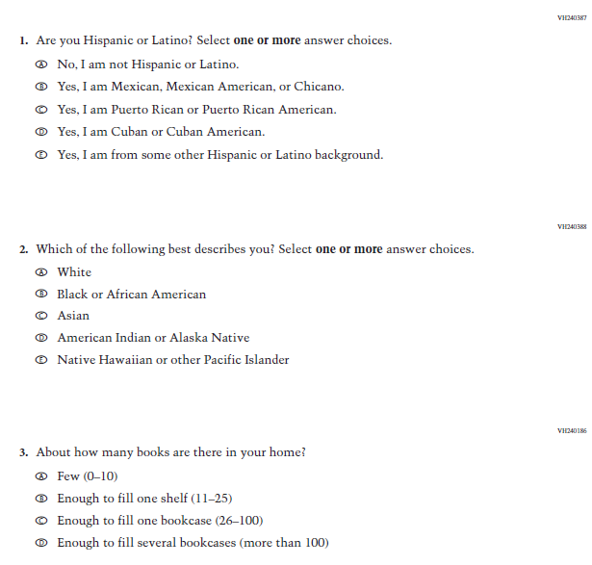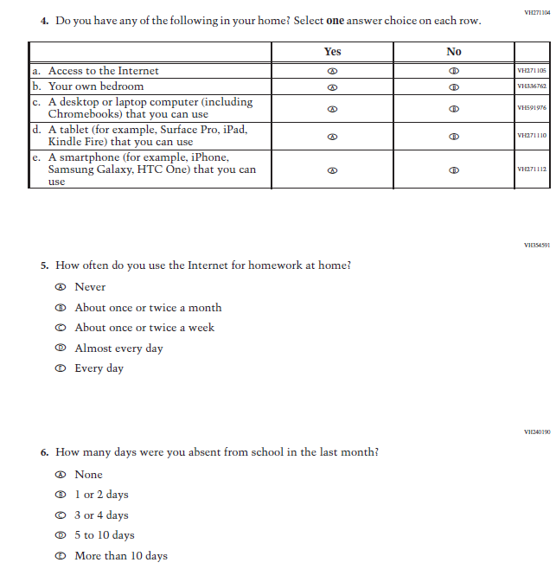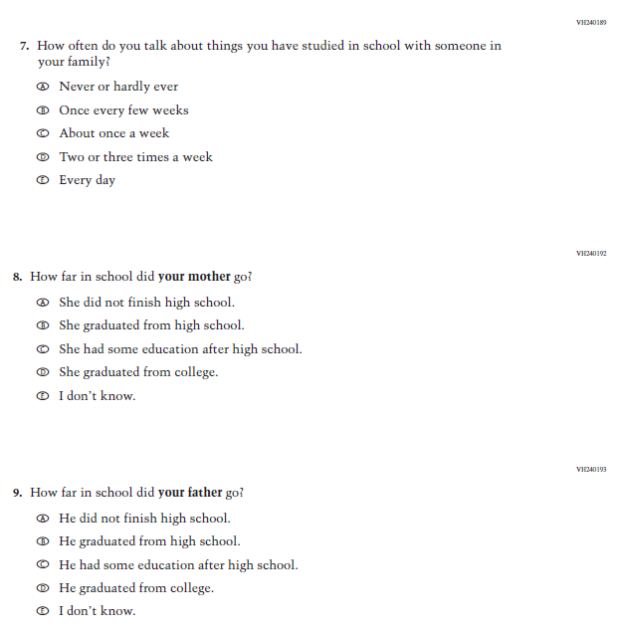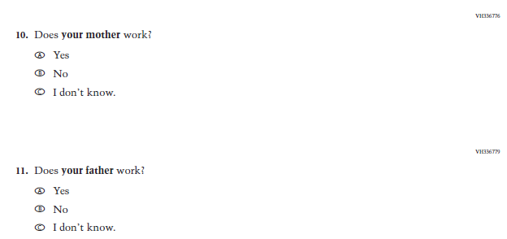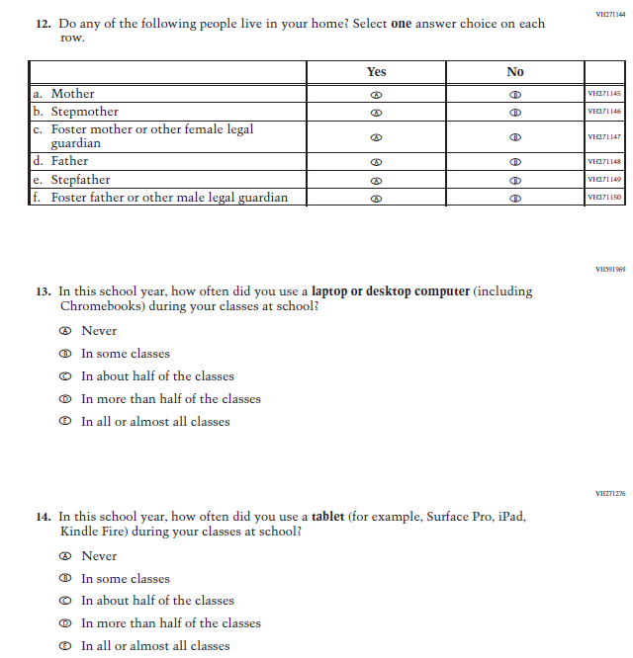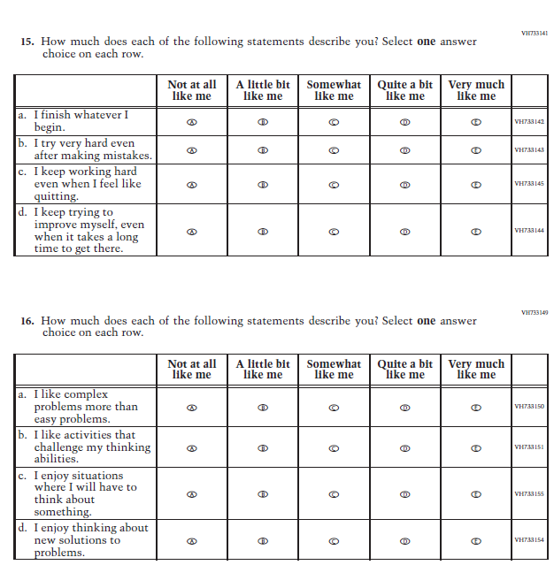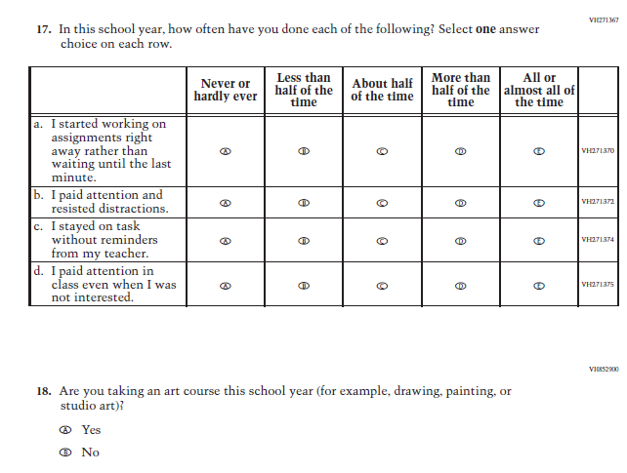

### **Appendix J1-5**: Summary of Changes Operational Grade 4 (Mathematics)

| **2022 Operational Grade 4 Mathematics Student** | | | |
| --- | --- | --- | --- |
| **Previous item** | **2022 item** | **D/A/ R/NC+** | **Rationale** |
| (2019 Grade 4) | **Issue:**  Organization of Instruction | NC | N/A |
| (2019 Grade 4) | **Issue:** Resources for Learning and Instruction | NC | N/A |
| (2019 Grade 4) | **Issue:** Resources for Learning and Instruction | NC | N/A |
| (2019 Grade 4) | **Issue:** Resources for Learning and Instruction | NC | N/A |
| (2019 Grade 4) | **Issue:** Resources for Learning and Instruction | NC | N/A |
| (2019 Grade 4) | **Issue:**  Resources for Learning and Instruction | NC | N/A |
| (2019 Grade 4) | **Issue:** Resources for Learning and Instruction | NC | N/A |

|  |  |  |  |
| --- | --- | --- | --- |
| **2022 Operational Grade 4 Mathematics Student** | | | |
| **Previous item** | **2022 item** | **D/A/ R/NC+** | **Rationale** |
| (2019 Grade 4) | N/A | D | To keep student burden low, this item was dropped. |
| (2019 Grade 4) | N/A | D | To keep student burden low, this item was dropped. |
| (2019 Grade 4) | **Issue:** Student Factors | NC | N/A |

| **2022 Operational Grade 4 Mathematics Student** | | | |
| --- | --- | --- | --- |
| **Previous item** | **2022 item** | **D/A/ R/NC+** | **Rationale** |
| (2019 Grade 4) | N/A | D | To keep student burden low, this item was dropped. |
| (2019 Grade 4) | **Issue:** Student Factors | NC | N/A |

|  |  |  |  |
| --- | --- | --- | --- |
| **2022 Operational Grade 4 Mathematics Student** | | | |
| **Previous item** | **2022 item** | **D/A/ R/NC+** | **Rationale** |
| (2019 Grade 4) | **Issue:** Student Factors | NC | N/A |

### **Appendix J1-6**: Operational Grade 4 (Mathematics)

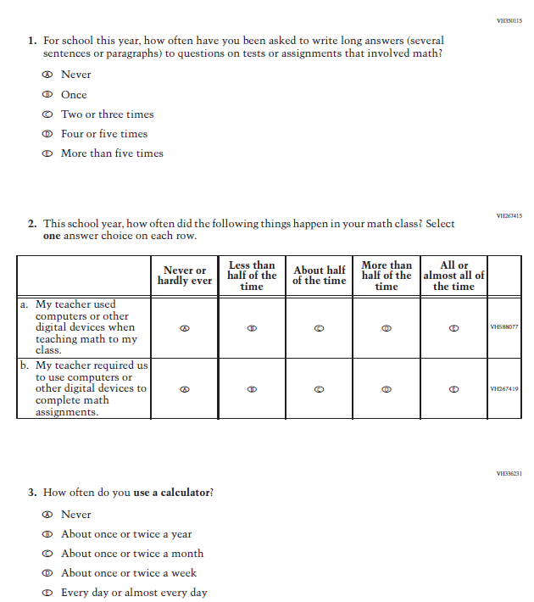

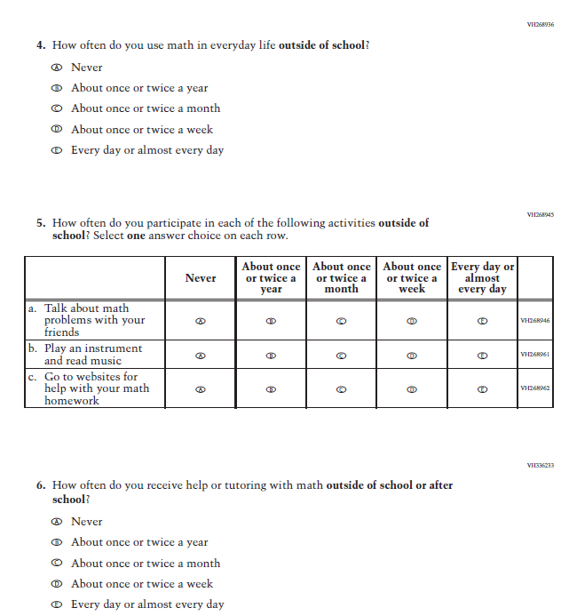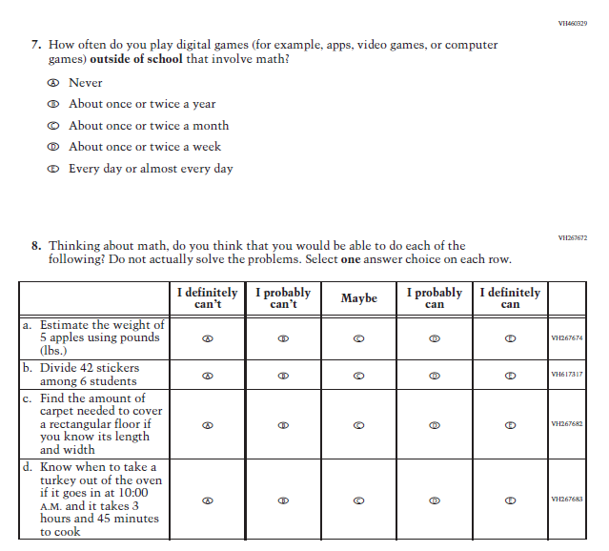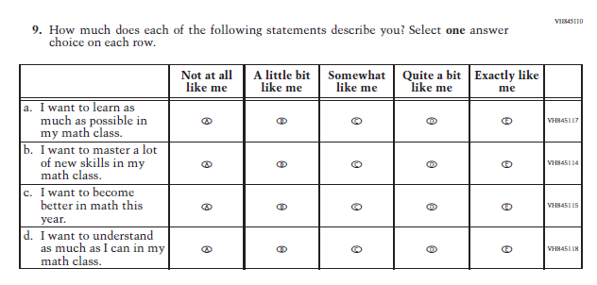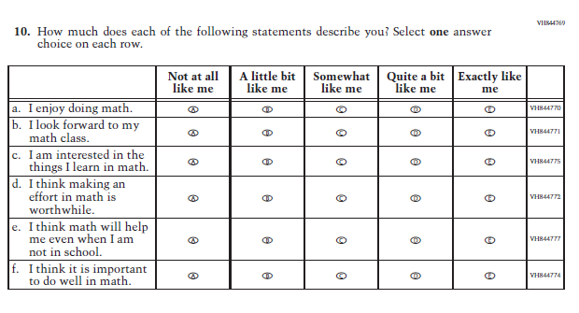

### **Appendix J1-7**: Summary of Changes Operational Grade 8 (Mathematics)

| **2022 Operational Grade 8 Mathematics Student** | | | |
| --- | --- | --- | --- |
| **Previous item** | **2022 item** | **D/A/ R/NC+** | **Rationale** |
| (2019 Grade 8) | **Issue:** Organization of Instruction | NC | N/A |
| (2019 Grade 8) | **Issue:** Organization of Instruction | NC | N/A |
| (2019 Grade 8) | **Issue:** Organization of Instruction | NC | N/A |

|  |  |  |  |
| --- | --- | --- | --- |
| **2022 Operational Grade 8 Mathematics Student** | | | |
| **Previous item** | **2022 item** | **D/A/ R/NC+** | **Rationale** |
| (2019 Grade 8) | **Issue:** Resources for Learning and Instruction | A: sub-item “b”  NC for SL and sub-items “a” and “c” | The “Scientific (not graphing) calculator” sub-item was dropped previously due to an oversight and is being reinstated to capture calculator features in mathematics as students progress from K to 12. |
| (2019 Grade 8) | **Issue:** Resources for Learning and Instruction | R | To keep student burden low, sub-items a and b were dropped. |

|  |  |  |  |
| --- | --- | --- | --- |
| **2022 Operational Grade 8 Mathematics Student** | | | |
| **Previous item** | **2022 item** | **D/A/ R/NC+** | **Rationale** |
| (2019 Grade 8) | N/A | D | To keep student burden low, this item has been dropped. |
| (2019 Grade 8) | **Issue:** Resources for Learning and Instruction | NC | N/A |
| (2019 Grade 8) | **Issue:** Resources for Learning and Instruction | NC | N/A |
| (2019 Grade 8) | **Issue:** Resources for Learning and Instruction | NC | N/A |

| **2022 Operational Grade 8 Mathematics Student** | | | |
| --- | --- | --- | --- |
| **Previous item** | **2022 item** | **D/A/ R/NC+** | **Rationale** |
| (2019 Grade 8) | N/A | D | To keep student burden low, this item was dropped. |
| (2019 Grade 8) | N/A | D | To keep student burden low, this item was dropped. |
| (2019 Grade 8) | N/A | D | To keep student burden low, this item was dropped. |
| (2019 Grade 8) | N/A | D | To keep student burden low, this item was dropped. |
| (2019 Grade 8) | **Issue:** Resources for Learning and Instruction | NC | N/A |
| (2019 Grade 8) | **Issue:** Student factors | NC | N/A |
| (2019 Grade 8) | N/A | D | To keep student burden low, this item was dropped. |
| (2019 Grade 8) | **Issue:** Student factors | NC | N/A |
| (2019 Grade 8) | **Issue:** Student Factors | NC | N/A |
| (2019 Grade 8) | **Issue:** Student Factors | NC | N/A |

### **Appendix J1-8**: Operational Grade 8 (Mathematics)

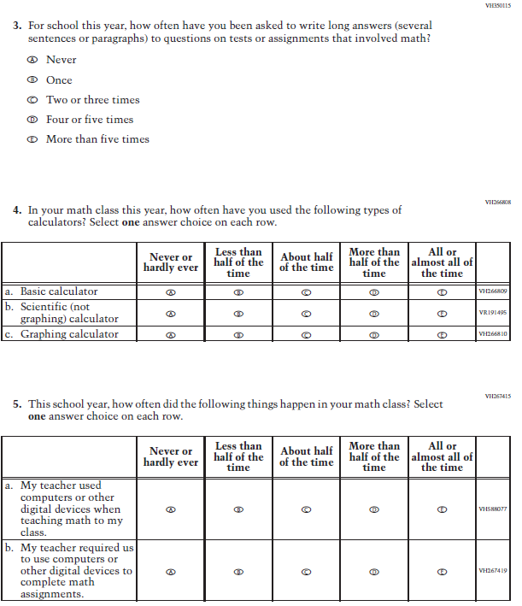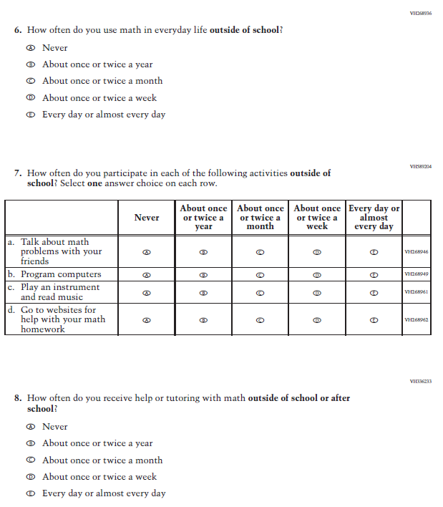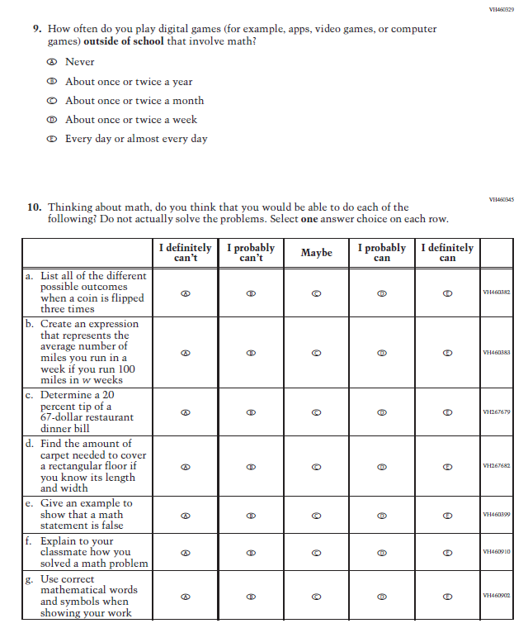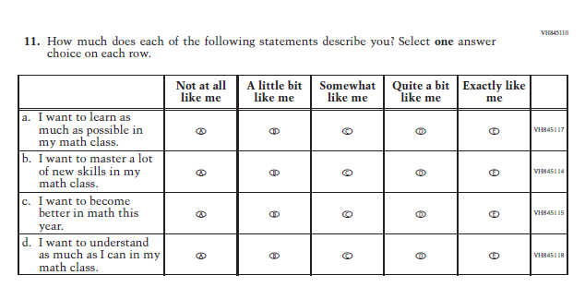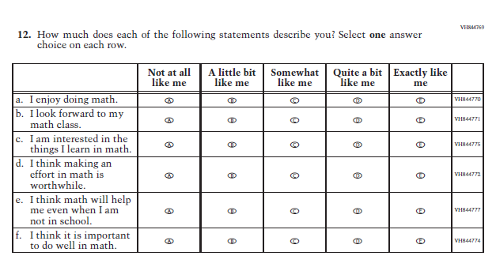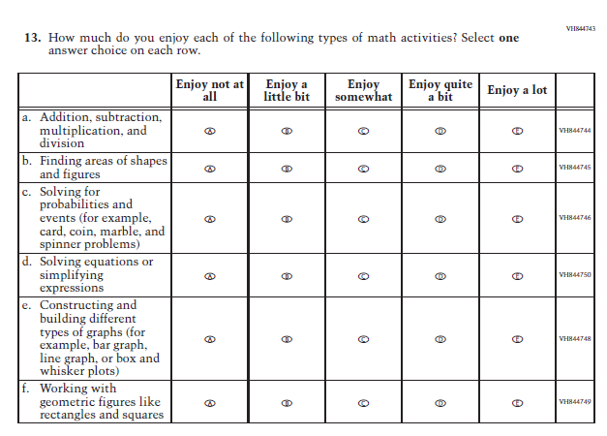

### **Appendix J1-9**: Summary of Changes Operational Grade 4 (Reading)

| **2022 Operational Grade 4 Reading Student** | | | |
| --- | --- | --- | --- |
| **Previous item** | **2022 item** | **D/A/ R/NC+** | **Rationale** |
| (2019 Grade 4) | **Issue:** Organization of Instruction | NC | N/A |
| (2019 Grade 4) | **Issue:** Organization of Instruction | NC | N/A |
| (2019 Grade 4) | **Issue:** Organization of Instruction | NC | N/A |
| (2019 Grade 4) | **Issue:** Organization of Instruction | NC | N/A |
| (2019 Grade 4) | N/A | D | To keep student burden low, this item was dropped. |
| (2019 Grade 4) | **Issue:** Resources for Learning and Instruction | NC | N/A |
| (2019 Grade 4) | **Issue:** Student Factors | NC | N/A |
| (2019 Grade 4) | N/A | D | To keep student burden low, this item was dropped. |
| (2019 Grade 4) | **Issue:** Student Factors | NC | N/A |
| (2019 Grade 4) | **Issue:** Student Factors | NC | N/A |
| (2019 Grade 4) | **Issue:** Student Factors | NC | N/A |
| (2019 Grade 4) | **Issue:** Resources for Learning and Instruction | NC | N/A |
| (2019 Grade 4) | **Issue:** Student Factors | R | To keep student burden low, sub-items b, d, and e were dropped. |

### **Appendix J1-10**: Operational Grade 4 (Reading)

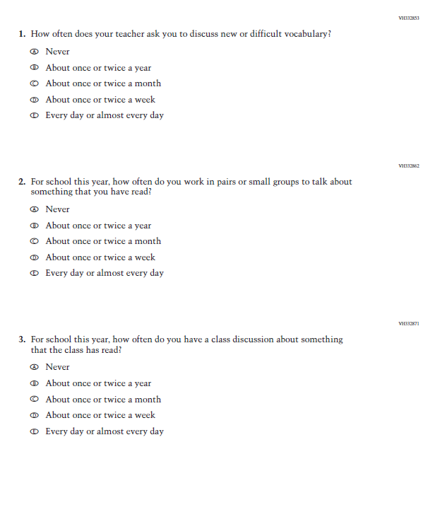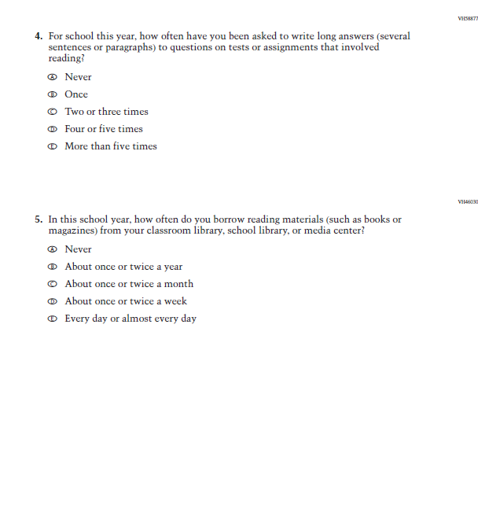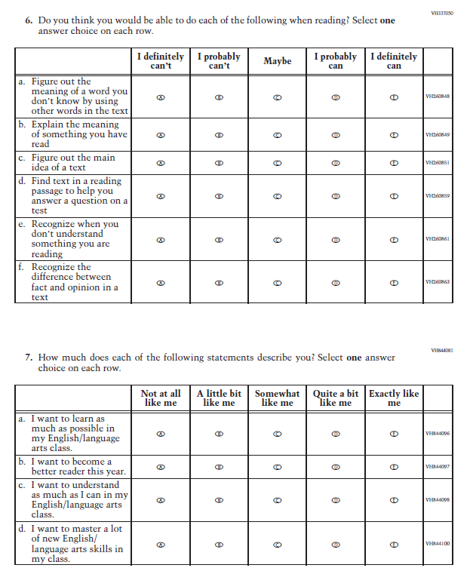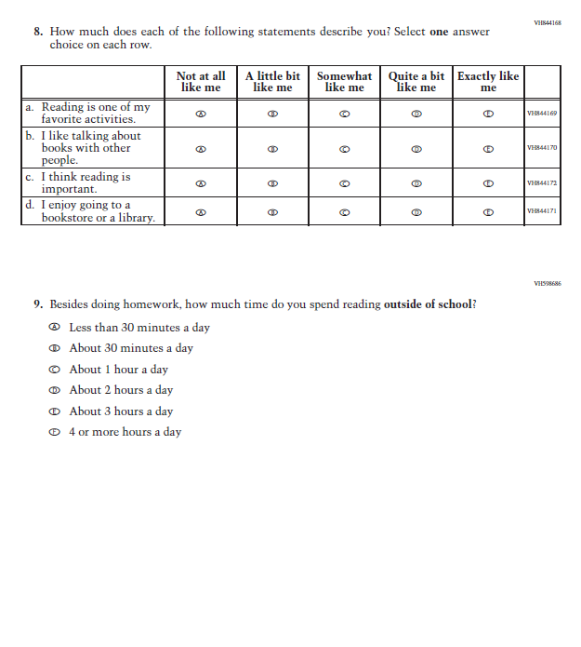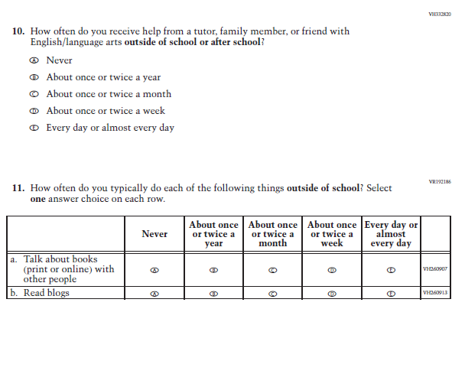

### **Appendix J1-11**: Summary of Changes Operational Grade 8 (Reading)

| **2022 Operational Grade 8 Reading Student** | | | |
| --- | --- | --- | --- |
| **Previous item** | **2022 item** | **D/A/ R/NC+** | **Rationale** |
| (2019 Grade 8) | **Issue:** Organization of Instruction | NC | N/A |
| (2019 Grade 8) | **Issue:** Organization of Instruction | NC | N/A |
| (2019 Grade 8) | **Issue:** Organization of Instruction | NC | N/A |
| (2019 Grade 8) | **Issue:** Organization of Instruction | NC | N/A |
| (2019 Grade 8) | N/A | D | To keep student burden low, this item was dropped. |
| (2019 Grade 8) | N/A | D | To keep student burden low, this item was dropped. |
| (2019 Grade 8) | **Issue:** Student Factors | NC | N/A |
| (2019 Grade 8) | **Issue:** Student Factors | NC | N/A |
| (2019 Grade 8) | N/A | D | To keep student burden low, this item was dropped. |
| (2019 Grade 8) | **Issue:** Student Factors | NC | N/A |
| (2019 Grade 8) | **Issue:** Student Factors | NC | N/A |
| (2019 Grade 8) | **Issue:** Student Factors | NC | N/A |
| (2019 Grade 8) | **Issue:** Student Factors | R | The order of sub-items b, c, and d was revised. |
| (2019 Grade 8) | **Issue:** Resources for Learning and Instruction | NC | N/A |
| (2019 Grade 8) | **Issue:** Student Factors | R | To keep student burden low, sub-items d and e were dropped. |

### **Appendix J1-12**: Operational Grade 8 (Reading)

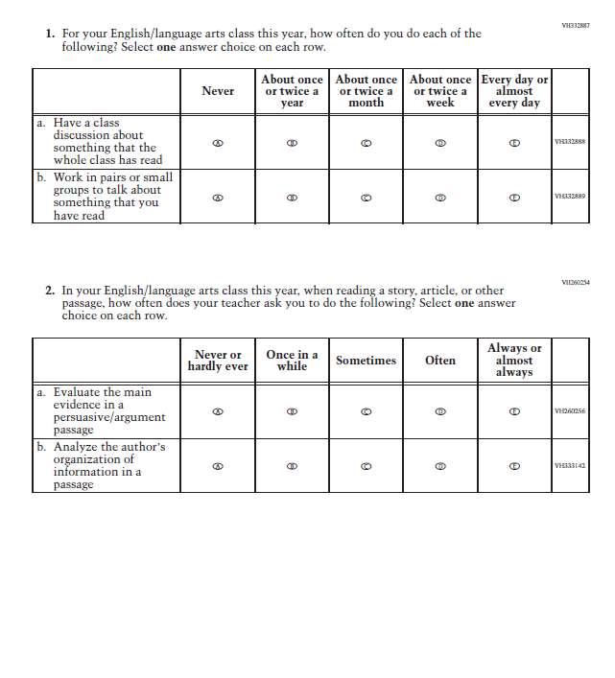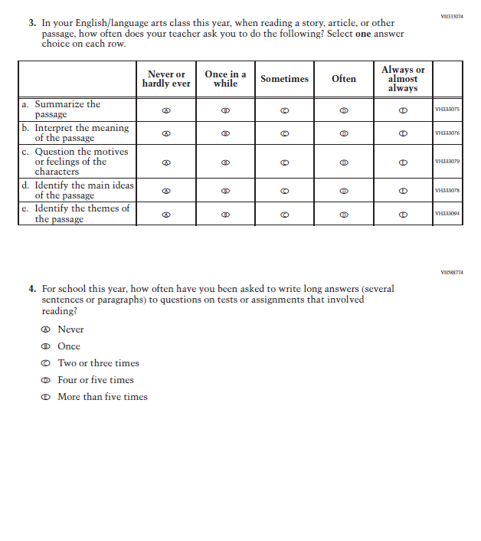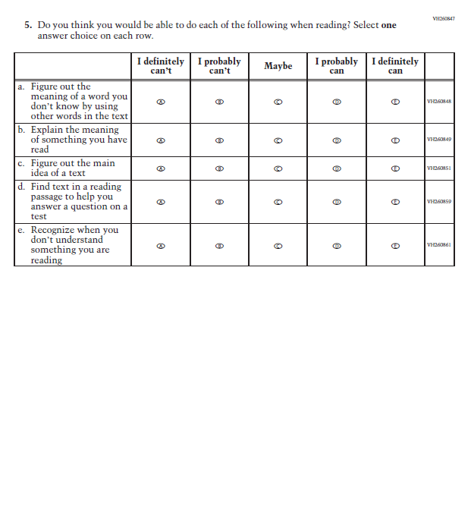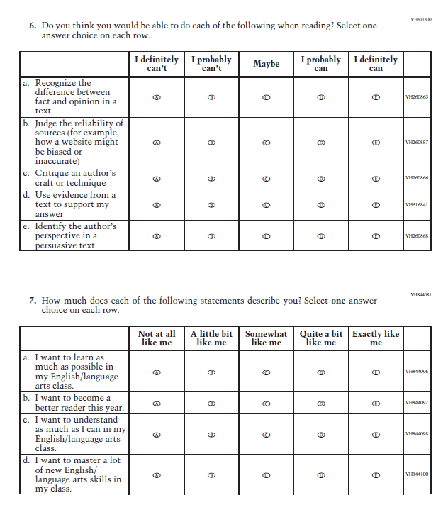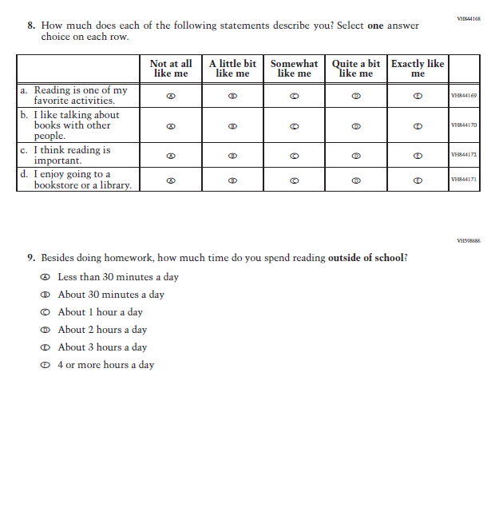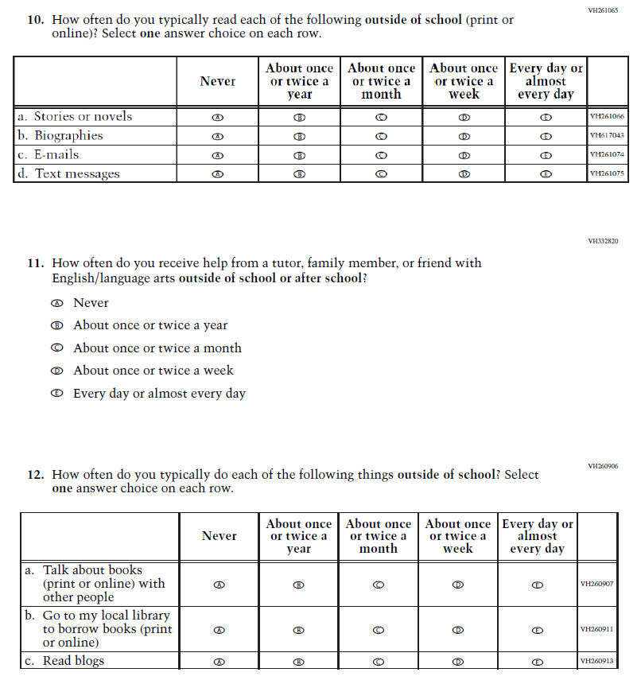

### **Appendix J1-13**: Summary of Operational Grade 8 Civics

| **2022 Operational Grade 8 Civics Student** | | | |
| --- | --- | --- | --- |
| **Previous item** | **2022 item** | **D/A/ R/NC+** | **Rationale** |
| (2018 Grade 8) | **Issue**: Organization of Instruction | NC | N/A |
| (2018 Grade 8) | **Issue**: Organization of Instruction | NC | N/A |
| (2018 Grade 8) | N/A | D | To keep student burden low, this item was dropped. |
| (2018 Grade 8) | N/A | D | To keep student burden low, this item was dropped. |
| (2018 Grade 8) | **Issue**: Organization of Instruction | R | To keep student burden low, sub-items b and d were dropped. |
| (2018 Grade 8) | **Issue:** Organization of Instruction | R | To keep student burden low, sub-items a and d were dropped. |
| (2018 Grade 8) | **Issue**: Organization of Instruction | NC | N/A |
| (2018 Grade 8) | **Issue**: Student Factors | NC | N/A |
| (2018 Grade 8) | **Issue**: Student Factors | NC | N/A |
| (2018 Grade 8) | N/A | D | To keep student burden low, this item was dropped. |
| (2018 Grade 8) | **Issue**: Student Factors | NC | N/A |
| (2018 Grade 8) | **Issue**: Student Factors | R | To keep student burden low, sub-items a, b, and c were dropped. |
| (2018 Grade 8) | **Issue**: Student Factors | NC | N/A |
| (2018 Grade 8) | **Issue**: Resources for Learning and Instruction | NC | N/A |
| (2018 Grade 8) | N/A | D | To keep student burden low, this item was dropped. |

### **Appendix J1-14**: Operational Grade 8 Civics

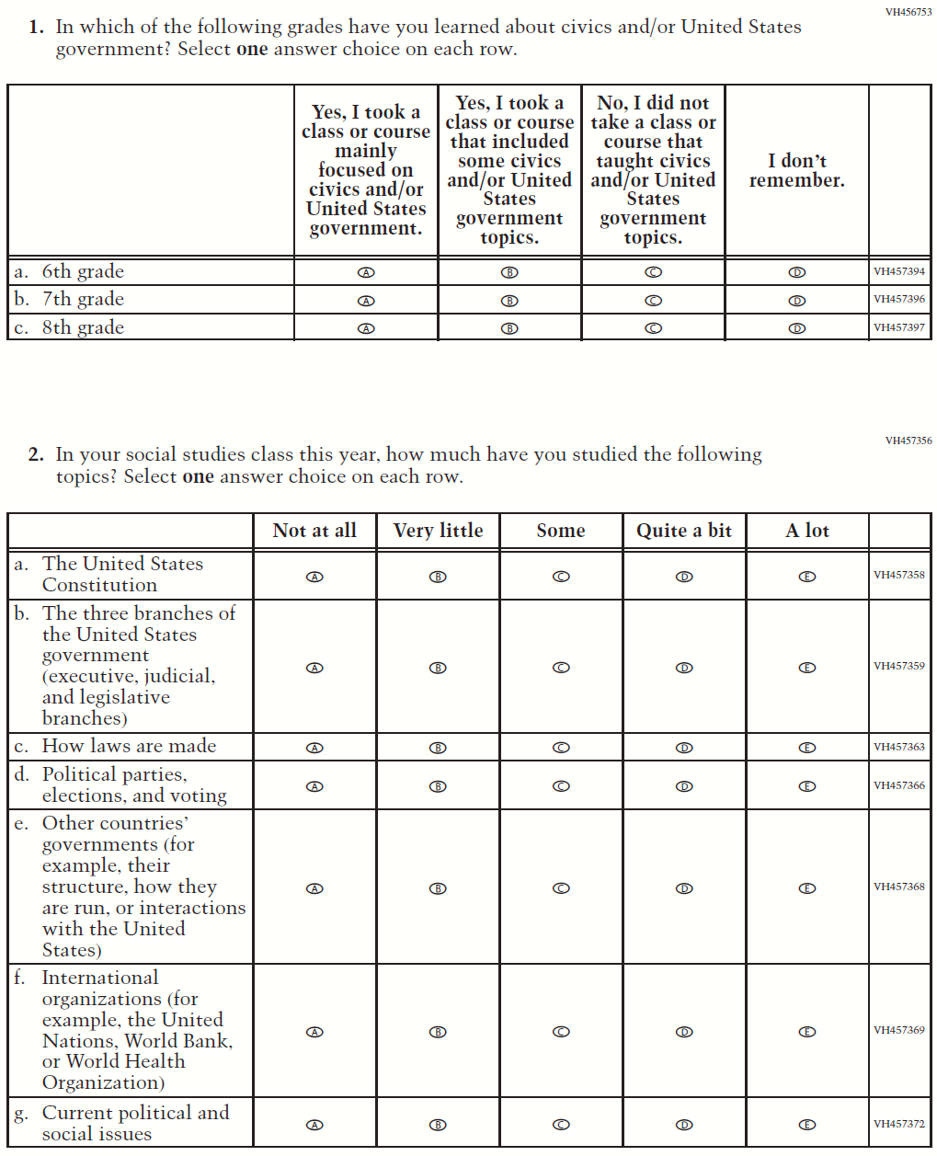

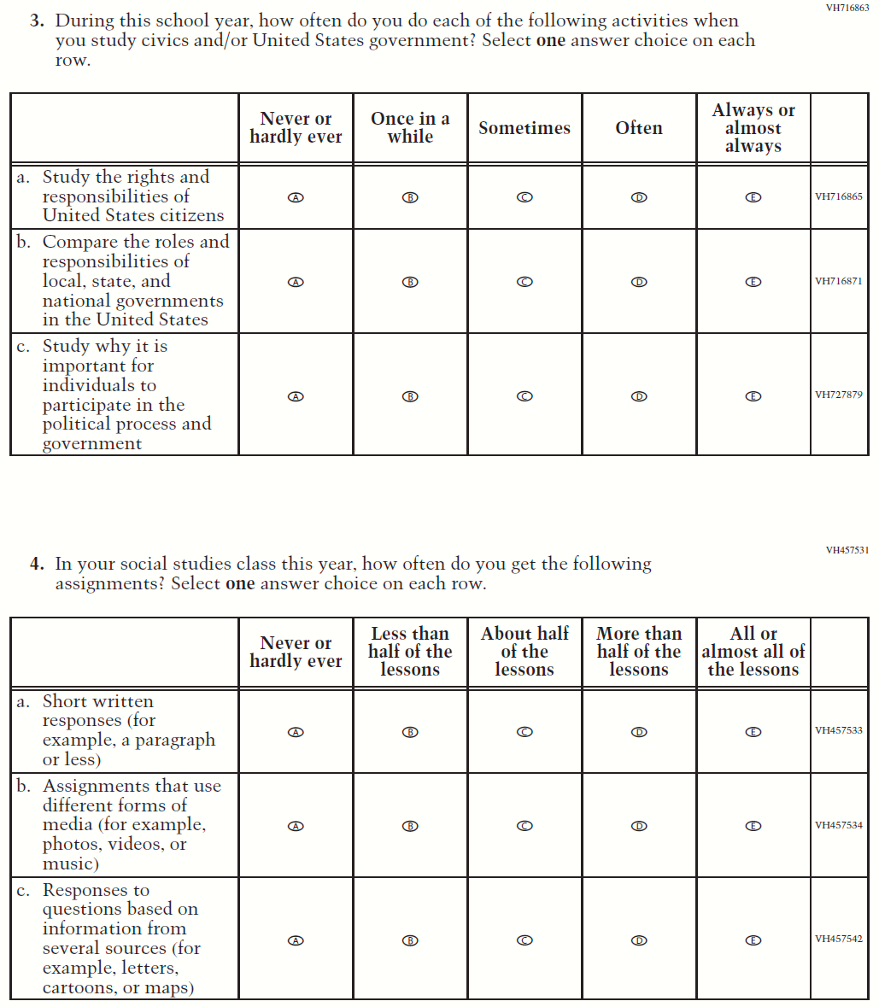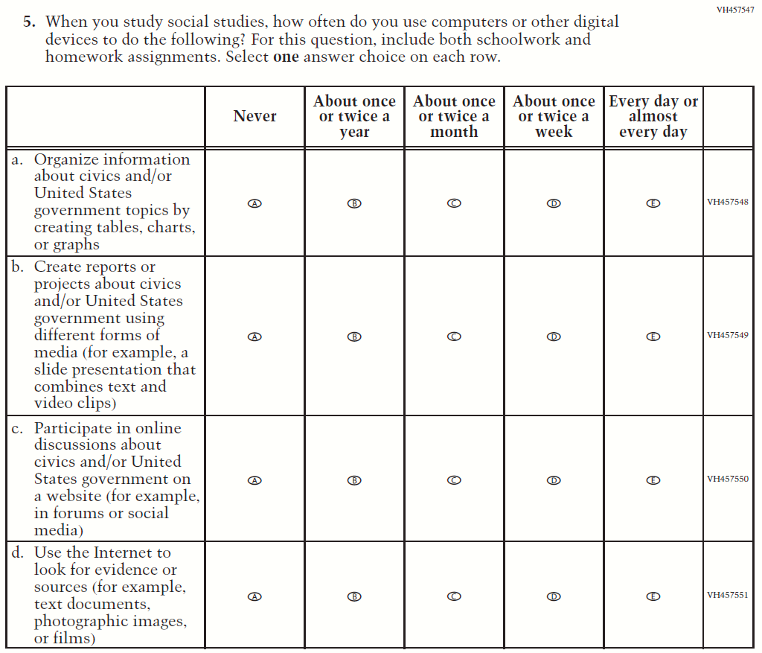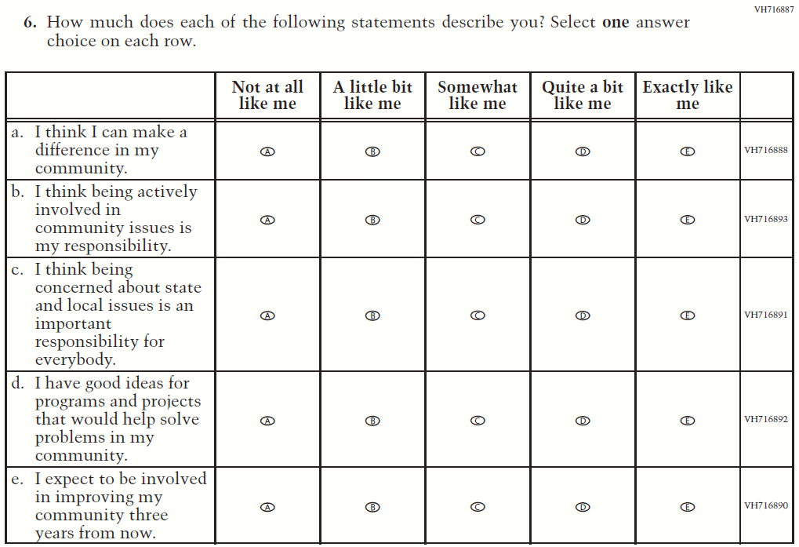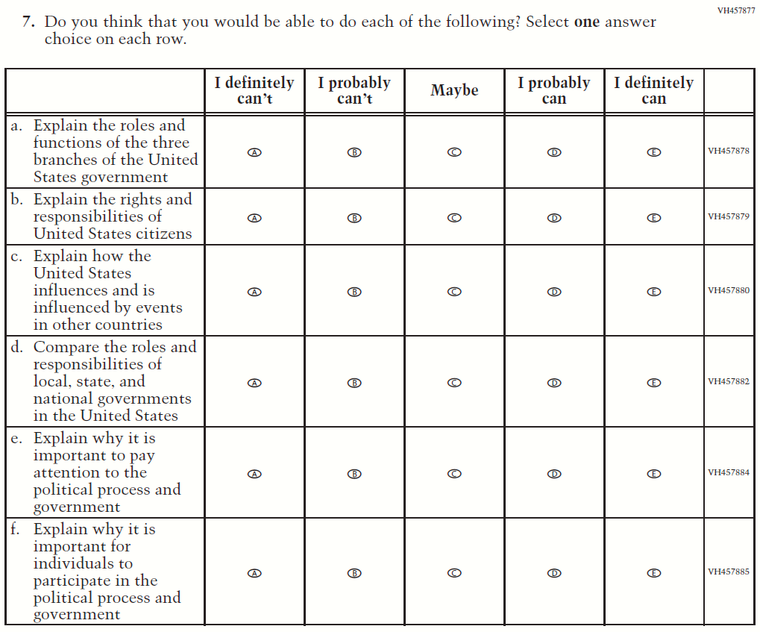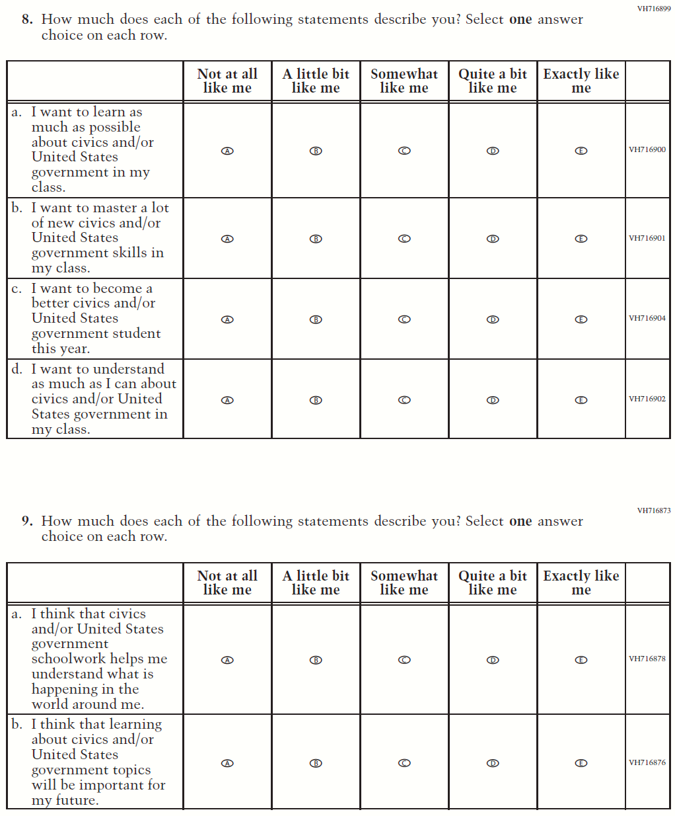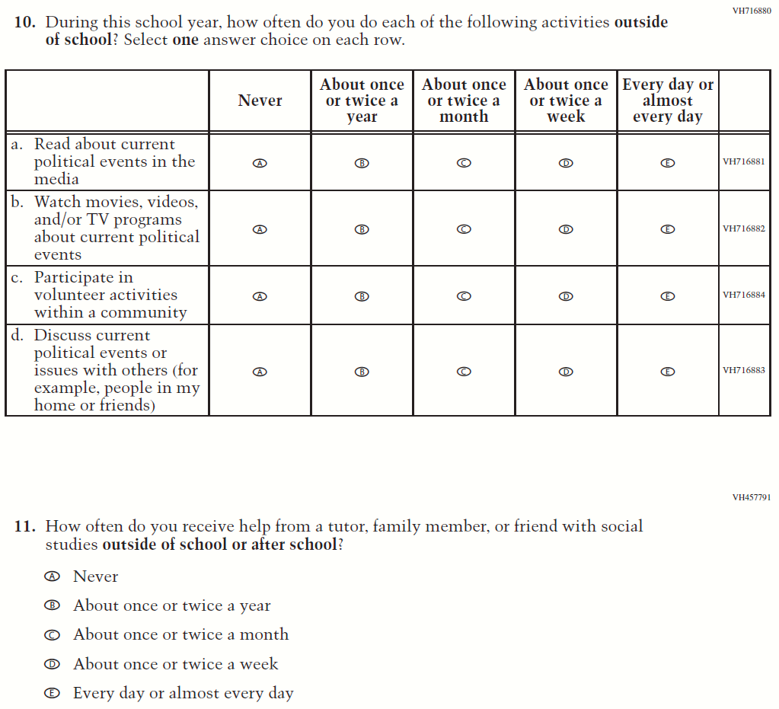

### **Appendix J1-15**: Summary of Operational Grade 8 U.S. History

| **2022 Operational Grade 8 U.S. History Student** | | | |
| --- | --- | --- | --- |
| **Previous item** | **2022 item** | **D/A/ R/NC+** | **Rationale** |
| (2018 Grade 8) | **Issue**: Organization of Instruction | NC | N/A |
| (2018 Grade 8) | **Issue**: Organization of Instruction | NC | N/A |
| (2018 Grade 8) | N/A | D | To keep student burden low, this item was dropped. |
| (2018 Grade 8) | N/A | D | To keep student burden low, this item was dropped. |
| (2018 Grade 8) | **Issue**: Organization of Instruction | NC | N/A |
| (2018 Grade 8) | **Issue:** Organization of Instruction | R | To keep student burden low, sub-items a and d were dropped. |
| (2018 Grade 8) | N/A | D | To keep student burden low, this item was dropped. |
| (2018 Grade 8) | **Issue**: Student Factors | NC | N/A |
| (2018 Grade 8) | **Issue**: Student Factors | NC | N/A |
| (2018 Grade 8) | N/A | D | To keep student burden low, this item was dropped. |
| (2018 Grade 8) | **Issue**: Student Factors | NC | N/A |
| (2018 Grade 8) | N/A | D | To keep student burden low, this item was dropped. |
| (2018 Grade 8) | **Issue**: Student Factors | R | To keep student burden low, sub-items c and d were dropped. |
| (2018 Grade 8) | **Issue**: Resources for Learning and Instruction | NC | N/A |
| (2018 Grade 8) | N/A | D | To keep student burden low, this item was dropped. |

### **Appendix J1-16**: Operational Grade 8 U.S. History

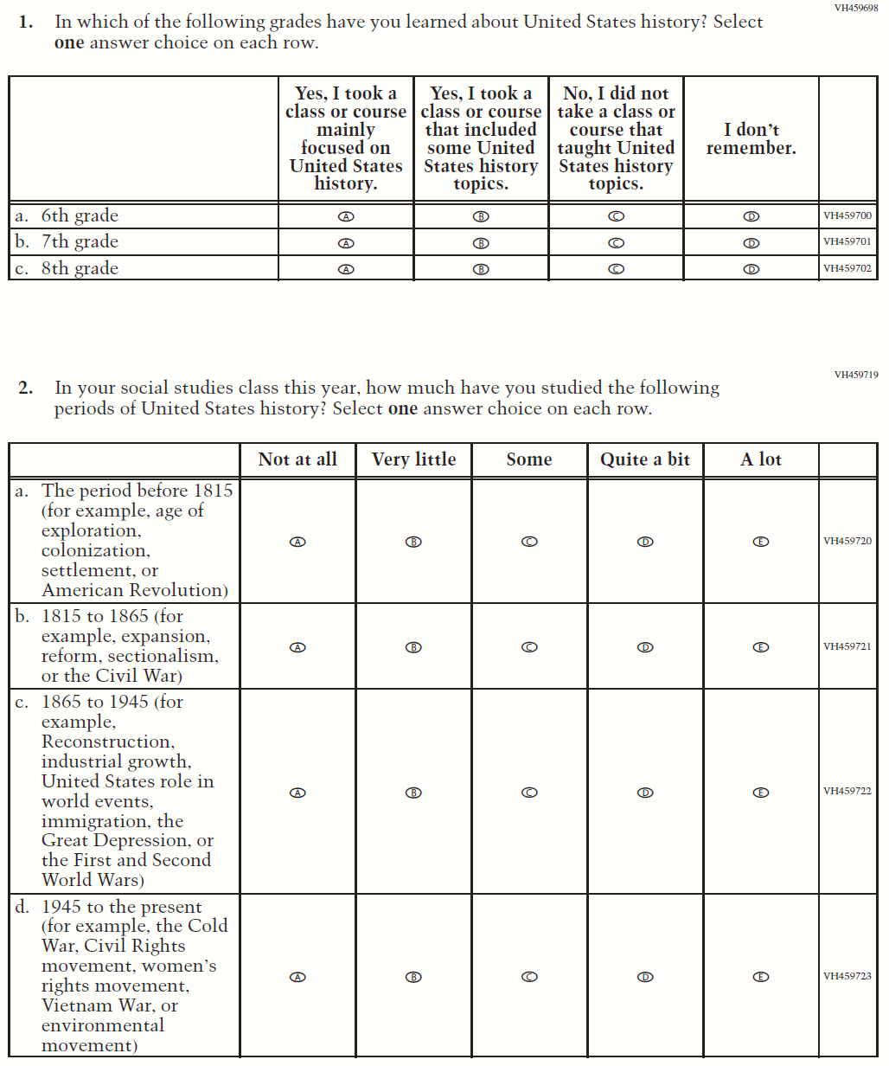

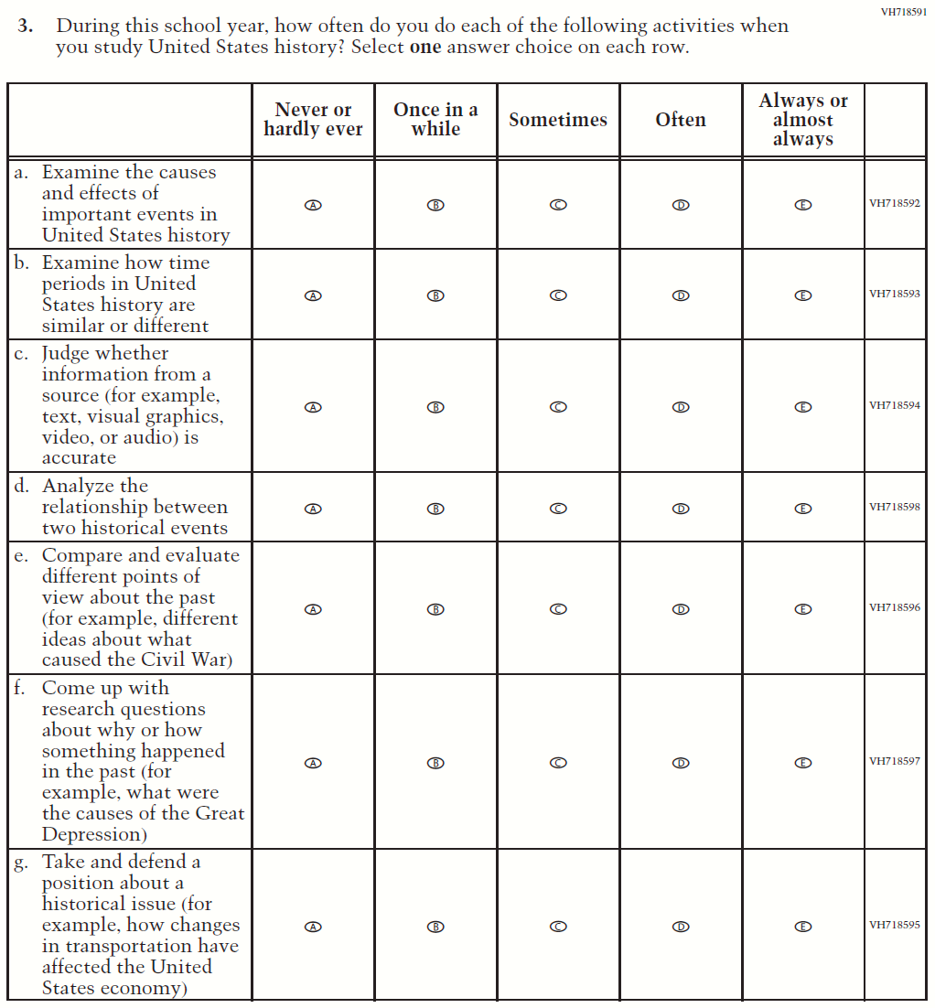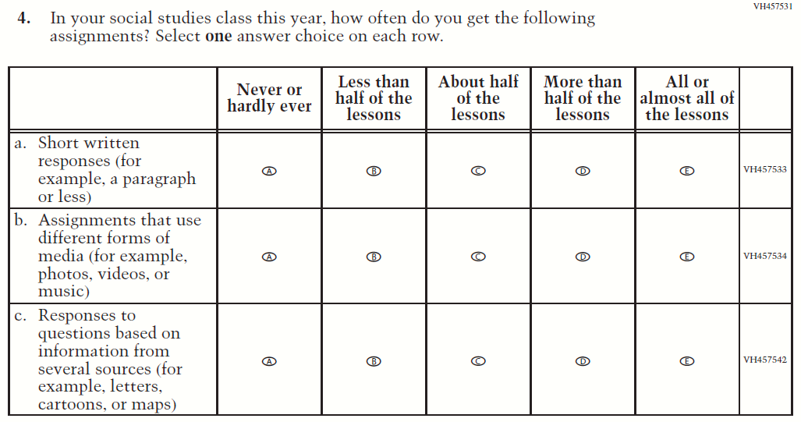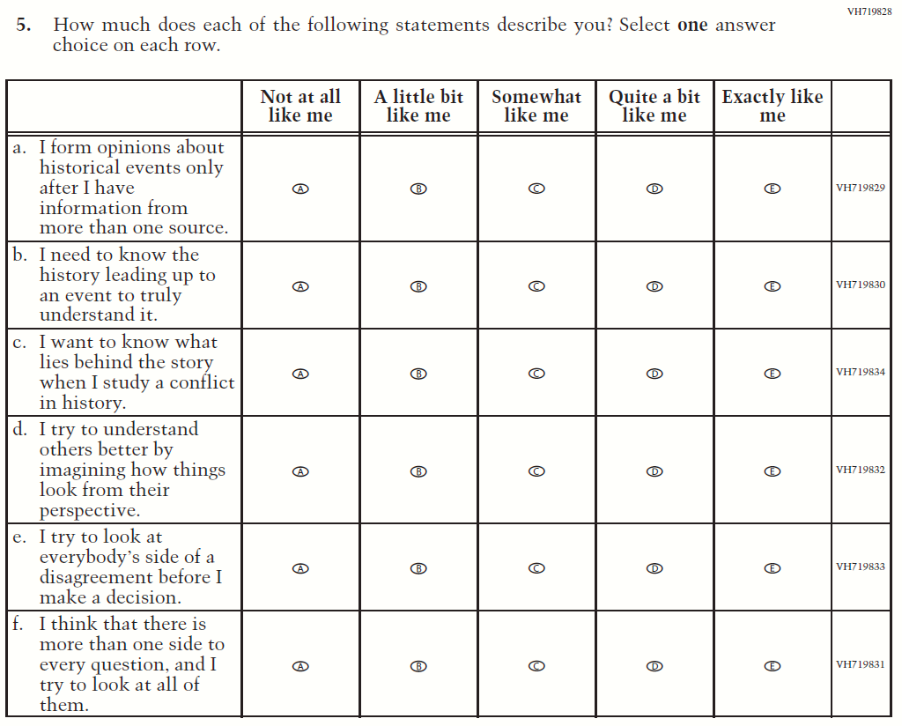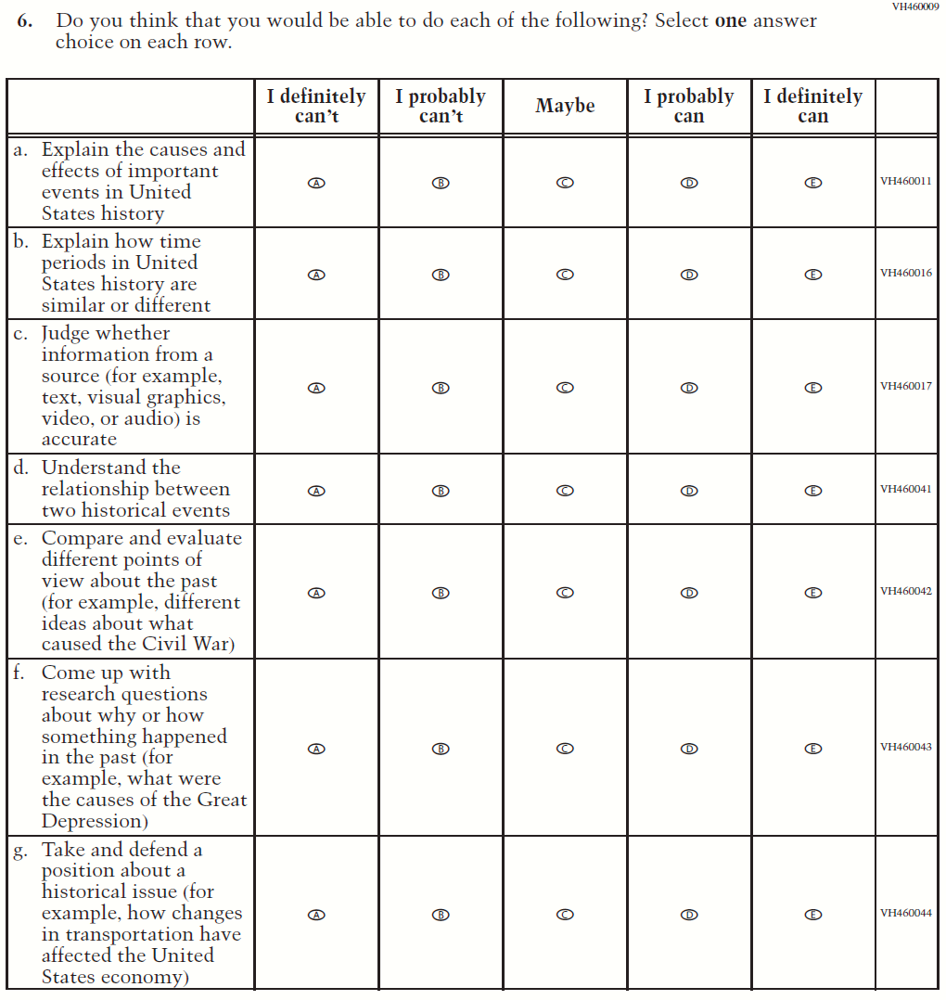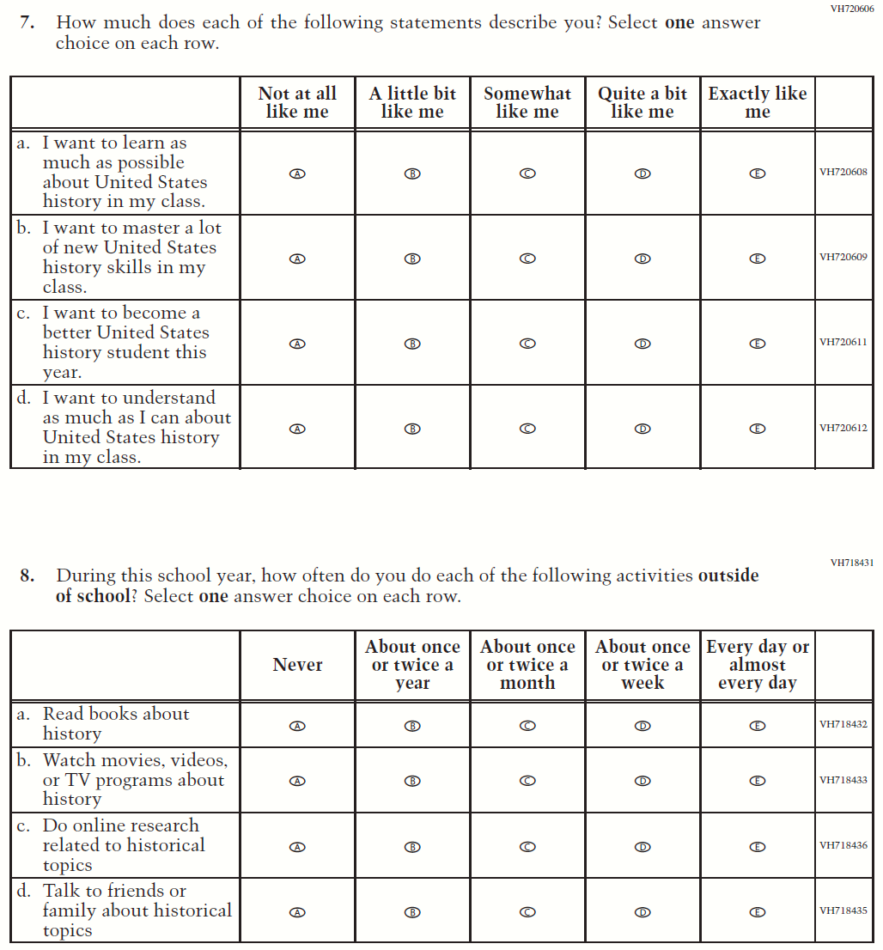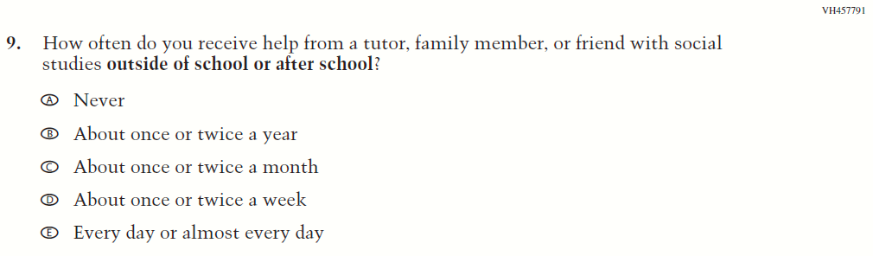

### **Appendix J1-17**: Summary of Operational Grade 4 Debrief

| **2022 Operational Grade 4 Debrief Student** | | | |
| --- | --- | --- | --- |
| **Previous item** | **2022 item** | **D/A/ R/NC+** | **Rationale** |
| (2019 Grade 4, 8, and 12) | N/A | D | To keep student burden low, this item was dropped. |
| (2019 Grade 4, 8, and 12) | **Issue:** Debrief | NC | N/A |

### **Appendix J1-18**: Operational Grade 4 Debrief

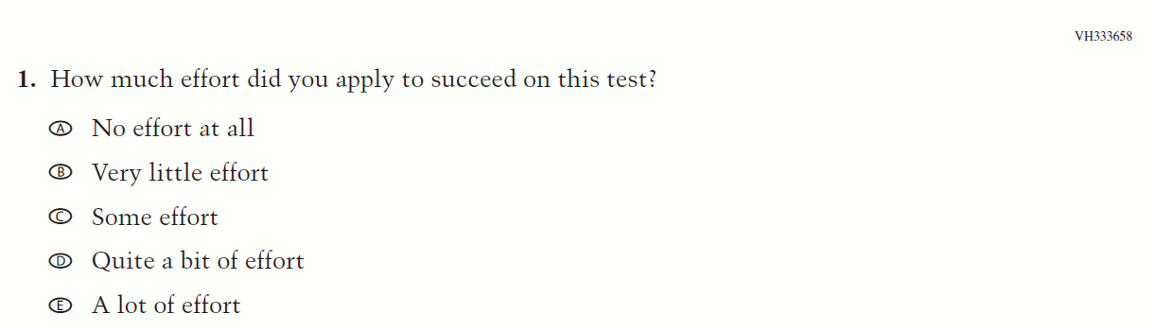

### **Appendix J1-19**: Summary of Operational Grade 8 Debrief

| **2022 Operational Grade 8 Debrief Student** | | | |
| --- | --- | --- | --- |
| **Previous item** | **2022 item** | **D/A/ R/NC+** | **Rationale** |
| (2019 Grade 4, 8, and 12) | **Issue:** Debrief | NC | N/A |
| (2019 Grade 4, 8, and 12) | **Issue:** Debrief | NC | N/A |

### **Appendix J1-20**: Operational Grade 8 Debrief

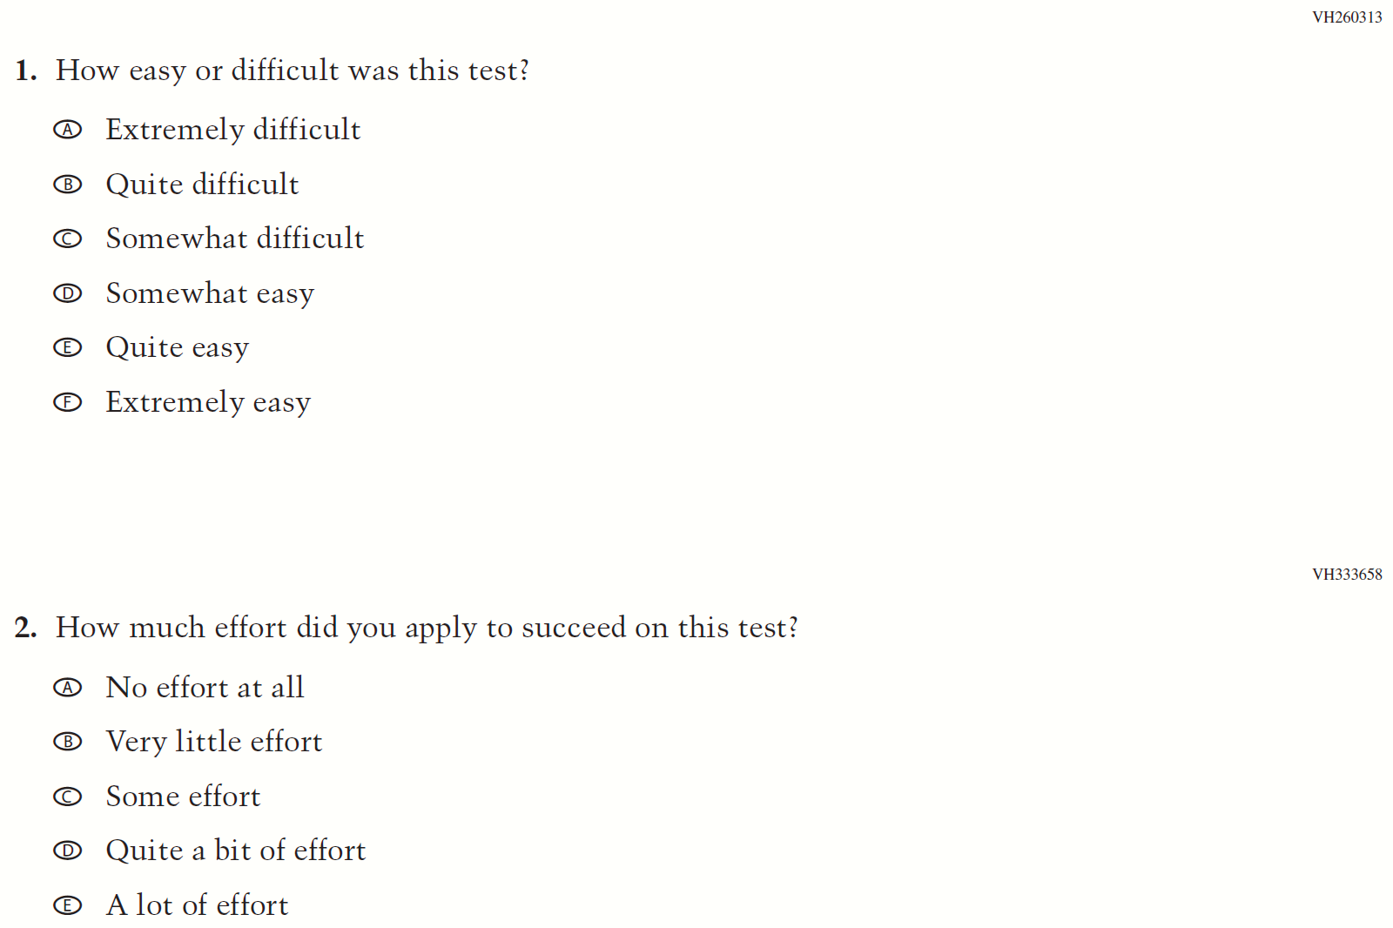

### **Appendix J1-21**: Operational Grade 4 COVID-19 Student Items (ELA)

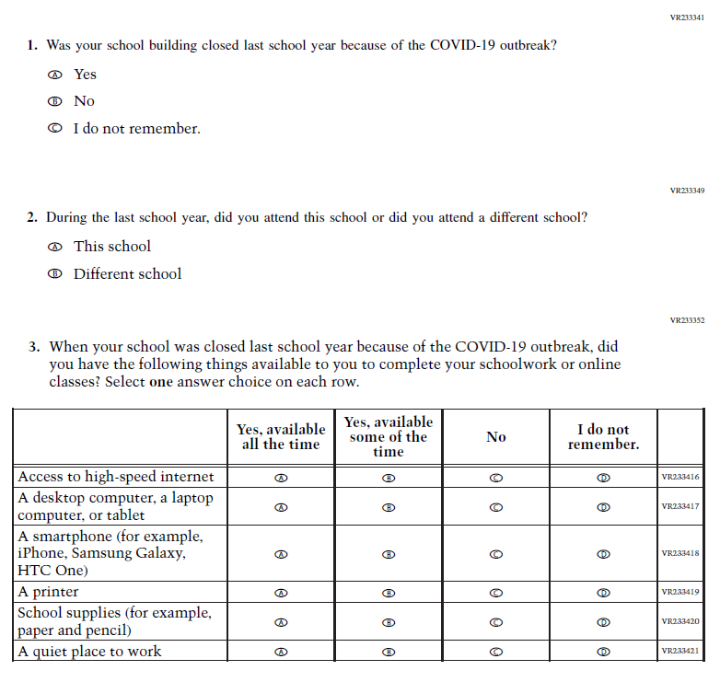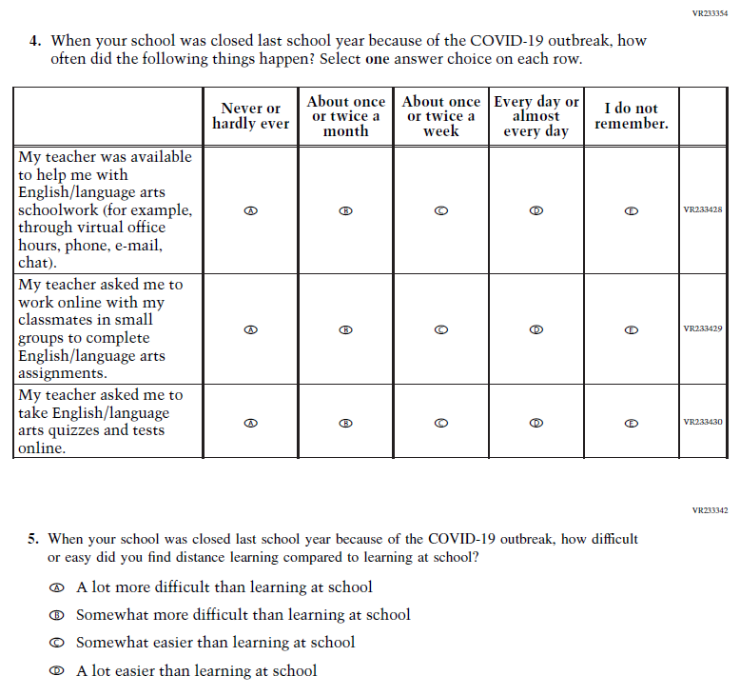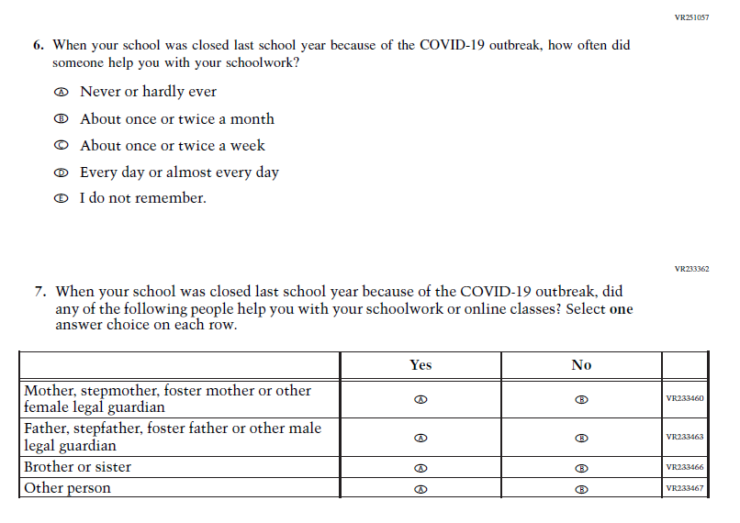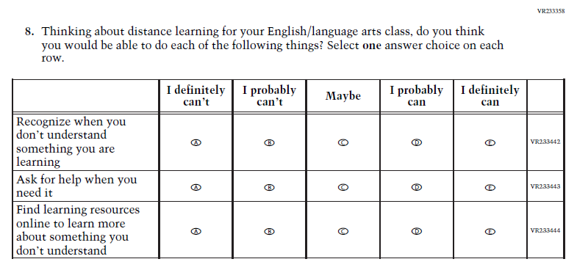

### **Appendix J1-22**: Operational Grade 8 COVID-19 Student Items (ELA)

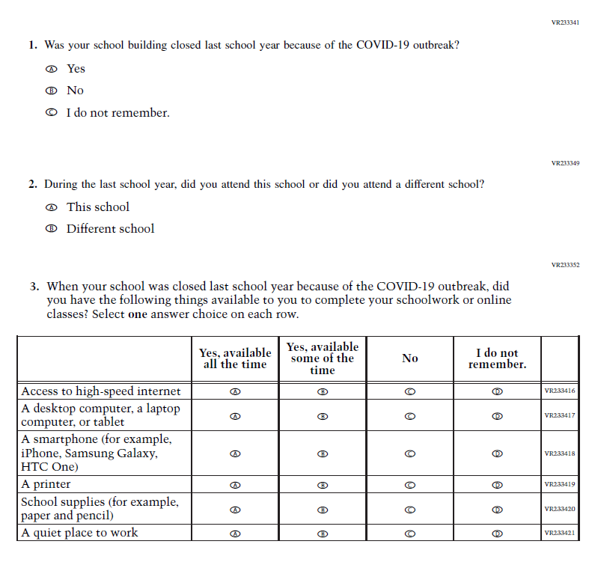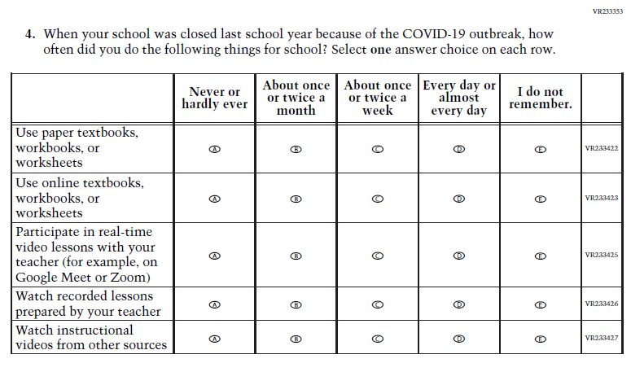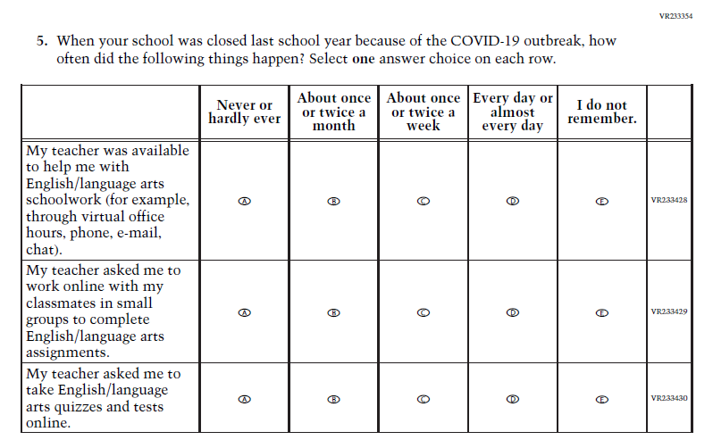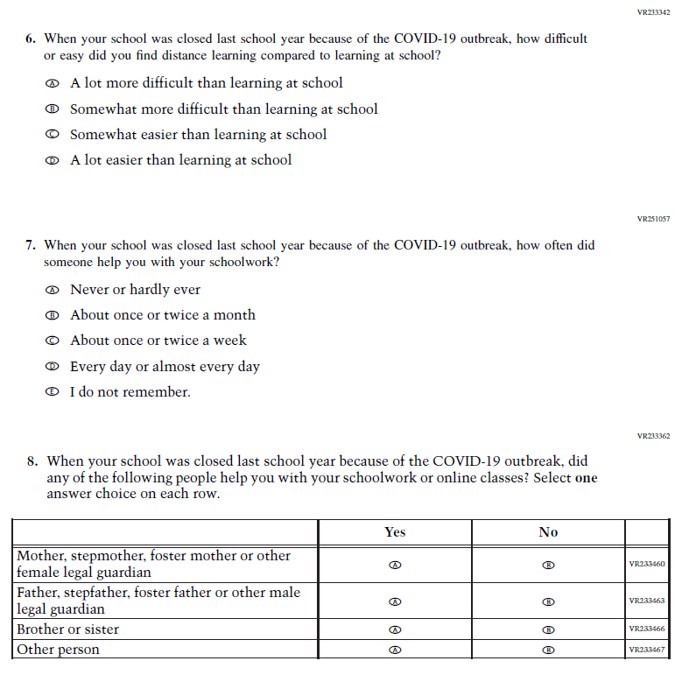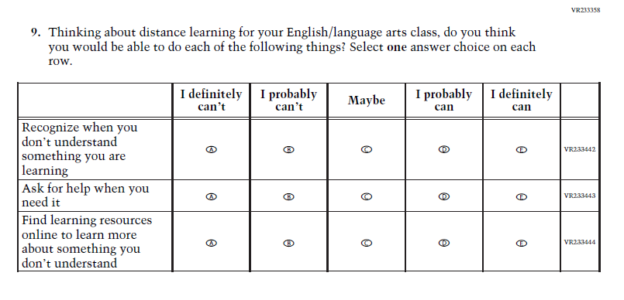

### **Appendix J1-23**: Operational Grade 4 COVID-19 Student Items (Math)

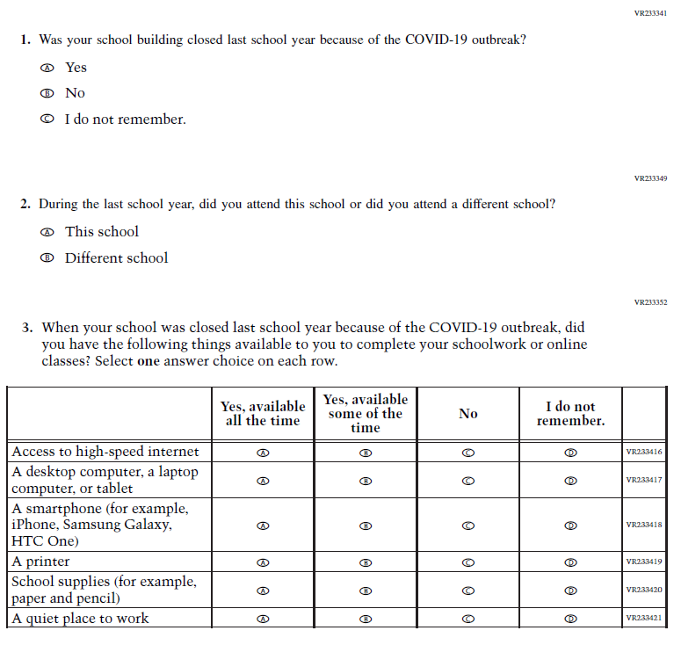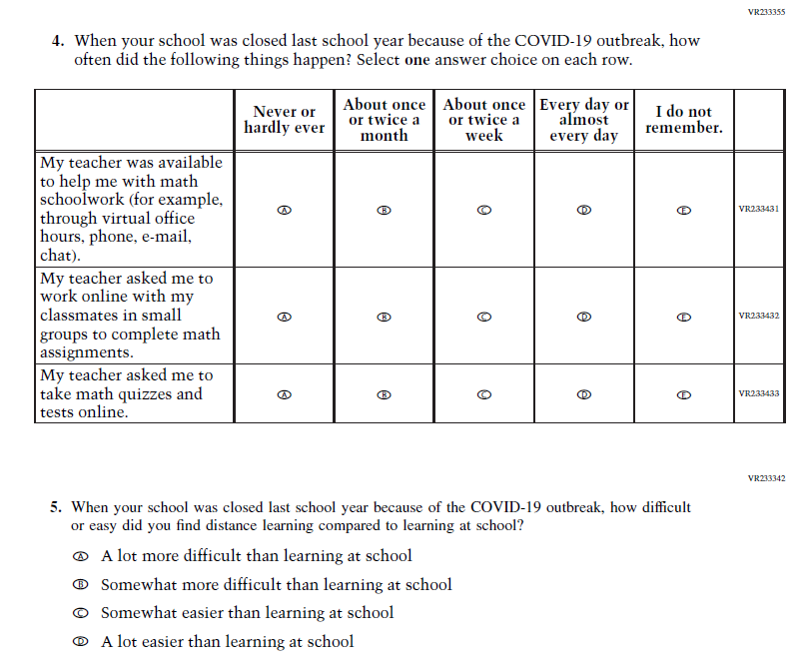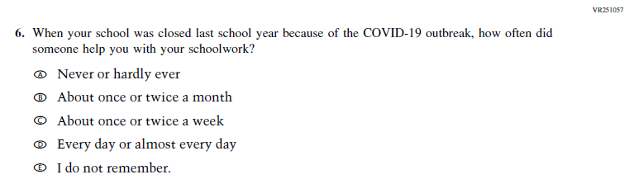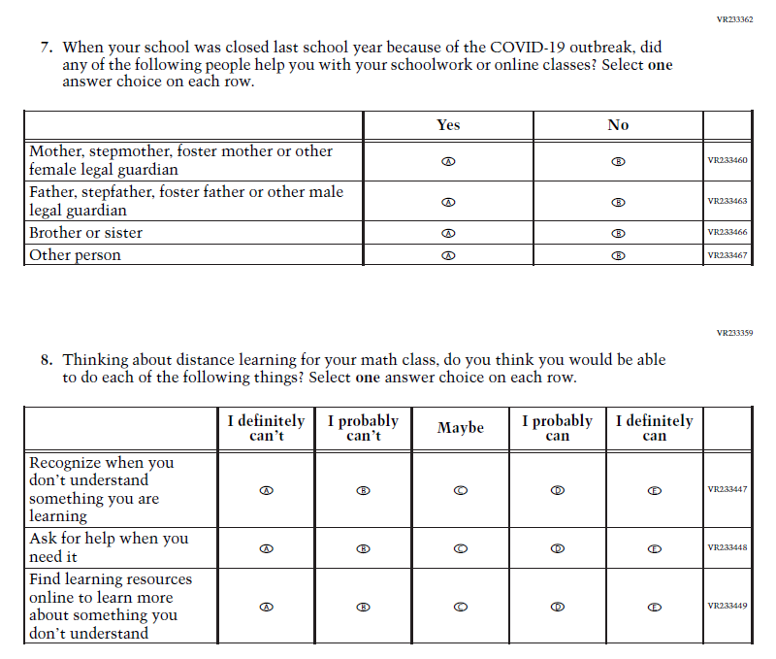

### **Appendix J1-24**: Operational Grade 8 COVID-19 Student Items (Math)

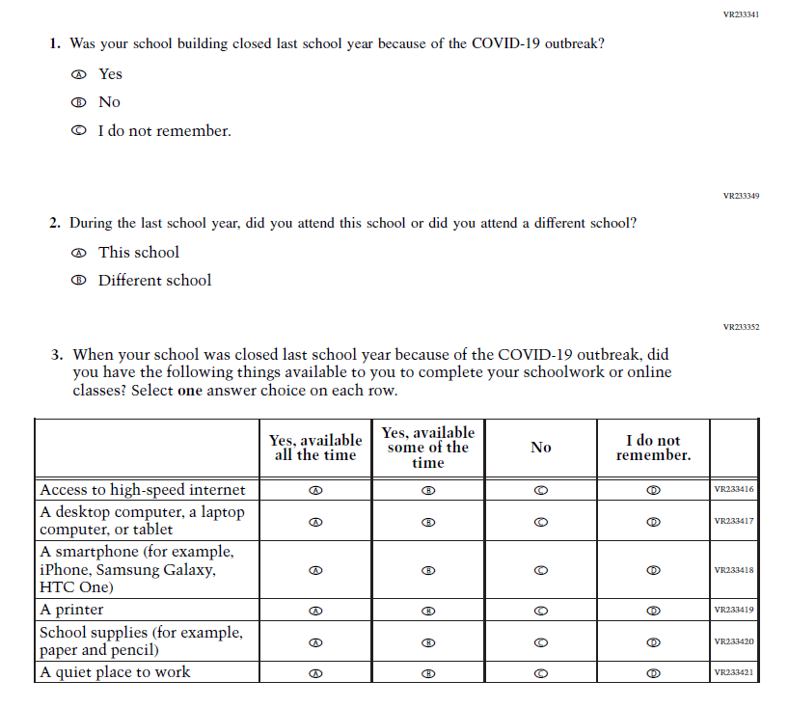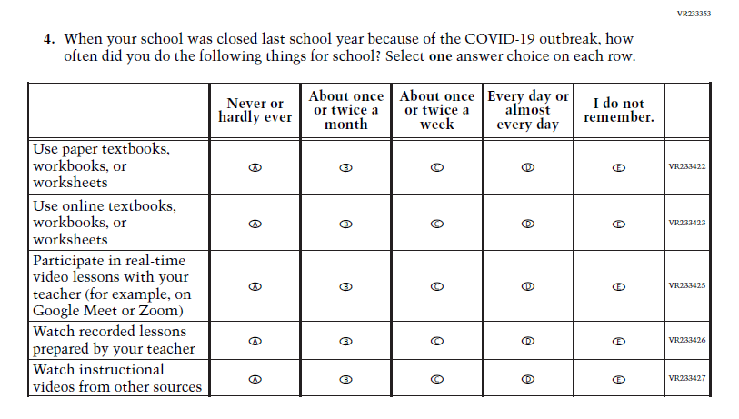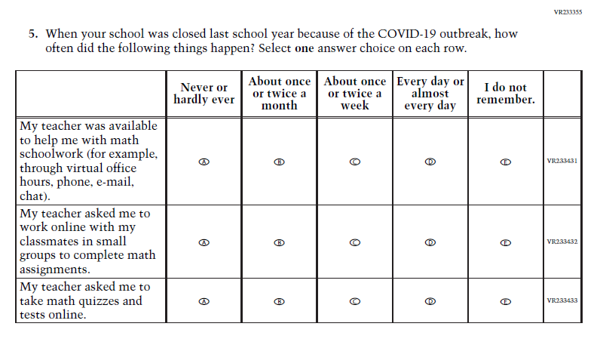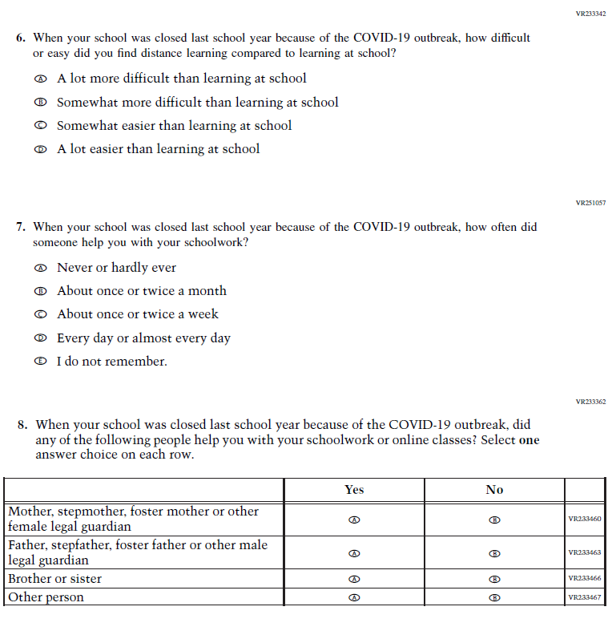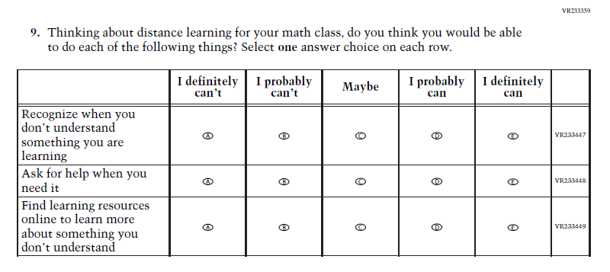

### **Appendix J1-25**: Operational Grade 8 COVID-19 Student Items (Civics)

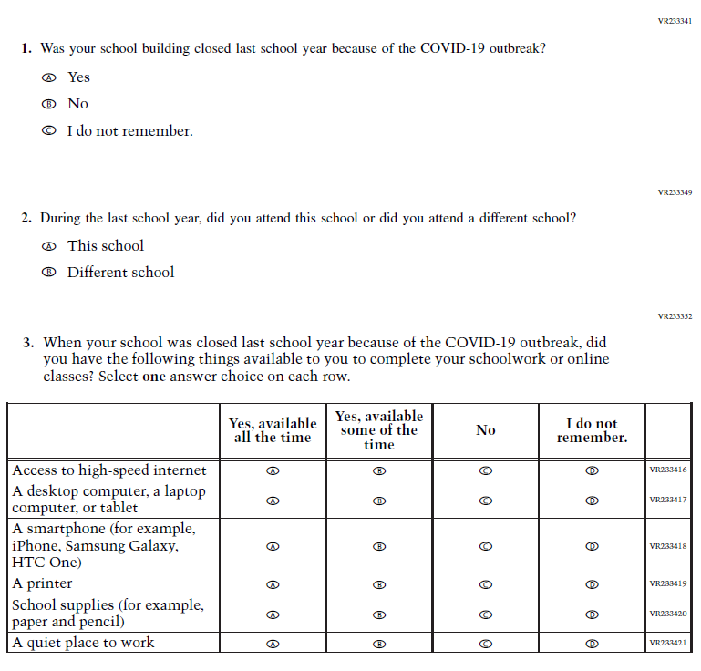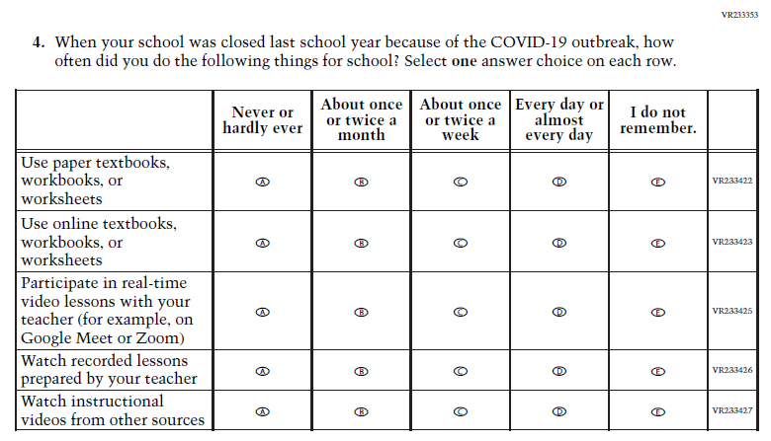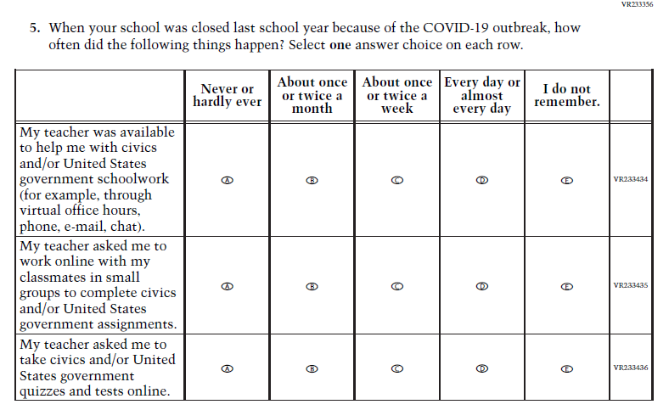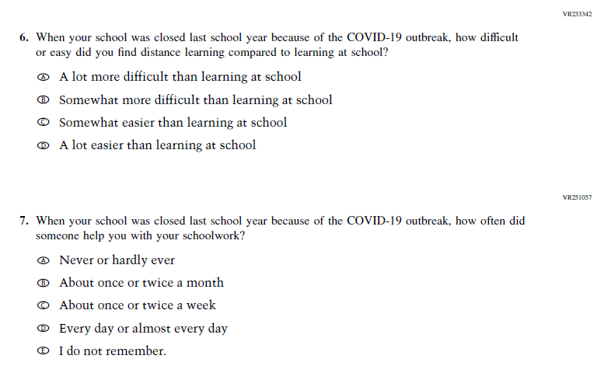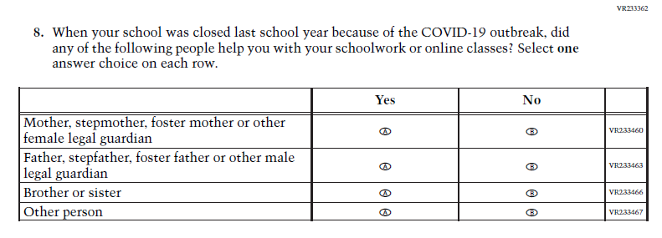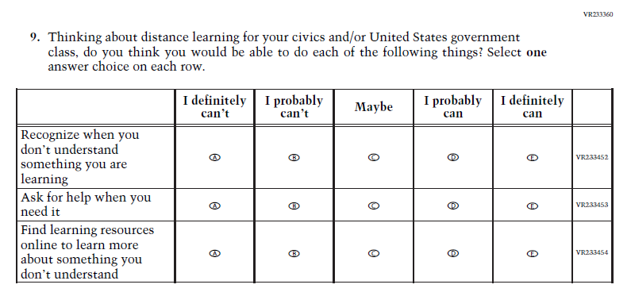

### **Appendix J1-26**: Operational Grade 8 COVID-19 Student Items (U.S. History)

