Trends in International Mathematics and Science Study (TIMSS 2023)

Field Test Data Collection and

Main Study Sampling, Recruitment, and Data Collection

OMB #1850-0695 v.17

Appendix A

Recruitment Materials

Submitted by

National Center for Education Statistics

U.S. Department of Education

June 2021

revised August 2021

**Appendix A**

**TIMSS 2023 Field Test and Main Study Recruitment Materials**

To facilitate review, each document has been marked in the header to indicate if it is new, revised, or previously approved (unchanged) from the prior package (v.16), and also specifies if the document is to be used for the field test, main study, or both.

Contents

Appendix A1 State TIMSS Letter (Option A - in-school) – revised – field test and main study 4

Appendix A1a State TIMSS Letter (Option B – recruiting while schools are virtual) – revised – field test and main study 5

Appendix A2 Endorsement Letter Template – previously approved – field test and main study 6

Appendix A3 Request for Letter of Support from Endorsing Organizations – previously approved – field test and main study 7

Appendix A4a School District TIMSS Field Test Letter (Option A - in-school) – previously approved – field test only 8

Appendix A4a1 TIMSS 2023 School District TIMSS Letter (Option A – in-school) – revised – main study only 10

Appendix A4b School TIMSS Field Test Letter (Option A - in-school) – previously approved – field test only 12

Appendix A4b.1 TIMSS 2023 School TIMSS Letter (Option A – in-school) – new – main study only 14

Appendix A4c TIMSS School Reminder Email – Grade 4 (Option A – in-school) – revised – field test and main study 15

Appendix A4d TIMSS School Reminder Email – Grade 8 (Option A – in-school) – revised – field test and main study 16

Appendix A5a District TIMSS Field Test Letter (Option B – recruiting while schools are virtual) – previously approved – field test only 17

Appendix A5a.1 District TIMSS 2023 Letter (Option B – recruiting while schools are virtual) – new – main study only 19

Appendix A5b School TIMSS Field Test Letter (Option B - recruiting while schools are virtual) – previously approved – field test only 21

Appendix A5b.1 School TIMSS 2023 Letter (Option B - recruiting while schools are virtual) – new – main study only 23

Appendix A5c TIMSS School Reminder Email Grade 4 – (Option B - recruiting while schools are virtual) – revised – field test and main study 25

Appendix A5d TIMSS School Reminder Email – Grade 8 (Option B - recruiting while schools are virtual) – revised – field test and main study 26

Appendix A6 School Web-Enabled Agreement Emails – revised – field test and main study 27

Appendix A7 Teacher TIMSS Field Test Letter- now Appendix B12 29

Appendix A8 TIMSS 2023 Study Brochure Content: 8 ½ X 11in Tri-fold – revised – field test and main study 30

Appendix A9 TIMSS 2023 Field Test FAQ (Option A - in-school) – previously approved – field test only 32

Appendix A9.1 TIMSS 2023 FAQ (Option A - in-school) – new – main study only 34

Appendix A10 Summary of School Activities: TIMSS 2023 Field Test – previously approved – field test only 36

Appendix A10.1 Summary of School Activities: TIMSS 2023 – new –main study only 37

Appendix A11 Email reminders to districts and schools – revised – field test and main study 38

Appendix A12a School Coordinator (SC) Email to Login and Provide School Information (PSI) – revised – field test and main study 43

Appendix A12b TIMSS 2023 Login and Provide School Information (PSI) Guide – revised – field test and main study 45

Appendix A12c Automated Email for all TIMSS 2023 registrants – revised – field test and main study 48

AppendixA12d Automated Email for TIMSS 2023 School Coordinator registrant – revised – field test and main study 49

Appendix A12e TIMSS 2023 Student-Teacher Linkage Form (STLF) Email – revised (was 14a) – field test and main study 50

AppendixA12f TIMSS 2023 Student Tracking Form (STF) Email – revised (was 14b) – field test and main study 51

Appendix A12g Instructions for TIMSS 2023 Student Tracking Form (STF) – revised – field test and main study 52

AppendixA13a TIMSS 2023 Portal Home Page – revised – field test and main study 53

AppendixA13b TIMSS 2023 Provide School Information (PSI) Page – revised – field test and main study 54

Appendix A13c TIMSS 2023 Prepare for Assessment Page – revised – field test and main study 56

Appendix A13d Student-Teacher Linkage Form (STLF) Template – Grade 4 vs. Grade 8 – previously approved – field test and main study 57

Appendix A13e Web-Enabled Agreement – new – field test and main study 59

Appendix A14a TIMSS 2023 Website Main Page – revised – field test and main study 60

AppendixA14b TIMSS 2023 Documents Page – revised – field test and main study 61

AppendixA14c TIMSS 2023 Website: Resources, Newsletters & Reports, and Contact Us Pages – new – field test and main study 62

AppendixA15a School Principal Questionnaire Login Card/Email- now Appendix B15 64

AppendixA15b Teacher Questionnaire Selection Email- Now Appendix B13 64

AppendixA15c Teacher Questionnaire Reminder Email- removed 64

AppendixA16 Online Questionnaire Login Screen Text – previously approved – field test and main study 65

AppendixA17a Student Certificate of Completion – previously approved – field test and main study 66

AppendixA17b School Certificate of Completion – previously approved – field test and main study 67

Appendix A18 Email to School Coordinator to Submit Class– Grade 4 – revised – field test and main study 68

Appendix A18a Instructions for Submitting Class Lists – Grade 4 – revised – field test and main study 69

Appendix A18b Email to School Coordinator to Submit Student-Teacher Linkage Form – Grade 4 – new – field test and main study 72

Appendix A18c Instructions for Submitting Student-Teacher Linkage Forms – Grade 4 – new – field test and main study 73

Appendix A19 Email to School Coordinator to Submit Class – Grade 8 – revised – field test and main study 75

Appendix A19a Instructions for Submitting Class Lists – Grade 8 – revised – field test and main study 76

Appendix A19b Email to School Coordinator to Submit Student-Teacher Linkage Form – Grade 8 – new – field test and main study 79

Appendix A19c Instructions for Submitting Student-Teacher Linkage Forms – Grade 8 – new – field test and main study 80

Appendix A20 TIMSS 2023 COVID-19 Protocols – revised – field test and main study 82

Appendix A21 TIMSS 2023 School Posters – new – field test and main study 84

## Appendix A1 State TIMSS Letter (Option A - in-school) – revised – field test and main study

<Title First Name Last Name> <Date>

<National Education Organization Official’s Title>

<National Education Organization>

<Address>

<City, State Zip>

Dear <Name>:

The United States is participating in an important international study: Trends in International Mathematics and Science Study 2023 (TIMSS). Over the past 28 years, TIMSS has measured U.S. students’ science and mathematics achievement in an international context. TIMSS’ high quality, internationally comparative trend data provide critical information to inform education policy discussions and monitor educational inequalities (e.g., socioeconomic, racial/ethnic, and gender) within and across countries.

*TIMSS data can help identify student misunderstandings of key math and science principles. Findings can also be used to identify attitudes and characteristics of high-performing and especially resilient students.*

Schools in your state have been selected to participate in <the TIMSS 2023 field test/TIMSS 2023> which **will occur in the spring of <2022/2023>.**

**Please partner with us by learning more about TIMSS and encouraging participation of your states’ districts and schools that are selected to represent the U.S. in this study.** Your support shows how important this research is and can increase participation and success of the study.

**Next steps:** Review the enclosed materials to learn more about TIMSS. Support TIMSS by providing a letter of support and sharing information about the study with your sampled districts and schools.

We are in contact with your state assessment director and NAEP State Coordinator to keep them informed about <the TIMSS field test/TIMSS>. You may contact RTI International project staff with questions at 833-870-0485 or TIMSS@rti.org. You may also contact TIMSS Project Officer Lydia Malley at the National Center for Educational Statistics at [lydia.malley@ed.gov](mailto:lydia.malley@ed.gov) or (202) 245-7266.

Thank you for your support of this research and your help to ensure that the United States has a representative sample of schools across the country.

Sincerely,

Peggy G. Carr, Ph.D.

Commissioner, National Center for Education Statistics

cc: <State assessment director> <NAEP State Coordinator>

Enclosures: TIMSS Brochure and Frequently Asked Questions (FAQs) sheet

The National Center for Education Statistics (NCES) is authorized to conduct this study under the Education Sciences Reform Act of 2002 (ESRA 2002, 20 U.S.C. §9543), and to collect students’ education records from educational agencies or institutions for the purpose of evaluating federally supported education programs under the Family Educational Rights and Privacy Act (FERPA, 34 CFR §§ 99.31(a)(3)(iii) and 99.35). All of the information you provide may be used only for statistical purposes and may not be disclosed, or used, in identifiable form for any other purpose except as required by law (20 U.S.C. §9573 and 6 U.S.C. §151). In the United States, TIMSS is conducted by NCES, part of the U.S. Department of Education, and the data are being collected by RTI International. The U.S. Office of Management and Budget has approved the data collection under OMB #1850-0695.

## Appendix A1a State TIMSS Letter (Option B – recruiting while schools are virtual) – revised – field test and main study

<Title First Name Last Name> <Date>

<National Education Organization Official’s Title>

<National Education Organization>

<Address>

<City, State Zip>

Dear <Name>:

The United States is participating in an important international study: Trends in International Mathematics and Science Study 2023 (TIMSS). Over the past 28 years, TIMSS has measured U.S. students’ science and mathematics achievement in an international context. TIMSS’ high quality, internationally comparative trend data provide critical information to inform education policy discussions and monitor educational inequalities (e.g., socioeconomic, racial/ethnic, and gender) within and across countries.

Schools in your state have been selected to participate in <the TIMSS 2023 field test/TIMSS 2023>. We realize these are unprecedented times, and we are very aware of the strain the coronavirus pandemic has put on schools’ plans to deliver meaningful learning experiences to students while operating in a virtual environment. We are reaching out to you now with the expectation TIMSS will take place in on-campus classroom settings in spring <2022/2023>.

**Please partner with us by learning more about TIMSS and encouraging participation of your states’ districts and schools that are selected to represent the U.S. in this study.** Your support shows how important this research is and can increase participation and success of the study.

**Next steps:** Review the enclosed materials to learn more about TIMSS. Support TIMSS by providing a letter of support and sharing information about the study with your sampled districts and schools.

We are in contact with your state assessment director and NAEP State Coordinator to keep them informed about <the TIMSS field test/TIMSS>. You may contact RTI International project staff with questions at 833-870-0485 or TIMSS@rti.org. You may also contact TIMSS Project Officer Lydia Malley at the National Center for Educational Statistics at [lydia.malley@ed.gov](mailto:lydia.malley@ed.gov) or (202) 245-7266.

Thank you for your support of this research and your help to ensure that the United States has a representative sample of schools across the country.

Sincerely,

Peggy G. Carr, Ph.D.

Commissioner, National Center for Education Statistics

cc: <State assessment director> <NAEP State Coordinator>

Enclosures: TIMSS Brochure and Frequently Asked Questions (FAQs) sheet

*The National Center for Education Statistics (NCES) is authorized to conduct this study under the Education Sciences Reform Act of 2002 (ESRA 2002, 20 U.S.C. §9543), and to collect students’ education records from educational agencies or institutions for the purpose of evaluating federally supported education programs under the Family Educational Rights and Privacy Act (FERPA, 34 CFR §§ 99.31(a)(3)(iii) and 99.35). All of the information you provide may be used only for statistical purposes and may not be disclosed, or used, in identifiable form for any other purpose except as required by law (20 U.S.C. §9573 and 6 U.S.C. §151). In the United States, TIMSS is conducted by NCES, part of the U.S. Department of Education, and the data are being collected by RTI International. The U.S. Office of Management and Budget has approved the data collection under OMB #1850-0695.*

## Appendix A2 Endorsement Letter Template – previously approved – field test and main study

State Department of Education/ National Education Organization Letterhead

<Date>

<State CSSO/Executive Director/CEO Name>

<Title>

<Organization Name>

<Address>

<City, State Zip>

Dear <Organization Members>:

On behalf of the <INSERT STATE EDUCATION AGENCY OR ORGANIZATION> we are pleased to support; **Trends in International Mathematics and Science Study 2023 (TIMSS)** being conducted by the National Center for Education Statistics (NCES) within the Institute of Education Sciences (IES) of the U.S. Department of Education (ED). We understand it is the NCES’ goal in conducting this study to provide valuable comparative information about the U.S. population’s educational performance, competencies, and skills in an international context.

This study compliments our <vision/mission/goal> of_____________________________________________ ________________________________________________________________________________________.

TIMSS assesses mathematics and science knowledge and skills at grades 4 and 8 and is designed to align broadly with curricula in the participating countries. The results, therefore, suggest the degree to which students have learned concepts and skills likely to have been taught in school. Data compiled and collected from TIMSS 2023 allows for evidence-based decisions to be made for the purposes of educational improvement.

Collection of these data is not possible without the participation of selected school districts and schools. By participating in the study, you are providing trend information about student achievement in mathematics and science relative to other countries, as well as indicators that show how this achievement relates to demographic and curricular, school, teacher, and student factors that provide the educational context for achievement.

We strongly encourage your participation in TIMSS 2023. <STATE ED AGENCY: **We are confident that schools in our state will understand the importance of this international study and will accept the invitation to participate if selected.> <**NATIONAL ED ORGANIZATION: **We are confident that our members and partners, and state and local education leadership will understand the importance of this national study and will accept the invitation to participate if selected.>**

Should you have any questions, please call the TIMSS information number, (833) 870-0485, or send an email to TIMSS@rti.org. You may also contact Lydia Malley at NCES at [lydia.malley@ed.gov](mailto:lydia.malley@ed.gov) (202) 245-7266 for more information.

Thank you for your dedication to education research and your help in making TIMSS 2023 a success.

Sincerely,

<Name>

Education Commissioner/Superintendent/Executive Director

State Education Agency/ Organization Name

*The National Center for Education Statistics (NCES) is authorized to conduct this study under the Education Sciences Reform Act of 2002 (ESRA 2002, 20 U.S.C. §9543), and to collect students’ education records from educational agencies or institutions for the purpose of evaluating federally supported education programs under the Family Educational Rights and Privacy Act (FERPA, 34 CFR §§ 99.31(a)(3)(iii) and 99.35). All of the information you provide may be used only for statistical purposes and may not be disclosed, or used, in identifiable form for any other purpose except as required by law (20 U.S.C. §9573 and 6 U.S.C. §151). In the United States, TIMSS is conducted by NCES, part of the U.S. Department of Education, and the data are being collected by RTI International. The U.S. Office of Management and Budget has approved the data collection under OMB #1850-0695.*

## Appendix A3 Request for Letter of Support from Endorsing Organizations – previously approved – field test and main study

<Date>

Dear Executive Director:

We are writing to request support from your organization for the **Trends in International Mathematics and Science Study 2023 (TIMSS**), which in the United States is conducted by the National Center for Education Statistics (NCES) within the Institute of Education Sciences (IES) of the U.S. Department of Education (ED).

Over the past 28 years, TIMSS has measured U.S. students‘ science and mathematics achievement in an international context. TIMSS’ high quality, internationally comparative trend data provide critical information to inform education policy discussions and monitor educational inequalities (e.g., socioeconomic, racial/ethnic, and gender) within and across countries.

*Use of TIMSS data can help identify how students are misunderstanding key math and science principles. Findings can be used to enhance curriculum of foundational items to improve student understanding nationally.*

**Please partner with us by learning more about TIMSS and encouraging participation of schools that are selected to represent the U.S. educational experience in this study.** Your support and a letter of endorsement shows how important this research is and can increase participation and success of the study. Without school participation, the validity of national estimates is at risk.

**Next steps:** Support TIMSS by lending your logo and name, providing a letter of endorsement, and sharing information about the study with your members and partners.

*Results from TIMSS will give policymakers, researchers, and educators information they need to chart national progress against international standards and inform national discussions about international competitiveness.*

Should you have any questions please call the TIMSS information number, 833-870-0485, or send an email to TIMSS@rti.org. You may also contact Lydia Malley at NCES at [lydia.malley@ed.gov](mailto:lydia.malley@ed.gov) or (202) 245-7266. Thank you for your support of this research and your partnership in helping us to advance the quality of education for all our students.

Sincerely,

Peggy G. Carr, Ph.D.

Commissioner, National Center for Education Statistics

Enclosures: TIMSS Brochure and Frequently Asked Questions (FAQs) sheet

*The National Center for Education Statistics (NCES) is authorized to conduct this study under the Education Sciences Reform Act of 2002 (ESRA 2002, 20 U.S.C. §9543), and to collect students’ education records from educational agencies or institutions for the purpose of evaluating federally supported education programs under the Family Educational Rights and Privacy Act (FERPA, 34 CFR §§ 99.31(a)(3)(iii) and 99.35). All of the information you provide may be used only for statistical purposes and may not be disclosed, or used, in identifiable form for any other purpose except as required by law (20 U.S.C. §9573 and 6 U.S.C. §151). In the United States, TIMSS is conducted by NCES, part of the U.S. Department of Education, and the data are being collected by RTI International. The U.S. Office of Management and Budget has approved the data collection under OMB #1850-0695.*

## Appendix A4a School District TIMSS Field Test Letter (Option A - in-school) – previously approved – field test only

<Date>

<DistrictName>

One-day data collection: spring 2022

On average, 1-2 classrooms per school are selected.

Study will provide equipment and staff for student data collection.

**TIMSS fIELD TEST SNAPSHOT**

<Address>

<CitySTZip>

Dear <Superintendent>,

The United States is participating in an important international study: Trends in International Mathematics and Science Study 2023 (TIMSS). Over the past 28 years, TIMSS has measured U.S. students’ science and mathematics achievement in an international context. TIMSS’ high quality, internationally comparative trend data provide critical information to inform education policy discussions and monitor educational inequalities (e.g., socioeconomic, racial/ethnic, and gender) within and across countries.

One or more schools in your <district/diocese> has been selected to represent the United States in the TIMSS 2023 field test to occur in **spring 2022** **(see enclosure for school list)**.

**Benefits of TIMSS 2023 include:**

* Schools will receive $200 or nonmonetary equivalent value
* If allowed, teachers will receive a monetary compensation for completing a web-based survey
  + No-cost interactive webinars on timely topics such as social and emotional learning, project-based learning, or STEM for eligible <district/diocese> and school staff.
  + A certificate of service from the U.S. Department of Education for participating students and staff.

Within a few days, study materials will be sent to selected schools in your <district/diocese> and our contractor, RTI International, will contact them to coordinate their participation. <Name>, your NAEP State Coordinator, may contact your staff with additional information.

If you have any questions, please do not hesitate to call 833-870-0485 or send an email to [TIMSS@rti.org](mailto:TIMSS@rti.org) or the U.S. National Research Coordinator: Lydia.Malley@ed.gov.

Sincerely,

<State CSSO> or

<Peggy G. Carr, Ph.D.,

Commissioner, National Center for Education Statistics>

Enclosures: TIMSS Brochure, Frequently Asked Questions (FAQs) sheet, State Letter of Endorsement (if provided), List of Sampled Schools

*The National Center for Education Statistics (NCES) is authorized to conduct this study under the Education Sciences Reform Act of 2002 (ESRA 2002, 20 U.S.C. §9543), and to collect students’ education records from educational agencies or institutions for the purpose of evaluating federally supported education programs under the Family Educational Rights and Privacy Act (FERPA, 34 CFR §§ 99.31(a)(3)(iii) and 99.35). All of the information you provide may be used only for statistical purposes and may not be disclosed, or used, in identifiable form for any other purpose except as required by law (20 U.S.C. §9573 and 6 U.S.C. §151). In the United States, TIMSS is conducted by NCES, part of the U.S. Department of Education, and the data are being collected by RTI International. The U.S. Office of Management and Budget has approved the data collection under OMB #1850-0695.*

**Please partner with us by encouraging participation of your schools that are selected to represent the U.S. in TIMSS.** **Your support can show the importance of this mission critical research.**

Within the next few days, a representative of RTI International will contact the following school or schools in your <district/diocese> that have been selected for the field test.

|  |  |
| --- | --- |
| School name |  |
|  |  |
|  |  |
|  |  |

<IF APPLICABLE: We **may** also contact <LIST REPLACEMENT SCHOOLS HERE>.>

|  |  |
| --- | --- |
| School name |  |
|  |  |
|  |  |
|  |  |

## Appendix A4a1 TIMSS 2023 School District TIMSS Letter (Option A – in-school) – revised – main study only

<Date>

One time data collection point: spring 2023

On average, 1-2 classrooms per school will be selected.

Study will provide equipment and staff for student data collection.

**TIMSS SNAPSHOT**

<DistrictName>

<Address>

<CitySTZip>

Dear <Superintendent>,

The United States is participating in an important international study: Trends in International Mathematics and Science Study 2023 (TIMSS). Over the past 28 years, TIMSS has measured U.S. students’ science and mathematics achievement in an international context. TIMSS’ high quality, internationally comparative trend data provide critical information to inform education policy discussions and monitor educational inequalities (e.g., socioeconomic, racial/ethnic, and gender) within and across countries.

One or more schools in your <district/diocese> has been selected to represent the United States in TIMSS to occur in **spring 2023** **(see enclosure for school list)**.

**Benefits of TIMSS 2023 include:**

* Schools will receive <$200/$800> or nonmonetary equivalent value
* If allowed, teachers will receive monetary compensation for completing a web-based survey
* A school-level report for schools with sufficient participation
* No-cost interactive webinars on timely topics such as social and emotional learning, project-based learning, or STEM for eligible <district/diocese> and school staff.
* A certificate of service from the U.S. Department of Education for participating students and staff.

Within a few days study materials will be sent to selected schools in your <district/diocese>, and our contractor RTI International will contact them to participate. <Name>, your NAEP State Coordinator, may contact your staff with additional information.

If you have any questions, please do not hesitate to call 833-870-0485 or send an email to [TIMSS@rti.org](mailto:TIMSS@rti.org) or the U.S. National Research Coordinator: Lydia.Malley@ed.gov.

Sincerely,

<State CSSO> or

<Peggy G. Carr, Ph.D.,

Commissioner,

National Center for Education Statistics>

Enclosures: TIMSS Brochure, Frequently Asked Questions (FAQs) sheet, State Letter of Endorsement (if provided), List of Sampled Schools

*The National Center for Education Statistics (NCES) is authorized to conduct this study under the Education Sciences Reform Act of 2002 (ESRA 2002, 20 U.S.C. §9543), and to collect students’ education records from educational agencies or institutions for the purpose of evaluating federally supported education programs under the Family Educational Rights and Privacy Act (FERPA, 34 CFR §§ 99.31(a)(3)(iii) and 99.35). All of the information you provide may be used only for statistical purposes and may not be disclosed, or used, in identifiable form for any other purpose except as required by law (20 U.S.C. §9573 and 6 U.S.C. §151). In the United States, TIMSS is conducted by NCES, part of the U.S. Department of Education, and the data are being collected by RTI International. The U.S. Office of Management and Budget has approved the data collection under OMB #1850-0695.*

**Please partner with us by encouraging participation of your schools that are selected to represent the U.S. in TIMSS.** **Your support can show the importance of this mission critical research.**

Within the next few days, a representative of RTI International will contact the following school or schools in your <district/diocese> that have been selected for TIMSS 2023.

|  |  |
| --- | --- |
| School name |  |
|  |  |
|  |  |
|  |  |

<IF APPLICABLE: We **may** also contact <LIST REPLACEMENT SCHOOLS HERE>

|  |  |
| --- | --- |
| School name |  |
|  |  |
|  |  |
|  |  |

## Appendix A4b School TIMSS Field Test Letter (Option A - in-school) – previously approved – field test only

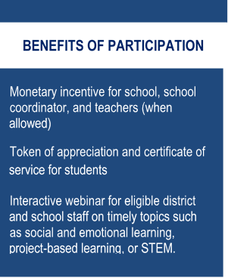<Principal name> <Date>

<school name>

<address>

<city> <state> <zip>

Dear <Principal Name>,

The United States is participating in an important international study: Trends in International Mathematics and Science Study 2023 (TIMSS). Over the past 28 years, TIMSS has measured U.S. students’ science and mathematics achievement in an international context. TIMSS’ high quality, internationally comparative, trend data provide critical information to inform education policy discussions and monitor educational inequalities (e.g., socioeconomic, racial/ethnic, and gender) within and across countries.

Your school has been randomly selected to represent schools across the United States by participating in the TIMSS 2023 field test to occur in **spring 2022**. Please put this assessment window date on your 2021-2022 school calendar. The purpose of the field test is to determine whether TIMSS questions are valid and fair for U.S. students and to help ensure that the TIMSS field operations will be effective for the main study in 2023. Students will take the assessment digitally on equipment supplied by the TIMSS 2023 Field Test Team.

Your district has been notified of your selection. Within the next few weeks, [Name of representative], a representative from TIMSS, will contact you to discuss your participation and obtain the name of your school coordinator (SC).

**Next Steps:**

* Review the enclosed study materials
* Write down the name and email address of your school coordinator (SC)
* You will receive a call in the next few days to discuss the study and provide the name of your SC
* If you prefer to contact us first, we can be reached at 833-870-0485 or TIMSS@rti.org

Your participation in TIMSS 2023 is very important to its success. To meet the rigorous standard of TIMSS data, we need to ensure that students in schools like yours are represented in our evaluation of assessment items and questionnaires. Thank you for your time and for supporting this important international study.

Sincerely,

< NAEP State Coordinator or Peggy G. Carr, Ph.D., Commissioner, National Center for Education Statistics>

cc: <District Test Coordinator>

Enclosures: TIMSS Brochure, Frequently Asked Questions (FAQs) sheet, State Letter of Endorsement (if provided)

*The National Center for Education Statistics (NCES) is authorized to conduct this study under the Education Sciences Reform Act of 2002 (ESRA 2002, 20 U.S.C. §9543), and to collect students’ education records from educational agencies or institutions for the purpose of evaluating federally supported education programs under the Family Educational Rights and Privacy Act (FERPA, 34 CFR §§ 99.31(a)(3)(iii) and 99.35). All of the information you provide may be used only for statistical purposes and may not be disclosed, or used, in identifiable form for any other purpose except as required by law (20 U.S.C. §9573 and 6 U.S.C. §151). In the United States, TIMSS is conducted by NCES, part of the U.S. Department of Education, and the data are being collected by RTI International. The U.S. Office of Management and Budget has approved the data collection under OMB #1850-0695.*

## Appendix A4b.1 TIMSS 2023 School TIMSS Letter (Option A – in-school) – new – main study only

<Principal name> <Date>

<school name>

Monetary incentive for school, school coordinator, and teachers (when allowed)

Token of appreciation and certificate of service for students

Interactive webinar for eligible district and school staff on timely topics such as social and emotional learning, project-based learning, or STEM

School-level report for schools with sufficient participation

**Benefits of Participation**

<address>

<city> <state> <zip>

Dear <Principal Name>,

The United States is participating in an important international study: Trends in International Mathematics and Science Study 2023 (TIMSS). Over the past 28 years, TIMSS has measured U.S. students’ science and mathematics achievement in an international context. TIMSS’ high quality, internationally comparative, trend data provide critical information to inform education policy discussions and monitor educational inequalities (e.g., socioeconomic, racial/ethnic, and gender) within and across countries.

Your school has been randomly selected to represent schools across the United States by participating in TIMSS to occur in **spring 2023**. Please put this assessment window date on your 2022-2023 school calendar. TIMSS measures trends in academic achievement at grades 4 and 8 in countries around the world. Students will take the assessment digitally on equipment supplied by the TIMSS team.

Your district has been notified of your selection. Within the next few weeks, [Name of representative], a representative from TIMSS, will contact you to discuss your participation and obtain the name of your school coordinator (SC).

**Next Steps:**

* Review the enclosed study materials
* Write down the name and email address of your school coordinator (SC)
* You will receive a call in the next few days to discuss the study and provide the name of your SC
* If you prefer to contact us first, we can be reached at 833-870-0485 or [TIMSS@rti.org](mailto:TIMSS@rti.org)

Your participation in TIMSS 2023 is very important to its success. To meet the rigorous standard of TIMSS data, we need to ensure that students in schools like yours are represented in our evaluation of assessment items and questionnaires. Thank you for your time and for supporting this important international study.

Sincerely,

<NAEP State Coordinator or Peggy G. Carr, Ph.D., Commissioner, National Center for Education Statistics>

cc: <District Test Coordinator>

Enclosures: TIMSS Brochure, Frequently Asked Questions (FAQs) sheet, State Letter of Endorsement (if provided)

*The National Center for Education Statistics (NCES) is authorized to conduct this study under the Education Sciences Reform Act of 2002 (ESRA 2002, 20 U.S.C. §9543), and to collect students’ education records from educational agencies or institutions for the purpose of evaluating federally supported education programs under the Family Educational Rights and Privacy Act (FERPA, 34 CFR §§ 99.31(a)(3)(iii) and 99.35). All of the information you provide may be used only for statistical purposes and may not be disclosed, or used, in identifiable form for any other purpose except as required by law (20 U.S.C. §9573 and 6 U.S.C. §151). In the United States, TIMSS is conducted by NCES, part of the U.S. Department of Education, and the data are being collected by RTI International. The U.S. Office of Management and Budget has approved the data collection under OMB #1850-0695.*

## Appendix A4c TIMSS School Reminder Email – Grade 4 (Option A – in-school) – revised – field test and main study

Dear Principal:

Earlier this year, <<our team/<NSC> from <SEA>> communicated with you regarding your participation in the Trends in International Mathematics and Science Study (TIMSS) <field test>. TIMSS assesses mathematics and science knowledge and skills at grades 4 and 8 and is designed to align broadly with curricula in the participating countries. This is a friendly reminder that RTI International will be contacting you in the coming weeks to coordinate your school’s data collection logistics.

If you have already identified who will serve as your School Coordinator (SC), and communicated the information to us, thank you very much. If you have not chosen someone to serve as the study SC, please identify someone in the next few days to work with us. Please click the link below to register your school for TIMSS and to designate your SC or you may send an email to [TIMSS@rti.org](mailto:TIMSS@rti.org) with the name of your school and the SC’s name and contact information. RTI will do all that we can to minimize the burden on school staff and resources.

<Insert web agreement link> {see Appendix A13e}

We realize these are unprecedented times, and we are very aware of the strain the coronavirus pandemic has put on schools’ plans to deliver meaningful learning experiences. We are reaching out to you now with the expectation that TIMSS will take place in on-campus classroom settings in spring <2022/2023>. We have multiple ways to conduct the student assessment in order to be responsive to each school’s unique instruction schedule.

Students in one or two of your 4th grade math classes will be selected to participate, with <the TIMSS field test/TIMSS> scheduled to take place on <**Date**>. If these dates are not convenient for your school, RTI will work with you to find an alternate date. Also, one school administrator and the math teacher(s) of the selected classroom(s) will be asked to complete a web-based questionnaire.

As a token of appreciation for participating in TIMSS, your school will receive <$200/$800>. Students who participate in TIMSS will receive a small gift as a token of appreciation. Your school’s TIMSS SC, (the staff person you designate to liaise with TIMSS project staff) will receive $100 for his or her time and effort coordinating TIMSS activities. Selected teachers will receive $25 for completing a brief questionnaire.

If you have any questions, please do not hesitate to contact the TIMSS team at 833-870-0485 or email: [TIMSS@rti.org](mailto:TIMSS@rti.org). Further information about TIMSS may be found by visiting the TIMSS website at [https://surveys.nces.ed.gov/TIMSS](https://nam04.safelinks.protection.outlook.com/?url=https%3A%2F%2Fsurveys.nces.ed.gov%2FTIMSS&data=04%7C01%7Csecarter%40rti.org%7C457b5d87a5524febf6e808d921cd05ed%7C2ffc2ede4d4449948082487341fa43fb%7C0%7C0%7C637577986716150264%7CUnknown%7CTWFpbGZsb3d8eyJWIjoiMC4wLjAwMDAiLCJQIjoiV2luMzIiLCJBTiI6Ik1haWwiLCJXVCI6Mn0%3D%7C1000&sdata=ytt4aAncwGfsMQVPsqBaD9XQoKzTtrY%2FXJxRpT2NTy4%3D&reserved=0)[.](https://surveys.nces.ed.gov/Pirls/)

Thank you for your time and for supporting this important international study.

Sincerely,

Debbie Herget

TIMSS 2023 Project Director, RTI International

*The National Center for Education Statistics (NCES) is authorized to conduct this study under the Education Sciences Reform Act of 2002 (ESRA 2002, 20 U.S.C. §9543), and to collect students’ education records from educational agencies or institutions for the purpose of evaluating federally supported education programs under the Family Educational Rights and Privacy Act (FERPA, 34 CFR §§ 99.31(a)(3)(iii) and 99.35). All of the information you provide may be used only for statistical purposes and may not be disclosed, or used, in identifiable form for any other purpose except as required by law (20 U.S.C. §9573 and 6 U.S.C. §151). In the United States, TIMSS is conducted by NCES, part of the U.S. Department of Education, and the data are being collected by RTI International. The U.S. Office of Management and Budget has approved the data collection under OMB #1850-0695.*

## Appendix A4d TIMSS School Reminder Email – Grade 8 (Option A – in-school) – revised – field test and main study

Dear Principal:

Earlier this year, <<our team/<NSC> from <SEA>> communicated with you regarding your participation in the Trends in International Mathematics and Science Study (TIMSS) <field test>. TIMSS assesses mathematics and science knowledge and skills at grades 4 and 8 and is designed to align broadly with curricula in the participating countries. This is a friendly reminder that RTI International will be contacting you in the coming weeks to coordinate your school’s data collection logistics.

If you have already identified who will serve as your School Coordinator (SC), and communicated the information to us, thank you very much. If you have not chosen someone to serve as the study SC, please identify someone in the next few days to work with us. Please click the link below to register your school for TIMSS and to designate your SC or you may send an email to [TIMSS@rti.org](mailto:TIMSS@rti.org) with the name of your school and the SC’s name and contact information. RTI will do all that we can to minimize the burden on school staff and resources.

<Insert web agreement link> {see Appendix A13e}

We realize these are unprecedented times, and we are very aware of the strain the coronavirus pandemic has put on schools’ plans to deliver meaningful learning experiences. We are reaching out to you now with the expectation that TIMSS will take place in on-campus classroom settings in spring <2022/2023>. We have multiple ways to conduct the student assessment in order to be responsive to each school’s unique instruction schedule.

Students in one or two of your 8th grade math classes will be selected to participate, with <the TIMSS field test/TIMSS> scheduled to take place on <**Date**>. If these dates are not convenient for your school, RTI will work with you to find an alternate date. The math teacher(s) of the selected classroom(s) will be asked to complete a web-based questionnaire. TIMSS also needs a complete and current list of all of your school’s eighth-grade science teachers in order to link information about science teachers to the assessed students. One school administrator and science teachers of participating students will also be asked to complete online questionnaires.

As a token of appreciation for participating in TIMSS, your school will receive <$200/$800>. Students who participate in TIMSS will receive a small gift as a token of appreciation. Your school’s TIMSS SC (the staff person you designate to liaise with TIMSS project staff) will receive $100 for his or her time and effort coordinating TIMSS activities. Selected teachers will receive $25 for completing a brief questionnaire.

If you have any questions, please do not hesitate to contact the TIMSS team at 833-870-0485 or email: TIMSS@rti.org. Further information about TIMSS may be found by visiting the TIMSS website at [https://surveys.nces.ed.gov/TIMSS](https://nam04.safelinks.protection.outlook.com/?url=https%3A%2F%2Fsurveys.nces.ed.gov%2FTIMSS&data=04%7C01%7Csecarter%40rti.org%7C457b5d87a5524febf6e808d921cd05ed%7C2ffc2ede4d4449948082487341fa43fb%7C0%7C0%7C637577986716150264%7CUnknown%7CTWFpbGZsb3d8eyJWIjoiMC4wLjAwMDAiLCJQIjoiV2luMzIiLCJBTiI6Ik1haWwiLCJXVCI6Mn0%3D%7C1000&sdata=ytt4aAncwGfsMQVPsqBaD9XQoKzTtrY%2FXJxRpT2NTy4%3D&reserved=0).

Thank you for your time and for supporting this important international study.

Sincerely,

Debbie Herget

TIMSS 2023 Project Director, RTI International

*The National Center for Education Statistics (NCES) is authorized to conduct this study under the Education Sciences Reform Act of 2002 (ESRA 2002, 20 U.S.C. §9543), and to collect students’ education records from educational agencies or institutions for the purpose of evaluating federally supported education programs under the Family Educational Rights and Privacy Act (FERPA, 34 CFR §§ 99.31(a)(3)(iii) and 99.35). All of the information you provide may be used only for statistical purposes and may not be disclosed, or used, in identifiable form for any other purpose except as required by law (20 U.S.C. §9573 and 6 U.S.C. §151). In the United States, TIMSS is conducted by NCES, part of the U.S. Department of Education, and the data are being collected by RTI International. The U.S. Office of Management and Budget has approved the data collection under OMB #1850-0695.*

## Appendix A5a District TIMSS Field Test Letter (Option B – recruiting while schools are virtual) – previously approved – field test only

**One-time data collection point: spring 2022**

**On average, 1-2 classrooms per school will be selected**

**Study will provide equipment and staff for student data collection**.

**TIMSS fIELD TEST SNAPSHOT**

<Title First Name Last Name> <Date>

<DistrictName>

<Address>

<CitySTZip>

Dear <Superintendent>,

The United States is participating in an important international study: Trends in International Mathematics and Science Study 2023 (TIMSS). Over the past 28 years, TIMSS has measured U.S. students’ science and mathematics achievement in an international context. TIMSS’ high quality, internationally comparative, trend data provide critical information to inform education policy discussions and monitor educational inequalities (e.g., socioeconomic, racial/ethnic, and gender) within and across countries.

One or more schools in your <district/diocese> has been selected to represent the United States in the TIMSS 2023 field test to occur in **spring 2022** **(see enclosure for school list)**.

We realize these are unprecedented times, and we are very aware of the strain the coronavirus pandemic has put on schools’ plans to deliver meaningful learning experiences to students while operating in a virtual environment. We are reaching out to you now with the expectation that TIMSS will take place in on-campus classroom settings in spring 2022. We have multiple ways to conduct the student assessment in order to be responsive to each school’s unique instruction schedule.

**Benefits of TIMSS 2023 include:**

* Schools will receive $200 or nonmonetary equivalent value
* If allowed, teachers will receive monetary compensation for completing a web-based survey
* No-cost interactive webinars on timely topics such as social and emotional learning, project-based learning, or STEM for eligible <district/diocese> and school staff.
* A certificate of service from the U.S. Department of Education for participating students and staff.

Within a few days, study materials will be sent to selected schools in your <district/diocese>, and our contractor RTI International will contact them to coordinate their participation. <Name>, your NAEP State Coordinator, may contact your staff with additional information.

If you have any questions, please do not hesitate to call 833-870-0485 or send an email to [TIMSS@rti.org](mailto:TIMSS@rti.org) or the U.S. National Research Coordinator: Lydia.Malley@ed.gov.

Sincerely,

<State CSSO or Peggy Carr, Ph.D., Commissioner, National Center for Education Statistics>

Enclosures: TIMSS Brochure, Frequently Asked Questions (FAQs) sheet, State Letter of Endorsement (if provided), List of Sampled Schools

*The National Center for Education Statistics (NCES) is authorized to conduct this study under the Education Sciences Reform Act of 2002 (ESRA 2002, 20 U.S.C. §9543), and to collect students’ education records from educational agencies or institutions for the purpose of evaluating federally supported education programs under the Family Educational Rights and Privacy Act (FERPA, 34 CFR §§ 99.31(a)(3)(iii) and 99.35). All of the information you provide may be used only for statistical purposes and may not be disclosed, or used, in identifiable form for any other purpose except as required by law (20 U.S.C. §9573 and 6 U.S.C. §151). In the United States, TIMSS is conducted by NCES, part of the U.S. Department of Education, and the data are being collected by RTI International. The U.S. Office of Management and Budget has approved the data collection under OMB #1850-0695.*

**Please partner with us by encouraging participation of your schools that are selected to represent the U.S. in TIMSS.** **Your support can show the importance of this mission critical research.**

Within the next few days, a representative of RTI International will contact the following school or schools in your <district/diocese> that have been selected for the field test.

|  |  |
| --- | --- |
| School name |  |
|  |  |
|  |  |
|  |  |

<IF APPLICABLE: We may also contact <LIST REPLACEMENT SCHOOLS HERE>.>

|  |  |
| --- | --- |
| School name |  |
|  |  |
|  |  |
|  |  |

## Appendix A5a.1 District TIMSS 2023 Letter (Option B – recruiting while schools are virtual) – new – main study only

**One-time data collection point: spring 2023**

**On average, 1-2 classrooms per school will be selected**

**Study will provide equipment and staff for student data collection**.

**TIMSS SNAPSHOT**

<Title First Name Last Name> <Date>

<DistrictName>

<Address>

<CitySTZip>

Dear <Superintendent>,

The United States is participating in an important international study: Trends in International Mathematics and Science Study 2023 (TIMSS). Over the past 28 years, TIMSS has measured U.S. students’ science and mathematics achievement in an international context. TIMSS’ high quality, internationally comparative, trend data provide critical information to inform education policy discussions and monitor educational inequalities (e.g., socioeconomic, racial/ethnic, and gender) within and across countries.

One or more schools in your <district/diocese> has been selected represent the United States in TIMSS to occur in **spring 2023** **(see enclosure for school list)**.

We realize these are unprecedented times, and we are very aware of the strain the coronavirus pandemic has put on schools’ plans to deliver meaningful learning experiences to students while operating in a virtual environment. We are reaching out to you now with the expectation that TIMSS will take place in on-campus classroom settings in spring 2023. We have multiple ways to conduct the student assessment in order to be responsive to each school’s unique instruction schedule.

**Benefits of TIMSS 2023 include:**

* Schools will receive <$200/$800> or nonmonetary equivalent value
* If allowed, teachers will receive monetary compensation for completing a web-based survey
* A school-level report for schools with sufficient participation
* No-cost interactive webinars on timely topics such as social and emotional learning, project-based learning, or STEM for eligible <district/diocese> and school staff.
* A certificate of service from the U.S. Department of Education for participating students and staff.

Within a few days, study materials will be sent to selected schools in your <district/diocese> and our contractor, RTI International, will contact them to coordinate participation. <Name>, your NAEP State Coordinator, may contact your staff with additional information.

If you have any questions, please do not hesitate to call 833-870-0485 or send an email to [TIMSS@rti.org](mailto:TIMSS@rti.org) or the U.S. National Research Coordinator: Lydia.Malley@ed.gov.

Sincerely,

<State CSSO or Peggy G. Carr, Ph.D., Commissioner, National Center for Education Statistics>

Enclosures: TIMSS Brochure, Frequently Asked Questions (FAQs) sheet, State Letter of Endorsement (if provided), List of Sampled Schools

*The National Center for Education Statistics (NCES) is authorized to conduct this study under the Education Sciences Reform Act of 2002 (ESRA 2002, 20 U.S.C. §9543), and to collect students’ education records from educational agencies or institutions for the purpose of evaluating federally supported education programs under the Family Educational Rights and Privacy Act (FERPA, 34 CFR §§ 99.31(a)(3)(iii) and 99.35). All of the information you provide may be used only for statistical purposes and may not be disclosed, or used, in identifiable form for any other purpose except as required by law (20 U.S.C. §9573 and 6 U.S.C. §151). In the United States, TIMSS is conducted by NCES, part of the U.S. Department of Education, and the data are being collected by RTI International. The U.S. Office of Management and Budget has approved the data collection under OMB #1850-0695.*

**Please partner with us by encouraging participation of your schools that are selected to represent the U.S. in TIMSS.** **Your support can show the importance of this mission critical research.**

Within the next few days, a representative of RTI International will contact the following school or schools in your <district/diocese> that have been selected for TIMSS 2023.

|  |  |
| --- | --- |
| School name |  |
|  |  |
|  |  |
|  |  |

<IF APPLICABLE: We **may** also contact <LIST REPLACEMENT SCHOOLS HERE>.>

|  |  |
| --- | --- |
| School name |  |
|  |  |
|  |  |
|  |  |

## Appendix A5b School TIMSS Field Test Letter (Option B - recruiting while schools are virtual) – previously approved – field test only

Monetary incentive for school, school coordinator, and teachers (when allowed)

Token of appreciation and certificate of service for students

Interactive webinar for eligible district and school staff on timely topics such as social and emotional learning, project-based learning, or STEM.

**Benefits of Participation**

<Principal name> <Date>

<school name>

<address>

<city> <state> <zip>

Dear <Principal Name>,

The United States is participating in an important international study: Trends in International Mathematics and Science Study 2023 (TIMSS). Over the past 28 years, TIMSS has measured U.S. students’ science and mathematics achievement in an international context. TIMSS’ high quality, internationally comparative, trend data provide critical information to inform education policy discussions and monitor educational inequalities (e.g., socioeconomic, racial/ethnic, and gender) within and across countries.

Your school has been randomly selected to represent schools across the United States by participating in the TIMSS 2023 field test to occur in **spring 2022**. Please put this assessment window date on your 2021-2022 school calendar. The purpose of the field test is to determine whether TIMSS questions are valid and fair for U.S. students and to help ensure that the TIMSS field operations will be effective for the main study in 2023. Students will take the assessment digitally on equipment supplied by the TIMSS 2023 Field Test Team.

We realize these are unprecedented times, and we are very aware of the strain the coronavirus pandemic has put on schools’ plans to deliver meaningful learning experiences to students while operating in a virtual environment. We are reaching out to you now with the expectation that TIMSS will take place in on-campus classroom settings in spring 2022. We have multiple ways to conduct the student assessment in order to be responsive to each school’s unique instruction schedule.

Your district has been notified of your selection. Within the next few weeks, [Name of representative], a representative from TIMSS, will contact you to discuss your participation and obtain the name of your school coordinator (SC).

**Next Steps:**

* Review the enclosed study materials
* Write down the name and email address of your school coordinator (SC)
* You will receive a call in the next few days to discuss the study and provide the name of your SC
* If you prefer to contact us first, we can be reached at 833-870-0485 or TIMSS@rti.org

Your participation in TIMSS 2023 is very important to its success. To meet the rigorous standard of TIMSS data, we need to ensure that students in schools like yours are represented in our evaluation of assessment items and questionnaires. Thank you for your time and for supporting this important international study.

Sincerely,

<NAEP State Coordinator or Peggy G. Carr, Ph.D., Commissioner, National Center for Education Statistics

cc: <District Test Coordinator>

Enclosures: TIMSS Brochure, Frequently Asked Questions (FAQs) sheet, State Letter of Endorsement (if provided)

*The National Center for Education Statistics (NCES) is authorized to conduct this study under the Education Sciences Reform Act of 2002 (ESRA 2002, 20 U.S.C. §9543), and to collect students’ education records from educational agencies or institutions for the purpose of evaluating federally supported education programs under the Family Educational Rights and Privacy Act (FERPA, 34 CFR §§ 99.31(a)(3)(iii) and 99.35). All of the information you provide may be used only for statistical purposes and may not be disclosed, or used, in identifiable form for any other purpose except as required by law (20 U.S.C. §9573 and 6 U.S.C. §151). In the United States, TIMSS is conducted by NCES, part of the U.S. Department of Education, and the data are being collected by RTI International. The U.S. Office of Management and Budget has approved the data collection under OMB #1850-0695.*

## Appendix A5b.1 School TIMSS 2023 Letter (Option B - recruiting while schools are virtual) – new – main study only

Monetary incentive for school, school coordinator, and teachers (when allowed)

Token of appreciation and certificate of service for students

Interactive webinar for eligible district and school staff on timely topics such as social and emotional learning, project-based learning, or STEM

School-level report for schools with sufficient participation

**Benefits of Participation**

<Principal name> <Date>

<school name>

<address>

<city> <state> <zip>

Dear <Principal Name>,

The United States is participating in an important international study: Trends in International Mathematics and Science Study 2023 (TIMSS). Over the past 28 years, TIMSS has measured U.S. students’ science and mathematics achievement in an international context. TIMSS’ high quality, internationally comparative, trend data provide critical information to inform education policy discussions and monitor educational inequalities (e.g., socioeconomic, racial/ethnic, and gender) within and across countries.

**Your school has been randomly selected to represent schools across the United States by participating in TIMSS to occur in spring 2023**. Please put this assessment window date on your 2022-2023 school calendar.

We realize these are unprecedented times, and we are very aware of the strain the coronavirus pandemic has put on schools’ plans to deliver meaningful learning experiences to students while operating in a virtual environment. We are reaching out to you now with the expectation that TIMSS will take place in on-campus classroom settings in spring 2023. We have multiple ways to conduct the student assessment in order to be responsive to each school’s unique instruction schedule.

Your district has been notified of your selection. Within the next few weeks, [Name of representative], a representative from TIMSS, will contact you to answer any questions and obtain the name of your school coordinator (SC).

**Next Steps:**

* Review the enclosed study materials
* Write down the name and email address of your school coordinator (SC)
* You will receive a call in the next few days to discuss the study and provide the name of your SC or you can provide that information at <insert web agreement link> {see Appendix A13e}
* If you prefer to contact us first, we can be reached at 833-870-0485 or [TIMSS@rti.org](mailto:TIMSS@rti.org)

Your participation in TIMSS 2023 is very important to its success. To meet the rigorous standard of TIMSS data, we need to ensure that students in schools like yours are represented in our evaluation of assessment items and questionnaires. Thank you for your time and for supporting this important international study.

Sincerely,

<NAEP State Coordinator or Peggy G. Carr, Ph.D., Commissioner, National Center for Education Statistics>

cc: <District Test Coordinator>

Enclosures: TIMSS Brochure, Frequently Asked Questions (FAQs) sheet, State Letter of Endorsement (if provided)

*The National Center for Education Statistics (NCES) is authorized to conduct this study under the Education Sciences Reform Act of 2002 (ESRA 2002, 20 U.S.C. §9543), and to collect students’ education records from educational agencies or institutions for the purpose of evaluating federally supported education programs under the Family Educational Rights and Privacy Act (FERPA, 34 CFR §§ 99.31(a)(3)(iii) and 99.35). All of the information you provide may be used only for statistical purposes and may not be disclosed, or used, in identifiable form for any other purpose except as required by law (20 U.S.C. §9573 and 6 U.S.C. §151). In the United States, TIMSS is conducted by NCES, part of the U.S. Department of Education, and the data are being collected by RTI International. The U.S. Office of Management and Budget has approved the data collection under OMB #1850-0695.*

## Appendix A5c TIMSS School Reminder Email Grade 4 – (Option B - recruiting while schools are virtual) – revised – field test and main study

Dear Principal:

Earlier this year, <NSC> from <SEA> communicated with you regarding your participation in the Trends in International Mathematics and Science Study (TIMSS) <field test>. TIMSS assesses mathematics and science knowledge and skills at grades 4 and 8 and is designed to align broadly with curricula in the participating countries. This is a friendly reminder that RTI International will be contacting you in the coming weeks to coordinate your school’s data collection logistics.

If you have already identified who will serve as your School Coordinator (SC), and communicated the information to us, thank you very much. If you have not chosen someone to serve as the study SC, please identify someone in the next few days to work with us. Please click the link below to register your school for TIMSS and to designate your SC or you may send an email to [TIMSS@rti.org](mailto:TIMSS@rti.org) with the name of your school and the SC’s name and contact information. RTI will do all that they can to minimize the burden on school staff and resources.

<Insert Web Agreement link> {see Appendix A13e}

We realize these are unprecedented times, and we are very aware of the strain the coronavirus pandemic has put on schools’ plans to deliver meaningful learning experiences to students while operating in a virtual environment. We are reaching out to you now with the expectation that TIMSS will take place in on-campus classroom settings in spring <2022/2023>. We have multiple ways to conduct the student assessment in order to be responsive to each school’s unique instruction schedule.

Students in one or two of your 4th grade math classes will be selected to participate, with TIMSS <field test> scheduled to take place on <**Date**>. If these dates are not convenient for your school, RTI will work with you to find an alternate date. Also, one school administrator and the math teacher(s) of the selected classroom(s) will be asked to complete a web-based questionnaire.

As a token of appreciation for participating in TIMSS, your school will receive <$200/$800>. Students who participate in TIMSS will receive a small gift as a token of appreciation. Your school’s TIMSS SC, (the staff person you designate to liaise with TIMSS project staff) will receive $100 for his or her time and effort coordinating TIMSS activities. Selected teachers will receive $25 for completing a brief questionnaire.

If you have any questions, please do not hesitate to contact the TIMSS team at 833-870-0485 or email: TIMSS@rti.org. Further information about TIMSS may be found by visiting the TIMSS website at [https://surveys.nces.ed.gov/TIMSS](https://nam04.safelinks.protection.outlook.com/?url=https%3A%2F%2Fsurveys.nces.ed.gov%2FTIMSS&data=04%7C01%7Csecarter%40rti.org%7C457b5d87a5524febf6e808d921cd05ed%7C2ffc2ede4d4449948082487341fa43fb%7C0%7C0%7C637577986716150264%7CUnknown%7CTWFpbGZsb3d8eyJWIjoiMC4wLjAwMDAiLCJQIjoiV2luMzIiLCJBTiI6Ik1haWwiLCJXVCI6Mn0%3D%7C1000&sdata=ytt4aAncwGfsMQVPsqBaD9XQoKzTtrY%2FXJxRpT2NTy4%3D&reserved=0).

Thank you for your time and for supporting this important international study.

Sincerely,

Debbie Herget

TIMSS 2023 Project Director, RTI International

*The National Center for Education Statistics (NCES) is authorized to conduct this study under the Education Sciences Reform Act of 2002 (ESRA 2002, 20 U.S.C. §9543), and to collect students’ education records from educational agencies or institutions for the purpose of evaluating federally supported education programs under the Family Educational Rights and Privacy Act (FERPA, 34 CFR §§ 99.31(a)(3)(iii) and 99.35). All of the information you provide may be used only for statistical purposes and may not be disclosed, or used, in identifiable form for any other purpose except as required by law (20 U.S.C. §9573 and 6 U.S.C. §151). In the United States, TIMSS is conducted by NCES, part of the U.S. Department of Education, and the data are being collected by RTI International. The U.S. Office of Management and Budget has approved the data collection under OMB #1850-0695.*

## Appendix A5d TIMSS School Reminder Email – Grade 8 (Option B - recruiting while schools are virtual) – revised – field test and main study

Principal:

Earlier this year, <<our team/<NSC> from <SEA>> communicated with you regarding your participation in the Trends in International Mathematics and Science Study (TIMSS) <field test>. TIMSS assesses mathematics and science knowledge and skills at grades 4 and 8 and is designed to align broadly with curricula in the participating countries. This is a friendly reminder that RTI International will be contacting you in the coming weeks to coordinate your school’s data collection logistics.

If you have already identified who will serve as your School Coordinator (SC), and communicated the information to us, thank you very much. If you have not chosen someone to serve as the study SC, please identify someone in the next few days to work with us. Please click the link below to register your school for TIMSS and to designate your SC or you may send an email to [TIMSS@rti.org](mailto:TIMSS@rti.org) with the name of your school and the SC’s name and contact information. RTI will do all that we can to minimize the burden on school staff and resources.

<Insert web agreement link> {see Appendix A13e}

to students while operating in a virtual environment. We are reaching out to you now with the expectation that TIMSS will take place in on-campus classroom settings in spring <2022/2023>. We have multiple ways to conduct the student assessment in order to be responsive to each school’s unique instruction schedule.

Students in one or two of your 8th grade math classes will be selected to participate, with <the TIMSS field test/TIMSS> scheduled to take place on <**Date**>. If these dates are not convenient for your school, RTI will work with you to find an alternate date. The math teacher(s) of the selected classroom(s) will be asked to complete a web-based questionnaire. TIMSS also needs a complete and current list of all of your school’s eighth-grade science teachers in order to link information about science teachers to the assessed students. One school administrator and science teachers of participating students will also be asked to complete online questionnaires.

As a token of appreciation for participating in TIMSS, your school will receive <$200/$800>. If you have any questions, please do not hesitate to contact the TIMSS team at 833-870-0485 or email: TIMSS@rti.org. Further information about TIMSS may be found by visiting the TIMSS website at [https://surveys.nces.ed.gov/TIMSS](https://nam04.safelinks.protection.outlook.com/?url=https%3A%2F%2Fsurveys.nces.ed.gov%2FTIMSS&data=04%7C01%7Csecarter%40rti.org%7C457b5d87a5524febf6e808d921cd05ed%7C2ffc2ede4d4449948082487341fa43fb%7C0%7C0%7C637577986716150264%7CUnknown%7CTWFpbGZsb3d8eyJWIjoiMC4wLjAwMDAiLCJQIjoiV2luMzIiLCJBTiI6Ik1haWwiLCJXVCI6Mn0%3D%7C1000&sdata=ytt4aAncwGfsMQVPsqBaD9XQoKzTtrY%2FXJxRpT2NTy4%3D&reserved=0).

Thank you for your time and for supporting this important international study.

Sincerely,

Debbie Herget

TIMSS 2023 Project Director, RTI International

*The National Center for Education Statistics (NCES) is authorized to conduct this study under the Education Sciences Reform Act of 2002 (ESRA 2002, 20 U.S.C. §9543), and to collect students’ education records from educational agencies or institutions for the purpose of evaluating federally supported education programs under the Family Educational Rights and Privacy Act (FERPA, 34 CFR §§ 99.31(a)(3)(iii) and 99.35). All of the information you provide may be used only for statistical purposes and may not be disclosed, or used, in identifiable form for any other purpose except as required by law (20 U.S.C. §9573 and 6 U.S.C. §151). In the United States, TIMSS is conducted by NCES, part of the U.S. Department of Education, and the data are being collected by RTI International. The U.S. Office of Management and Budget has approved the data collection under OMB #1850-0695.*

## Appendix A6 School Web-Enabled Agreement Emails – revised – field test and main study

**Web Enabled Agreement Email 1**

Dear Principal,

We hope this email finds you well! Your school was selected to participate in the Trends in International Mathematics and Science Study (**TIMSS**) <field test> taking place in spring of <2022/2023>. We haven’t been able to reach you by phone and would like to learn the name of your selected School Coordinator (SC). Please follow the link below to add your SC and we will follow up with them in the next few days.

Incentives are available for your school as a thank you for participating. If you have any questions, please give us a call at 833-870-0485 or email TIMSS@rti.org. We look forward to working with your staff and students!

<Insert URL>

Sincerely,

The TIMSS Team

**Web Enabled Agreement Email 2**

Dear Principal,

Did you know that the U.S. is one of approximately 65 countries participating in the Trends in International Mathematics and Science Study (**TIMSS)**? Your school was selected for <TIMSS 2023, taking place in the Spring of 2023. TIMSS is a cornerstone assessment for measuring U.S. student achievement in an international context. OR the field test taking place in spring 2022. The field test is essential to determine fairness in the assessment questions that will be used in the main study. Efforts in the field test help ensure that our nation’s achievement in grades 4 and 8 can be fairly reported/participation in the spring of 2023. >

Please follow the link below to reserve your space in <the TIMSS field test/TIMSS> and designate your School Coordinator (SC). Incentives are available to your school as a thank you. If you have any questions, please reach out to us at 833-870-0485 or TIMSS@rti.org.

<Insert URL>

Thanks again,

The TIMSS Team

**Web Enabled Agreement Email 3**

Dear Principal,

The Trends in International Mathematics and Science Study **(TIMSS)** occurs only once every four years; our continual participation has opened a window into the educational systems of other countries and revealed new possibilities for U.S. education. The participation of your school is *critical* in <the TIMSS field test/TIMSS>, which is taking place in spring <2022/2023>.

Please follow the link below to register your school in <the TIMSS field test/TIMSS> and designate your School Coordinator (SC). Our team will reach out to your SC in the next few days; you may also contact us if you have any questions at 833-870-0485 or TIMSS@rti.org. Thank you for your partnership!

<Insert URL>

With appreciation,

The TIMSS Team

**Web Enabled Agreement Email 4**

Dear Principal,

Thank you for all that you do for students! We know how busy you are, so we are reaching out with a simplified way to communicate with the Trends in International Mathematics and Science Study (**TIMSS**) Team. As you know, your school was selected to represent the U.S. in <the TIMSS field test/TIMSS> taking place in spring <2022/2023>. Please follow the link below to designate your School Coordinator (SC).

We will contact your SC in the next few days; if you have any questions, we are available at 833-870-0485 or TIMSS@rti.org. We look forward to working with your staff and students!

<Insert URL>

With sincere thanks,

The TIMSS Team

## Appendix A7 Teacher TIMSS Field Test Letter- now Appendix B12

Please see Appendix B12 for content

## Appendix A8 TIMSS 2023 Study Brochure Content: 8 ½ X 11in Tri-fold – revised – field test and main study

***Title page:***

Trends in International Mathematics and Science Study (TIMSS) 2023

***Inside panels:***

**What is TIMSS?**

The Trends in International Mathematics and Science Study (TIMSS) 2023 is an international assessment and research project designed to measure trends in mathematics and science achievement at the fourth- and eighth-grade levels as well as school and teacher practices. Since 1995, TIMSS has been administered every 4 years. TIMSS 2023 will involve students from approximately 65 countries, including the United States.

TIMSS is sponsored by the International Association for the Evaluation of Educational Achievement (IEA) and conducted in the United States by the National Center for Education Statistics (NCES), part of the U.S. Department of Education.

**Why is TIMSS important?**

TIMSS provides a unique opportunity to compare U.S. students’ math and science knowledge and skills with that of their peers in countries around the world. TIMSS complements state and national assessments by identifying the strengths and weaknesses of student performance relative to students around the world.

TIMSS provides benchmark information on how U.S. students compare to students around the world, allows educators and policymakers to examine other educational systems for practices that could have application to the United States, and contributes to ongoing discussions about educational equity and improvement for all students.

**What type of assessment is TIMSS?**

TIMSS is developed through an international consensus building process involving input from U.S. and international experts in mathematics, science, and measurement. The assessment contains a mix of questions: some require students to select appropriate responses, while others require that students solve problems and provide written answers. TIMSS 2023 will be a digitally-based assessment administered on supplied tablets.

**How does the United States compare internationally? Results from TIMSS 2019**

* The U. S. had higher average scores than most participating countries in mathematics and science at both the 4th and 8th grades.
* The U.S. had relatively large score gaps between the top-and bottom-performing students.
* Boys outperformed girls in 4th grade in both mathematics and science; there were no gender differences in 8th grade in either subject.
* In mathematics, in both 4th and 8th grades, average scores increased over the long term.
* In science, in 4th and 8th grades, there were no significant changes over the long term.

Additional TIMSS 2019 results can be found at <https://nces.ed.gov/timss/results19>.

***Back panels:***

**Other information collected by TIMSS**

TIMSS also considers the context in which learning occurs. Students, teachers, and schools are asked about a variety of aspects of the environments in which content is taught, learned, practiced, and applied. In this way, TIMSS provides each country with information on the factors related to mathematics and science achievement.

**Participating education systems in TIMSS 2019**

**Countries**

|  |  |  |
| --- | --- | --- |
| **North and South America**  Canada  Chile  United States  **Asia and Middle East**  Armenia  Azerbaijan  Bahrain  Chinese Taipei  Georgia  Hong Kong CHN  Iran, Islamic Rep. of  Israel  Japan  Jordan  Kazakhstan  Korea, Republic of  Kuwait  Lebanon  Malaysia  Oman  Pakistan  Philippines  Qatar  Russian Federation  Saudi Arabia  Singapore  United Arab Emirates | **Europe**  Albania  Austria  Belgium (Flemish)- BEL  Bosnia and Herzegovina  Bulgaria  Croatia  Cyprus  Czech Republic  Denmark  England- GBR  Finland  France  Germany  Hungary  Ireland  Italy  Kosovo  Latvia  Lithuania  North Macedonia  Malta  Montenegro  Netherlands  Norway  Northern Ireland-GBR  Poland  Portugal  Romania  Serbia  Slovak Republic  Spain  Sweden  Turkey | **Africa**  Egypt  Morocco  South Africa  **Australia and Oceania**  Australia  New Zealand |
| **Benchmarking participants** | | |
| Abu Dhabi - UAE  Dubai- UAE  Gauteng- ZAF  Source: https://nces.ed.gov/timss/participation.asp | Madrid-ESP  Moscow City-RUS  Western Cape-ZAF | Ontario- CAN  Quebec-CAN |

NCES is authorized to conduct TIMSS under the Education Sciences Reform Act of 2002 (ESRA 2002, 20 U.S.C. §9543). Information collected will help the U.S. Department of Education’s ongoing efforts to benchmark student achievement in the United States. Participation is voluntary. All of the information provided by school staff and students may be used only for statistical purposes and may not be disclosed, or used, in identifiable form for any other purpose except as required by law (20 U.S.C. §9573 and 6 U.S.C. §151). The U.S. Office of Management and Budget has approved the data collection under OMB#1850-0695. Individual responses will be combined with those from other participants to produce summary statistics and reports.

Contact Information: Toll-Free Help Desk: 833-870-0485 or email [TIMSS@rti.org](mailto:TIMSS@rti.org). Learn more at: <https://surveys.nces.ed.gov/TIMSS>

## Appendix A9 TIMSS 2023 Field Test FAQ (Option A - in-school) – previously approved – field test only

**Trends in International Mathematics and Science Study**

**Frequently Asked Questions**

TIMSS 2023 field test will occur in the spring of 2022.

**What is TIMSS?**

The Trends in International Mathematics and Science Study (TIMSS) is an international assessment and research project designed to measure trends in mathematics and science achievement at the fourth- and eighth-grade levels as well as school and teacher practices related to instruction. Since 1995, TIMSS has been administered every 4 years. TIMSS 2023, the eighth study in the series, will involve students from approximately 65 countries, including the United States. TIMSS 2023 will be administered digitally.

**What is the field test for?**

Field tests are a critical part of the development of assessments like TIMSS. Field tests (small-scale, trial runs of an assessment) allow assessment developers to try out new questions to determine their performance when administered to students around the world. The results of the U.S. field test will help assessment developers to determine specific wording or content that may put U.S. students at a disadvantage relative to students in other countries. It will also allow the United States to fine tune operational procedures for the 2023 assessment.

**Why was my school selected for participation?**

Your school was randomly selected so that the overall U.S. field test sample will be representative of the overall U.S. school population. Field-testing on a diverse sample of students from a variety of schools, locations, and backgrounds ensures that the assessment wording and concepts are not regionally, culturally, or socially biased, and to evaluate performance among students with a variety of digital skills.

**Why should my school and students participate?**

TIMSS informs national discussions about education policy as well as international competitiveness. By participating, students ensure fairness in the questions that will be used in the main study in 2023. Field-testing the assessment questions will identify specific wording and content that could disadvantage U.S. students in the main study. Their participation helps ensure that students in schools like theirs are represented in our evaluation of assessment content. Students’ efforts in the field test help ensure that the achievement of our nation’s grade 4 and 8 students can be accurately and fairly reported.

**Will all our fourth- or eighth-grade students be asked to participate?**

It depends on the number of fourth- or eighth-grade classrooms in the school. In schools with only one or two such classrooms, all students will be asked to participate. In schools with more than two such classrooms, only students in two randomly selected classrooms will be asked to participate. In addition, some students with special needs or limited English proficiency may be excused from the assessment.

**Who conducts the TIMSS assessment?**

The National Center for Education Statistics (NCES), within the U.S. Department of Education, is authorized to conduct this study under the Education Sciences Reform Act of 2002 (ESRA 2002, 20 U.S.C. §9543), and approval of the U.S. Office of Management and Budget under OMB# 1850-0695. The entire assessment process will be administered on behalf of NCES by trained staff from RTI International, a research organization under contract with NCES.

**How are the school and teacher questionnaires administered?**

The teacher and school questionnaires are administered online from a secure website. Teacher questionnaires take about 35 minutes to complete, and ask teachers questions about their experience, available resources, and instructional practices. School questionnaires take about 30 minutes to complete and ask about school practices and resources.

**Do teachers need to help administer the assessment?**

No, RTI International field staff will visit the school on the day of the assessment, bringing with them all the materials required. These field staff will administer the assessments to students.

**Do schools need to provide computer equipment for the field test?**

No, RTI International field staff will bring all the equipment needed for the field test, including tablets and keyboards.

**When will the field test be conducted?**

The field test will be conducted in March and April 2022. RTI International will work with schools to identify an assessment date convenient for the school in that time period.

**Where will the field test be conducted?**

The assessment will be conducted in the schools that are selected to participate.

**How long does the field test take?**

The field test will take approximately 2 ½ hours to complete. This includes time for directions, the assessment, and a questionnaire that students complete about themselves.

**What will happen with the collected data?**

The field test data will be used to evaluate whether the assessment fairly and accurately measures students’ knowledge and skills in all participating countries. All of the information provided by school staff and students may be used only for statistical purposes and may not be disclosed, or used, in identifiable form for any other purpose except as required by law (20 U.S.C. §9573 and 6 U.S.C. §151). Reports of the findings from the field test will not identify participating districts, schools, students, parent/guardians, or individual staff. Individual responses will be combined with those of other participants to produce summary statistics and reports.

**Where can I find more information about TIMSS?**

Visit the TIMSS 2023 website at [https://surveys.nces.ed.gov/TIMSS](https://nces.ed.gov/TIMSS).

For additional information about TIMSS 2023, contact the TIMSS U.S. home office at 1-833-870-0485 or email TIMSS@rti.org.

## Appendix A9.1 TIMSS 2023 FAQ (Option A - in-school) – new – main study only

**Trends in International Mathematics and Science Study**

**Frequently Asked Questions**

TIMSS 2023 will occur in the spring of 2023.

**What is TIMSS?**

The Trends in International Mathematics and Science Study (TIMSS) is an international assessment and research project designed to measure trends in mathematics and science achievement at the fourth- and eighth-grade levels as well as school and teacher practices related to instruction. Since 1995, TIMSS has been administered every 4 years. TIMSS 2023, the eighth study in the series, will involve students from approximately 65 countries, including the United States. TIMSS 2023 will be administered digitally.

**Why was my school selected for participation?**

Your school was randomly selected to participate and represent our country in the study. The U.S. sample includes both public and private school representative of the nation at grade 4 and grade 8. Two classrooms per school will be selected where feasible. In schools containing only one class, this class will be selected.

**Why should my school and students participate?**

TIMSS provides a unique opportunity to compare U.S. students’ math and science knowledge and skills at the fourth- and eighth-grade levels with that of their peers in countries around the world. TIMSS complements what we learn from national assessments by identifying the strengths and weaknesses of student performance relative to students around the world. The results inform national discussions about education as well as international competitiveness.

TIMSS provides valuable benchmark information on how U.S. students compare to students around the world, allows educators and policymakers to examine other educational systems for practices that could have application to the United States, and contributes to ongoing discussions of ways to improve the quality of education of all students.

**Will all our fourth- or eighth-grade students be asked to participate?**

It depends on the number of fourth- or eighth-grade classrooms in the school. In schools with only one or two such classrooms, all students will be asked to participate. In schools with more than two such classrooms, only students in two randomly selected classrooms will be asked to participate. In addition, some students with special needs or limited English proficiency may be excused from the assessment.

**Who conducts the TIMSS assessment?**

The National Center for Education Statistics (NCES), within the U.S. Department of Education, is authorized to conduct this study under the Education Sciences Reform Act of 2002 (ESRA 2002, 20 U.S.C. §9543), and approval of the U.S. Office of Management and Budget under OMB# 1850-0695. The entire assessment process will be administered on behalf of NCES by trained staff from RTI International, a research organization under contract with NCES.

**How are the school and teacher questionnaires administered?**

The teacher and school questionnaires are administered online from a secure website. Teacher questionnaires take about 35 minutes to complete, and ask teachers questions about their experience, available resources, and instructional practices. School questionnaires take about 30 minutes to complete and ask about school practices and resources.

**Do teachers need to help administer the assessment?**

No, RTI International field staff will visit the school on the day of the assessment, bringing with them all the materials required. These field staff will administer the assessments to students.

**Do schools need to provide computer equipment for TIMSS?**

No, RTI International field staff will bring all the equipment needed for the study, including tablets and keyboards.

**When will TIMSS be conducted?**

TIMSS 2023 will be conducted in April through May 2023. RTI International will work with schools to identify an assessment date convenient for each school in that time period.

**Where will TIMSS be conducted?**

The student session will be conducted in the schools that are selected to participate.

**How long does the student session take?**

The session will take approximately 2 ½ hours to complete. This includes time for directions, the assessment, and a questionnaire that students complete about themselves.

**What will happen with the collected data?**

All of the information provided by school staff and students may be used only for statistical purposes and may not be disclosed, or used, in identifiable form for any other purpose except as required by law (20 U.S.C. §9573 and 6 U.S.C. §151). Reports of the findings from the study will not identify participating districts, schools, students, or individual staff. Individual responses will be combined with those of other participants to produce summary statistics and reports.

**Where can I find more information about TIMSS?**

Visit the TIMSS 2023 website at <https://surveys.nces.ed.gov/TIMSS>.

For additional information about TIMSS 2023, contact the TIMSS U.S. home office at 833-870-0485 or email [TIMSS@rti.org](mailto:TIMSS@rti.org).

## Appendix A10 Summary of School Activities: TIMSS 2023 Field Test – previously approved – field test only

|  |  |  |  |  |
| --- | --- | --- | --- | --- |
| **Summary of School Activities: TIMSS 2023 Field Test** | | | | |
|  | **May 2021- March 2022** | **January-February 2022**  **Prior to assessment day** | **March-April 2022**  **Assessment day** | **Benefits** |
| **Principal** | * Designate a school coordinator |  | * Support assessment day activities * Encourage students to participate and do their best on the assessment * Complete a brief web-based School Questionnaire on the characteristics of the school, its enrollment, resources, policies, and learning environment. Share the importance of participation in the study with school staff | * Represent other similar U.S. schools * Receive $200 check for the school * Eligible staff may register for a no-cost webinar on timely topics project-based learning, social and emotional learning, or STEM |
| **School coordinator** | * Confirm an assessment date convenient for your school | * Arrange assessment day location * Confirm date and location with TIMSS assessment staff * Provide class lists and student lists through the TIMSS 2023 website portal * Notify teachers, selected students, and students’ parents of the study and benefit of participating * Work with study staff to identify students with special needs * Coordinate the principal’s completion of the school questionnaire and teacher’s completion of teacher questionnaires (online) * Collect parental consent forms where required and submit to TIMSS staff | * Confirm space for assessment is problem-free * Ensure all sampled students attend the assessment session * Meet with assessment staff and provide feedback about the assessment process | * If permitted, receive a $100 check or gift card for school supplies |
| **Selected Math & Science Teachers** |  | * Distribute parental permission forms and track permission status | * Complete a brief web-based survey on teacher classroom practices, mathematics and science topics taught, and use of technology | * If permitted, receive a $25 or gift card for school supplies |
| **Selected Students** |  |  | * Attend the assessment sessions, complete the assessment and student questionnaire | * Receive a small thank-you gift * Represent the United States in preparations for the international study |
| **RTI International assessment staff** | * Work with the school to set an assessment date * Help school coordinator with assessment details and logistics * Protect school and student information | * Call the school coordinator to discuss assessment day location and student participation * Select classroom sample and notify school of selected classes | * Administer student session from start to finish * Furnish all equipment * Administer a brief debriefing interview with the school coordinator at the end of the session * Maintain security of all materials | * Ensure quality, uniformity and security of data collected across the United States |

For additional information, go to <https://surveys.nces.ed.gov/TIMSS>.

## Appendix A10.1 Summary of School Activities: TIMSS 2023 – new –main study only

|  |  |  |  |  |
| --- | --- | --- | --- | --- |
| **Summary of School Activities: TIMSS 2023** | | | | |
|  | **May 2022- March 2023** | **January-February 2023**  **Prior to assessment day** | **April-May 2023**  **Assessment day** | **Benefits** |
| **Principal** | * Designate a school coordinator |  | * Support assessment day activities * Encourage students to participate and do their best on the assessment * Complete a brief web-based School Questionnaire on the characteristics of the school, its enrollment, resources, policies, and learning environment. Share the importance of participation in the study with school staff | * Represent other similar U.S. schools * Receive <$200/$800> check for the school * Eligible staff may register for a no-cost webinar on timely topics project-based learning, social and emotional learning, or STEM * Receive a school-level report (with sufficient participation) including data on math, science, and Social Emotional Learning measures |
| **School coordinator** | * Confirm an assessment date convenient for your school | * Arrange assessment day location * Confirm date and location with TIMSS assessment staff * Provide class lists and Student-Teacher Linkage Forms through the TIMSS 2023 website portal * Notify teachers, selected students, and students’ parents of the study and benefit of participating * Work with study staff to identify students with special needs * Coordinate the principal’s completion of the school questionnaire and teacher’s completion of teacher questionnaires (online) * Collect parental consent forms where required and submit to TIMSS staff | * Confirm space for assessment is problem-free * Ensure all sampled students attend the assessment session * Meet with assessment staff and provide feedback about the assessment process | * If permitted, receive a $100 check or gift card for school supplies |
| **Selected Math & Science Teachers** |  | * Distribute parental permission forms and track permission status | * Complete a brief web-based survey on teacher classroom practices, mathematics and science topics taught, and use of technology | * If permitted, receive a $25 or gift card for school supplies |
| **Selected Students** |  |  | * Attend the assessment sessions, complete the assessment and student questionnaire | * Receive a small thank-you gift * Represent the United States in preparations for the international study |
| **RTI International assessment staff** | * Work with the school to set an assessment date * Help school coordinator with assessment details and logistics * Protect school and student information | * Call the school coordinator to discuss assessment day location and student participation * Select classroom sample and notify school of selected classes | * Administer student session from start to finish * Furnish all equipment * Administer a brief debriefing interview with the school coordinator at the end of the session * Maintain security of all materials | * Ensure quality, uniformity and security of data collected across the United States |

For additional information, go to [https://surveys.nces.ed.gov/TIMSS](https://nces.ed.gov/TIMSS).

## Appendix A11 Email reminders to districts and schools – revised – field test and main study

**District and School Engagement Email 1**

**Did you know** that changes in TIMSS evolve gradually? More than half the items are maintained in common from cycle to cycle to monitor trends in students’ achievement, but no items are kept for more than three assessments, so that the entire assessment is being refreshed continually[1]. Visit the **TIMSS** 2023 Frameworks <insert URL> to see what’s new.

Be sure to check current U.S. participation status for <the **TIMSS** 2023 field test/TIMSS 2023> on the study website (<https://surveys.nces.ed.gov/TIMSS>). We look forward to working with your students and will be in touch with you soon!

The TIMSS 2023 Team

833-870-0485

[TIMSS@rti.org](mailto:TIMSS@rti.org)

*The National Center for Education Statistics (NCES) is authorized to conduct this study under the Education Sciences Reform Act of 2002 (ESRA 2002, 20 U.S.C. §9543), and to collect students’ education records from educational agencies or institutions for the purpose of evaluating federally supported education programs under the Family Educational Rights and Privacy Act (FERPA, 34 CFR §§ 99.31(a)(3)(iii) and 99.35). All of the information you provide may be used only for statistical purposes and may not be disclosed, or used, in identifiable form for any other purpose except as required by law (20 U.S.C. §9573 and 6 U.S.C. §151). In the United States, TIMSS is conducted by NCES, part of the U.S. Department of Education, and the data are being collected by RTI International. The U.S. Office of Management and Budget has approved the data collection under OMB #1850-0695.*

**District and School Engagement Email 2 (Grade 4)**

We are writing to say **THANK YOU!** By participating in research studies like the Trends in International Mathematics and Science Study **(TIMSS**) you are contributing information that will help our country understand how students are learning to apply math and science. This knowledge will inform policymakers, researchers, and educators at all levels to improve outcomes for youth today and for years to come.

**Did you know**…

U.S. fourth-grade students have, on average, shown long-term improvement on the TIMSS mathematics assessments. At the fourth grade, U.S. students’ average mathematics scores was 17 points higher in 2019 than 1995 (initial administration) but was not significantly different from the score in 2015.[2]

Here are some math resources you may be interested in. Check out <https://ies.ed.gov/ncee/wwc/Math/> and <https://ies.ed.gov/ncee/wwc/Docs/ReferenceResources/RemoteMath_Elementary.pdf>

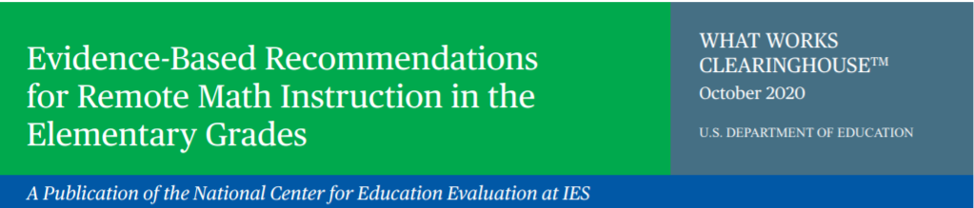

The TIMSS 2023 Team

833-870-0485

[TIMSS@rti.org](mailto:TIMSS@rti.org)

*The National Center for Education Statistics (NCES) is authorized to conduct this study under the Education Sciences Reform Act of 2002 (ESRA 2002, 20 U.S.C. §9543), and to collect students’ education records from educational agencies or institutions for the purpose of evaluating federally supported education programs under the Family Educational Rights and Privacy Act (FERPA, 34 CFR §§ 99.31(a)(3)(iii) and 99.35). All of the information you provide may be used only for statistical purposes and may not be disclosed, or used, in identifiable form for any other purpose except as required by law (20 U.S.C. §9573 and 6 U.S.C. §151). In the United States, TIMSS is conducted by NCES, part of the U.S. Department of Education, and the data are being collected by RTI International. The U.S. Office of Management and Budget has approved the data collection under OMB #1850-0695.*

**District and School Engagement Email 3 (Grade 8)**

We are writing to say **THANK YOU!** By participating in research studies like the Trends in International Mathematics and Science Study **(TIMSS**) you are contributing information that will help our country understand how students are learning to apply math and science. This knowledge will inform policymakers, researchers, and educators at all levels to improve outcomes for youth today and for years to come.

**Did you know**…

At the eighth grade, U.S. students’ average **TIMSS** mathematics score in 2019 was 23 points higher than in 1995, but was not significantly different from the score in 2015. Over 24 years, U.S. eighth-graders’ mathematics scores increased from 492 points in 1995 to 515 points in 2019[3].

Here are some math resources you may be interested in. Check out <https://ies.ed.gov/ncee/wwc/Math/> and <https://ies.ed.gov/ncee/wwc/Docs/ReferenceResources/RemoteMath_Secondary.pdf>.

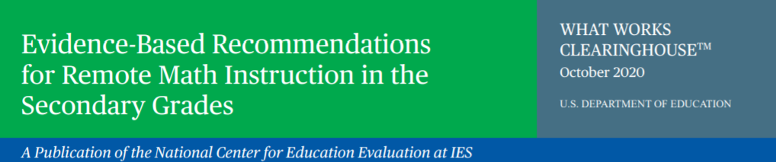

The TIMSS 2023 Team

833-870-0485

[TIMSS@rti.org](mailto:TIMSS@rti.org)

*The National Center for Education Statistics (NCES) is authorized to conduct this study under the Education Sciences Reform Act of 2002 (ESRA 2002, 20 U.S.C. §9543), and to collect students’ education records from educational agencies or institutions for the purpose of evaluating federally supported education programs under the Family Educational Rights and Privacy Act (FERPA, 34 CFR §§ 99.31(a)(3)(iii) and 99.35). All of the information you provide may be used only for statistical purposes and may not be disclosed, or used, in identifiable form for any other purpose except as required by law (20 U.S.C. §9573 and 6 U.S.C. §151). In the United States, TIMSS is conducted by NCES, part of the U.S. Department of Education, and the data are being collected by RTI International. The U.S. Office of Management and Budget has approved the data collection under OMB #1850-0695.*

**District and School Engagement Email 4**

This is just a quick email to say THANK YOU! By participating in research like the Trends in International Mathematics and Science Study (**TIMSS**) in the spring of <2022/2023>, you are helping to improve the condition of education for students today and years to come. To learn more about the current condition of education, check out the link below.

*Here is “The Condition of Education” 2021 report:*

[*https://nces.ed.gov/programs/coe/*](https://nces.ed.gov/programs/coe/)

[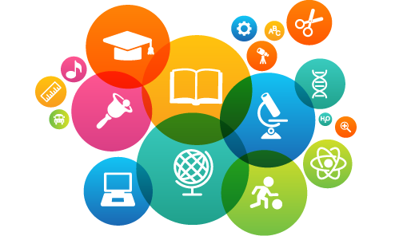](https://nces.ed.gov/programs/coe/)

We look forward to talking with you again soon!

The TIMSS 2023 Team

833-870-0485

[TIMSS@rti.org](mailto:TIMSS@rti.org)

*The National Center for Education Statistics (NCES) is authorized to conduct this study under the Education Sciences Reform Act of 2002 (ESRA 2002, 20 U.S.C. §9543), and to collect students’ education records from educational agencies or institutions for the purpose of evaluating federally supported education programs under the Family Educational Rights and Privacy Act (FERPA, 34 CFR §§ 99.31(a)(3)(iii) and 99.35). All of the information you provide may be used only for statistical purposes and may not be disclosed, or used, in identifiable form for any other purpose except as required by law (20 U.S.C. §9573 and 6 U.S.C. §151). In the United States, TIMSS is conducted by NCES, part of the U.S. Department of Education, and the data are being collected by RTI International. The U.S. Office of Management and Budget has approved the data collection under OMB #1850-0695.*

**District and School Engagement Email 5**

We are writing to say **THANK YOU**! By participating in international research like the Trends in International Mathematics and Science (**TIMSS**), our country can continue to take part and learn about emerging issues in content and the contexts for learning.

Be sure to check current U.S. participation status on the study website <https://surveys.nces.ed.gov/TIMSS>. We look forward to working with your students in spring of <2022/2023>.

Thank you for your time and contribution.

The TIMSS 2023 Team

833-870-0485

[TIMSS@rti.org](mailto:TIMSS@rti.org)

*The National Center for Education Statistics (NCES) is authorized to conduct this study under the Education Sciences Reform Act of 2002 (ESRA 2002, 20 U.S.C. §9543), and to collect students’ education records from educational agencies or institutions for the purpose of evaluating federally supported education programs under the Family Educational Rights and Privacy Act (FERPA, 34 CFR §§ 99.31(a)(3)(iii) and 99.35). All of the information you provide may be used only for statistical purposes and may not be disclosed, or used, in identifiable form for any other purpose except as required by law (20 U.S.C. §9573 and 6 U.S.C. §151). In the United States, TIMSS is conducted by NCES, part of the U.S. Department of Education, and the data are being collected by RTI International. The U.S. Office of Management and Budget has approved the data collection under OMB #1850-0695.*

## Appendix A12a School Coordinator (SC) Email to Login and Provide School Information (PSI) – revised – field test and main study

Dear <School Coordinator Name>,

We hope that this finds you well and enjoying another terrific school year! We are following up with you to remind you to put the *Trends in International Mathematics and Science Study (TIMSS) 2023* <Field Test> assessment date on your school calendar at <school name>. We appreciate your commitment to TIMSS, and we know your students will be excited and proud to represent U.S. students in this important international assessment. The TIMSS team looks forward to working with you to coordinate TIMSS in your school.

A sample of your grade <4/8> classes will be taking TIMSS. In most schools, TIMSS will randomly select about two <IF GRADE 8: math> classes to participate in the assessment.

You will have several responsibilities critical to making TIMSS a success. Please review the attached *Summary of School Activities: TIMSS 2023* for an overview of these responsibilities. The TIMSS website ([https://surveys.nces.ed.gov/TIMSS](https://nces.ed.gov/TIMSS)) will assist you with these responsibilities and provide information about the assessment. You can refer to the attached *TIMSS Registration and Provide School Information (PSI) Guide* to assist you through the immediate next steps.

Your user ID to login is: <insert user ID>. The first time you login an email will be sent to you in order to create your password.

Once you have logged in, please make sure to complete the **Provide School Information** section of the Task Menu.

The timeline below provides an overview of these activities:

* **Today** – Login to TIMSS and complete tasks labeled ‘Input Needed’ on the task menu page.
* **August <2021/2022>- December 10th, <2021/2022>**– Prepare and provide a list of classes on the Submit Class List page or by phone (833-870-0485) or email (TIMSS@rti.org). Once classes are submitted, TIMSS staff will inform you of the selected classes and will email you to submit the list of students in selected classes on the Student-Teacher Linkage Form page of TIMSS. The TIMSS 2023 team will contact you in January with directions for submitting the class and Student-Teacher Linkage Forms.
  + **January through March of <2022/2023>** –
* Receive a packet of TIMSS materials, including a TIMSS 2023 Parent FAQ and sample parent/guardian notification letters. These materials will also be available on the TIMSS website.
* Review lists of students and teachers.
* An assigned TIMSS representative will contact you to discuss assessment logistics and accommodations for students with disabilities or English language learners.
* Notify parents/guardians that their children have been selected for the assessment. A sample parent/guardian notification letter will be available on the TIMSS website for you to customize and print on your school letterhead.
* **One week before the session** – <IF GRADE 8: Distribute student appointment cards mailed to you prior to the session and> notify teachers in advance so they know when to release students and remind them to complete an online TIMSS Teacher Questionnaire, which should have been emailed to them by the TIMSS team. Request that the school principal complete the TIMSS School Questionnaire as well.

Thank you in advance for your cooperation and effort in helping to coordinate this important study. If you have any questions, please feel free to contact the TIMSS information hotline at 833-870-0483 or TIMSS@rti.org. You may also get more information about this study by visiting the TIMSS website at https://surveys.nces.ed.gov/TIMSS.

Sincerely,

<Debbie Herget, TIMSS 2023 Project Director, RTI International/ or NAEP State Coordinator>

Attachment: *Summary of School Activities: TIMSS 2023*

*TIMSS Registration and PSI Guide*

*The National Center for Education Statistics (NCES) is authorized to conduct this study under the Education Sciences Reform Act of 2002 (ESRA 2002, 20 U.S.C. §9543), and to collect students’ education records from educational agencies or institutions for the purpose of evaluating federally supported education programs under the Family Educational Rights and Privacy Act (FERPA, 34 CFR §§ 99.31(a)(3)(iii) and 99.35). All of the information you provide may be used only for statistical purposes and may not be disclosed, or used, in identifiable form for any other purpose except as required by law (20 U.S.C. §9573 and 6 U.S.C. §151). In the United States, TIMSS is conducted by NCES, part of the U.S. Department of Education, and the data are being collected by RTI International. The U.S. Office of Management and Budget has approved the data collection under OMB #1850-0695.*

## Appendix A12b TIMSS 2023 Login and Provide School Information (PSI) Guide – revised – field test and main study

To prepare for <the TIMSS field test/TIMSS> in grades 4 or 8, log in to the TIMSS website (<https://surveys.nces.ed.gov/TIMSS>). If you have never logged in to the website and cannot find the User ID number provided to you by your state coordinator or TIMSS Staff, please contact your state coordinator or the TIMSS hotline at TIMSS@rti.org / 833-870-0485.

1. Once you have your User ID, go to the TIMSS website (<https://surveys.nces.ed.gov/TIMSS>)
2. Enter your User ID and click “Continue.”

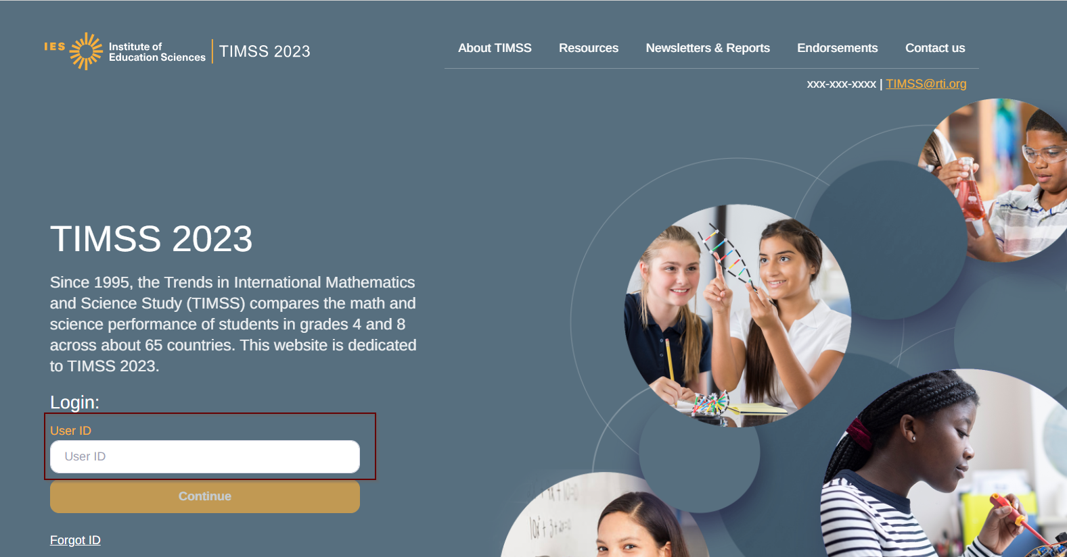

1. You will then receive an email with instructions on creating a password. After your initial login you will not need to do this step again.
2. On your first login you will see the ‘what to expect page’ which gives a brief overview of the TIMSS 2023 process, then click next.

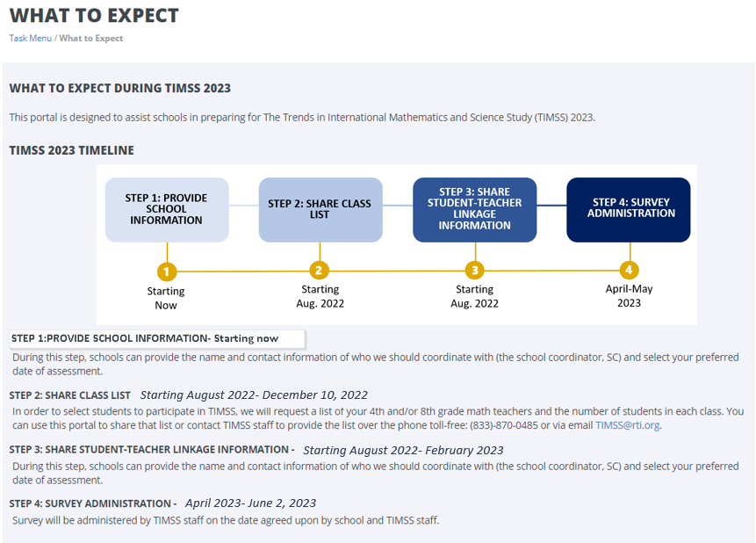

1. You will then be taken to the task menu page, that will show you the tasks you can complete (labeled as ‘In Progress”). Make sure to confirm the district and school name shown at the top of the page are correct.

Then click on the ‘initial step’ and complete the necessary information.

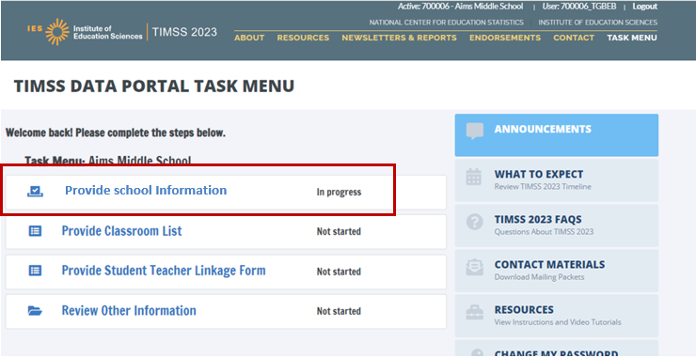

**Provide School Information (PSI)**

The first step in TIMSS is to complete the **Provide School Information** Task. Click the **Provide School Information** link, which is the first option on the Task Menu.

On the PSI page, there are 5 sections that you will need to either confirm the information or enter current information available for your school. Please make updates in these sections: School Address, School Principal, School Coordinator, School Assessment Date, and other Key Dates. Be sure to click submit once you fill in information for each section.

Note: You will see status: Input Needed until all required fields are filled out completely:

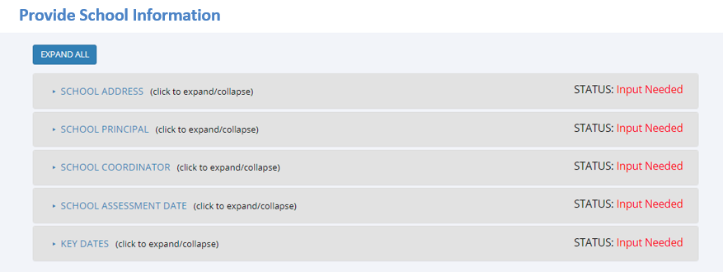

In August of <2022/2023>, we will email you instructions for submitting class lists and Student-Teacher Linkage Forms.

Thank you for you school’s participation in <the TIMSS field test/TIMSS 2023 >!

The TIMSS 2023 Team

833-870-0485

[TIMSS@rti.org](mailto:TIMSS@rti.org)

## Appendix A12c Automated Email for all TIMSS 2023 registrants – revised – field test and main study

Thank you for creating a TIMSS account for the Trends in International Mathematics and Science Study 2023 (TIMSS). To access TIMSS, go to <https://surveys.nces.ed.gov/TIMSS> and enter your username and password.

**User ID: <userID>**

**Password information:** You created your own password the first time you logged in. Use the **"Forgot Password"** links on TIMSS login page if needed. You will be prompted to change your password after 120 days.

TIMSS is a secure site that contains confidential information, so it is important to remember your username and password.

If you have questions or need help accessing the website, please contact the TIMSS hotline at [TIMSS@rti.org](mailto:TIMSS@rti.org) or at 833-870-0485 Monday through Friday between 9 a.m. and 5:00 p.m. ET.

Sincerely,

The TIMSS 2023 Team

*The National Center for Education Statistics (NCES) is authorized to conduct this study under the Education Sciences Reform Act of 2002 (ESRA 2002, 20 U.S.C. §9543), and to collect students’ education records from educational agencies or institutions for the purpose of evaluating federally supported education programs under the Family Educational Rights and Privacy Act (FERPA, 34 CFR §§ 99.31(a)(3)(iii) and 99.35). All of the information you provide may be used only for statistical purposes and may not be disclosed, or used, in identifiable form for any other purpose except as required by law (20 U.S.C. §9573 and 6 U.S.C. §151). In the United States, TIMSS is conducted by NCES, part of the U.S. Department of Education, and the data are being collected by RTI International. The U.S. Office of Management and Budget has approved the data collection under OMB #1850-0695.*

## AppendixA12d Automated Email for TIMSS 2023 School Coordinator registrant – revised – field test and main study

Dear <school coordinator>,  
  
Thank you for creating a TIMSS account for the Trends in International Mathematics and Science Study (TIMSS) on <https://surveys.nces.ed.gov/TIMSS>. TIMSS is a secure website for sharing information and files related to your school’s participation in the TIMSS 2023. The website’s **"What To Expect"** page will guide you through the upcoming TIMSS activities and “Task Menu” will show what information you can provide.  
  
The first step is to complete the **Provide School Information** page. If you have not already done so, please go to <https://surveys.nces.ed.gov/TIMSS>, and click on the Task Menu to view activities that need to be completed at this time.   
  
Before data collection begins, you will need to provide a complete and current list of **all of your school’s <fourth-grade classes/eighth-grade mathematics classes>** for the TIMSS team to randomly select a minimum of two classes to participate in the TIMSS 2023. You will then be asked to submit lists of **all students in the selected classes**. TIMSS also needs a list of **all of your school’s <fourth grade classrooms or eighth-grade science teachers** and the courses they teach to assign teacher questionnaires that will be used to link information about science teachers to the assessed students>. We will email you in the fall with instructions about how to submit the class list, Student-Teacher Linkage Form, and teacher list through <https://surveys.nces.ed.gov/TIMSS>.   
  
Please see the **attached** Summary of School Activities for a complete list of activities associated with your school’s participation in <the TIMSS Field Test/TIMSS>.  
  
Thank you very much for participating in TIMSS, and for playing a key role in making the assessment a success at <school name>!  
  
Sincerely,  
  
The TIMSS Team  
  
*The National Center for Education Statistics (NCES) is authorized to conduct this study under the Education Sciences Reform Act of 2002 (ESRA 2002, 20 U.S.C. §9543), and to collect students’ education records from educational agencies or institutions for the purpose of evaluating federally supported education programs under the Family Educational Rights and Privacy Act (FERPA, 34 CFR §§ 99.31(a)(3)(iii) and 99.35). All of the information you provide may be used only for statistical purposes and may not be disclosed, or used, in identifiable form for any other purpose except as required by law (20 U.S.C. §9573 and 6 U.S.C. §151). In the United States, TIMSS is conducted by NCES, part of the U.S. Department of Education, and the data are being collected by RTI International. The U.S. Office of Management and Budget has approved the data collection under OMB #1850-0695.*

## Appendix A12e TIMSS 2023 Student-Teacher Linkage Form (STLF) Email – revised (was 14a) – field test and main study

Dear <school coordinator>,

The list of students selected to participate in TIMSS is available in the Student-Teacher Linkage Form (STLF)!

The **Student-Teacher Linkage Form (**STLF) lists the students who have been selected to participate in the assessment at your school. This list is based on the class and student information you submitted. To access the STLF, please login at <https://surveys.nces.ed.gov/TIMSS>,then go to Task Menu **Prepare for Assessment** and select **“Click here to download the STLF.”** In the two STLF excel files, there is a worksheet for each set of classes or students selected, so please make sure to review each STLF excel file. Most schools will have two excel files, one for each class.

For the Student-Teacher Linkage Form (STLF), you will only need to make sure the students on that list match the teachers to the selected students in the header of Column 6. If you see any errors, please contact the TIMSS Help Desk at TIMSS@rti.org or 833-870-0485. Please do not email the list back to us.

Within a week of the STLF posting, you will receive an email informing you that the final list of selected students and teachers are available. These lists, called the Student Tracking Forms (STF) will be posted on this same **Prepare for Assessment** page.

Thank you very much for participating in TIMSS, and for submitting your school's class and student lists!

Sincerely,

The TIMSS Team

*The National Center for Education Statistics (NCES) is authorized to conduct this study under the Education Sciences Reform Act of 2002 (ESRA 2002, 20 U.S.C. §9543), and to collect students’ education records from educational agencies or institutions for the purpose of evaluating federally supported education programs under the Family Educational Rights and Privacy Act (FERPA, 34 CFR §§ 99.31(a)(3)(iii) and 99.35). All of the information you provide may be used only for statistical purposes and may not be disclosed, or used, in identifiable form for any other purpose except as required by law (20 U.S.C. §9573 and 6 U.S.C. §151). In the United States, TIMSS is conducted by NCES, part of the U.S. Department of Education, and the data are being collected by RTI International. The U.S. Office of Management and Budget has approved the data collection under OMB #1850-0695.*

## AppendixA12f TIMSS 2023 Student Tracking Form (STF) Email – revised (was 14b) – field test and main study

Dear <School Coordinator>,

Thank you for providing information about all the <fourth/eighth> grade classes in your school! The list of students and teachers selected to participate in TIMSS is now available in the Student Tracking Forms (STF) available on the TIMSS website. Please see below for more details about the forms and parent notification.

* Student Tracking Form (STF) –The forms list the students who have been selected to participate in the assessment at your school. Instructions on how to access and review the forms are attached.
* Sample Parent Notification Letter and Facts for Parents about TIMSS 2023 <Field Test> (Parent FAQ) – A sample parent/guardian notification letter is attached for you to customize and print on your school letterhead. Please distribute the parent notification letter and the *Facts for Parents about TIMSS 2023 <Field Test>* to the parents of the selected students prior to the assessment. A Spanish version of the letter is available on the TIMSS site under **Documents.**
* Shipment
  + Within a week, a shipment of hard-copies of the *Facts for Parents* *about TIMSS 2023 <Field Test> (Parent FAQ)* will be delivered to you. You can also distribute them electronically or share the Parent FAQ link available here: [<https://surveys.nces.ed.gov/TIMSS>](https://nces.ed.gov/timss/parents/)
  + Student Appointment/invitations cards to give to selected students will be sent to you as well.

As your assessment date approaches, your Test Administrator will be contacting you to finalize the assessment day activities and discuss accommodations, if necessary.

If you have any questions, please do not hesitate to call 833-870-0485or send an email to [TIMSS@rti.org](mailto:TIMSS@rti.org). You may also get more information about this study by visiting the TIMSS website at <https://surveys.nces.ed.gov/TIMSS>.

Thank you for your assistance with this study!

Sincerely,

The TIMSS 2023 Team

Attachments:

Sample Parent Notification Letter

Facts for Parents about TIMSS 2023 <Field Test> (Parent FAQ)

STF Instructions

*The National Center for Education Statistics (NCES) is authorized to conduct this study under the Education Sciences Reform Act of 2002 (ESRA 2002, 20 U.S.C. §9543), and to collect students’ education records from educational agencies or institutions for the purpose of evaluating federally supported education programs under the Family Educational Rights and Privacy Act (FERPA, 34 CFR §§ 99.31(a)(3)(iii) and 99.35). All of the information you provide may be used only for statistical purposes and may not be disclosed, or used, in identifiable form for any other purpose except as required by law (20 U.S.C. §9573 and 6 U.S.C. §151). In the United States, TIMSS is conducted by NCES, part of the U.S. Department of Education, and the data are being collected by RTI International. The U.S. Office of Management and Budget has approved the data collection under OMB #1850-0695.*

## Appendix A12g Instructions for TIMSS 2023 Student Tracking Form (STF) – revised – field test and main study

**Reviewing the Student Tracking Form (STF)**

The two **Student Tracking Form** (STF) lists the students who have been selected to participate in the assessment at your school. This list is based on the student information you submitted. You can take notes on this form in preparation for the pre-assessment call in which the Test Administrator will ask you about any updates to this form over the phone. To access the STF, please login at <https://surveys.nces.ed.gov/TIMSS>, then go to **Prepare for Assessment** and select **“Click here to download the STF.”**

As the first step in reviewing the Student Tracking Form, please verify the student information for accuracy after you open the excel file you just downloaded. See below for what should be reviewed. Please also make sure the school name and students match what you expect.

* Student’s name is listed in **Column 1**.
* Date of birth is listed in **Column 4.**
* Gender (using codes—1 for female and 2 for male) is listed in **Column 5**.
* Exclusion status in **Column 6.**
* Participation status in **Column 7.**

**Student Exclusions and Accommodations**

If a student is to be excluded from the assessment because he or she requires an accommodation, please make a note in column 6 using the codes at the bottom of the STF.

**Participation Status + Newly-enrolled or no-longer-enrolled students**

If many of the students listed in the STF are not enrolled in the school, please contact timss@rti.org ASAP, but you do not need to contact timss@rti.org if only 1 to 3 students are no longer enrolled or are newly enrolled. These new or no-longer-enrolled students can be discussed with your Test Administrator when they call you for the pre-assessment call (usually 1-2 weeks before assessment date). You can make a note on the form regarding these students in the first column in column 7 using the status codes shown at the bottom of the STF. You can also use status codes 1 through 4 to provide more information about a student.

**Updates and Questions**

If you have updates to the STF, please have the form ready for the pre-assessment call. You can also provide the hardcopy to the Test Administrator when they come to your school on assessment day. If you have any questions about completing this form, please address them with your Test Administrator when they contact you. For urgent questions on the STF, you can also contact the TIMSS Help Desk at timss@rti.org. The STF is just for you to take notes on in preparation for the pre-assessment call so you know parents of which students should be notified. Please do not send the STF back to us. You can however give it to the Test Administrator in person, if you would like, when they come on the assessment day.

## AppendixA13a TIMSS 2023 Portal Home Page – revised – field test and main study

Welcome to TIMSS 2023!

This portal is designed to assist schools in preparing for The Trends in International Mathematics and Science Study (TIMSS) 2023.

TIMSS 2023 TIMELINE

**STEP 1: PROVIDE SCHOOL INFORMATION: Starting Now**

During this step, schools can provide the name and contact information of who we should coordinate with (the school coordinator, SC) and select your preferred date of assessment.

**STEP 2: SHARE CLASS LIST- Starting August <2021/2022>- December 10th, <2021/2022>**

In order to select students to participate in TIMSS, we will request a list of your 4th and/or 8th grade math teachers and the number of students in each class. You can use this portal to share that list or contact TIMSS staff to provide the list over the phone toll-free: 833-870-0485 or via email [TIMSS@rti.org](mailto:TIMSS@rti.org).

**STEP 3: SHARE STUDENT-TEACHER LINKAGE INFORMATION- Starting August <2021/2022>- February, <2022/2023>**

Two classes in your 4th and/or 8th grade will be selected to participate. If class sizes are small, we may select more than two. Once the classes are selected, we will request a list of students from each class, and the names of their math and science teacher(s).

**STEP 4: SURVEY ADMINISTRATION- <March- April, 2022/March-May, 2023>**

Survey will be administered by TIMSS staff on the date agreed upon by school and TIMSS staff.

Main Study screen shot:



## AppendixA13b TIMSS 2023 Provide School Information (PSI) Page – revised – field test and main study

(screenshot)

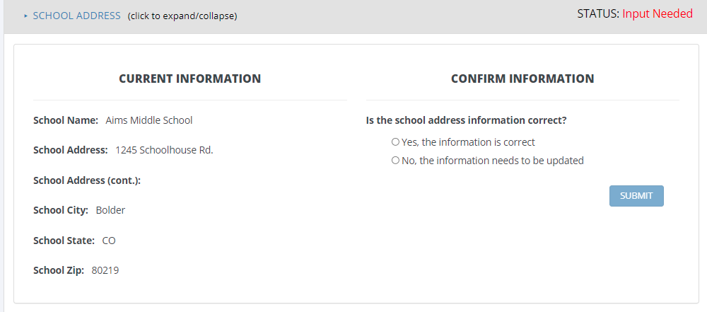

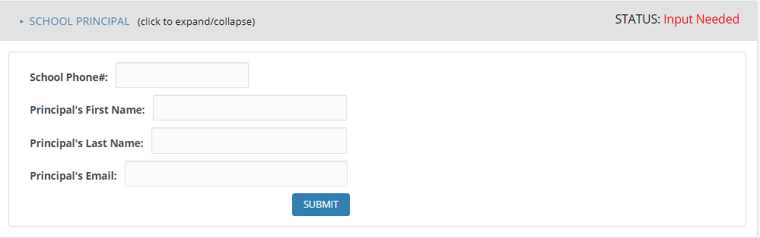

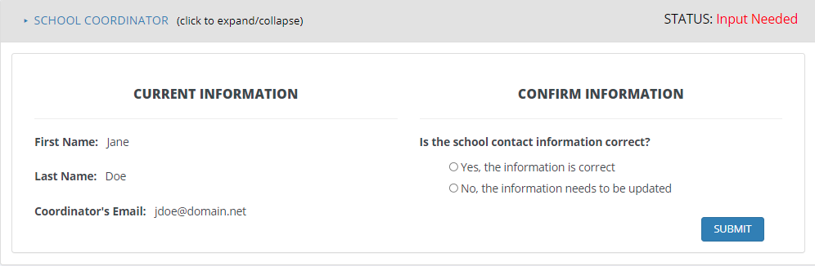

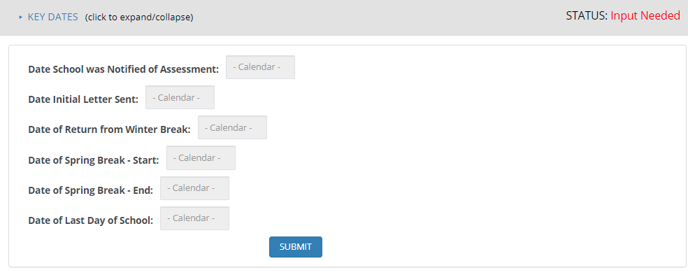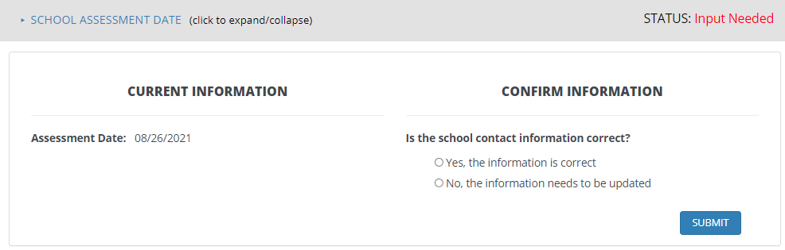



## Appendix A13c TIMSS 2023 Prepare for Assessment Page – revised – field test and main study

**Prepare for Assessment**

Thank you for providing information about all the <fourth-grade/eighth-grade math> classes in your school! After submitting both class and student lists, you will receive an email telling you that your sample of classes has been selected. Return to this webpage when you receive the email from TIMSS@rti.org: “The list of students selected to participate in TIMSS is available in the Student-Teacher Linkage Form (STLF)”

**Student Tracking Linkage Form (download both if more than one link is shown)**

**Student-Teacher Linkage Forms (STLF)** – The forms list the selected students and their teachers. Please make sure students and teachers are linked correctly on the form. Instructions on how to access and review the forms were emailed to you and are in the Documents section on this website.

**Please note the following:**

If the students and teacher linkages appear fine in the STLF, no need to contact the TIMSS Help Desk. Three business days later, please return to this page. Two new links will be shown here to download STF1 and STF2 (Student Tracking Forms). This is the form you can review to see if any student names, information, new enrollees, no longer enrolled students, should be updated. Contact the TIMSS Help Desk if there are major updates needed on this form. You can discuss the minor updates with your Test Administrator when they call you in the pre-assessment call.

**Student Tracking Form (download both if more than one link is shown)**

**Student Tracking Form (STF)–**The forms list the students who have been selected to participate in the assessment at your school. Instructions on how to access and review the forms are in the Documents section on this website. The STF will become available about a week after the STLF has been posted.

**Sample Parent Notification Letter and Facts for Parents about TIMSS**. You will receive a packet of TIMSS materials including a parent/guardian notification letter and a TIMSS Parent FAQ.

A sample parent/guardian notification letter and Parent FAQ is in the Documents section for your reference. These are available in both English and Spanish. As your assessment date approaches, your Test Administrator will be contacting you to go over the parent materials and finalize the assessment day activities.

If you have questions, please contact us at 833-870-0485 or send an email to [TIMSS@rti.org](mailto:TIMSS@rti.org).

## Appendix A13d Student-Teacher Linkage Form (STLF) Template – Grade 4 vs. Grade 8 – previously approved – field test and main study

(Sample of Student-Teacher-linkage-form that will be avaiable to download within the TIMSS portal)

Grade 4 STLF

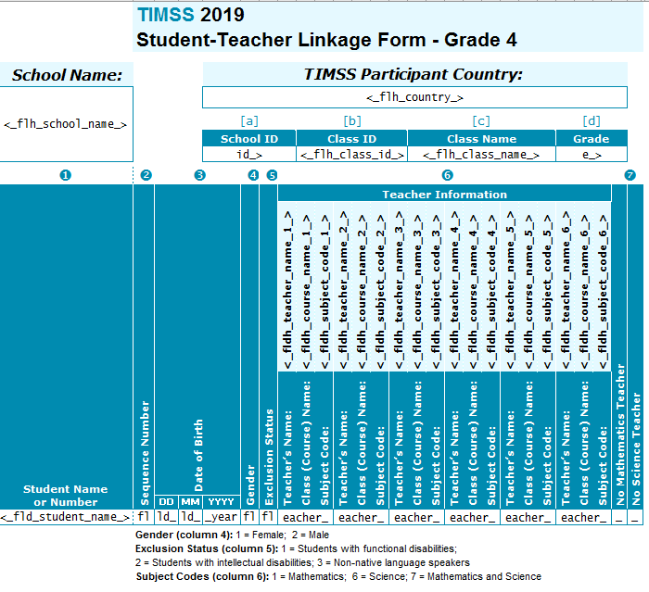

Grade 8 STLF

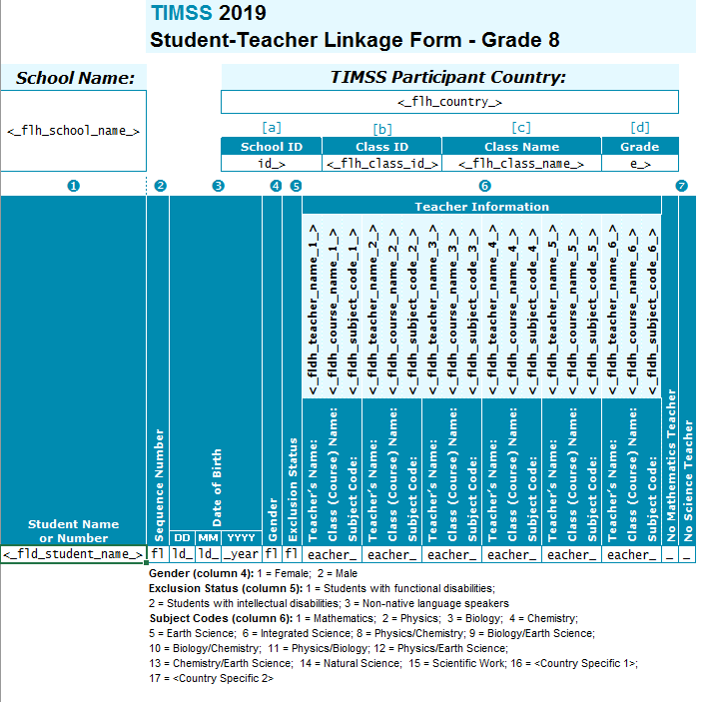

## Appendix A13e Web-Enabled Agreement – new – field test and main study

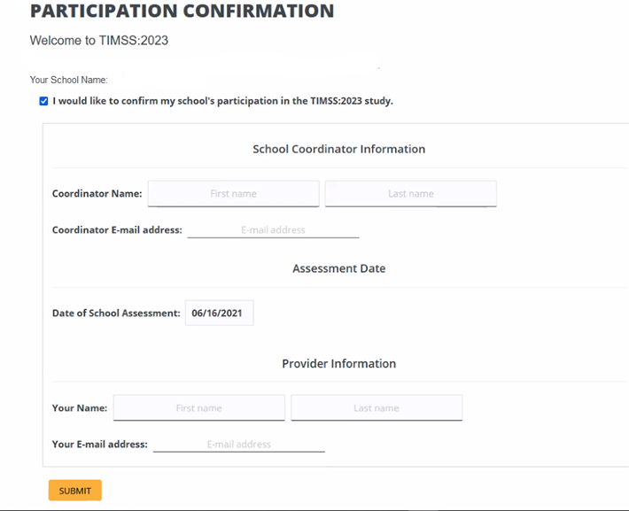

## Appendix A14a TIMSS 2023 Website Main Page – revised – field test and main study

(TIMSS 2023 Login page screenshot)

<https://surveys.nces.ed.gov/TIMSS> 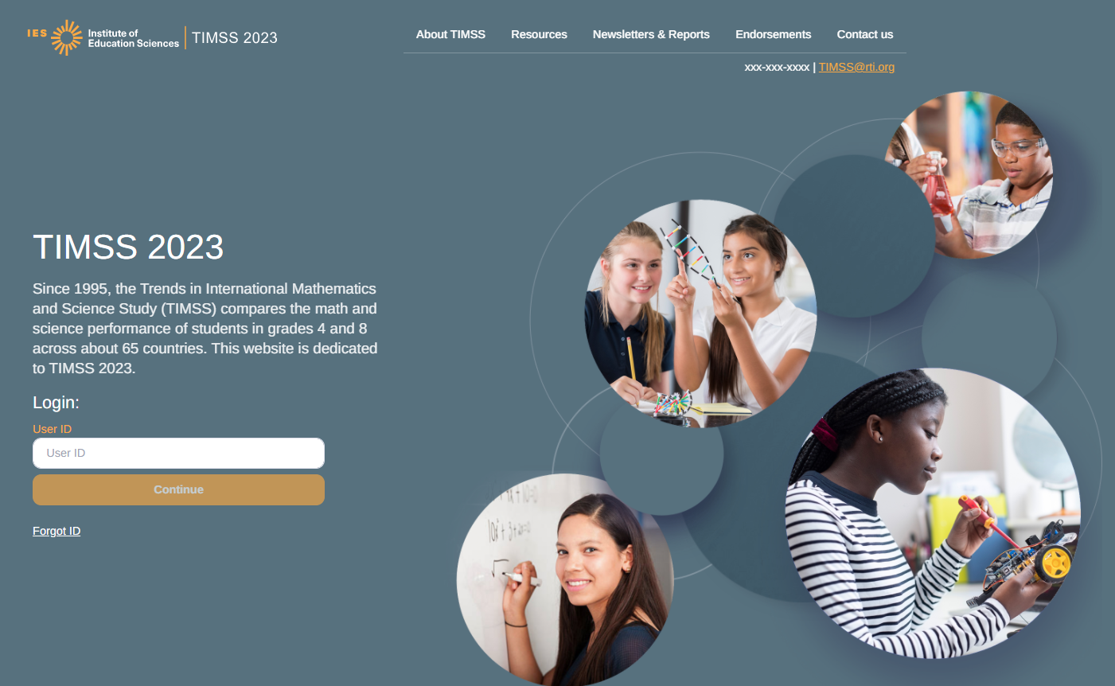

Data collected by RTI International [Insert Logo]

*The National Center for Education Statistics (NCES) is authorized to conduct this study under the Education Sciences Reform Act of 2002 (ESRA 2002, 20 U.S.C. §9543), and to collect students’ education records from educational agencies or institutions for the purpose of evaluating federally supported education programs under the Family Educational Rights and Privacy Act (FERPA, 34 CFR §§ 99.31(a)(3)(iii) and 99.35). All of the information you provide may be used only for statistical purposes and may not be disclosed, or used, in identifiable form for any other purpose except as required by law (20 U.S.C. §9573 and 6 U.S.C. §151). In the United States, TIMSS is conducted by NCES, part of the U.S. Department of Education, and the data are being collected by RTI International. The U.S. Office of Management and Budget has approved the data collection under OMB #1850-0695.*

According to the Paperwork Reduction Act of 1995, no persons are required to respond to a collection of information unless such collection displays a valid OMB control number. The valid OMB control number for this voluntary information collection is 1850-0695. The time required to complete this information collection and participate in study activities is estimated to average 30 minutes per school administrator, 35 minutes per teacher, and 240 minutes per school coordinator, including the time to review instructions, search existing data resources, gather the data needed*,* and complete and review the information collection. If you have any comments or concerns regarding the accuracy of the time estimate(s), suggestions for improving the form, or questions about the status of your individual submission of this form, write directly to: Trends in International Mathematics and Science Study (TIMSS), National Center for Education Statistics, Potomac Center Plaza, 550 12th Street, SW, 4th floor, Washington, DC 20202.

OMB No. 1850-0695, Approval Expires xx/xx/20xx.

## AppendixA14b TIMSS 2023 Documents Page – revised – field test and main study

**General TIMSS Information**

Brochure

Frequently Ask Question (FAQ)

TIMSS Login and Provide School Information Guide

Parent FAQ

COVID Protocols

List of Endorsing Agencies

**District and School Letters**

Letter sent to District Superintendents

Letter sent to School Principals

Letter sent to School Coordinators

**Parent Notification Letters**

Sample Parent/Guardian Notification Letter

Sample Parent/Guardian Notification Letter (Spanish)

**Class List and Student-Teacher Linkage Forms**

Email to SC for providing class list (4th & 8th grade)

Instructions for providing class list (4th & 8th grade)

Class List Template

Email to SC for providing STLF (4th & 8th grade)

Instructions for TIMSS 2023 Student Tracking Form (4th & 8th grade)

STLF template

(Grade 4 example below)

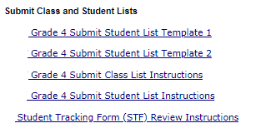

## AppendixA14c TIMSS 2023 Website: Resources, Newsletters & Reports, and Contact Us Pages – new – field test and main study

Resources: (Screen shot of the planned resources available on the public facing TIMSS 2023 website)

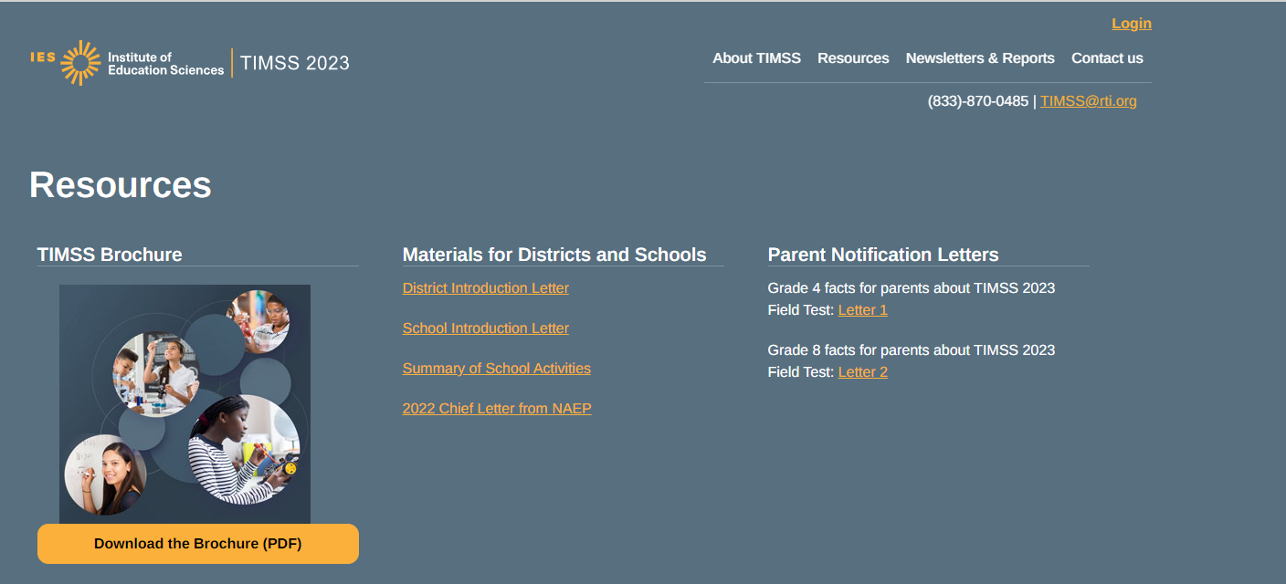

Newsletters & Reports

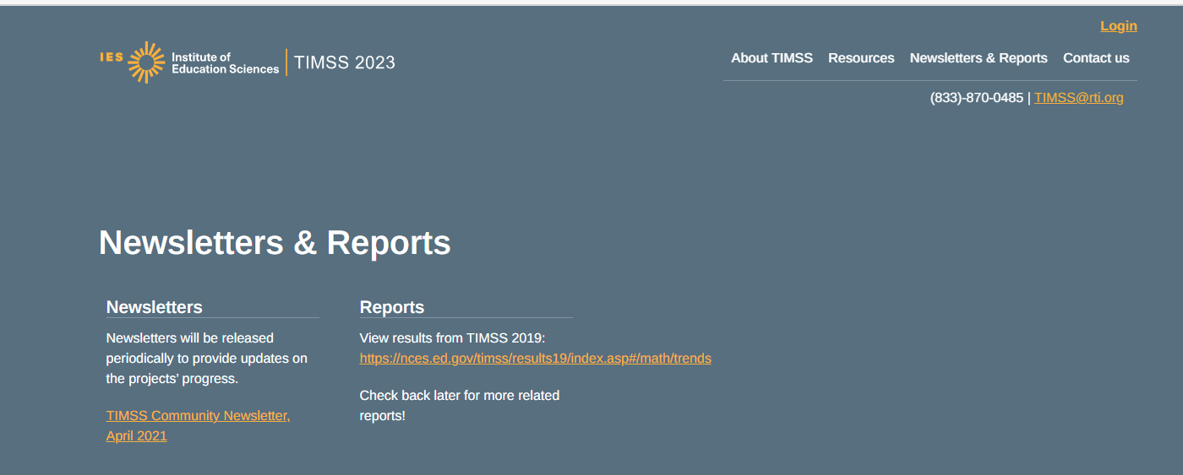

Contact us Page: 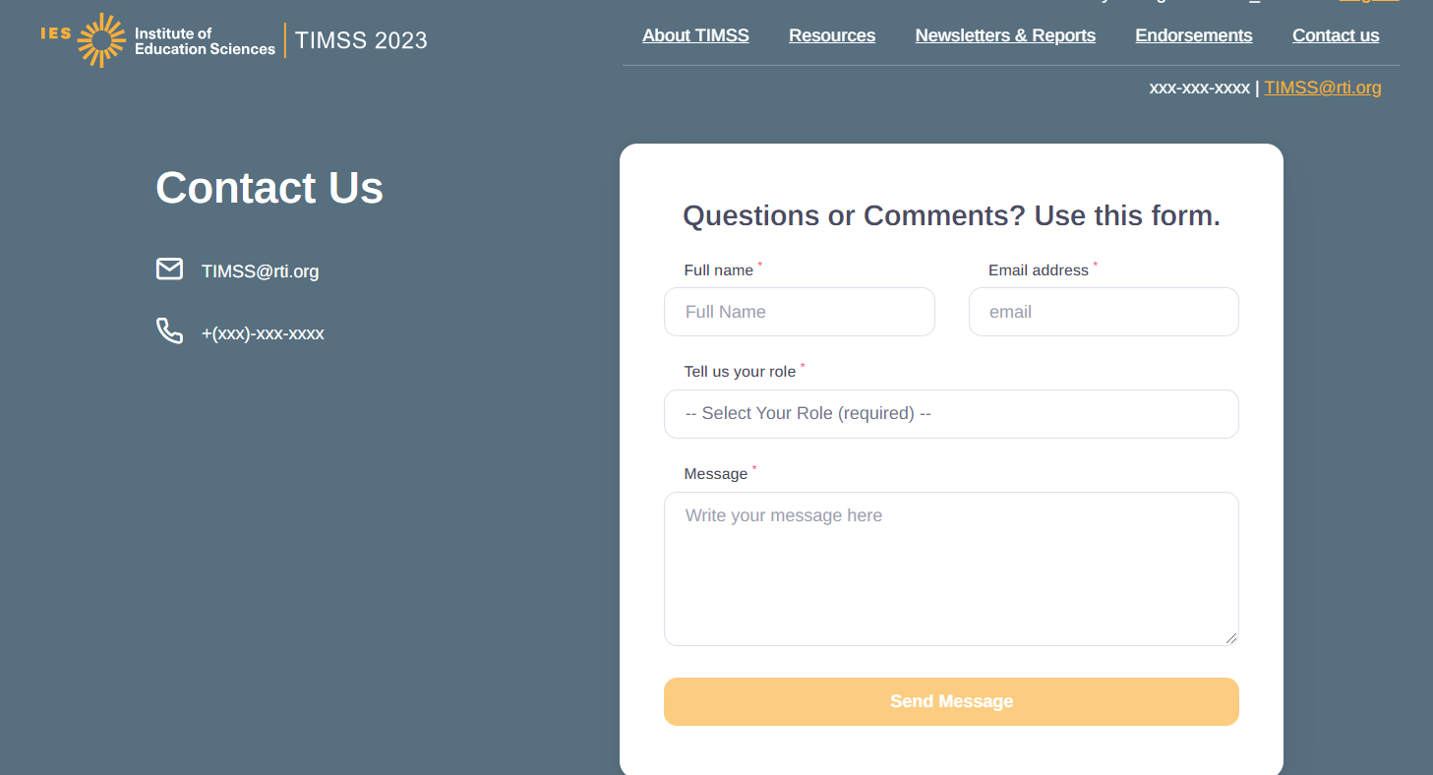

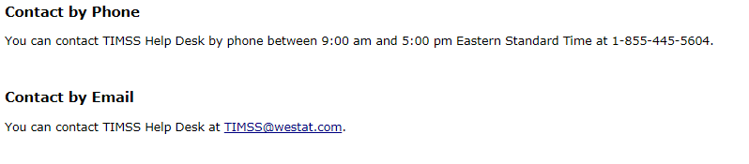

## AppendixA15a School Principal Questionnaire Login Card/Email- now Appendix B15

See Appendix B15 for content

## AppendixA15b Teacher Questionnaire Selection Email- Now Appendix B13

See Appendix B13 for content

## AppendixA15c Teacher Questionnaire Reminder Email- removed

## AppendixA16 Online Questionnaire Login Screen Text – previously approved – field test and main study

(for the Principal, Teachers, and Students)

TIMSS 2023 <Field Test> - English (United States)

You are not logged in.

Welcome to the IEA - DPC SurveySystem

Online Questionnaires

Please enter your user ID and password (Checksum).

User ID:

Password:

*The National Center for Education Statistics (NCES) is authorized to conduct this study under the Education Sciences Reform Act of 2002 (ESRA 2002, 20 U.S.C. §9543), and to collect students’ education records from educational agencies or institutions for the purpose of evaluating federally supported education programs under the Family Educational Rights and Privacy Act (FERPA, 34 CFR §§ 99.31(a)(3)(iii) and 99.35). All of the information you provide may be used only for statistical purposes and may not be disclosed, or used, in identifiable form for any other purpose except as required by law (20 U.S.C. §9573 and 6 U.S.C. §151). In the United States, TIMSS is conducted by NCES, part of the U.S. Department of Education, and the data are being collected by RTI International. The U.S. Office of Management and Budget has approved the data collection under OMB #1850-0695.*

According to the Paperwork Reduction Act of 1995, no persons are required to respond to a collection of information unless such collection displays a valid OMB control number. The valid OMB control number for this voluntary information collection is 1850-0695. The time required to complete this information collection is estimated to average 30 minutes per principal, 35 minutes per teacher, and 30 minutes per student, including the time to review instructions, search existing data resources, gather the data needed, and complete and review the information collection. If you have any comments or concerns regarding the accuracy of the time estimate(s), suggestions for improving the form, or questions about the status of your individual submission of this form, write directly to: Trends in International Mathematics and Science Study (TIMSS), National Center for Education Statistics, Potomac Center Plaza (PCP), 550 12th St., SW, 4th floor, Washington, DC 20202.

OMB No. 1850-0695, Approval Expires 5/31/2024.

© IEA Online SurveySystem <<20XX>> - Help

## AppendixA17a Student Certificate of Completion – previously approved – field test and main study

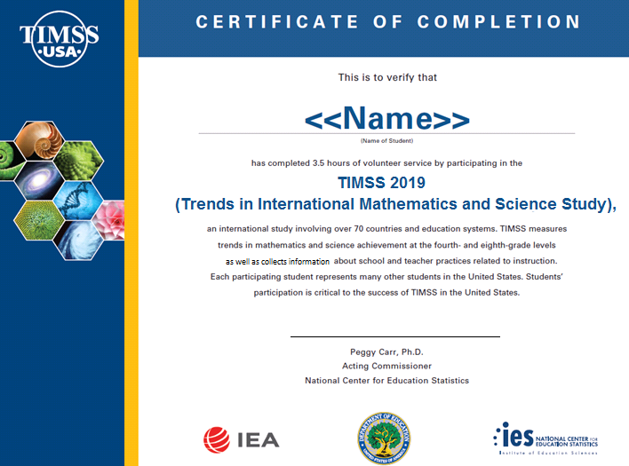

Associate Commissioner, Assessment Division

National Center for Education Statistics

60

**TIMSS 2023**

## AppendixA17b School Certificate of Completion – previously approved – field test and main study

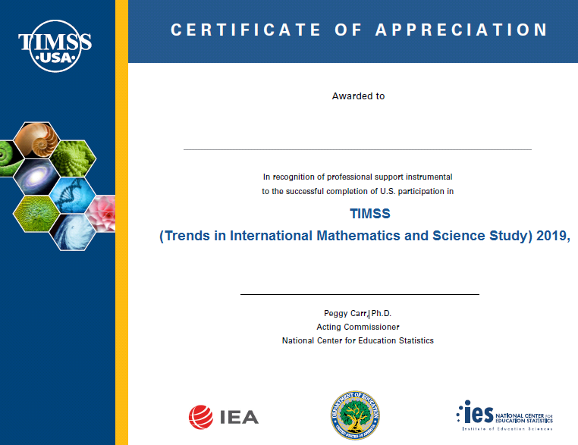

Associate Commissioner, Assessment Division

National Center for Education Statistics

**2023.**

## Appendix A18 Email to School Coordinator to Submit Class– Grade 4 – revised – field test and main study

Dear <School Coordinator>,

It was a pleasure speaking with you regarding <the TIMSS 2023 field test study/TIMSS 2023>; thank you again for your time.

In order to randomly sample the 4th grade classrooms, we first need information for each of your school’s 4th grade classes (see table below). If there are multi-grade classes (i.e., students from more than one grade level in the same class), only the fourth-gradestudents should be counted as a class in the list. For example, if three Grade 3 students, five Grade 4 students, and ten Grade 5 students form a multi-grade class and the target grade is four, then the School Coordinator should record one Grade 4 class with five students in that class list.

We have 3 options for you to provide this information:

1. Go to <https://surveys.nces.ed.gov/TIMSS> to submit your class list. If you have forgotten your login ID please contact the TIMSS helpdesk at [TIMSS@rti.org](mailto:TIMSS@rti.org) or 1-833-870-0485. If you have forgotten your password, you can request a new password on the login page.
2. Send your class list to [TIMSS@rti.org](mailto:TIMSS@rti.org)
3. Call 833-870-0485 and provide

Instructions for **Submit Class List** are attached. These tip sheets and Excel templates can also be found in the **Documents** section of <https://surveys.nces.ed.gov/TIMSS>.

If you have any questions about submitting your list, please email or call the TIMSS Help Desk at [TIMSS@rti.org](mailto:TIMSS@rti.org) or 1-833-870-0485. ​

Please provide your class list by <date>**.** TIMSS will process your submission and select the sample of fourth-grade classes to be assessed. You will be informed of the classes selected within a few weeks of submitting your lists, at which time we will request the list of students in the selected classrooms.

Thank you very much for participating in TIMSS, and for submitting your school's class and Student-Teacher Linkage Forms!

Sincerely,

The TIMSS 2023 Team

Attachments: Instructions for Submitting Class Lists – Grade 4

*The National Center for Education Statistics (NCES) is authorized to conduct this study under the Education Sciences Reform Act of 2002 (ESRA 2002, 20 U.S.C. §9543), and to collect students’ education records from educational agencies or institutions for the purpose of evaluating federally supported education programs under the Family Educational Rights and Privacy Act (FERPA, 34 CFR §§ 99.31(a)(3)(iii) and 99.35). All of the information you provide may be used only for statistical purposes and may not be disclosed, or used, in identifiable form for any other purpose except as required by law (20 U.S.C. §9573 and 6 U.S.C. §151). In the United States, TIMSS is conducted by NCES, part of the U.S. Department of Education, and the data are being collected by RTI International. The U.S. Office of Management and Budget has approved the data collection under OMB #1850-0695.*

## Appendix A18a Instructions for Submitting Class Lists – Grade 4 – revised – field test and main study

**TIMSS 2023: Instructions for Grade 4 Submit Class List**

TIMSS needs a complete and current list of all of your school’s fourth-grade classes in order to randomly select classes to be assessed. Typically, one or two classes are sampled in each school, and all students in the selected classes will be assessed. You can provide this information in 3 ways:

1. Complete Table A (below) and email it to [TIMSS@rti.org](mailto:TIMSS@rti.org)
2. Complete Table A and call the TIMSS teams to provide the information over the phone
3. Login to <https://surveys.nces.ed.gov/TIMSS>, select **Submit Class List** from the navigation menu. Enter information for each fourth-grade class in the web form.

**Table A. Example Class List**

|  |  |  |  |  |  |  |
| --- | --- | --- | --- | --- | --- | --- |
| **Class Name/Homeroom Teacher** | **Grade** | **Class Group** | **Number of  4th grade students in that class** | **Class Exclusion Status\*** | **Name of Math Teacher for that class**  (may be the same as the class name/homeroom teacher) | **Name of Science Teacher for that class**  (may be the same as the class name/homeroom teacher) |
|  | 4 |  |  |  |  |  |
|  | 4 |  |  |  |  |  |
|  | 4 |  |  |  |  |  |
|  | 4 |  |  |  |  |  |
|  | 4 |  |  |  |  |  |

(* Class Exclusions Status: 1- all students in class have functional disabilities, 2- students with intellectual disability, and 3-non-native language class.)

**Additional Information on Submitting Class List Online.**

After you have entered information for each class, click on the *Save* button, and another row will appear for you to enter information about another class.

Continue until you have entered information for all classes that contain fourth-grade students. Include the following information for each class:

• *Class Name*

• *Class Group or Track* (If applicable)

• *Number of Students*

• *Class Exclusion Status* (If applicable)

• *Name of Mathematics Teacher*

• *Name of Science Teacher*

When you have entered information for fourth-grade classes in your school, click on the *Finished* button.

**Example 1: Small school with the same Mathematics and Science Teacher for each class**

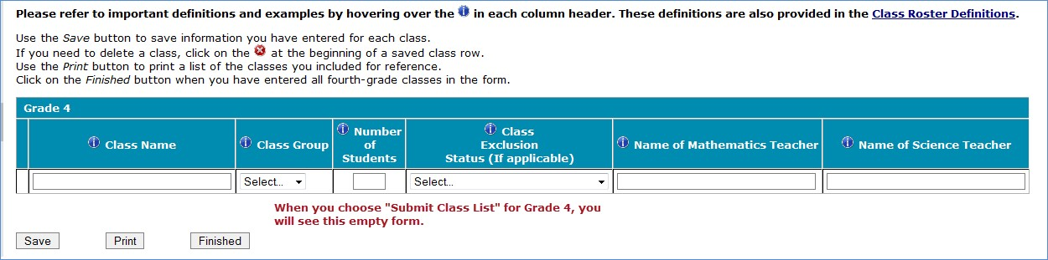

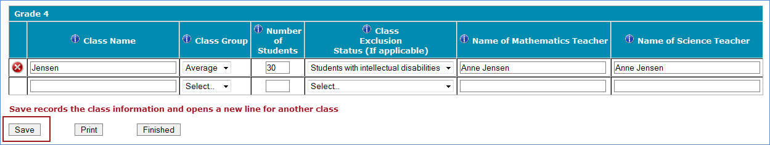

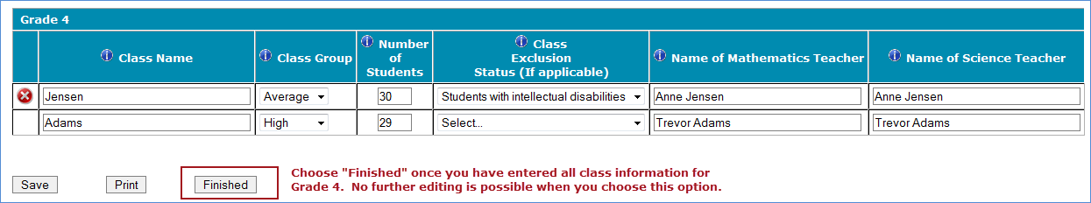

**Example 2: Larger school with multiple Grade 4 classes**

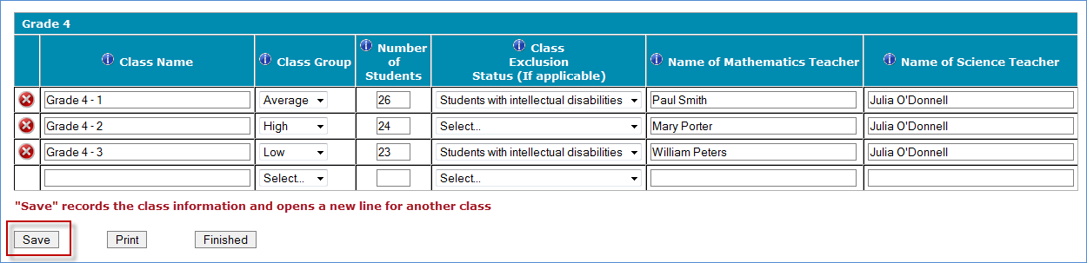

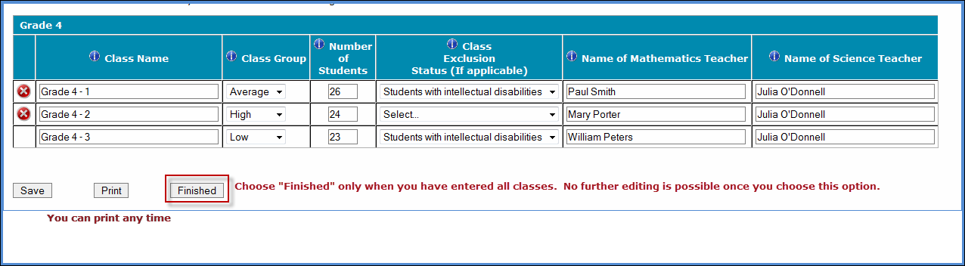

**Additional tips for submitting information about your fourth-grade classes:**

* Refer to the important definitions in the **Class Roster Definitions** document in the **Documents** section of <https://surveys.nces.ed.gov/TIMSS>.
* Record the Class Name that is typically used by your school to refer to the class.
* For classes with students from more than one grade level, include in *Number of Students* only those students in grade 4. For example, if the class has 5 third-graders, 6 fourth-graders, and 4 fifth-graders, enter “6” as the *Number of Students* in this class.
* Use the most current enrollment information.
* Include all classes, even if they typically are excluded from your state testing program, or all students take alternate assessments. You can indicate information about the class in *Class Exclusion Status*.
* Name of mathematics teacher and name of science teacher may be the same.
* Print a list of the classes you included for your future reference using the *Print* button.

**If you need assistance, email** [**TIMSS@rti.org**](mailto:TIMSS@rti.org) **or call 833-870-0485.**

## Appendix A18b Email to School Coordinator to Submit Student-Teacher Linkage Form – Grade 4 – new – field test and main study

Dear <School Coordinator>,

Thank you for providing the complete list of 4th grade classrooms; thank you again for your time. We have sampled <fill number of classrooms> of your school’s 4th grade classrooms.

**Sampled Classrooms**

* <fill classroom 2>
* <fill classroom 3>
* <fill classroom 5>

We will now need the Student-Teacher Linkage Form of these sampled classrooms. In order to ensure data security, this information needs to be submitted through our secure website. Go to <https://surveys.nces.ed.gov/TIMSS> to submit your Student-Teacher Linkage Form. If you have forgotten your login ID please contact the TIMSS helpdesk at [TIMSS@rti.org](mailto:TIMSS@rti.org) or 1-833-870-0485. If you have forgotten your password, you can request a new password on the TIMSS login page.

Instructions for **Submitting Student-Teacher Linkage Form** are attached. These tip sheets and Excel templates can also be found in the **Documents** section of <https://surveys.nces.ed.gov/TIMSS>.

If you have any questions about submitting your list, please email or call the TIMSS Help Desk at [TIMSS@rti.org](mailto:TIMSS@rti.org) or 1-833-870-0485. ​

Please provide your Student-Teacher Linkage Form by <date>**.** TIMSS will process your submission and will be in touch in order to secure parent notification and schedule the session date.

Thank you very much for participating in TIMSS, and for submitting your school's class and Student-Teacher Linkage Forms!

Sincerely,

TIMSS 2023 Team

Attachments: Grade 4 Submit Student-Teacher Linkage Form Tip Sheet

*NCES is authorized to conduct this study under the Education Sciences Reform Act of 2002 (ESRA 2002, 20 U.S.C. §9543). All of the information you provide may be used only for statistical purposes and may not be disclosed, or used, in identifiable form for any other purpose except as required by law (20 U.S.C. §9573 and 6 U.S.C. §151). The National Center for Education Statistics (NCES) is authorized to conduct this study under the Education Sciences Reform Act of 2002 (ESRA 2002, 20 U.S.C. §9543), and to collect students’ education records from educational agencies or institutions for the purpose of evaluating federally supported education programs under the Family Educational Rights and Privacy Act (FERPA, 34 CFR §§ 99.31(a)(3)(iii) and 99.35). All of the information you provide may be used only for statistical purposes and may not be disclosed, or used, in identifiable form for any other purpose except as required by law (20 U.S.C. §9573 and 6 U.S.C. §151). In the United States, TIMSS is conducted by NCES, part of the U.S. Department of Education, and the data are being collected by RTI International. The U.S. Office of Management and Budget has approved the data collection under OMB #1850-0695.*

## Appendix A18c Instructions for Submitting Student-Teacher Linkage Forms – Grade 4 – new – field test and main study

**TIMSS 2023: Instructions for Grade 4 Submit Student-Teacher Linkage Form**

TIMSS needs a complete and current list of **all students** in the sampled grade 4 classrooms to participate in the assessment. Your student data electronic file must be submitted as a Microsoft Excel file.

You may use one of the **TIMSS Grade 4 Excel Templates** (located in **Documents** on <https://surveys.nces.ed.gov/TIMSS> and described below) or you may provide an Excel file with the same information. If you cannot submit your student data with this information in an Excel file, please call or email the TIMSS Help Desk at [[TIMSS@rti.org](mailto:TIMSS@rti.org)](mailto:%3cemail%20address%3e%20) or 1-833-870-0485.

**Step 1 – Compile Data in an Excel File**

Prepare an Excel file with the following data elements for all students in grade 4.

|  |  |
| --- | --- |
| **Data Element** | **Description** |
| Class | The fourth-grade class the student is enrolled in. Please use the  same class names you used in **Submit Class List.** |
| Teacher Name | Teacher of the above-named class |
| Student Name | The preferred format is First Name, Middle Name (or Initial), and  Last Name in separate columns. However, TIMSS will accept student names in one column. |
| Sex | Codes (numeric or text) for Male/Female |
| Date of Birth | The preferred format is Month of Birth and Year of Birth in  separate columns. However, TIMSS will accept Date of Birth in one column. |
| Student with a Disability  (SD) Status | School-defined codes for:  • Yes, IEP: Student has an Individualized Education Plan (IEP).  Students with 504 plans that need accommodations can be coded this value as well.  • No, not SD:  • Information unavailable at this time. |
| English Language  Learner (ELL) Status | School-defined codes for:  • Yes, ELL  • No, not ELL  • Information unavailable at this time. |

You may use one of the templates provided or create your own Excel file with these data for each student. It is preferred that you include column headers as the first row in your File, as in these templates. However, Files without column headers will be accepted.

*Template 1* has student name in three separate columns, and month of birth and year of birth in two separate columns.



*Template 2* has student name in one column, and date of birth in one column.



Tips for ensuring the File process goes smoothly:

• Use the template or provide column headers. Student information should begin on the second row. There should be no empty rows within the student data.

• Be sure to give your file a unique, descriptive name. Within Excel, click on *File*, then *Save As*,

and give your file a name such as “Your School Name Grade 4.xls.”

• The first row of data in your file will be read as the column header unless you indicate otherwise on the **Submit Student-Teacher Linkage Form** webpage. Each succeeding row will be considered a student record.

• There should be only one worksheet with data in the Excel file. If there are other worksheets, they must not contain any data.

**Step 2 – Upload Your Excel File**

Once your file is prepared and checked for accuracy and completeness, login to  [https://surveys.nces.ed.gov/TIMSS](%20https://surveys.nces.ed.gov/TIMSS%20) and select “Submit Student-Teacher Linkage Form” from the task menu.

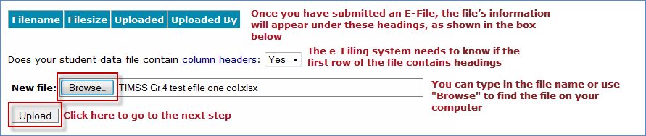

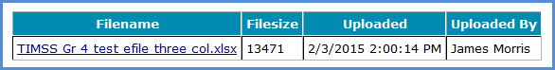

**Step 3 – RTI Staff will review**

Once you have uploaded your file RTI staff will be notified and will review your file. Should there be any questions about the column headings or values, a RTI staff member will reach out to you.

**If you need assistance, please contact the TIMSS Help Desk at** [[**TIMSS@rti.org**](mailto:TIMSS@rti.org)](mailto:%20%3cemail%20address%3e%20)**or 1-833-870-0485.**

## Appendix A19 Email to School Coordinator to Submit Class – Grade 8 – revised – field test and main study

Dear <School Coordinator>,

It was a pleasure speaking with you regarding <the TIMSS 2023 field test study/TIMSS 2023>; thank you again for your time.

In order to randomly sample the 8th grade mathematics classrooms, we first need the below table completed for each of your school’s 8th grade mathematics classes. If there are multi-grade classes (i.e., students from more than one grade level in the same class), only the eight-gradestudents should be counted as a class in the list. For example, if three Grade 7 students, five Grade 8 students, and ten Grade 9 students form a multi-grade class and the target grade is 8, then the School Coordinator should record one Grade 8 class with five students in that class list.

We have 3 options for you to provide this information:

1. Go to <https://surveys.nces.ed.gov/TIMSS> to submit your class list. If you have forgotten your login ID please contact the TIMSS helpdesk at [TIMSS@rti.org](mailto:TIMSS@rti.org) or 1-833-870-0485. If you have forgotten your password, you can request a new password on the TIMSS login page.
2. Send your class list to [[TIMSS@rti.org](mailto:TIMSS@rti.org)](mailto:email@email.com)
3. Call 833-870-0485 and provide

Instructions for **Submit Class List** are attached. These tip sheets and Excel templates can also be found in the **Documents** section of <https://surveys.nces.ed.gov/TIMSS>.

If you have any questions about submitting your list, please email or call the TIMSS Help Desk at TIMSS@rti.org or 1-833-870-0485. ​

Please submit your class list by <date>**.** TIMSS will process your submission and select the sample of eighth-grade mathematics classes to be assessed. You will be informed of the classes selected within a few weeks of submitting your lists, at which time we will request the list of students in the selected classrooms.

Thank you very much for participating in TIMSS, and for submitting your school's class and Student-Teacher Linkage Forms!

Sincerely,

The TIMSS 2023 Team

Attachments: Grade 8 Submit Class List Tip Sheet

*The National Center for Education Statistics (NCES) is authorized to conduct this study under the Education Sciences Reform Act of 2002 (ESRA 2002, 20 U.S.C. §9543), and to collect students’ education records from educational agencies or institutions for the purpose of evaluating federally supported education programs under the Family Educational Rights and Privacy Act (FERPA, 34 CFR §§ 99.31(a)(3)(iii) and 99.35). All of the information you provide may be used only for statistical purposes and may not be disclosed, or used, in identifiable form for any other purpose except as required by law (20 U.S.C. §9573 and 6 U.S.C. §151). In the United States, TIMSS is conducted by NCES, part of the U.S. Department of Education, and the data are being collected by RTI International. The U.S. Office of Management and Budget has approved the data collection under OMB #1850-0695.*

## Appendix A19a Instructions for Submitting Class Lists – Grade 8 – revised – field test and main study

**TIMSS 2023: Instructions for Grade 8 Submit Class List**

TIMSS needs a complete and current list of all of your school’s eighth-grade mathematics classes in order to randomly select classes to be assessed. Typically, two classes are sampled in each school, and all students in the selected classes will be assessed. You can provide this information in 3 ways:

1. Complete Table A (below) and email it to TIMSS@rti.org
2. Complete Table A and call the TIMSS teams to provide the information over the phone
3. Login to <https://surveys.nces.ed.gov/TIMSS>, select **Submit Class List** from the navigation menu. Enter information for each eight-grade math class in the web form.

**Table A. Example Class List**

|  |  |  |  |  |  |
| --- | --- | --- | --- | --- | --- |
| **Class Name/Homeroom Teacher** | **Grade** | **Class group** | **Number of  8th grade students in that class** | **Class Exclusion Status\*** | **Name of Math Teacher for that class**  (may be the same as the class name/homeroom teacher) |
|  | 8 |  |  |  |  |
|  | 8 |  |  |  |  |
|  |  |  |  |  |  |
|  |  |  |  |  |  |
|  |  |  |  |  |  |

(*Class exclusions Status: 1- all students in class have functional disabilities, 2- students with intellectual disability, and 3-non-native language class.)

**Additional Information on Submitting Class List Online.**

**Step 1 – Enter information about all eighth-grade mathematics classes**

On <https://surveys.nces.ed.gov/TIMSS>, select **Submit Class List** from the navigation menu. Enter information for each eighth-grade mathematics class in the web form. After you have entered information for each mathematics class, click on the *Save* button, and another row will appear for you to enter information about another mathematics class. Continue until you have entered information for all mathematics classes that contain eighth-grade students.

Include the following information for each class:

• *Class Name*

• *Class Group or Track* (If applicable)

• *Number of Students*

• *Class Exclusion Status* (If applicable)

• *Name of Mathematics Teacher*

**Example:**

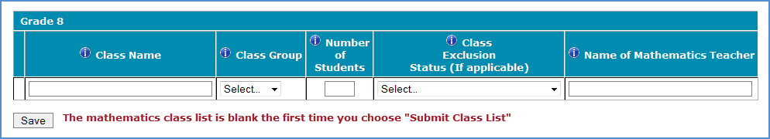

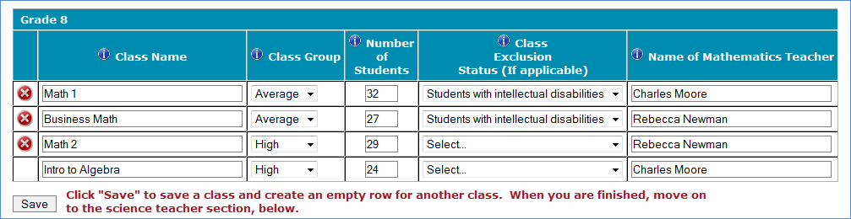

**Step 2 – Enter information about your eighth-grade science teachers**

TIMSS also needs a complete and current list of all of your school’s eighth-grade science teachers in order to link information about science teachers to the assessed students. Enter each teacher’s name and the course the teacher teaches (e.g. biology, integrated science) into the form. Click *Save* after entering each teacher. Continue until you have entered information about all science teachers who teach eighth-grade students.

**Example:**

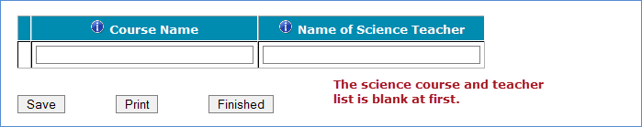

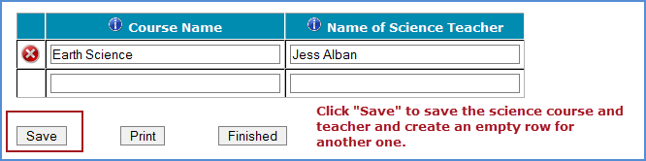

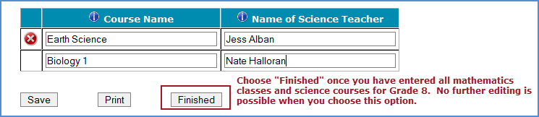

When you have entered information for eighth-grade mathematics classes, and eighth-grade science teachers, in your school, click on the *Finished* button.

**Additional tips for submitting information about your eighth-grade mathematics classes:**

• Refer to the important definitions in the **Class Roster Definitions** document in the **Documents** section of [https://surveys.nces.ed.gov/TIMSS](https://nam04.safelinks.protection.outlook.com/?url=https%3A%2F%2Fsurveys.nces.ed.gov%2FTIMSS&data=04%7C01%7Csecarter%40rti.org%7C457b5d87a5524febf6e808d921cd05ed%7C2ffc2ede4d4449948082487341fa43fb%7C0%7C0%7C637577986716150264%7CUnknown%7CTWFpbGZsb3d8eyJWIjoiMC4wLjAwMDAiLCJQIjoiV2luMzIiLCJBTiI6Ik1haWwiLCJXVCI6Mn0%3D%7C1000&sdata=ytt4aAncwGfsMQVPsqBaD9XQoKzTtrY%2FXJxRpT2NTy4%3D&reserved=0).

• Record the Class Name that is typically used by your school to refer to the class.

• For math classes with students from more than one grade level, include in *Number of Students* only those students in grade 8. For example, if the class has 5 seventh-graders, 6 eighth- graders, and 4 ninth-graders, enter “6” as the *Number of Students* in this class.

• Use the most current enrollment information.

• Include all classes, even if they typically are excluded from your state testing program, or all students take alternate assessments. You can indicate information about the class in *Class Exclusion Status*.

• Examples of science courses include: general science, integrated science, biology, physical science. Use the course names that you use in your school.

• Print a list of the mathematics classes and science teachers you included for your future reference using the *Print* button.

**If you need assistance, email** [**TIMSS@rti.org**](mailto:TIMSS@rti.org%20) **or call 1-833-870-0485.**

## Appendix A19b Email to School Coordinator to Submit Student-Teacher Linkage Form – Grade 8 – new – field test and main study

Dear <<School Coordinator>>,

Thank you for providing the complete list of 8th grade classrooms; thank you again for your time. We have sampled <fill number of classrooms> of your school’s 8th grade classrooms.

**Sampled Classrooms**

* <fill classroom 2>
* <fill classroom 3>
* <fill classroom 5>

We will now need the Student-Teacher Linkage Form of these sampled classrooms. In order to ensure data security, this information needs to be submitted through our secure website. Go to <https://surveys.nces.ed.gov/TIMSS> to submit your Student-Teacher Linkage Form. If you have forgotten your login ID please contact the TIMSS helpdesk at TIMSS@rti.org or 1-833-870-0485. If you have forgotten your password, you can request a new password on the TIMSS login page.

Instructions for **Submitting Student-Teacher Linkage Form** are attached. These tip sheets and Excel templates can also be found in the **Documents** section of <https://surveys.nces.ed.gov/TIMSS>.

If you have any questions about submitting your list, please email or call the TIMSS Help Desk at [TIMSS@rti.org](mailto:TIMSS@rti.org) or 833-870-0485. ​

Please provide your Student-Teacher Linkage Form by <<date>>**.** TIMSS will process your submission and will be in touch in order to secure parent notification and schedule the session date.

Thank you very much for participating in TIMSS, and for submitting your school's class and Student-Teacher Linkage Forms!

Sincerely,

TIMSS 2023 Team

Attachments: Grade 8 Submit Student-Teacher Linkage Form Tip Sheet

*NCES is authorized to conduct this study under the Education Sciences Reform Act of 2002 (ESRA 2002, 20 U.S.C. §9543). All of the information you provide may be used only for statistical purposes and may not be disclosed, or used, in identifiable form for any other purpose except as required by law (20 U.S.C. §9573 and 6 U.S.C. §151).*

## Appendix A19c Instructions for Submitting Student-Teacher Linkage Forms – Grade 8 – new – field test and main study

**TIMSS 2023: Instructions for Grade 8 Submit Student-Teacher Linkage Form**

Along with the list of classes, TIMSS needs a complete and current list of **all students** in grade 8 in order to draw a random sample of mathematics classes (and therefore students) to participate in the assessment. Your student data electronic file (E-File) must be submitted as a Microsoft Excel file.

You may use one of the **TIMSS Grade 8 Excel Templates** (located in **Documents** on [https://surveys.nces.ed.gov/TIMSS](https://nam04.safelinks.protection.outlook.com/?url=https%3A%2F%2Fsurveys.nces.ed.gov%2FTIMSS&data=04%7C01%7Csecarter%40rti.org%7C457b5d87a5524febf6e808d921cd05ed%7C2ffc2ede4d4449948082487341fa43fb%7C0%7C0%7C637577986716150264%7CUnknown%7CTWFpbGZsb3d8eyJWIjoiMC4wLjAwMDAiLCJQIjoiV2luMzIiLCJBTiI6Ik1haWwiLCJXVCI6Mn0%3D%7C1000&sdata=ytt4aAncwGfsMQVPsqBaD9XQoKzTtrY%2FXJxRpT2NTy4%3D&reserved=0) and described below) or you may provide an Excel file with the same information. If you cannot submit your student data with this information in an Excel file, please call or email the TIMSS File Help Desk at  [TIMSS@rti.org](mailto:%3cemail%20address%3e%20) or 1-833-870-0485.

**Step 1 – Compile Data in an Excel File**

Prepare an Excel file with the following data elements for all students in grade 8.

|  |  |
| --- | --- |
| **Data Element** | **Description** |
| Mathematics Class | The mathematics class the student is enrolled in. Please use the  same class names you used in **Submit Class List.** |
| Mathematics Teacher | Teacher of the above named mathematics class that the student is  taking |
| Science Teacher | Name of science teacher who teaches science to each student |
| Student Name | The preferred format is First Name, Middle Name (or Initial), and  Last Name in separate columns. However, TIMSS will accept student names in one column. |
| Sex | Codes (numeric or text) for Male/Female |
| Date of Birth | The preferred format is Month of Birth and Year of Birth in  separate columns. However, TIMSS will accept Date of Birth in one column. |
| Student with a Disability  (SD) Status | School-defined codes for:  • Yes, IEP: Student has an Individualized Education Plan (IEP).  Students with 504 plans that need accommodations can be  coded this value as well.  • No, not SD:  • Information unavailable at this time. |
| English Language  Learner (ELL) Status | School-defined codes for:  • Yes, ELL  • No, not ELL  • Information unavailable at this time. |

You may use one of the templates provided or create your own Excel file with these data for each student. It is preferred that you include column headers as the first row in your E-File, as in these templates. However, Files without column headers will be accepted.

*Template 1* has student name in three separate columns, and month of birth and year of birth in two separate columns.



*Template 2* has student name in one column, and date of birth in one column.



Tips for ensuring the File process goes smoothly:

* Use the template or provide column headers. Student information should begin on the second row. There should be no empty rows within the student data.
* Be sure to give your file a unique, descriptive name. Within Excel, click on *File*, then *Save As*,
  + and give your file a name such as “Your School Name Grade 8.xls.”
* The first row of data in your file will be read as the column header unless you indicate otherwise on the **Submit Student-Teacher Linkage Form** webpage. Each succeeding row will be considered a student record.
* There should be only one worksheet with data in the Excel file. If there are other worksheets, they must not contain any data.

**Step 2 – Upload Your Excel File**

Once your file is prepared and checked for accuracy and completeness, login to [https://surveys.nces.ed.gov/TIMSS](https://nam04.safelinks.protection.outlook.com/?url=https%3A%2F%2Fsurveys.nces.ed.gov%2FTIMSS&data=04%7C01%7Csecarter%40rti.org%7C457b5d87a5524febf6e808d921cd05ed%7C2ffc2ede4d4449948082487341fa43fb%7C0%7C0%7C637577986716150264%7CUnknown%7CTWFpbGZsb3d8eyJWIjoiMC4wLjAwMDAiLCJQIjoiV2luMzIiLCJBTiI6Ik1haWwiLCJXVCI6Mn0%3D%7C1000&sdata=ytt4aAncwGfsMQVPsqBaD9XQoKzTtrY%2FXJxRpT2NTy4%3D&reserved=0) and select “Submit Student-Teacher Linkage Form” from the left-hand menu.

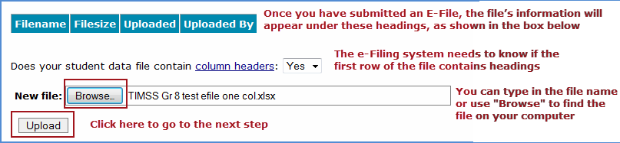

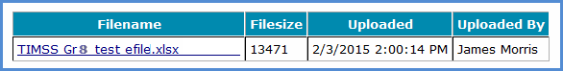

**Step 3 – RTI Staff will review**

Once you have uploaded your file RTI staff will be notified and will review your file. Should there be any questions about the column headings or values, a RTI staff member will reach out to you.

**If you need assistance, please contact the TIMSS File Help Desk at**  [**TIMSS@rti.org**](mailto:%20TIMSS@rti.org%20) **or 833-870-0485.**

## Appendix A20 TIMSS 2023 COVID-19 Protocols – revised – field test and main study

*(Notes: If needed at the time of data collection, protocols will be updated to reflect the most recent CDC guidelines and RTI Infectious Disease Response Teams (IDRT) guidance. A graphically designed document will be created with these protocols. All protocols will be reviewed by the IDRT in advance of any in-person data collection.)*

TIMSS 2023 COVID-19 Protocols

The coronavirus (COVID-19) pandemic continues to pose significant challenges for state agencies, districts, and schools, while also affecting us all personally. TIMSS representatives’ top priority is to protect the health and safety of students and staff.

Our COVID-19 mitigation protocol has been developed using CDC guidelines with the input of doctors, public health experts, industrial hygienists, and other subject matter experts on RTI’s Infectious Disease Response Team. These protocols are intended to be flexible to adapt to the changing landscape presented by COVID-19. TIMSS representatives will work with districts and schools to ensure that their COVID-19 protocols are also followed.

TIMSS project staff will monitor local, county, and state public health restrictions weekly to determine whether in-person data collection is appropriate at that time, and the level of PPE necessary to ensure the safety of field staff. All protocols developed work to integrate physical distancing, minimizing shared contact points, and provision of preventative hygiene supplies. The protocol includes:

* Provide Personal Protective Equipment (PPE)
  + TIMSS will provide field staff with the following PPE:
    - Masks (Fit N95, cloth, and disposable)
    - Face shields
    - Disposable gloves
    - Hand sanitizer
    - Sanitizing wipes & sprays for equipment and surfaces
* Sanitizing and PPE Protocol
  + Multiple times during the assessment day, field staff will follow protocols to:
    - Sanitize testing equipment and equipment cases
    - Replace gloves and masks between assessment sessions
    - Used disposable PPE will be discarded in TIMSS-supplies trash bags and removed from the school by field staff
* Field Staff COVID-19 Protocol training
  + All field staff will be trained on COVID-19 protocols, including:
    - Donning and removing PPE
    - Proper disposal of used PPE
    - Social distancing requirements
    - Sanitizing equipment and equipment cases
    - Other school protocols
* Health Monitoring
  + Before in-person work, all RTI staff are required to sign a Workplace Health Pledge, which states that employees will not conduct in-person data collection if they or any members of their household have been diagnosed with COVID-19 within the past 14 days, if they or any members of their household show any COVID-19 symptoms within the past 14 days, or if they have had a fever in the last 48 hours.
  + In adhering to the pledge, staff will be required to take their own temperature each day before reporting to work using the thermometer provided by RTI. Staff will not be permitted to work if they present with a fever.
    - Any field staff who do not successfully pass the daily health assessment will not report to school that day, and will be required to either:
      1. Test Negative for COVID-19 in accordance with CDC guidelines
      2. Be free of COVID-19 symptoms for a 14-day period before conducting any assessment in schools
      3. Provide written documentation from their healthcare provider releasing their return to work
* School Protocols
  + Field Staff will follow any and all school-specific required CDC protocols, which may include but are not limited to the following:
    - Temperature checks and other symptom assessments by the school upon arrival at the school
    - Social distancing guidelines of staff and students
    - Additional school required PPE
    - Additional sanitizing requirements

## Appendix A21 TIMSS 2023 School Posters – new – field test and main study

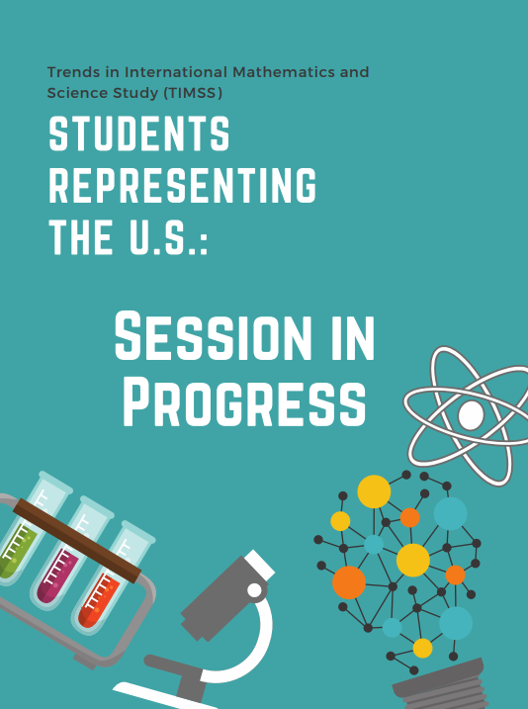

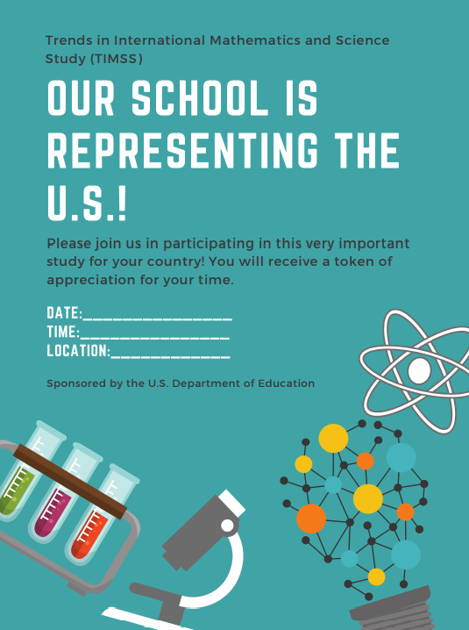

1. http://timssandpirls.bc.edu/timss2015/international-results/timss2015/wp-content/uploads/2016/T15-20-years-of-TIMSS.pdf
2. https://nces.ed.gov/timss/results19/index.asp#/math/trends
3. https://nces.ed.gov/timss/results19/index.asp#/math/trends