Below is a screenshot of the eSubmit “Welcome” screen showing the blue banner that is displayed on all screens for the OMB NO: 2138-0009 data entry application for collecting the 298C data.
Below the blue banner is OST-R>BTS which indicated that the Bureau of Transportation Statistics (BTS) is under the Department of Transporation’s Office of the Secretary for Research and Technology.
This blue banner remains in a fixed position as users move from screen to screen and page down on a screen:
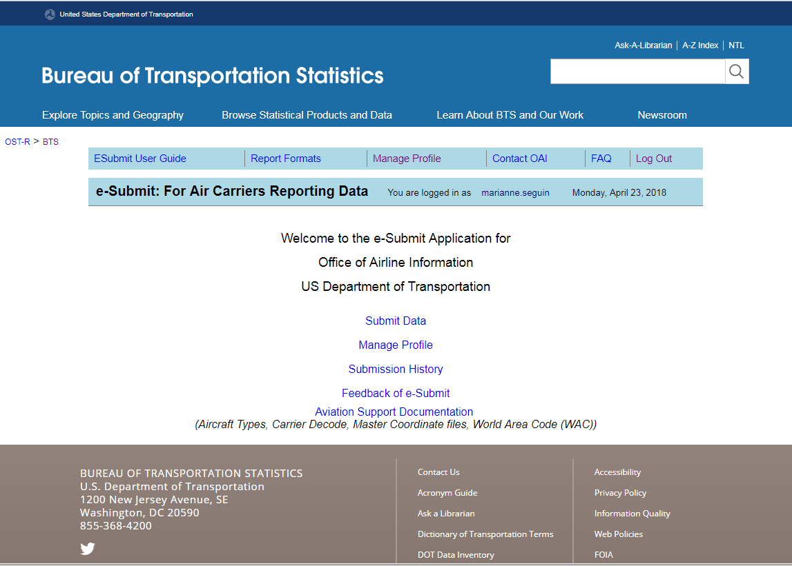

Form 298C, Schedule F-1, Report of Financial Data, Data Entry Screen:
Below is a screenshot of the top part of the 298C F1 data entry screen to show the burden statement:
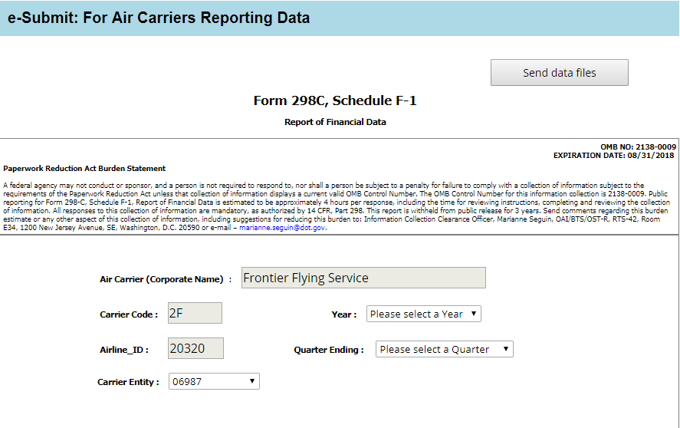
Below is the wording for the 298C F1 burden statement in a larger font:
OMB NO: 2138-0009
EXPIRATION DATE: 08/31
Paperwork Reduction Act Burden Statement
A federal agency may not conduct or sponsor, and a person is not required to respond to, nor shall a person be subject to a penalty for failure to comply with a collection of information subject to the requirements of the Paperwork Reduction Act unless that collection of information displays a current valid OMB Control Number. The OMB Control Number for this information collection is 2138-0009. Public reporting for Form 298-C, Schedule F-1, Report of Financial Data is estimated to be approximately 4 hours per response, including the time for reviewing instructions, completing and reviewing the collection of information. All responses to this collection of information are mandatory, as authorized by 14 CFR, Part 298. This report is withheld from public release for 3 years. Send comments regarding this burden estimate or any other aspect of this collection of information, including suggestions for reducing this burden to: Information Collection Clearance Officer, Marianne Seguin, OAI/BTS/OST-R, RTS-42, Room E34, 1200 New Jersey Avenue, SE, Washington, D.C. 20590 or e-mail – marianne.seguin@dot.gov.
Below is a screenshot of the entire 298C F1 data entry screen:
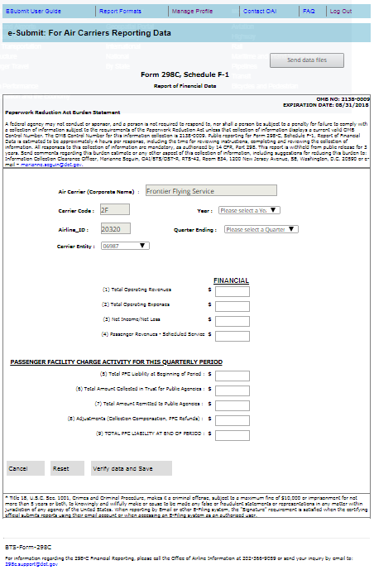
Form 298C, Schedule F-2, Report of Airport Operating Expenses and Aircraft Related Statistics:
Below is a screenshot of the top part of the 298C F2 data entry screen to show the burden statement:
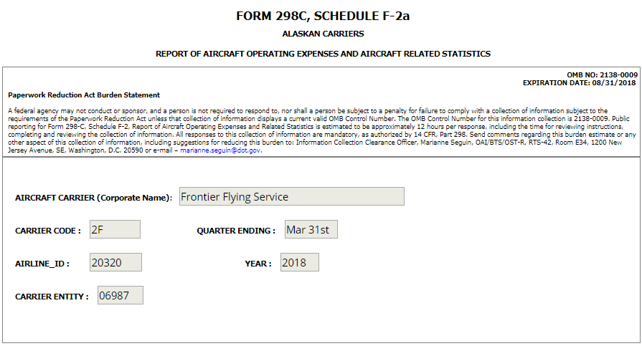
Below is the wording for the 298C F2 burden statement in a larger font:
OMB NO: 2138-0009
EXPIRATION DATE: 08/31/2018
Paperwork Reduction Act Burden Statement
A federal agency may not conduct or sponsor, and a person is not required to respond to, nor shall a person be subject to a penalty for failure to comply with a collection of information subject to the requirements of the Paperwork Reduction Act unless that collection of information displays a current valid OMB Control Number. The OMB Control Number for this information collection is 2138-0009. Public reporting for Form 298-C, Schedule F-2, Report of Aircraft Operating Expenses and Related Statistics is estimated to be approximately 12 hours per response, including the time for reviewing instructions, completing and reviewing the collection of information. All responses to this collection of information are mandatory, as authorized by 14 CFR, Part 298. Send comments regarding this burden estimate or any other aspect of this collection of information, including suggestions for reducing this burden to: Information Collection Clearance Officer, Marianne Seguin, OAI/BTS/OST-R, RTS-42, Room E34, 1200 New Jersey Avenue, SE, Washington, D.C. 20590 or e-mail – marianne.seguin@dot.gov.
Below are screenshots of the 298C F2 data entry screen used by Alaskan Carriers:
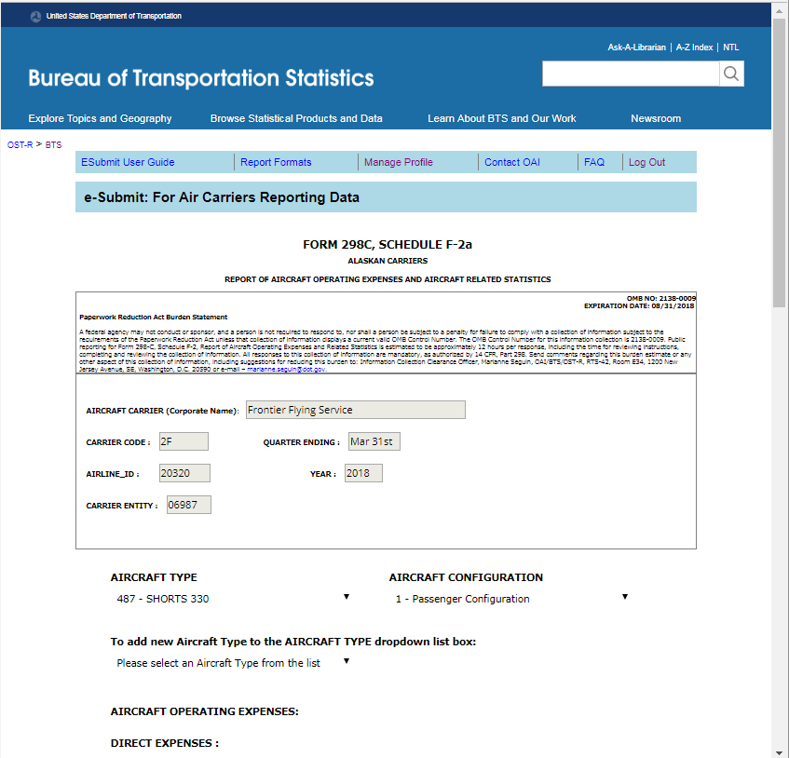

… scrolling down on the page … continued …
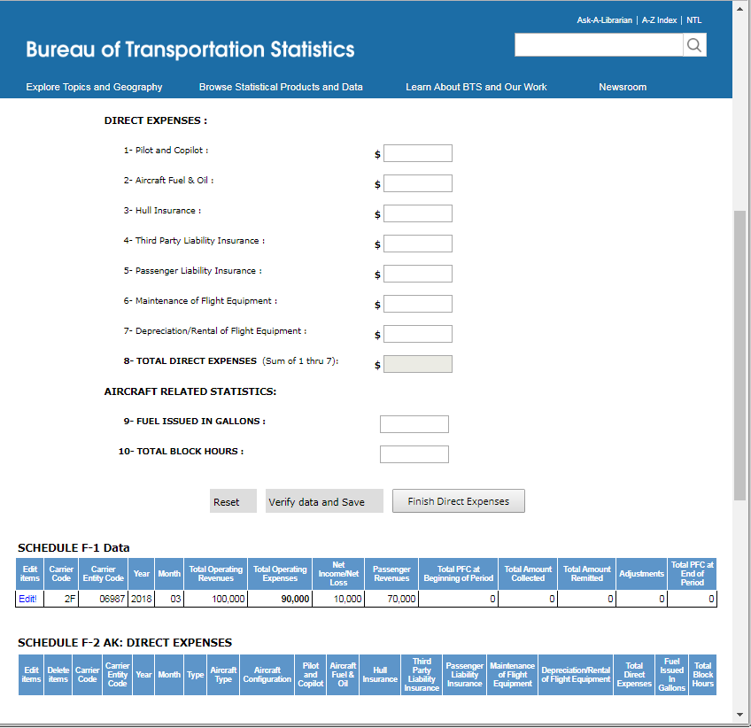
… scrolling down on the page … continued …
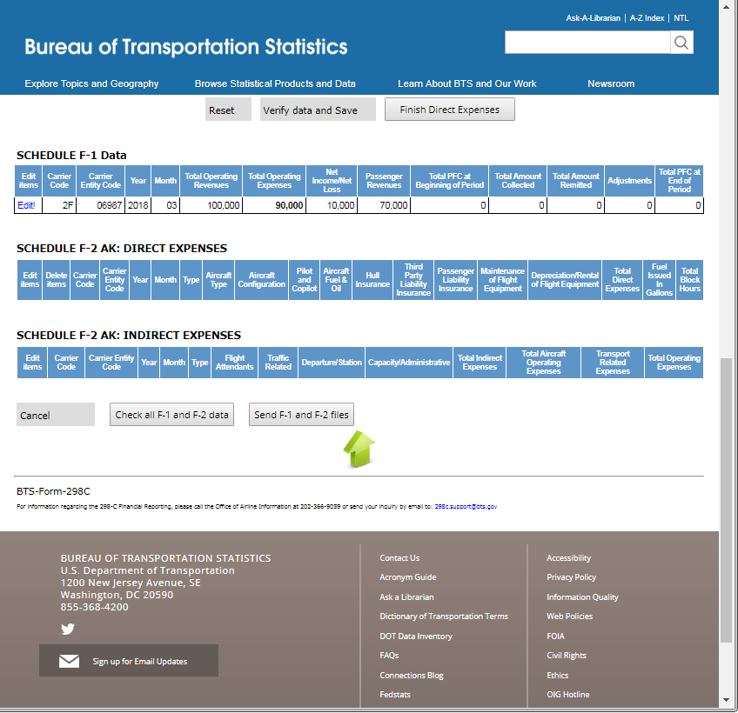

Below are screenshots of the 298C F2 data entry screen used by NON Alaskan Carriers:
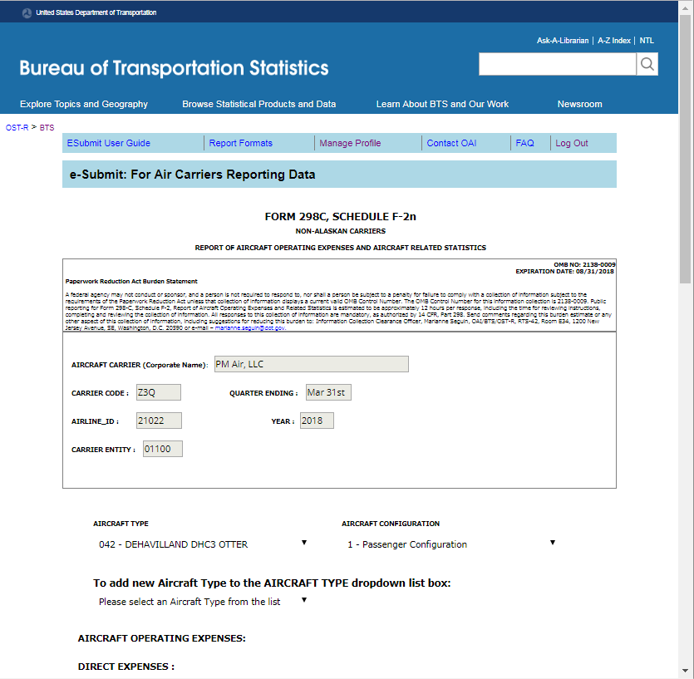

… scrolling down on the page … continued …
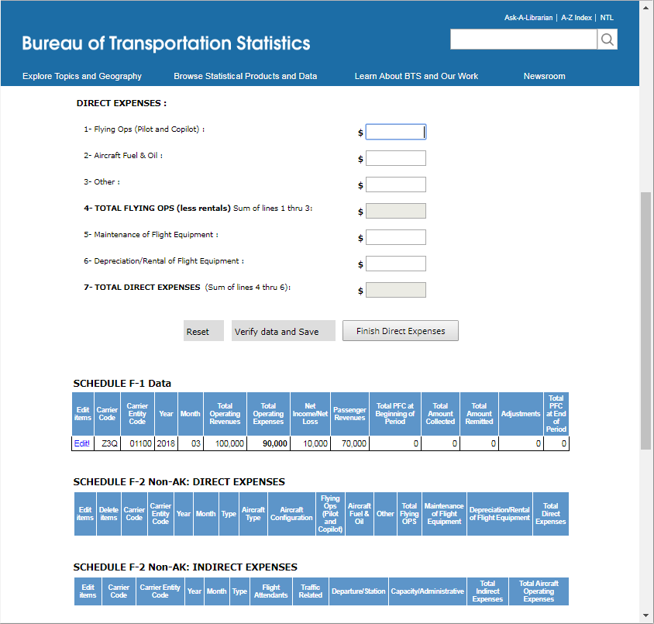

… scrolling down on the page … continued …
