Exhibit B- Audited Financial Assessment Subsystem-Public Housing
(FASS-PH) Template
Contents
Audited Screen 1 – OMB Control Number Page 2
Audited Screen 2 – FASS PH Main Menu 3
Audited Screen 3 – Inbox 4
Audited Screen 4 – PHA Information Page 5
Audited Screen 5 – PHA Information Page (Program Selection Page) 5
Audited Screen 6 – PHA Information Page (Add a Program Page) 7
Audited Screen 7 – PHA Information Page (Comments Page) 8
Audited Screen 8 – PHA Information Page (Late Reason Page) 9
Audited Screen 9 – PHA Information Page (Material Difference Page) 10
Audited Screen 10 – FDS Balance Sheet Page 11
Audited Screen 11 – FDS Balance Sheet Modified Accrual Page (HCV) 14
Audited Screen 12 – FDS Balance Sheet Page (Detail Links) 17
Audited Screen 13 – FDS Income Statement Page 25
Audited Screen 14 – FDS Income Statement Page (Detail Links) 29
Audited Screen 15 – FDS Income Statement Page (HCV Program Detail Links) 34
Audited Screen 16 – Data Collection Form (General Information Page) 43
Audited Screen 17 – Data Collection Form (Financial Statement Page) 45
Audited Screen 18 – Data Collection Form (Fund Opinion Details Page) 46
Audited Screen 19 – Data Collection Form (Federal Program Page) 48
Audited Screen 20 – Data Collection Form (TFAE Page) 49
Audited Screen 21 – Data Collection Form (Compliance Requirement Page) 50
Audited Screen 22 – Data Collection Form (Supplemental Information Page) 51
Audited Screen 23 – Notes and Findings (Notes Page) 52
Audited Screen 24 – Notes and Findings (Audit Information Page) 53
Audited Screen 25 – Notes and Findings (Action Plans Page) 54
Audited Screen 26 – Notes and Findings (Financial Statement Page) 55
Audited Screen 27 – Notes and Findings (MD & A Page) 56
Audited Screen 28 – Notes and Findings (Audit Findings Page) 57
Audited Screen 29 – Auditor’s Agreed Upon Procedures (AUP) Page 58
Audited Screen 30 – Submit Page 60

Audited Screen 1 – OMB Control Number Page

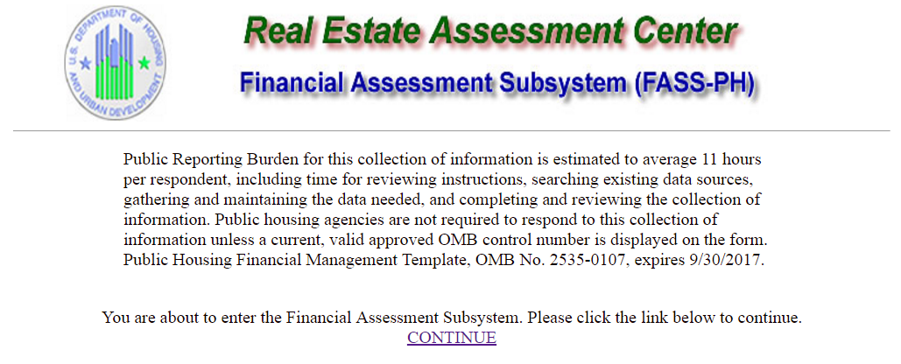

Audited Screen 2 – FASS PH Main Menu

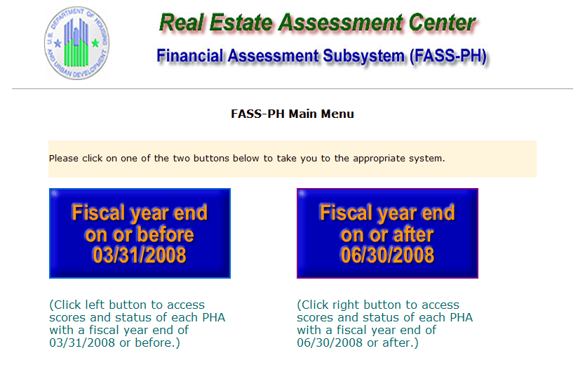

Audited Screen 3 – Inbox

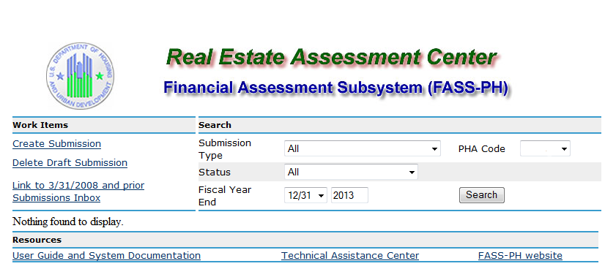

Audited Screen 4 – PHA Information Page

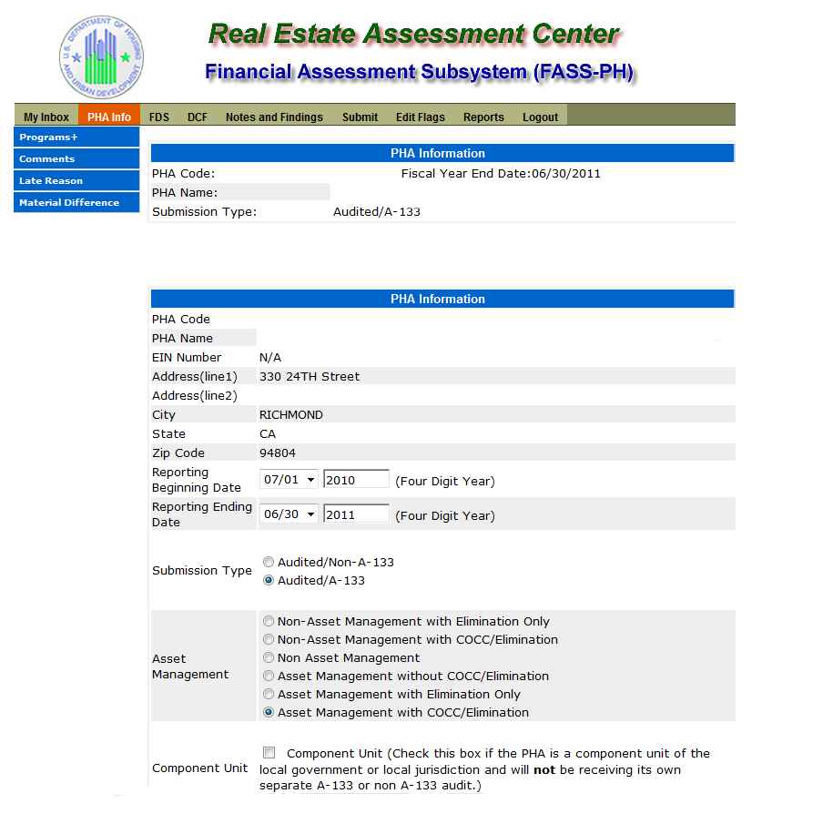

Audited Screen 5 – PHA Information Page (Program Selection Page)
Fiscal Year End Date: 06/30/2016
Audited/Single Audit
Audited/Single Audit
Audited/Non Single Audit
local government or local jurisdiction and will not be receiving its own separate Single Audit or Financial Audit

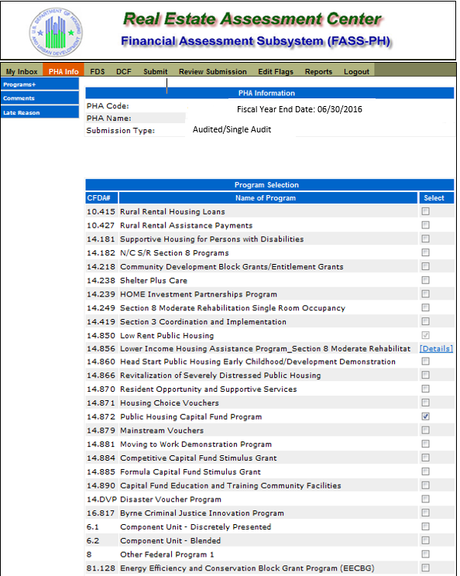
Audited/Single Audit
Fiscal Year End Date: 06/30/2016

Audited Screen 6 – PHA Information Page (Add a Program Page)

Audited Screen 7 – PHA Information Page (Comments Page)

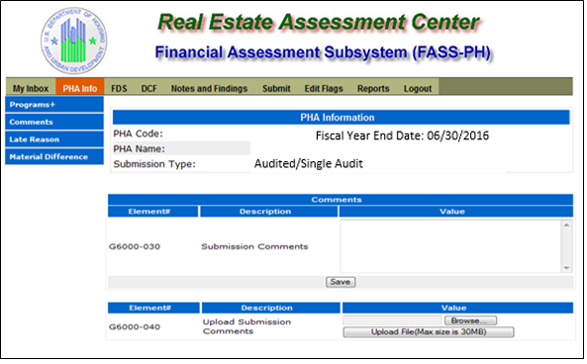

Audited Screen 8 – PHA Information Page (Late Reason Page)

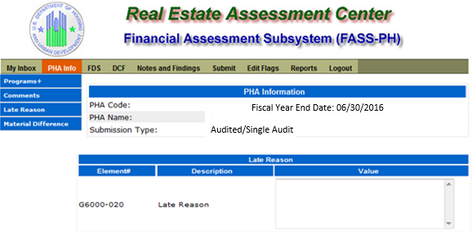

Audited Screen 9 – PHA Information Page (Material Difference Page)

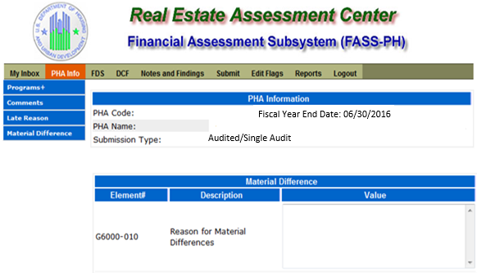

Audited Screen 10 – FDS Balance Sheet Page

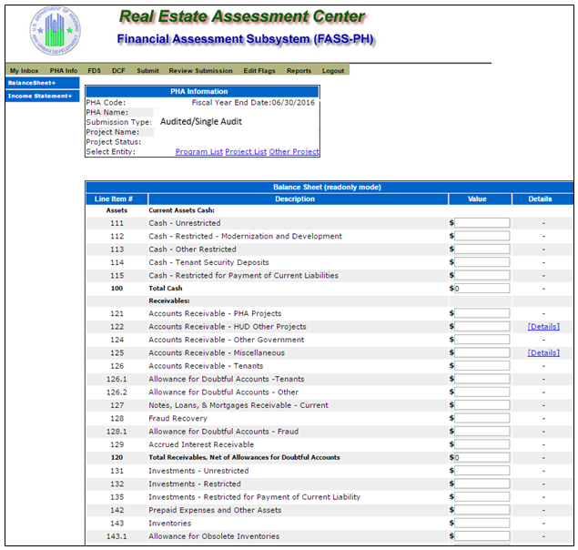

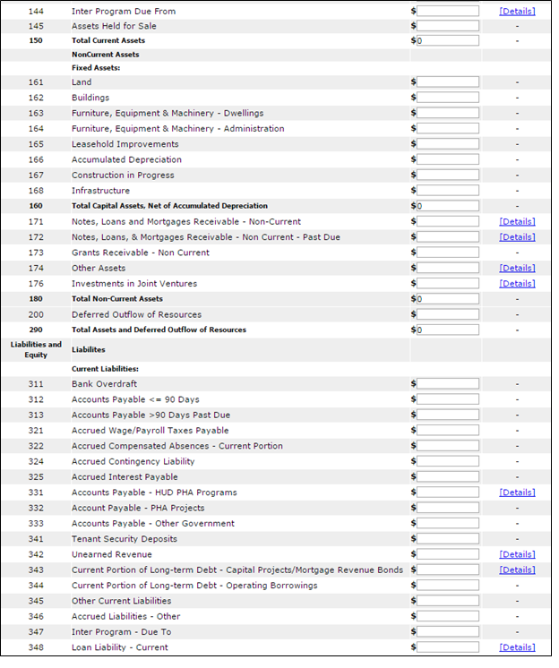

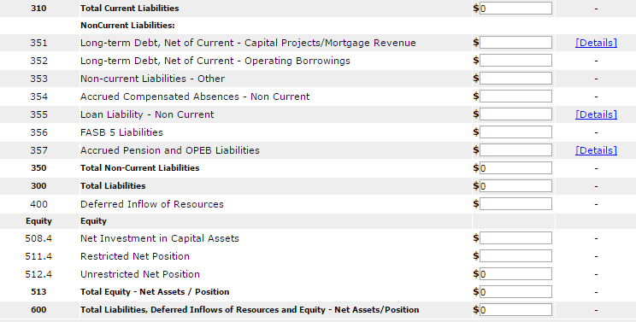

Audited Screen 11 – FDS Balance Sheet Modified Accrual Page (HCV)

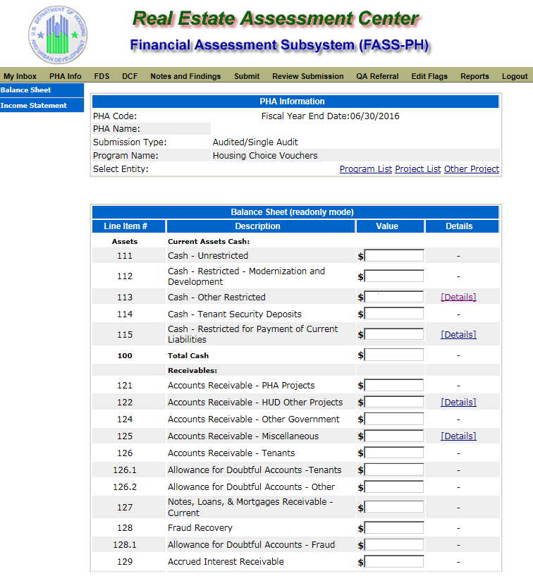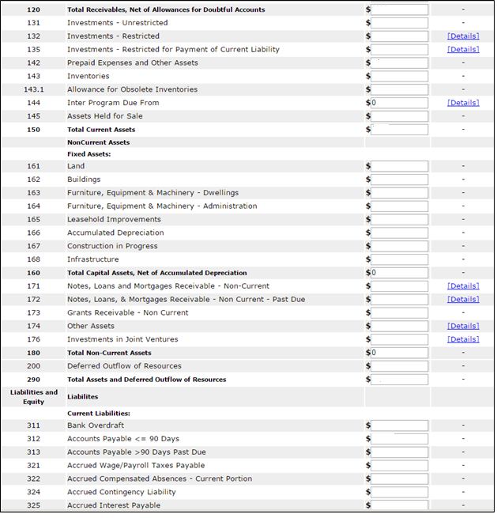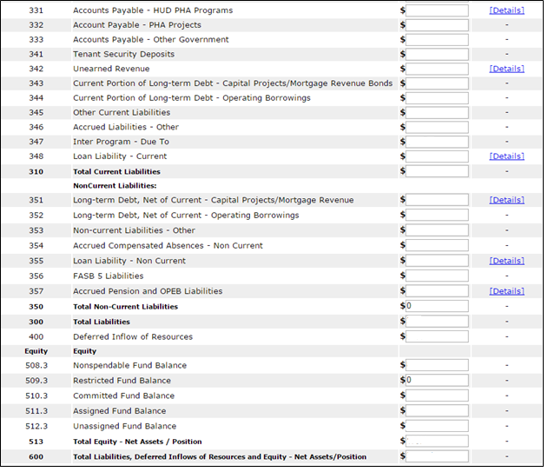

Audited Screen 12 – FDS Balance Sheet Page (Detail Links)

The following screen provides the detail link associated for the following FDS line Item: 113. FDS Line Item 115 has a similar detail link.

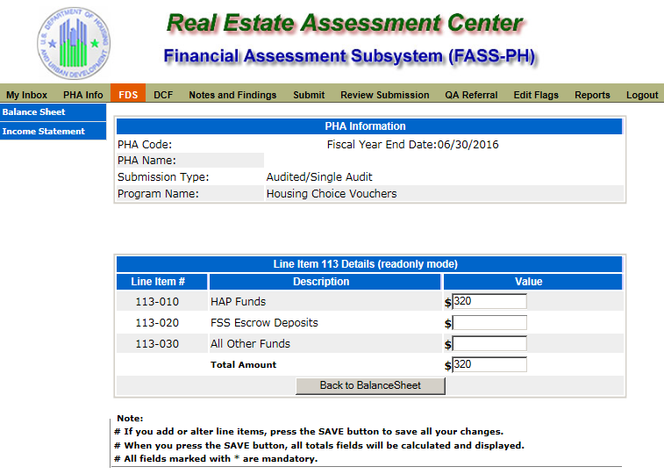
The following screen provides the detail link associated for the following FDS line Item: 122. FDS Line Items 331 and 342 have a similar detail link.

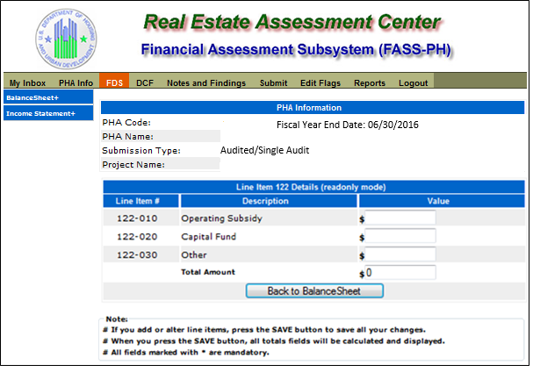
The following screen provides the detail link associated for the following FDS line Item: 125. FDS Line Items 171, 172, 174, 176, 348, and 355 have a similar detail link.

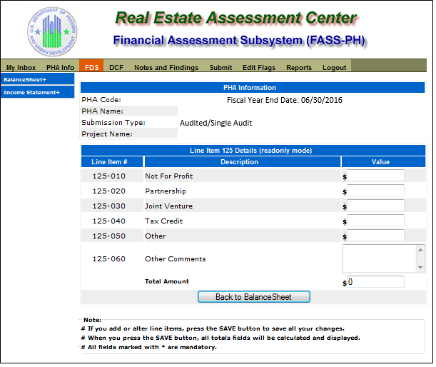

The following screen provides the detail link associated for the following FDS Line Item: 132. FDS Line Item 135 has a similar detail link.

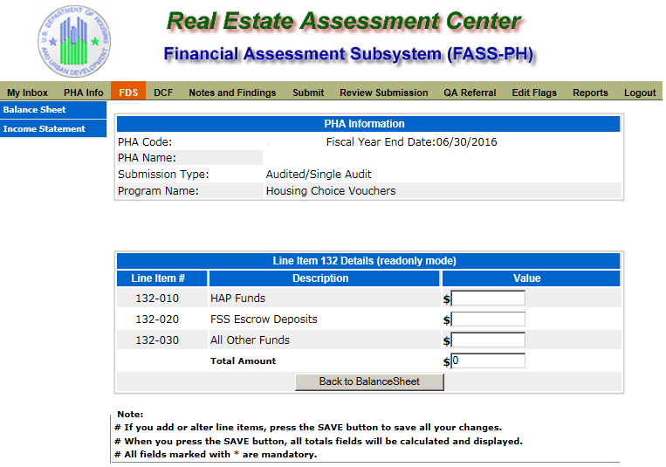

The following screen provides the detail link associated for the following FDS Line Item: 144.

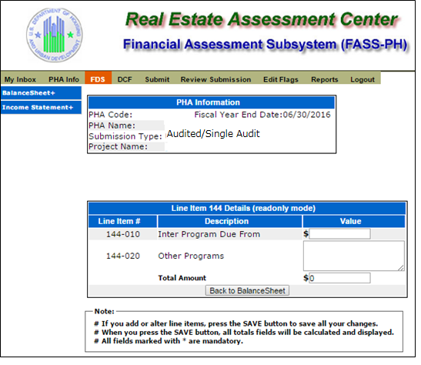

The following screen provides the detail link associated for the following FDS Line Item 331. FDS Line Item 342 has a similar detail link.

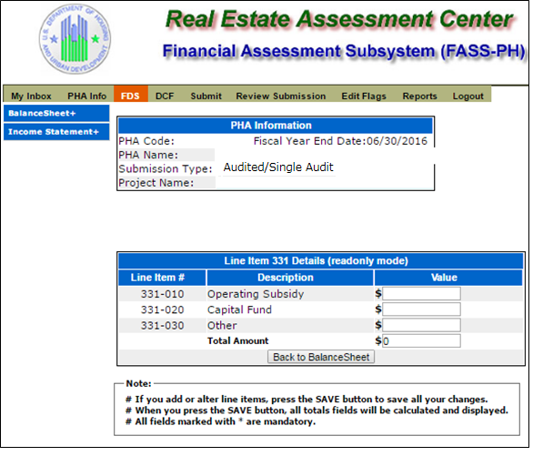

The following screen provides the detail link associated for the following FDS Line Item: 343. FDS Line Item 351 has a similar detail link.

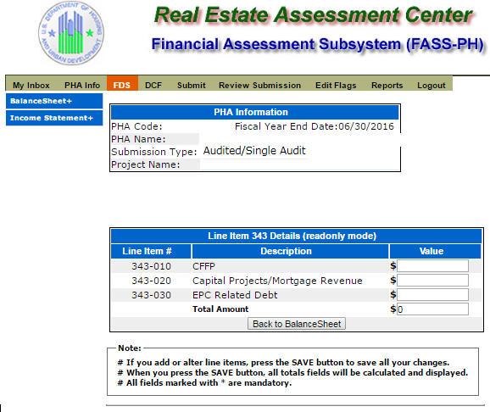

The following screen provides the detail link associated for the following FDS line Item: 357.

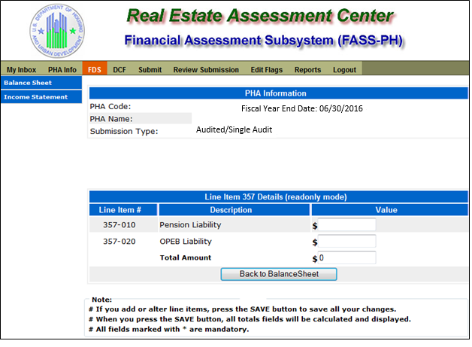

Audited Screen 13 – FDS Income Statement Page

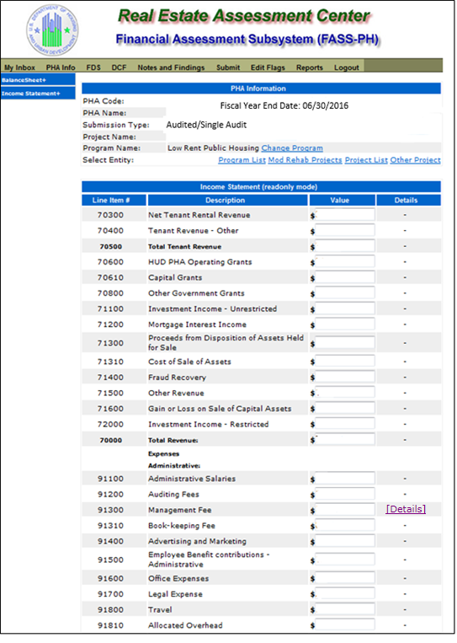

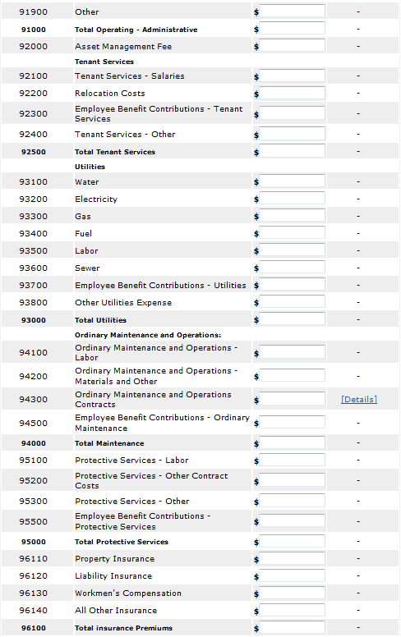

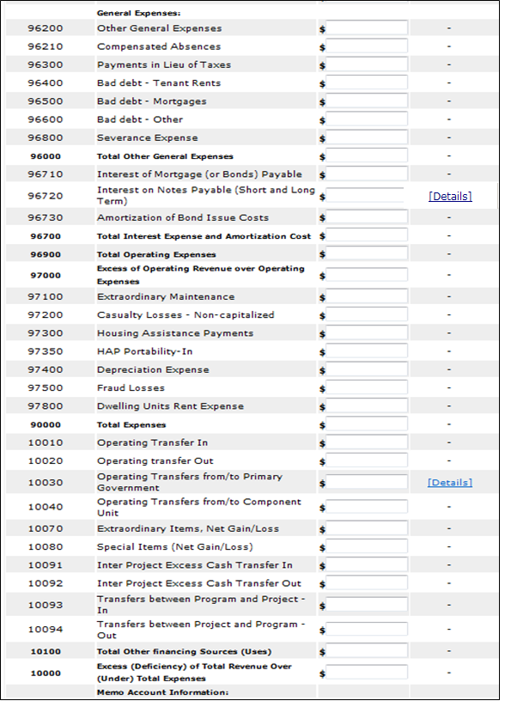

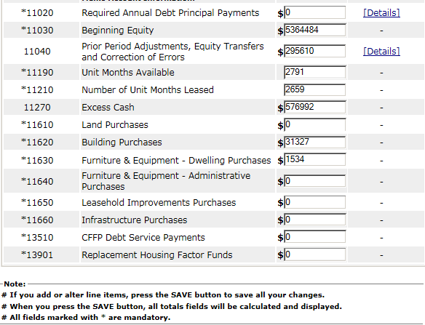

Audited Screen 14 – FDS Income Statement Page (Detail Links)

The following screen provides the detail link associated with the following FDS Line Item: 91300. FDS Line Item 70750 has a similar detail link that is applicable to COCC program only.

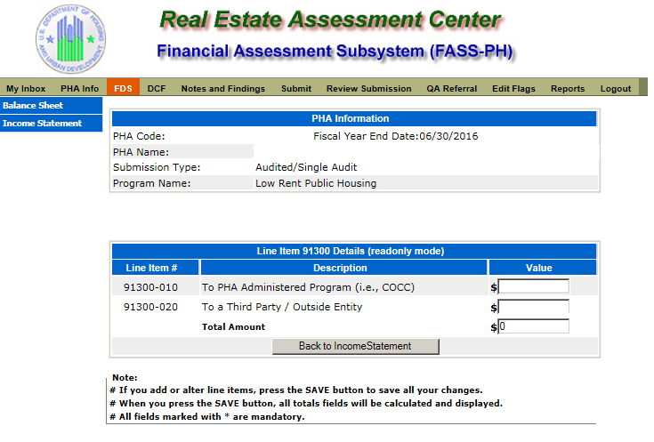
The following screen provides the detail link associated with the following FDS Line Item: 94300.

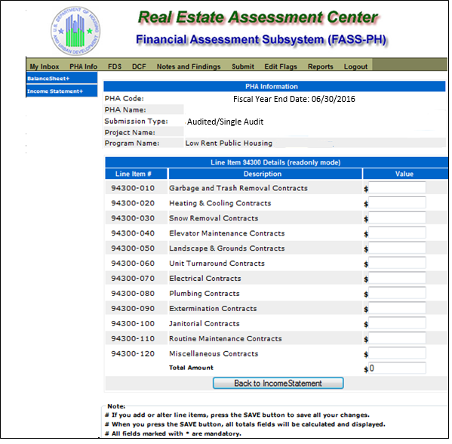
The following screen provides the detail link associated with the following FDS Line Item: 96720. FDS Line Item 11020 has a similar detail link.

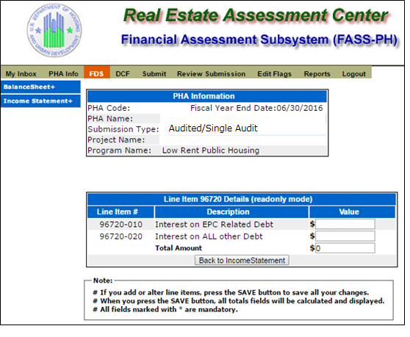
The following screen provides the detail link associated with the following FDS Line Item: 10030.

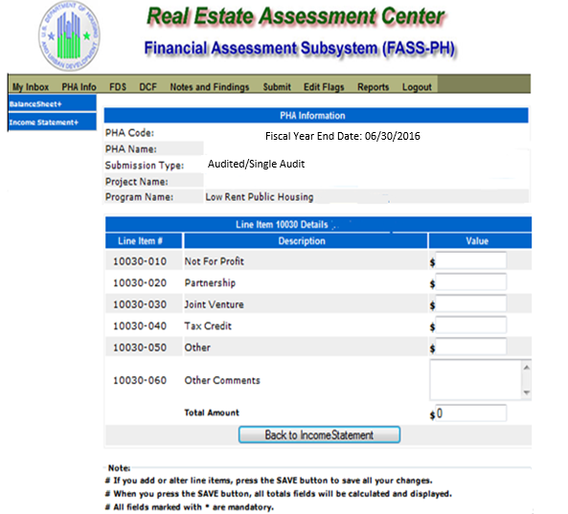

The following screen provides the detail link associated with the following FDS Line Item:
11040.

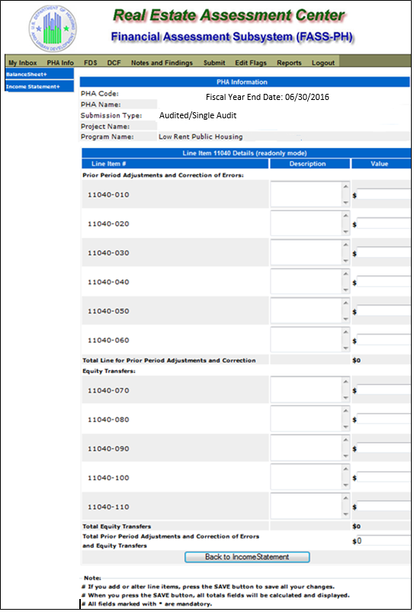

Audited Screen 15 – FDS Income Statement Page (HCV Program Detail Links)

The following screen provides the detail link associated with the following FDS Line Item: 70600. This detail link is only applicable to the Housing Choice Voucher Program.

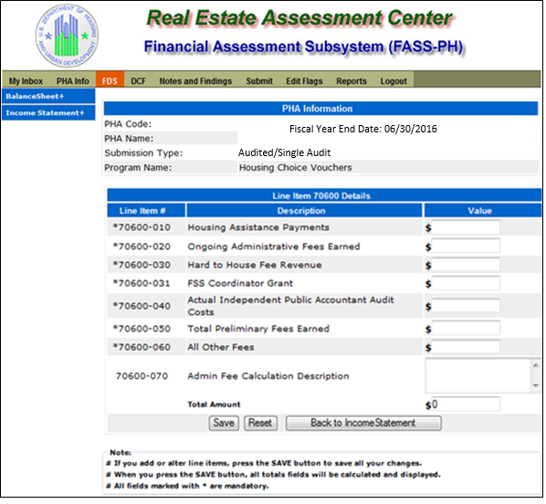
The following screen provides the detail link associated with the following FDS Line Item: 71100. This detail link is only applicable to the Housing Choice Voucher Program.

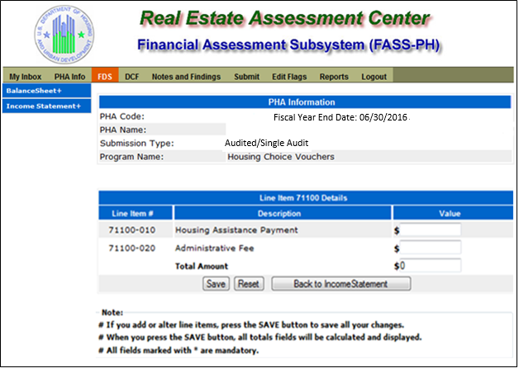

The following screen provides the detail link associated with the following FDS Line Item: 71400. This detail link is only applicable to the Housing Choice Voucher Program.

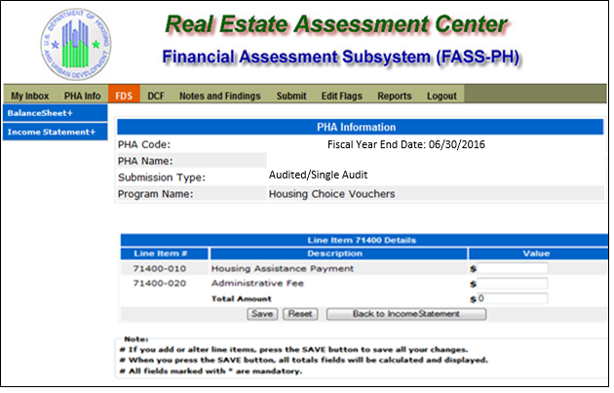

The following screen provides the detail link associated with the following FDS Line Item: 72000. This detail link is only applicable to the Housing Choice Voucher Program.

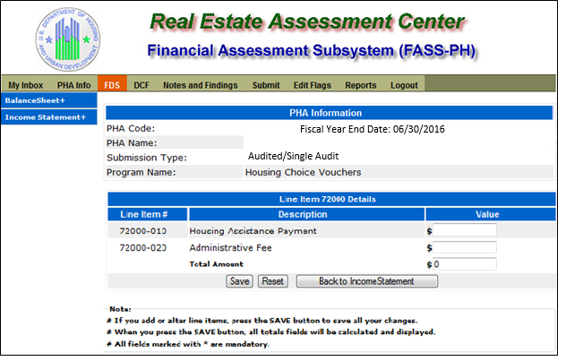

The following screen provides the detail link associated with the following FDS Line Item: 97300. This detail link is only applicable to the Housing Choice Voucher Program.

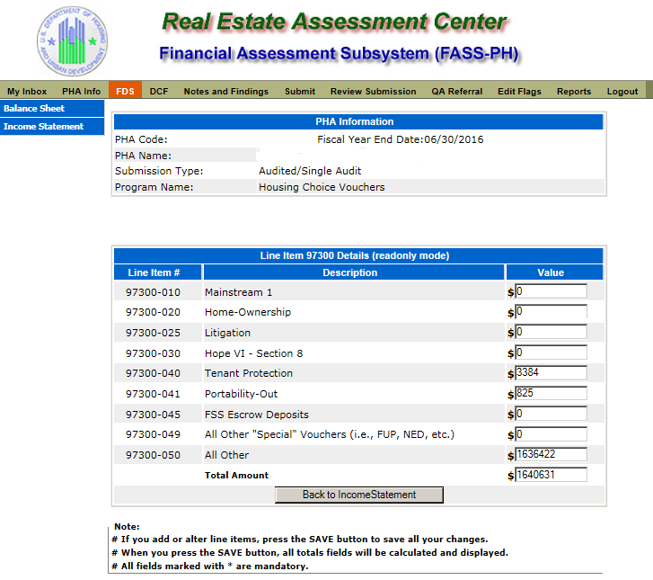

The following screen provides the detail link associated with the following FDS Line Item: 11140. This detail link is only applicable to the Housing Choice Voucher Program.

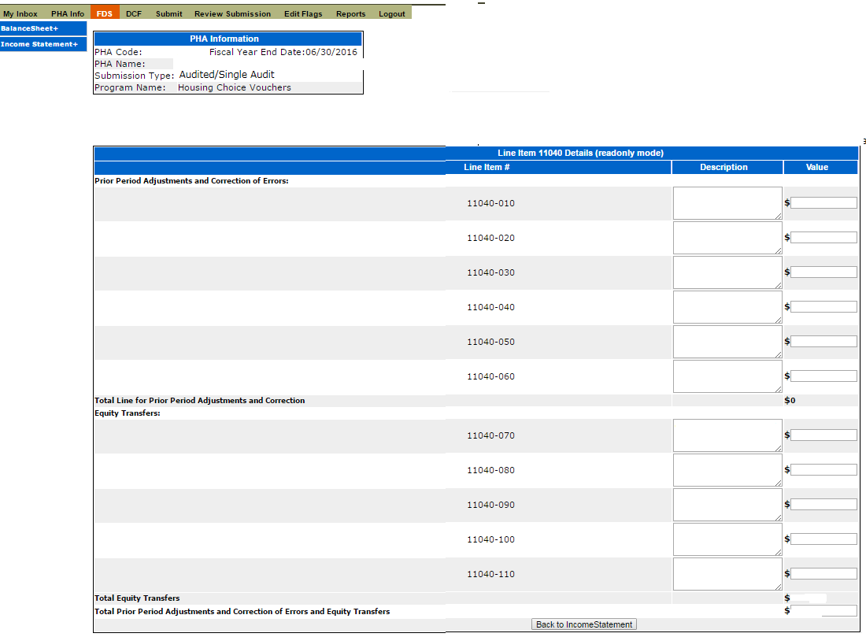

The following screen provides the detail link associated with the following FDS Line Item: 11170. This detail link is only applicable to the Housing Choice Voucher Program.

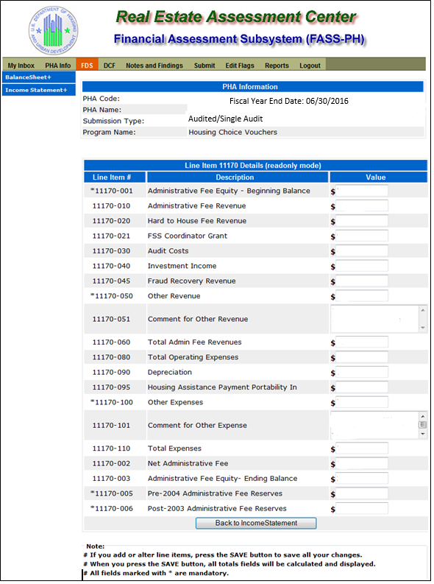

The following screen provides the detail link associated with the following FDS Line Item: 11180. This detail link is only applicable to the Housing Choice Voucher Program.

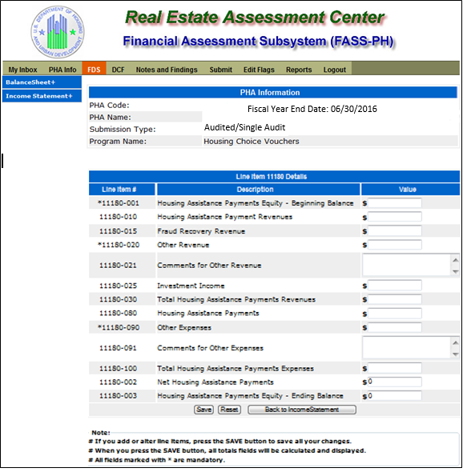

The following screen provides the detail link associated with the following FDS Line Item: 11190. This detail link is only applicable to the Housing Choice Voucher Program.

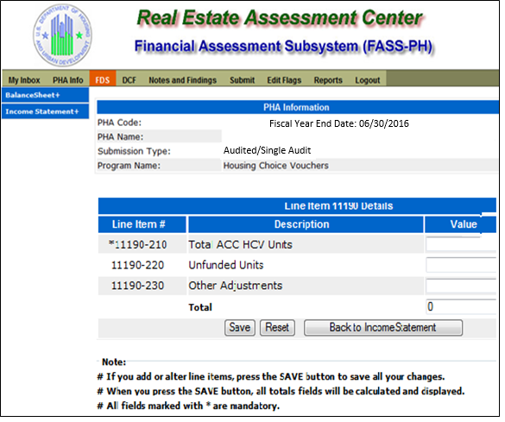

Audited Screen 16 – Data Collection Form (General Information Page)

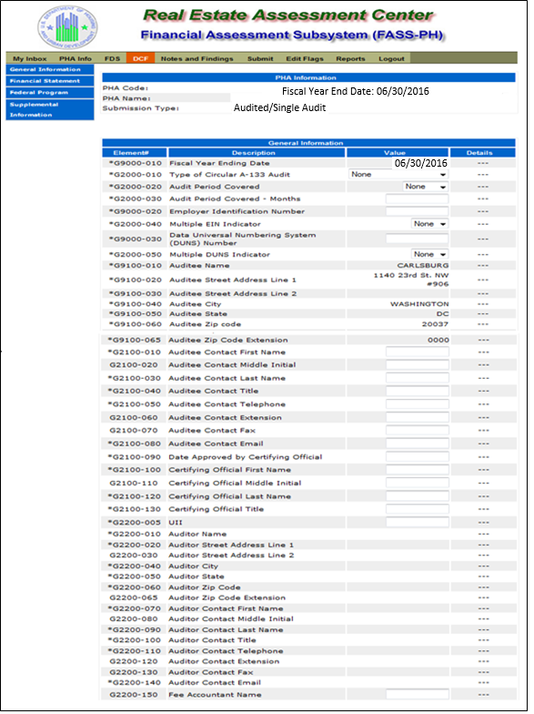

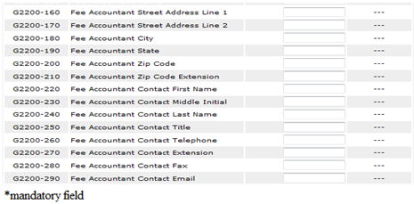

Audited Screen 17 – Data Collection Form (Financial Statement Page)

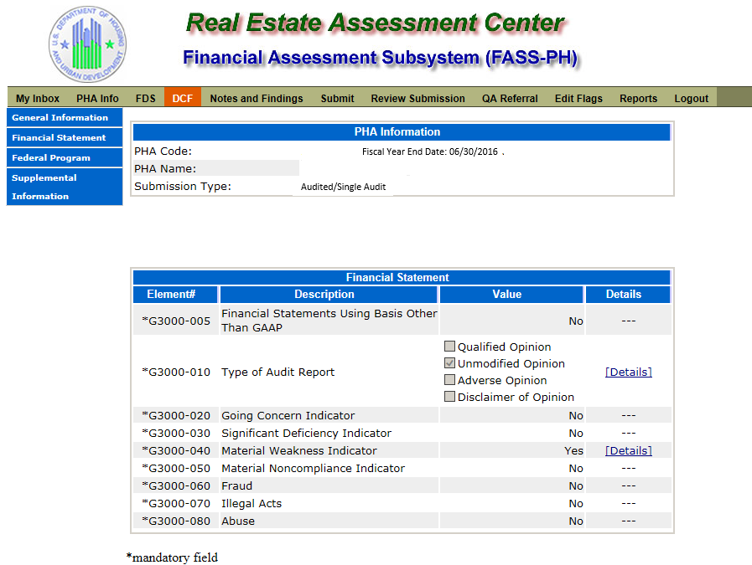

Audited Screen 18 – Data Collection Form (Fund Opinion Details Page)

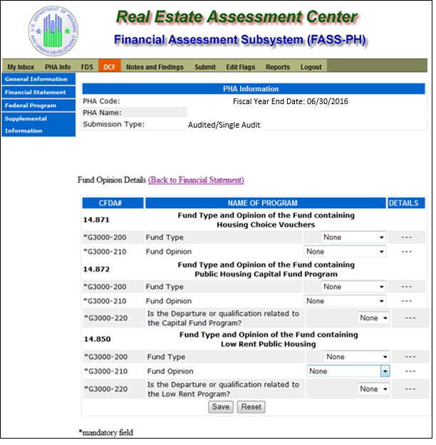
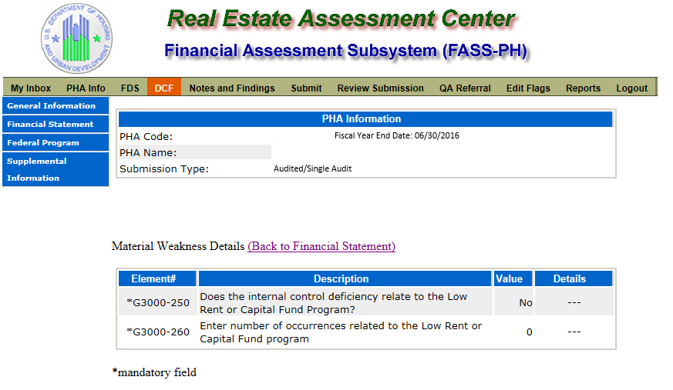

Audited Screen 19 – Data Collection Form (Federal Program Page)

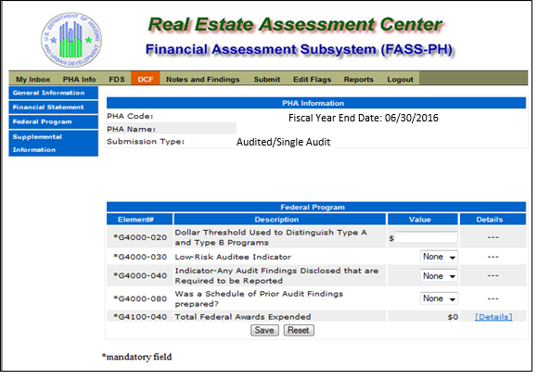

Audited Screen 20 – Data Collection Form (TFAE Page)

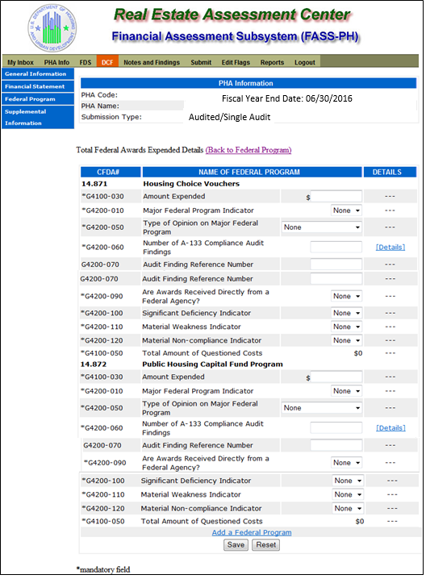

Audited Screen 21 – Data Collection Form (Compliance Requirement Page)

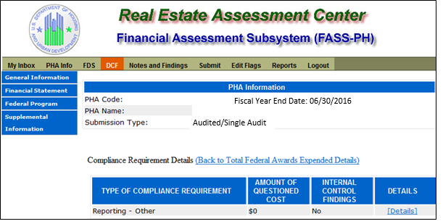

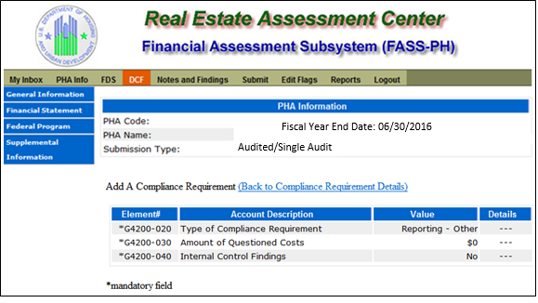

Audited Screen 22 – Data Collection Form (Supplemental Information Page)

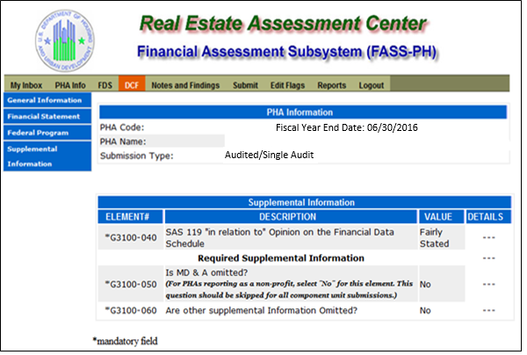

Audited Screen 23 – Notes and Findings (Notes Page)

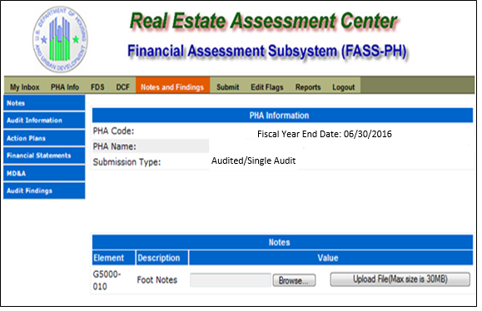

Audited Screen 24 – Notes and Findings (Audit Information Page)

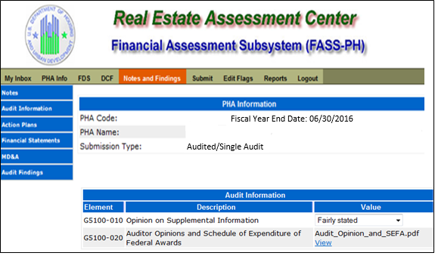

Audited Screen 25 – Notes and Findings (Action Plans Page)

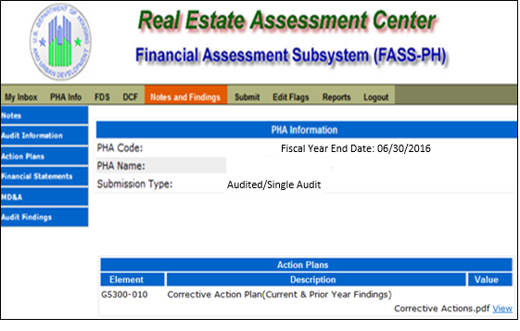

Audited Screen 26 – Notes and Findings (Financial Statement Page)

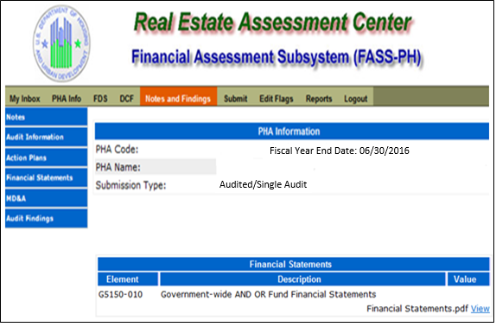

Audited Screen 27 – Notes and Findings (MD & A Page)

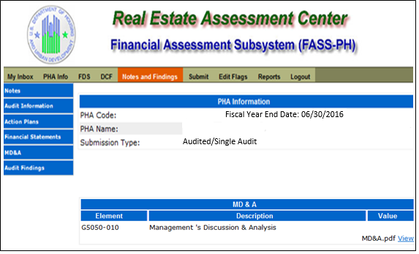

Audited Screen 28 – Notes and Findings (Audit Findings Page)

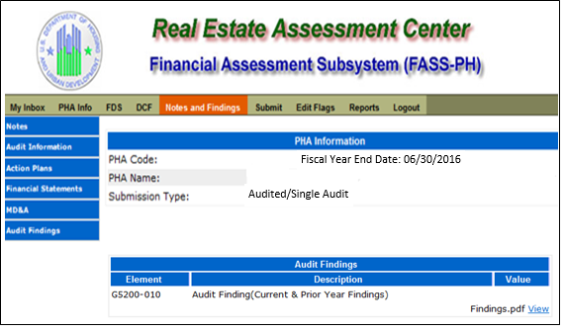

Audited Screen 29 – Auditor’s Agreed Upon Procedures (AUP) Page
Independent Accountant’s Report on Applying Agreed-Upon Procedure
We have performed the procedure described in the second paragraph, which was agreed to by _____________________________¹ (the Housing Authority) and the U.S. Department of Housing and Urban Development, Real Estate Assessment Center (REAC), solely to assist them in determining whether the electronic submission of certain information agrees with related hard copy documents included within the Single Audit reporting package. The Housing Authority is responsible for the accuracy and completeness of the electronic submission. This agreed-upon procedure engagement was conducted in accordance with attestation standards established by the American Institute of Certified Public Accountants. The sufficiency of the procedure is solely the responsibility of those parties specified in this report. Consequently, we make no representation regarding the sufficiency of the procedure described below either for the purpose for which this report has been requested or for any other purpose.

We compared the electronic submission of the items listed in the “UFRS Rule Information” column with the corresponding printed document listed in the “Hard Copy Documents” column. The results of the performance of our agreed-upon procedure indicate agreement or non-agreement of electronically submitted information and hard copy documents as shown in the chart below.

We were engaged to perform an audit in accordance with 2 CFR 200 Subpart F, Audit Requirements, Audit of States, Local Governments, and Non-Profit Organizations, for the Housing Authority as of and for the year ended __________², and have issued our reports thereon dated __________³. The information in the “Hard Copy Documents” column was included within the scope, or was a by-product, of that audit. Further, our opinion on the fair presentation of the Housing Authority’s Financial (FDS) dated __________⁴, was expressed in relation to the basic financial statements of the Housing Authority taken as a whole.

A copy of the reporting package required by OMB, which includes the auditor’s reports, is available in its entirety from the Housing Authority. We have not performed any additional auditing procedures since the date of the aforementioned audit reports. Further we take no responsibility for the security of the information transmitted electronically to the U.S. Department of Housing and urban Development, REAC.

This report is intended solely for the information and use of the Housing Authority and the U.S. Department of Housing and Urban Development, REAC, and is not intended to be and should not be used by anyone other than these specified parties.
Audited Single Audit Non Component Unit (Same Auditor)

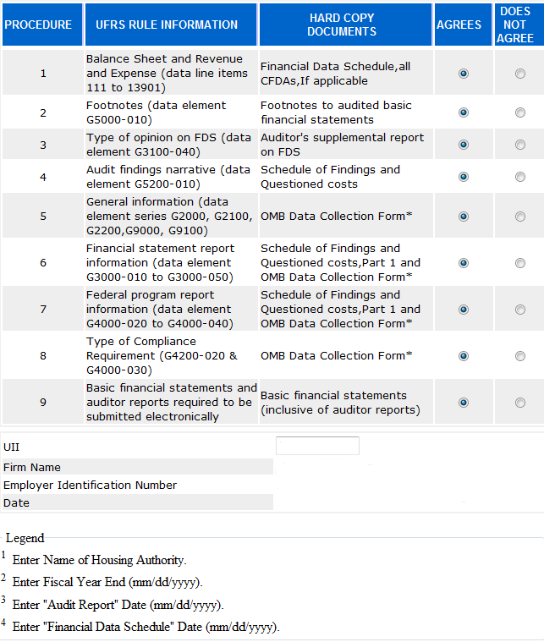

Audited Screen 30 – Submit Page

