**Exhibit A**

**Unaudited Financial Assessment Subsystem-Public Housing (FASS-PH) Template**

Contents

Unaudited Screen 1 – OMB Control Number Page 2

Unaudited Screen 2 – FASS-PH Main Menu 3

Unaudited Screen 3 – Inbox 4

Unaudited Screen 4 – PHA Information Page 5

Unaudited Screen 5 – PHA Information Page (Program Selection Page) 6

Unaudited Screen 6 – PHA Information Page (Add a Program Page) 7

Unaudited Screen 7 – PHA Information Page (PHA Comments Page) 8

Unaudited Screen 8 – PHA Information Page (Late Reason Page) 9

Unaudited Screen 9 – FDS Balance Sheet Page 10

Unaudited Screen 10 – FDS Balance Sheet Modified Accrual Page (HCV) 13

Unaudited Screen 11 – FDS Balance Sheet Page (Detail Links) 16

Unaudited Screen 12 – FDS Income Statement Page 24

Unaudited Screen 13 – FDS Income Statement Page (Detail Links) 28

Unaudited Screen 14 – FDS Income Statement Page (HCV Program Detail Links) 33

Unaudited Screen 15 – Data Collection Form Page (General Information) 41

Unaudited Screen 16 – Data Collection Form Page (TFAE Detail) 43

Unaudited Screen 17 – Submit Page 44

# Unaudited Screen 1 – OMB Control Number Page

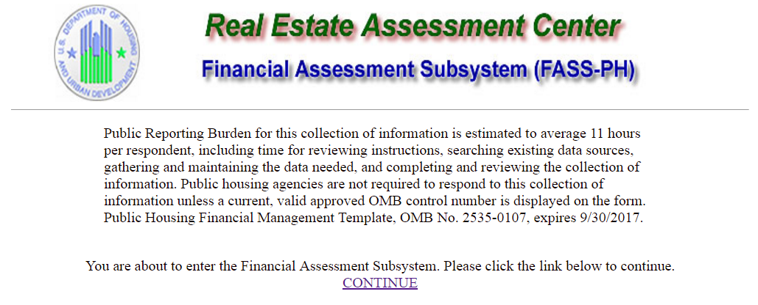

# Unaudited Screen 2 – FASS-PH Main Menu

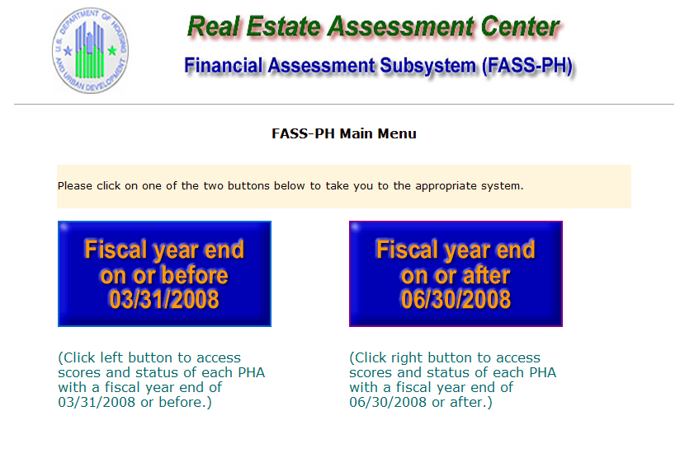

# Unaudited Screen 3 – Inbox

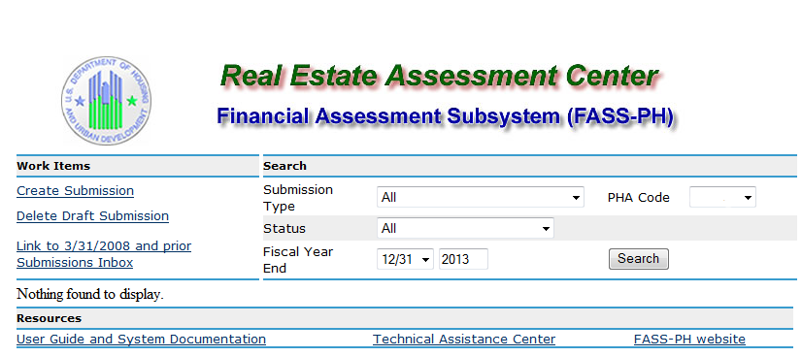

# Unaudited Screen 4 – PHA Information Page

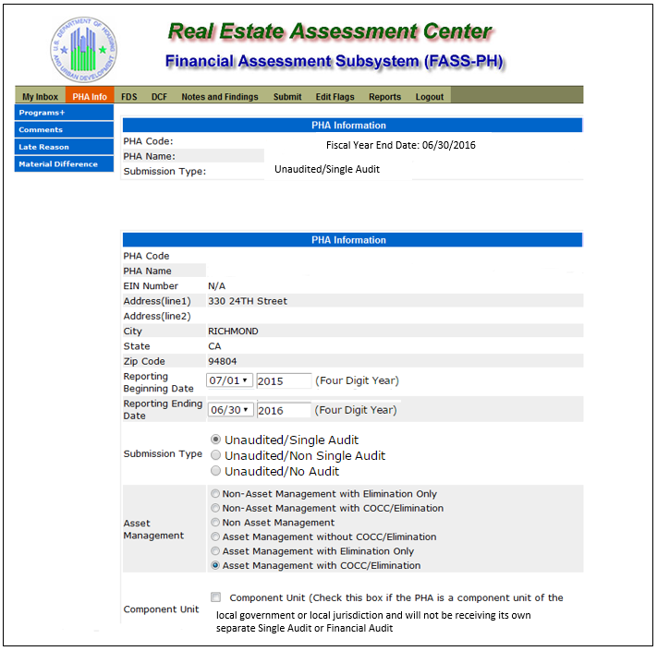

# Unaudited Screen 5 – PHA Information Page (Program Selection Page)

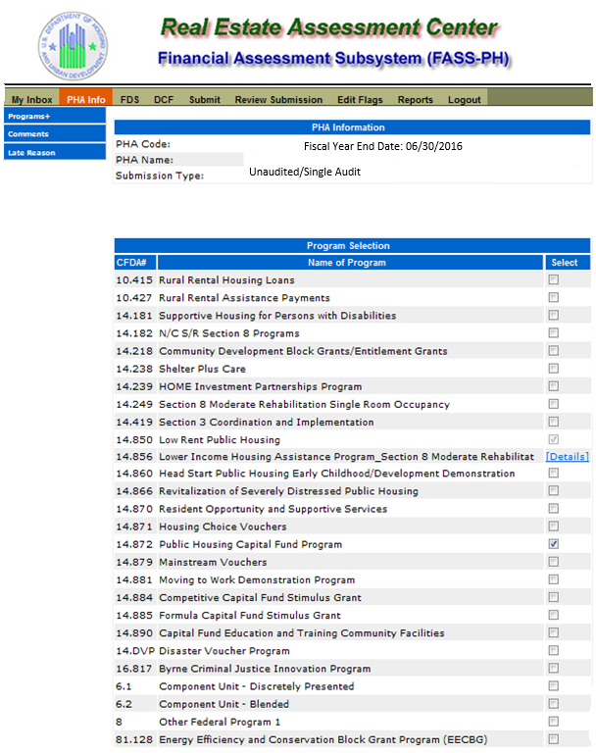

# Unaudited Screen 6 – PHA Information Page (Add a Program Page)

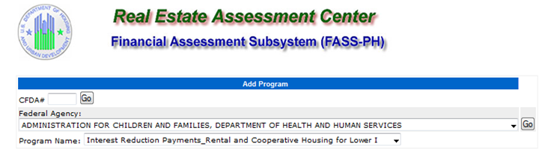

# Unaudited Screen 7 – PHA Information Page (PHA Comments Page)

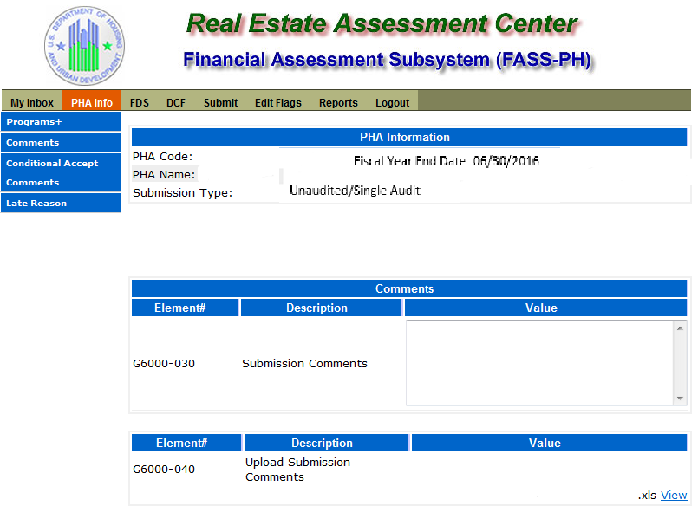

# Unaudited Screen 8 – PHA Information Page (Late Reason Page)

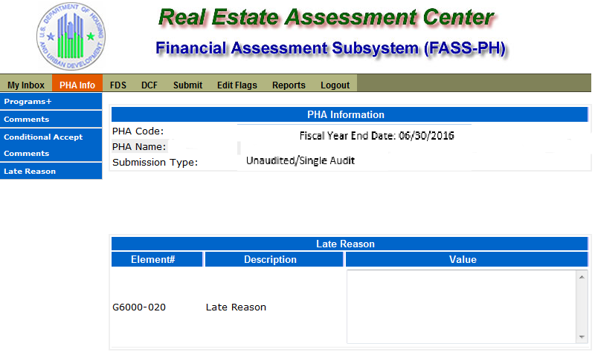

# Unaudited Screen 9 – FDS Balance Sheet Page

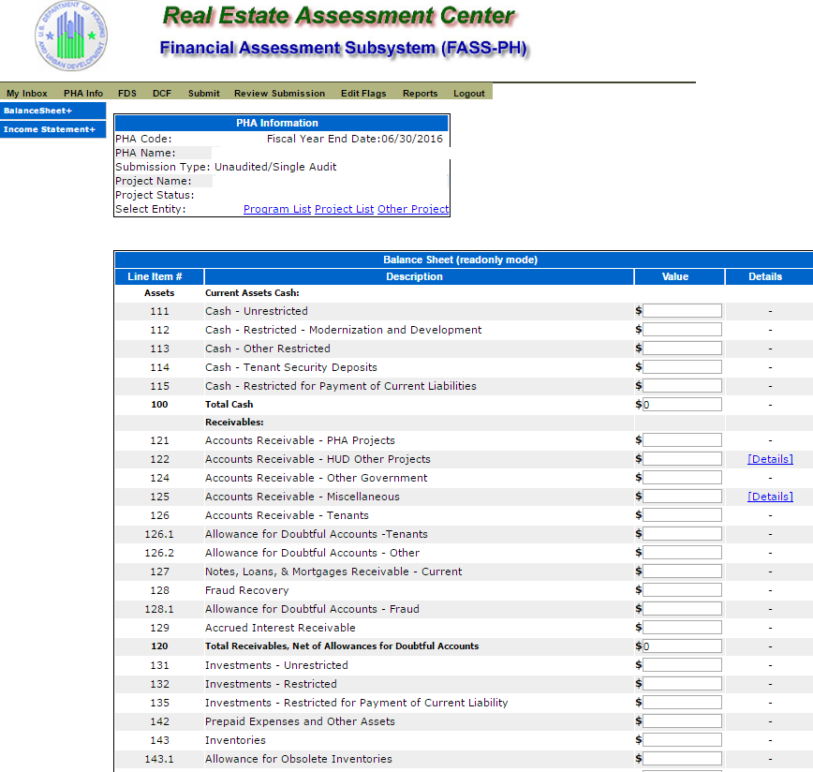

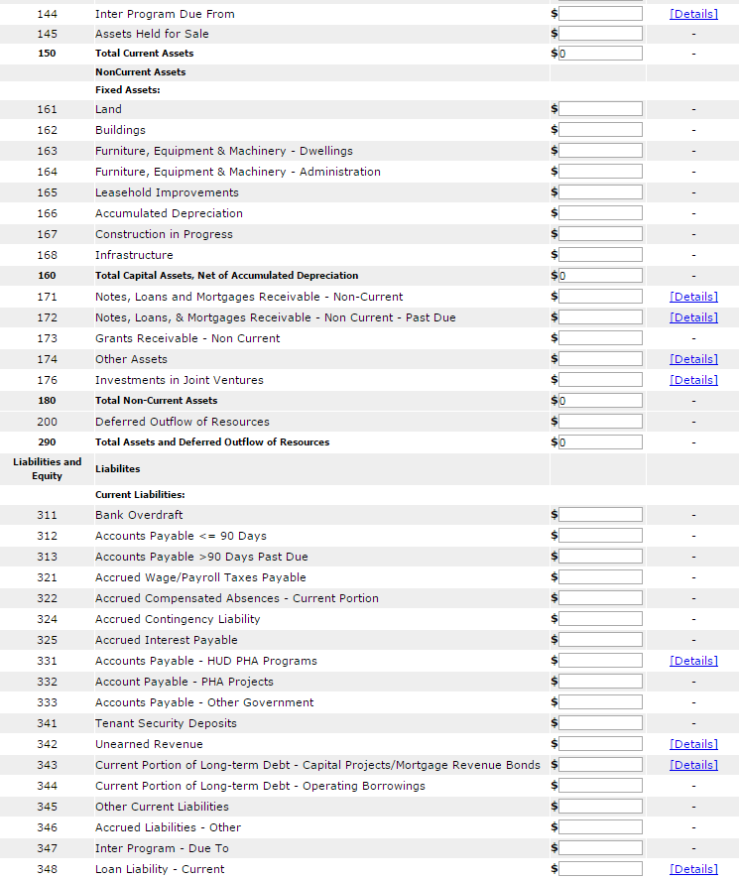

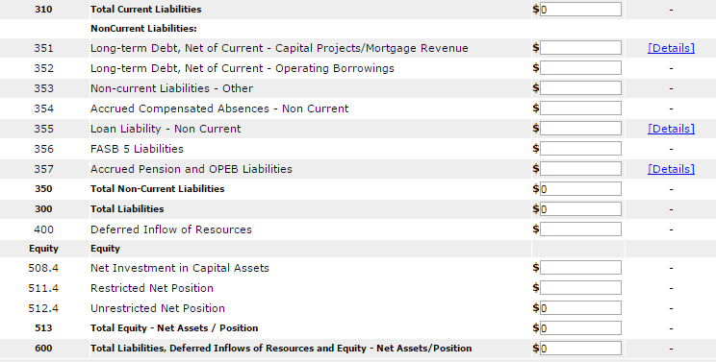

# Unaudited Screen 10 – FDS Balance Sheet Modified Accrual Page (HCV)

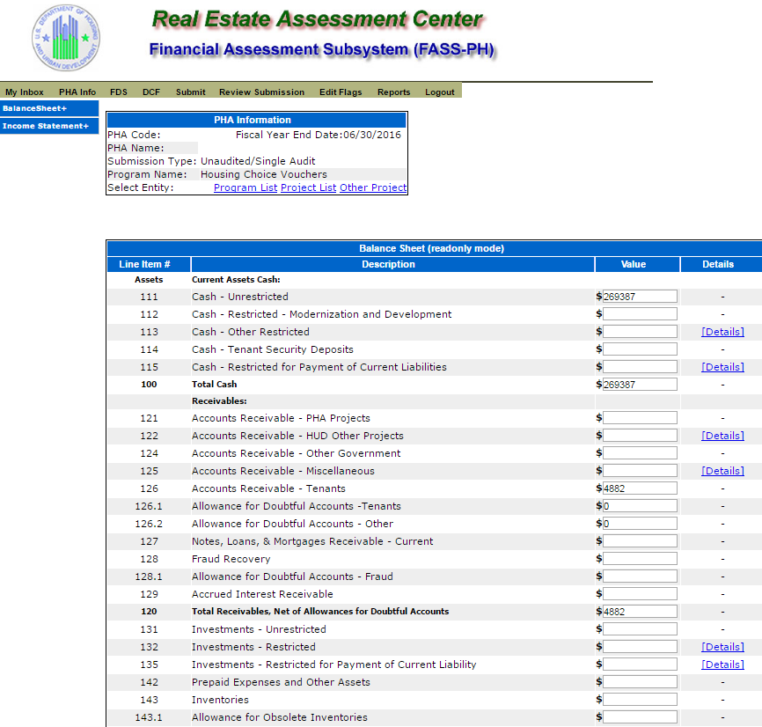

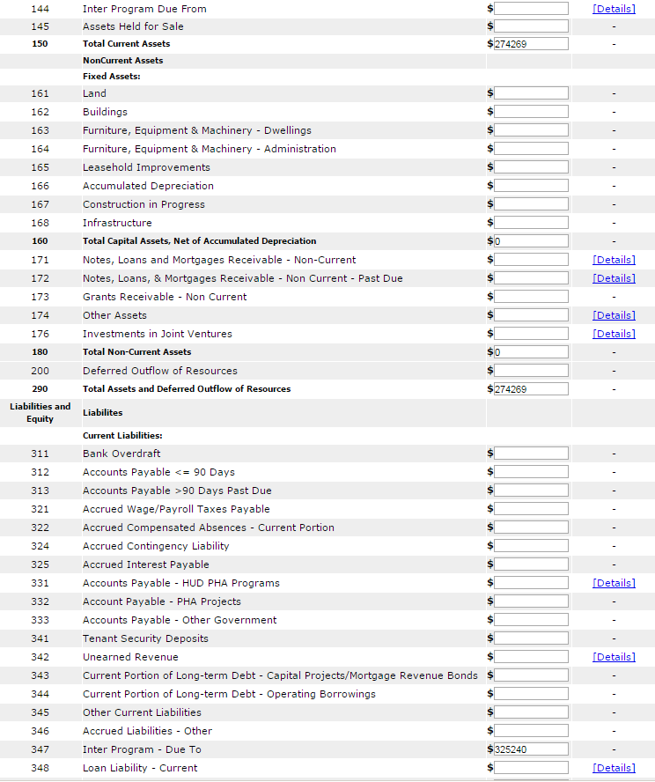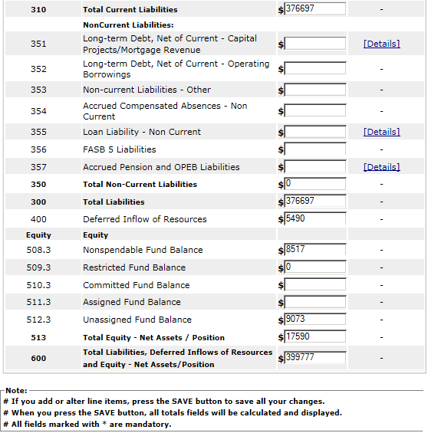

# Unaudited Screen 11 – FDS Balance Sheet Page (Detail Links)

The following screen provides the detail link associated for the following FDS line Item: 113. FDS Line Item 115 has a similar detail link.

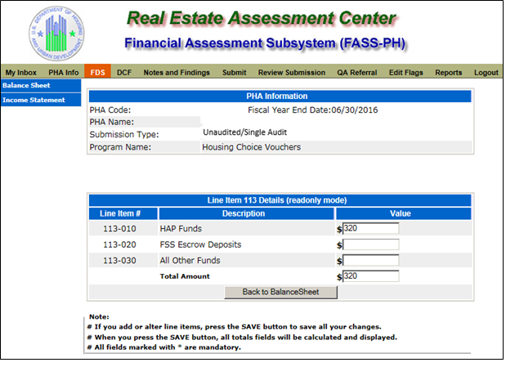

The following screen provides the detail link associated for the following FDS line Item: 122. FDS Line Items 331 and 342 have a similar detail link.

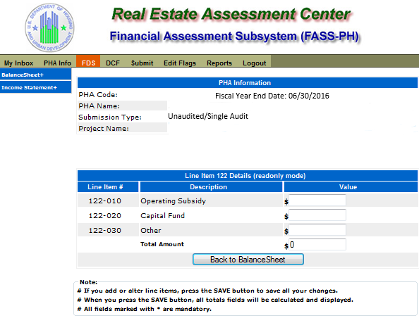

The following screen provides the detail link associated for the following FDS line Item: 125. FDS Line Items 171, 172, 174, 176, 348, and 355 have a similar detail link.

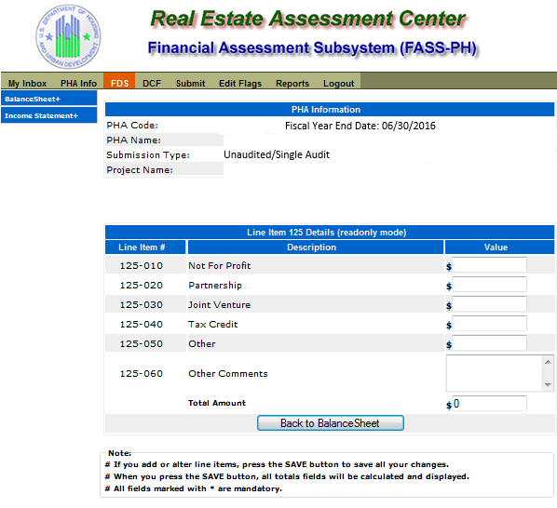

The following screen provides the detail link associated for the following FDS Line Item: 132. FDS Line Item 135 has a similar detail link.

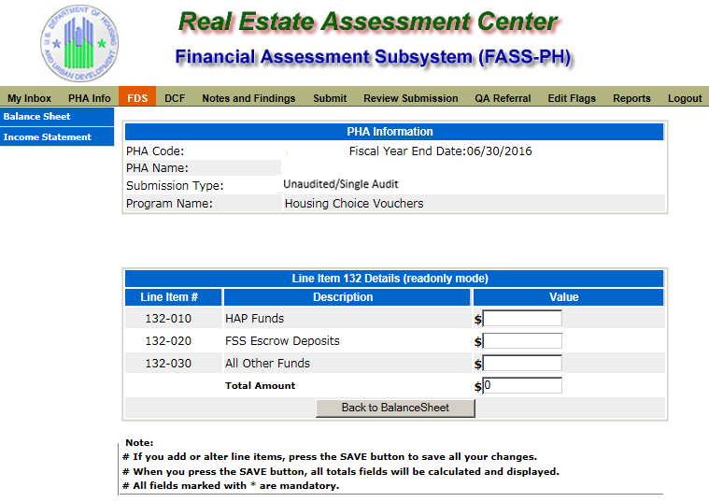

The following screen provides the detail link associated for the following FDS Line Item: 144.

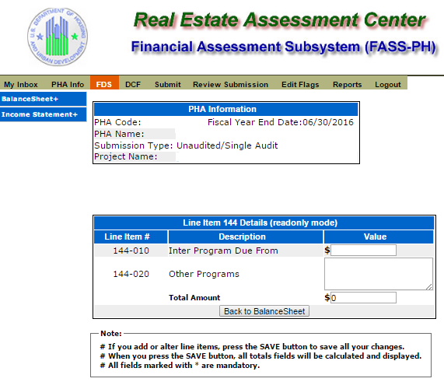

The following screen provides the detail link associated for the following FDS Line Item 331. FDS Line Item 342 has a similar detail link.

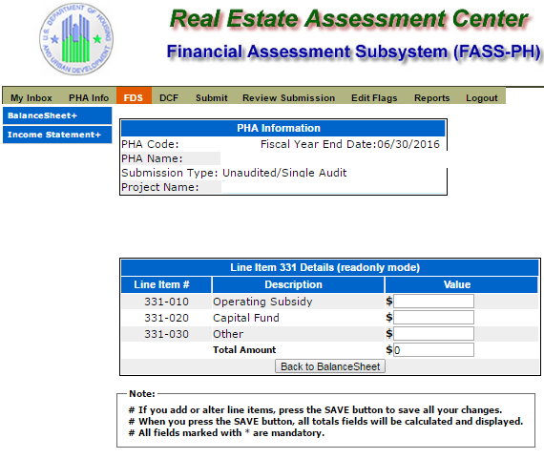

The following screen provides the detail link associated for the following FDS Line Item: 343. FDS Line Item 351 has a similar detail link.

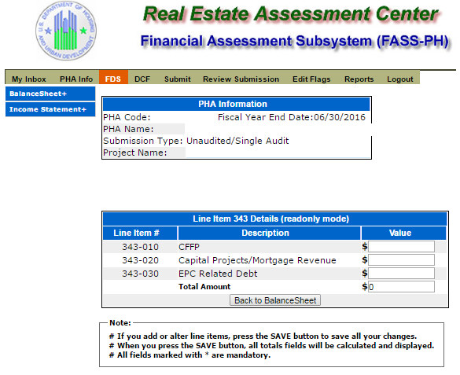

The following screen provides the detail link associated for the following FDS line Item: 357.

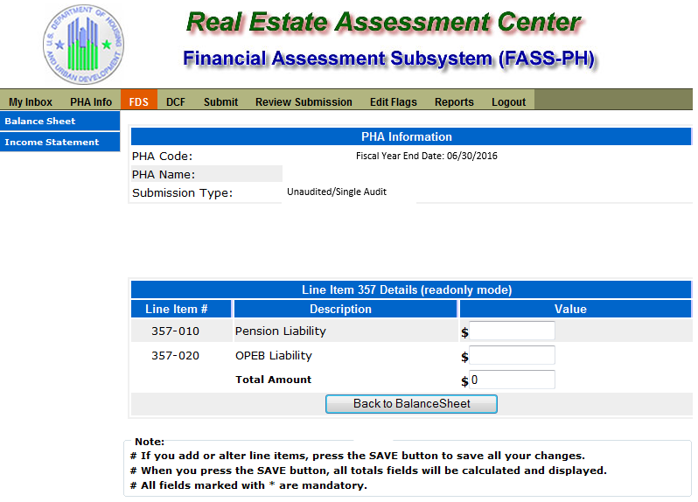

# Unaudited Screen 12 – FDS Income Statement Page



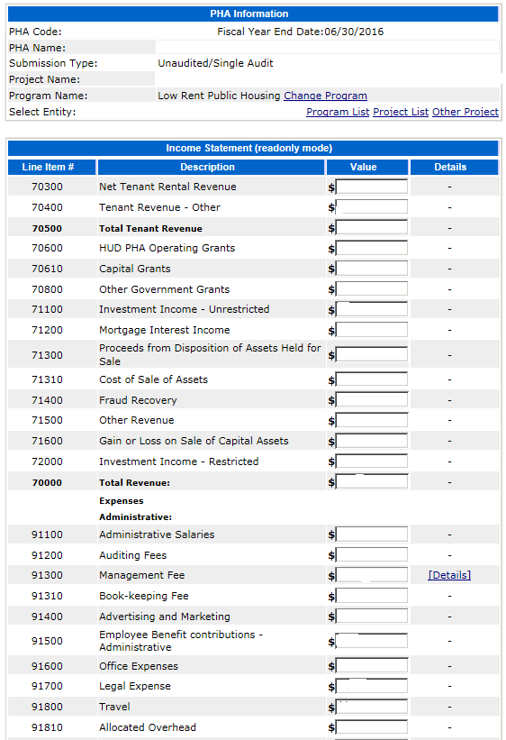

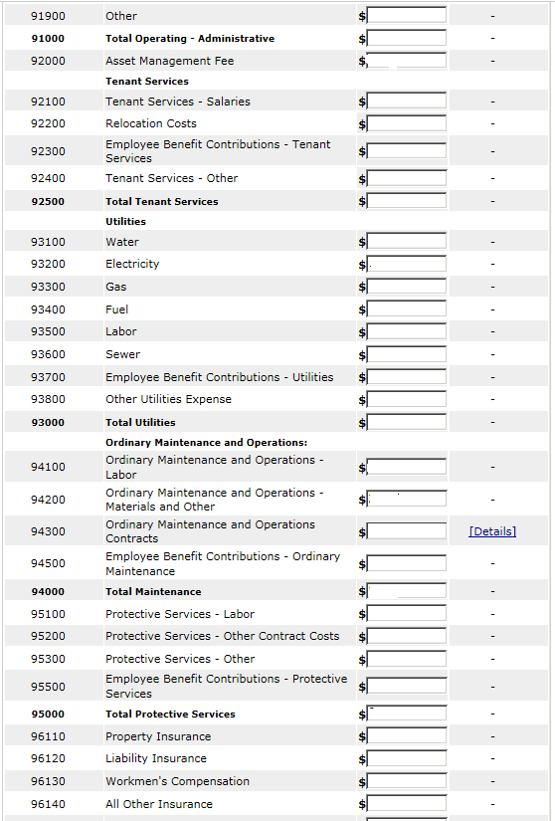

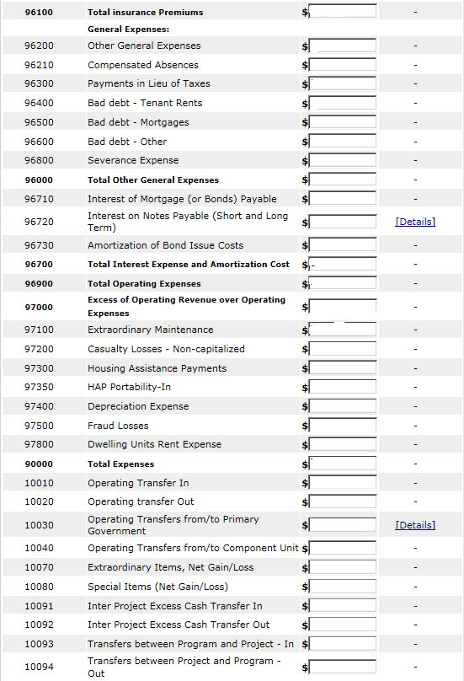

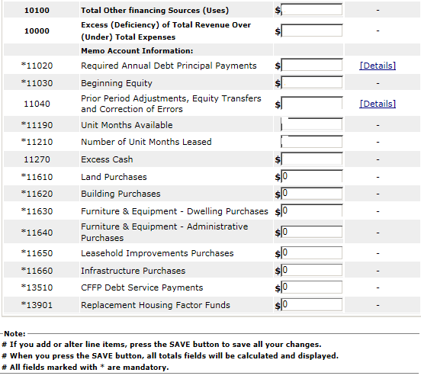

# Unaudited Screen 13 – FDS Income Statement Page (Detail Links)

The following screen provides the detail link associated with the following FDS Line Item: 91300. FDS Line Item 70750 has a similar detail link that is applicable to COCC program only.

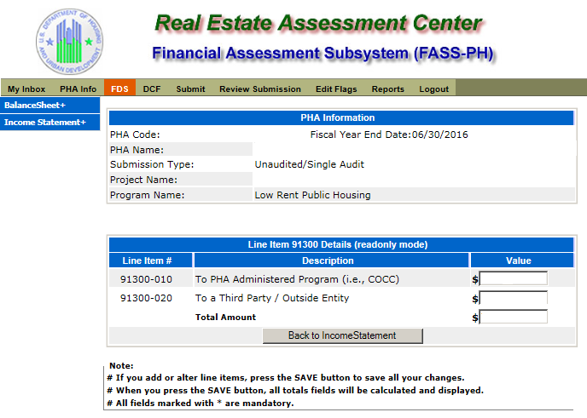

The following screen provides the detail link associated with the following FDS Line Item: 94300

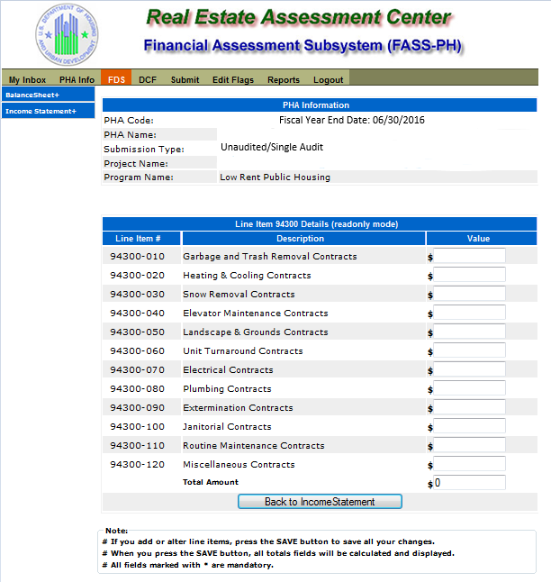

The following screen provides the detail link associated with the following FDS Line Item: 96720. FDS Line Item 11020 has a similar detail link.

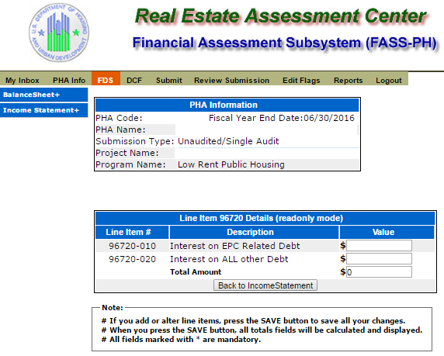

The following screen provides the detail link associated with the following FDS Line Item: 10030.

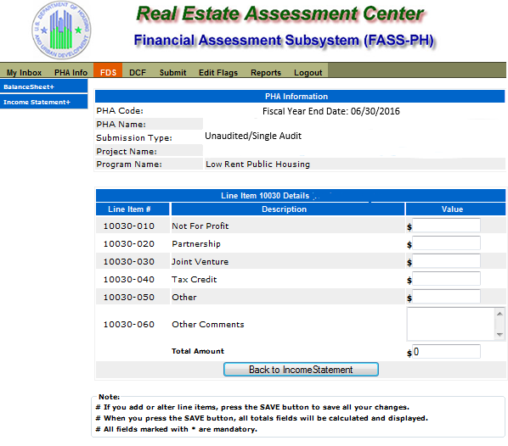

The following screen provides the detail link associated with the following FDS Line Item: 11040

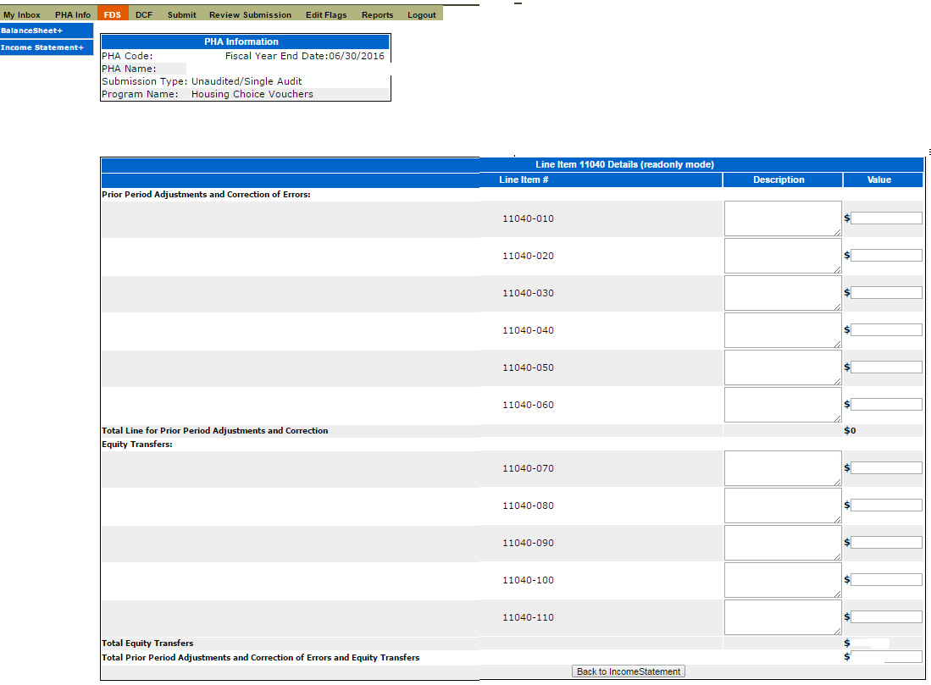

# Unaudited Screen 14 – FDS Income Statement Page (HCV Program Detail Links)

The following screen provides the detail link associated with the following FDS Line Item: 70600. This detail link is only applicable to the Housing Choice Voucher Program.

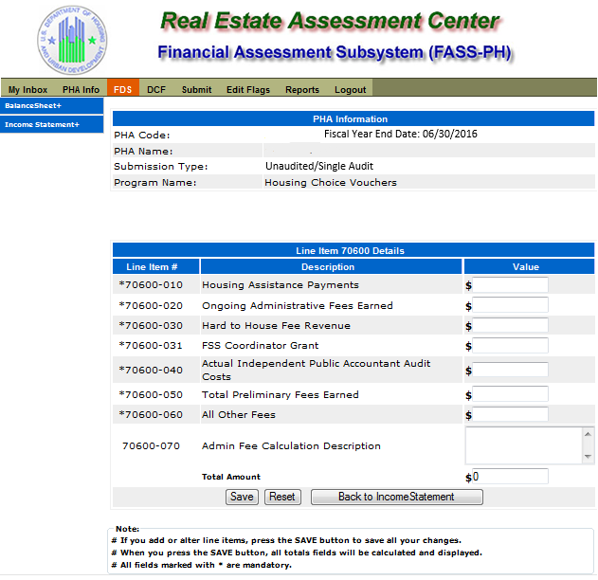

The following screen provides the detail link associated with the following FDS Line Item: 71100. This detail link is only applicable to the Housing Choice Voucher Program.

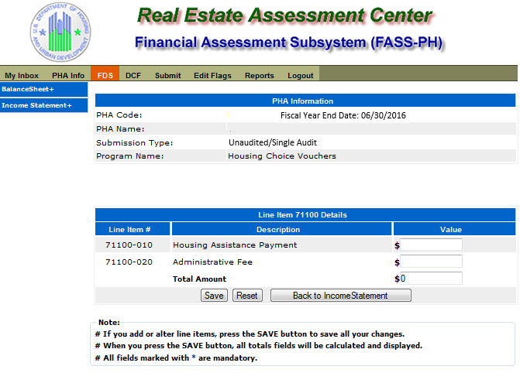

The following screen provides the detail link associated with the following FDS Line Item: 71400. This detail link is only applicable to the Housing Choice Voucher Program.

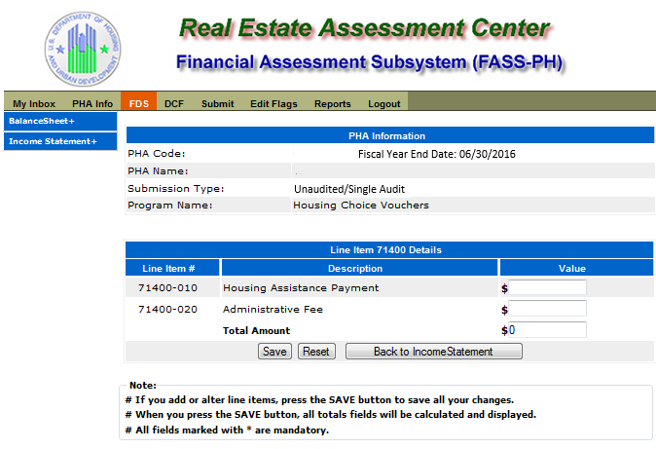

The following screen provides the detail link associated with the following FDS Line Item: 72000. This detail link is only applicable to the Housing Choice Voucher Program.

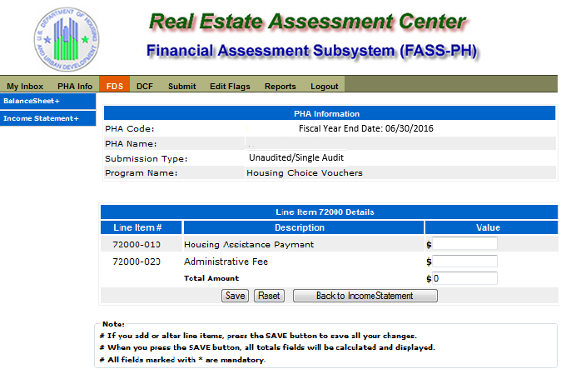

The following screen provides the detail link associated with the following FDS Line Item: 97300. This detail link is only applicable to the Housing Choice Voucher Program.

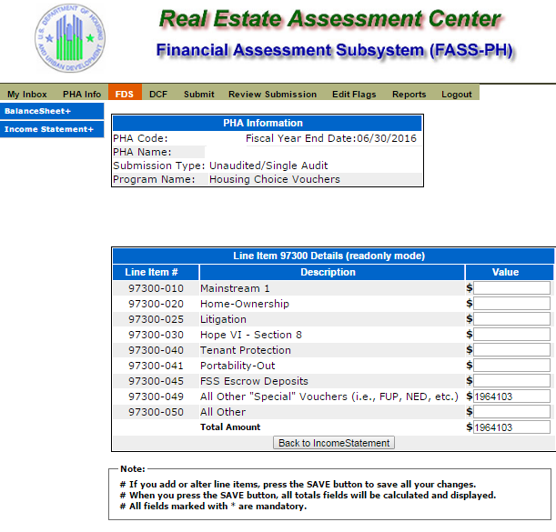

The following screen provides the detail link associated with the following FDS Line Item: 11170. This detail link is only applicable to the Housing Choice Voucher Program.

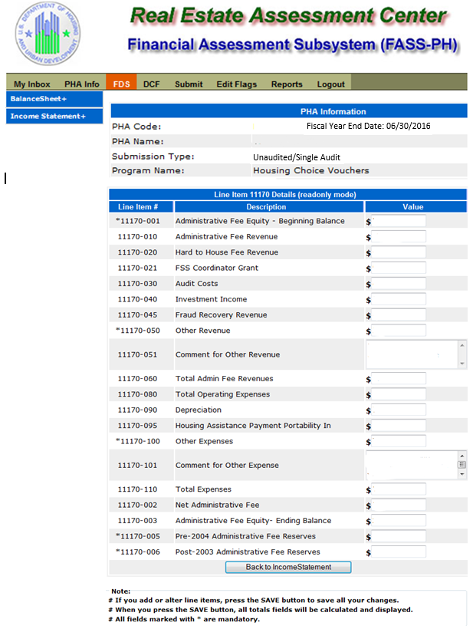

The following screen provides the detail link associated with the following FDS Line Item: 11180. This detail link is only applicable to the Housing Choice Voucher Program.

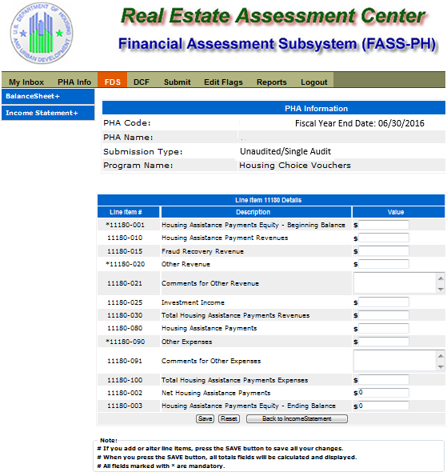

The following screen provides the detail link associated with the following FDS Line Item: 11190. This detail link is only applicable to the Housing Choice Voucher Program.

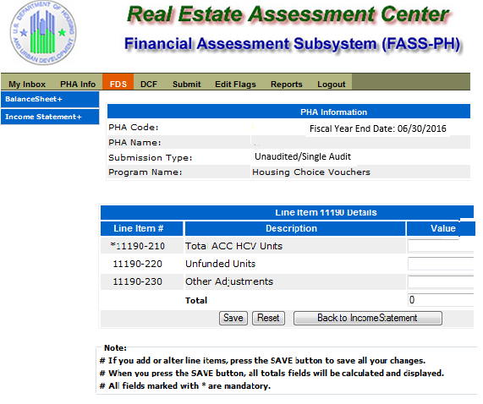

# Unaudited Screen 15 – Data Collection Form Page (General Information)

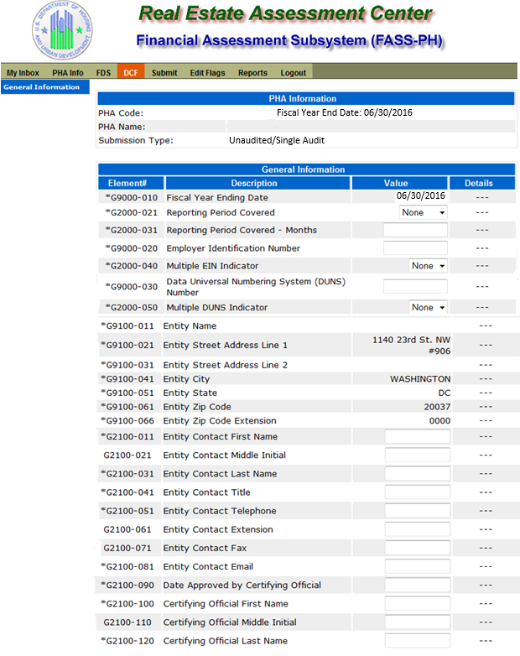

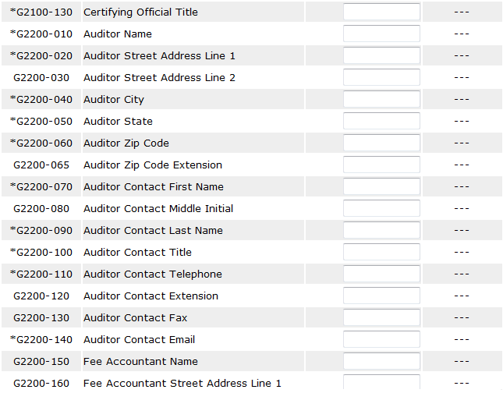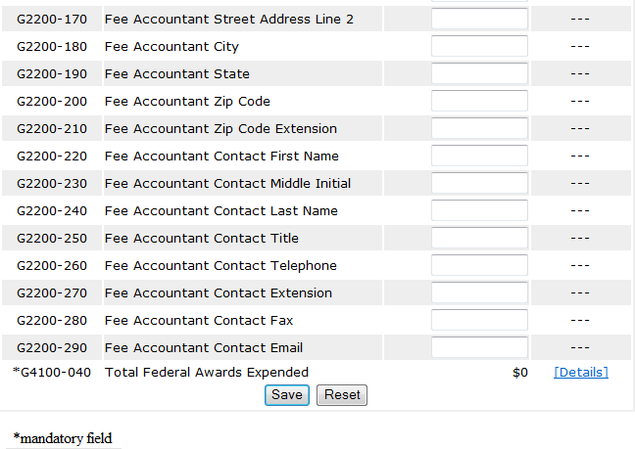

# Unaudited Screen 16 – Data Collection Form Page (TFAE Detail)

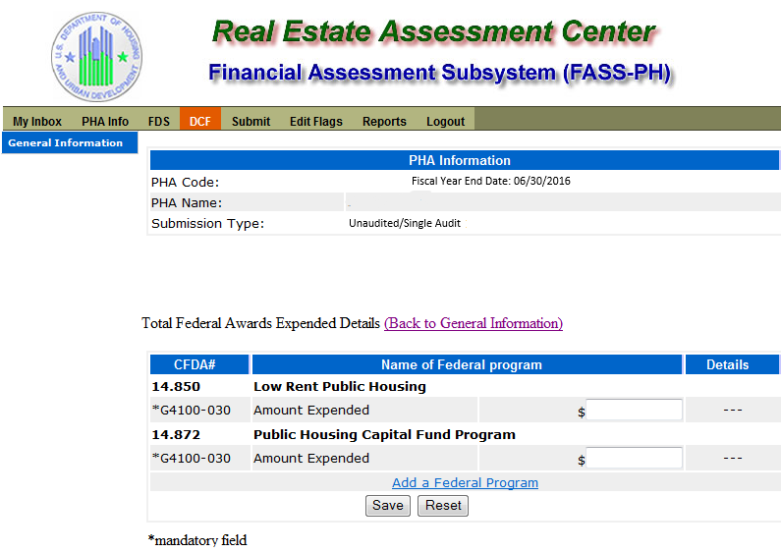

# Unaudited Screen 17 – Submit Page

