Kennedy Space Center COVID Vaccination Registration

Registration URL: Registration URL: https://www.eventbrite.com/e/ksc-vaccines-tickets-145860565879?utm_source=eventbrite&utm_medium=ebcampaigns&utm_campaign=664102&aff=odeccpebemailcampaigns&utm_term=ctabutton&mipa=ABIdvVtH9fW-G04EiIbcEtREKUZT8-UkeLTYSj7LJHU-B0BR2dmnhy6bvgYyWj5wR3sJuRflZUJ8KMlDrULmaAK4f91HPxX_3K-AtJZDy8Tjqcc-b70SJwK-xMx8lZSYhehD5IyeQE4hUmFkFQt7W2eRGRhQPj_rzraw5uBVh-3XeQJPHEFeVp7FybWKNBBCfREYeLvsv8qPoeoOB0REHeoMNRjAUNcSCBXK1OvKt80AjB22c8on8PqkncKOG3S15pXSrOaZHeebRmK-xgg_RDrcWS2MW5pE4A#tickets

Event Main Page: (Contains Privacy Statement)

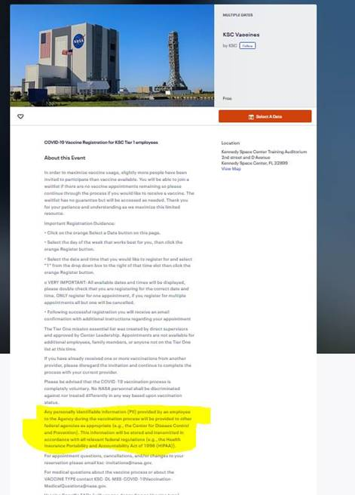

Text of privacy statement (highlighted above):

Any personally identifiable information (PII) provided by an employee to the Agency during the vaccination process will be provided to other federal agencies as appropriate (e.g., the Center for Disease Control and Prevention). This information will be stored and transmitted in accordance with all relevant federal regulations (e.g., the Health Insurance Portability and Accountability Act of 1996 (HIPAA)).

Registration Form:

