FCC Form 500
The below screenshots demonstrate how an FCC Form 500 may be filed within the E-Rate Productivity Center (EPC).
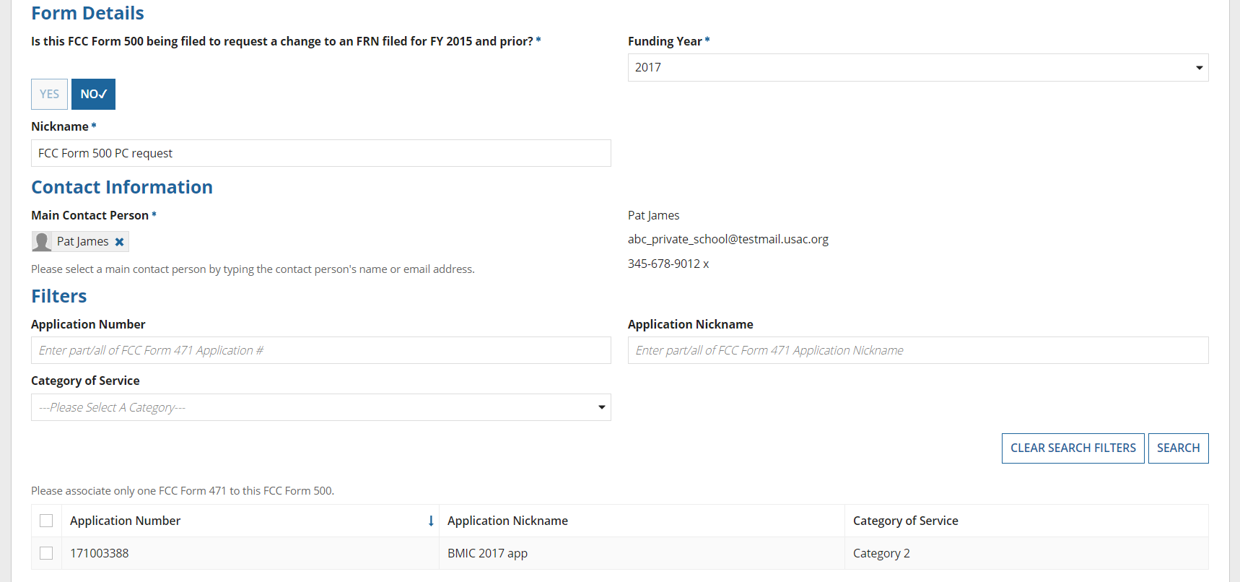
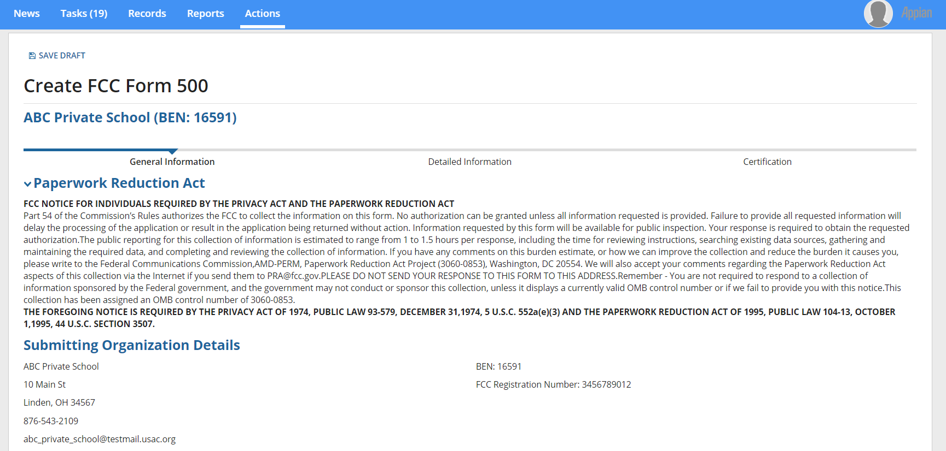
Respondents provide contact and application information, then indicate how they will be using the FCC Form 500 (e.g., by selecting changing service start date, canceling an FRN, or another option).

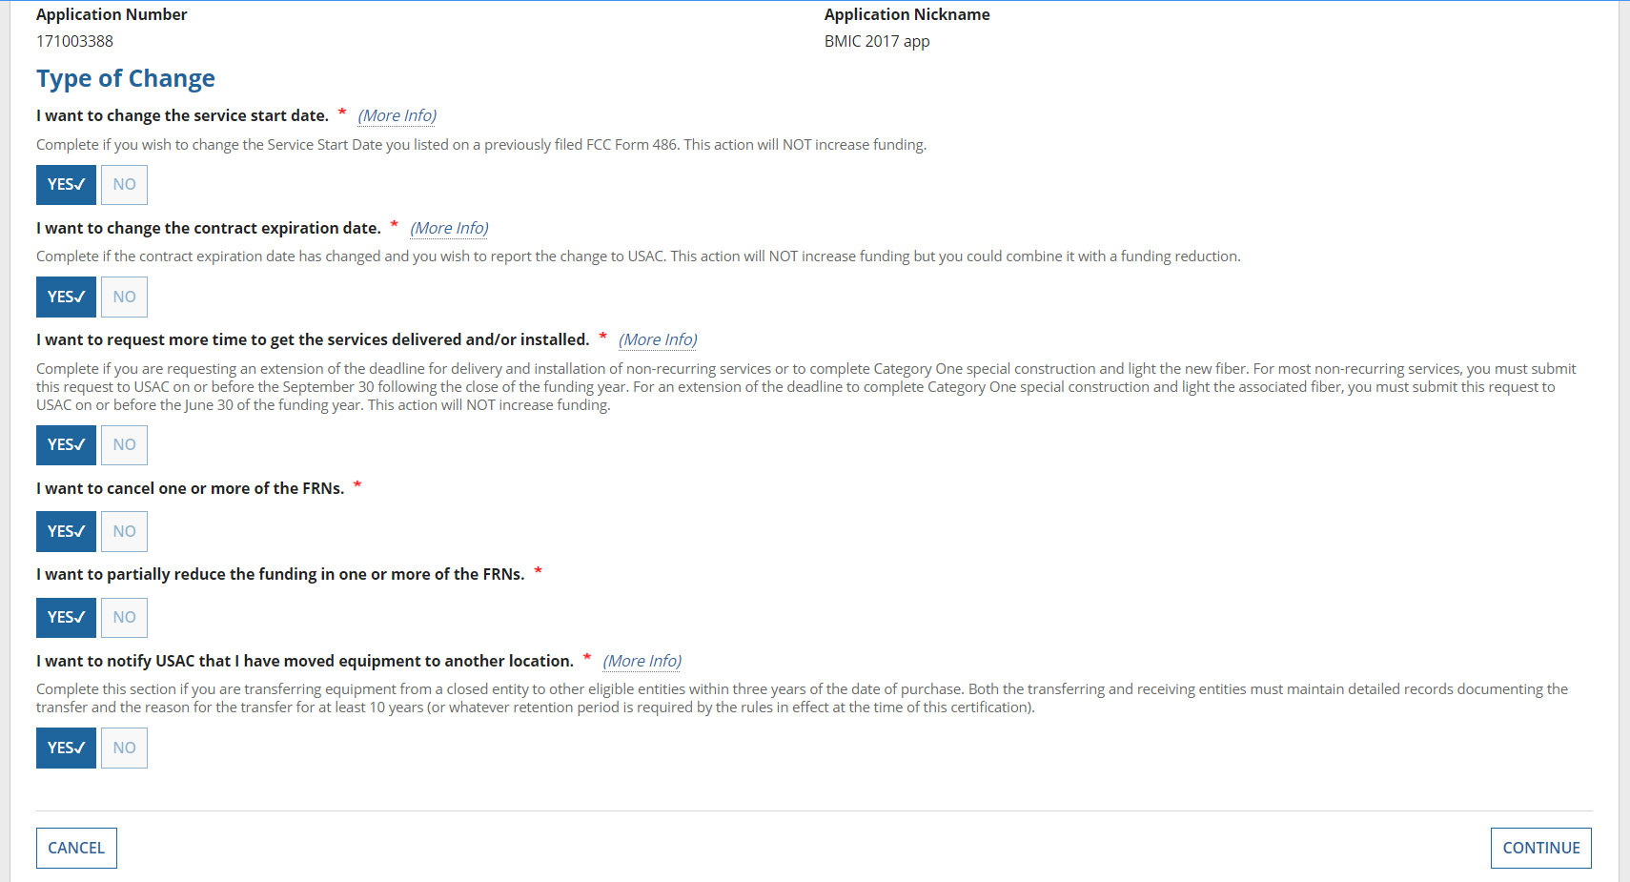
Helper text at the bottom of the screen provides additional information.
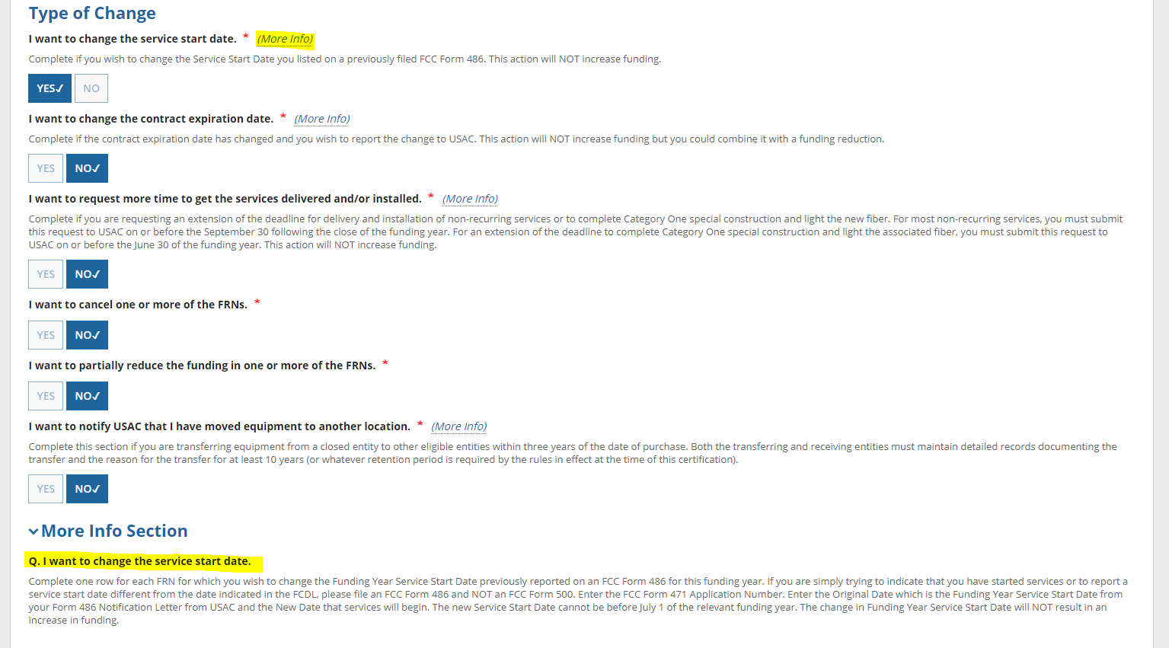
Change Service Start Date

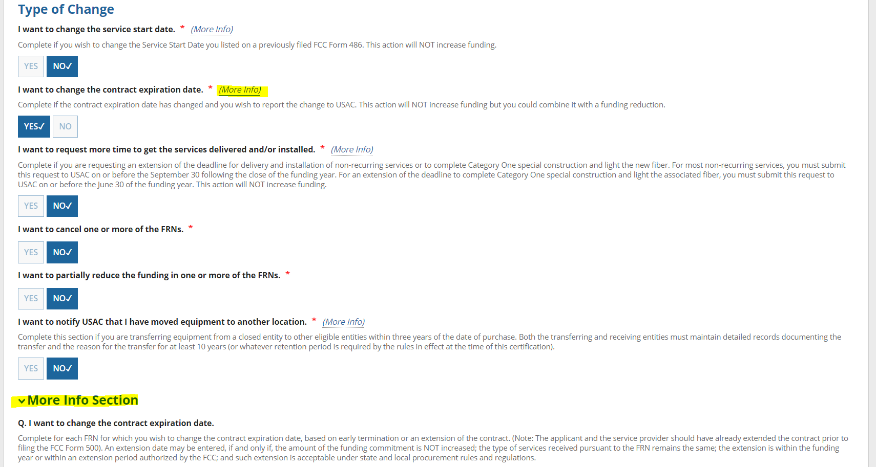
Change Contract Expiration Date
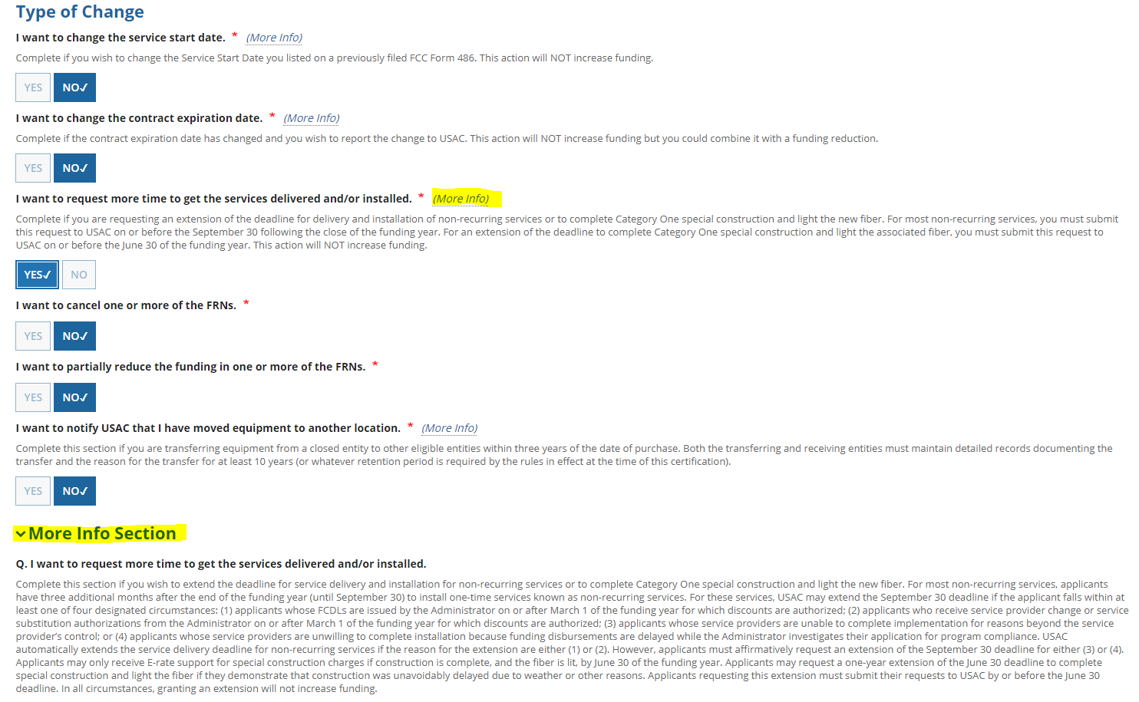
Request Additional Time for Service Delivery/Installation

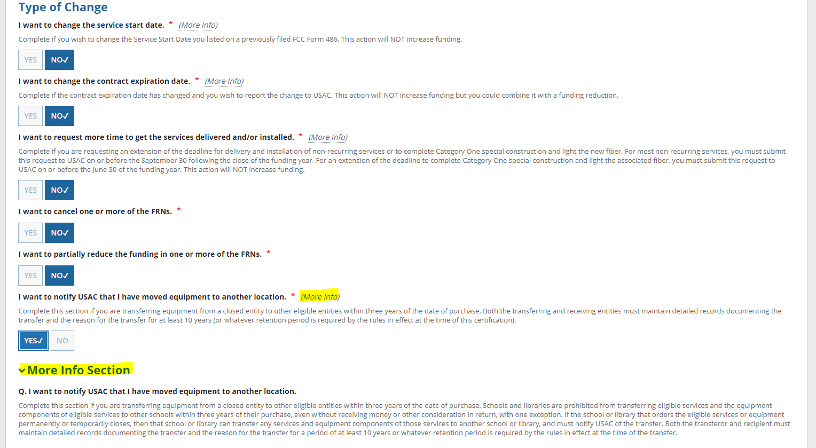
Equipment Transfer Notification
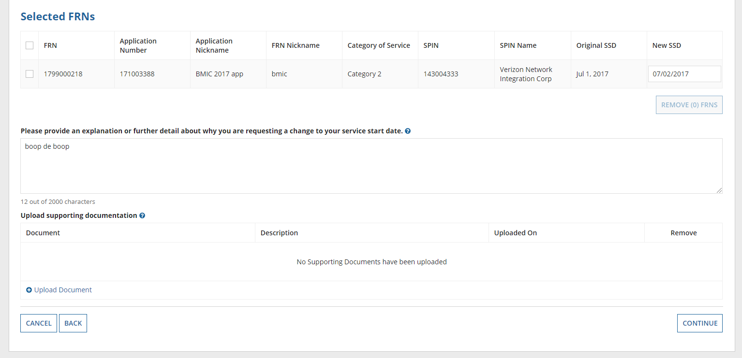
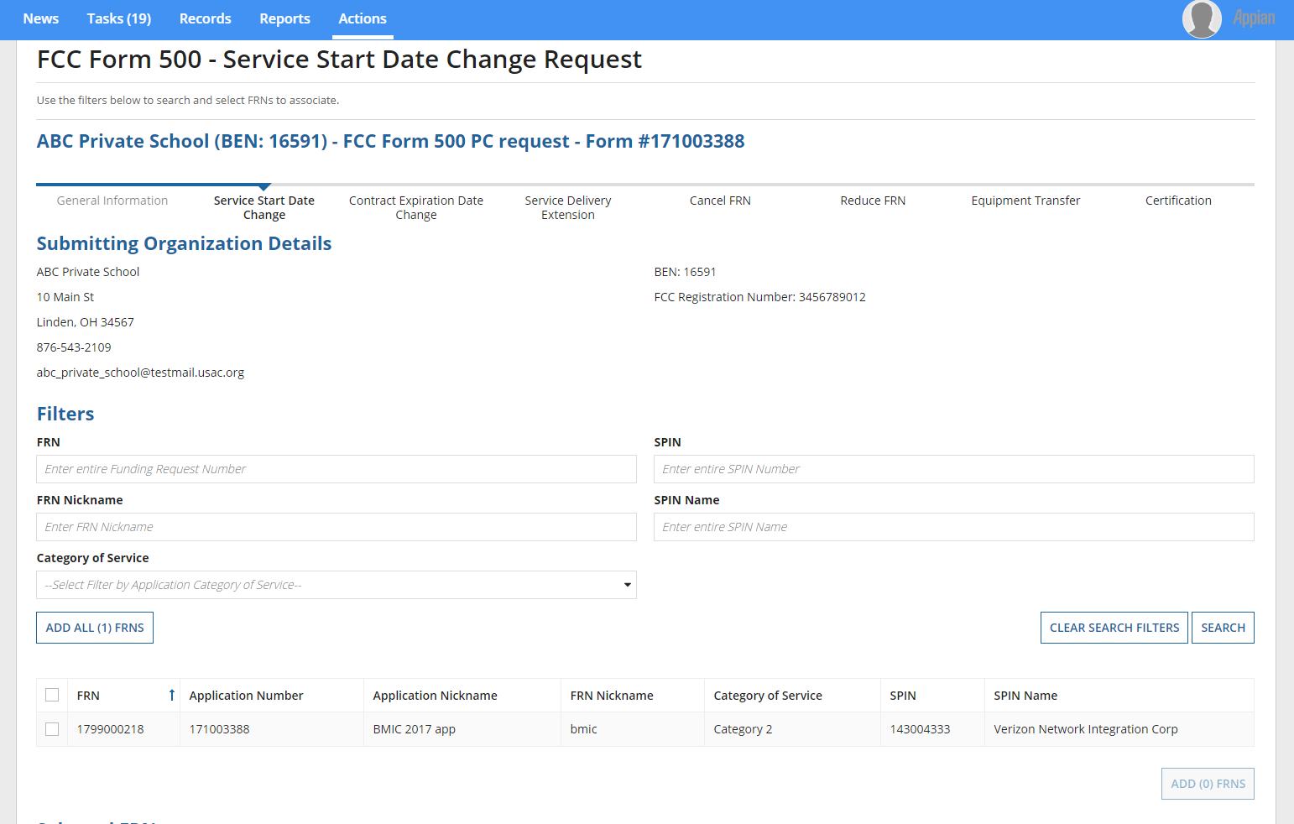
If respondents use the FCC Form 500 to change the service start date, they will be prompted to provide additional information in the below screens in EPC.

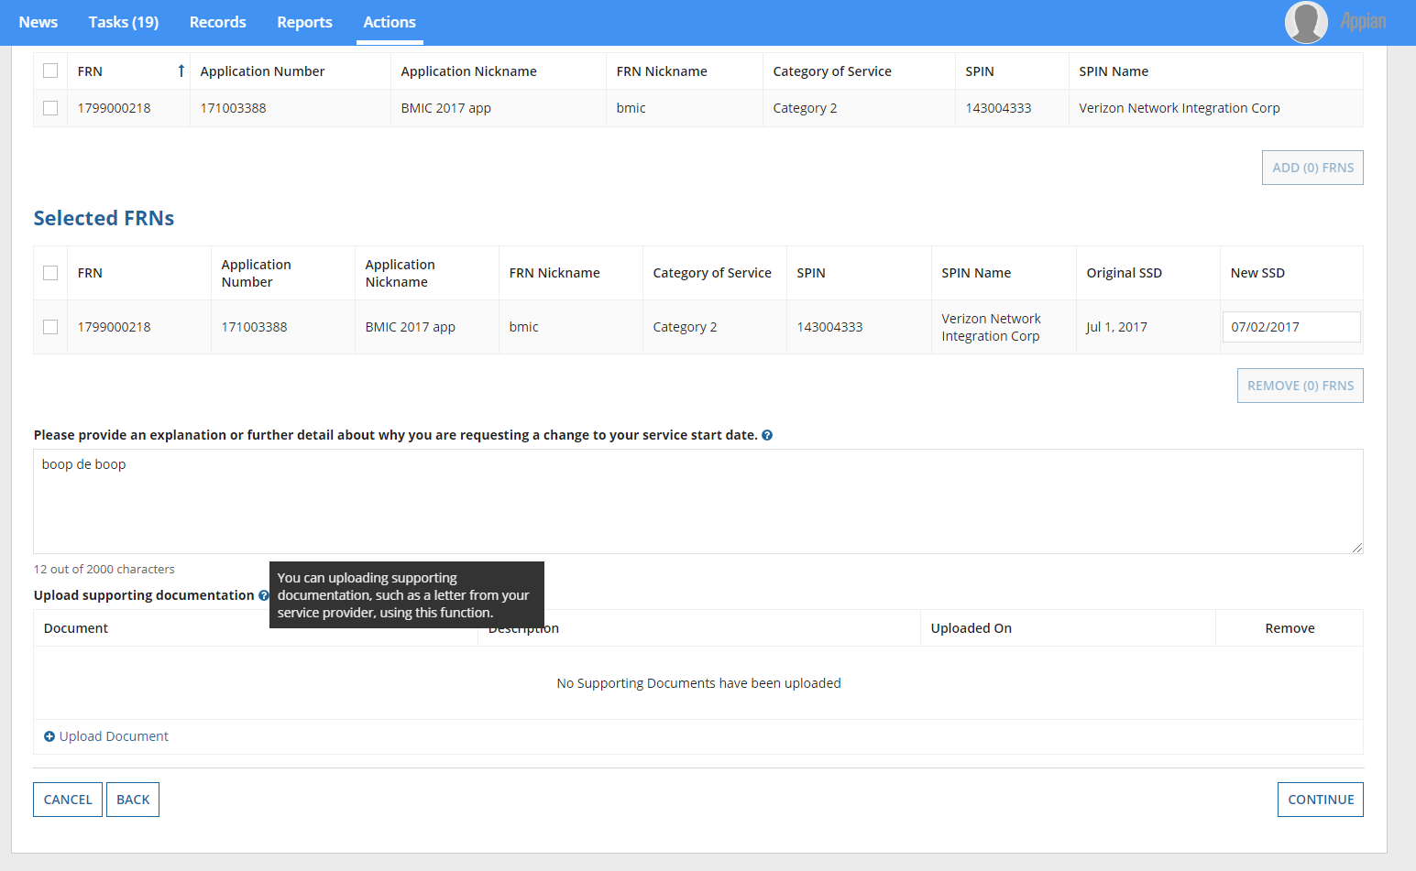
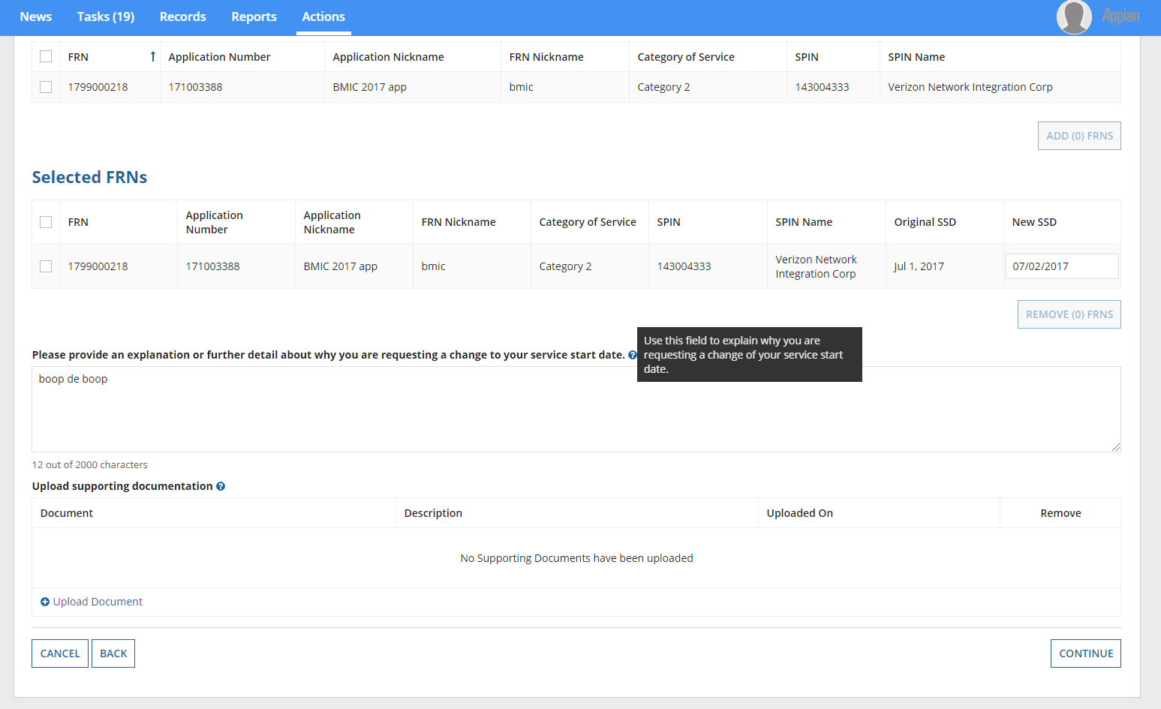
Hover text provides respondents with additional information.

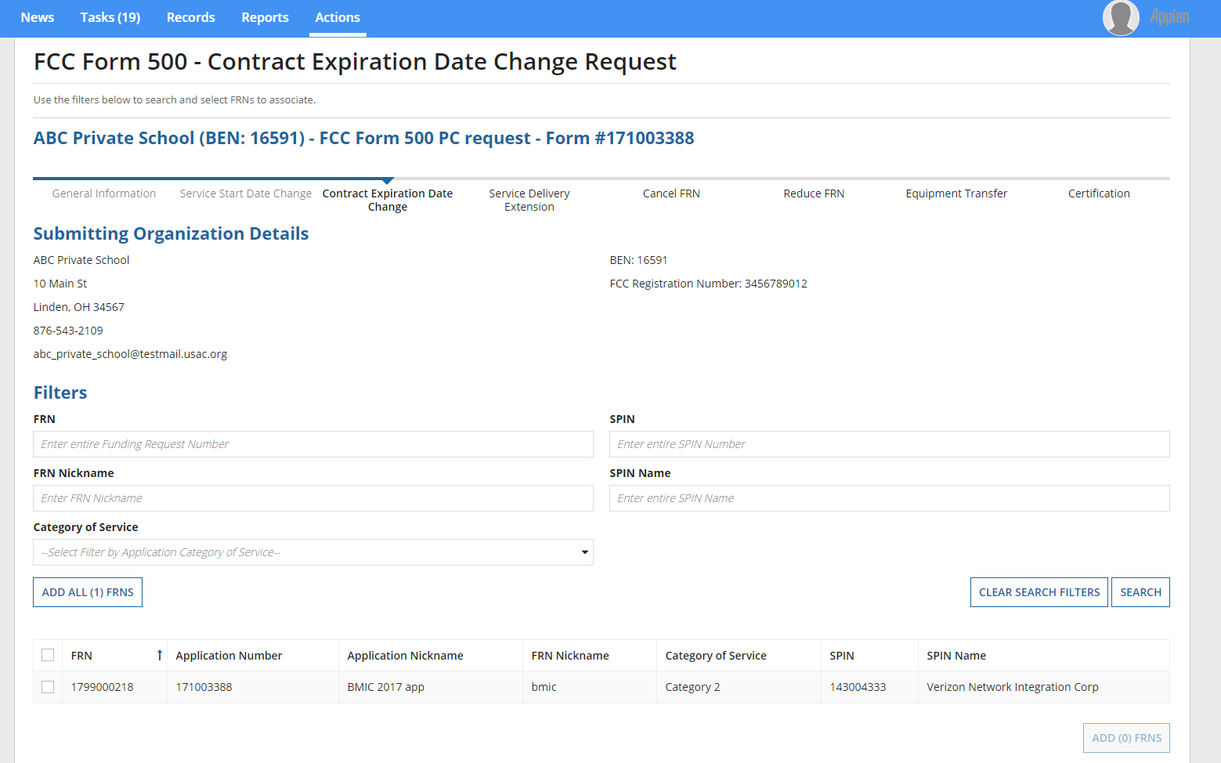
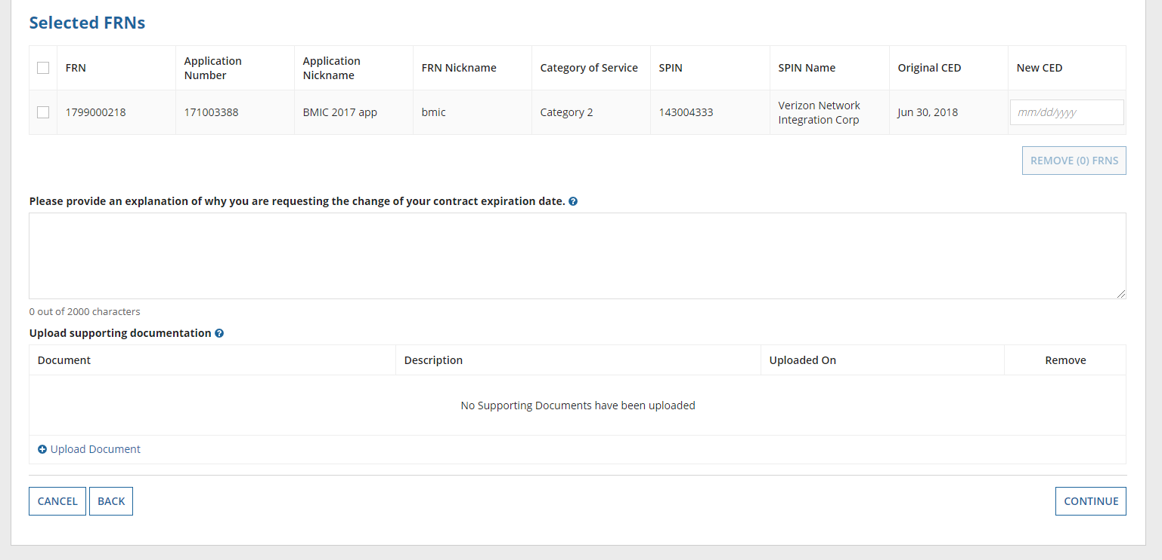
If respondents use the FCC Form 500 to change the contract expiration date, they will be prompted to provide additional information in the below screens in EPC.

Hover text provides respondents with additional information.
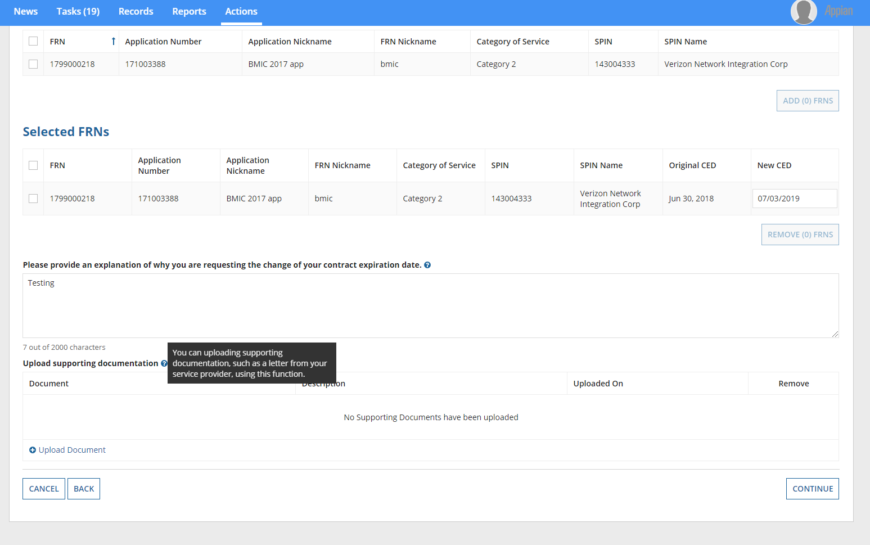
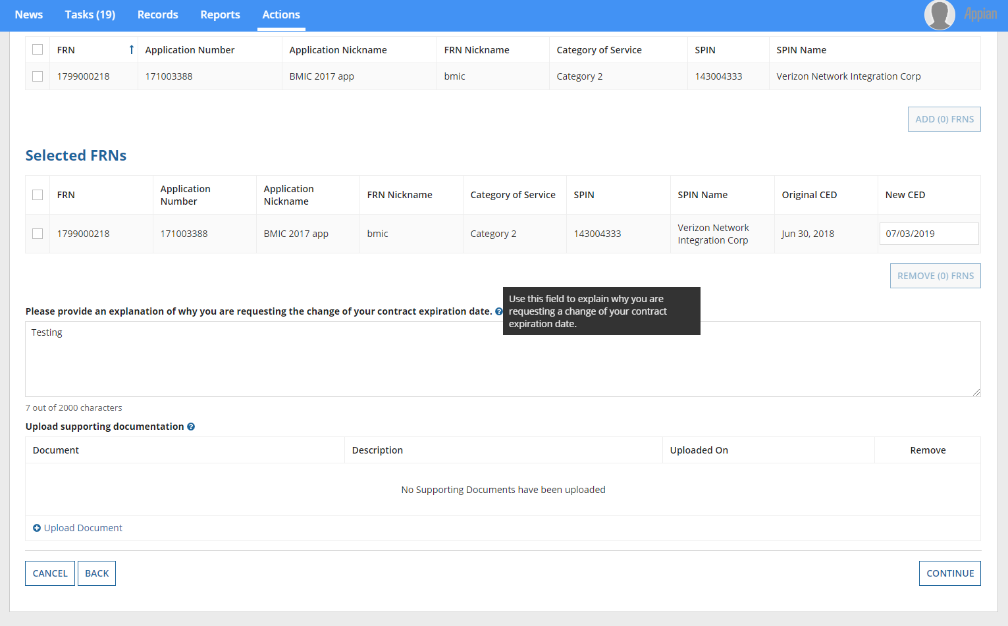
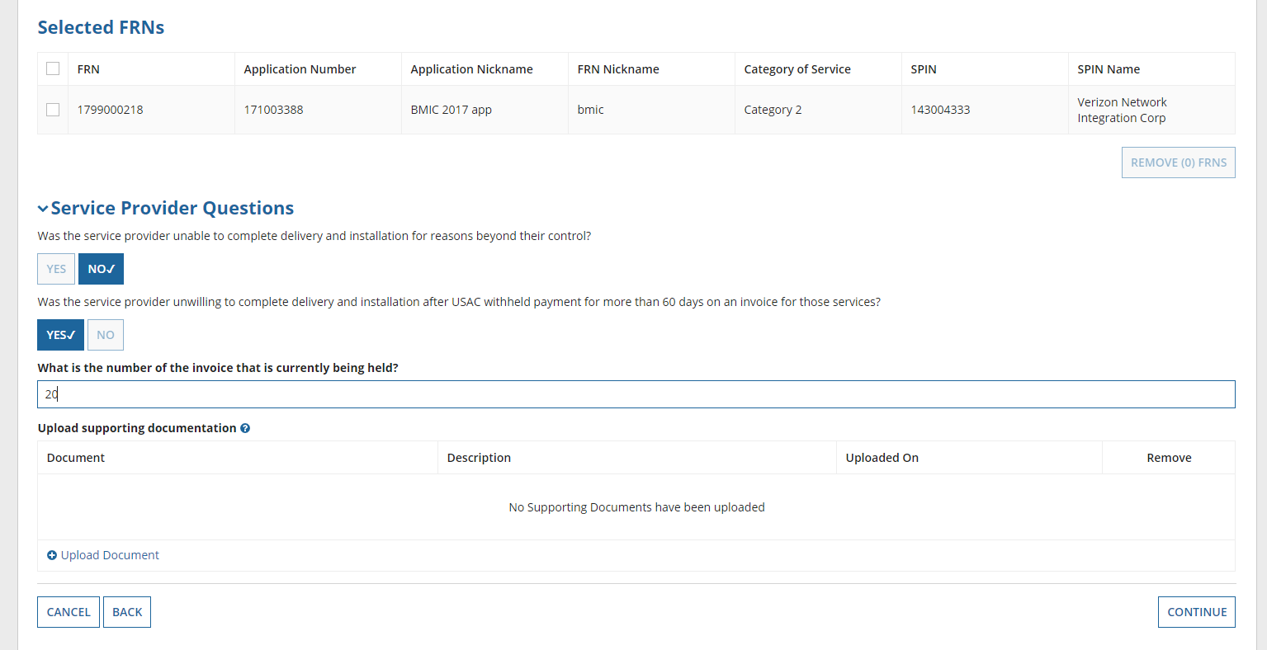
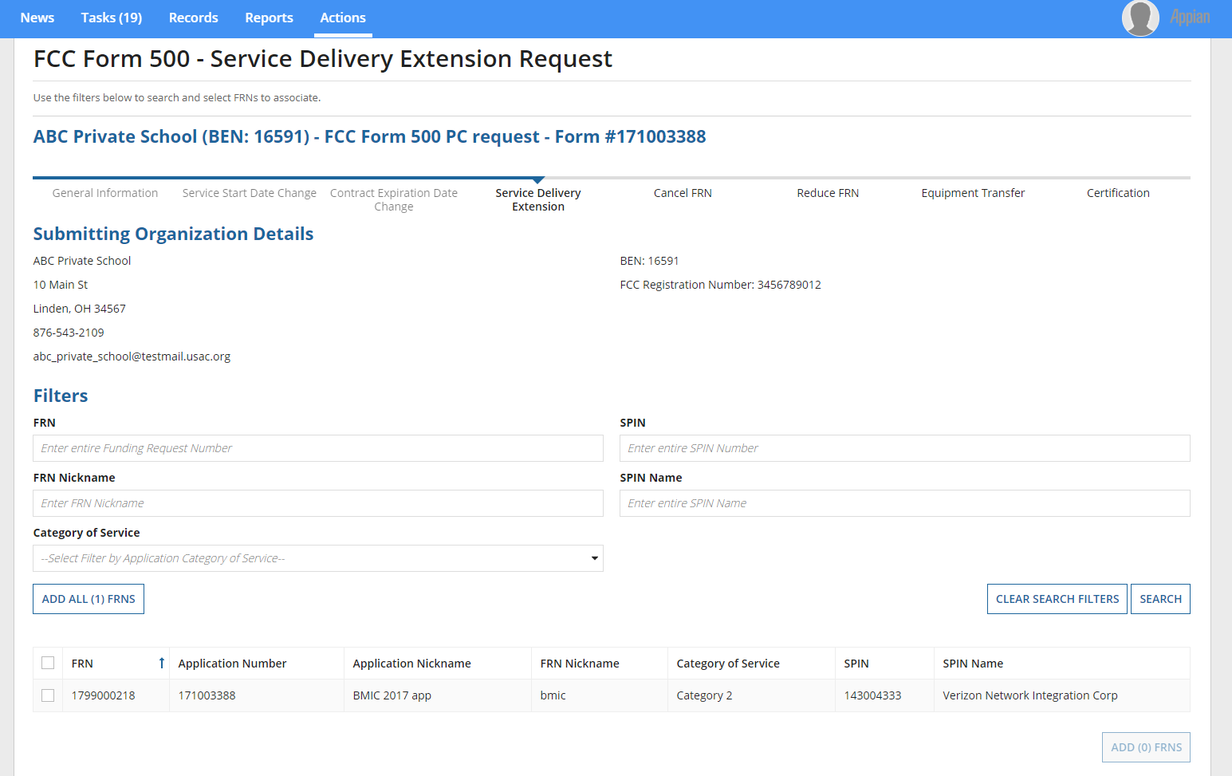
If respondents use the FCC Form 500 to request additional time for service delivery or installation, they will be prompted to provide additional information in the below screens in EPC.

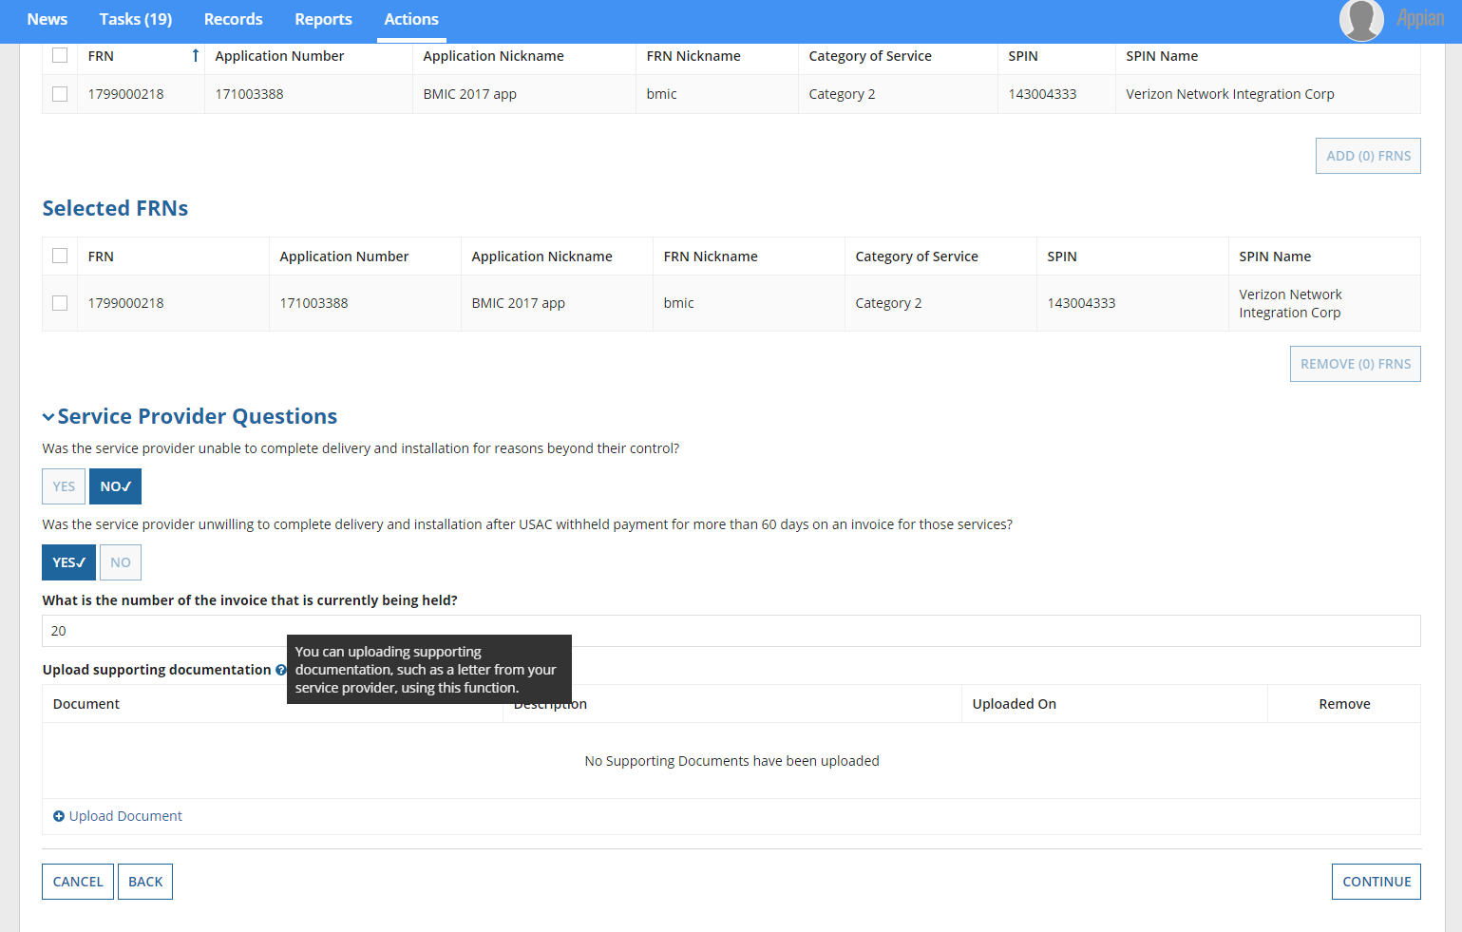
Hover text provides respondents with additional information.
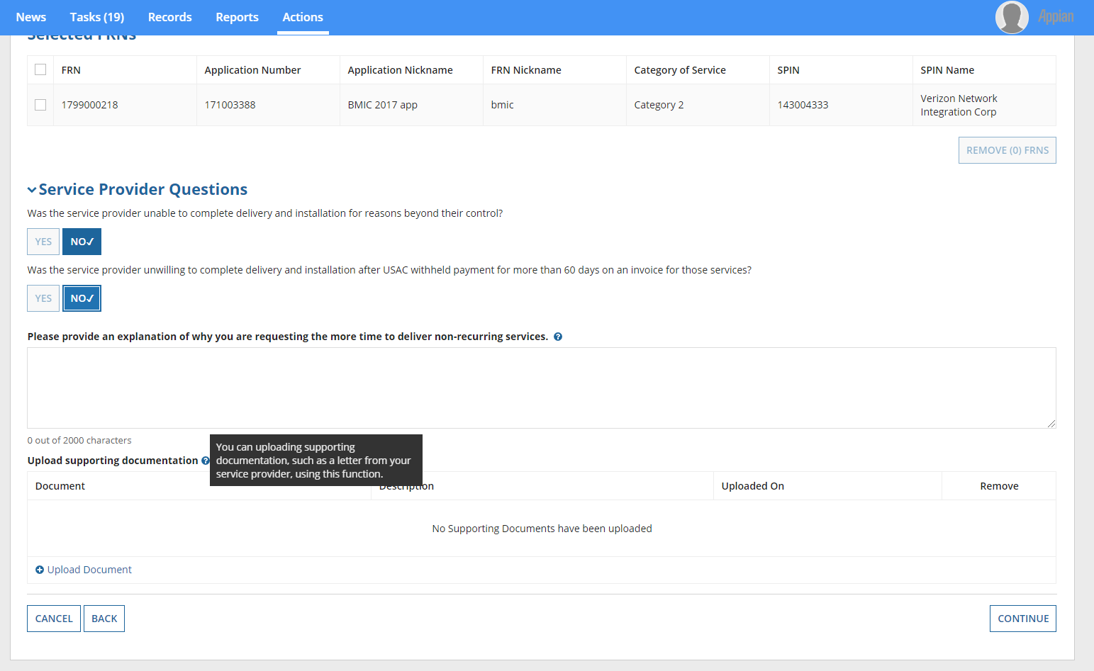
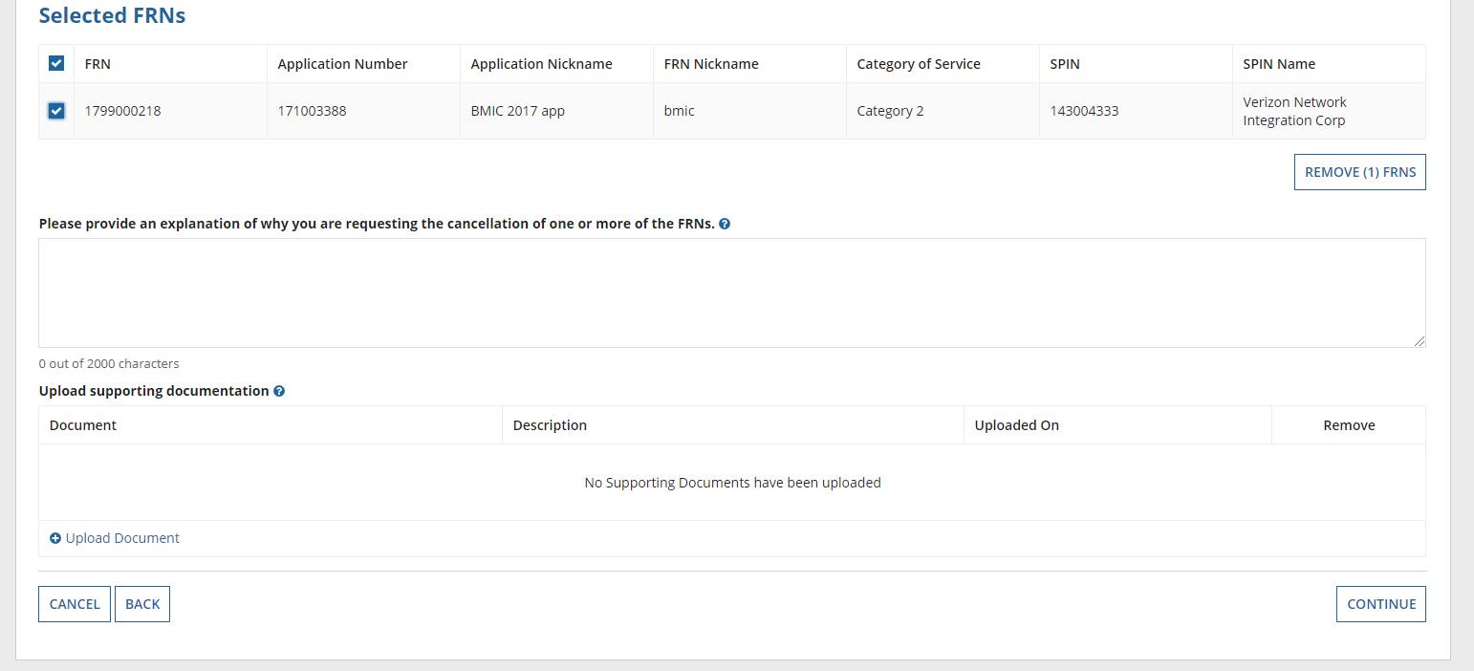
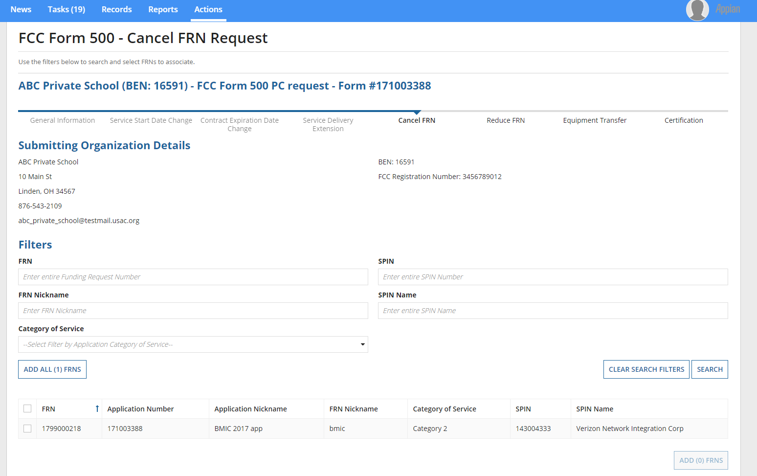
If respondents use the FCC Form 500 to cancel a funding request, they will be prompted to provide additional information in the below screens in EPC.

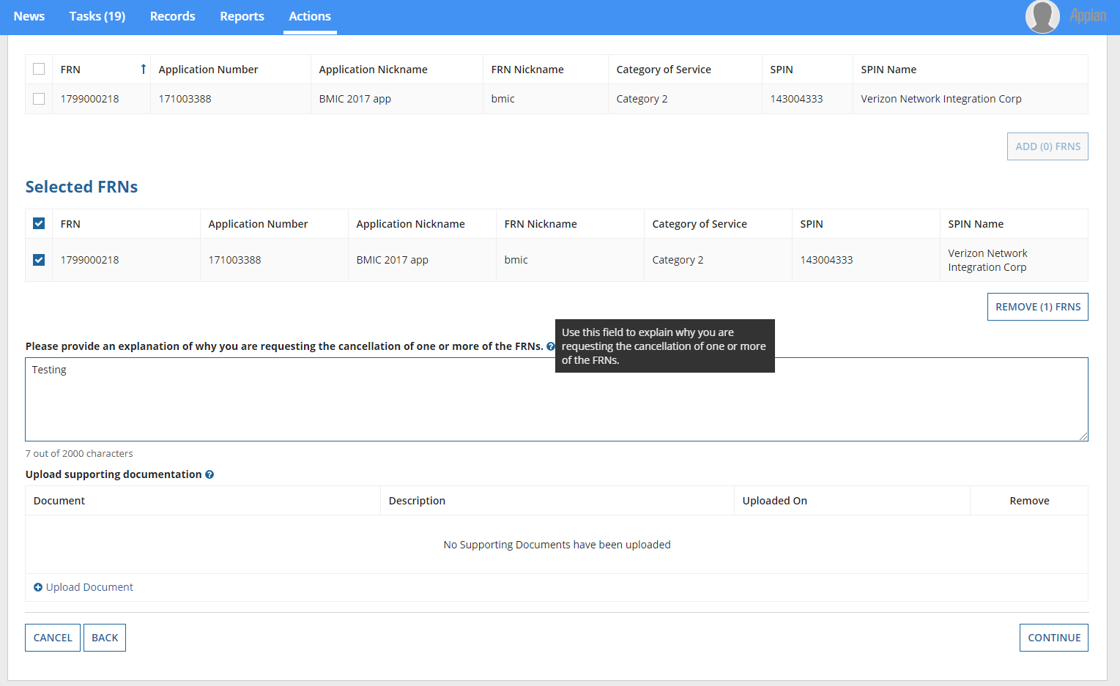
Hover text provides respondents with additional information.
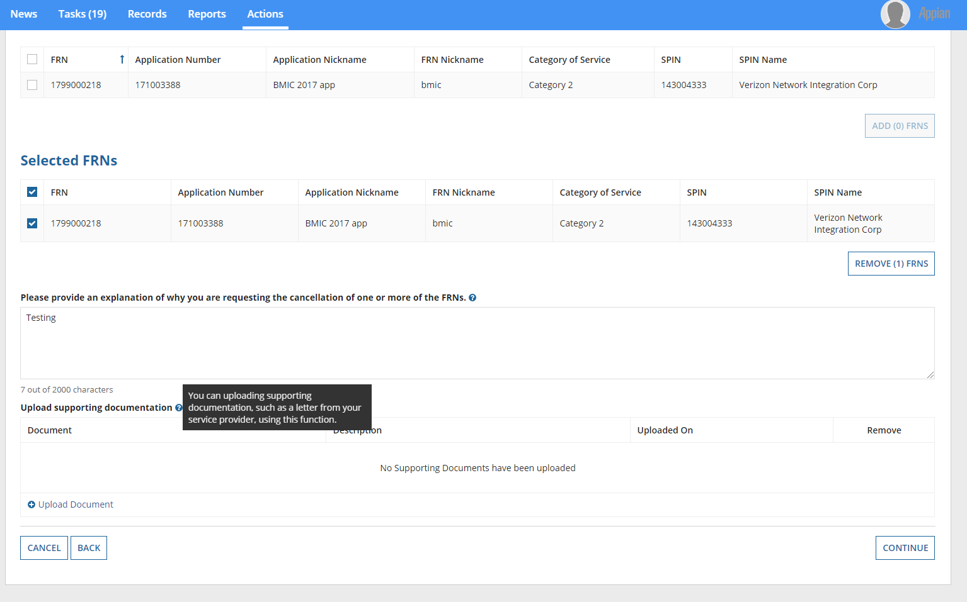
A warning screen provides respondents with additional information.
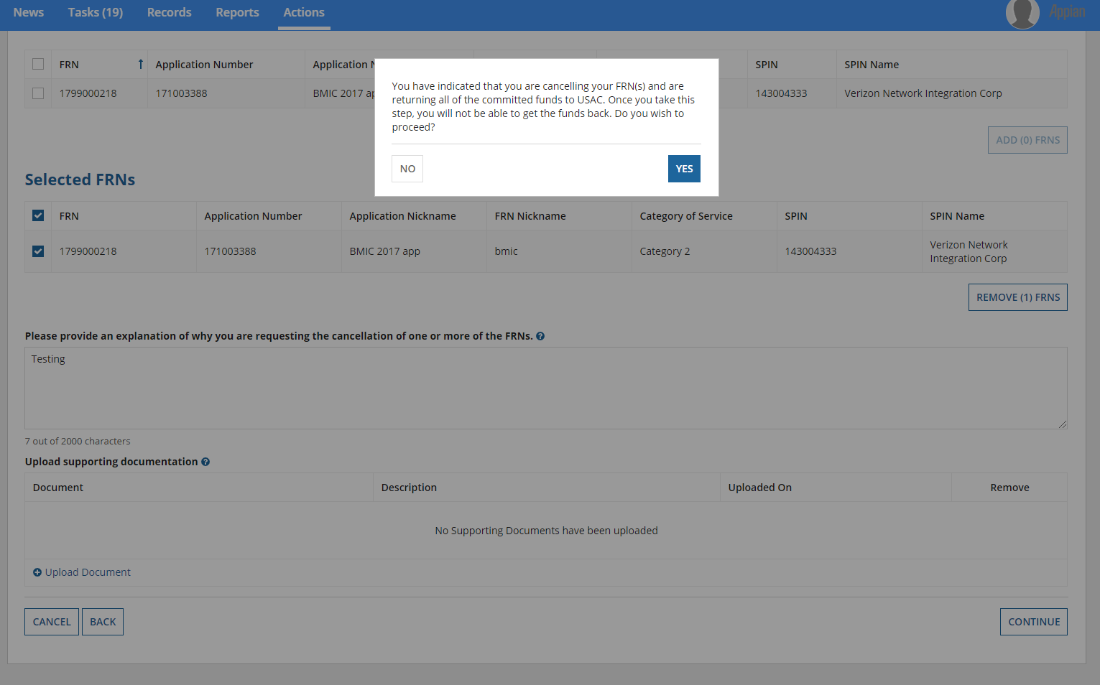
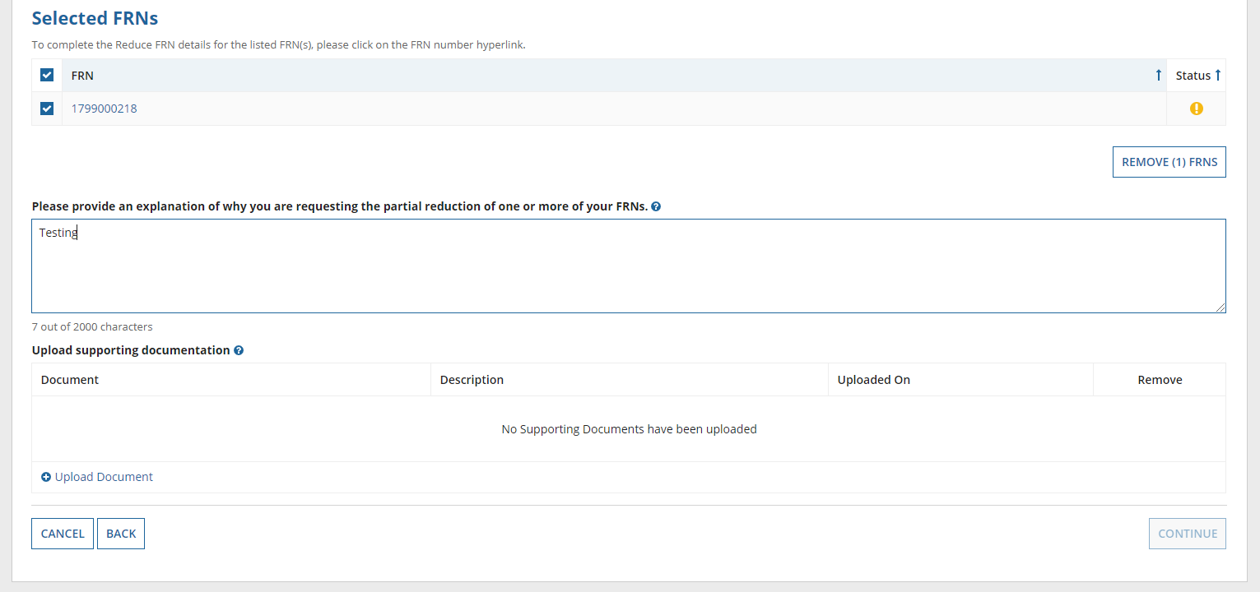
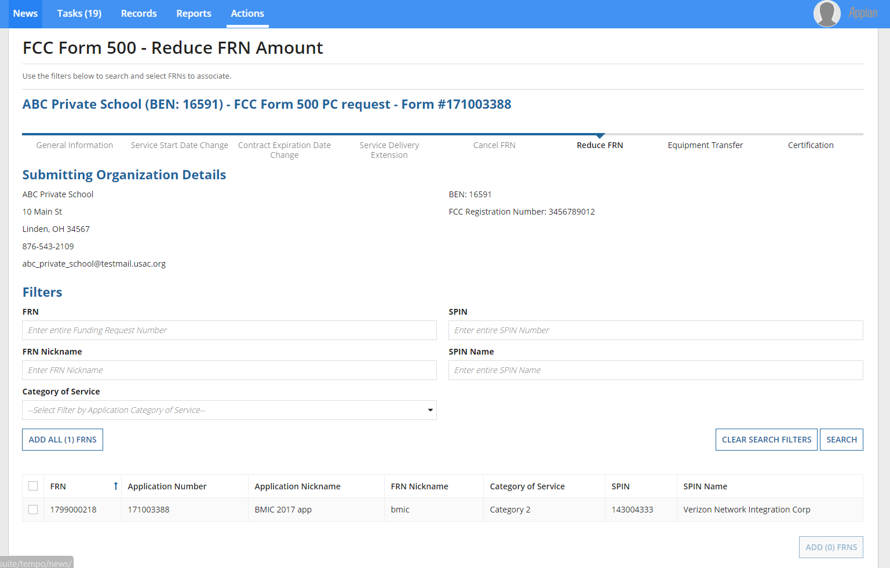
If respondents use the FCC Form 500 to reduce the amount of funding requested, they will be prompted to provide additional information in the below screens in EPC.

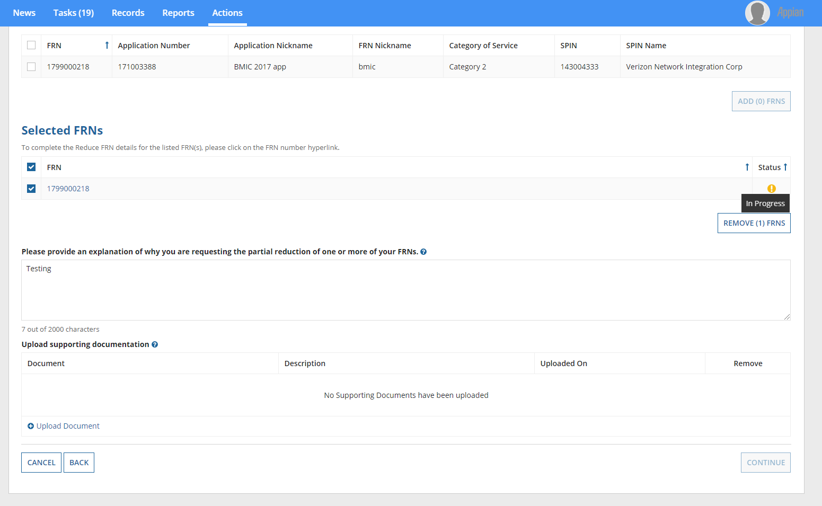
Hover text provides respondents with additional information.
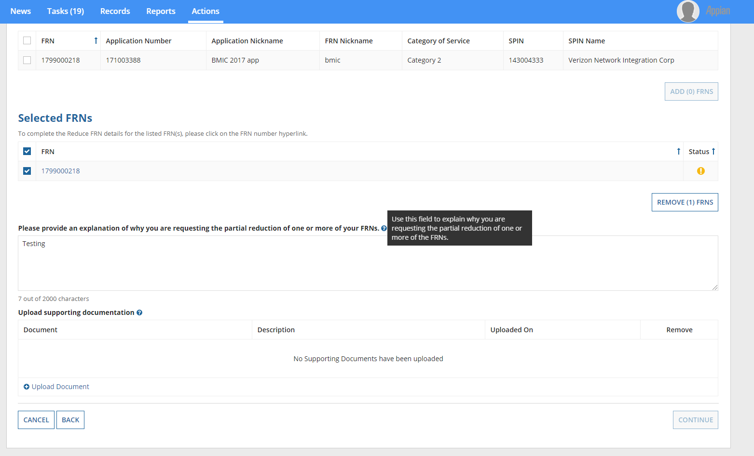
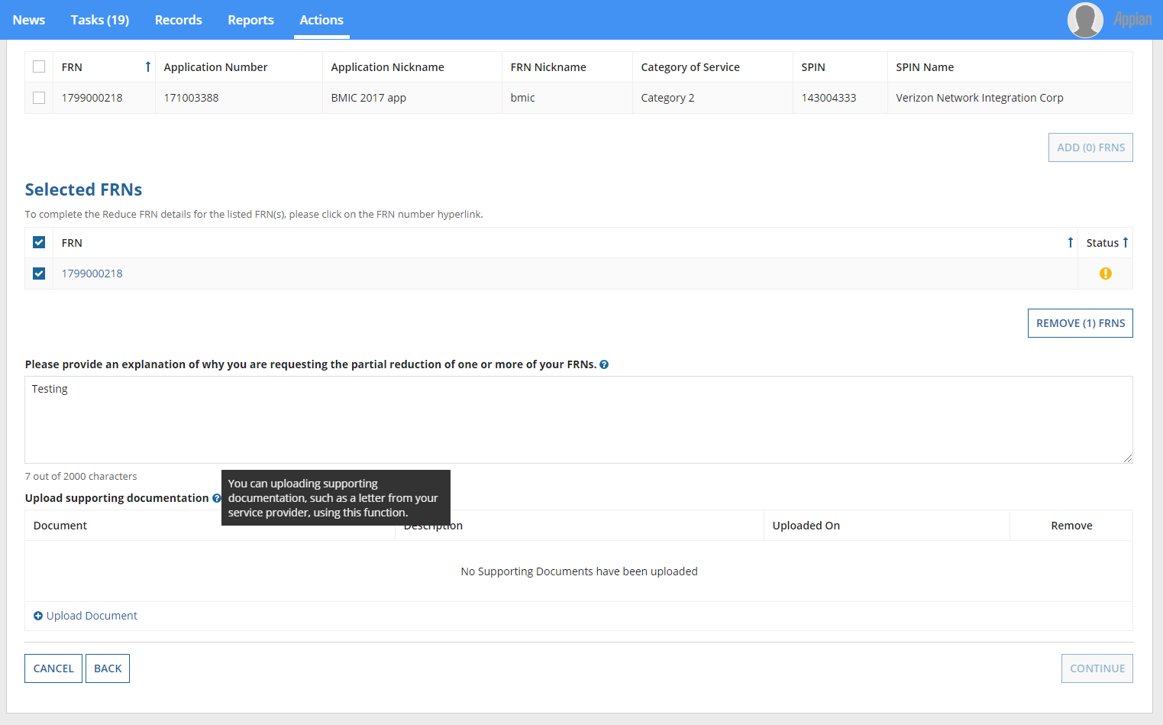
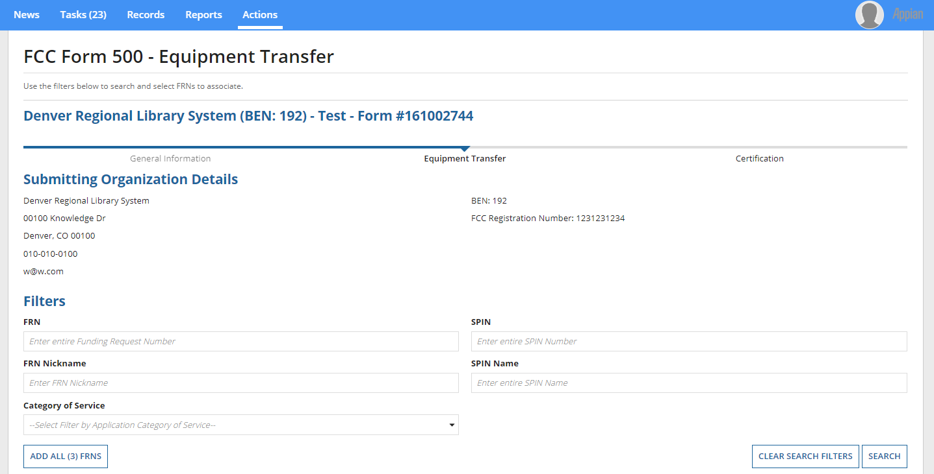
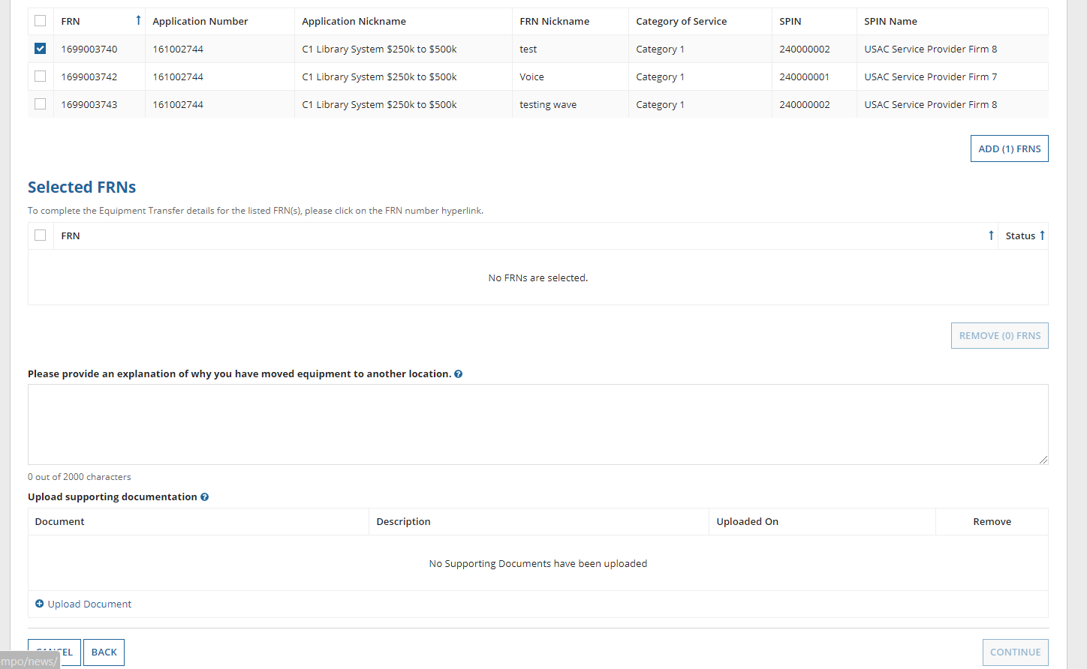
If respondents use the FCC Form 500 to notify the Administrator about an equipment transfer, they will be prompted to provide additional information in the below screens in EPC.

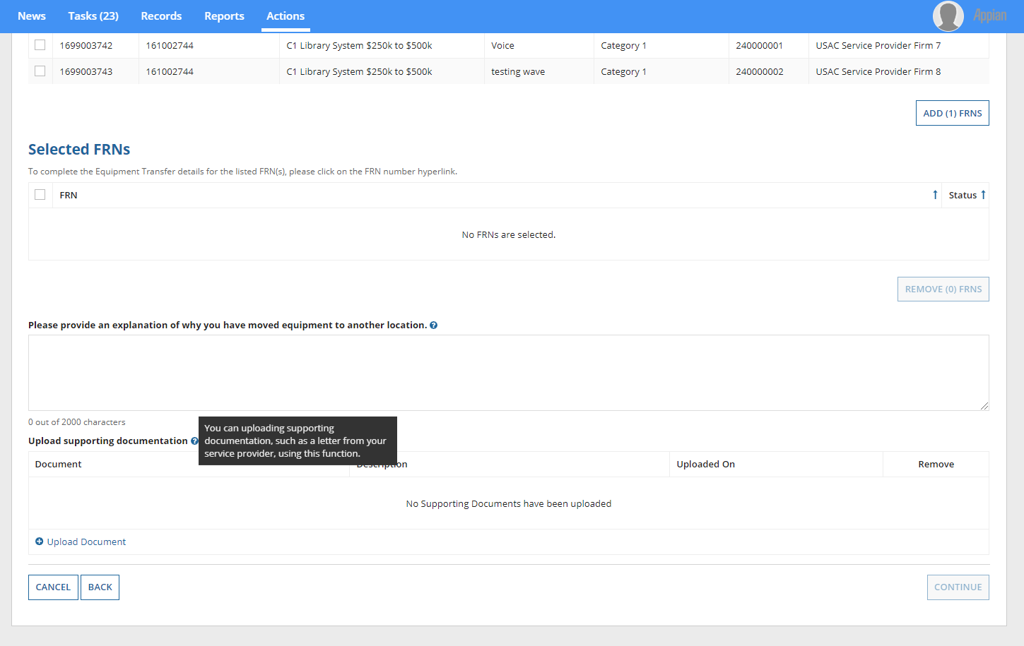
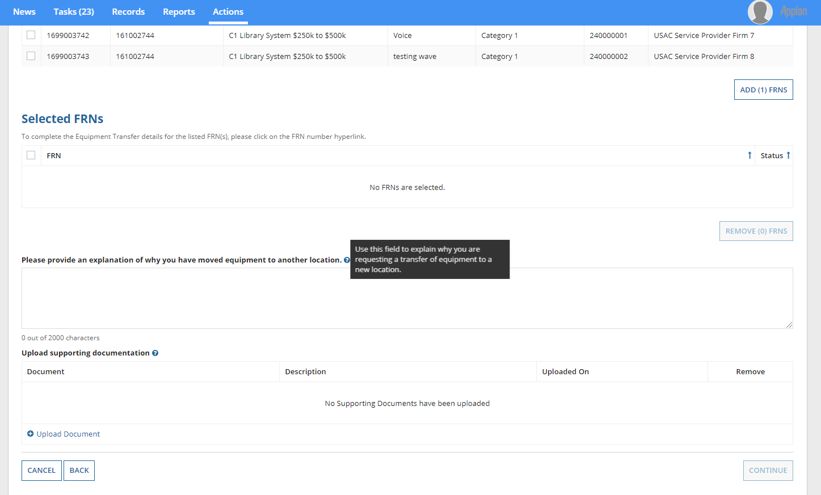
Hover text provides respondents with additional information.
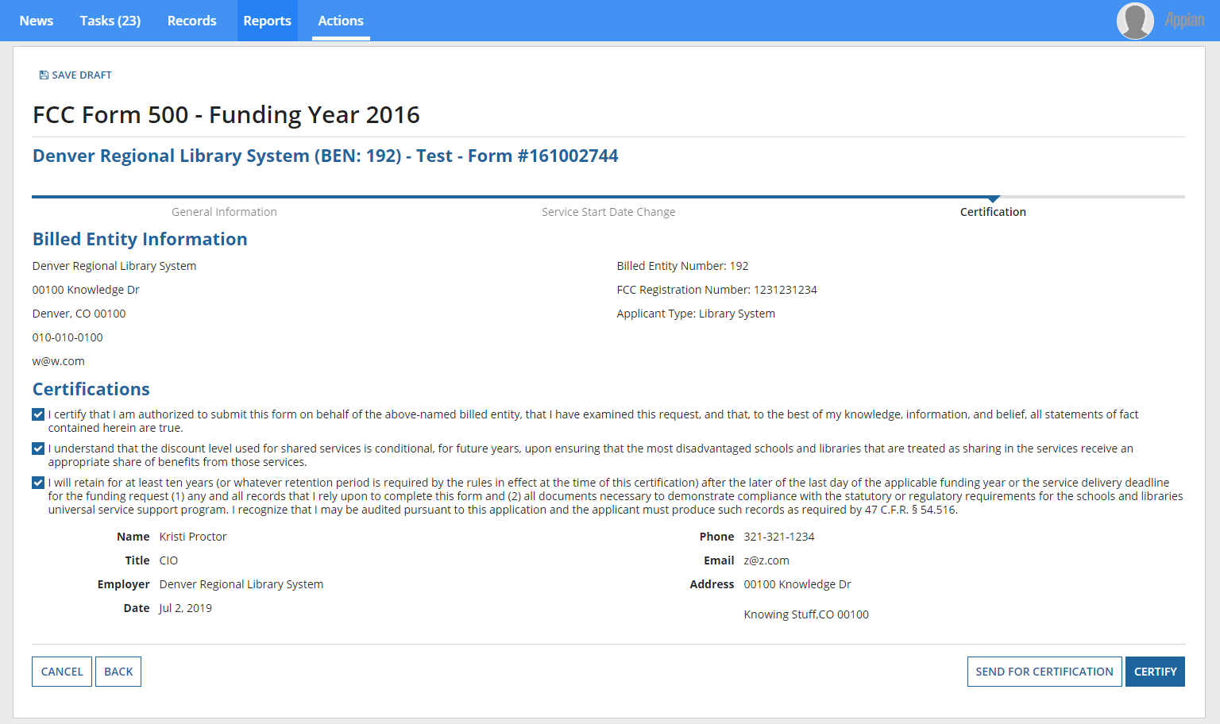
Before submitting the FCC Form 500, respondents are required to certify certain information.
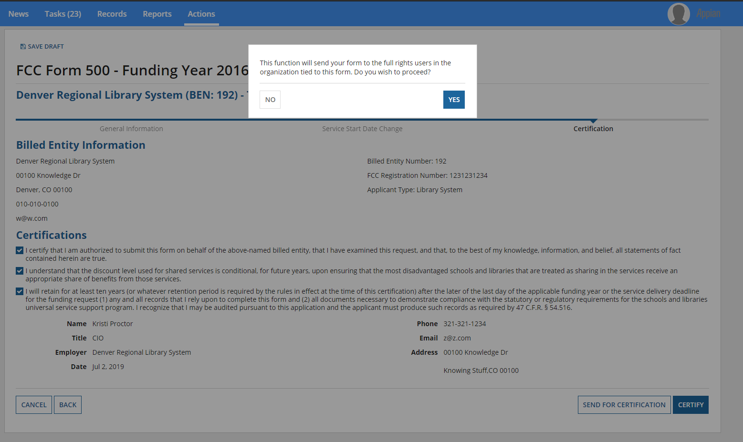
If the respondent is not authorized to certify forms, they send it to an authorized user within their organization.
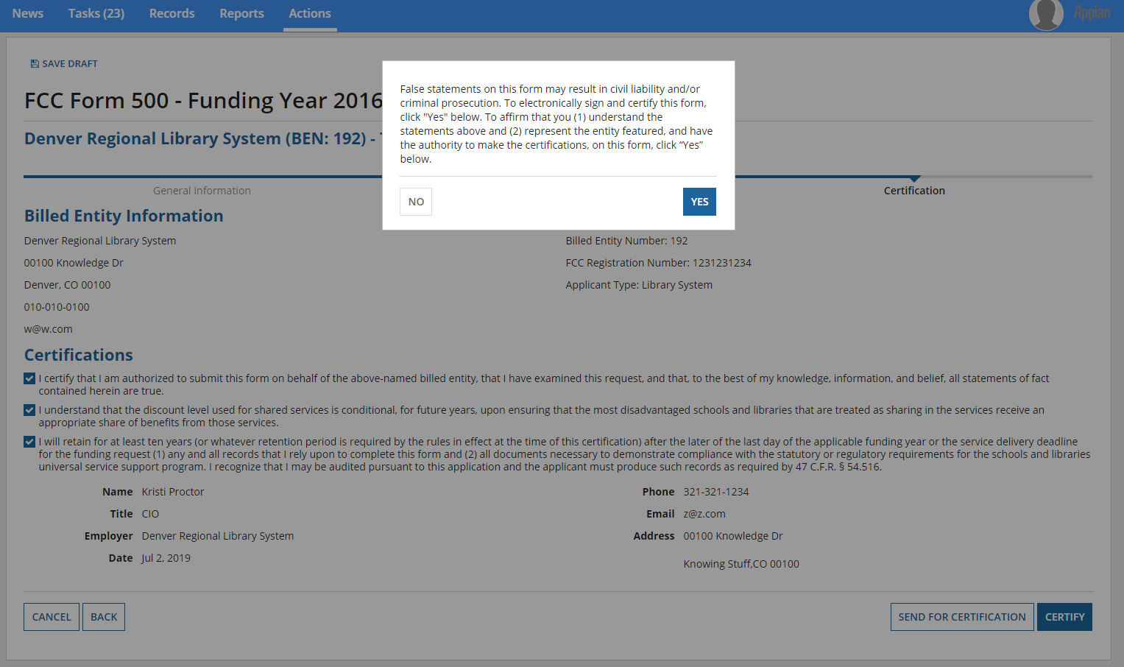
Respondents that certify the FCC Form 500 are prompted to affirm their certification.

After the FCC Form 500 has been certified, a notification screen confirms that the FCC Form 500 has been successfully created.
