FCC Form 500
The below screenshots are examples of where language referencing equipment transfers will be removed from the FCC Form 500 as filed within the E-Rate Productivity Center (EPC).
Respondents will no longer have to notify USAC that they have moved equipment to another location.

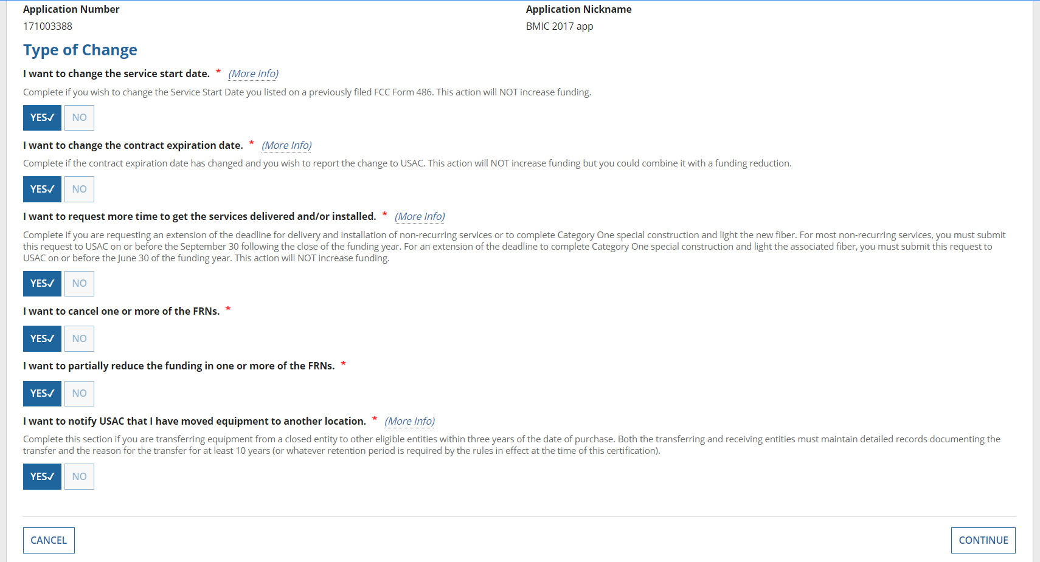
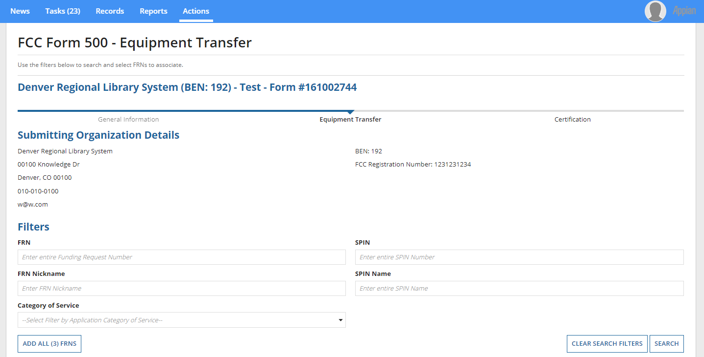
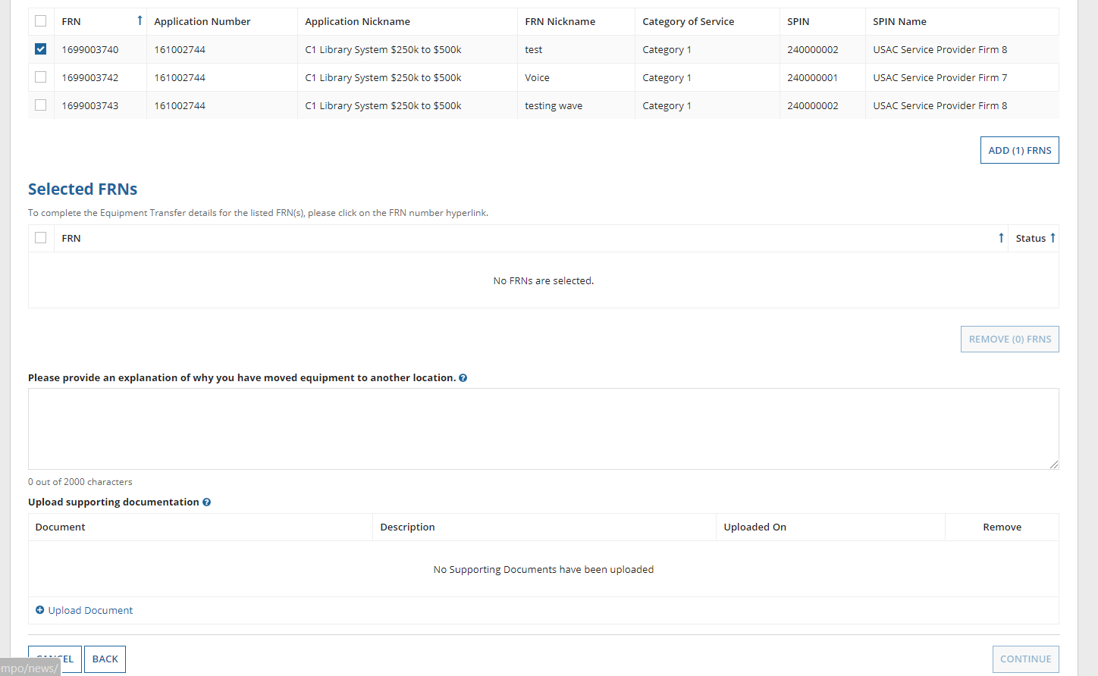
Respondents will no longer be asked to use the FCC Form 500 to notify the Administrator about an equipment transfer. The in the below screens in EPC will be removed.
