**United States Department of Agriculture**

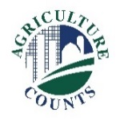

National Agricultural Statistics Service

2022

This year the U.S. Department of Agriculture (USDA) is conducting the first-ever National Agroforestry Survey. The survey gathers information on the five agroforestry practices used by farmers and ranchers for conservation and production benefits including windbreaks, silvopasture, riparian forest buffers, alley cropping, as well as forest farming & multi-story cropping.

A representative from the National Association of State Departments of Agriculture (NASDA) will work with you to complete your survey by telephone. During the telephone interview, our representative will ask you detailed questions about the types of agroforestry practices you use on your agricultural property. To make the interview process faster, please have any pertinent records available.

This reference sheet will help you and our representative find and record the correct agroforestry practices. The reference sheet lists each practice. If you do not find the correct agroforestry practice listed in this reference sheet, record as much information about your agroforestry as possible.

**Your participation is important.** By responding to this survey, you are helping USDA compile an accurate picture of agroforestry in the United States. This will ensure that the decisions impacting the well-being of farms are based on accurate, timely information.

**Your survey response is confidential**,protected by federal law (Title V, Subtitle A, Public Law 107-347). The information you provide will be combined with other responses to ensure that no individual operation or producer can be identified.

Thank you for participating and for your support of our programs and U.S. agriculture. If you have any questions, please feel free to contact us at 1-888-424-7828, or visit: [www.nass.usda.gov/go/agroforestry](http://www.nass.usda.gov/go/agroforestry).

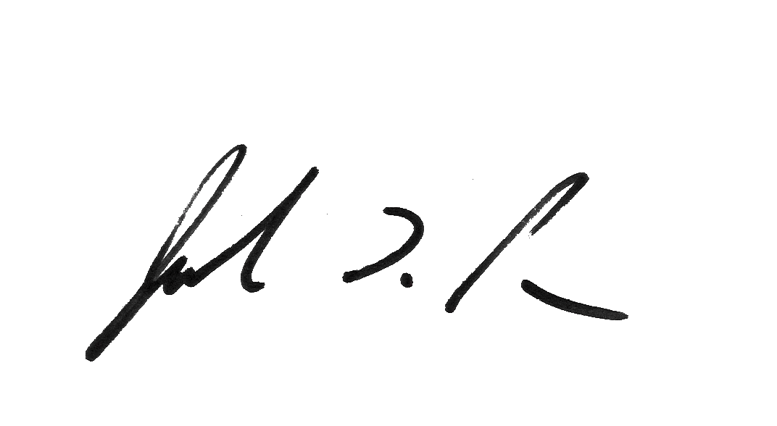

Sincerely,

Joseph L. Parsons

Chair, Agricultural Statistics Board  
Enclosure

Responding online is convenient and secure.

**Online Survey Response**

The online questionnaire:

* skips questions that don’t apply to you
* calculates totals automatically
* eliminates the need for return postage and data entry

**To complete your survey online:**

1. Go to www.agcounts.usda.gov.

2. Enter your unique survey code, which is shown above your address and barcode on the front of the questionnaire, then click “Continue.”

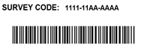

3. Click on the National Agroforestry.

4. Verify and complete your contact information, then continue to the survey.

5. Complete the survey questions.

If you need to stop, press the “Save & Return Later” icon at the top of the page. When you return, go back to Step 1 above. After the opening page, the survey tool will take you to the last page you visited.

6. When you finish the survey, click “Submit.” *If you do not see the “Submit” button, reduce the zoom setting on your screen.*

You will receive a confirmation code and can choose to view your completed questionnaire. Using the options provided by your browser, you can copy, save, or print your form.