**United States Department of Agriculture**

OMB No, 0xxx-xxxx Exp. Date x/xx/20xx

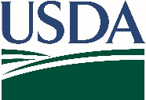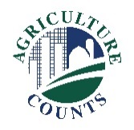

National Agricultural Statistics Service

January 10, 2022

**What should I do when I receive my questionnaire?**

Complete your survey in one of the following ways:

**Online** at agcounts.usda.gov. **Online reporting is fast and secure*.*** All you need is the Survey Code on the enclosed form to begin.

By **mail or fax**. Complete the questionnaire and mail it back in the prepaid return envelope provided or fax it to

(855) 415-3687.

**Why am I receiving this letter?**

You are receiving this letter because you responded “yes” to an agroforestry related question in a previous Census of Agriculture. Beginning in February 2022, USDA’s National Agricultural Statistics Service (NASS) will be collecting agroforestry data from farm operations across the United States. Your information is important, and we know your time is valuable, so we will offer several options to respond.

**How will the data be used?**



Agroforestry reports will provide data on five agroforestry practices used by farmers and ranchers for conservation and production benefits. The agroforestry practices include windbreaks, silvopasture, riparian forest buffers, alley cropping, as well as forest farming & multi-story cropping. See [www.fs.usda.gov/nac/practices/](http://www.fs.usda.gov/nac/practices/) for definitions and additional information.

This project is conducted as a cooperative effort with the USDA National Agroforestry Center, which is a partnership between USDA’s Forest Service and Natural Resources Conservation Service. The National Agroforestry Center will release the summarized data in publications, studies, highlights, and press releases. Highlights will give an overview of how agroforestry practices are used in regions across the United States. For updates, visit [www.nass.usda.gov/go/agroforestry](http://www.nass.usda.gov/go/agroforestry).

The information you provide will be used for statistical purposes only. **In accordance with Federal law, your responses will be kept confidential and will not be disclosed in an identifiable form**.

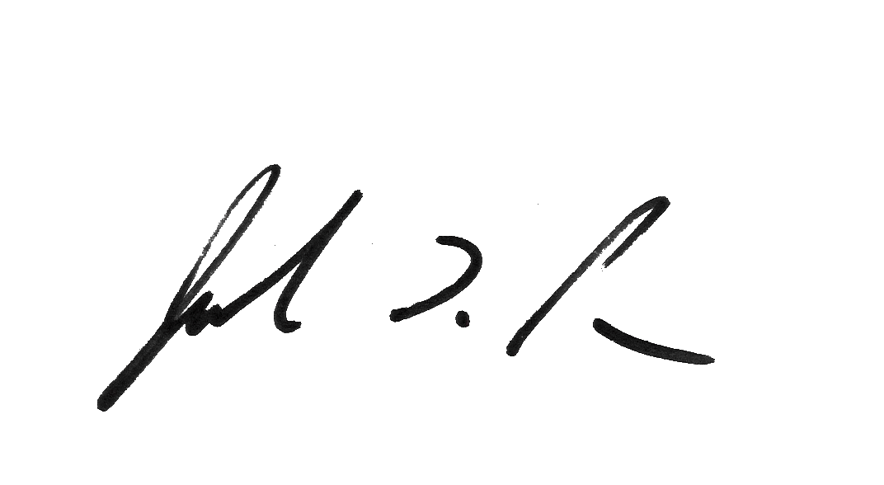Thank you for participating and for your support of our programs and U.S. agriculture. If you have any questions, please contact us at 888-424-7828.

Sincerely,

Joseph L. Parsons

Chair, Agricultural Statistics Board

Enclosure

According to the Paperwork Reduction Act of 1995, an agency may not conduct or sponsor, and a person is not required to respond to a collection of information unless it displays a valid OMB control number. The valid OMB number is 0xx-xxxx. The time required to complete this information collection is estimated to average 50 minutes, including the time for reviewing instructions, searching existing data sources, gathering, and maintaining the data needed, and completing and reviewing the collection of information.