 | NATIONAL AGRICULTURAL STATISTICS  SERVICE | 2019 ORGANIC SURVEY  Telephone Follow-Up Quality Control Form  For Poultry Operations | Form Approved  OMB Number 0535-0249  Approval Expires 07/31/2017  Project code 968
U.S. Department of Agriculture
Rm 5829, South Building
1400 Independence Avenue, S.W.
Washington, D.C. 20250-2000
1-800-727-9540
Fax: 202-690-2090
E-mail: nass-dc@nass.usda.gov
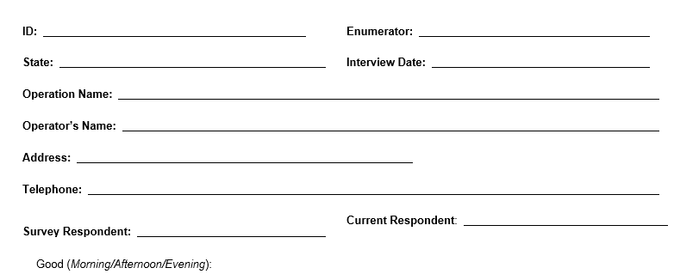
OMB No. 0535-0249
Approval Expires: 7/31/2017
Project Code:968 QID:
SMetaKey: Version 1
I am with the USDA’s National Agricultural Statistics Service. You completed the Certified Organic Survey earlier this year. Do you remember filling that out?

Thank you for your response. I am calling you today to verify some of the poultry data you provided. Your response is voluntary and not required by law, but your cooperation will be appreciated. Your information will be kept confidential. Will you help me by answering a few questions?

First, I would like to verify the data that you provided on the survey. Then, I will ask some follow-up questions. Do you have any questions before we begin? (Information that was provided by the respondents will be entered into the table below.)
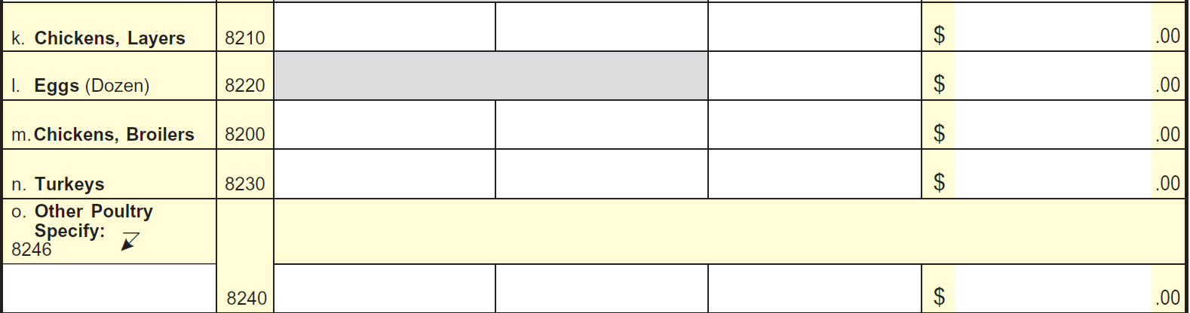
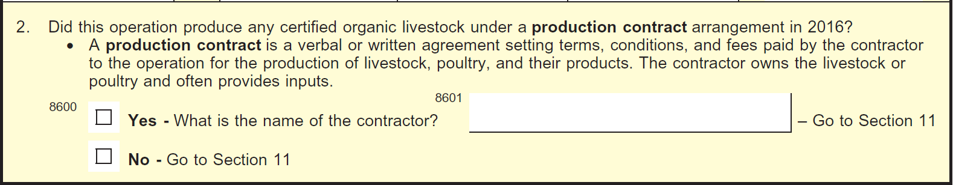

- Are you a poultry contractor?
xxx Yes (Continue)
xxx No (Conclude)

- Do these data include poultry from your production contract farms?
xxx Yes ( Continue).
xxx No ( go to question 6).

First, I have a few questions about the certified organic _______produced by your company owned farms.

- What was the peak inventory number of certified organic __________you had on hand at any time during 2019 on your company owned farms? _______________
(If none, go to question 6)

- What was the inventory number of certified organic __________you had on hand on Dec. 31 on your company owned farms? ______________

- What was the quantity of certified organic __________sold or moved from your company owned farms during 2019? ____________
I have a few questions about the certified organic _______produced by your production contract farms.

- What was the peak inventory number of certified organic __________you had on hand at any time during 2019 on your production contract farms? ____________
(If none, go to question 9)

- What was the inventory number of certified organic __________you had on hand on Dec. 31 on your production contract farms? ______________

- What was the quantity of certified organic __________moved from your production contract farms during 2019? ______________
All Farms

- What was the total number of certified organic _________handled or controlled by your company on all farms during 2019? _____________

