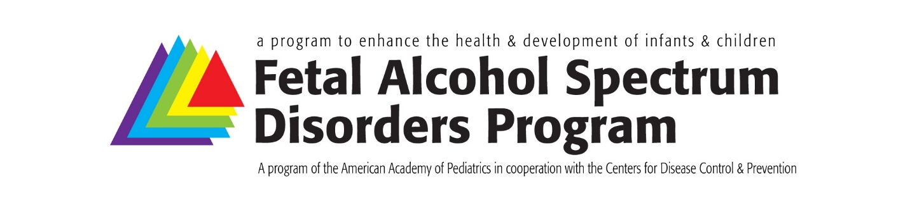
Fetal Alcohol Spectrum Disorders (FASD)
Improving Continuity of Care for Children and Families Affected by Prenatal Alcohol Exposure

Train the Trainer Session Evaluation

The public reporting burden of this collection of information is estimated to average 15 minutes per response, including the time for reviewing instructions, searching existing data sources, gathering and maintaining the data needed, and completing and reviewing the collection of information. An agency may not conduct or sponsor, and a person is not required to respond to a collection of information unless it displays a currently valid OMB control number. Send comments regarding this burden estimate or any other aspect of this collection of information, including suggestions for reducing this burden to - CDC/ATSDR Reports Clearance Officer; 1600 Clifton Road NE, MS D-74, Atlanta, Georgia 30333 ATTN: PRA (xxxx-xxxx)

Identifier:
Please indicate your primary employment site setting, that is, the setting where you spend most of your time. Please indicate only ONE response.
☐ Self-employed solo practice
☐ Two physician practice
☐ Pediatric group practice, 3-10 pediatricians
☐ Pediatric group practice, >10 pediatricians
☐ Multispecialty group practice
☐ Health maintenance organization (staff model)
☐ Medical school or parent university
☐ Non-profit community health center
☐ Non-government hospital or clinic
☐ City/county/state government hospital or clinic
☐ US government hospital or clinic
☐ Other:
Please describe the community in which your primary practice/position is located?
☐ Urban, inner city
☐ Urban, not inner city
☐ Suburban
☐ Rural
This project is support by CoAg# OT18-1892 from the Centers for Disease Control and Prevention.

On a scale of 1 to 5 (1 strongly disagree to 5 strongly agree) Please rate the extent to which the train the trainer meeting achieved the stated learning objectives
Learning objective 1  Physicians able to recognize the physical, neurodevelopmental and behavioral risk factors associated with fetal alcohol spectrum disorders (FASDs) | 1 | 2 | 3 | 4 | 5
Learning objective 2  Physicians understand the role that implicit bias plays in health equity for children with FASDs and value of universal screening for prenatal alcohol exposure as one strategy to overcome bias and discrimination. | 1 | 2 | 3 | 4 | 5
Learning objective 3  Physicians confident in their ability to implement an integrated plan of care for children with (or being assessed for; or assumed to have) FASDs. | 1 | 2 | 3 | 4 | 5
Learning objective 4  Physicians able to document medical necessity for neurodevelopmental evaluation and school-based resources to support children with FASDs. | 1 | 2 | 3 | 4 | 5

Comments or suggestions related to how the learning objectives could better support the educational session and your needs as a precepting attending?

How would you rate this educational activity overall
☐ Poor
☐ Fair
☐ Good
☐ Very good
☐ Excellent

Session feedback – On a scale of 1 to 5 (1 strongly disagree) to 5 strongly agree) rate your agreement with each statement. Circle one.
  - I can use the information presented in my practice 1 | 2 | 3 | 4 | 5
  - Format of the sessions enhanced achievement of 1 | 2 | 3 | 4 | 5
learning objectives
  - Presentation materials/slides helped me to meet my 1 | 2 | 3 | 4 | 5
professional development goals
  - Registration and travel details was straight forward 1 | 2 | 3 | 4 | 5
Speaker/facilitator feedback – On a scale of 1 to 5 (1 strongly disagree to 5 strongly agree) rate your agreement with each statement. Circle one.
  - Speakers/facilitators presented content that was 1 | 2 | 3 | 4 | 5
relevant to the topic and objectives
  - Speakers/facilitators responded to audience needs 1 | 2 | 3 | 4 | 5
during the presentations
  - Speaker’s/facilitator’s knowledge and expertise was 1 | 2 | 3 | 4 | 5
appropriate for this session
Rate your knowledge, skills and attitudes related to the identification and treatment for children who have or may have one of the FASDs from 1-below average to 3-above average
  - Before the session 1 below average | 2 average | 3 above average
  - After the session 1 below average | 2 average | 3 above average
On a scale of 1 to 5 (1 not confident to 5 very confident), rate your perceived ability to provide supervision and support to pediatric residents/trainees regarding the identification of children with FASDs and implementation of a plan of care in the medical home.
  - My self-rating before the session 1 | 2 | 3 | 4 | 5
  - My self-rating after the session 1 | 2 | 3 | 4 | 5
Based on what you learned in this activity, do you plan to change:
- The strategies you implement in practice (e.g., how you diagnose/manage Yes | No
patients, coordinate care, etc.)?
- What you do in practice (e.g., how you perform exams, instruct, counsel Yes | No
patients/families, etc.)?
If YES to either of the above questions, please identify any changes in practice that you plan to make:
If NO and you do not plan to make changes in practice, other than lack of time and resources, why not? (select all that apply)
☐ Systems-related barriers - please describe:
☐ The activity reinforced what I am already doing in practice
☐ No practice changes were recommended
☐ Changes were not appropriate options for my practice
☐ Other - please describe:

On a scale of 1 to 7, what was the return on your investment of time/effort for 1 | 2 | 3 | 4 | 5 | 6 | 7
participating in this activity? Circle one. (1 low return to 7 high return)

Do you feel a commercial product, device, or service was inappropriately promoted Yes | No
in the educational content?
If yes, please comment:

On a scale of 1 to 5 (1 not at all valuable to 5 highly valuable), please rate the value 1 | 2 | 3 | 4 | 5
of the inclusion of MOC points for participating in this activity.

This MOC activity is relevant to my current practice. Yes | No
If yes, please explain why:

Please share any additional comments and suggestions for how to improve this educational session.

Thank you for participating in this session and for completing this evaluation!
Submit to:
Josh Benke, FASD Program Manager,
American Academy of Pediatrics, Division of Children with Special Needs
V: 630/626-6081 | F: 847/434-8000 | E: jbenke@aap.org

