Attachment J
Parents Wanted for
Research Study

The National Center for Health Statistics is
looking for parents of children 19 to 35 months
of age, for a [XX] minute interview testing questions that will be used in a national health survey. All parents are welcome, but we are especially interested in those whose children are not up-to-date with their immunization shots. Participants will receive [$XX].

FOR MORE INFORMATION,
Please call: [fill telephone number]

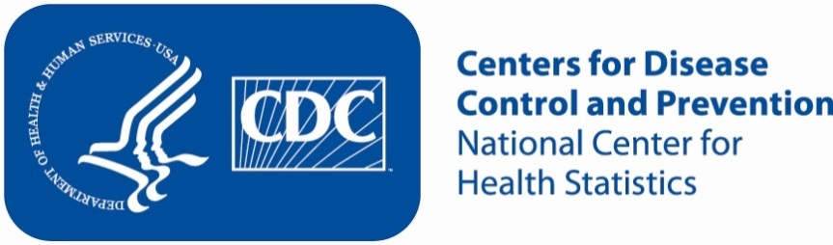
Sample Newspaper Advertisement

