Attachment L
Sample of a 2017 advance letter sent to NHIS respondents
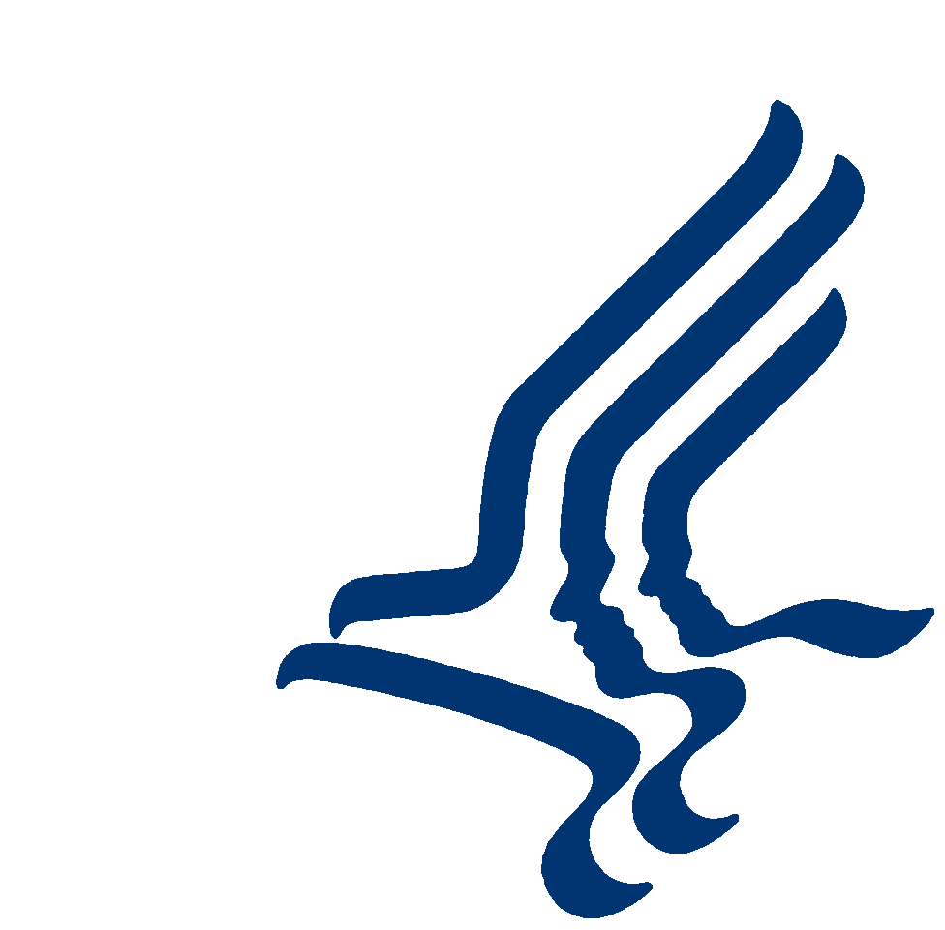DEPARTMENT OF HEALTH & HUMAN SERVICES Centers for Disease Control and Prevention

HIS-600(L) ATLANTA
(2-2017)
National Center for Health Statistics
3311 Toledo Road
Hyattsville, MD 20782

From the Director of the United States National Center for Health Statistics

I’m Charles Rothwell and I head the National Center for Health Statistics (NCHS), part of CDC (the U.S. Centers for Disease Control and Prevention). In partnership with the U.S. Census Bureau, my agency is conducting a major survey about the nation’s health and we need your help.

In the next few days, a Census Bureau interviewer will ask you some questions to see if you are eligible for the National Health Interview Survey. For your protection, the interviewer will show you an official identification card.

Please know that nothing you tell us will be shared. Your answers are used only for health research, and to help understand and solve today’s health problems and anticipate future health issues. Quality health information is necessary to make good decisions and sound policies. In this way, taking part in the survey indirectly benefits all Americans.

Strict federal laws protect your information. Questions 5 and 6 on the back of this letter describes these laws and who may see your personal information.

I hope you will want to take part in the survey–it is your choice. No penalties or loss of benefits will come from refusing.

The length of the interview will depend on the size and health of your family. Most interviews will take about an hour, but you can stop at any time and you can choose not to answer any questions you do not wish to answer. Health and health care information from other records may
be combined with your survey answers. These data also will be kept strictly private. You also may be given the choice to take part in other surveys sponsored by the National Center for Health Statistics.

Please contact the Census Bureau, toll-free, at 1–800–424–6974, press 0, Ext. 53935, if you have questions about the survey or to schedule an interview. About a week after the interview, some households will be asked a few extra questions for quality purposes.

You can learn more about the survey at our website: http://www.cdc.gov/nchs/nhis.htm

I know your time and privacy are valuable so I am very grateful for your help. Thank you for your cooperation.

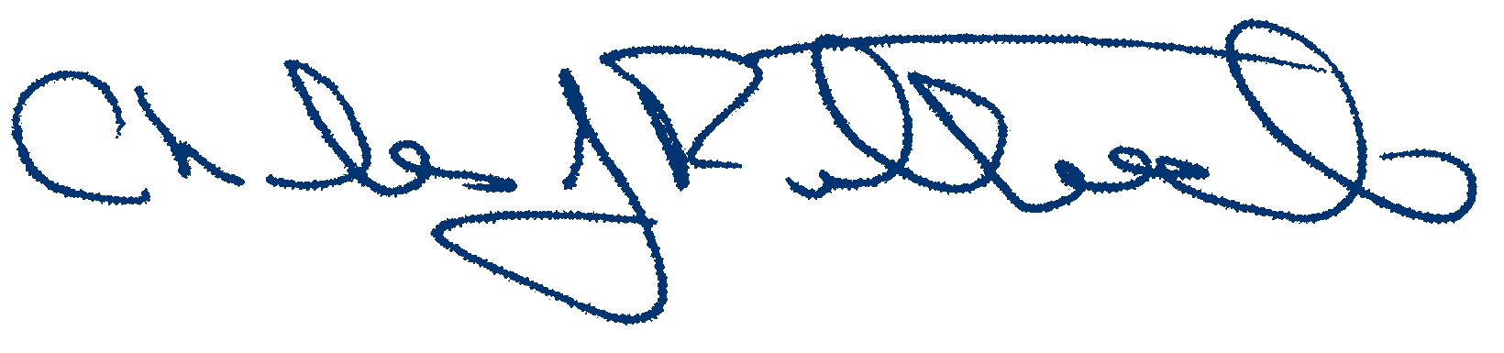Sincerely,

REGIONAL OFFICE
US CENSUS BUREAU
101 MARIETTA ST NW STE 3200
ATLANTA GA 30303-2711
1-800-424-6974, press 0, Ext. 53935

Charles J. Rothwell
Director, National Center for Health Statistics
Centers for Disease Control and Prevention

National Health Interview Survey
Since – 1957

FREQUENTLY ASKED QUESTIONS ABOUT THE NATIONAL HEALTH INTERVIEW SURVEY (NHIS)

1. HOW WAS I CHOSEN FOR THE SURVEY?
Every month we pick between 5,300 and 5,500 home addresses across the entire United States. We pick addresses using scientific methods so they represent all communities in the U.S.

2. WHY NOT INTERVIEW AT THE HOUSE ACROSS THE STREET? WHY IS MY PARTICIPATION IMPORTANT?
It is important that the people living at the address selected be in the survey. Due to the scientific methods used to pick addresses, we cannot exchange one address for another. If we did that, the survey results would not describe the entire country.

3. I AM NOT SICK – WHY SHOULD I TAKE PART IN A HEALTH SURVEY?
This is a survey of the Nation’s health. We want to know how many people are sick and why they are sick, but it is also important to know how many people are healthy and why they are healthy. Everyone’s answers are important. Congress authorized the NHIS data collection in Section 306 of the Public Health Service Act (42 United States Code 242k).

4. WHAT ARE YOU GOING TO ASK ME?
The NHIS covers a wide range of topics like doctor visits, medical conditions, health insurance, physical activity, and injuries. We also ask questions that help us better understand the health information you give us. For example, we ask about race, income, and permission to combine your answers with information from other places, like medical records. Most people have no difficulty with any of the questions in the NHIS. However, others find some questions to be sensitive. You do not have to answer any questions you don’t want to.

5. WHO WILL SEE MY ANSWERS?
We take your privacy very seriously. The answers you give us are used for statistical research only. This means that your answers will be combined with other people’s answers in a way that protects everyone’s identity. As required by federal law, only those NCHS employees, our specially designated agents (such as the U.S. Census Bureau), and our full research partners who must use your personal information for a specific reason can see your answers. Anyone else is allowed to use your data only after all information that could identify you and/or your family has been removed.

Strict laws prevent us from releasing information that could identify you or your family to anyone else without your consent. A number of federal laws require that all information we collect be held in strict confidence: Section 308(d) of the Public Health Service Act (42 United States Code 242m(d)), the Confidential Information Protection and Statistical Efficiency Acts (CIPSEA, Title 5 of Public Law 107-347), and the Privacy Act of 1974, 5 U.S.C. 552a. Every NCHS employee, contractor, research partner, and agent has taken an oath to keep your information private. Any NCHS employee, contractor, or agent who willfully discloses ANY identifiable information could get a jail term of up to five year, a fine of up to $250,000, or both. In addition, NCHS complies with Federal Cybersecurity Enhancement Acts of 2015. This law requires the federal government to protect federal computer networks by using computer security programs to identify cybersecurity risk like hacking, internet attacks, and other security weaknesses.

6. WHAT DO MY ANSWERS HAVE TO DO WITH CYBERSECURITY?
The purpose of the Federal Cybersecurity Enhancement Act of 2015 is NOT to read your and/or your family’s personal health information. The Act allows software programs to scan information that is sent, stored on, or processed by government networks in order to protect the networks from hacking, denial of service attacks, and other security threats. If any information is suspicious, it may be reviewed for specific threats by computer network experts working for the government (or contractors or agency who have governmental authority to do so). Only information directly related to government network security is monitored. The Act requires any personal information that identifies you, your family, or your answer to health questions to be removed from suspicious files before they are shared.

7. WHO LOOKS OUT FOR THE INTERESTS OF SURVEY PARTICIPANTS?
Every year, the Research Ethics Review Board (ERB) of the National Center for Health Statistics reviews survey content and methods to protect study participants. You may call the ERB if you want to ask about your rights as a participant in this research study. The toll-free number is
1–800–223–8118. Please leave a brief message with your name and phone number. Say you are calling about Protocol # 2009-16. Your call will be returned promptly.

HIS-600(L) (2-2017)

