Voices of Freedom — Sample Conversation Starters
KEY FACTS
- The best StoryCorps conversations are between two people who know each other.
- Conversations are not scripted.
- With your permission, interviews will be archived at the American Folklife Center at the Library of Congress.

Interview Tips
- Think of it as a conversation. Speak normally and address the person you are interviewing.
- Keep in mind that future listeners may not be familiar with people and places you mention. Set up context and background.
- Ask questions that encourage details — these can help paint a picture for the listener.
- Be prepared to ask follow-up questions.
- Feel free to abandon the planned question list and go with questions that emerge!

Great Questions to Ask Anyone
- How did we first meet? What do you remember about meeting me?
PREPARING FOR THE INTERVIEW
- Speak normally and address your partner.
- Choose 5–10 questions to focus on. Feel free to ask follow-up questions!
- Think about future listeners and provide some context to your story.
- Feel free to let pauses or silences linger.
- Ask questions like “How does this make you feel?”
- Be curious, honest, and reflective.
- As a child, what were your hopes for your future? What did you think you would be when you grew up?
- Describe your community. What do you love about it? What would you change?
- Who has had the biggest influence on your life?
- How has your life been different than what you’d imagined?
- What was the happiest moment of your life? The saddest?
- What is one thing you want others to know about you?
- What does your future hold?
- How would you like to be remembered? What legacy do you want to leave for your family or community?

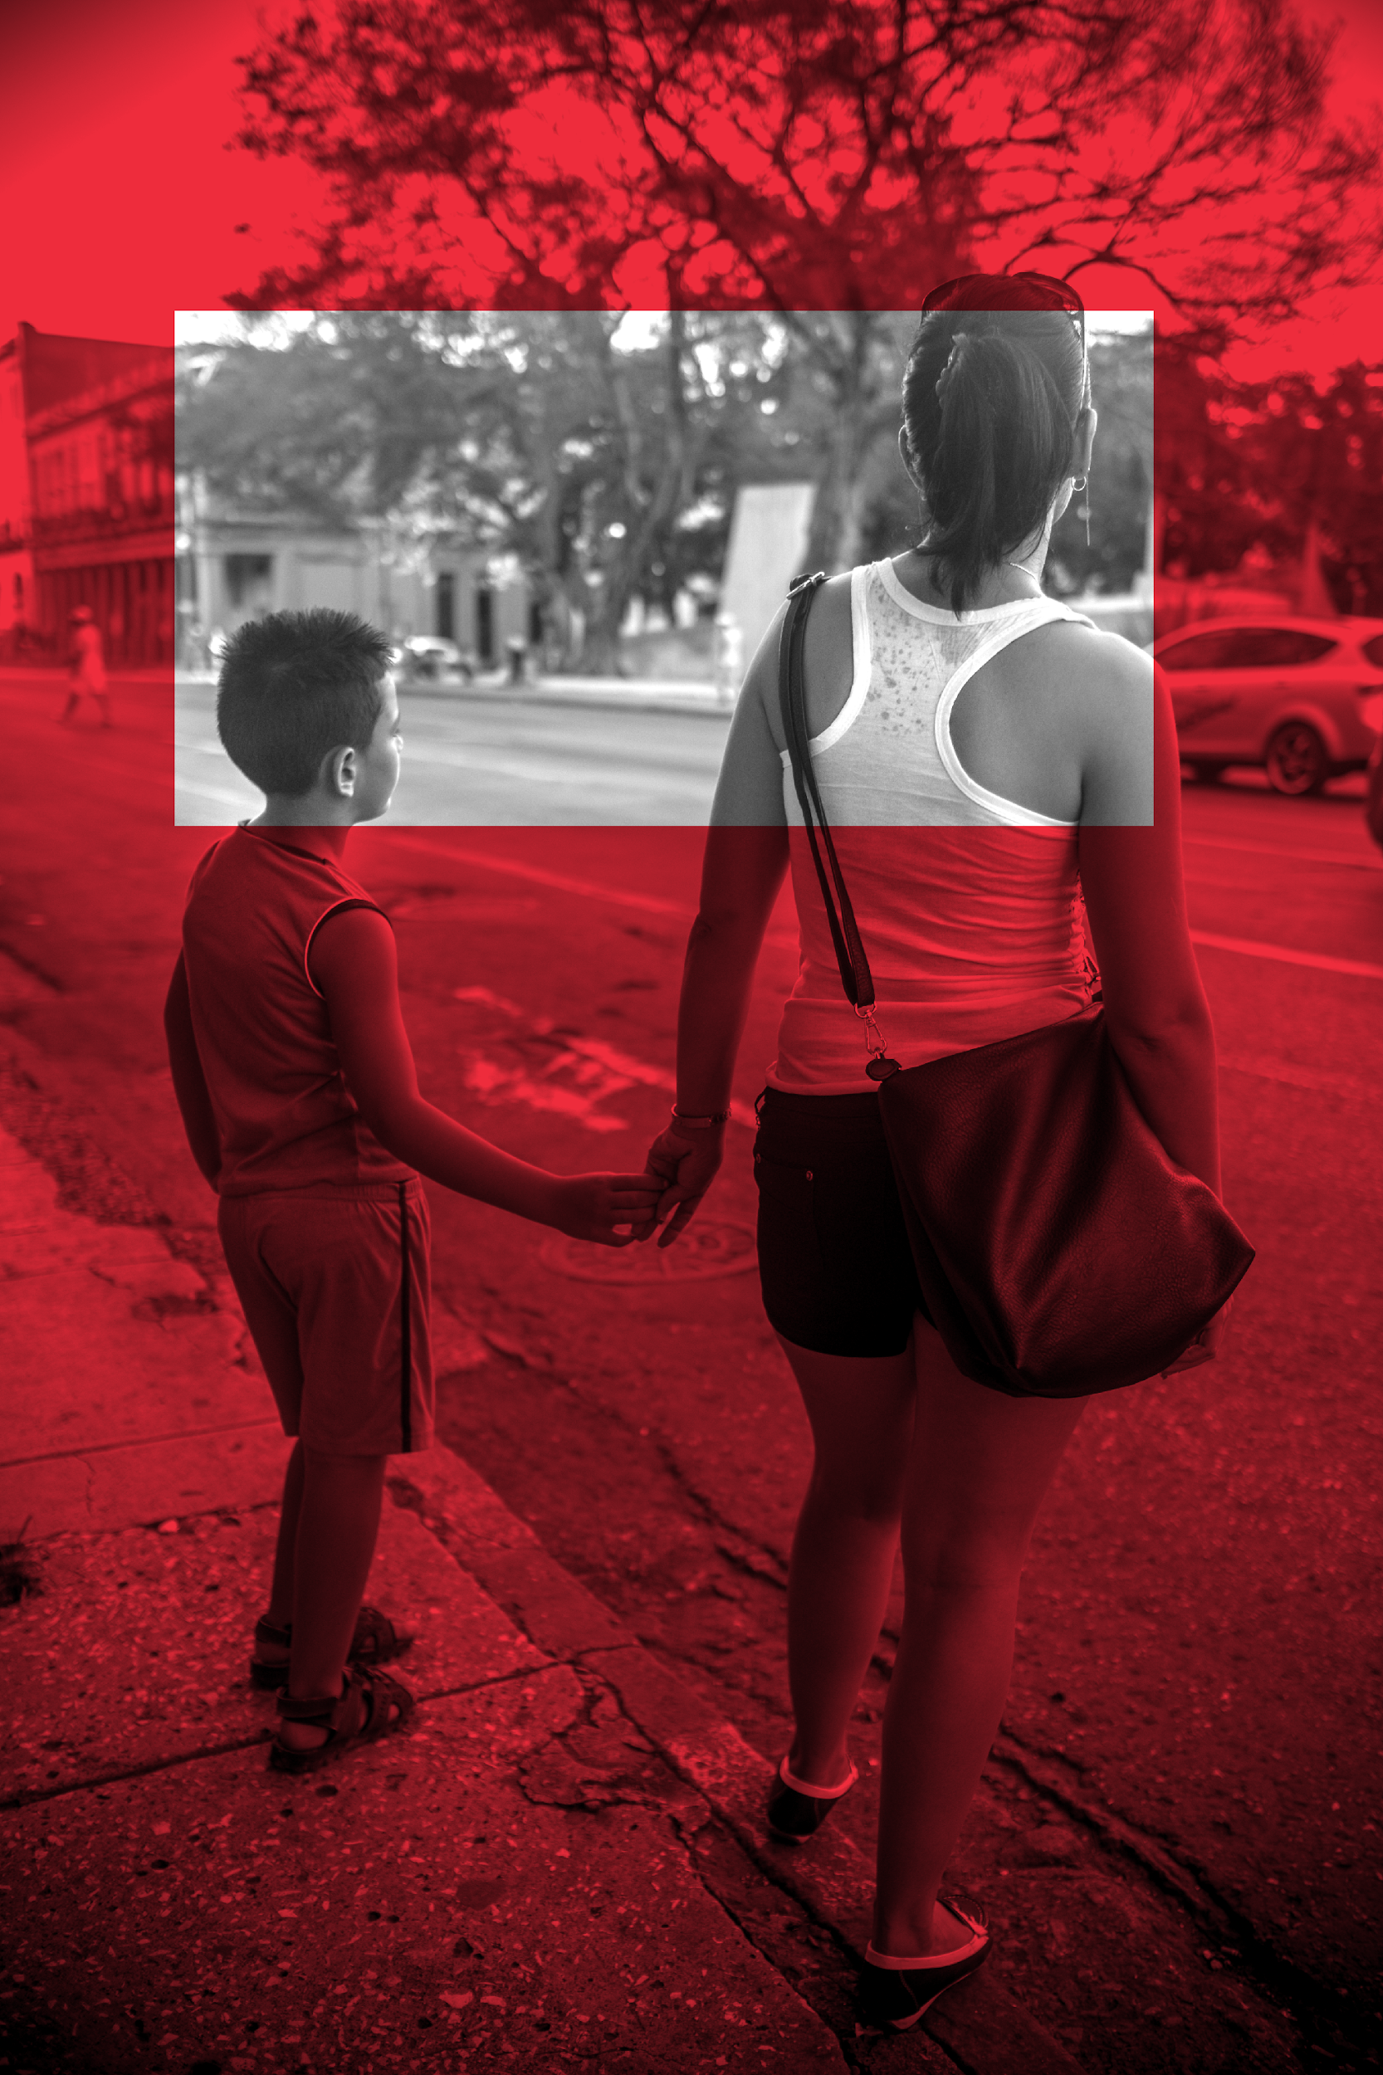
Reflections on Lived Experience
- How do you think your life experiences contributed to your work today?
- Who were your mentors or role models growing up?
- How do you define resilience? What have been the sources of resilience in your life?
- What advice would you give to a younger version of yourself?
- Is there anything about your life so far that surprises you?
- What message would you like to send to someone 50 years into the future?

Reflections on the Anti-Trafficking Field
- Describe the work that brought you here today. How did you get started?
- Was there a specific person or event that inspired you to start this work?
- What or who inspires you or keeps you motivated in the work you do?
- How does your work differ from most people’s perceptions of anti-trafficking work?
- What do you wish more people knew or understood about human trafficking and the fight to end it?
- Do you have any favorite stories from your journey?
- What is the greatest lesson you have learned from the work you’ve done?
- What are some of the greatest successes the anti-trafficking field has accomplished in the last twenty years?
- Are there gaps in the anti-trafficking response that need to be addressed?
- Tell me about a time at work when you felt proud to do what you do.
- What lasting change have you made in your community that you are most proud of?
- Is there an individual you have served who sticks out in your mind? Why?
- Do you have any advice for people wishing to make a difference?

