Instrument 7 –Non-Grantee Use of nFORM – Staff Data Entry
SIRF will implement an intervention in one site that is not a federal Responsible Fatherhood grantee. Therefore, we are requesting burden to cover collection of program operations data entered into the nFORM, a performance measures data collection system designed for Responsible Fatherhood grantees, by staff in a non-grantee site. These screens collect information on services provided to participants are part of the full nFORM information collection request package - Healthy Marriage and Responsible Fatherhood Performance Measures and Additional Data Collection (ICR Ref #202102-0970-014)..
Note: Screen shots include fictional names for illustrative purposes. OMB Control Number and Expiration Date appear on entry to nFORM system and individual surveys.

C1-C6. Client Level Data on Service Contacts, Referrals, Incentives, and Workshops
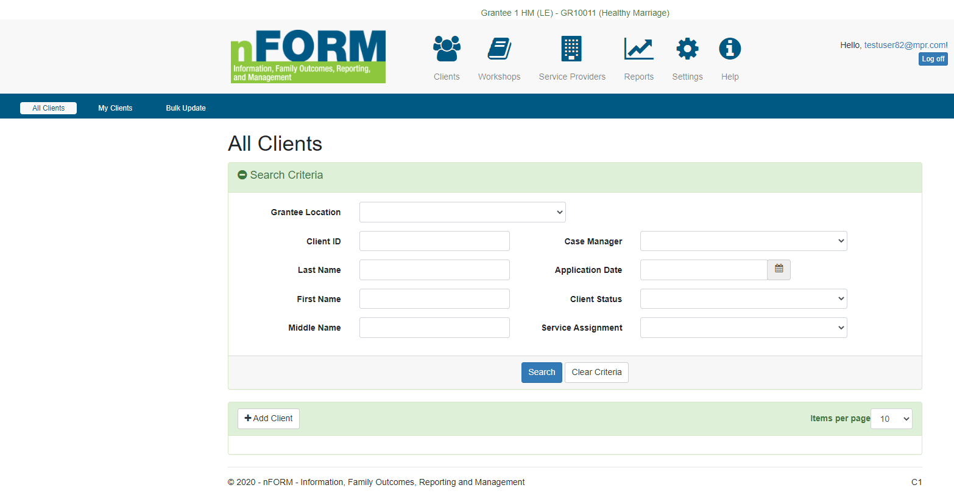

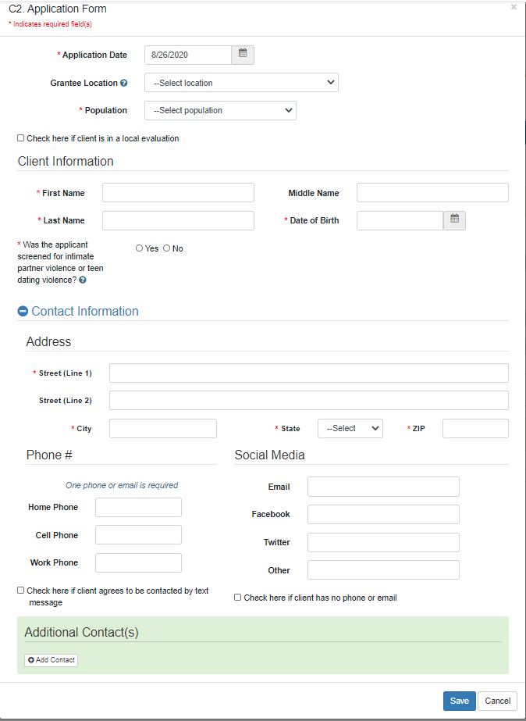
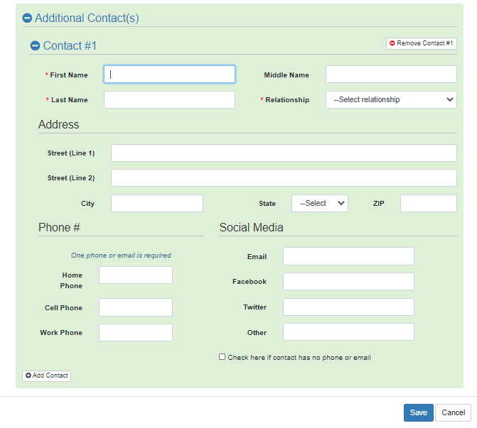

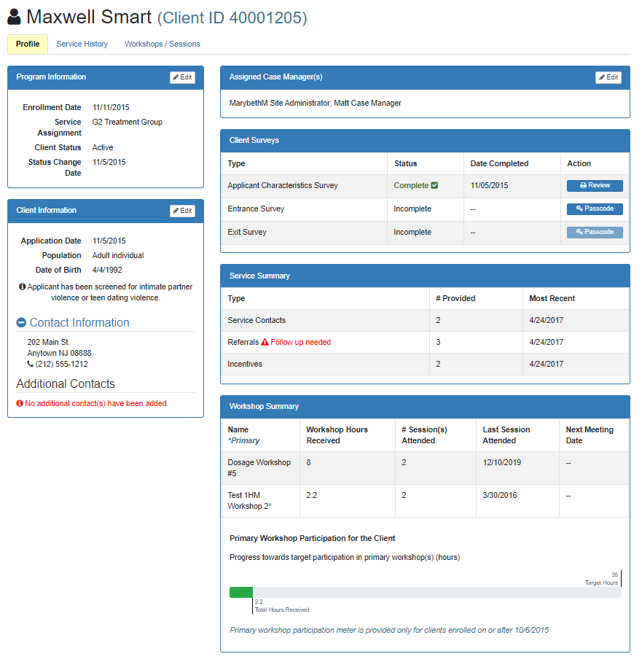

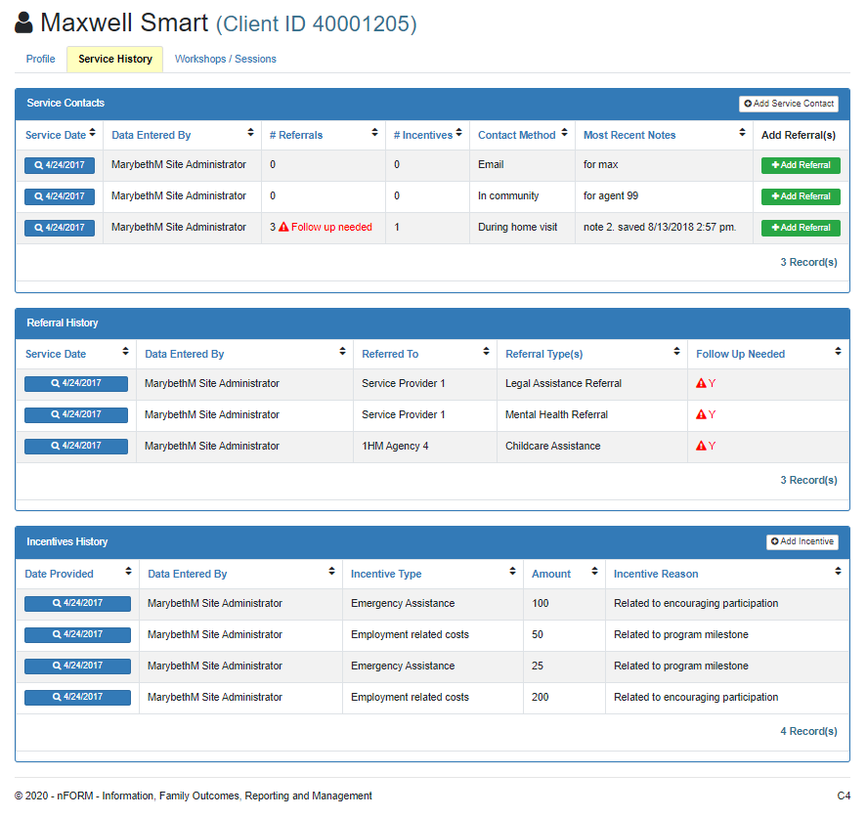

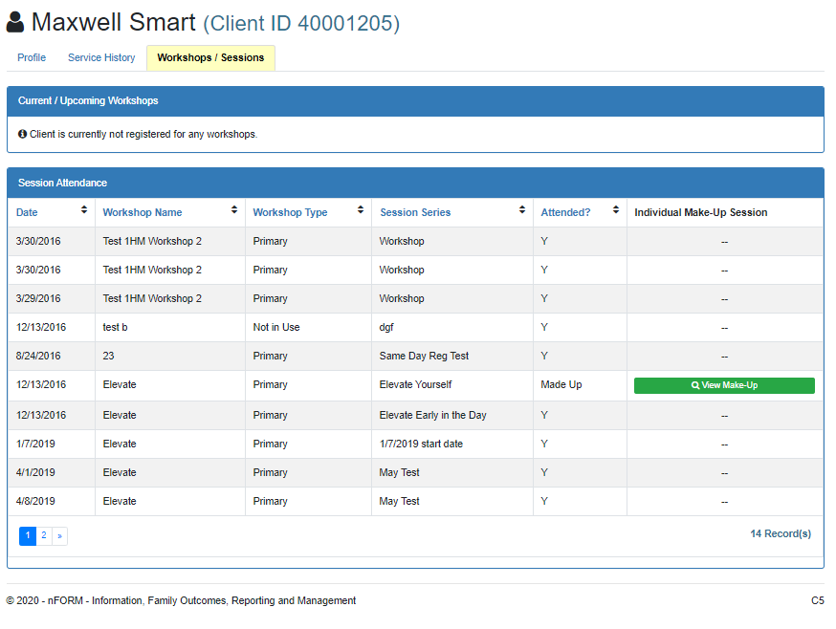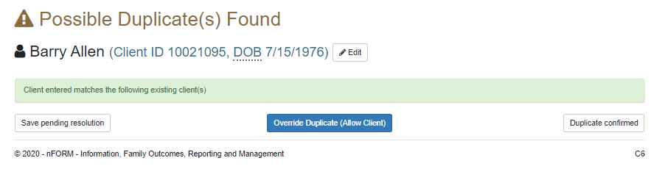

C7/C12/C13. Add/Edit Client Service Contacts, Referrals, and Incentives
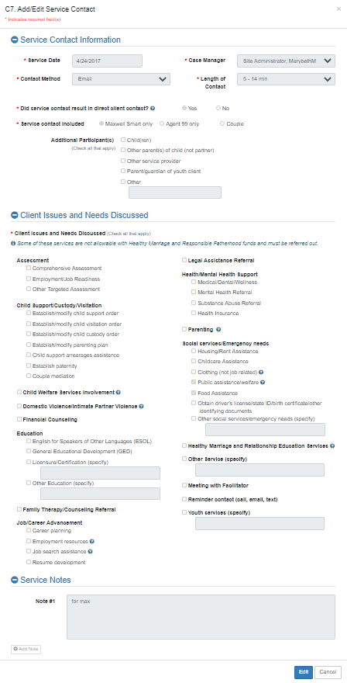
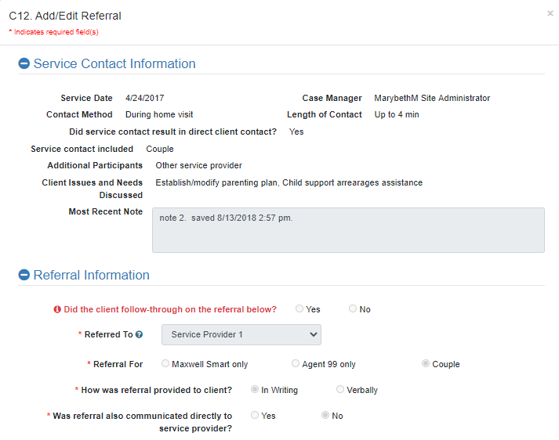
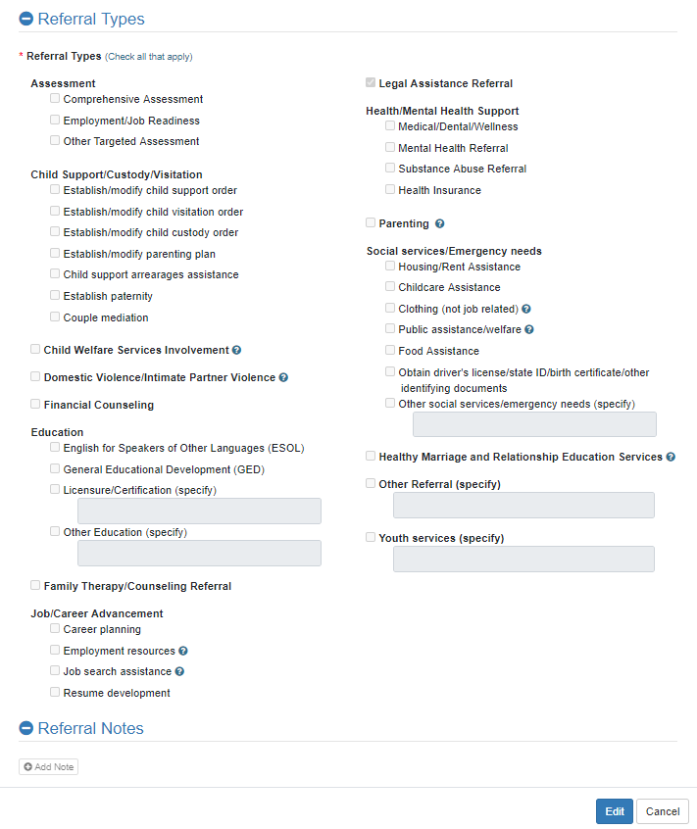

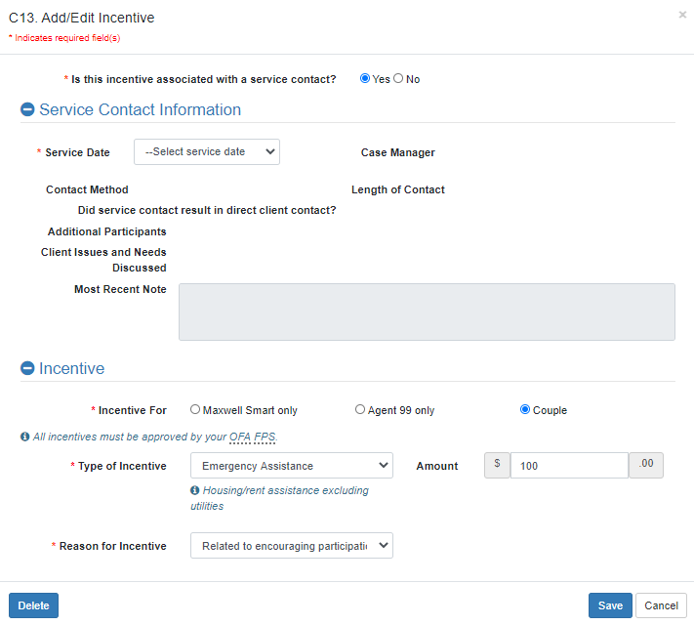

W1. Workshop List
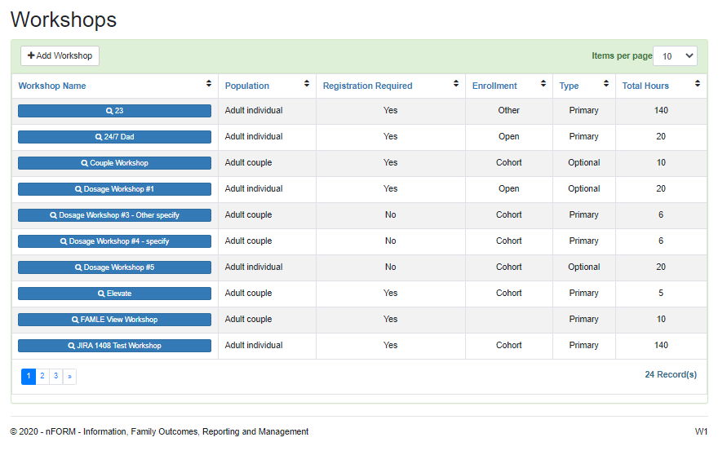

W2. Add/Edit Workshop
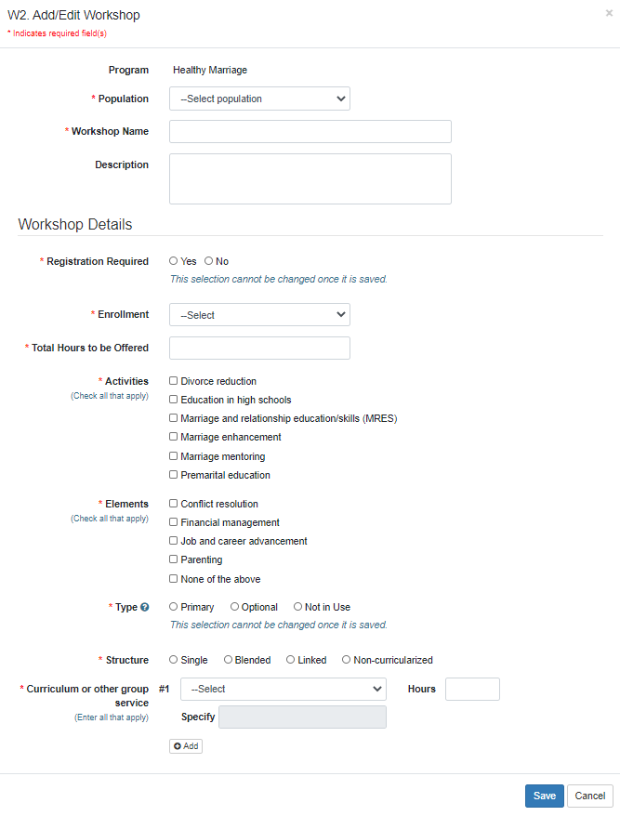
W5. Add/Edit Workshop Session Series
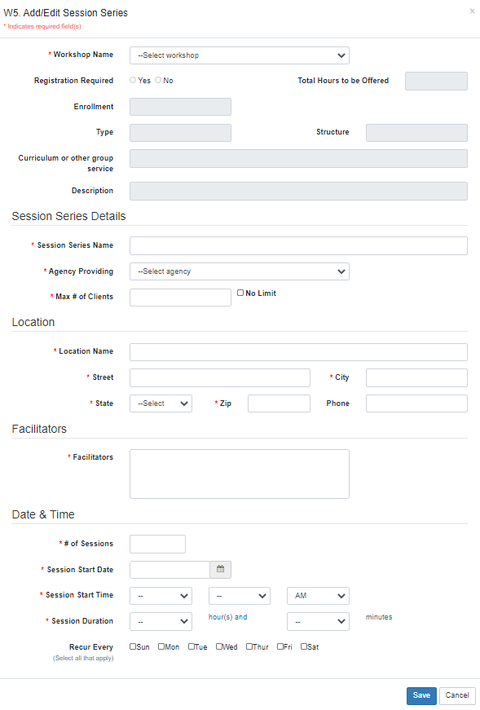
W4/W8. Manage Session Series and Client Registration
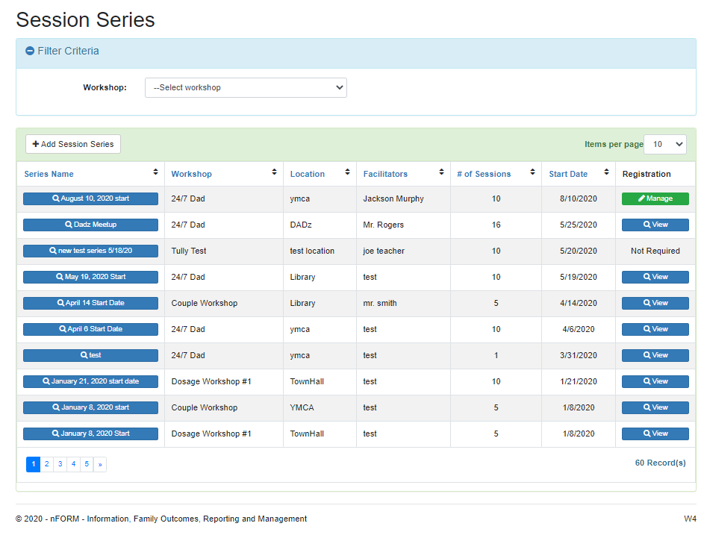

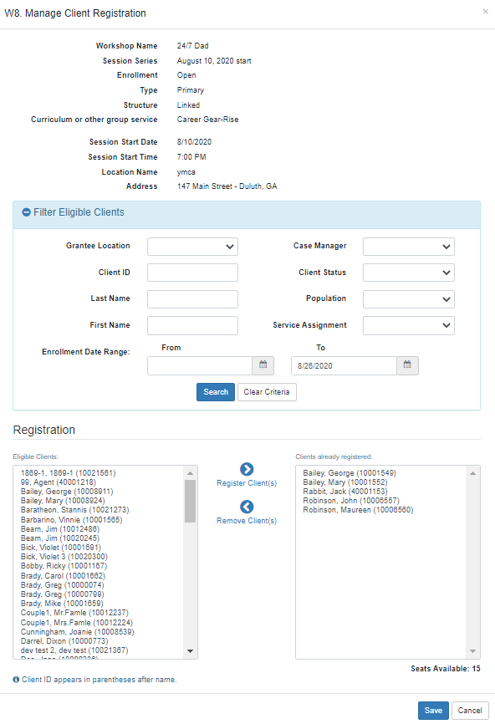
W7/W9/C11. Manage Session Occurrences and Attendance
