OCSE O&M and Continuous Improvements
Federally Assisted State Transmitted (FAST) Levy
Software Interface Specification
Version 3.1
December 30, 2020
Administration for Children and Families
Office of Child Support Enforcement
330 C Street, SW, 5th Floor
Washington, DC 20201

This document was prepared for the United States Department of Health and Human Services, Office of Child Support Enforcement under Contract Number HHSN316201200034W by Leidos Innovations Corporation. The work was authorized in compliance with the following specific prime task order:
Delivery Order Number: C-34668-O
Delivery Order Title: Federally Assisted State Transmitted (FAST) Levy
Document Date: December 30, 2020
Document Number: C2-C0211J.84.02

PAPERWORK REDUCTION ACT OF 1995 (Pub. L. 104-13) STATEMENT OF PUBLIC BURDEN: The purpose of this voluntary information collection is for child support enforcement purposes. Public reporting estimated burden for this collection of information is 1,716 hours per respondent to program using the “Response Withhold” record specifications and 1,610 hours per respondent using the “Request Withhold” record specifications, including the time for reviewing instructions, gathering and maintaining the data needed, and reviewing the collection of information. As provided by 42 U.S.C.653(m) any confidential information collected for this program is accessed only by authorized users. A federal agency may not conduct or sponsor an information collection without a valid OMB Control Number. No individual or entity is required to respond to, nor shall an individual or entity be subject to a penalty for failure to comply with a collection of information subject to the requirements of the Paperwork Reduction Act of 1995, without a current valid OMB Control Number. If you have any comments on this collection of information, please contact OCSEFedSystems@acf.hhs.gov

Table of Contents
1. Introduction 1-1
1.1 Purpose of Document 1-1
2. FAST Levy Files 2-1
2.1 Connectivity 2-1
2.2 Financial Institution Connectivity 2-2
2.3 State Connectivity 2-2
2.4 File Types 2-2
2.5 File Format 2-3
2.6 File Extensions 2-3
2.7 File Structure 2-3
2.8 File Names 2-4
2.9 File Processing 2-7
2.9.1 Daily Processing 2-7
2.9.2 Reject and Error Processing 2-7
2.9.3 Record Processing 2-8
2.9.3.1 Responses to a Request 2-8
2.9.3.2 Maintenance Requests 2-8
2.9.4 Financial Institution Initiated Responses 2-8
2.10 Email Notification 2-8
3. FAST Levy Input Transaction Layouts 3-1
3.1 Electronic Withhold Request 3-1
3.1.1 One-Step/Two-Step Process 3-1
3.1.2 Customer Level/Account Level Request 3-2
3.1.3 Electronic Withhold Response 3-2
A. Electronic Withholding Request Record (State to FI) A-1
B. Electronic Withholding Response Record (FI to State) B-1
C. Summary of Changes C-1
List of Figures and Charts
Figure 1-1: Process Diagram 1-2
Figure 2-1: Connectivity 2-1
Figure 2-2: State Request File Structure 2-3
Figure 2-3: FI Response File Structure 2-3
Figure 2-4: Email Notification (State) 2-9
Figure 2-5: Email Notification (FI) 2-9
Chart 2-1: FAST Levy Standard File Name for States 2-4
Chart 2-2: FAST Levy/X9 Standard File Name via NSC for FIs 2-5
Chart 2-3: FAST Levy Standard File Name via ODC for FIs 2-5
Chart 2-4: File Names and Naming Conventions Examples 2-6
Chart A-1: Electronic Withholding Request Header Record A-1
Chart A-2: Electronic Withholding Request Detail Record A-3
Chart A-3: Electronic Withholding Request Trailer Record A-15
Chart A-4: Electronic Withholding Request Notice Record A-17
Chart B-1: Electronic Withholding Response Header Record B-1
Chart B-2: Electronic Withholding Response Detail Record B-4
Chart B-3: Electronic Withholding Response Trailer Record B-13
Chart C-1: Summary of Changes C-1

Introduction
The Multistate Financial Institution Data Match (MSFIDM) Federally Assisted State Transmitted (FAST) Levy initiative provides a transport delivery mechanism that allows states and financial institutions (FIs) to exchange information about levy actions through a single, centralized location. The goal of centralizing the FAST Levy process is to reduce costs and increase efficiency and collections by using the federal Office of Child Support Enforcement’s (OCSE) Child Support Portal (Portal) to transmit levy actions electronically between FIs and states.
Currently, states send levy actions to multiple FIs and FIs receive levy actions from multiple states – all on paper. The centralized transport process allows states to send levy actions to a single location for distribution to multiple FIs. It also allows FIs to receive and respond to levy actions from multiple states from a single location, thus minimizing communication setups with individual FIs and states.
OCSE supports FAST Levy and X9 Legal Order Exchange record layouts from FIs, but only FAST Levy record layouts from states. FIs should refer to X9 Legal Order Exchange standards for further details.

Purpose of Document
This document describes the process required for states and FIs to exchange levy requests and responses via FAST Levy. The file naming convention, file type, connectivity, emails, and transaction record layouts of the FAST Levy system are included. The transaction record layouts include the following:
- Electronic Withholding Request Record
- Electronic Withholding Response Record
Figure 1-1 shows the FAST Levy process.

Figure 1-1: Process Diagram
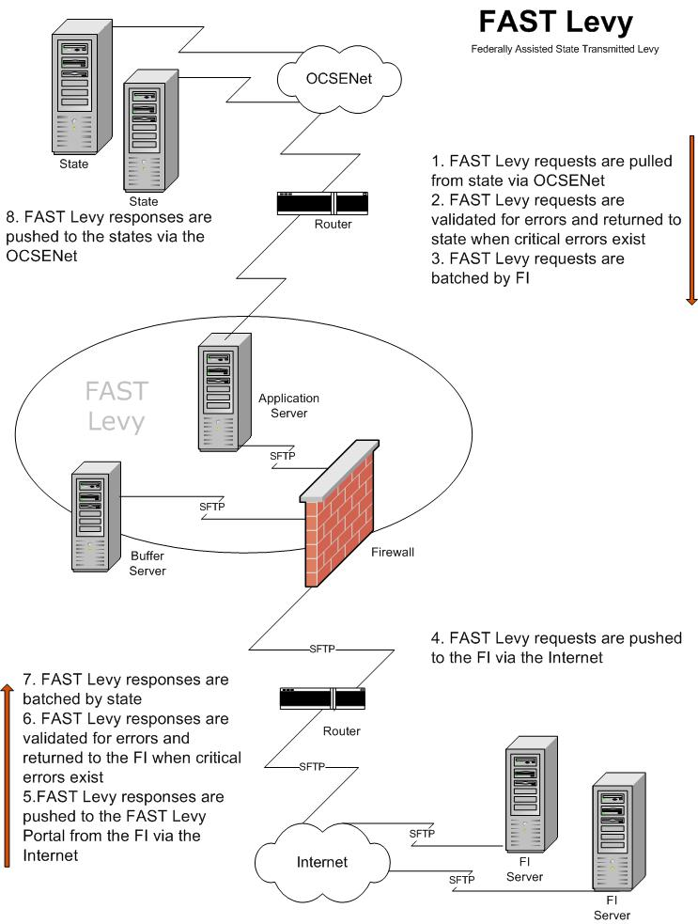

FAST Levy Files
The Portal houses the FAST Levy system. The system is capable of transmitting standard fixed-length files between states and FIs and variable length files between OCSE and FIs using X9 Legal Order Exchange standards.
The following sections describe the connectivity, file types, file extensions, and formats submitted to the FAST Levy system, as well as the email notification process.

Connectivity
Figure 2-1 shows the site architecture that supports the file transmission and connections needed for the exchange between states and FIs.
Figure 2-1: Connectivity
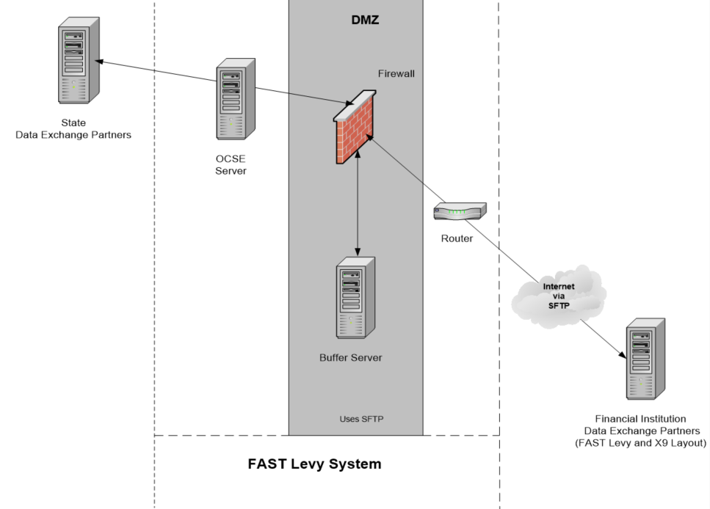

Financial Institution Connectivity
OCSE connects to FIs via the internet with Secure File Transfer Protocol (SFTP). The FI generally uses the existing transfer connection the MSFIDM process uses. If the FI does not have an MSFIDM connection, we will discuss other options with the FI to determine the best option for connecting to the FAST Levy application.

State Connectivity
States connect to the OCSE network through IPsec site-to-site VPNs. States exchange FAST Levy data through this connection to an SFTP or FTP server at the state. An IPsec site-to-site VPN must be established between OCSE and the state.
All FAST Levy files require a designated location on the state SFTP, FTP, or FTPS server for pick-up and delivery. This requires a user ID and password to log on to the state server. SSH key authentication can be used instead of a password if the state requests it. Read and write privileges on files need to be granted to the user ID used by OCSE to log on to the state server. If using SFTP, the state can use the standard TCP port (22) or another TCP port upon request.
The process for setting up SFTP without a password, using public-private keys includes the following steps:
- Create a public-private key pair for a user on the server by running the following command: ssh-keygen -t rsa
- The public-private key pair default location is: /home/xx/.ssh/id_rsa.pub and /home/xx/.ssh/id_rsa
- OCSE sends its SSH public key to FIs via email.
- The FI must append OCSE’s SSH public key to the /home/xx/.ssh/authorized_keys2 file on its SFTP server. The state must create this file if it is not there.

File Types
The various files transmitted via the FAST Levy system include:
State Request File (REQ) – A file generated by the state and sent to the FI that contains requests to levy an account.
FI Response File (RSP) – A file generated by the FI and returned to the state. The file contains records for each request and indicates whether the request is accepted or rejected and, if rejected, the reason for the rejection.
State Error File (ERQ) – Generated by the FAST Levy system in response to the receipt and validation of a state request. This contains the errors found in these files.
FI Error File (ERS) – Generated by the FAST Levy system in response to the receipt and validation of an FI response. This contains the errors found in these files.

File Format
The FAST Levy process accepts the text file format.

File Extensions
States and FIs must include file extensions for all files they are providing. A file extension is a three-digit code at the end of the file name to distinguish the type of file (for example, file.txt informs the user the file is a text file). Text (.txt) files are required for all file transmissions. The system returns files if they have no extension; it does not accept files with .zip or .exe extensions.

File Structure
Each file must contain a header record, detail records, and a trailer record. These record layouts are presented in section 3, “FAST Levy Input Transaction Layouts.”
The files must adhere to the file structure below. Figure 2-2 shows the file structure for a state request. Figure 2-3 shows the file structure for an FI response.
Figure 2-2: State Request File Structure
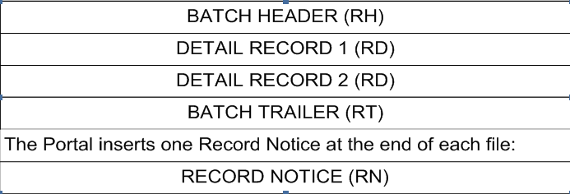
Figure 2-3: FI Response File Structure
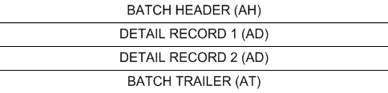

- Each file must contain at least one batch header and a batch trailer
- A file containing only detail records is invalid
- All files must include at least one detail record within a batch
- All records start with a two-digit document code that identifies the type of record
- Document code values display in the record layouts in the appendices
- The system batches state requests by FI
- The system batches FI responses by state

File Names
States and FIs supply file names for files via the FAST Levy Profile form. States and FIs can either use a predefined naming standard unique to their organization (must be a unique constant name and cannot be variable) or the FAST Levy system’s “standard file name.” We will agree on file names during connectivity setup. File names are not case sensitive.
Chart 2-1 describes the values of each section of the FAST Levy standard file name.
Chart 2-1: FAST Levy Standard File Name for States
Field Name | Value
Identifier | FIPS + 0000000  FXXX + 00000  (If a state, the nine digits are a two-digit FIPS code plus seven zeroes; if an FI, it is the four-digit Transmitter Code and five zeros)
Separator | Period (.)
File Type | State:  LER – Error Record to state, Invalid levy  LRS – Response file to states  LVY– Request file from state  LRJ – Error file to state, Invalid sequence  L – Error file to state, Rejected
Separator | Period (.)
Date - Timestamp | CCYYMMDDHHMMSSS
Separator | Period (.)
Sequence Number | 0000 – Used by the FAST Levy system to incrementally account for files being created.
Separator | Period (.)
Extension Type | txt – Text
Chart 2-2 describes the values of each section of the FAST Levy/X9 standard file name via the National Support Center (NSC).
Chart 2-2: FAST Levy/X9 Standard File Name via NSC for FIs
Field Name | Value
Identifier | FXXX  Four-digit Transmitter Code
Separator | Period (.)
File Type | Financial Institution  FSTLVYCO – Response file from FI  FSTLVYIO – Error file to FI  FSTLVYO – Levy file to FI  FSTLYRO – Error file to FI, Rejected  FSTLYBO – Error file to FI, Invalid sequence
Separator | Period (.)
System | FPLS
Separator | Period (.)
Run Date | RYYMMDD
Separator | Period (.)
Timestamp | THHMMSS
Separator | Period (.)
Extension Type | txt – Text
Chart 2-3 describes the values of each section of the FAST Levy standard file name via the OCSE Data Center (ODC).
Chart 2-3: FAST Levy Standard File Name via ODC for FIs
Field Name | Value
Identifier | FIPS + 0000000  FXXX + 00000  (If a state, the nine digits are a two-digit FIPS code plus seven zeroes; if an FI, it is the four-digit Transmitter Code and five zeros)
Separator | Period (.)
File Type | Financial Institution  RER – Error record to FI, Failed required field type  RES – Response file from FI  VLY – Levy request file to FIs  RRJ – Error file to FI , Invalid sequence  R – Error file to FI, Rejected
Separator | Period (.)
Date - Timestamp | CCYYMMDDHHMMSSS
Separator | Period (.)
Sequence Number | 0000 – Used by the FAST Levy system to incrementally account for files being created. Not used for a .zip file.
Separator | Period (.)
Extension Type | txt – Text
Chart 2-4 shows examples of different files and naming conventions.
Chart 2-4: File Names and Naming Conventions Examples
Sample State Detail File Name | Description
180000000.LER.201805230225081.txt | Error record to the state – Failed required field
180000000.LRS.201805230225081.txt | Response file to state
180000000.LVY.201805230225081.txt | Request file from state
180000000.LRJ.201805230225081.txt | Error file to the state – Invalid sequence
180000000.L.201805230225081.txt | Error file to the state – Invalid length, invalid header, detail, or trailer
FAST Levy/X9 Sample FI Detail File Name (via NSC) | Description
F123.FSTLVYCO. 201805230225081.txt | Response file from FI
F123.FSTLVYIO. 201805230225081.0001.txt | Error file to FI, Failed – Requires field types
F123.FSTLVYO. 201805230225081.0001.txt | Levy file to FI
F123.FSTLYRO. 201805230225081.txt | Error file to FI – Invalid length, invalid header, detail, or trailer
F123.FSTLYBO.200708060115087.txt | Error file to FI – Invalid sequence
Sample FI Detail File Name (via ODC) | Description
123456789.RER.201805230225081.txt | Error record to the FI – Failed – Requires field types
F123.RES. 201805230225081.txt | Response file from the FI
123456789.VLY.201805230225081.0001.txt | Levy file to FI
123456789.RRJ.201805230225081.txt | Error file to FI – Invalid length, invalid header, detail, and trailer
123456789.R.201805230225081.0001.txt | Error file to FI – Invalid sequence

File Processing

Daily Processing
FI files must be received by 7:30 a.m. to be included in that day’s processing. The FAST Levy processing starts with picking up outbound files from states at 7:50 a.m. FAST Levy begins to push inbound files to states at 9:00 a.m. and to FIs at 9:30 a.m. The system sends email notifications for that day’s processing starting at 9:30 a.m.
Note: All times are Eastern time.

Reject and Error Processing
The FAST Levy process performs validation on all inbound files to comply with the FAST Levy specifications. There is strict validation of structure and fields for specifications compliance. The FAST Levy process will reject or return files for error at three levels: file, batch, and record.
Full file rejection can occur if the following are incorrect:
- File extension
- Record length
- File sequencing
- Record identifier
The file will be returned in its entirety.
Batch rejection will occur for the following reasons:
- The total number of records submitted in the batch and the batch record count do not agree
- FEIN or FIPS code entered may not be participating in FAST Levy
Individual records can be returned for error in the following instances:
- Required fields are missing
- Conditionally required fields do not comply with the validation rules
- Data is invalid due to noncompliance with data-type rules or not following specified patterns

Record Processing

Responses to a Request
Normally the state receives one Response record for each Request record sent. In some cases, two responses may be returned for delayed responses, such as a response of manual review followed by a second response indicating the action after the manual review.

Maintenance Requests
A single file can contain multiple maintenance requests for the same SSN. For example, a file could contain a maintenance request record to extend the number of freeze days for a request previously sent, followed by a maintenance request record to amend the levy amount for the same individual.

Financial Institution Initiated Responses
There are two FI-initiated response records that could be follow-up responses to an original request-response combination. These responses are an FI freeze or an amended amount for a freeze sent by the FI based on a condition or information that it is aware of. An example may be one or more customer accounts were frozen in error and the FI sends a response to the state that the freezes were released.
In addition to the above scenarios for FIs using X9 Legal Orders Exchange standards, states will receive amended responses in a separate batch (refer to Chart B-1, Chart B-2, and Chart B-3 for record layout).

Email Notification
The FAST Levy process sends an email notification to the state or FI when processing is successful or when there are errors in processing or transferring a file. Figure 2-4 is an example of an email sent to a state. Figure 2-5 is an example of an email sent to an FI.
Figure 2-4: Email Notification (State)
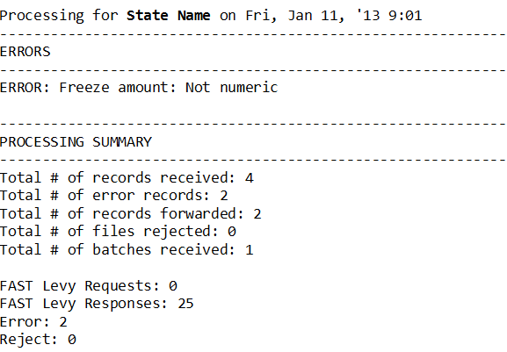

Figure 2-5: Email Notification (FI)
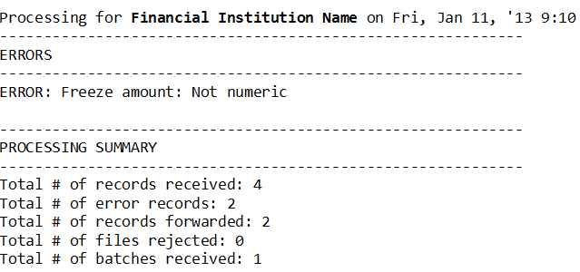

FAST Levy Input Transaction Layouts
The appendix contains the following transaction layouts accepted by the FAST Levy system:
- Electronic Withholding Request Record
- Electronic Withholding Response Record
Each record layout in the appendices includes:
- Field name
- Field length
- Location
- Field types (alphabetic, numeric, or alphanumeric)
- Field comments
The comment section in the record layouts indicates whether the field is required for the transaction or describes the conditions for Conditionally Required fields. Comments also provide an explanation about the field and its relationship to other fields or records. Optional fields must be filled with spaces if not used or data is not available.
The file structure for the electronic Withhold Request and Response are the same. Each file can consist of one or more batches. Each batch contains at least one header record, followed by one or more detail records, and then a trailer record to complete the batch.

Electronic Withhold Request
The Electronic Withhold Request is batched by the Federal Employer Identification Number (FEIN). If a request from a state is being made to multiple FIs, there will be a batch for each FEIN included in the file being sent to the FAST Levy Portal. A header will exist for each FI with its FEIN and the state’s Federal Information Processing Standards (FIPS) code in that header.
States may send either one-step or two-step levy requests and direct the FIs to attach assets at the customer level or at an account level (customer’s account and type of account are required for freezing and seizing assets).
Following the Withhold Request batches is the Notice of Right to Garnish Federal Benefits record. Each file sent will include one of these records at the end of the file.

One-Step/Two-Step Process
States can elect to execute levying in a one- or two-step process. A one-step process enables the state to issue a request to freeze the customer accounts and remit with one request. The FI will freeze the accounts and at the end of the freeze hold period automatically remit the funds. Hold periods are specific to each state.
In a two-step process, the state will issue a request to freeze the customer account and after the state hold period, it will issue a second request to remit the funds. The withdrawal amount in the remit request should be the same as that in the freeze request unless the FI responded that the withdrawal amount was less than the freeze requested. If this is the case, the state should use the amount the FI noted in its response. To amend the amount between freeze and remit requests, the state should submit a maintenance levy request with a new amount.

Customer Level/Account Level Request
Customer level requests instruct the FI to freeze and seize accounts belonging to the obligor. This allows the FI to determine which accounts to freeze and seize when the obligor has more than one account. Based on internal polices, the FI will determine which accounts to freeze and seize based on a FAST Levy request. Account level requests instruct the FI to freeze and seize specific accounts and amounts in those accounts, consistent with state law.
States can send levy freeze requests for either a customer (all accounts) or a specific account. While states can use both freeze request types, it’s doubtful there would be a levy request at a customer level and one at an account level for the same SSN in the same request file.

Electronic Withhold Response
The Electronic Withhold Response is batched from an FI by state. If an FI is responding to several state requests, there will be one header with the FIs FEIN for each state in the file. The file will also contain the state’s FIPS code for each batch in the file.

Electronic Withholding Request Record (State to FI)
Chart A-1: Electronic Withholding Request Header Record
No. | Field Name | Length | Location | A/N | Comments
1 | Record Identifier | 2 | 1-2 | A | Required  The characters ‘RH,’ which identify the record as a Request Header.
2 | FEIN | 9 | 3-11 | N | Required  The FI’s FEIN.
3 | Filler | 1 | 12-12 | A/N | For future versions. For this version, fill with spaces.
4 | FIPS Code | 2 | 13-14 | N | Required  The two-digit numeric FIPS code of the requesting state.
5 | Local County Code | 3 | 15-17 | A/N | Optional  A three-digit local county code or filled with spaces.
6 | Processing Date | 8 | 18-25 | N | Required  The run date for the batch. Must be in CCYYMMDD format.
7 | Batch ID | 6 | 26-31 | A/N | Required  A unique identifier for each batch sent to the Portal daily. Use the unique Batch ID only once per day.
8 | Batch Type Code | 2 | 32-33 | A | Required  The type of request for the batch. Valid values are:  AG – Group account request – All requests contained in the batch will have the same SSN for different account numbers. FIs will handle a group account request as a single request and one fee will apply.  AS – Single account request – All requests contained in the batch are single account requests and will be handled by the FI at the account level. Each request will be for one SSN and one account number.  CL – Customer level request – All requests contained in the batch will be handled by the FI at a customer level and not by specific account for the customer.
9 | Portal Error Message Text | 30 | 34-63 | A/N | Portal Use  The field number that was in error, along with the error code, when the Portal performed its validation. Header records with errors will return the entire batch. The returned batch will contain all requests originally sent. Filled with spaces by the requestor. Up to six errors are returned.  The format is NN:CD, NN:CD, NN:CD, NN:CD, NN:CD, NN:CD where ‘NN’ is equal to the field number and ‘CD’ is equal to the error code.  Valid CD values are:  IN – Invalid data  RQ – Missing required data  NU – Not numeric
10 | Filler | 537 | 64-600 | A/N | For future versions. For this version, fill with spaces.

Chart A-2: Electronic Withholding Request Detail Record
No. | Field Name | Length | Location | A/N | Comments
1 | Record Identifier | 2 | 1-2 | A | Required  The characters ‘RD,’ which identify the record as a Request Detail.
2 | Action Code | 2 | 3-4 | N | Required  The code of the action to be taken. Valid values are:  Original Requests:  01 – Execute lien and levy, used for one-step process  03 – Execute lien, used for two-step process  Maintenance/Subsequent Requests:  02 – Release withhold  04 – Amend levy amount  05 – Execute levy, used for two-step process  06 – Extend freeze number of days
3 | SSN | 9 | 5-13 | N | Required  The Social Security number (SSN) of the obligor.
4 | Last Name | 20 | 14-33 | A/N | Required  The obligor’s last name.  Valid special characters are:  - Hyphens (-)  - Apostrophes (’)  - Periods (.)  - Space  The first character must not be a space.
5 | First Name | 15 | 34-48 | A/N | Required  The obligor’s first name.  Valid special characters are:  - Hyphens (-)  - Apostrophes (’)  - Periods (.)  - Space  The first character must not be a space.
6 | Middle Name | 15 | 49-63 | A/N | Optional  The obligor’s middle name.  Valid special characters are:  - Hyphens (-)  - Apostrophes (’)  - Periods (.)  The first character must not be a space if middle name is populated. Fill with spaces if no middle name is available.
7 | Name Suffix | 4 | 64-67 | A/N | Optional  The obligor’s suffix name. Example: Jr., Sr., III.  Valid special characters are:  - Hyphens (-)  - Apostrophes (‘)  - Periods (.)  The first character must not be a space. Fill with spaces if no suffix name is available.
8 | DOB | 8 | 68-75 | A/N | Optional  The obligor’s date of birth (DOB), in CCYYMMDD format. Fill with spaces if no DOB is available.
9 | Account Type Code | 2 | 76-77 | A/N | Conditionally Required  The type of account for the withhold request. Required when the Batch Type Code – ‘AS’ or ‘AG.’  Valid values are:  01 – Savings account  04 – Checking/demand deposit account  05 – Term deposit certificate  06 – Collateral account  11 – Money market account  12 – IRA/KEOGH  14 – ERISA Plan account  16 – Cash balances  17 – Compound account  18 – Other  Fill with spaces if Batch Type Code is ‘CL.’
10 | Account Number | 20 | 78-97 | A/N | Conditionally Required  The Account Number the state is requesting funds to be withheld from, if the Batch Type Code is ‘AS’ or ‘AG.’  Fill with spaces if the Batch Type Code is ‘CL.’  Left justified padded with spaces to the right; hyphens and embedded spaces are allowed. This should reflect the manner returned on the MSFIDM quarterly match.
11 | Withhold Amount | 10 | 98-107 | N | Conditionally Required  The maximum dollar amount and cents to withhold. Action Codes ‘01’ execute lien and levy (one-step), ‘03’ execute lien (two-step), and ‘04’ amend levy amount must be greater than all zeroes.  Action Codes ‘02’ release withhold, ‘05’ execute levy (two-step), and ‘06’ extend freeze number of days can be equal to or greater than all zeroes. Two-digit decimal is assumed.  The field must be formatted as follows:  - Numeric  - Decimal Assumed  - Unsigned  - Right Justify  - Zero Fill to Left  - Zero Fill if N/A
12 | Threshold Amount | 6 | 108-113 | N | Required  The minimum dollar amount and cents that must be in the accounts after the fees and exemptions are deducted. Two-digit decimal is assumed. Fill with zeroes when there is no threshold amount.  For example, the account balance is $500. The FI fee is $50. The amount in the account after fees and exemptions is $450. The state threshold amount is $500. This would not meet the threshold amount the state submitted for the request.  The field must be formatted as follows:  - Numeric  - Decimal Assumed  - Unsigned  - Right Justify  - Zero Fill to Left  - Zero Fill if N/A
13 | Request Date | 8 | 114-121 | N | Required  The date the withhold was requested, in CCYYMMDD format. Maintenance/Subsequent requests with Action Codes equal to ‘02’ release withhold, ‘04’ amend levy amount, ‘05’ execute levy, used for the two-step process, and ‘06’ extend freeze number of days, must contain the request date from the original withhold request.
14 | Passback Text | 40 | 122-161 | A/N | Optional  Allows the state to capture information pertaining to the request.  Returned by the FI in the response.  Fill with spaces if not used.  This field must not contain PII.
15 | Freeze Number Days | 4 | 162-165 | N | Required  The additional number of days the accounts must be frozen beyond the submitting state’s standard timeframe. If no additional days are needed, fill with zeroes. Value cannot be zeroes if Action Code is equal to ’06,’ extend freeze number of days.  Note: FI will follow the rules for the state to determine business versus calendar days.  The field must be formatted as follows:  - Numeric  - Unsigned  - Right Justify  - Zero Fill to Left  - Zero Fill if N/A
16 | Exemption Amount | 10 | 166-175 | N | Required  The dollar amount and cents to be excluded from the levy action. Any amount over the exemption amount is available for freeze and seize.  Two digit decimal is assumed.  Fill with zeroes if no exemption amount is required.  The field must be formatted as follows:  - Numeric  - Decimal Assumed  - Unsigned  - Right Justify  - Zero Fill to Left  - Zero Fill if N/A
17 | Legal Attachment Code | 2 | 176-177 | A/N | Required  The type of legal document for the withhold request.  Default Value is ‘CS’ for Child Support Order.
18 | Legal Attachment Action Code | 2 | 178-179 | A/N | Optional  The type of attachment for the withhold request. Fill with spaces if not needed. Spaces in this field will default to ‘PT.’  Valid values are:  OL – Continuous or ongoing levy  PT – Point in time levy
19 | Contact Name | 50 | 180-229 | A/N | Required  The first and last name of the person or a point of contact (POC) who the FI will refer the customer to for additional information.
20 | Contact Phone Number | 10 | 230-239 | N | Required  The phone number of the person or a POC for which the FI will refer the customer to for additional information.
21 | Contact Phone Extension Text | 5 | 240-244 | A/N | Optional  A phone extension for the person or a POC the FI should contact for additional information.  Can be 1-5 positions.  Fill with spaces if no extension is available.
22 | Contact E-mail Text | 50 | 245-294 | A/N | Optional  An email address for the person or a POC the FI should contact for additional information.  Fill with spaces if no email is available.  When sending to X9 FIs, OCSE will use the Contact Email text the state reported on the FAST Levy Profile form.
23 | Agency Name | 50 | 295-344 | A/N | Required  The name of the child support agency.
24 | Payment Type Code | 1 | 345-345 | A | Required  The method the state would prefer to receive the payment from the FI if the FI has the capability to send per the state’s request.  Valid values are:  E – Electronic request  M – Check request
25 | Address Line 1 Text | 50 | 346-395 | A/N | Required  The street address of the child support agency where the FI should mail the payment.
26 | Address Line 2 Text | 50 | 396-445 | A/N | Optional  The street address of the child support agency where the FI should mail the payment.
27 | Address Line 3 Text | 50 | 446-495 | A/N | Required  The city, state, and ZIP code of the child support agency where the FI should mail the payment.
28 | Request Timestamp | 12 | 496-507 | A/N | Required  Must contain spaces.  The FAST Levy Portal will populate this field. The timestamp format is HH:MM:SS:SSS.
29 | Portal Error Message Text | 30 | 508-537 | A/N | Portal Use  The field number that was in error, along with the error code, when the Portal performed its validation. Request records with errors will be returned in their original batch if a request did not pass validation. The returned batch will only contain requests that did not pass validation. All requests that pass validation will be sent to the FI. Filled with spaces by the requestor. Up to six errors are returned.  The format is NN:CD, NN:CD, NN:CD, NN:CD, NN:CD, NN:CD where ‘NN’ is equal to the field number and ‘CD’ is equal to the error code.  Valid CD values are:  IN – Invalid data  RQ – Missing required data  NU – Not numeric
30 | Agency Identifier | 20 | 538-557 | A/N | Required  A unique identifier assigned by the agency. Maintenance/subsequent requests with Action Codes equal to ‘02’ release withhold, ‘04’ amend levy amount, ‘05’ execute levy, used for the two-step process, and ‘06’ extend freeze number of days, must contain the agency identifier from the original withhold request. All information recorded in this field will appear on the ACH response.  This field must not contain PII.
31 | OCSE Processing Date | 8 | 558-565 | N | Required  Must contain spaces.  The FAST Levy Portal will populate this field. This field must contain the date OCSE received the request in CCYYMMDD format.
32 | Filler | 43 | 566-600 | A/N | For future versions. For this version, fill field with spaces.

Chart A-3: Electronic Withholding Request Trailer Record
No. | Field Name | Length | Location | A/N | Comments
1 | Record Identifier | 2 | 1-2 | A | Required  The characters ‘RT,’ which identify the record as a Request Trailer.
2 | FEIN | 9 | 3-11 | N | Required  The FI’s FEIN.
3 | Filler | 1 | 12-12 | A/N | For future versions. For this version, fill with spaces.
4 | FIPS Code | 2 | 13-14 | N | Required  The two-digit numeric FIPS code of the requesting state.
5 | Local County Code | 3 | 15-17 | A/N | Optional  A three-digit local county code or is filled with spaces.
6 | Record Count | 6 | 18-23 | N | Required  The total number of records submitted in this batch.  The field must be formatted as follows:  - Numeric  - Unsigned  - Right Justify  - Zero Fill to Left  - Zero Fill if N/A
7 | Portal Error Message Text | 30 | 24-53 | A/N | Portal Use  The field number that was in error, along with the error code, when the Portal performed its validation. Trailer records with errors will return the entire batch. The returned batch will contain all requests originally sent. Filled with spaces by the requestor. Up to six errors are returned.  The format is NN:CD, NN:CD, NN:CD, NN:CD, NN:CD, NN:CD where ‘NN’ is equal to the field number and ‘CD’ is equal to the error code.  Valid CD values are:  IN – Invalid data  RQ – Missing required data  NU – Not numeric
8 | Filler | 547 | 54-600 | A/N | For future versions. For this version, fill with spaces.

Chart A-4: Electronic Withholding Request Notice Record
No. | Field Name | Length | Location | A/N | Comments
1 | Record Identifier | 2 | 1-2 | A | Required  The characters ‘RN,’ which identify the record as a Request Notice.
2 | Notice of Right to Garnish Federal Benefits Text | 598 | 3-600 | A/N | Required by Portal  The Notice of Right to Garnish Federal Benefits text. The Notice of Right to Garnish Federal Benefits is created by the FAST Levy Portal, not by the state. Each file will have one Notice Record at the end of the file.  Proposed Notice of Right to Garnish Federal Benefits  State child support agencies (CSA) issued these orders pursuant to authority to attach or seize obligors’ assets in financial institutions (FI) [42 U.S.C. Section 666]. The garnishee is notified that procedures established by 31 CFR 212 to identify and protect federal benefits deposited to FI accounts do not apply to these orders. The garnishee must comply with the terms of these orders including instructions for withholding and retaining funds in any account(s) covered by these orders pending further state CSA notice.

Electronic Withholding Response Record (FI to State)
Chart B-1: Electronic Withholding Response Header Record
No. | Field Name | Length | Location | A/N | Comments
1 | Record Identifier | 2 | 1-2 | A | Required  The characters ‘AH,’ which identify the record as a Response Header.
2 | FEIN | 9 | 3-11 | N | Required  The FI’s FEIN.
3 | Filler | 1 | 12-12 | A/N | For future versions. For this version, fill with spaces.
4 | FIPS Code | 2 | 13-14 | N | Required  The two-digit numeric FIPS code of the requesting state.
5 | Local County Code | 3 | 15-17 | A/N | Optional  A three-digit local county code or filled with spaces.  This field will be filled with spaces for amended responses from FIs using X9.
6 | Processing Date | 8 | 18-25 | N | Required  The run date for the batch in CCYYMMDD format.
7 | Batch ID | 6 | 26-31 | A/N | Required  The state’s unique identifier submitted for this batch of records. Return the state’s Batch ID sent in the Withhold Request file.  This field will have CSP_AM for amended responses from FIs using X9.
8 | Batch Type Code | 2 | 32-33 | A | Required  The type of request submitted for this batch of records. Return the state’s Batch Type Code sent in the Withhold Request file.  This field will be filled with spaces for amended responses from FIs using X9.
9 | Contact Name | 50 | 34-83 | A/N | Optional  The first and last name of the person the state should contact for additional information. Fill with spaces if no Contact Name is available.  This field will be filled with spaces for amended responses from FIs using X9.
10 | Contact Phone Number | 10 | 84-93 | N | Required  The phone number for the person the state should contact for additional information.
11 | Contact Phone Extension Number | 5 | 94-98 | A/N | Optional  A phone extension for the person the state should contact for additional information.  Can be 1-5 positions.  Fill with spaces if no extension is available.  This field will be filled with spaces for amended responses from FIs using X9.
12 | Contact E-mail Text | 50 | 99-148 | A/N | Optional  An email address for the person the state should contact for additional information. Fill with spaces if no email address is available.  This field will be filled with spaces for amended responses from FIs using X9.
13 | Portal Error Message Text | 30 | 149-178 | A/N | Portal Use  The field number that was in error, along with the error code, when the Portal performed its validation. Header records with errors will return the entire batch. The returned batch will contain all requests originally sent. Filled with spaces by the requestor. Up to six errors are returned.  The format is NN:CD, NN:CD, NN:CD, NN:CD, NN:CD, NN:CD where ‘NN’ is equal to the field number and ‘CD’ is equal to the error code.  Valid CD values are:  IN – Invalid data  RQ – Missing required data  NU – Not numeric
14 | Filler | 222 | 179-400 | A/N | For future versions. For this version, fill with spaces.

Chart B-2: Electronic Withholding Response Detail Record
No. | Field Name | Length |  | Location | A/N | Comments
1 | Record Identifier | 2 |  | 1-2 | A | Required  The characters ‘AD,’ which identify the record as a Response Detail.
2 | Response Code | 2 |  | 3-4 | N | Required  The response type code. Valid values are:  04 – Bypassed accounts did not meet minimum balance requirement or account balance was less than or equal to $0.00  05 – Accounts satisfy part or all of the levy and account is frozen  06 – Match is good but no attachable accounts  07 – Manual review  10 – Customer not found  12 – Match good, closed account  20 – Full or partial amount released from withhold (in response to Maintenance Action Code equal to ‘02’ release withhold, ‘04’ amend levy amount, from Request Record)  States will not receive Transaction Code 20 from X9 FIs; X9 FIs do not expect to return responses for maintenance request codes ‘02’ and ‘04’  50 – Reject, FI could not process request, for example, if the noncustodial parent is in a bankruptcy status  You may receive the following responses after a bank sends a response code of ‘05’ to a state's original request:  22 – FI Initiated Response (FIR) – FI released the freeze or restraint on the account and reduced the freeze amount to zero dollars  24 – FIR, FI reduced the original amount of the freeze or restraint to an amount greater than zero dollars
2 | Response Code (Cont.) | 2 |  | 3-4 | N | You will receive the following response codes when X9 FIs send amended responses to the previous response code ‘05’  Valid values are:  07 – Manual review – Will be used if FI sends an increase in freeze amount. See FI Message Text field for further information.  22 – FI Initiated Response (FIR) – FI released the freeze or restraint on the account and reduced the freeze amount to zero dollars. See Message Text field for further information.  24 – FIR – FI reduced the original amount of the freeze or restraint to an amount greater than zero dollars. See Message Text field for further information.
3 | SSN | 9 |  | 5-13 | N | Required  The Social Security number (SSN) of the obligor for the FI to initiate an action to withhold.  This field will be filled with spaces for amended responses from FIs using X9.
4 | Last Name | 20 |  | 14-33 | A/N | Required  The obligor’s last name.  Valid special characters are:  - Hyphens (-)  - Apostrophes (’)  - Periods (.)  - Space  The first character must not be a space.  This field will be filled with spaces for amended responses from FIs using X9.
5 | First Name | 15 |  | 34-48 | A/N | Required  The obligor’s first name.  Valid special characters are:  - Hyphens (-)  - Apostrophes (’)  - Periods (.)  - Space  The first character must not be a space.  This field will be filled with spaces for amended responses from FIs using X9.
6 | Middle Name | 15 |  | 49-63 | A/N | Optional  The obligor’s middle name.  Valid special characters are:  - Hyphens (-)  - Apostrophes (’)  - Periods (.)  The first character must not be a space if middle name is populated. Fill with spaces if no middle name is available.  This field will be filled with spaces for amended responses from FIs using X9.
7 | Name Suffix |  | 4 | 64-67 | A/N | Optional  The obligor’s suffix name. Example: Jr., Sr., III.  Valid special characters are:  - Hyphens (-)  - Apostrophes (’)  - Periods (.)  Fill with spaces if no suffix is available.  This field will be filled with spaces for amended responses from FIs using X9.
8 | DOB | 8 |  | 68-75 | A/N | Optional  The obligor’s date of birth (DOB), in CCYYMMDD format. Fill with spaces if no DOB is available.  This field will be filled with spaces for amended responses from FIs using X9.
9 | Filler | 2 |  | 76-77 | A/N | For future versions. For this version, fill with spaces.
10 | Account Number | 20 |  | 78-97 | A/N | Conditionally Required  Any account number that the FI attached or froze. If the state submitted an account level request, the Batch Type Code must contain ‘AS’ or ‘AG.’  Fill with spaces if Batch Type Code is ‘CL.’  Left justified padded with spaces to the right.  This field will be filled with spaces for amended responses from FIs using X9.
11 | Freeze Amount | 10 |  | 98-107 | N | Conditionally Required  The dollar amount and cents attached or frozen before fees and penalties are deducted. Two-digit decimal is assumed. If no amount is attached or frozen, fill with zeroes. The field is required when the FI returns ‘05’ in the Response Code.  The field must be formatted as follows:  - Numeric  - Decimal Assumed  - Unsigned  - Right Justify  - Zero Fill to Left  - Zero Fill if N/A  Note: This field is required when X9 FIs send amended responses.
12 | Filler | 3 |  | 108-110 | A/N | For future versions. For this version, fill with spaces.
13 | Date Type Code | 1 |  | 111 | A/N | Indicates if the date in the Withheld Date field is a remit date. The following scenarios apply:  - Spaces – Withheld date; or no remit date received from X9 FIs  - R – Remit date (Only used by X9 FIs)
14 | Withheld Date/Remit Date | 8 |  | 112-119 | A/N | Conditionally Required  The date the FI attached or froze the account for FAST Levy, or the date the X9 FI will remit the payment to the state.  No funds attached or frozen – Fill with spaces  Action Code ‘05:’  - For FAST Levy FIs – Requires the date in CCYYMMDD format  - For X9 FIs:  - One-step states – May be filled with spaces  - Two-step states and amended responses – Will be filled with spaces
15 | Passback Text | 40 |  | 120-159 | A/N | Conditionally Required  Allows the state to capture information about the request. Must be returned by the FI in the response. Must contain spaces if not used.  This field must not contain PII.
16 | Filler | 3 |  | 160-162 | A/N | For future versions. For this version, fill with spaces.
17 | Fee Amount | 6 |  | 163-168 | N | Required  The dollar amount and cents of fees and penalties charged by the FI for the withheld amount. Two-digit decimal is assumed. Fill with zeroes if no fee applies.  The field must be formatted as follows:  - Numeric  - Decimal Assumed  - Unsigned  - Right Justify  - Zero Fill to Left  - Zero Fill if N/A
18 | Account Relationship Code | 1 |  | 169-169 | A/N | Required  Information about the obligor’s ownership of the accounts. Valid values are:  0 – Sole owner of the matched account. Use this code as the default code for action codes that are not freezing funds.  1 – Secondary owner of the matched account  2 – Primary owner with secondary owners listed to matched account  3 – At least one of the accounts is a joint account. Use this code when the state submits the request at the customer level.  For responses from FIs using X9, valid values are only ‘0’ and ‘3.’  This field will be filled with spaces for amended responses from FIs using X9.
19 | Safe Deposit Box Indicator | 1 |  | 170-170 | A | Required  Indicates whether the account holder has a safe deposit box at the FI.  Valid values are:  Y – Yes  N – No  This field will be filled with spaces for amended responses from FIs using X9.
20 | Returned Timestamp | 12 |  | 171-182 | A/N | Required  The timestamp for the record sent by the state. FIs use this field to determine “first come, first serve.” The timestamp format is HH:MM:SS:SSS. Return the Request Timestamp in this field.  This field will be filled with spaces for amended responses from FIs using X9.
21 | Error Message Text | 30 |  | 183-212 | A/N | Portal Use  The field number that was in error, along with the error code, when the Portal performed its validation. Response records with errors will be returned in their original batch if a response did not pass validation. The returned batch will only contain responses that did not pass validation. All responses that passed validation records will be passed to the state. Filled with spaces by the responder. Up to six errors are returned.  The format is: NN:CD, NN:CD, NN:CD, NN:CD, NN:CD, NN:CD  Valid CD values are:  IN – Invalid data  RQ – Missing required data  NU – Not numeric
22 | FI Message Text | 100 |  | 213-312 | A/N | Conditionally Required  A text message that provides a reason why the FI rejected the request. If the FI uses code ‘50’ for the Response Code, this field must contain a reason.  From FIs using X9 Legal Order Exchange standards, expected values for the states are as follows:  - Duplicate service/request  - Customer deceased  - Prior service  - No match to original request  FIs using X9 standards may use this field to send a request acknowledgment to a state. This field will contain ‘Request Acknowledged’ and the response code will be ‘07.’  This field contains a text message that provides a reason for the X9 FI sending an amended response.
23 | Agency Identifier | 20 |  | 313-332 | A/N | Required  The agency identifier provided in the withhold request record. Maintenance/subsequent requests with Action Codes equal to ‘02’ release withhold, ‘04’ amend levy amount, ‘05’ execute levy, used for the two-step process, and ‘06’ extend freeze number of days, must contain the agency identifier from the original withhold request. All information recorded in this field will appear on the ACH response.
24 | Filler | 68 |  | 333-400 | A/N | For future versions. For this version, fill with spaces.

Chart B-3: Electronic Withholding Response Trailer Record
No. | Field Name | Length | Location | A/N | Comments
1 | Record Identifier | 2 | 1-2 | A | Required  The characters ‘AT,’ which identify the record as a Response Trailer.
2 | FEIN | 9 | 3-11 | N | Required  The FI’s FEIN.
3 | Filler | 1 | 12-12 | A/N | For future versions. For this version, fill with spaces.
4 | FIPS Code | 2 | 13-14 | N | Required  The two-digit numeric FIPS code of the requesting state.
5 | Local County Code | 3 | 15-17 | A/N | Optional  A three-digit local county code or is filled with spaces.
4 | Record Count | 6 | 18-23 | N | Required  The total number of records submitted in this batch. This count excludes the header and trailer record.
5 | Portal Error Message Text | 30 | 24-53 | A/N | Portal Use  The field number of the error, along with the error code, when the Portal performed its validation. Trailer records with errors will return the entire batch. The returned batch will contain all requests originally sent. Filled with spaces by the requestor. Up to six errors are returned.  The format is NN:CD, NN:CD, NN:CD, NN:CD, NN:CD, NN:CD where ‘NN’ is equal to the field number and ‘CD’ is equal to the error code.  Valid CD values are:  IN – Invalid data  RQ – Missing required data  NU – Not numeric
6 | Filler | 347 | 54-400 | A/N | For future versions. For this version, fill with spaces.

Summary of Changes
Chart C-1 lists the locations of changes in this document.
Note: Locations, except for the document header, are hyperlinks. To go to the location, click it. To return here, type Alt plus Left Arrow on the keyboard.
Chart C-1: Summary of Changes
Location | Change
Section 2.9, File Processing | Added new section
Chart B-2, Response Code, SSN, Last Name, First Name, Middle Name, Name Suffix, DOB, Account Number, Freeze Amount, Date Type Code, Withheld Date, Passback, Account Relationship Code, Safety Deposit Box Indicator, FI Message Text | Added clarification about how these fields are used by X9 FIs
Chart B-3, Record Count | Added clarification for the Record Count
Chart 2-2 through Chart 2-4 File Naming | Added clarification on file naming

