Pre-Screener Login Screen
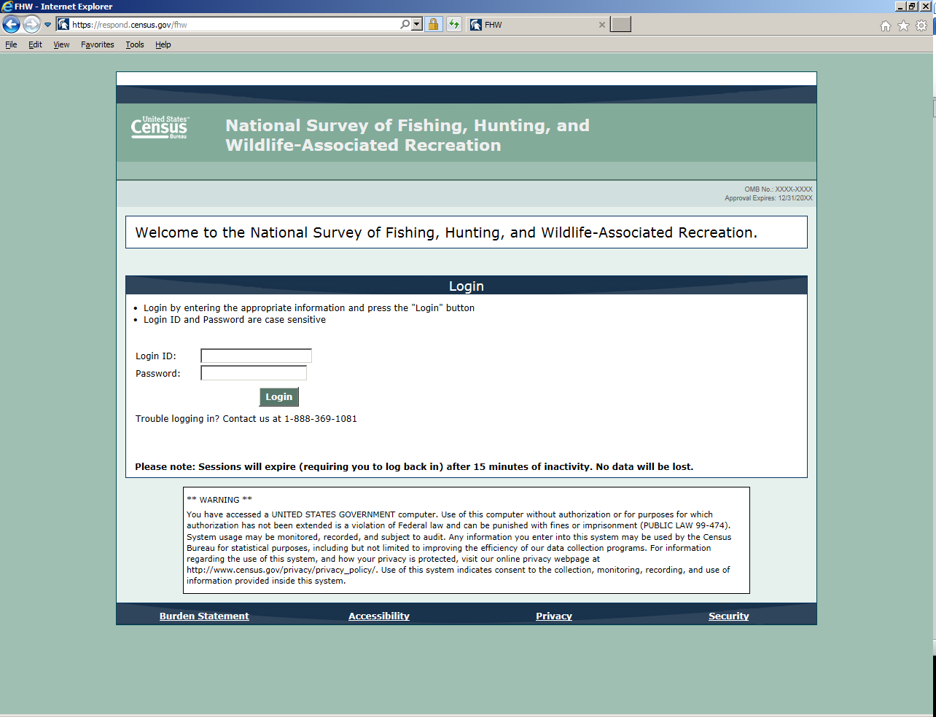

Pre-Screener Burden Statement Screen
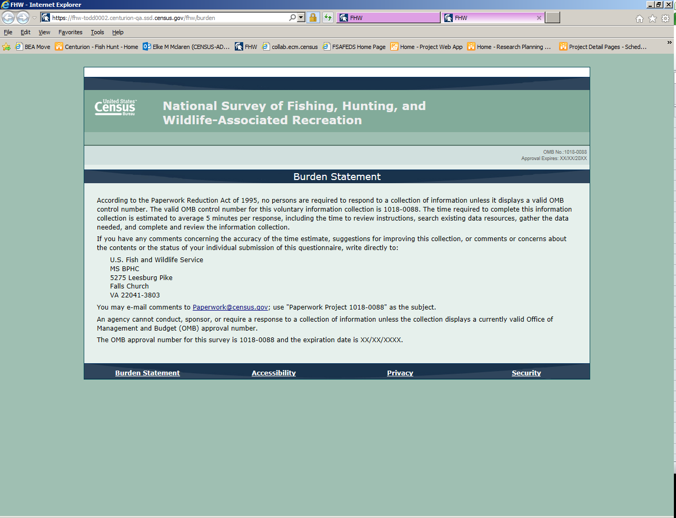

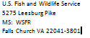
Please note: In the above screen, OMB Approval Number will be changed to OMB Control Number.

Pre-Screener Address Verification Screen
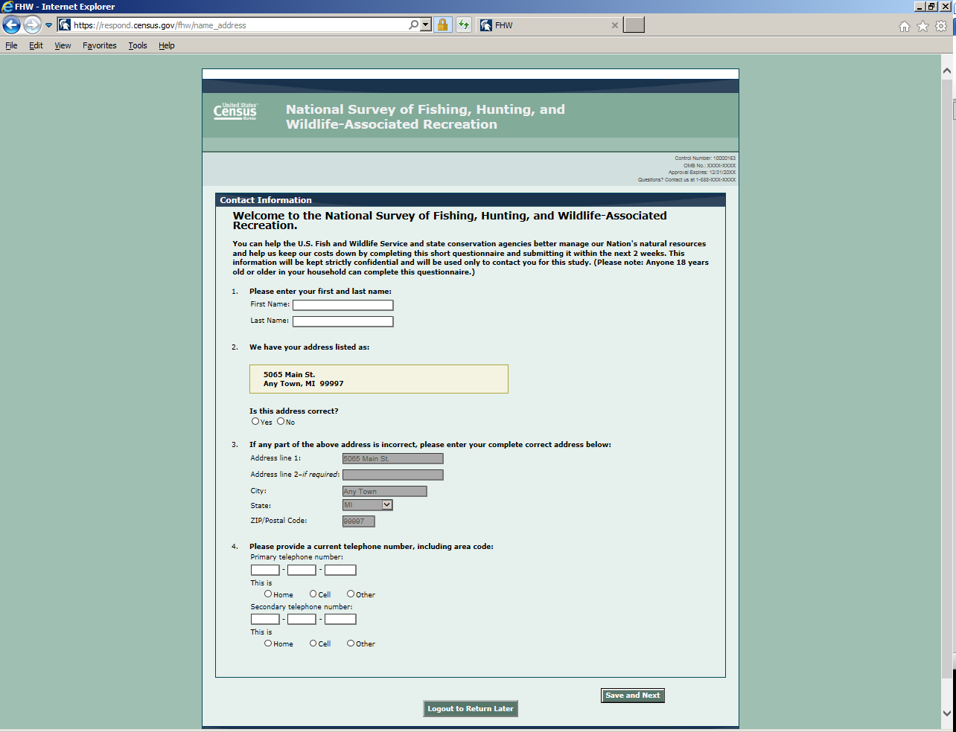

Pre-Screener Household Demographics Screen
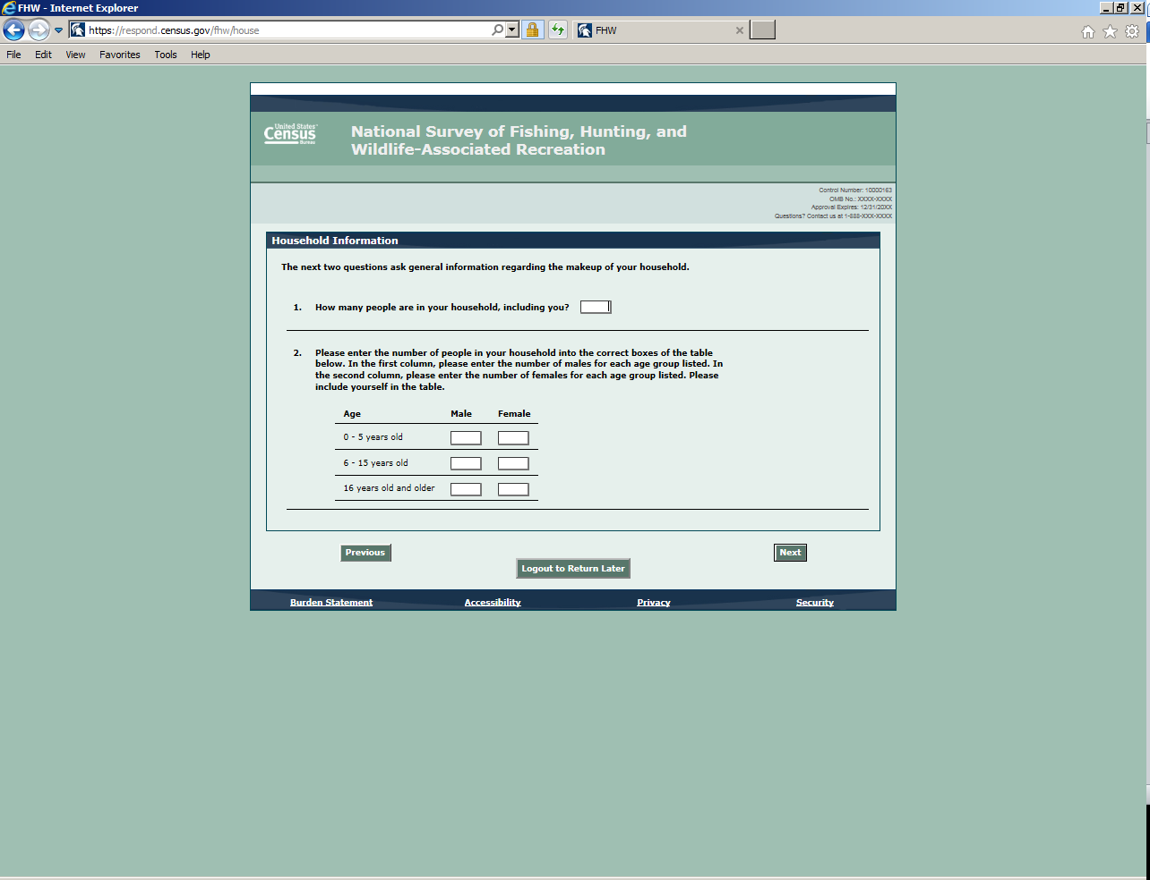

Pre-Screener Participation Screen
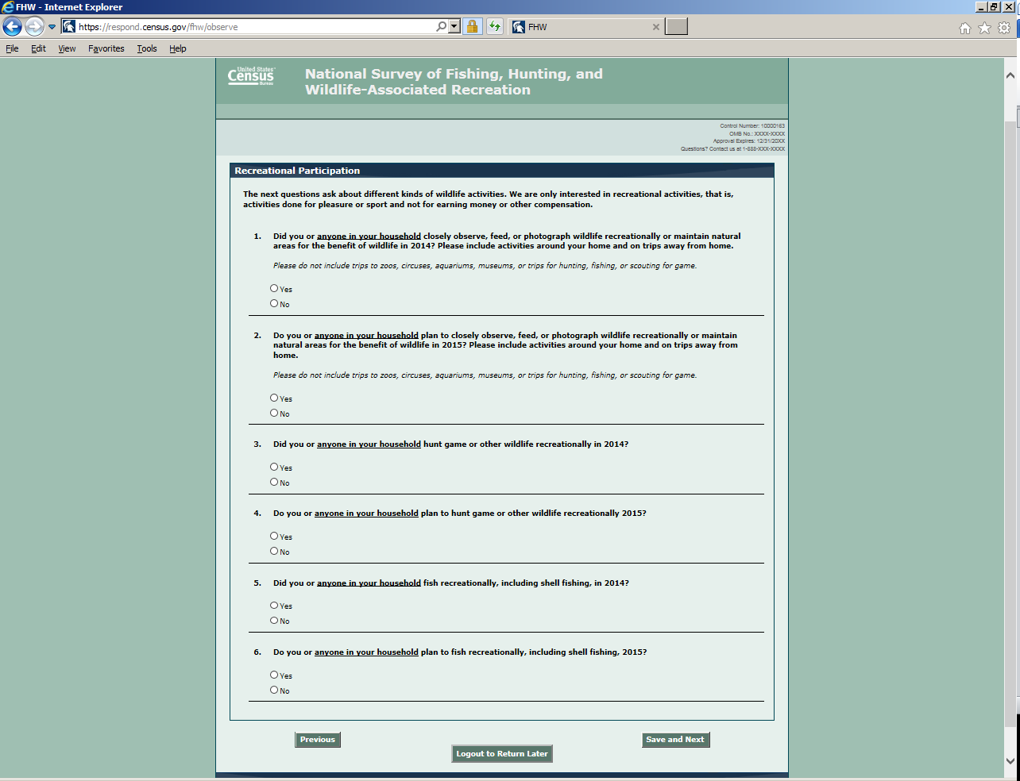
PLEASE NOTE: The questions on this screen will be updated as found below. Differences are in red.
1. Did you or anyone in your household closely observe, feed, or photograph wildlife recreationally or maintain natural areas for the benefit of wildlife in 2015 or so far in 2016? Please include activities around your home and on trips away from home.
2. Do you or anyone in your household anticipate closely observing, feeding, or photographing wildlife recreationally or maintaining natural areas for the benefit of wildlife in 2016? Please include activities around your home and on trips away from home.
3. Did you or anyone in your household hunt game or other wildlife recreationally in 2015 or so far in 2016?
4. Do you or anyone in your household anticipate hunting game or other wildlife recreationally in 2016?
5. Did you or anyone in your household fish recreationally, including shellfishing, in 2015 or so far in 2016?
6. Do you or anyone in your household anticipate fishing recreationally, including shellfishing, in 2016?
Pre-Screener Target Shooting/Archery Participation Screen
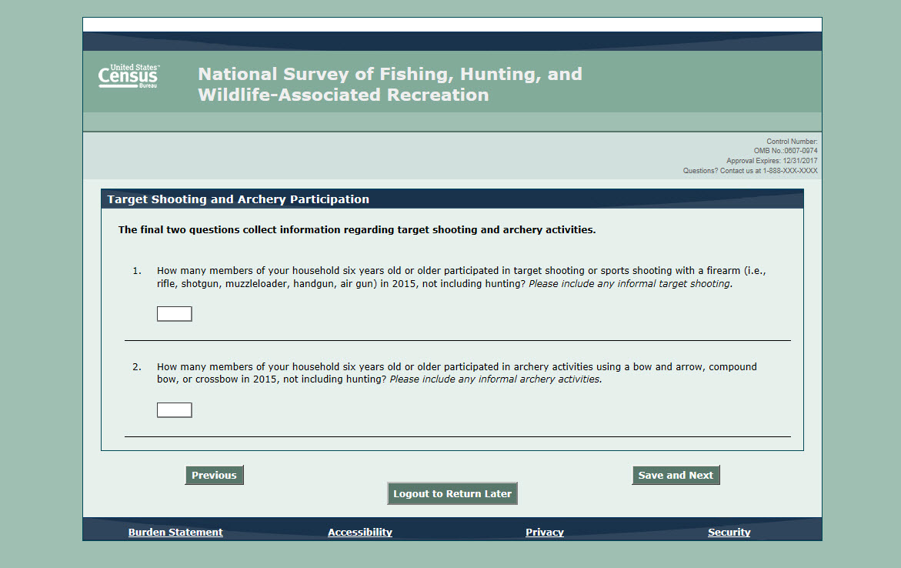
PLEASE NOTE: The questions on this screen will be updated as found below. Differences are in red.
- Did you or any members of your household do any target shooting or sport shooting with a firearm (rifle, shotgun, muzzleloader, handgun, airgun, etc.) in 2015, not including hunting? Please include any informal target shooting or sport shooting.
Yes
No

- Did you or any members of your household participate in archery activities using a bow and arrow, compound bow, or crossbow in 2015, not including hunting? Please include any informal archery activities.
Yes
No

Pre-Screener Submission Confirmation Screen
