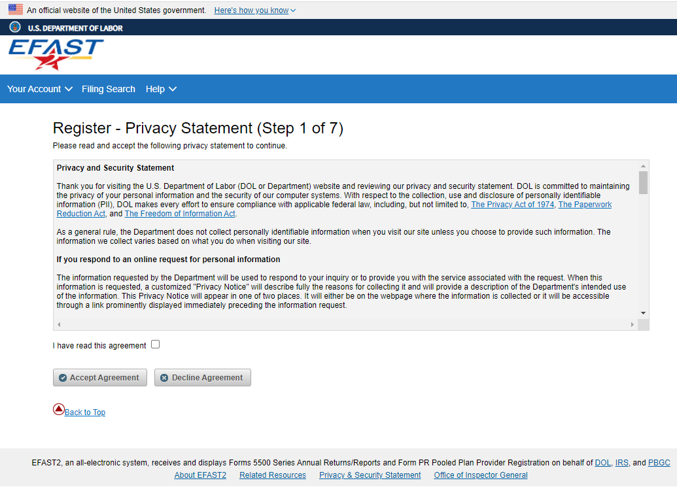

Full text of Statement:

**Privacy and Security Statement**  
  
Thank you for visiting the U.S. Department of Labor (DOL or Department) website and reviewing our privacy and security statement. DOL is committed to maintaining the privacy of your personal information and the security of our computer systems. With respect to the collection, use and disclosure of personally identifiable information (PII), DOL makes every effort to ensure compliance with applicable federal law, including, but not limited to, [The Privacy Act of 1974](https://www.justice.gov/opcl/privacy-act-1974), [The Paperwork Reduction Act](https://www.govinfo.gov/content/pkg/PLAW-104publ13/html/PLAW-104publ13.htm), and [The Freedom of Information Act](https://www.justice.gov/oip/blog/foia-update-freedom-information-act-5-usc-sect-552-amended-public-law-no-104-231-110-stat).  
  
As a general rule, the Department does not collect personally identifiable information when you visit our site unless you choose to provide such information. The information we collect varies based on what you do when visiting our site.  
  
**If you respond to an online request for personal information**  
  
The information requested by the Department will be used to respond to your inquiry or to provide you with the service associated with the request. When this information is requested, a customized "Privacy Notice" will describe fully the reasons for collecting it and will provide a description of the Department's intended use of the information. This Privacy Notice will appear in one of two places. It will either be on the webpage where the information is collected or it will be accessible through a link prominently displayed immediately preceding the information request.  
  
***Privacy Notice:***  
  
The Privacy Act of 1974 requires that when we ask you for information, we provide the basis of our legal right to ask for the information, why we are asking you for it, and how it will be used. We must also tell you what could happen if we do not receive it and whether your response is voluntary, required to obtain a benefit, or mandatory. The basis of our legal right to ask for the information is section 104 of the Employee Retirement Income Security Act (ERISA), 29 U.S.C. § 1024, which imposes certain annual reporting and filing requirements on pension and welfare benefit plans. All pension and welfare plans and direct filing entities that are required to submit an annual return/report under Title I of ERISA (Form 5500 Series) must file electronically. To do so, filers must register for electronic credentials through this website. If you do not register, you will not be able to meet your obligation to file the annual report.  
  
Generally, the information you provide for EFAST2 registration will be used to facilitate your registration, communicate with you about your credentials, and deliver official correspondence regarding your Form 5500 Series filing. DOL may also use it to inform you about any changes related to the Form Series filing, general education and outreach on ERISA, or for other official communications (including enforcement) regarding ERISA compliance. DOL may also share it with other federal agencies, if it determines by careful review that the records or information are both relevant and necessary to any enforcement, regulatory, investigative or prosecutive responsibility of the receiving entity, and that the use of such records or information is for a purpose that is compatible with the purposes for which the agency collected the records.  
  
We use contractors to perform various website and database functions. When we do, we make sure that the agreement language with the contractor ensures the security, confidentiality and integrity of any personal information.  
  
We may disclose to you and others the information you give us if authorized or required by Federal law, such as the Privacy Act. Also, if you provide false or fraudulent information, you may be subject to criminal prosecution. See section 1027, Title 18, U.S. Code (False statements and concealment of facts in relation to documents required by ERISA) and section 1001, Title 18, U.S. Code (Fraud and False Statements-Statements or entries generally). Other penalties may also apply.  
  
**If you visit our site to read or download information, we collect and store the following information**

* The name of the domain from which you access the internet (for example, dol.gov, if you are connecting from the Department of Labor's computer account).
* The date and time you access our site.
* The internet address of the website from which you directly linked to our site.
* Internet Protocol (IP) address.
* Type of browser and operating system you use to access our site.

This information is used by software programs on our website to collect summary statistics that allow us to assess the number of visitors to the different sections of our site, identify what information is of most and least interest, determine technical design specifications, monitor system performance, and help us make our site more useful to visitors.  
  
**If you identify yourself by sending an email containing personal information**  
  
You may send us personally identifiable information in an electronic mail message – for example you may send us your mailing address when requesting that information be mailed to you. This information is used solely for responding to your requests for information or records. We may forward your e-mail to other government employees at other Government agencies (e.g., Treasury Department/IRS, Pension Benefit Guaranty Corporation) who are better able to fulfill your requests. Should you wish to file a request under the Freedom of Information Act (FOIA), instructions are provided at [http://www.dol.gov/general/foia.](http://www.dol.gov/general/foia)  
  
**If you link to other sites outside DOL**  
  
Our website has many links to other sites. When you link to any of these sites, you are no longer on our site and are subject to the privacy policy of the new site.  
  
**Social Media and Third Party Sites**  
  
In addition to the Department's official websites, the Department uses social media and third party sites to provide DOL content in a different format that may be useful or interesting to you. When we use these sites, the information we provide is consistent with the intended purpose of the DOL website. No PII may be requested from or collected by DOL on social media sites. The privacy protection provided on social media and third party sites that are not a part of DOL websites may not be the same as the privacy protection given by the DOL and described here.  
  
**Cookie Use Notice**  
  
Cookies are small files that web servers place on a user's hard drive. They can serve several functions, depending upon how they are designed:

* They allow the website to identify you as a previous visitor each time you access a site;
* They track what information you view at a site (important to commercial sites trying to determine your buying preferences);
* In the more advanced cases they track your movements through many websites but not the whole web;
* Businesses use them for customer convenience to allow them to produce a list of items to buy and pay for them all at one time and to garner information about what individuals are buying at their sites;
* Advertisers use them to determine the effectiveness of their marketing and offer insights into consumer preferences and tastes by collecting data from many websites; and
* They can be used to help a website tailor screens for each customer's preference.

Some DOL pages have "session cookies," to facilitate use of that particular page. These disappear when the web user terminates a web session and closes the browser. DOL also permits the use of persistent cookies for the collection of web metrics; however, DOL does not collect any personally identifiable information about visitors to our webpages. Please see our [DOL Persistent Cookie Notice](https://www.dol.gov/general/persistentcookies)that details the types of information collected and how to opt-out by changing the cookie settings in your browsers.  
  
If you are concerned about the potential use of the information gathered from your computer by cookies, you can set your browser to prompt you before it accepts a cookie. Most internet browsers have settings that let you identify and/or reject cookies.  
  
For security purposes and to ensure that this service remains available to all users, our Web site also employs software programs to monitor network traffic to identify unauthorized attempts to upload or change information, or otherwise cause damage.  
  
Unauthorized attempts to upload information or change information on this service are strictly prohibited and may be punishable under the Computer Fraud and Abuse Act of 1986 and The National Information Infrastructure Protection Act of 1996.  
  
This statement is about your privacy when using this website. For information about the Department’s privacy program and our Senior Agency Official for Privacy (SAOP), visit our [Department of Labor Privacy Program page.](https://www.dol.gov/general/privacy)

