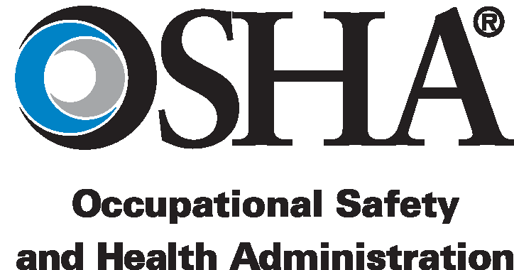
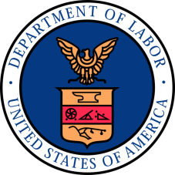
OMB No. 1218-0147
USDOL - OSHA
Office of Technical Programs and Coordination Activities
Directorate of Technical Support and Emergency Management
200 Constitution Ave., NW, Room N3655
Washington, DC 20210
Phone: 202-693-2110
Email: NRTLProgram@dol.gov
Account Number: F92031-NRTL
NRTL Program Fee Payment
 |  | Advance Payment |  |  |  |  |  |  |  |  |  | Payment for Services Rendered
Invoice No.: |  |  |  |  |  |  |  |  |  | Service Request Date:
Application/Fee Description (enter title from invoice or short description of services requested):
NRTL Company Name:
Billing Address 1:
Billing Address 2:
City: |  |  |  |  |  | State: |  |  | Postal Code: |  |  |  |  |  |  | Country:
Contact Person:
(Enter name of person who can be contacted regarding questions about payment.)
Telephone Number (include country code):
Email Address:
Additional Information:
 |  |  |  |  |  |  |  |  |  |  | PAYMENT: |  |  | $

